**Supplementary Information**

**Quantification of mulberrin and morusin in mulberry and other food plants via stable isotope dilution analysis using LC-MS/MS**

**Christian Schnurr1*†, Lance Buckett2†, Jana Bitenc1, Michael Rychlik1**

1 Chair of Analytical Food Chemistry, Technical University of Munich, Freising, Germany

2 Research Unit Analytical Biogeochemistry, Helmholtz Munich, Oberschleißheim, Germany

3 The University of Queensland, Queensland Alliance for Agriculture and Food Innovation, Brisbane, QLD, Australia

*Corresponding author: Christian Schnurr, christian.schnurr@tum.de

**†**Shared first authorship

List of Contents

1 LC-MS/MS parameters of (deuterated) MR and MB 1

2 Autosampler co-injection scheme for calibration graphs 2

3 Mass spectra of deuterated MB and MR 3

4 NMR analysis of deuterated MB 4

5 NMR analysis of deuterated MR 9

6 Optimization of sample preparation 14

7 LC-MS/MS chromatograms 16

7.1 Standard mix 16

7.2 Quality control 17

8 References 18

List of Tables

**Table S1** Retention times, MRM parameters and collision energies of (deuterated) MR and MB on the LC-MS/MS method. 1

**Table S2** Autosampler co-injection scheme for the creation of the calibration functions. 2

**Table S3** NMR data of MB and MB-D (1H-NMR 500 MHz, 13C-NMR 126 MHz, in acetone-d6). 5

**Table S4** NMR data of MR and MR-D (1H-NMR 500 MHz, 13C-NMR 126 MHz, in acetone-d6). 10

List of Figures

**Fig. S1.** Mass spectrum of deuterated MB in ESI(–)-mode. (Exact mass of [MB–H]– : 421,17). 3

**Fig. S2.** Mass spectrum of deuterated MR in ESI(–)-mode. (Exact mass of [MR–H]– : 419,15). 3

**Fig. S3.** Numbering scheme for MB. 4

**Fig. S4.** 1H-NMR spectrum of MB. 6

**Fig. S5.** 1H-NMR spectrum of MB-D. 7

**Fig. S6.** Comparison of the 1H-NMR spectra of MB-D (bottom) and MB (top). 8

**Fig. S7.** Numbering scheme for MR. 9

**Fig. S8.** 1H-NMR spectrum of MR. 11

**Fig. S9.** 1H-NMR spectrum of MR-D. 12

**Fig. S10.** Comparison of the 1H-NMR spectra of MR-D (bottom) and MR (top). 13

**Fig. S11.** Extraction of the analytes over sonication time during workup. 14

**Fig. S12.** Heat stability of the analytes at 40 °C tested over time. 14

**Fig. S13.** Storage stability of MR at room temperature, –27 °C, and –80 °C over 165 days. 15

**Fig. S14.** Storage stability of MB at room temperature, –27 °C, and –80 °C over 165 days. 15

**Fig. S15.** LC-MS/MS chromatogram of the standard mix. **A**: TICs of MB, MB-D, MR, and MR-D. **B**: EICs of MB and MR. **C**: EICs of MB-D and MR-D. 16

**Fig. S16.** LC-MS/MS chromatogram of the quality control. **A**: TICs of MB, MB-D, MR, and MR-D. **B**: EICs of MB and MR. **C**: EICs of MB-D and MR-D. 17

# LC-MS/MS parameters of (deuterated) MR and MB

**Table S1** Retention times, MRM parameters and collision energies of (deuterated) MR and MB on the LC-MS/MS method.

|  |  |  |  |
| --- | --- | --- | --- |
| Analyte | retention time [min] | mass transition [m/z [M–H]–] | collision energy [eV] |
| Morusin | 10.1 | 419.1485 > 297.1114 | 24 |
| 419.1485 > 191.0697 | 23 |
| Morusin-D | 10.1 | 425.1844 > 301.1379 | 23 |
| 425.1844 > 195.0959 | 24 |
| Mulberrin | 8.9 | 421.1639 > 309.0403 | 31 |
| 421.1639 > 299.1269 | 22 |
| Mulberrin-D | 8.9 | 424.1822 > 312.0593 | 27 |
| 424.1822 > 300.1351 | 23 |

# Autosampler co-injection scheme for calibration graphs

To a base of 44 μL water, varying amounts from three vials are added: one vial containing an analyte mix (a.m.1-a.m.3), one containing an IS-mix and one containing only ACN (to keep the injection volume constant). (The analyte mix is prepared at three different concentration levels in order to provide a wider range of molar analyte/IS ratios.)

**Table S2** Autosampler co-injection scheme for the creation of the calibration functions.

|  |  |  |  |  |  |
| --- | --- | --- | --- | --- | --- |
| n(MR)/n/MR-D) | n(MB)/n(MB-D) | V(IS-mix) [μL] | Analyte-mix | V(analyte-mix) [μL] | V(ACN) [μL] |
| 1.3E-02 | 1.3E-2 | 1 | a.m.1 | 0.5 | 3.5 |
| 4.0E-02 | 4.0E-02 | 1 | a.m.1 | 1.5 | 2.5 |
| 6.6E-02 | 6.6E-02 | 1 | a.m.1 | 2.5 | 1.5 |
| 0.1 | 0.1 | 1 | a.m.1 | 4.0 | 0 |
| 0.5 | 0.5 | 1 | a.m.2 | 0.2 | 3.8 |
| 1.3 | 1.3 | 1 | a.m.2 | 0.5 | 3.5 |
| 2.6 | 2.6 | 1 | a.m.2 | 1.0 | 3.0 |
| 5.3 | 5.3 | 1 | a.m.2 | 2.0 | 2.0 |
| 10.6 | 10.6 | 1 | a.m.2 | 4.0 | 0 |
| 26.4 | 26.4 | 1 | a.m.3 | 1.0 | 3.0 |
| 39.6 | 39.6 | 1 | a.m.3 | 1.5 | 2.5 |
| 52.8 | 52.9 | 1 | a.m.3 | 2.0 | 3.0 |
| 79.2 | 79.3 | 1 | a.m.3 | 3.0 | 1.0 |
|  | | | | | |
| c(IS-mix) [mg/mL] | | c(analyte mix, a.m.) [mg/mL] | | | |
| analyte | | analyte | a.m.1 | a.m.2 | a.m.3 |
| MR-D | 1.30E-03 | MR | 3.5E-05 | 3.5E-03 | 3.5E-02 |
| MB-D | 7.6E-04 | MB | 2.0E-05 | 2.0E-03 | 2.0E-02 |

Molar analyte/IS ratios, which were not used to generate the final calibration function, are greyed out.

# Mass spectra of deuterated MB and MR

Ein Bild, das Schwarz, Dunkelheit enthält.

**Fig. S1.** Mass spectrum of deuterated MB in ESI(–)-mode. (Exact mass of [MB–H]– : 421,17).

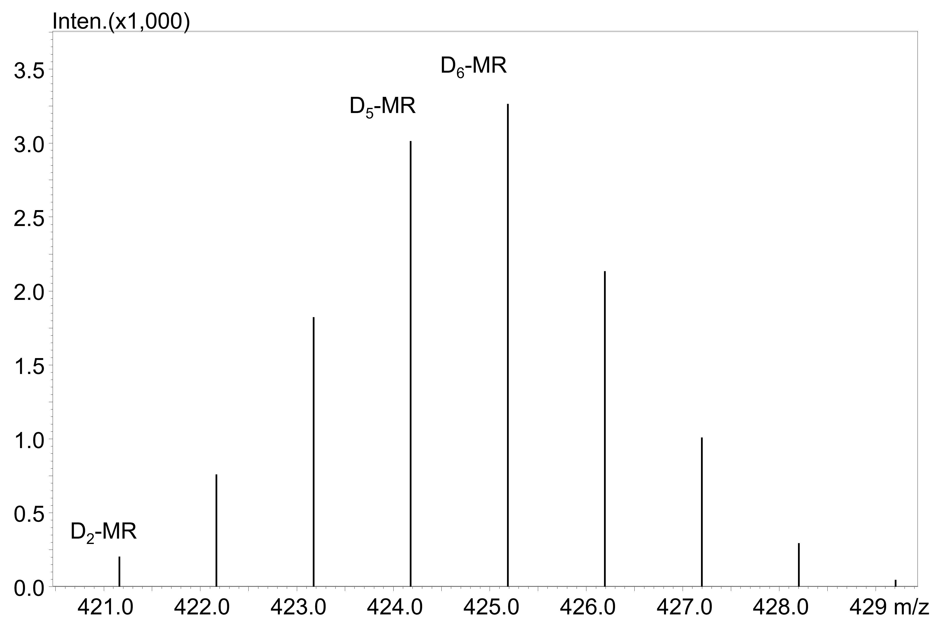

**Fig. S2.** Mass spectrum of deuterated MR in ESI(–)-mode. (Exact mass of [MR–H]– : 419,15).

# NMR analysis of deuterated MB

The following pages give details on the NMR analysis of MB deuteration. Table S4 lists the 1H- and 13C-NMR data of MB and MB-D. The values for MB are in accordance with literature reports (Zhang et al., 2016). Fig. S4 shows the 1H-NMR spectrum of MB. Fig. S5 shows the 1H-NMR spectrum of MB-D. Fig. S6 shows a comparison of both spectra. All discussions use the numbering scheme given in Fig. S3.



**Fig. S3.** Numbering scheme for MB.

NMR analysis shows that positions 6, 3’ and 5’ are deuterated in MB-D. This is consistent with the fact that these are the most acidic C-H positions in the molecule. The 1H-NMR spectrum of MB-D shows no residues of the H-6 signal and a strong decline (compared to MB) in the H-3’ and the H-5’ signal (integral = 0.02 and 0.08 instead of 1). Proton H-6’ which showed a doublet in the MB spectrum shows a singlet in the MB-D spectrum, accompanied by a very small residual doublet signal, confirming the almost complete deuteration of position 5’. Proton H-5’ showed a doublet of doublets in the MB spectrum, coupling with H-6’ (J = 8.4 Hz) and H-3’ (J = 2.3 Hz). In the MB-D spectrum, the residues of H-5’ show only a doublet, coupling with H-6’ (J = 8.3 Hz), but not with a proton at the 3’ position.

**Table S3** NMR data of MB and MB-D (1H-NMR 500 MHz, 13C-NMR 126 MHz, in acetone-d6).

|  |  |  |  |  |  |  |  |  |  |
| --- | --- | --- | --- | --- | --- | --- | --- | --- | --- |
| Position | HSQC | Mulberrin | | | | Deuterated mulberrin | | | |
|  |  | δC [ppm] | δH [ppm] | I | M [J/Hz] | δC [ppm] | δH [ppm] | I | M [J/Hz] |
| 2 | [C] | 162.30 |  |  |  | 162.29 |  |  |  |
| 3 | [C] | 121.21 |  |  |  | 121.18 |  |  |  |
| 4 | [C] | 183.37 |  |  |  | 183.29 |  |  |  |
| 4a | [C] | 105.24 |  |  |  | 105.21 |  |  |  |
| 5 | [C] | 160.91 |  |  |  | 160.86 |  |  |  |
| 6 | [CH] | 98.71 | 6.31 | 1H | s | – |  |  |  |
| 7 | [C] | 161.73 |  |  |  | 161.26 |  |  |  |
| 8 | [C] | 106.71 |  |  |  | 106.69 |  |  |  |
| 8a | [C] | 156.53 |  |  |  | 156.51 |  |  |  |
| 1‘ | [C] | 113.11 |  |  |  | 113.07 |  |  |  |
| 2‘ | [C] | 157.26 |  |  |  | 157.21 |  |  |  |
| 3‘ | [CH] | 103.79 | 6.57 | 1H | d [J = 2.3] | – | 6.57 | 0.02 H | s |
| 4‘ | [C] | 161.36 |  |  |  | 161.26 |  |  |  |
| 5‘ | [CH] | 108.02 | 6.52 | 1H | dd [J = 8.3, 2.3] | – | 6.52 | 0.08 H | d [J = 8.3] |
| 6‘ | [CH] | 132.36 | 7.22 | 1H | d [J = 8.3] | 132.23 | 7.22 | 1H | s |
| 1‘‘/  1‘‘‘ | 2 x [CH2] | 24.59  22.08 | 3.12/  3.36 | 2 x 2H | d [J = 7.1]  d [J = 7.4] | 24.61/  22.09 | 3.12/  3.36 | 2 x 2H | d [J = 7.1]  d [J = 7.4] |
| 2‘‘/  2‘‘‘ | 2 x [CH] | 122.77/  123.14 | 5.13/  5.20 | 2 x 1H | t [J = 7.1]  t [J = 7.4] | 122.78/  123.15 | 5.13/  5.20 | 2 x 1H | t [J = 7.1]  t [J = 7.4] |
| 3‘‘/  3‘‘‘ | 2 x [C] | 132.04/  131.64 |  |  |  | 132.01/  131.62 |  |  |  |
| 4‘‘/  4‘‘‘/  5‘‘/  5‘‘‘ | 4 x [CH3] | 25.86/  25.82/  17.73/  17.65 | 1.58/  1.58/  1.57/  1.43 | 4 x 3H | s | 25.86/  25.83/  17.74/  17.64 | 1.58/  1.57/  1.56/  1.43 | 4 x 3H | s |

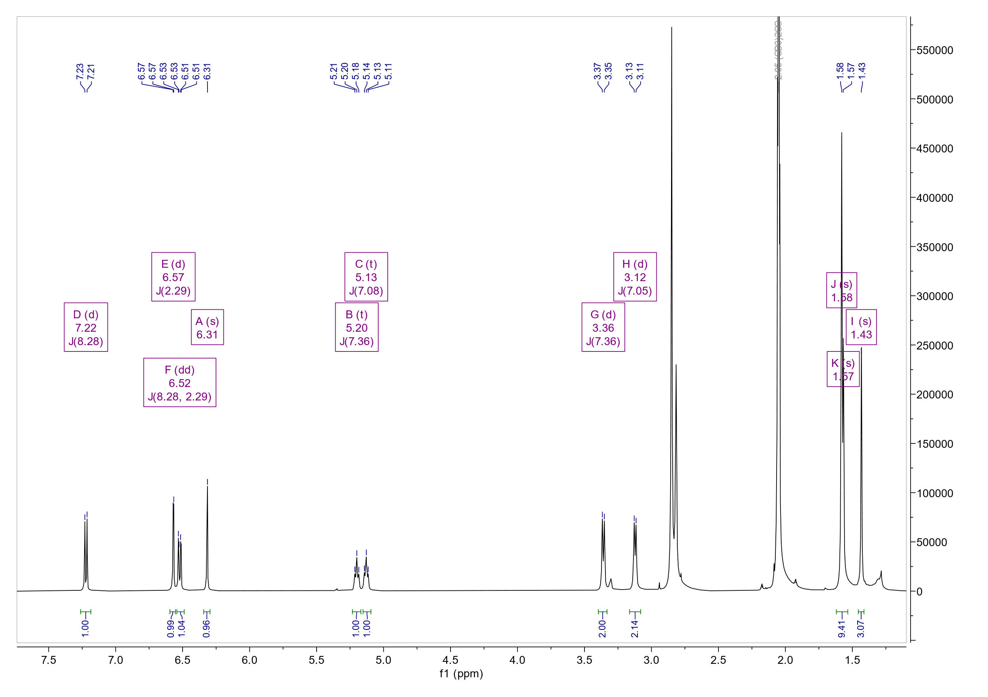

**Fig. S4.** 1H-NMR spectrum of MB.

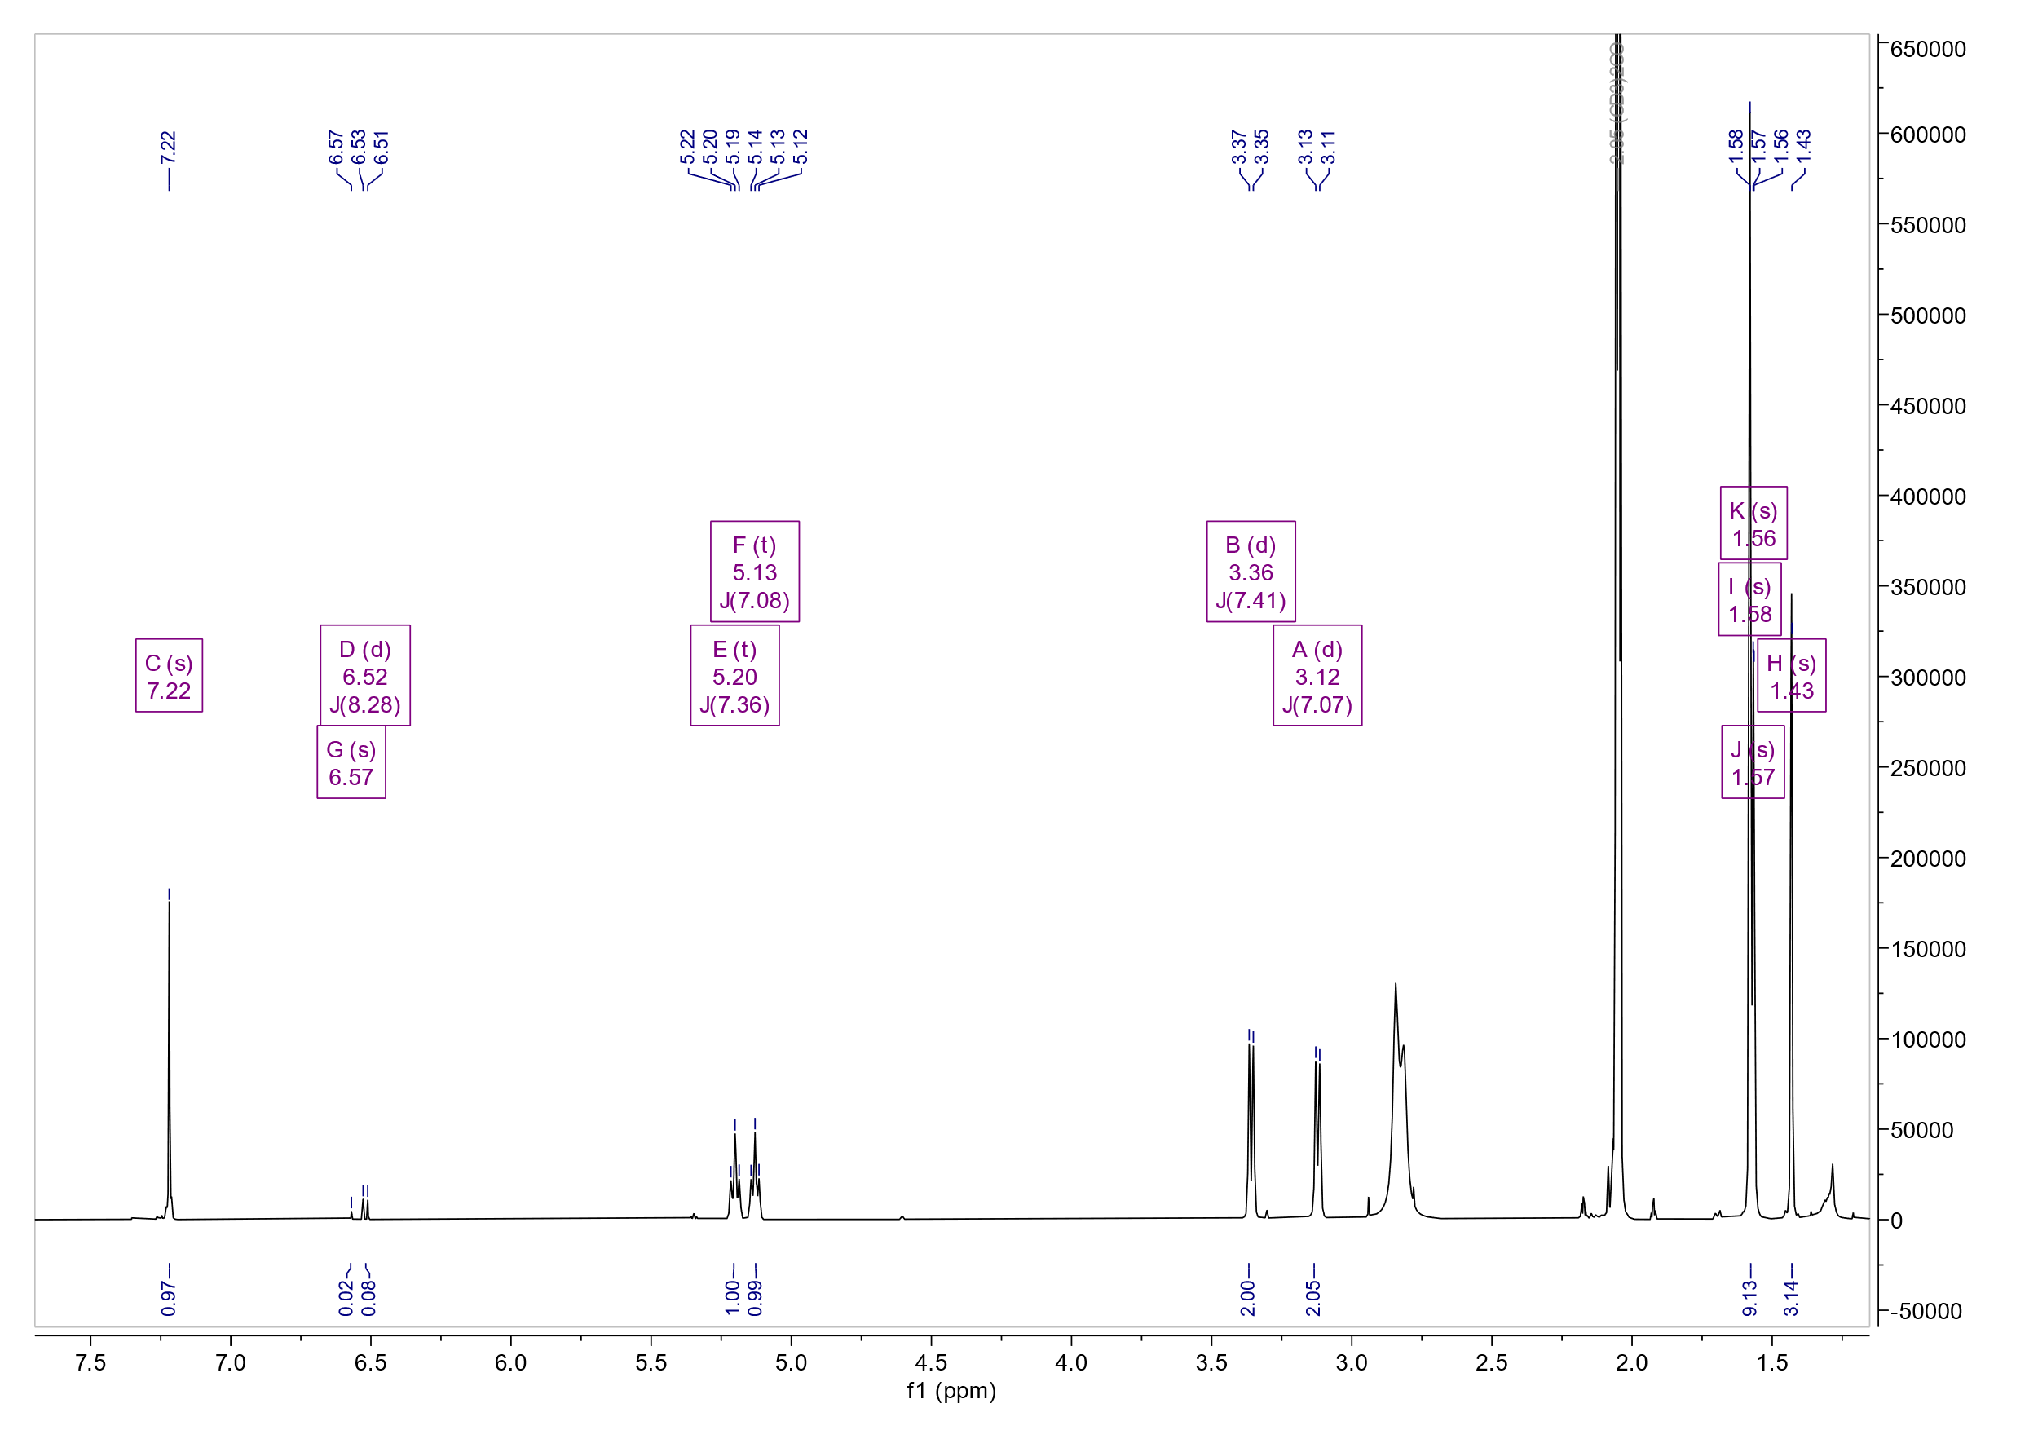

**Fig. S5.** 1H-NMR spectrum of MB-D.

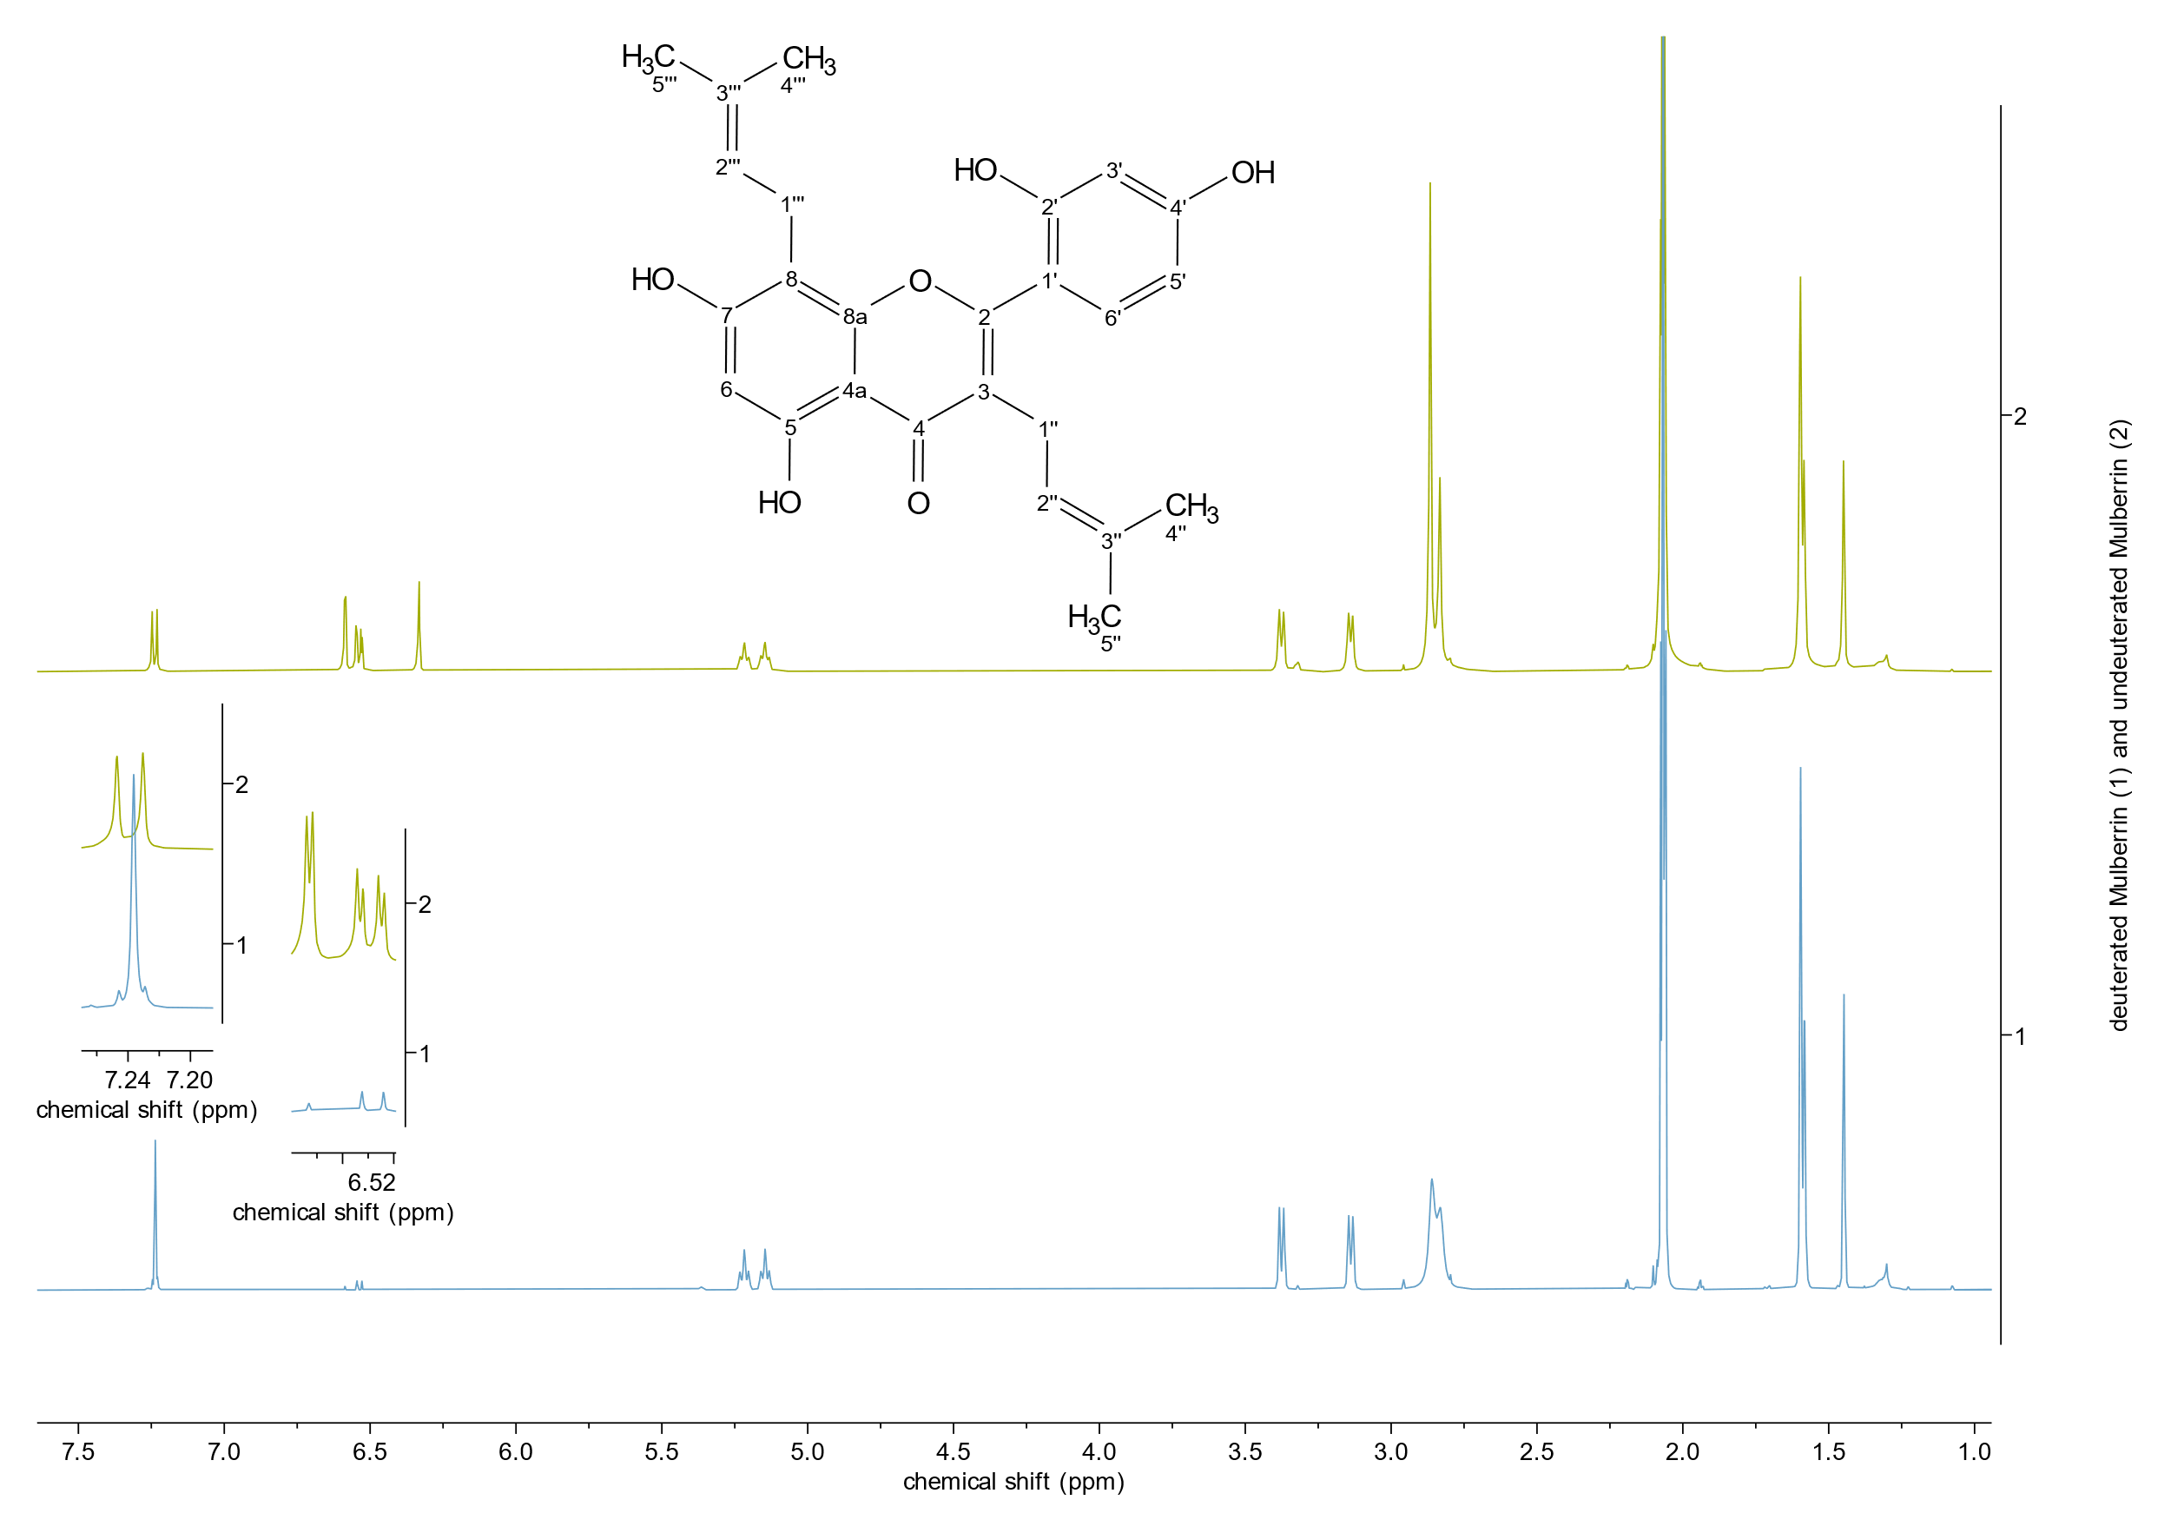

**Fig. S6.** Comparison of the 1H-NMR spectra of MB-D (bottom) and MB (top).

# NMR analysis of deuterated MR

The following pages give details on the NMR analysis of MR deuteration. Table S5 lists the 1H- and 13C-NMR data of MR and MR-D. The values for MR are in accordance with literature reports (Zhang et al., 2016). Fig. S8 shows the 1H-NMR spectrum of MR. Fig. S9 shows the 1H-NMR spectrum of MR-D. Fig. S10 shows a comparison of both spectra. All discussions use the numbering scheme given in Fig. S7.



**Fig. S7.** Numbering scheme for MR.

NMR analysis shows (just like for MB-D) that positions 6, 3’ and 5’ are deuterated in MR-D. However, in comparison to MB-D, these positions are less comprehensively deuterated, with the original proton signals being only reduced to an integral of 0.6, 0.1 and 0.3, and not (almost) completely gone as in the case of MB-D. Also, for MR-D the CH3 groups were partly deuterated. Instead of a cumulative integral of 12, they only amounted to 8.3. These differences are consistent with the observation that the deuteration of MR showed a Gaussian curve-like distribution of deuteration products in the MS spectrum.

**­****Table S4** NMR data of MR and MR-D (1H-NMR 500 MHz, 13C-NMR 126 MHz, in acetone-d6).

|  |  |  |  |  |  |  |  |  |  |
| --- | --- | --- | --- | --- | --- | --- | --- | --- | --- |
| Position | HSQC | Morusin | | | | Deuterated morusin | | | |
|  |  | δC [ppm] | δH [ppm] | I | M [J/Hz] | δC [ppm] | δH [ppm] | I | M [J/Hz] |
| 2 | [C] | 162.40 |  |  |  | 162.48 |  |  |  |
| 3 | [C] | 121.79 |  |  |  | 121.81 |  |  |  |
| 4 | [C] | 183.28 |  |  |  | 183.28 |  |  |  |
| 4a | [C] | 105.61 |  |  |  | 105.60 |  |  |  |
| 5 | [C] | 162.80 |  |  |  | – |  |  |  |
| 6 | [CH] | 99.75 | 6.16 | 1H | d [J = 2.1] | 99.73 | 6.15 | 0.6 H | s |
| 7 | [C] | 160.01 |  |  |  | 160.00 |  |  |  |
| 8 | [C] | 101.65 |  |  |  | 101.71 |  |  |  |
| 8a | [C] | 153.29 |  |  |  | 153.30 |  |  |  |
| 1‘ | [C] | 112.75 |  |  |  | 112.45 |  |  |  |
| 2‘ | [C] | 157.38 |  |  |  | 157.35 |  |  |  |
| 3‘ | [CH] | 103.90 | 6.57 | 1H | d [J = 2.3] | 103.90 | 6.57 | 0.1 H | s |
| 4‘ | [C] | 161.59 |  |  |  | 161.54 |  |  |  |
| 5‘ | [CH] | 108.22 | 6.53 | 1H | dd [J = 8.4, 2.3] | 108.17 | 6.52 | 0.3 H | d [J = 8.4] |
| 6‘ | [CH] | 132.46 | 7.26 | 1H | d [J = 8.4] | 132.41 | 7.25 | 1H | s / d[J = 8.4] |
| 1‘‘ | [CH2] | 24.65 | 3.13 | 2H | d [J = 7.1] | 24.66 | 3.13 | 2H | d [J = 7.1] |
| 2‘‘ | [CH] | 122.51 | 5.13 | 1H | t [J = 7.1] | 122.54 | 5.13 | 1H | t [J = 7.1] |
| 3‘‘ | [C] | 132.45 |  |  |  | 132.31 |  |  |  |
| 1‘‘‘ | [CH] | 115.43 | 6.60 | 1H | d [J = 10.0] | 115.45 | 6.60 | 1H | d [J = 10.0] |
| 2‘‘‘ | [CH] | 128.05 | 5.66 | 1H | d [J = 10.0] | 128.03 | 5.65 | 1H | d [J = 10.0] |
| 3‘‘‘ | [C] | 78.79 |  |  |  | 78.66 |  |  |  |
| 4‘‘/  4‘‘‘/  5‘‘/  5‘‘‘ | 4 x [CH3] | 28.28/  28.28/  25.8/  17.7 | 1.58/  1.44/  1.44/  1.44 | 4 x 3H | s | 25.81/  17.78 | 1.57/  1.44/  1.41/  1.40 | 3H  3H  1.5H  0.8H | s |

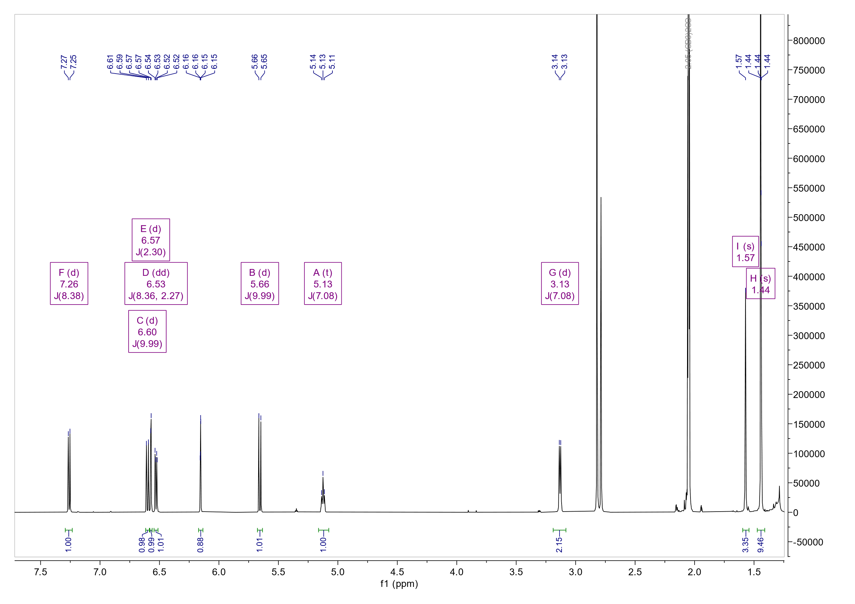

**Fig. S8.** 1H-NMR spectrum of MR.

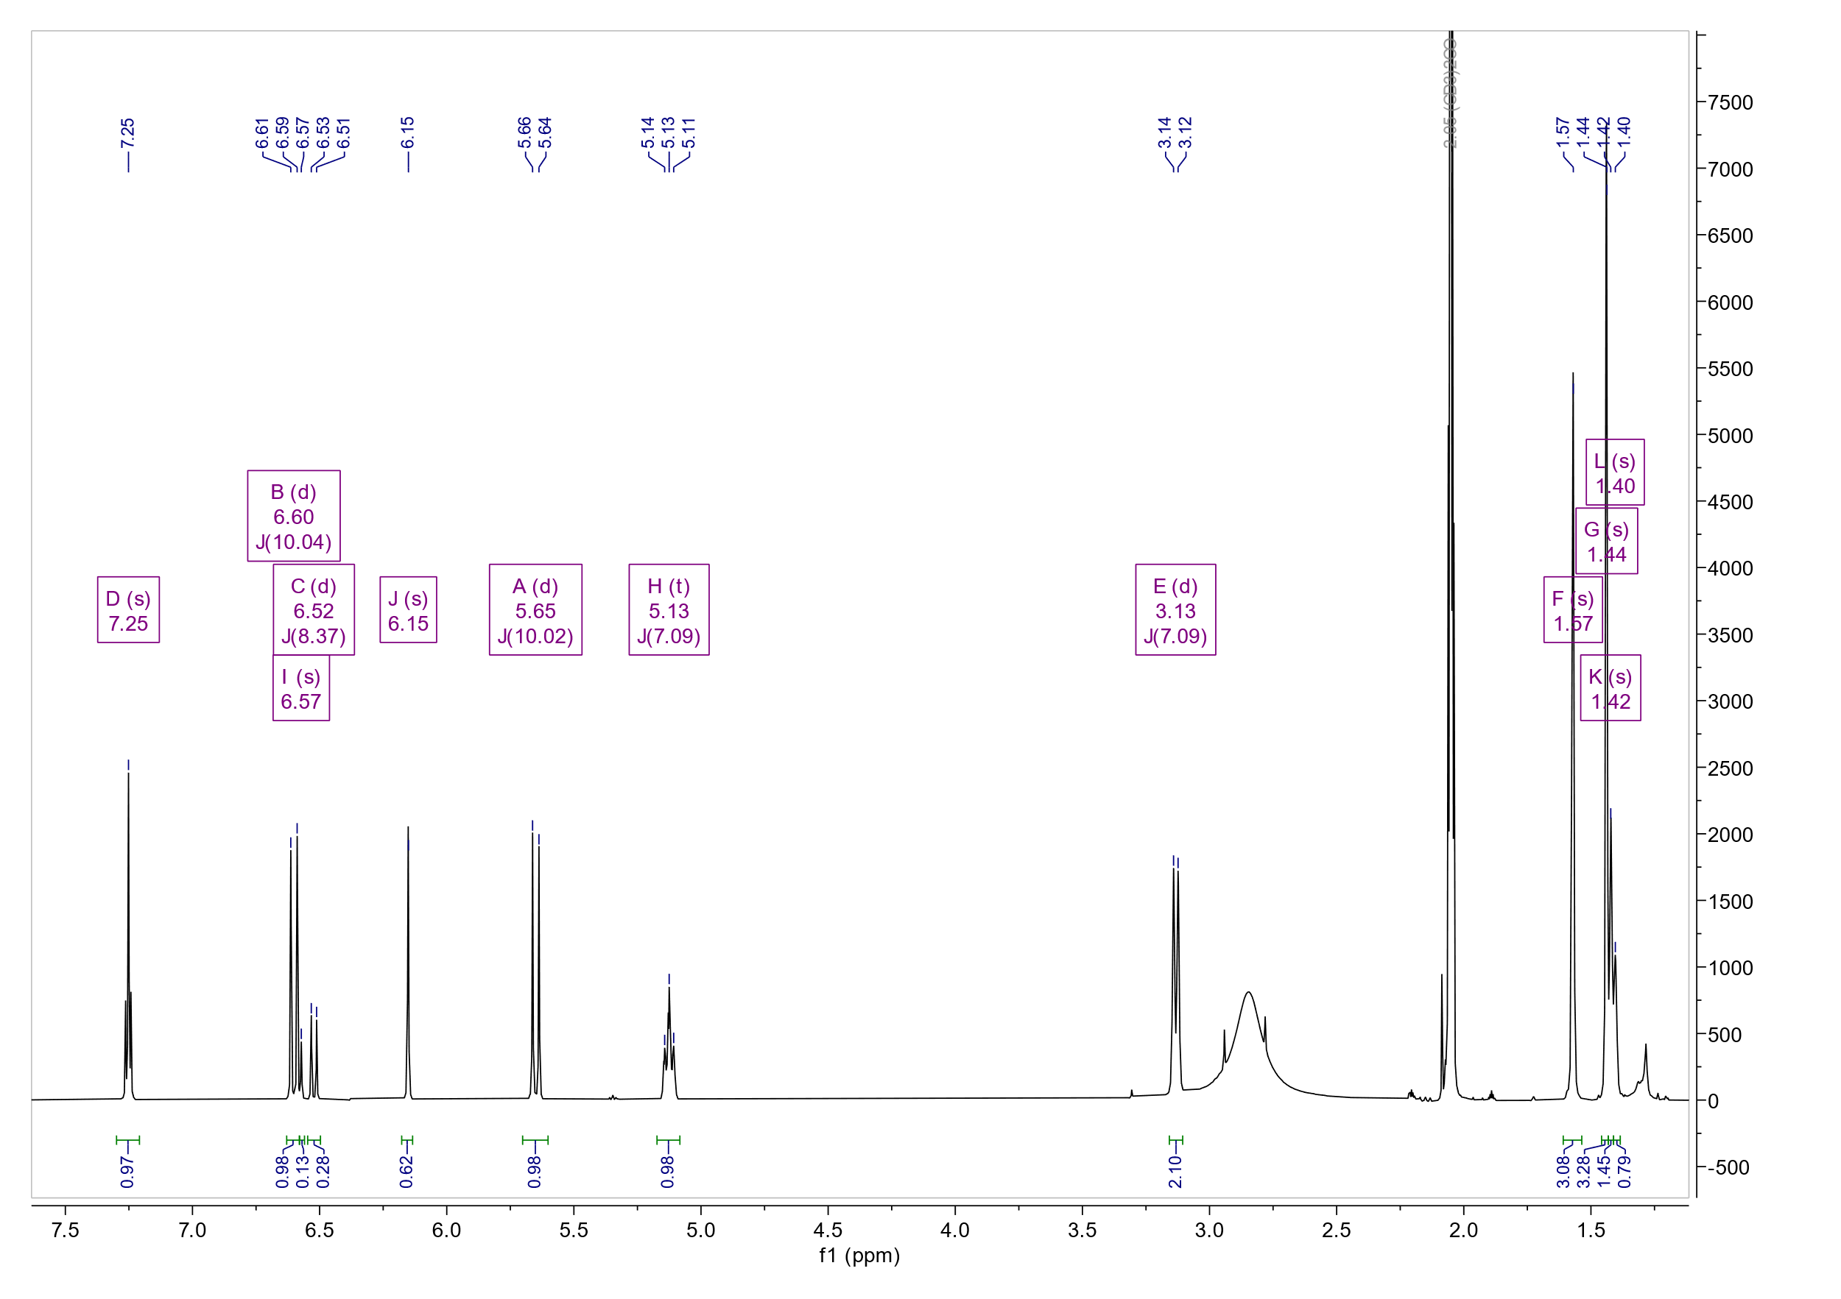

**Fig. S9.** 1H-NMR spectrum of MR-D.

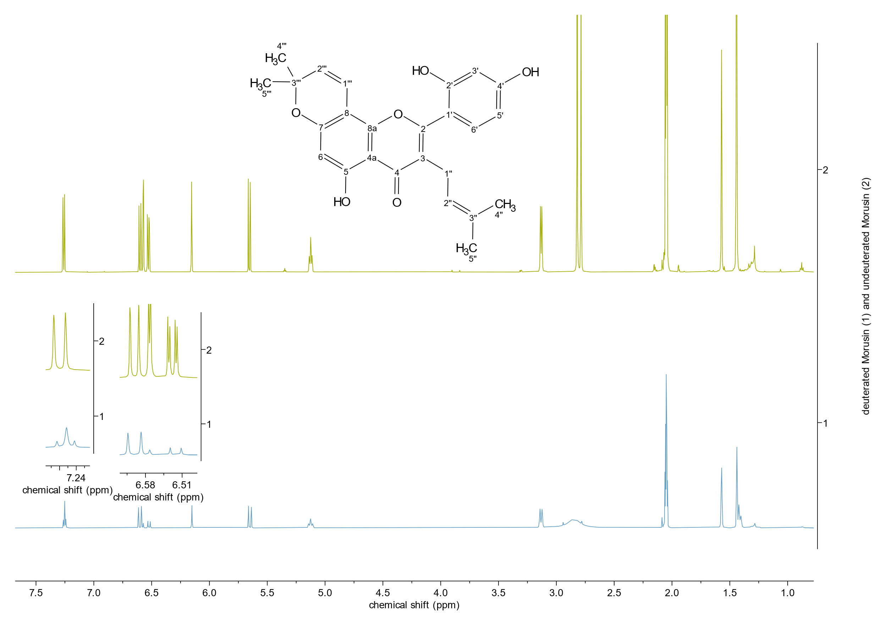

**Fig. S10.** Comparison of the 1H-NMR spectra of MR-D (bottom) and MR (top).

# Optimization of sample preparation

**Fig. S11.** Extraction of the analytes over sonication time during workup.

**Fig. S12.** Heat stability of the analytes at 40 °C tested over time.

**Fig. S13.** Storage stability of MR at room temperature, –27 °C, and –80 °C over 165 days.

**Fig. S14.** Storage stability of MB at room temperature, –27 °C, and –80 °C over 165 days.

Note: relative peak areas above 100 % (compared to day 1) are due to a detector cleanse.

# LC-MS/MS chromatograms

## Standard mix

The standard mix consisted of constant amounts of MB, MB-D, MR, and MR-D, and was regularly measured in between every few samples as a reference.

Ein Bild, das Text, Screenshot, Diagramm, Reihe enthält.

**Fig. S15.** LC-MS/MS chromatogram of the standard mix. **A**: TICs of MB, MB-D, MR, and MR-D. **B**: EICs of MB and MR. **C**: EICs of MB-D and MR-D.

Note: Five-fold deuterated MR has the same mass as MB-D, and four-fold deuterated MB has the same mass as MR-D (see Fig. S1 and S2), which is why in the chromatogram of the deuterated standards there is a second peak at the retention time of the other standard, respectively.

## Quality control

The quality control consisted of a mix of a small amount of every plant sample.

Ein Bild, das Text, Screenshot, Reihe, Diagramm enthält.

**Fig. S16.** LC-MS/MS chromatogram of the quality control. **A**: TICs of MB, MB-D, MR, and MR-D. **B**: EICs of MB and MR. **C**: EICs of MB-D and MR-D.

Note: Five-fold deuterated MR has the same mass as MB-D, and four-fold deuterated MB has the same mass as MR-D (see Fig. S1 and S2), which is why in the chromatogram of the deuterated standards there is a second peak at the retention time of the other standard, respectively.

References

Zhang, L., Tao, G., Chen, J., & Zheng, Z.-P. (2016). Characterization of a New Flavone and Tyrosinase Inhibition Constituents from the Twigs of Morus alba L. *Molecules*, *21*.