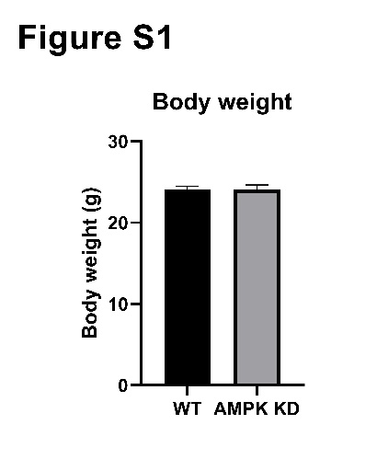

**Figure S1. Body weight is similar between wild-type (WT) and AMPKα2 kinase-dead (KD) mice at time of experiment.** Body weight of 16- to 18-week old wild-type (WT) and AMPKα2 kinase-dead (KD) mice after consuming a high-fat diet (HFD) for 8 weeks. n=48.

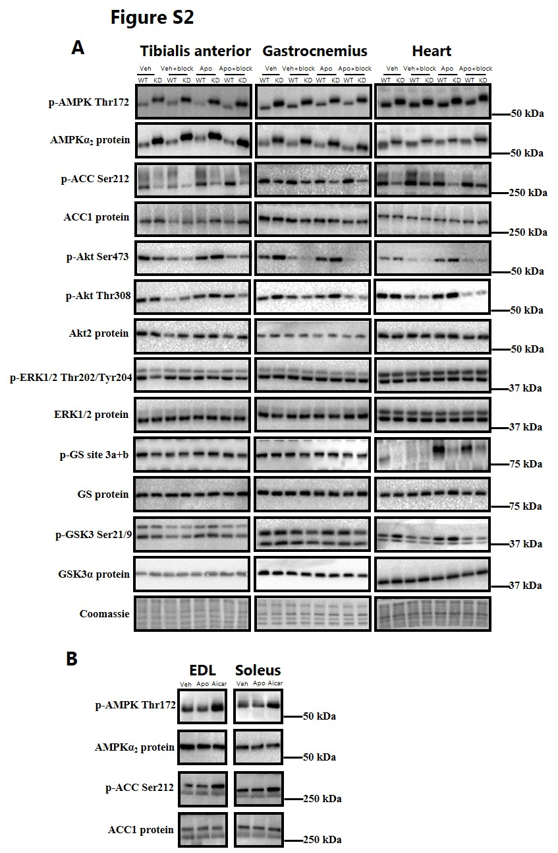

**Figure S2. Representative Western blots.** Representative Western blots of tibialis anterior, gastrocnemius, and heart muscle from wild-type (WT) and AMPKα2 kinase-dead (KD) mice *in vivo* treated with ApoA-1 (Apo; 14 mg/kg) or saline (Veh) and with (+block) or without insulin blockade (A) and representative Western blots of isolated extensor digitorum longus (EDL) and soleus from C57Bl/6 mice *ex vivo* incubated with either vehicle (Veh), recombinant ApoA-1 (60 µg/ml) or 2 mmol/L 5-aminoimidazole-4-carboxamide ribonucleotide (AICAR) for 3 hours.

**Table S1**

|  |  |
| --- | --- |
| **Primary antibodies** | **Source** |
| Anti-p-AMPK Thr172 | #2531 Cell Signaling Technology, US |
| Anti-AMPKα2 | Kindly donated by Dr. G. Hardie, Uni. of Dundee |
| Anti-p-ACC Ser212 | #07-303 Upstate Biotechnology |
| Anti-ACC1 | Kindly donated by Dr. G. Hardie, Uni. of Dundee |
| Anti-p-Akt Ser473 | # 9271 Cell Signaling Technology, US |
| Anti-p-Akt Thr308 | #9275 Cell Signaling Technology, US |
| Anti-Akt2 | #3063 Cell Signaling Technology, US |
| Anti-p-ERK1/2 Thr202/Tyr204 | # 9101 Cell Signaling Technology, US |
| Anti-ERK1/2 | # 9102 Cell Signaling Technology, US |
| Anti-p-GS site3a+b | Kindly donated by Dr. G. Hardie, Uni. of Dundee |
| Anti-GS | Kindly donated by Dr. Oluf Pedersen, Uni. of Copenhagen |
| Anti-p-GSK3 Ser21/Ser9 | #9331 Cell Signaling Technology, US |
| Anti-GSK3α | #06-391 Upstate Biotechnology, US |
|  |  |