New Aspects of the Photodegradation of Iron(III) Citrate: Spectroscopic Studies and Plant Related Factors
Authors: Maria Gracheva^{1,2*}, Zoltán Homonnay¹, Amarjeet Singh^{3,4}, Ferenc Fodor³, Vanda B. Marosi⁵, Ádám Solti³, Krisztina Kovács¹
*Corresponding author: gracheva@student.elte.hu

Supplementary material

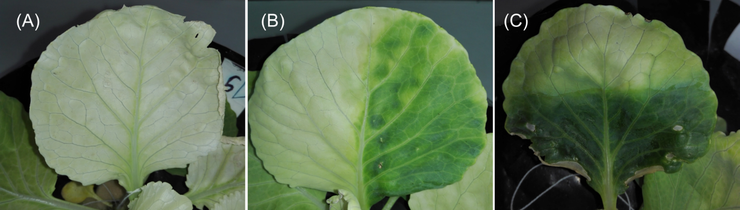

Supplementary Figure 1. Leaves of iron deficient (A) and iron(III) citrate treated (B and C) cabbage leaves. As for iron(III) citrate treatment, right or bottom half of the leaf blade (B and C, respectively) was subjected to the treatment. Images were taken one week after the first treatment, before leaves were harvested for later X-ray fluorescence analysis.

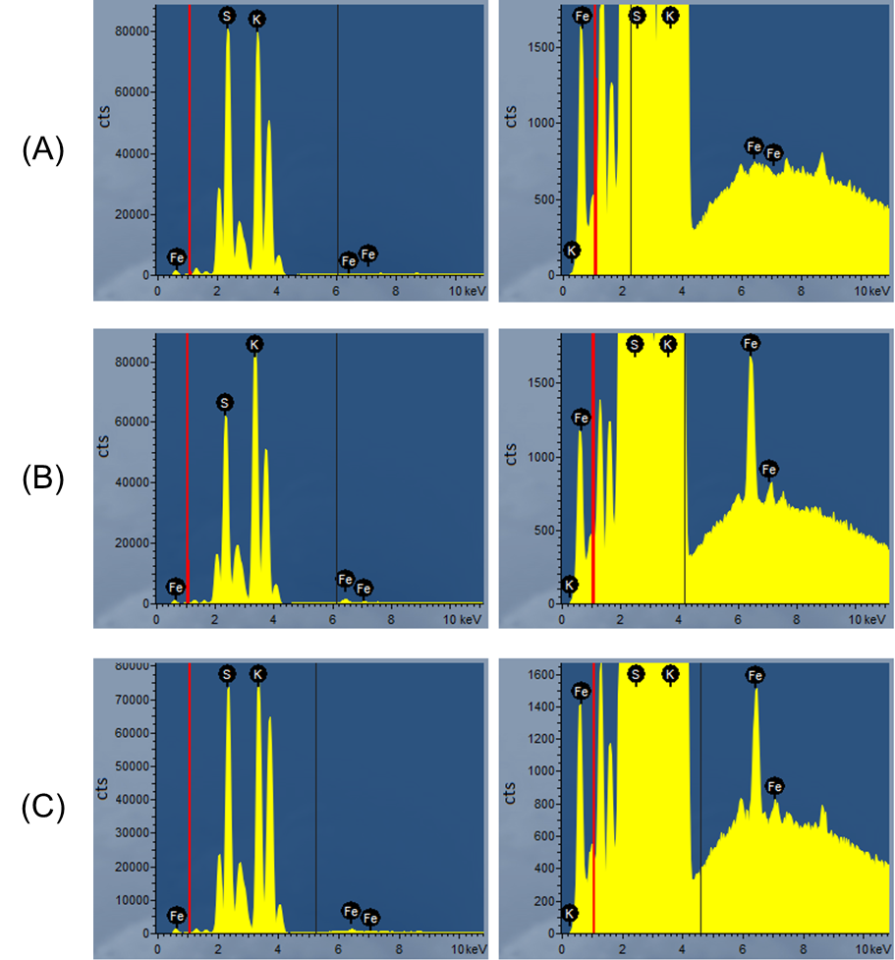
Supplementary Figure 2. Energy dispersive X-ray fluorescence (EDXRF) spectra of iron deficient (A), and iron(III) citrate treated cabbage leaves where the treatment was applied on the right and bottom side of the leaf blades (B and C, respectively). Spectra in the right block are zoomed on the Fe Kα peak. Spectra were obtained from the selected mapping area subjected to X-ray fluorescence analysis appearing on Figure 5 and Suppl. Fig 3, 4 & 5. Showing the most intensive relative abundance, S Kα and K Kα were identified at 2.309 and 3.314 keV, respectively. Fe Kα was identified at 6.405 keV. Red line at 1.040 keV indicates Na Kα as for detection limit of the instrument.
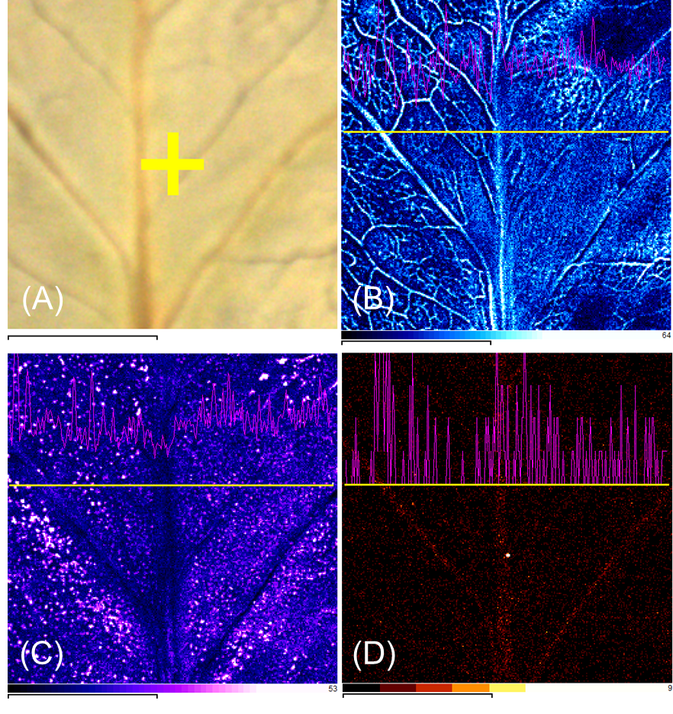
Supplementary Figure 3. Mapping area (A) and X-ray fluorescence images taken at K Kα, S Kα and Fe Kα (B, C and D, respectively) of an iron deficient cabbage leaf. Distribution pattern appearing in purple were taken as horizontal profiles at the yellow indicator lines. Scale bars are equal to 7 mm.
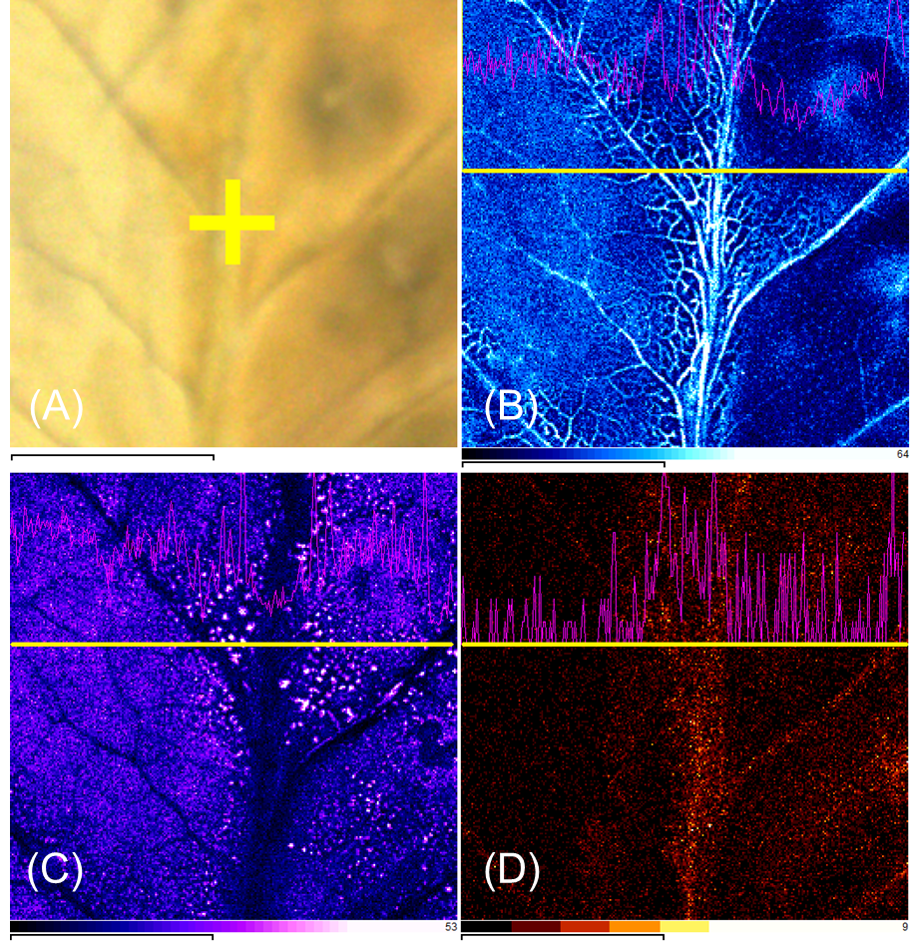
Supplementary Figure 4. Mapping area (A) and X-ray fluorescence images taken at K Kα, S Kα and Fe Kα (B, C and D, respectively) of a cabbage leaf treated with iron(III) citrate on the right side of the leaf blade. Note the differences in the pigment content between the two sides appearing on the mapping area (A). Distribution pattern appearing in purple were taken as horizontal profiles at the yellow indicator lines. Scale bars are equal to 7 mm.
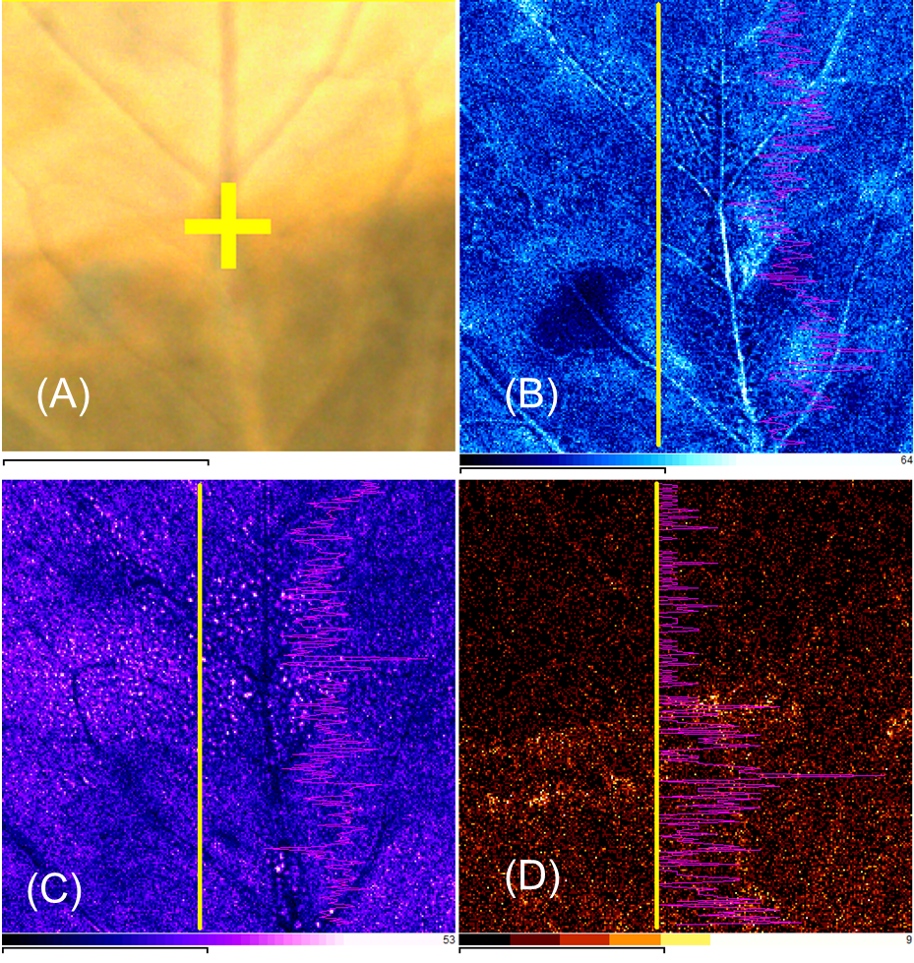
Supplementary Figure 5. Mapping area (A) and X-ray fluorescence images taken at K Kα, S Kα and Fe Kα (B, C and D, respectively) of a cabbage leaf treated with iron(III) citrate on the bottom side of the leaf blade. Note the differences in the pigment content between the two sides appearing on the mapping area (A). Distribution pattern appearing in purple were taken as vertical profiles at the yellow indicator lines. Scale bars are equal to 7 mm.

