**SUPPLEMENTARY MATERIAL**

# Methods (Methods and any associated references are available in the online version of the paper)

## Tumor specific fluorescence agent:

Bevacizumab (Avastin, Roche(R)) was conjugated to IRDye800CW (Licor) as previously published [1] [2] . All vial of bevazizumab-irdye800CW where produced at clinical grading from the Hospital Pharmacy (University Medical Center Groningen) according the local IRB approved protocols [1]. Bevacizumab-IRDye800CW was administered intravenously at a dose of 4.5 mg at a concentration of 1 mg/ml as intravenous bolus injection approximately 72 hours before surgery. No serious adverse events were reported during or after the study. The Surgery and Inclusion Criteria referred to female breast cancer patients with proven breast tumor of diameter than >15mm which were scheduled for lumpectomy or mastectomy.

## Intra-operative Camera System:

Intra-operative imaging was performed by a custom-designed concurrent multi-sensor imaging system. Fluorescence was excited by a fiber-coupled near-infrared (750nm-300mw) continuous wave diode laser (BWF2-750-0, B&W Tek, Newark, Delaware) guided through a widening lens (F260SMA-B, Thorlabs Inc, Newton, NJ, USA) and a diffuser (DG10-220, Thorlabs). Additionally the field of view was illuminated with white light provided by a 250 W halogen lamp (KL-2500LCD, Schott AG, Mainz, Germany), guided through a short pass filter (E700SP-2P, Chroma, Bellows Falls, VT,USA) to prevent illumination crosstalk to the fluorescence channel. The field of view was imaged by a motorized lens (CVO GAZ11569M, Goyo Optical, Japan), separated in visible and NIR fluorescence parts by a dichroic beam splitter (T760lpxr, Chroma) and relayed to appropriate CCD sensors accordingly (MAP10100100, Thorlabs). The NIR fluorescence image was guided through a band pass filter (ET810/90, Chroma) for eliminating non-fluorescence parts of the spectrum and acquired by a scientific deep-cooled (typically. -70°C ) back-illuminated CCD Camera (iXon DU-888,Andor Technology, Belfast, Northern Ireland). The color-reflection image was guided through a short pass filter (E700SP-2P, Chroma) and acquired by a 12-bit Bayer-patterned color camera (pixelfly QE 275xs PCO AG, Kelheim, Germany). For the mitigation of specular reflections on wet tissue surfaces in the color image, the white-light illumination and color camera reflection channel can optionally be equipped with linear-polarizer's (21003b, Chroma) in cross-polarization geometry.

The entire system was protected by a custom-made polyurethane housing, mounted on a surgical arm and wrapped in sterile drapes during surgery (OPMI nr 306071, Zeiss, Oberkochen, Germany). The heat disposal for the deep-cooled CCD camera was achieved by additional liquid cooling. Both, color and fluorescence images were acquired, processed, stored and displayed simultaneously at video rate. The acquisition was performed on a standard PC where image correlation, demosaicing, mapping to visualization dynamic range and image fusion are performed at video rates using the GPU [3]. All imaging parameters including the zoom, iris and focus of the motorized lens are controllable by a lightweight, user-friendly, GPU-accelerated acquisition and visualization software. The color reflectance image, the raw fluorescence image or a fused false-color overlay image are displayed instantly in video rate and latency-free at the built-in screens of the operational theater. During the surgery there were images acquired prior to incision, before tumor resection and after tumor resection at the open surgical cavity.

## Fluorescence validation, H&E & VEGF-A Staining

After surgery, the resected tissue parts are sliced in lamellae (~3mm thickness) and processed in standard patient care. Parts of the lamellae including tumor mass, tumor border and healthy tissue are resected and embedded in paraffin. Besides of patient standard care also fluorescence images of the paraffin cutting plane where acquired by a custom build high sensitive fluorescence imaging system. The fluorescence was excited by three continuous wave diode laser (BWF2-750-0, B&W Tek, Newark, Delaware) illuminating the FOV (20x20mm²). The emitted excitation light was filtered by a 750nm laser cleanup filter (ZET750NF, AHS Analysetechnik, Tübingen, Germany) to prevent parasitic spectral bands. The image was projected by a zoom lens (Z16 APO, Leica Leica Microsystems, Wetzlar, Germany ) and acquired with a scientific 16-Bit deep-cooled (typically. -70°C) CCD camera (Pixis 512B, Princeton Instruments) in 20s exposure time. The image acquisition path was equipped with a filter stack containing two 780nm long pass filters (ET780LP, Chroma) and one band pass filter 815nm +- 40nm ( ET815/40M, Chorma) for maximal fluorescence to background signal demarcation. For spatial reference corresponding macroscopic color reflectance images where acquired using a surgical Microscope equipped with a DSLR camera. Hematoxylin and eosin staining was performed on 4µm paraffin sections for tissue classification and digitalized in 0.32 µm/pixel resolution (Pannoramic Desk, 3DHISTEC Ltd., Budapest, Hungary)

Additionally interleaved paraffin sections (4µm thickness) where stained for VEGF-A expression by a polyclonal IgG VEGF A-20 Antibody (sc-152, Santa Cruz Biotechnology, Santa Cruz, USA). The paraffin blocks and thin slices (4µm) where additionally images by a fluorescence-exciting flat-bed scanner (Odyssey, LI-COR Biosciences ) on its 800nm channel. The paraffin blocks were scanned without additional treatment of the cutting plane. Potential adverse effects of the paraffin to the fluorescence signal can be neglected in the block imaging setup. Corresponding microtome slices (4µm) were deparaffinized in Xylene (2 changes, 3 minutes each) before undergoing flatbed scanning. The rehydration of the sample has strong negative effects on the fluorescence signal in terms of intensity and spatial integrity and thus was not performed in this study. All validation images, high sensitivity fluorescence, high resolution H&E and color reflection images were correlated with landmark feature based affine transformations resulting in one common image reference coordinate system for further analysis.

*Fluorescence Signals observed in skin:*

During in-situ imaging and imaging of excised breast tissue we observed strong fluorescence signals from the skin. Shown in Suppl. Fig. 1 are the raw images fluorescence images (a-d) and photographs of the corresponding tissue blocks from two patients, showing the primary tumor lesion (a,c fluorescence; e,g color photograph) and tissue segments containing the skin (b,d : fluorescence, f, h color photographs). Suppl.Fig.1 i-l show the corresponding H&E analyses of the specimen shown in (a-h). Suppl. Fig.1m,n plot the intensities of all pixels corresponding to the tumor and the skin as identified in the co-registered H&E slices. This fluorescence signal from the skin was present in all patients examined and it exhibited fluorescence values that on average were almost half of the values seen in tumors; but nevertheless much higher than typical non-malignant breast tissue values. This high fluorescence intensity seen in the skin did not affect the fluorescence observations in this study since tumors are clearly differentiated from skin based on anatomical markers, but it nevertheless presented an interesting finding. The contributions of skin fluorescence may be attributed to various parameters including the low absorption of skin compared to other tissues, the naturally occurring higher auto-fluorescence of skin and possibly due to increased agent accumulation in the skin.

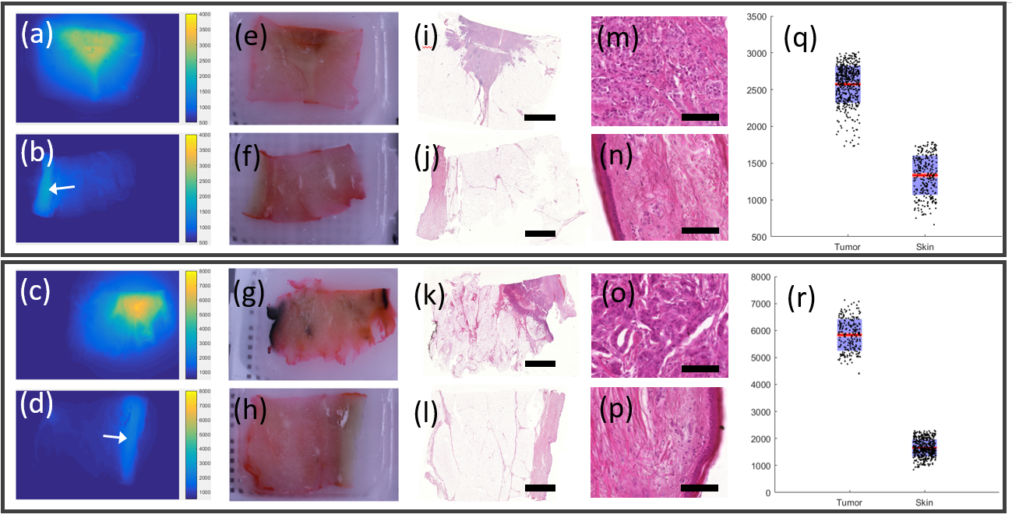

Suppl. Fig. 1. Comparison of tumor vs. skin fluorescence obtained from human breast tissue specimen. **(a)** The raw florescence image from a paraffin block tumor sample acquired with the high sensitivity fluorescence imaging system (subfigure 1f). **(b)** The corresponding fluorescence image of a skin containing non-tumor paraffin block sample of the same patient as (a). The skin area is marked by the white arrow. The images (a) and (b) are shown in the same color scaling. **(c)** The fluorescence signal of a similar patient as in (a) (both pathological grading 3). **(d)** The fluorescence image of the same patient as outlined in (c). The skin area is marked by the white arrow. The images (c) and (d) are shown in the same color-scaling. **(e)** Color reflectance image corresponding to (a). **(f)** Color reflectance image corresponding to (b). **(g)** Color reflectance image corresponding to (c). **(h)** Color reflectance image corresponding to (d). **(i)**H&E staining of the corresponding 4µm paraffin slice of (a) and (e). **(j)** H&E staining of the corresponding 4µm paraffin slice of (b) and (f). **(k)** H&E staining of the corresponding 4µm paraffin slice of (c) and (g). **(l)** H&E staining of the corresponding 4µm paraffin slice of (d) and (h). Each of the outlined rectangles contain samples of one (the same) patient presenting the images in identical color map scaling. The scale bar in (i-l) is 5mm **(m- p)** Magnification of the corresponding tumor or skin area respectively. The scale bar in (m-p) is 100µm **(q)** Plots the raw fluorescence count values for skin and tumor regions from samples (a) and (b). **(r)** Plots the raw fluorescence count values for skin and tumor regions from samples (c) and (d).In (q and r) the dark points represent raw pixel values. For visualization purposes the shown dark points are subsampled. The red lines show the mean for each data group. The standard deviation is shown as blue area. It can be observed that for the upper pair of samples (a, b) the tumor area in (a) and the skin area in (b) shows fluorescence signals in the same order of magnitude. Where in the second pair of samples (c, d) the tumors’ fluorescence signal (c) shows higher counts than the non-specific skin signal (d).

*Differences between thin and thick tissue slices and relevance to intraoperative imaging*

In the paragraph “Homogeneity of bevacizumab-IRDye800CW distribution” we applied an entropy calculation to examine the apparent fluorescence heterogeneity observed in the tissue blocks studied and compare the block (3mm-thick) appearance to corresponding 4µm thin slices obtained from the same tissue blocks. Suppl. Fig. 2 depicts a co-registered pair of fluorescence images obtained from a 4µm thin slice (Suppl. Fig 2a) and a paraffin block (Suppl. Fig 2b) allowing more detailed observation of magnified lesions (Suppl. Fig 2c,d)_between the slices of different thicknesses. The images appear markedly different on a magnified view with the images obtained from the 4µm thin slice allowing for observations of higher detail as expected. Supp. Fig.2 allows a comparison between the images as they are seen intra-operatively (b) or under conditions similar to the ones applied to pathology analysis (a). The methodology guided by fSTREAM in this study aimed in identifying thresholds that could be applied in images of diffusive appearance (i.e. Supp. Fig. 2b, d) since only such diffusive fluorescence images are available during surgery or endoscopy.

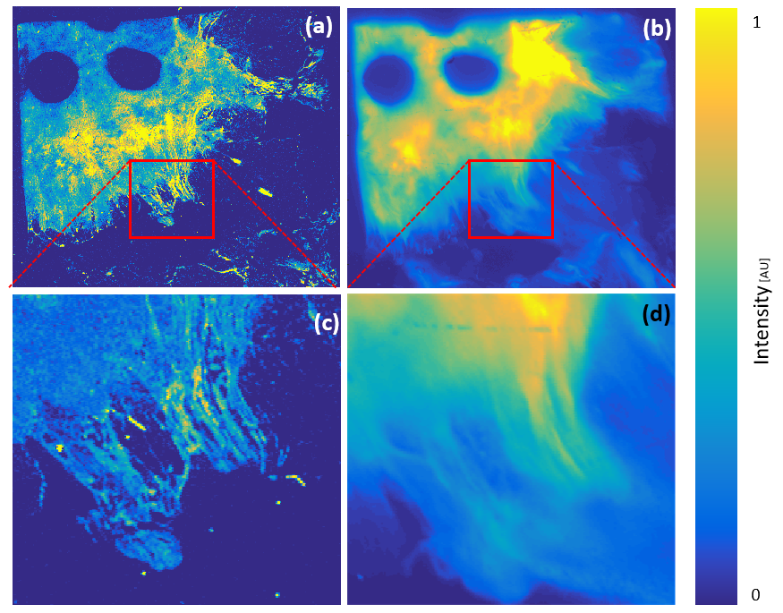

Suppl. Fig 2: Magnified comparison between fluorescence images obtained from 3mm thick paraffin slices and 4µm paraffin slices. **(a)** Shows the 4µm paraffin slice fluorescence image acquired by the flat-bed scanner. **(b)** Shows a fluorescence image from the same 3mm paraffin slice used to obtain the 4µm paraffin slice in (a). **(c)** Shows a magnification of (a) as indicated by the red rectangle on (a). **(d)** Shows as magnification of (b) as indicated by the red rectangle on (b). The differences in appearance due to photon diffusion are clearly visible in (d) when compared to (c).

**References: Supplementary Material:**

1. van Scheltinga AGT, van Dam GM, Nagengast WB, Ntziachristos V, Hollema H, Herek JL, Schröder CP, Kosterink JG, Lub-de Hoog MN, de Vries EG: **Intraoperative near-infrared fluorescence tumor imaging with vascular endothelial growth factor and human epidermal growth factor receptor 2 targeting antibodies.** *Journal of Nuclear Medicine* 2011, **52:**1778-1785.

2. ter Weele EJ, van Scheltinga AGT, Linssen MD, Nagengast WB, Lindner I, Jorritsma-Smit A, de Vries EG, Kosterink JG, Lub-de Hooge MN: **Development, preclinical safety, formulation, and stability of clinical grade bevacizumab-800CW, a new near infrared fluorescent imaging agent for first in human use.** *European Journal of Pharmaceutics and Biopharmaceutics* 2016, **104:**226-234.

3. Glatz J, Varga J, Garcia-Allende PB, Koch M, Greten FR, Ntziachristos V: **Concurrent video-rate color and near-infrared fluorescence laparoscopy.** *Journal of biomedical optics* 2013, **18:**101302-101302.