Supporting Information

**Reporter Gene-Based Optoacoustic Imaging of *E. coli* Targeted Colon Cancer *In vivo***

*Misun Yun1, Sung-Hwan You2, Vu Hong Nguyen3, Jaya Prakash1,4, Sarah Glasl1, Vipul Gujrati 1,6, Hyon E. Choy5, Andre C. Stiel1, Jung-Joon Min2* and Vasilis Ntziachristos1,6\**

1 Institute of Biological and Medical Imaging, Helmholtz Zentrum München GmbH, Neuherberg 85764, Germany.

2 Department of Nuclear Medicine, Chonnam National University Medical School, Gwangju, Republic of Korea

3 Department of Experimental Therapeutics, Beckman Research Institute of City of Hope, Duarte, California, USA

4 Department of Instrumentation and Applied Physics, Indian Institute of Science, C. V. Raman Avenue, Bengaluru- 560 012, India

5 Department of Microbiology, Chonnam National University Medical School, Gwangju, Republic of Korea

6 Chair of Biological Imaging, Center for Translational Cancer Research (TranslaTUM), School of Medicine, Technical University of Munich, Munich 81675, Germany.

Correspondence: [bioimaging.translatum@tum.de](mailto:bioimaging.translatum@tum.de) (V.N.), [jjmin@jnu.ac.kr](mailto:jjmin@jnu.ac.kr) (J.J.M.)

**Keywords:** Cancer imaging, *E. coli*, Melanin, Optoacoustic (OA) imaging, Colon cancer.

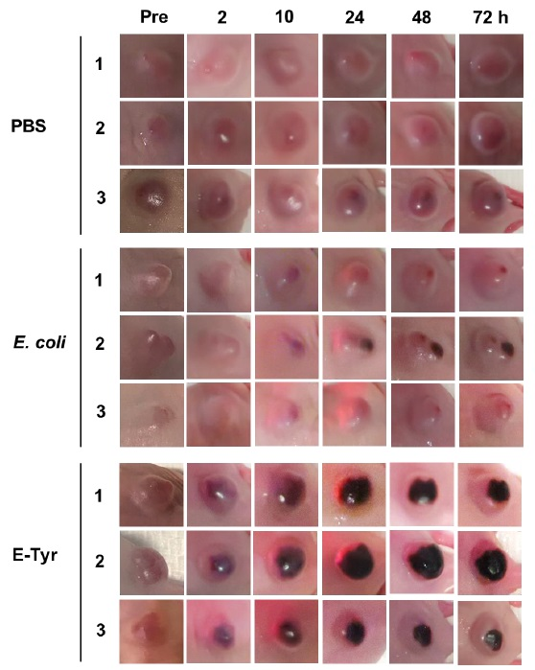

**Figure S1.** Photographs of representative tumors in each group were taken before (pre) and after injection (indicated times).

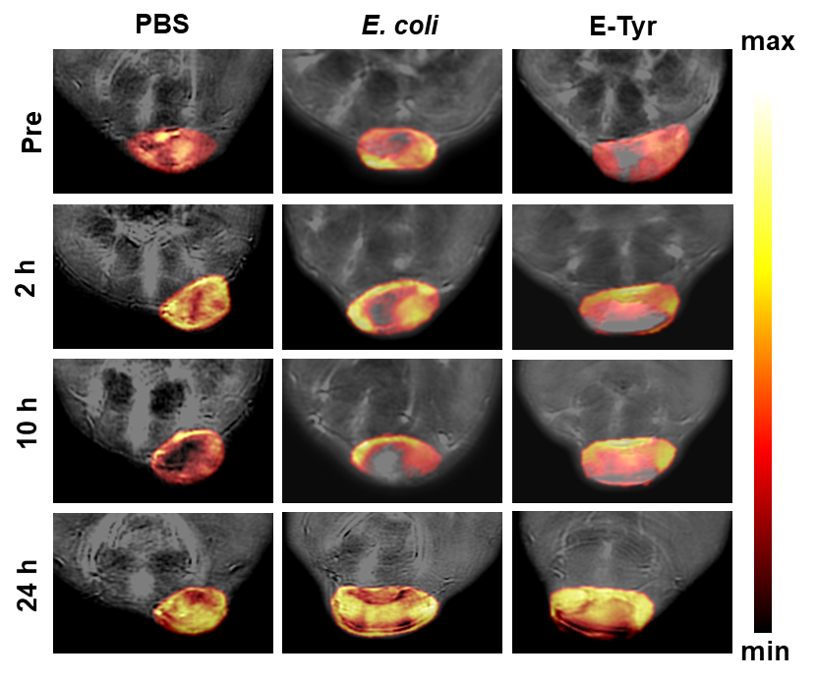

**Figure S2.** Representative images of tumors showing the spatial distribution of oxygen saturation at different time intervals.

(A)



(B)

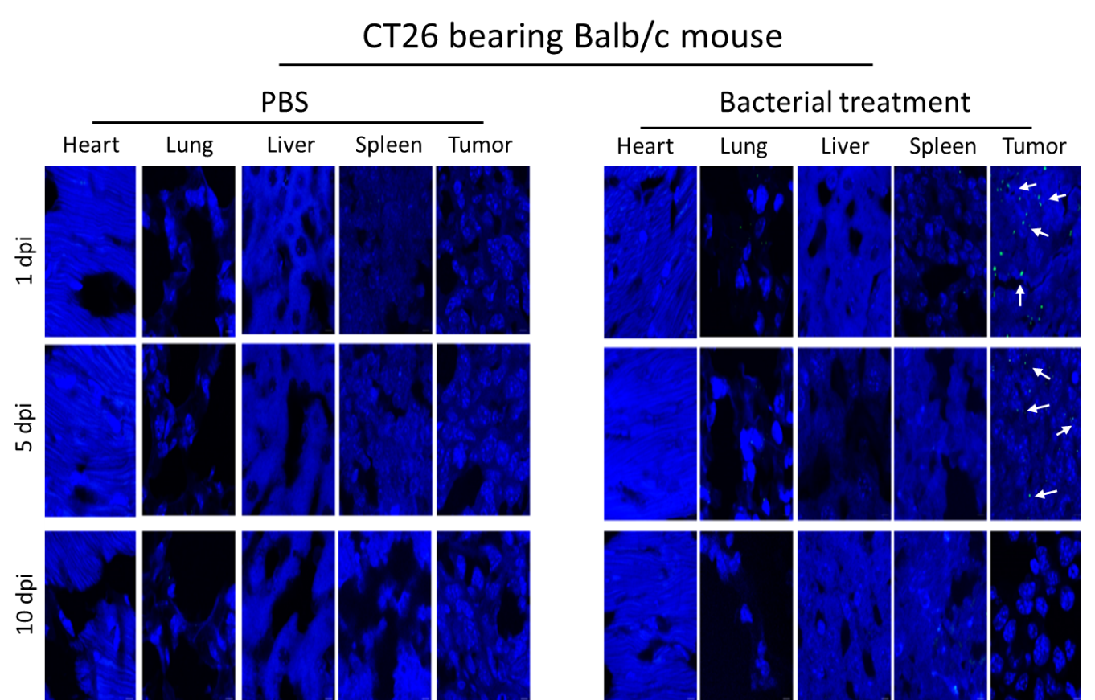

**Figure S3. Bacterial colonization in CT26 tumor-bearing Balb/c mice.** CT26 tumor-bearing competent mice received 108 cfu of E-Tyr through intravenous injection. Heart, lung, liver, spleen, and tumor tissues were harvested for further experiments. **(A)** Viable bacterial cell number was counted and **(B)** immunofluorescence staining was performed by using an anti-E.coli antibody (green) and DAPI (4, 6-diamidino-2-phenylindole) (blue) for nuclei staining at the indicated time points (n=3 mice/group**).**

(A)



(B)

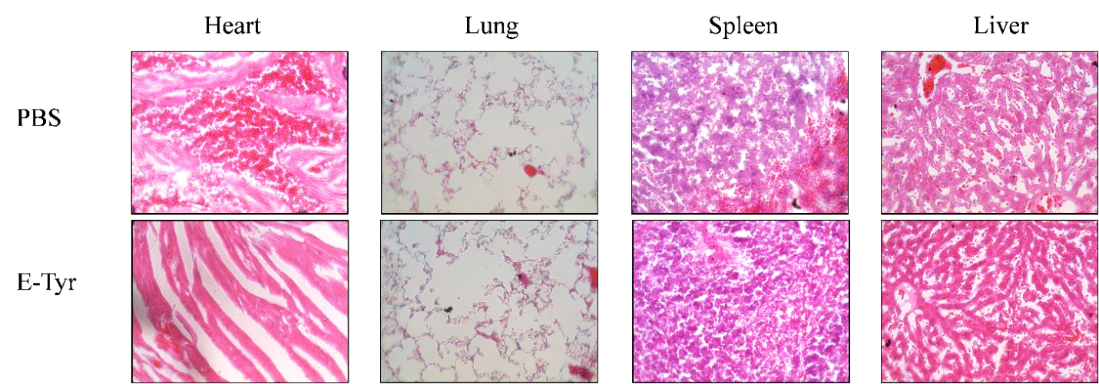

**Figure S4. Effect of E-tyr on survival and long-term toxicity of mice**. Competent Balb/c mice or immunocompromised Balb/c athymic nu-/nu- mice received 108 cfu of E-Tyr/mouse through intravenous injection (n=3 per group). **(A)** Survival of bacteria-infected mice as monitored for over one month and **(B)** H&E staining (40X) of normal tissue sections at day 5 after bacterial injection.