**Author’s post print[1] as submitted to**

***Journal of affective disorders***

**and later published as:**

Depression-related treatment and costs in Germany: Do they change with comorbidity? A claims data analysis

Christoph J. Wagnera[2], Florian G. Metzgerb, Christoph Sieversc, Ursula Marschallc, Helmut L’Hoestc, Bjoern Stollenwerkd, Stephanie Stocka

a *Institute for Health Economics and Clinical Epidemiology, Cologne University Hospital, Germany*

b *Department of Psychiatry and Psychotherapy and Geriatric Center, Tuebingen University Hospital, Germany*

c *BARMER GEK Statutory Health Insurance Fund, Headquarters, 42285 Wuppertal, Germany*

d *Institute of Health Economics and Health Care Management, Helmholtz Zentrum Muenchen, Germany*

*Volume 193, 2016, pages 257-266*

*DOI: 10.1016/j.jad.2015.12.06*

**Manuscript Summary**

- Abstract word count: 244

- Text word count: 4960

- Tables: 2

- Figures: 2

- Online Supplementary material: Table and URL

# Abstract

*Background:* Existing diverse bottom-up estimations of direct costs associated with depression in Germany motivated a detailed patient-level analysis of depression-related treatment (DRT), -costs (DRC) and Comorbidity.

*Methods:* A large sickness fund’s claims data was used to retrospectively identify patients aged 18 to 65 years with new-onset depression treatment between January 1st and February 15th 2010, and follow them until December 31st 2010, describe DRT, estimate associated DRC, and predict DRC with a generalized linear model.

*Results:* A total of 18,139 patients were analysed. Mean direct DRC were €783. Predictors of DRC regarding psychiatric comorbidities were: “Delusion, psychotic disorders and personality disorders” (DRC-ratio 1.72), “Alcohol/drug addiction” (1.82), “abuse of alcohol/drugs” (1.57). Predictors of DRC regarding medical comorbidities were: “Rheumatoid arthritis” (0.77), “atherosclerosis” (0.65), “pregnancy” (0.66), and “Osteoarthritis” (1.87). Of all patients, 60.8% received their most intense/specialised DRT from a general practitioner, a medical specialist (23.7%), a psychotherapist (8.0%), a medical specialist and psychotherapist (2.9%), or in hospital (4.6%). Serious psychiatric comorbidity nearly tripled depression-related hospitalization rates.

*Limitations:* Seasonal affective disorder and missing psychiatric outpatient clinic data must be considered.

*Conclusions:* Estimated DRC are significantly below the assessment of the German national guideline. Differing definitions of observation period and cost attribution might explain differing German DRC results. Signs of hospital psychiatric comorbidity bias indicate overestimation of hospital DRC. Identified associations of DRC with certain medical diseases in older adults warrant further research. Up to one quarter of patients with severe depression diagnosis might lack specialist treatment.

# Keywords

Depression, Depression-related treatment, Cost-of-illness, Direct costs, Comorbidity, Germany, Claims data

# 1. Introduction[3]

Depression has a high prevalence (Alonso et al., 2004; Bramesfeld et al., 2010; Gerste and Roick, 2014; Jacobi et al., 2014; Wittchen and Jacobi, 2005), often results in disabilities (Olesen and Leonardi, 2003; Ormel et al., 1999; Paykel et al., 2005), and causes substantial costs to society (Andlin-Sobocki et al., 2005; Cuijpers et al., 2007; Greenberg et al., 2003; Gustavsson et al., 2011). These facts are well-known at population level. However, relevant knowledge gaps still exist in patient-level health services research in Germany regarding (i) treatment, and (ii) costs *related* to depression, and (iii) how both are affected by medical or psychiatric comorbidities.

(i) The frequently used method to report treatment of depression disease is imprecise. Existing German studies using a more precise method either miss nationwide representativeness and inpatient data (Boenisch et al., 2011) or detailed information on further patient characteristics (Gerste and Roick, 2014).

Like Boenisch et al. (2011) and Gerste and Roick (2014) we define *Depression-related Treatment (DRT)* as outpatient physician visits or inpatient stays linked with a diagnosis of depression or affective disorder (Gerste and Roick, 2014). When focusing on depression disease, this is more precise than reporting *any mental health treatment* without diagnosis linkage. However, the latter method is frequently used in German (Bramesfeld et al., 2007a; Melchior et al., 2014; Wittchen et al., 1999) and international (Birnbaum et al., 2010; Fernandez et al., 2007; Melfi et al., 1999; Mojtabai and Olfson, 2006; Rhodes et al., 2006; Simon et al., 2001; Spijker et al., 2001) studies analysing depression disease. *Any mental health treatment* becomes a measure of limited precision when patients suffer another psychiatric comorbidity (Friemel et al., 2005; Salize et al., 2004), which frequently occurs (Kessler et al., 2003).

(ii) *Depression-related costs* (DRC) reported in Germany vary widely. Three studies analysing patient-level data reported annual mean costs per working age patient of €2,541 (Salize et al., 2004), €1,264 (Friemel et al., 2005), and €487 (Kleine-Budde et al., 2013) for combined inpatient and outpatient DRT (Berto et al., 2000; Luppa et al., 2007; Zerth et al., 2011). Kleine-Budde et al. (2013) were the first in Germany to estimate depression-*related* costs using depression diagnosis linkage for outpatient care, but with limited nationwide representativeness.

(iii) Evidence of medical or psychiatric *comorbidities’* influenceon DRT or DRC is scarce.(Gijsen et al., 2001).To our knowledge only Boenisch et al. (2011) analysed whether “depression-*specific* treatment” changed with coexisting medical or psychiatric comorbidities. They found that significantly more (less) patients with psychiatric (medical) comorbidity receive “threshold depression-specific treatment” but analysed only “some of the most prevalent comorbid somatic disorders” (Boenisch et al., 2011). We assume DRC to be a proxy for the intensity of DRT. DRC might be influenced by the German guideline for depression’s recommendation of psychotherapy for coexisting diabetes mellitus (AWMF 2012, p43), or limited patient capacities for DRT due to a physically impairing medical disease. Psychiatric comorbidity might induce more treatment complications, hospital admissions and medical specialist visits and higher DRC (Gijsen et al., 2001), or efficient outpatient one-stop treatment and lower DRC (Carstensen et al., 2012). We analysed comorbidities to assess real world treatment diversity not covered by clinical trials, and to detect strongly deviating comorbidities possibly relevant for clinical or health services research and risk adjustment.

Imprecise or incomplete information on DRT and uncertainty about DRC impede a precise assessment of appropriate health service provision, planning of services across providers, and economic models. We devised claims data methods to address the variety in depression cost estimations and provide detailed data for policy decisions and service planning. The main objective of this study was to estimate and discuss DRC by building on existing work with the diagnosis linkage method. As a secondary objective we explored the association of DRC with categorised or single psychiatric or medical comorbidities. Detailed cost analysis requires previous detailed analysis of single providers’ services. The third objective is a detailed description of depression-*related* treatment for a study population selected nationwide, with the purpose to validate DRC results and to explore cross-provider DRT.

# 2. Methods

## 2.1. Data and study design

We analysed claims data of the ‘BARMER GEK’ statutory health insurance (SHI) fund for this retrospective observational study. In 2010, the BARMER GEK was the single largest SHI fund, covering about 8.67 million insured or about 11% of the German SHI population (Grobe et al., 2012). Regionally, the BARMER GEK covered between 6% and 16% of the inhabitants of all 16 German federal states (Grobe et al., 2011). The year 2010 served as base year. Claims data regarding outpatient care, inpatient care, and outpatient drug prescriptions was analysed on an anonymized patient and anonymized provider level. We analysed a cohort of patients with new-onset DRT for a period of 320 to 365 days during 2010 (Beekman et al., 2001; Johnson et al., 2013; Ray, 2003; Spijker et al., 2004; Wittchen and Uhmann, 2010). Reported service use and costs reflect SHI reimbursed services and costs without taking into account the comparably low co-payments for drugs or hospital.

## 2.2. Study population

We included insured persons of working age (18 to 65 years) with continuous enrolment and full coverage during the last 183 days of 2009 and 365 days in 2010. Adolescents and elderly patients above 65 years of age were regarded as separate homogeneous groups and were not included in our analysis (Bramesfeld et al., 2007a; Curry et al., 2011; Wittchen and Jacobi, 2005). From this base population we selected patients with new-onset depression treatment in three steps (Figure 1):

First, patients with a diagnosis of a single depressive epi­so­de (F32.0/1/2/8/9ICD-10) or recurrent depression (F33.0/1/2/8/9ICD-10) in the year of 2010 were included if they had at least (Gerste and Roick, 2014; Kleine-Budde et al., 2013):

* two confirmed outpatient diagnoses by two different physicians or
* two confirmed outpatient diagnoses in two different quarters or
* one hospital discharge diagnosis.

We concentrated on unipolar depression and excluded patients with bipolar affective disorder (F31.x) or depression with psychotic symptoms (F32.3/F33.3).

Second, to secure *new-onset* of depression treatment in 2010, patients were excluded if they had at least one (i) confirmed out­pa­ti­ent diagnosis F32.x or F33.x or (ii) hospital discharge diagnosis F32.x or F33.x or (iii) anti­de­pressant prescription with anatomic therapeutic chemical classification code (ATC) N06A (WHO, 2012) in the 183 days preceding the index year 2010. Most clinical trials of antidepressants define 6 months or 183 days as a period of “wash out” (IQWiG, 2013).

Third, to secure observation of at least 320 and at most 365 days for available year 2010 data, we selected patients receiving their first depression service between Jan­uary 1st and February 15th in 2010. A patient’s first depression service was defined as:

* hospital admission with depression discharge diagnosis or
* outpatient visit with depression diagnosis and depression service or
* antidepressant prescription.

Comparable studies used similar case definitions to identify patients with depression and mark a depression treatment index date (Boenisch et al., 2011; Bramesfeld et al., 2010; Gerste and Roick, 2014).

## 2.3. Patient characteristics

We classified each patient’s level of *severe* (F32.2/F33.2), *moderate* (F32.1/F33.1), *mild* (F32.0/F33.0) or *other* (F32.8/F33.8/F32.9/F33.9) depression using the most severe confirmed outpatient or inpatient discharge diagnosis present during the observation period (Gerste and Roick, 2014; Kleine-Budde et al., 2013). A diagnosis of F33.x marked a *recurrent depressive episode*.

Comorbidity research often collapses ICD-codes into diagnosis groups (Prados-Torres et al., 2014). Since 2009, the German federal insurance authority uses a comprehensive disease classification system to predict and distribute SHI funds. Disease classification relies on joint continuous scientific recommendation (Busse et al., 2007; Drösler et al., 2011; Reschke et al., 2004). The year 2010 classification (Bundesversicherungsamt, 2011) covered 336 clinically homogeneous and statistically robust *diagnosis groups* (DxG) further collapsed into 128 *morbidity groups* (MG) by homogeneous disease, organ system and costs (Busse et al., 2007) for outpatient, inpatient and drug data algorithms. MG mostly cover diseases with a “serious course, continuity and chronicity” (Busse et al., 2007).

Eight MG representing *psychiatric illness* were available without “bipolar disorders”, which were excluded from the study. “Anxiety disorders and unspecific depression disorders” and “depression, posttraumatic stress disorder, behavioural disorder” were excluded because they contained depression diagnoses. The remaining 6 MG mostly covered the diagnostic groups F1/F2/F5/F6ICD-10, and the upper ranks of ICD-10 chapter “Mental- and behavioural disorders”. They were considered as *serious* psychiatric comorbidity. The classification contained 119 MG representing *medical illness.* Seven MG did not occur because of age or rarity. We subsumed five MG for different conditions of diabetes mellitus and seven MG for different cancer diseases.

As a result we used six serious psychiatric and 101 medical MG. These were grouped into four comorbidity categories: Patients were assigned (1) “no comorbidity”, (2) “serious psychiatric comorbidity”, (3) “medical comorbidity”, (4) “serious psychiatric *and* medical comorbidity” where no, one or more appropriate MG existed. *Multiple Comorbidity* was defined as more than three different MG per patient. Analysis of single MG was done for all MG present in at least rounded 1% of patients (Freund et al., 2012; van den Bussche et al., 2011). See supplementary material for MG and ICD-10 documentation.

## 2.4. Measures

*Depression-related treatment* (DRT) by a specified provider was assigned if a patient visited a specified provider at least once during the observation period and obtained a confirmed outpatient diagnosis or hospital discharge diagnosis of depression (F32.x/F33.x) (Boenisch et al., 2011; Gerste and Roick, 2014; Kleine-Budde et al., 2013) (Figure 1). According to single services specified hereinafter, a physician visit with a diagnosis of depression disease could for example involve a 10-minute interview, electroencephalogram, test, psychotherapy or an urgent home visit.

Specified providers were grouped by physician group or specialty: (1) *general practitioner* comprising general practitioner, medical practitioner, internist; (2) *medical specialist* comprising neurologist, psychiatrist, specialist for psychosomatic medicine and psychotherapy, psychiatrist and psychotherapist; (3) *psychotherapist* comprising psychological psychotherapist, physician working as a psychotherapist; (4) *hospital* comprising any hospital or rehabilitation clinic, inpatient or part-residential acute care paid by SHI. Patients with at least one reimbursed prescription of ATC-code N06Axx were categorized *antidepressants* users (Figure 1).

DRT rates were reported *by patient*, assigning each patient hierarchically to his most specialised provider, or the patient’s highest level of *stepped* DRT (Table 1) (Bower and Gilbody, 2005; Heggestad et al., 2011). Additionally, DRT rates were reported *by provider* allowing for multiple counts of patients visiting more than one provider (Figure 2c).

*Hospital* DRC represent the sum of billed and closed *hospital* stays with a depression discharge diagnosis (F32.x/F33.x) per patient. *Antidepressant* costs represent the sum of SHI reimbursements for prescriptions with an ATC-Code N06A excluding copayments (Figure 1).

German physician associations use a fee-for-service system and a comprehensive list of single service codes to distribute SHI payments. The direct estimate of *outpatient physician and psychotherapist* DRC is difficult to be measured due to limitations of (i) data structure and (ii) reimbursement system. (i) In German SHI data, physician’s service codes per patient and day cannot be directly linked to a separate list of diagnoses per patient and quarter according to data transfer agreements between physician and SHI associations (Zeidler et al., 2013). (ii) Especially general practitioner’s services are frequently subsumed in lump-sums.

(i) To determine outpatient service codes *related* to a diagnosis, Zeidler et al. (2013) proposed *expert code review.* From a trial population of patients solely diagnosed with depression during 2010 (n = 1.015) we extracted all service codes and ranked them by frequency per physician group. From each physician group’s list of service codes, a physician and a health economist further excluded service codes not attributable to depression disease (Figure 1). A *sample list of depression-related service codes* per physician group was obtained (list available on request). (ii) We attributed lump-sums to diagnostic groups using *weights for the number of different diagnostic groups* (first two digits of ICD-10), a method used by the federal statistical office (GBE-Bund, 2013) and Kleine-Budde et al. (2013).

Using *a selected list of service codes* and *weights for lump-sums,* outpatient DRC per provider were approximated in three steps (Figure1): (1) We collected all quarterly reimbursement files from a defined provider containing a depression diagnosis (F32.x/F3.xICD-10). (2) From each reimbursement file we extracted service codes matching the selected list and priced them with the year 2010 nationwide value of 3.5048 Euro-cents per base unit. (3) We weighted service codes marking a lump-sum by the number of different diagnosis categories per reimbursement file.

Psychiatric outpatient clinic data was not available because of year 2010 regionally heterogeneous reimbursement and data agreements (Gerste and Roick, 2014). However, some psychiatric outpatient clinics billed using the standard outpatient physician reimbursement system and were analysed anonymously (Gerste and Roick, 2014). Auxiliary services were not analysed. They cannot be consistently aligned to depression diagnosis (Kleine-Budde et al., 2013). Relevant parts of the described cost analysis method were originally used for cost-effectiveness report on antidepressants performed by the Institute for Quality and Efficiency in Health Care (IQWiG, 2013).

## 2.5. Statistical analysis

To explore the association of comorbidity categories and single MG with DRC we developed a log-gamma generalised linear model (GLM). This method is recommended (Blough and Ramsey, 2000; Briggs et al., 2005; Manning and Mullahy, 2001) and used (Gruber et al., 2012; Haas et al., 2012; Halpern et al., 2013) for right skewed, not normally distributed non-zero healthcare costs. Five observations with zero DRC were set to one Euro. Coefficients were exponentiated to provide each covariate’s DRC-ratio. DRC-ratios indicate percentage deviation from reference.

Referencing comparable mental health-related regression models based on claims data (Bramesfeld et al., 2010; Halpern et al., 2013; Kleine-Budde et al., 2013; Zeidler et al., 2012), we hypothesizedDRC to be a function of four categories of comorbidity (Table 2a) *or* single MG (Table 2b), multimorbidity, depression disease characteristics, sociodemographic characteristics, use of antidepressants, and pre-index hospital stays. We controlled for use of antidepressants since antidepressant therapy often is initiated in hospital and thus associated with higher DRC (Simon et al., 1995). We applied a linear relation of age and adopted an interaction of age and sex due to its significant association with DRC.

Analysis was performed with Statistical Analysis System (SAS) Version 9.2 and the GENMOD procedure for multivariate analysis. Results were considered statistically significant for p-values <0.05. Additionally, for cost comparison with results reported annually, we extrapolated mean DRC for full 365 days, assuming even distribution of costs, 22 missing days per patient, and that 29% of patients still require treatment after 342 days (Spijker et al., 2002).

# 3. Results

## 3.1. Study population

Of 18,139 identified patients, 75% were female (Table 1). Mean age was 45.7 years (SD: 12.2). Nearly half or 47.7% of patients were diagnosed solely with “other depression” (F32.8/F33.8/F32.9/F33.9), whereas 7.3% had a “mild”, 29.9% a “moderate”, and 15.1% a “severe” diagnosed depression severity during observation. Recurrent depression was diagnosed in 23.3% of patients. At least one MG other than depression existed in 52.3% of patients; 39.4% had at least one medical MG, 7.0% at least one serious psychiatric MG and 5.8% both. Multi-comorbidity or more than one different MG per patient prevailed in 27.1% of the patients.

## 3.2. Depression-related costs

The estimated mean total direct DRC per patient were €783 (SD: €2,547, Figure 2a) for a new-onset period of DRT observed for 320 to 365 days. Mean DRC extrapolated for 365 days were €797. Mean DRC (SD) per provider per patient treated were €8,699 (€7,321) for hospital*,* €1,202 (€974) for psychotherapist, €379 (€661) for medical specialist, €77 (€143) for general practitioner, and €142 (€211) for antidepressant prescriptions (Figure 2a). Hospital accounted for 51.1%, psychotherapist for 18.3%, medical specialist for 14.3%, general practitioner for 8.3% and use of antidepressants for 8.1% of total DRC (Figure 2b).

## 3.3. Depression-related costs and serious psychiatric comorbidity

Compared to DRC for patients without any MG, DRC nearly doubled for patients with “serious psychiatric comorbidity” (DRC-ratio 1.92; p<0.001, Table 2a). With regard to single MG analysis (Table 2b), this effect correlates with the most frequent psychiatric MG “delusion, psychotic disorders and personality disorders” (DRC-ratio 1.72; p<0.001; Hospital DRT 16.2%), “alcohol or drug addiction” (DRC-ratio 1.82; p<0.001; Hospital DRT 11.5%), and “abuse of alcohol or drugs (without addiction)” (DRC-ratio 1.57; p=0.016; Hospital DRT 17.0%). The remaining less frequent MG “schizophrenia”, “alcohol or drug induced psychosis”, or “anorexia nervosa/bulimia” did not predict DRC.

## 3.4. Depression-related costs and medical comorbidity

“Medical comorbidity” showed a non-significant tendency for lower DRC (DRC-ratio 0.92; p=0.098, Table 2a). Three out of 23 single medical MG predicted lower DRC (Table 2b): “pregnancy” (DRC-ratio 0.66; p=0.008), “rheumatoid arthritis, inflammable disorders of connective tissue” (DRC-ratio 0.77; p=0.015), and “atherosclerosis, arterial aneurysm, diseases of arteries/arterioles” (DRC-ratio 0.65; p=0.010). A high significant positive association with DRC existed for “Osteoarthritis of hip or knee” (DRC-ratio 1.87; p<0.001). The remaining 19 MG including the most common chronic conditions were not associated with DRC.

## 3.5. Depression-related costs and combined or multiple comorbidity

”Serious psychiatric and medical comorbidity” predicted higher DRC (DRC-ratio 1.40; p<0.001, Table 2a). The effect of sole “serious psychiatric comorbidity” - without any medical MG - was however bigger. Defined “Multiple comorbidity” was not associated with DRC (Table 2).

## 3.6. Depression-related costs and patient characteristics

Compared to patients with a single episode, patients with recurrent depression episodes had nearly 50% higher DRC (DRC-ratio 1.49; p<0.001). Compared to males, females’ DRC decreased significantly more per year of life (DRC-ratio of age*female 0.992; p=0.034). Age, sex, unemployment, and retirement before the age of 66 were not significantly associated with DRC (Table 2b).

## 3.7. Depression-related treatment

According to DRT rates by provider, 84.5% of patients visited a general practitioner at least once, 29.5% a medical specialist, 11.9% a psychotherapist, 4.6% hospital, and 44.9% had at least one antidepressant prescription (Figure 2c). Antidepressant prescriptions and sole general practitioner DRT were observed in 20.2% of patients (Table 1, 45.1% related to total).

According to stepped DRT rates, 60.8% of patients were observed to receive their most intense DRT from a general practitioner, 23.7% from a medical specialist, 8.0% from a psychotherapist, 2.9% from a medical specialist and psychotherapist, and 4.6% in hospital (Table 1). Combined DRT from a general practitioner and medical specialist, or psychotherapist or hospital DRT was provided to 23.7% of patients (Table 1: General Practitioner versus Figure 2c: General practitioner). In 15.5% of patients we found medical specialist, psychotherapist or hospital DRT and no general practitioner DRT (Figure 2c, calculation).

The hospital DRT rate approximately tripled with sole “serious psychiatric comorbidity” (Table 1: 14.5% of subgroup vs. 4.6% of total), and about doubled with “serious psychiatric comorbidity and medical comorbidity” (11.7% of subgroup vs. 4.6% of total). Among patients with hospital DRT, 36.9% had at least one out of six analysed serious psychiatric (co)morbidity groups (Table 1, calculation).

The categorized severity of the diagnosed depression mostly matched a seemingly appropriate level of specialist care. However, we found sole general practitioner treatment in 26.5% of patients with a severe depression diagnosis (4.0% of total) and in 38.8% of patients with recurrent depression diagnosis of any severity (9.0% of total, Table 1).

# 4. Discussion

## 4.1. Depression-related costs

Mean total DRC of €797 extrapolated for 365 days differed from previously reported annual results of

* €2,541 for “depression-specific treatment” in patients fulfilling the diagnosis criterion of F32.x/F33.xICD-10 (Salize et al., 2004, group two),
* €487 for “depression-specific costs” during baseline year 2007 (Kleine-Budde et al., 2013),
* €1,264 for “direct costs of depression disease” in patients with service utilisation (Friemel et al., 2005).

These differences might be explained by differences in (i) observation period or (ii) attribution of costs to depression disease. According to Spijker et al. (2002), about 76% of patients recover from depression within one year. DRC reported by Salize et al. (2004) more than tripled this analysis’ mean DRC presumably because 52 weeks of *continuous* depression treatment were extrapolated from 8 weeks of survey for *all* patients (Friemel et al., 2005).

Using a very similar claims data costing algorithm, Kleine-Budde et al. (2013) estimated notably lower DRC. The studies’ annual cross sectional design included censored - less costly - treatment or observation periods. Additionally, the studies’ East German study population included 66% of retirees and 80% of patients with atypical/unspecified depression diagnoses. This explains lower depression costs (Bramesfeld et al., 2010; Bramesfeld et al., 2007b).

Meandirect costs of depression surveyed by Friemel et al. (2005) possibly exceed our result because *all* *mental health services* including services provided for other psychiatric illness were *attributed* to depression treatment. Discussed studies were chosen because they surveyed/observed detailed patient-level costs and matched this analysis’ study population - of patients with a diagnosis of depression disease and utilisation of SHI services - , cost definition and survey method to the best possible extent.

Gustavsson et al. (2011) modelled mean €781 direct annual health care costs of mood disorders (F33/F32/F31/F30ICD-10) in Germany. We consider Gustavsson et al. (2011) to confirm this DRC analysis of a nationwide study population because prevalence of bipolar affective disorders’ (F31) and manic episodes (F30) - not analysed here – were reportedly low (Jacobi et al., 2014; Pini et al., 2005). The German national guideline for depression reports €2,000 annual direct depression specific costs (AWMF, 2012, p173). Discussed results suggest that these are either overestimated or patients in our sample do not receive full guideline-concordant care.

Hospital DRC accounted for 51.1% of total DRC. Thus 4.6% of inpatients covered more than half of the total study population’s DRC. DRC underestimation due to missing DRC data from psychiatric outpatient clinics, auxiliary services, and medical specialists other than mental health amounts to about 5% (Friemel et al., 2005; Kleine-Budde et al., 2013; Salize et al., 2004).

## 4.2. Comorbidity

According to Hasin et al. (2005), p1097 “substance dependence, panic and generalized anxiety disorder, and several personality disorders” are the most frequent psychiatric comorbidities among patients with depression. Correspondingly, this analysis’ most frequent serious psychiatric MG were “delusion, psychotic disorders and personality disorders”, “alcohol and drug addiction”, “abuse of alcohol or drugs”. Jacobi et al. (2014) reported at least one psychiatric comorbidity in 67% of patients with depression. We explored associations of serious psychiatric MG, present in 12.8% of patients. “Although psychiatric disorders are wide-spread, serious cases are concentrated among a relatively small proportion of cases with high comorbidity (Kessler et al., 2005), p617”. We assumed “serious cases” of psychiatric comorbidity to be covered in this analysis. The most prevalent psychiatric comorbidities *not analysed* were “somatoform disorders” and “anxiety” (Melchior et al., 2014). Beyond data description, “co-occurrence” of psychotic disorders or delusion in patients diagnosed with depression may raise concerns about the true disease nature of affected study subjects and possibly the validity of their depression diagnosis.

## 4.3. DRC and serious psychiatric comorbidity

DRC nearly doubled with “serious psychiatric comorbidity”. Likewise, Boenisch et al. (2011) reported significantly more “depression-specific threshold treatment” for patients with “psychiatric comorbidity”. However, only the comorbid MG (i) “delusion, psychotic disorders and personality disorder”, (ii) “alcohol or drug addiction” - confirmed by Sullivan et al. (2005) -, and (iii) “abuse of alcohol or drugs without addiction” predicted higher DRC. High rates of hospital DRT (Table 2c) suggest “hospital comorbidity bias (Bak et al., 2005), p817”. Even accepting systematic comorbidity difference by setting, we assume hospital DRC overestimation when using cost attribution by discharge diagnosis for named three MG. Further serious psychiatric MG did not predict DRC. This roughly internally validates our attribution of costs related to depression and not related to other psychiatric illness.

## 4.4. DRC and medical comorbidity

“Medical comorbidity” did not significantly predict DRC (Table 2a). The most frequent, wide-spread chronic medical diseases and 19 out of 23 analysed medical MG did not predict DRC, except certain MG in older adults. The MG “atherosclerosis” and “rheumatoid arthritis” predicted lower DRC. Both diseases’ prevalence is positively associated with depression prevalence (Tiemeier et al., 2004). Affected patients might frequently receive a depression diagnosis but rarely expensive DRT.

The MG “osteoarthritis” predicted seriously higher DRC. Likewise, Carstensen et al. (2012) found the interaction of depression and osteoarthritis *not* tolower total healthcare costs despite a hypothesised synergy effect. For osteoarthritis “there are no current interventions proven to […] curb the disease process” besides joint replacement (Krasnokutsky et al., 2007). We hypothesised this to intensify depression severity and costly depression treatment “substitution”.

Depression diagnosis prevalence reaches its peak beyond the analysed maximum of 65 years (Gerste and Roick, 2014; Melchior et al., 2014). Observed associations of MG prevalent in elderly patients with depression need to be tested for a majority of even older patients. Pregnancy predicted lower DRC. Reduced depression care before or after birth confirms this finding (Bennett et al., 2010).

## 4.5. DRC and patient characteristics

Sex predicted DRC only when interacted with age. Accordingly, Halpern et al. (2013) found no significant sex difference for mental health-related healthcare costs or hospitalisations in patients with depression aged 18-64 years. Sex difference in DRC may stand to reason when controlling for gender sensitive MG like e.g. pregnancy or hypertension.

## 4.6. Depression-related treatment

Available comparable measures confirmed observed providers’ DRT rates. Melchior et al. (2014) and (Gerste and Roick, 2014) reported sole general practitioner DRT in 59% (64.1%, study population without hospital DRT) of patients, closely matching identified 60.8% in our study. Bramesfeld et al. (2007a) identified 11.7% of patients contacting a psychotherapist for *any* psychiatric illness in 2004. This analysis observed psychotherapist DRT in 11.9% of patients in 2010. Although depression discharge diagnoses were analysed in the same fashion for each source, the hospitalisation rate varied between 5.4% (Gerste and Roick, 2014), 4.6% (Table 1),3% (Bramesfeld et al., 2007a) and 2.8% (Melchior et al., 2014). Differences in age ranges used (Gustavsson et al., 2011) and SHI funds’ morbidity (Hoffmann and Icks, 2012) might explain this.

DRT description identifiednearly threefold hospital DRT when “serious psychiatric comorbidity” was present. The coexisting MG “Delusion, psychotic disorders personality disorders”, “alcohol or drug addiction”, and “abuse of alcohol or drugs” seriously increased crude *depression* hospitalisation rates (Table 2c). Supporting this find, Moustgaard et al. (2013) reported more than doubled Hazard ratios for depression hospitalisation with “other psychotropic medication” or “substance use disorders treatment”.

The national guideline recommends specialist treatment for diagnosed severe depression (AWMF, 2012). This recommendation was possibly not met for about one quarter of patients with observed severe depression diagnosis and sole general practitioner DRT. Similarly, Gerste and Roick (2014) identified 37.8% of patients with severe depression without specialist treatment (study population without hospital DRT). In nearly half of patients with at least one antidepressant prescription (45.1%) we observed sole general practitioner DRT. This suggests a high rate of antidepressant therapy initiation without specialist or hospital involvement, as the patients included had no antidepressant prescriptions 6 months before the baseline.

Both findings are subject to missing psychiatric outpatient clinic data. Patients possibly accessed this specialist care provider without notice. Like Gerste and Roick (2014), we assumed observed specialist treatment deficiency to persist even if missing psychiatric outpatient clinic data might reduce its quantity because general practitioners frequently do not transfer patients with depression to specialists (Jacobi et al., 2002; Schneider et al., 2004).

## 4.7. Strengths and limitations

We consider the inclusion of individuals from the general population of all German federal states as a major strength of our study. Retrospective analysis of new-onset DRT enabled temporal coverage of a complete perceived episode of depression disease up to 365 days, avoided possible observation time bias of cross-sectional analysis (Beekman et al., 2001) and possible recall bias. However, observation started in January or February. “Seasonal affective disorder” is possible, which might ambiguously increase (Harris, 1986; Morken et al., 2002) or reduce (Blazer et al., 1998) DRC or DRT results.

A large study population and a comprehensive (co)morbidity classification system enabled first exploration of many specific disease combinations. However, only serious psychiatric MG were available. Despite using comprehensive data, most psychiatric outpatients clinic’s data were unavailable. As discussed, this might be negligible for cost estimation, but weakens our assumption of undersupply for some severely ill patients.

Based on preceding work by Kleine-Budde et al. (2013) and Zeidler et al. (2013) we proposed a detailed algorithm for approximation of depression-*related* costs in outpatient care which could be adapted for further diseases. Full data set linkage was provided for 2010 only. To facilitate patient selection, the observation period had to vary between 320 to 365 days.

The multivariate model included relevant variables commonly used in claims data. However, controls for “education”, “marital status”, “urbanity” (Wang et al., 2005), “social support” (Dew et al., 1991), “somatoform disorders” and “anxiety” were missing (Spijker et al., 2001). The model estimators might be subject to overt bias.

## 4.8. Conclusion

* The most relevant finding of this study is a precise estimation of mean direct Depression-related costs of €783 for near annual observation of new-onset treatment in a nationwide study population.
* Estimated €783 were largely below the German national guideline’s assessment. Direct spending specifically for depression care might be below known assumptions based on costing methods with varying cost attribution and observation period.
* More than 50% of total DRC was due to the hospitalisation of less than 5% of all patients. Collaborative outpatient care for some of them could possibly improve healthcare budgets and patient’s quality of life.
* Among serious psychiatric comorbidities only “delusion, psychotic and personality disorders” and “substance abuse/addiction” predicted relevantly higher DRC. Focused combination treatment of “substance abuse/addiction” *and* depression in accessible patients might possibly reduce the ongoing high rate of hospital DRT. Co-occurrence of psychotic disorders or delusion partly questions the validity of depression hospital discharge diagnoses, and could indicate overestimation of hospital DRC.
* The age-related diseases “atherosclerosis(-)”, “rheumatoid arthritis(-)” and “osteoarthritis(+)” predicted DRC. Confirmation for patients older than 65 years and further detail on depression treatment is required.
* According to cross provider analysis, up to one quarter of patients with severe depression diagnosis might lack outpatient specialist treatment.

# Acknowledgements

We thank the BARMER GEK Statutory Health Insurance, Andreas Gerber-Grote (Institute for Quality and Efficiency in Health Care, IQWiG), and Sandra Milev (Canadian Agency for Drugs and Research in Health, CADTH) for data provision, advise and proof reading.

# References

Alonso, J., Angermeyer, M.C., Bernert, S., Bruffaerts, R., Brugha, T.S., Bryson, H., De Girolamo, G., De Graaf, R., Demyttenaere, K., Gasquet, I., Haro, J.M., Katz, S.J., Kessler, R.C., Kovess-Masfety, V., Lépine, J.P., Ormel, J., Polidori, G., Russo, L.J., Vilagut, G., 2004. Prevalence of mental disorders in Europe: results from the European study of the Epidemiology of Mental Disorders (ESMeD) project. Acta Psychiatr. Scand. 109, 21-27.

Andlin-Sobocki, P., Jonsson, B., Wittchen, H.U., Olesen, J., 2005. Cost of disorders of the brain in Europe. Eur. J. Neurol. 12 Suppl 1, 1-27.

AWMF, 2012. Arbeitsgemeinschaft-der-Wissenschaftlichen-Medizinischen-Fachgesellschaften: S3-Leitlinie/NVL unipolare Depression: Langfassung; Version 1.3. Ärztliches Zentrum für Qualität in der Medizin.

Bak, M., Drukker, M., van Os, J., Delespaul, P., 2005. Hospital comorbidity bias and the concept of schizophrenia. Soc. Psychiatry Psychiatr. Epidemiol. 40, 817-821.

Beekman, A.T., Deeg, D.J., Geerlings, S.W., Schoevers, R.A., Smit, J.H., van Tilburg, W., 2001. Emergence and persistence of late life depression: a 3-year follow-up of the Longitudinal Aging Study Amsterdam. J. Affect. Disord. 65, 131-138.

Bennett, I.M., Marcus, S.C., Palmer, S.C., Coyne, J.C., 2010. Pregnancy-related discontinuation of antidepressants and depression care visits among Medicaid recipients. Psychiatr. Serv. 61, 386-391.

Berto, P., D'Ilario, D., Ruffo, P., Virgilio, R.D., Rizzo, F., 2000. Depression: cost-of-illness studies in the international literature, a review. The Journal of Mental Health Policy and Economics 3, 3-10.

Birnbaum, H.G., Kessler, R.C., Kelley, D., Ben-Hamadi, R., Joish, V.N., Greenberg, P.E., 2010. Employer burden of mild, moderate, and severe major depressive disorder: mental health services utilization and costs, and work performance. Depress. Anxiety 27, 78-89.

Blazer, D.G., Kessler, R.C., Swartz, M.S., 1998. Epidemiology of recurrent major and minor depression with a seasonal pattern. The National Comorbidity Survey. Br. J. Psychiatry 172, 164-167.

Blough, D.K., Ramsey, S.D., 2000. Using generalized linear models to assess medical care costs. Health Serv Outcomes Res Methodol 1, 185-202.

Boenisch, S., Kocalevent, R.D., Matschinger, H., Mergl, R., Wimmer-Brunauer, C., Tauscher, M., Kramer, D., Hegerl, U., Bramesfeld, A., 2011. Who receives depression-specific treatment? A secondary data-based analysis of outpatient care received by over 780,000 statutory health-insured individuals diagnosed with depression [Epub ahead of print]. Soc. Psychiatry Psychiatr. Epidemiol.

Bower, P., Gilbody, S., 2005. Stepped care in psychological therapies: access, effectiveness and efficiency. Narrative literature review. Br. J. Psychiatry 186, 11-17.

Bramesfeld, A., Grobe, T., Schwartz, F.W., 2007a. Who is treated, and how, for depression? An analysis of statutory health insurance data in Germany. Soc. Psychiatry Psychiatr. Epidemiol. 42, 740-746.

Bramesfeld, A., Grobe, T., Schwartz, F.W., 2010. Prevalence of depression diagnosis and prescription of antidepressants in East and West Germany: an analysis of health insurance data. Soc. Psychiatry Psychiatr. Epidemiol. 45, 329-335.

Bramesfeld, A., Grobe, T.G., Schwartz, F.W., 2007b. Who is diagnosed as suffering from depression in the German statutory health care system? An analysis of health insurance data. Eur. J. Epidemiol. 22, 397-403.

Briggs, A., Nixon, R., Dixon, S., Thompson, S., 2005. Parametric modelling of cost data: some simulation evidence. Health Econ. 14, 421-428.

Bundesversicherungsamt, 2011. Festlegung der Morbiditätsgruppen, des Zuordnungsalgorithmus, des Regressions- sowie des Berechnungsverfahrens: 02a Anlage 1; ICD Zuordnung und Gültigkeitskriterien JA2011 [Excel-Tabelle].

Busse, R., Droesler, S., Glaeske, G., Greiner, W., Schäfer, T., Schrappe, M., 2007. Wissenschaftliches Gutachten für die Auswahl von 50 bis 80 Krankheiten zur Berücksichtigung im morbiditätsorientierten Risikostrukturausgleich, Berlin.

Carstensen, J., Andersson, D., Andre, M., Engstrom, S., Magnusson, H., Borgquist, L.A., 2012. How does comorbidity influence healthcare costs? A population-based cross-sectional study of depression, back pain and osteoarthritis. British Medical Journal open 2, e000809.

Cuijpers, P., Smit, F., Oostenbrink, J., De Graaf, R., Ten Have, M., Beekman, A., 2007. Economic costs of minor depression: a population-based study. Acta Psychiatr. Scand. 115, 229-236.

Curry, J., Silva, S., Rohde, P., Ginsburg, G., Kratochvil, C., Simons, A., Kirchner, J., May, D., Kennard, B., Mayes, T., Feeny, N., Albano, A.M., Lavanier, S., Reinecke, M., Jacobs, R., Becker-Weidman, E., Weller, E., Emslie, G., Walkup, J., Kastelic, E., Burns, B., Wells, K., March, J., 2011. Recovery and recurrence following treatment for adolescent major depression. Arch. Gen. Psychiatry 68, 263-269.

Dew, M.A., Bromet, E.J., Schulberg, H.C., Parkinson, D.K., Curtis, E.C., 1991. Factors affecting service utilization for depression in a white collar population. Soc. Psychiatry Psychiatr. Epidemiol. 26, 230-237.

Drösler, S., Hasford, J., Kurth, B., Schaefer, M., Wasem, J., Wille, E., 2011. Evaluationsbericht zum Jahresausgleich 2009 im Risikostrukturausgleich, Berlin, p. 2011.

Fernandez, A., Haro, J.M., Martinez-Alonso, M., Demyttenaere, K., Brugha, T.S., Autonell, J., de Girolamo, G., Bernert, S., Lepine, J.P., Alonso, J., 2007. Treatment adequacy for anxiety and depressive disorders in six European countries. Br. J. Psychiatry 190, 172-173.

Freund, T., Kunz, C.U., Ose, D., Szecsenyi, J., Peters-Klimm, F., 2012. Patterns of multimorbidity in primary care patients at high risk of future hospitalization. Population health management 15, 119-124.

Friemel, S., Bernert, S., Angermeyer, M.C., König, H.M., 2005. Die direkten Kosten von depressiven Erkrankungen in Deutschland. Psychiatr. Prax. 32, 113-121.

GBE-Bund, 2013. Federal statistical office: Health: Expenditures, cost of illness and personnel - methods. Federal statistical office, Wiesbaden.

Gerste, B., Roick, C., 2014. Prävalenz und Inzidenz sowie Versorgung depressiver Erkrankungen in Deutschland - Eine Analyse auf Basis der in Routinedaten dokumentierten Depressionsdiagnosen, In: Klauber, J., Günster, C., Gerste, B., Robra, B.P., Schmacke, N. (Eds.), Versorgungs-Report 2013/2014: Schwerpunkt: Depression. Schattauer GmbH, pp. 21-51.

Gijsen, R., Hoeymans, N., Schellevis, F.G., Ruwaard, D., Satariano, W.A., van den Bos, G.A., 2001. Causes and consequences of comorbidity: a review. J. Clin. Epidemiol. 54, 661-674.

Greenberg, P.E., Kessler, R.C., Birnbaum, H.G., Leong, S.A., Lowe, S.W., Berglund, P.A., Corey-Lisle, P.K., 2003. The economic burden of depression in the United States: how did it change between 1990 and 2000? J. Clin. Psychiatry 64, 1465-1475.

Grobe, T.G., Dörning, H., Schwartz, F.W., 2011. Barmer GEK Arztreport 2011: Auswertungen zu Daten bis 2009; Schwerpunkt: bildgebende Diagnistik, Computer- und Magnetresonanztomographie. Asgard-Verlag, St. Augustin.

Grobe, T.G., Dörning, H., Schwartz, F.W., 2012. Barmer GEK Arztreport 2012: Auswertungen zu Daten bis 2010; Schwerpunkt Kindergesundheit. Asgard-Verlag, St. Augustin.

Gruber, E.V., Stock, S., Stollenwerk, B., 2012. Breast cancer attributable costs in Germany: a top-down approach based on sickness funds data. PLoS ONE 7, e51312.

Gustavsson, A., Svensson, M., Jacobi, F., Allgulander, C., Alonso, J., Beghi, E., Dodel, R., Ekman, M., Faravelli, C., Fratiglioni, L., Gannon, B., Jones, D.H., Jennum, P., Jordanova, A., Jonsson, L., Karampampa, K., Knapp, M., Kobelt, G., Kurth, T., Lieb, R., Linde, M., Ljungcrantz, C., Maercker, A., Melin, B., Moscarelli, M., Musayev, A., Norwood, F., Preisig, M., Pugliatti, M., Rehm, J., Salvador-Carulla, L., Schlehofer, B., Simon, R., Steinhausen, H.C., Stovner, L.J., Vallat, J.M., Van den Bergh, P., van Os, J., Vos, P., Xu, W., Wittchen, H.U., Jonsson, B., Olesen, J., Group, C.D., 2011. Cost of disorders of the brain in Europe 2010. Eur. Neuropsychopharmacol. 21, 718-779.

Haas, L., Stargardt, T., Schreyoegg, J., Schlosser, R., Danzer, G., Klapp, B.F., 2012. Inpatient costs and predictors of costs in the psychosomatic treatment of anorexia nervosa. Int. J. Eat. Disord. 45, 214-221.

Halpern, R., Nadkarni, A., Kalsekar, I., Nguyen, H., Song, R., Baker, R.A., Nelson, J.C., 2013. Medical Costs and Hospitalizations Among Patients with Depression Treated with Adjunctive Atypical Antipsychotic Therapy: An Analysis of Health Insurance Claims Data (July/August). Ann. Pharmacother.

Harris, C.M., 1986. Further observations on seasonal variation. 2. Depression. J. R. Coll. Gen. Pract. 36, 319-321.

Hasin, D.S., Goodwin, R.D., Stinson, F.S., Grant, B.F., 2005. Epidemiology of major depressive disorder: results from the National Epidemiologic Survey on Alcoholism and Related Conditions. Arch. Gen. Psychiatry 62, 1097-1106.

Heggestad, T., Lilleeng, S.E., Ruud, T., 2011. Patterns of mental health care utilisation: distribution of services and its predictability from routine data. Soc. Psychiatry Psychiatr. Epidemiol. 46, 1275-1282.

Hoffmann, F., Icks, A., 2012. Unterschiede in der Versichertenstruktur von Krankenkassen und deren Auswirkungen für die Versorgungsforschung: Ergebnisse des Bertelsmann-Gesundheitsmonitors. Das Gesundheitswesen 74, 291-297.

IQWiG, 2013. Institut für Qualität und Wirtschaftlichkeit im Gesundheitswesen: Kosten-Nutzen-Bewertung von Venlafaxin, Duloxetin, Bupropion und Mirtazapin im Vergleich zu weiteren verordnungsfähigen medikamentösen Behandlungen: Abschlussbericht, Auftrag G09-01.

Jacobi, F., Höfler, M., Meister, W., Wittchen, H.U., 2002. Prävalenz, Erkennens- und Verschreibungsverhalten bei depressiven Syndromen: eine bundesdeutsche Hausarztstudie. Nervenarzt 73, 651-658.

Jacobi, F., Hofler, M., Siegert, J., Mack, S., Gerschler, A., Scholl, L., Busch, M.A., Hapke, U., Maske, U., Seiffert, I., Gaebel, W., Maier, W., Wagner, M., Zielasek, J., Wittchen, H.U., 2014. Twelve-month prevalence, comorbidity and correlates of mental disorders in Germany: the Mental Health Module of the German Health Interview and Examination Survey for Adults (DEGS1-MH). Int. J. Methods Psychiatr. Res.

Johnson, E.S., Bartman, B.A., Briesacher, B.A., Fleming, N.S., Gerhard, T., Kornegay, C.J., Nourjah, P., Sauer, B., Schumock, G.T., Sedrakyan, A., Sturmer, T., West, S.L., Schneeweiss, S., 2013. The incident user design in comparative effectiveness research. Pharmacoepidemiol Drug Saf 22, 1-6.

Kessler, R.C., Berglund, P., Demler, O., Jin, R., Koretz, D., Merikangas, K.R., Rush, A.J., Walters, E.E., Wang, P.S., 2003. The epidemiology of major depressive disorder: results from the National Comorbidity Survey Replication (NCS-R). JAMA 289, 3095-3105.

Kessler, R.C., Chiu, W.T., Demler, O., Merikangas, K.R., Walters, E.E., 2005. Prevalence, severity, and comorbidity of 12-month DSM-IV disorders in the National Comorbidity Survey Replication. Arch. Gen. Psychiatry 62, 617-627.

Kleine-Budde, K., Muller, R., Kawohl, W., Bramesfeld, A., Moock, J., Rossler, W., 2013. The cost of depression - a cost analysis from a large database. J. Affect. Disord. 147, 137-143.

Krasnokutsky, S., Samuels, J., Abramson, S.B., 2007. Osteoarthritis in 2007. Bulletin-Hospital for joint diseases New York 65, 222.

Luppa, M., Heinrich, S., Angermeyer, M.C., Konig, H.H., Riedel-Heller, S.G., 2007. Cost-of-illness studies of depression: a systematic review. J. Affect. Disord. 98, 29-43.

Manning, W.G., Mullahy, J., 2001. Estimating log models: to transform or not to transform? J. Health Econ. 20, 461-494.

Melchior, H., Schulz, H., Härter, M., 2014. Faktencheck Gesundheit - Regionale Unterschiede in der Diagnostik und Behandlung von Depressionen. Bertelsmann Stiftung, [www.faktencheck-gesundheit.de](http://www.faktencheck-gesundheit.de).

Melfi, C.A., Croghan, T.W., Hanna, M.P., 1999. Access to treatment for depression in a Medicaid population. J. Health Care Poor Underserved 10, 201-215.

Mojtabai, R., Olfson, M., 2006. Treatment seeking for depression in Canada and the United States. Psychiatr. Serv. 57, 631-639.

Morken, G., Lilleeng, S., Linaker, O.M., 2002. Seasonal variation in suicides and in admissions to hospital for mania and depression. J. Affect. Disord. 69, 39-45.

Moustgaard, H., Joutsenniemi, K., Martikainen, P., 2013. Does hospital admission risk for depression vary across social groups? A population-based register study of 231,629 middle-aged Finns. Soc. Psychiatry Psychiatr. Epidemiol.

Olesen, J., Leonardi, M., 2003. The burden of brain diseases in Europe. Eur. J. Neurol. 10, 471-477.

Ormel, J., Vonkorff, M., Oldehinkel, A.J., Simon, G., Tiemens, B.G., Ustun, T.B., 1999. Onset of disability in depressed and non-depressed primary care patients. Psychol. Med. 29, 847-853.

Paykel, E.S., Brugha, T., Fryers, T., 2005. Size and burden of depressive disorders in Europe. Eur. Neuropsychopharmacol. 15, 411-423.

Pini, S., de Queiroz, V., Pagnin, D., Pezawas, L., Angst, J., Cassano, G.B., Wittchen, H.U., 2005. Prevalence and burden of bipolar disorders in European countries. Eur. Neuropsychopharmacol. 15, 425-434.

Prados-Torres, A., Calderón-Larrañaga, A., Hancco-Saavedra, J., Poblador-Plou, B., van den Akker, M., 2014. Multimorbidity patterns: a systematic review. J. Clin. Epidemiol. 67, 254-266.

Ray, W.A., 2003. Evaluating medication effects outside of clinical trials: new-user designs. Am. J. Epidemiol. 158, 915-920.

Reschke, P., Sehlen, S., Schiffhorst, G., Schräder, W., Lauterbach, K., Wasem, J., 2004. Klassifikationsmodelle für Versicherte im Risikostrukturausgleich – Endbericht, Untersuchung im Auftrag des Bundesministeriums für Gesundheit, Bonn.

Rhodes, A., Jaakkimainen, R.L., Bondy, S., Fung, K., 2006. Depression and mental health visits to physicians--a prospective records-based study. Soc. Sci. Med. 62, 828-834.

Salize, H.J., Stamm, K., Schubert, M., Bergmann, F., Härter, M., Berger, M., Gaebel, W., Schneider, F., 2004. Behandlungskosten von Patienten mit Depressionsdiagnose in haus- und fachärztlicher Versorgung in Deutschland. Psychiatr. Prax. 31, 147-156.

Schneider, F., Kratz, S., Bermejo, I., Menke, R., Mulert, C., Hegerl, U., Berger, M., Gaebel, W., Harter, M., 2004. Insufficient depression treatment in outpatient settings. German medical science : GMS e-journal 2, Doc01.

Simon, G.E., Von Korff, M., Rutter, C.M., Peterson, D.A., 2001. Treatment process and outcomes for managed care patients receiving new antidepressant prescriptions from psychiatrists and primary care physicians. Arch. Gen. Psychiatry 58, 395-401.

Simon, G.E., VonKorff, M., Barlow, W., 1995. Health care costs of primary care patients with recognized depression. Arch. Gen. Psychiatry 52, 850-856.

Spijker, J., Bijl, R.V., de Graaf, R., Nolen, W.A., 2001. Care utilization and outcome of DSM-III-R major depression in the general population. Results from the Netherlands Mental Health Survey and Incidence Study (NEMESIS). Acta Psychiatr. Scand. 104, 19-24.

Spijker, J., de Graaf, R., Bijl, R.V., Beekman, A.T., Ormel, J., Nolen, W.A., 2002. Duration of major depressive episodes in the general population: results from The Netherlands Mental Health Survey and Incidence Study (NEMESIS). Br. J. Psychiatry 181, 208-213.

Spijker, J., de Graaf, R., Bijl, R.V., Beekman, A.T., Ormel, J., Nolen, W.A., 2004. Determinants of persistence of major depressive episodes in the general population. Results from the Netherlands Mental Health Survey and Incidence Study (NEMESIS). J. Affect. Disord. 81, 231-240.

Sullivan, L.E., Fiellin, D.A., O'Connor, P.G., 2005. The prevalence and impact of alcohol problems in major depression: a systematic review. Am. J. Med. 118, 330-341.

Tiemeier, H., van Dijck, W., Hofman, A., Witteman, J.C., Stijnen, T., Breteler, M.M., 2004. Relationship between atherosclerosis and late-life depression: the Rotterdam Study. Arch. Gen. Psychiatry 61, 369-376.

van den Bussche, H., Schön, G., Kolonko, T., Hansen, H., Wegscheider, K., Glaeske, G., Koller, D., 2011. Patterns of ambulatory medical care utilization in elderly patients with special reference to chronic diseases and multimorbidity-Results from a claims data based observational study in Germany. BMC Geriatr. 11, 54.

Wang, P.S., Lane, M., Olfson, M., Pincus, H.A., Wells, K.B., Kessler, R.C., 2005. Twelve-month use of mental health services in the United States: results from the National Comorbidity Survey Replication. Arch. Gen. Psychiatry 62, 629-640.

WHO, 2012. Collaborating Centre for Drug Statistics Methodology,

Guidelines for ATC classification and DDD assignment 2013. Oslo.

Wittchen, H., Schuster, P., Pfister, H., Müller, N., Storz, S., Isensee, B., 1999. Depressionen in der Allgemeinbevölkerung–schlecht erkannt und selten behandelt. Nervenheilkunde 18, 202-209.

Wittchen, H.U., Jacobi, F., 2005. Size and burden of mental disorders in Europe: a critical review and appraisal of 27 studies. Eur. Neuropsychopharmacol. 15, 357-376.

Wittchen, H.U., Uhmann, S., 2010. The timing of depression: an epidemiological perspective. Medicographia 32, 115-125.

Zeidler, J., Lange, A., Braun, S., Linder, R., Engel, S., Verheyen, F., Graf von der Schulenburg, J.M., 2013. [Calculation of disease-related costs in claims data analyses with the example of attention-deficit hyperactivity disorder. Comparison of methods]. Bundesgesundheitsblatt Gesundheitsforschung Gesundheitsschutz 56, 430-438.

Zeidler, J., Slawik, L., Fleischmann, J., Greiner, W., 2012. The costs of schizophrenia and predictors of hospitalisation from the statutory health insurance perspective. Health economics review 2, 9.

Zerth, J., Akmaz, B.L., Domdey, A., 2011. Die Rolle der Arzneimittelkosten in der Depressionsbehandlung aus Sicht deutscher Krankenkassen. Psychopharmakotherapie 18, 27-33.

# Illustrations

**Figure 1**

Selection of study population and costing algorithm

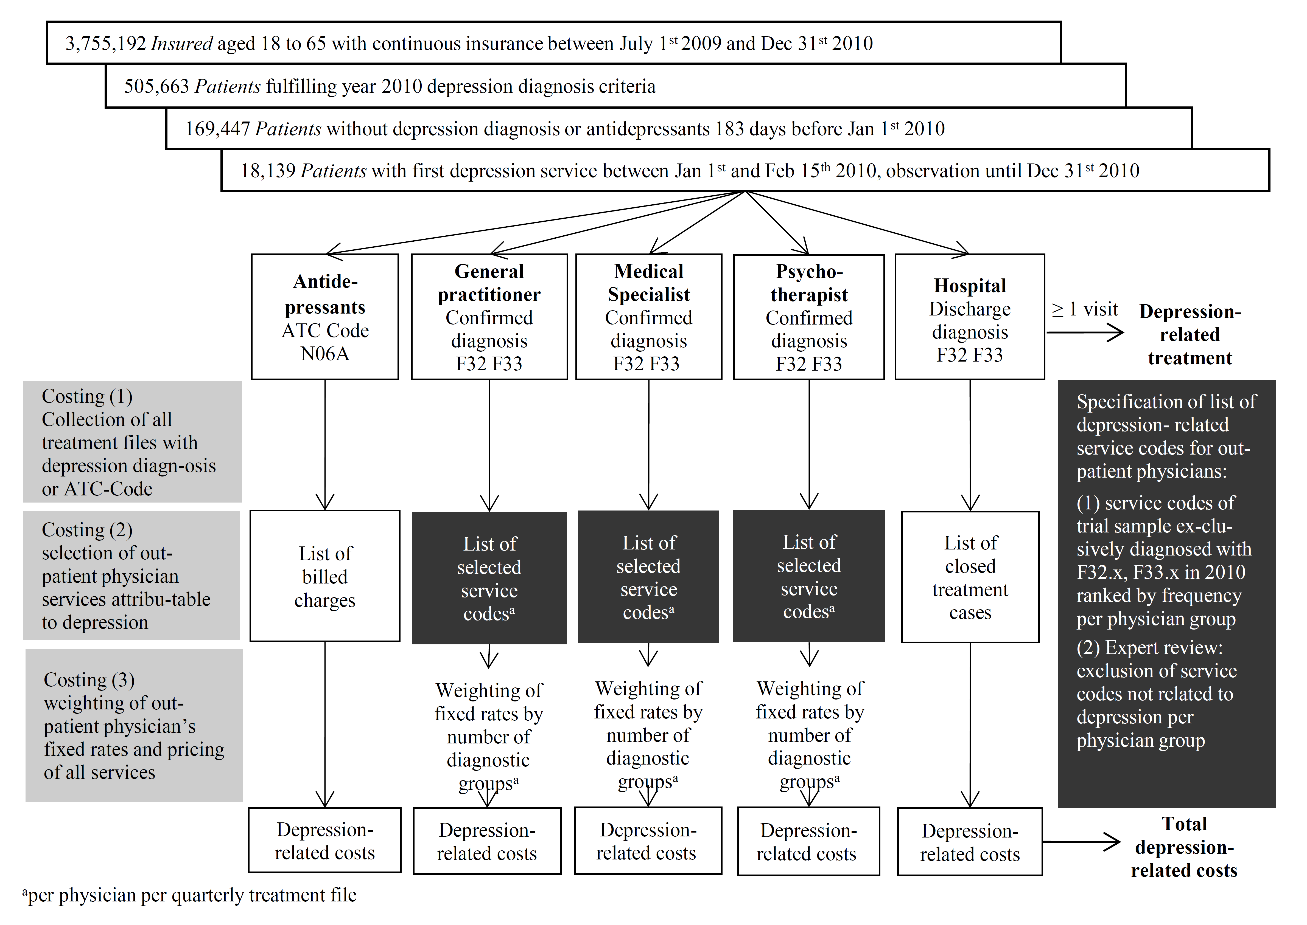

**Table 1**

Patient characteristics and distribution of stepped depression-related treatment

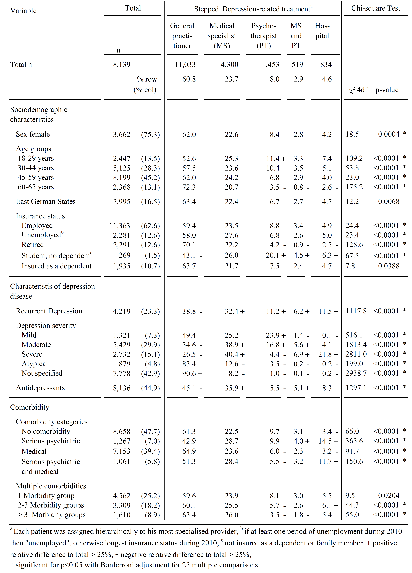



**Figure 2**

Depression-related costs and depression-related treatment

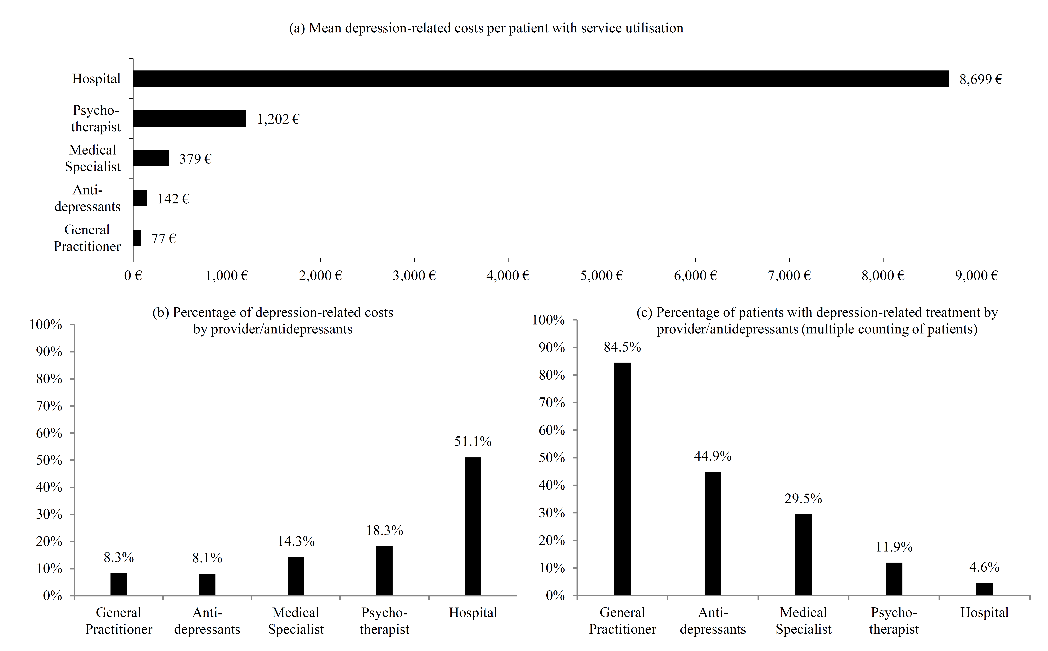

**Table 2**

Factors associated with depression-related costs in a Generalised Linear Model



# Supplementary material

Table of ICD-10 diagnosis codes of Morbidity Groups analysed in the Generalised Linear Model

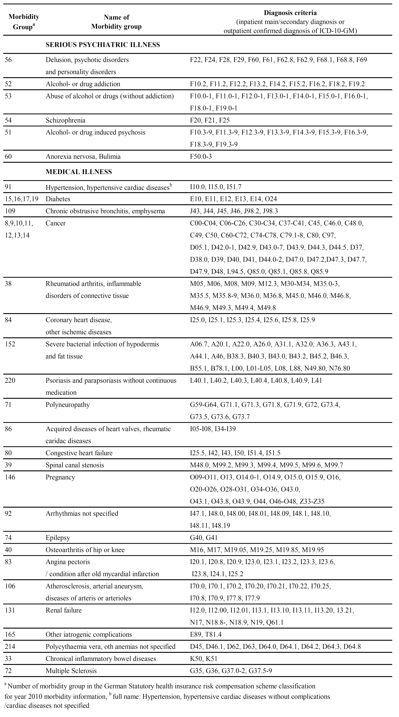

Technical specifications of the morbidity classification system provided by German federal insurance authority:

<http://www.bundesversicherungsamt.de/fileadmin/redaktion/Risikostrukturausgleich/Festlegungen/AJ_2011/Festlegung_Klassifikationssystem_2011.zip>

1. <http://www.sherpa.ac.uk/romeo/index.php>
2. Corresponding Author: Tel.: +49 (0)30 120595 76, E-Mail: [wagnerc1@uni-koeln.de](mailto:wagnerc1@uni-koeln.de) (Christoph Wagner)
3. Abbreviations. DRT: Depression-related treatment, DRC: Depression-related costs, MG: (Co)morbidity group(s), SHI: Statutory health insurance