# **Supplemental material**

**Fig. S1** Soil moisture readings in control, drought and salt treatments measured with a ML2

ThetaProbe connected to a HH2 moisture meter (Delta-T, UK). Salt treatment started on 20th June and gradually reached the final concentration of 600 mM NaCl on 24th June. Drought treatment started on 24th June. Grey arrows indicate the harvest time points.

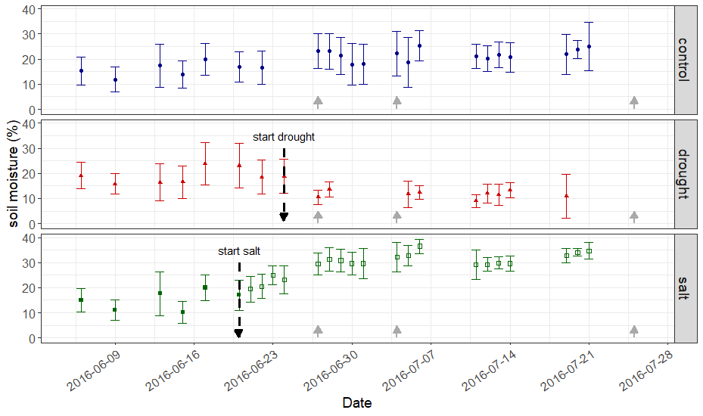

C:\Users\baoguo\Dropbox\Date palm-2nd Munich\Khalas C and N from drought and salt\Fig. Biomass.TIF

Fig. S2 Fresh weight of shoot (A), root (B) and total (C, sum of shoot and root) of date palm subjected to water deprivation and salt exposure. Data are mean ± SD (n = 5). Different letters indicate significant differences (*p* < 0.05) between control (grey bars), water deprivation (hatched bars) and salt exposure (black bars) at the same sampling date.