**Barley susceptibility factor RACB modulates transcriptional patterns in a compatible interaction with *Blumeria graminis* f.sp. *hordei***

Vera Schnepf1, Corina Vlot2, Karl Kugler3, Ralph Hückelhoven1*

1*Phytopathology, School of Life Sciences Weihenstephan, Technical University of Munich, D-85354 Freising, Germany*, 2 , 3

**Abstract**

RHO (rat sarcoma homologue) GTPases are regulators of downstream transcriptional responses of eukaryotes to intracellular and extracellular stimuli. For plants, little is known about the function of Rho-like GTPases (called RACs [rat sarcoma-related C botulinum substrate] or ROPs [RHO of plants]) in transcriptional reprogramming of cells. However, in plant hormone response and innate immunity RAC/ROP proteins influence gene expression patterns. The barley RAC/ROP RACB is required for susceptibility of barley to the powdery mildew fungus *Blumeria graminis* f.sp. *hordei* (*Bgh*). We compared the transcriptomes of barley plants either under-expressing RACB or expressing constitutively activated RACB with and without inoculation with *Bgh*. This revealed a large overlap of the barley transcriptome during early response to *Bgh* and during ubiquitous expression of constitutively activated RACB. Global pathway analyses and stringent analyses of de-regulated genes suggest that RACB influences among others the expression of signalling receptor kinases. Transient induced gene silencing of RACB-regulated signalling genes suggests that they might be involved in barley susceptibility to powdery mildew. We discuss the function of RACB in regulating transcriptional responses of susceptible barley to *Bgh*.

**Keywords: receptor-like kinase, leucine-rich repeat, wall associated kinase, DUF26**

***\*Correspondence:*** *Ralph Hückelhoven, Phytopathology; School of Life Sciences Weihenstephan, Technical University of Munich, Emil-Ramann-Str.2, D-85354 Freising, Germany, e-mail:* [*hueckelhoven@wzw.tum.de*](mailto:hueckelhoven@wzw.tum.de)

**Introduction**

GTPases of the RHO family are eukaryotic signalling switches that act in polar cell development and response to hormones, morphogens and environmental signals. Many effects of RHO GTPases can be explained by their function in remodelling the cytoskeleton and membranes. However, RHO GTPases can be also considered as transcriptional regulators because their downstream factors strongly affect gene expression and chromatin structure (Rajakyla and Vartiainen, 2014;Tong and Tergaonkar, 2014;Yu and Brown, 2015). The plant specific subfamily of RHO GTPases is called ROP (Rho of plants) or RAC, because of their highest sequence similarity to the mammalian RAC subfamily of RHO. Plant RAC/ROP proteins are increasingly well characterized modulators of immunity, cytoskeleton and membrane dynamics (Yang, 2008;Bloch and Yalovsky, 2013;Kawano et al., 2014). Less is known about whether and how RAC/ROPs modulate plant gene expression. However, several reports suggest a function of RAC/ROPs as direct or indirect modulators of plant gene expression (Tao et al., 2002;Nibau et al., 2006;Kim et al., 2012;Li et al., 2012;Poraty-Gavra et al., 2013;Scheler et al., 2016).

Plant endogenous ROP activity is tightly regulated. By contrast, ectopic expression of inactive dominant negative or constitutively activated versions of ROPs causes substantial alterations in cell polarity, hormone or pathogen response. ROP GTPases are activated at the plasma membrane by guanine nucleotide exchange factors (GEFs), which can be activated by receptor like kinases (RLKs), and release GDP in exchange for GTP from inactive ROP-GDP. Activated ROP-GTP signals downstream by binding to so-called ROP effectors that mediate execution of cellular responses. The activated ROP-GTP has low intrinsic GTPase activity. However, it forms a complex with GTPase-activating proteins (GAPs) that support hydrolysis of GTP to GDP and Pi and hence switch off ROPs. ROP-GDP can be sequestered in the cytoplasm by interaction with guanine nucleotide dissociation inhibitors (Mucha et al., 2011).

The barley RAC/ROP protein RACB is a susceptibility factor in the compatible interaction with the barley powdery mildew fungus *Blumeria graminis* f.sp. *hordei* (*Bgh*) and a potential effector target (Schultheiss et al., 2002;Hoefle et al., 2011). Susceptibility factors can be negative regulators of plant immunity or can provide structural or metabolic keys to pathogen establishment and proliferation (Hückelhoven, 2005;Hückelhoven et al., 2013;Lapin and Van den Ackerveken, 2013;van Schie and Takken, 2014). Constitutively activated RACB supports the accommodation of *Bgh* haustoria in intact epidermal cells and subsequent fungal success in sporulation. Silencing the expression of RACB limits fungal success in haustorium formation and restricts fungal reproduction (Schultheiss et al., 2002;Schultheiss et al., 2005;Hoefle et al., 2011). At the mechanistic level, RACB and the interacting proteins, MAGAP1 (microtubule-associated ROPGAP 1) and the receptor-like cytoplasmic kinase RBK1 (ROP binding kinase 1), influence organization of cytoskeleton in interaction with *Bgh* (Opalski et al., 2005;Hoefle et al., 2011;Huesmann et al., 2012). However, little is known about whether RACB might also influence gene expression patterns of barley with or without challenge by inoculation with *Bgh*. We recently described that constitutively activated (CA) RACB supports expression of selected pathogenesis-related genes in super-susceptible barley, which is counter-intuitive for a susceptibility factor (Scheler et al., 2016). Generally, global gene expression analyses suggested a massive reprogramming of the barley transcriptome during interaction with *Bgh* (Caldo et al., 2004;Wise et al., 2007;Bischof et al., 2011;Molitor et al., 2011). We therefore conducted a global gene expression analysis of transgenic barley mis-expressing *RACB* and compared results to those from wild type barley. Data suggest that activated RACB influences transcript abundance of a substantial subset of genes that are regulated in the compatible interaction with *Bgh*. In particular signalling genes including those coding receptor-like kinases were over-represented in the lists of *RACB*-modulated genes. Most stringently selected genes included new susceptibility factors that might function in a common signalling pathway with RACB.

**Results**

***Activated RACB and Bgh provoke overlapping transcript patterns in barley***

To study if RACB might influence gene expression in barley, we analysed global gene expression by the use of a custom-made 44K agilent microarray with a design based on the HARVEST35 assembly of the barley transcriptome (Mayer et al., 2011). Therefore, we analysed gene expression in mock-inoculated plants and after dense conidial inoculation in wild type Golden Promise, barley expressing *CA RACB-G15V* (CA RACB) and *RACB*-silenced barley (RACB RNAi) at 12 and 32 HAI with Bgh or after mock-inoculation. Plant material was validated before and showed all typical phenotypes caused by mis-expression of RACB (Schultheiss et al., 2005;Hoefle et al., 2011;Scheler et al., 2016). In total we compared normalized signal intensities in seven comparisons per time (Table 1). We applied stringent selection criteria with false discovery rate correction of p-values <0.05 and a cut-off of 2-fold change in expression. Inoculation with *Bgh* influenced expression of a high number of genes (for reasons of simplicity each probe on the array was considered to represent one gene). In the wild type, 5636 genes were regulated in response to *Bgh* at 12HAI with 3477 of them being upregulated. CA RACB barley also reacted strongly to *Bgh* at 12 HAI. 3904 genes were regulated in CA RACB barley in response to the pathogen, and with 2522 most of them were up-regulated. In RACB RNAi plants, 6547 genes were significantly regulated 12 HAI with *Bgh*. A bit more than half of them, 3520 genes, were up-regulated by *Bgh* at 12 HAI (Table 1).

CA RACB also significantly influenced expression of 2015 genes without fungal attack at 12 h after mock-inoculation (HAMI) when compared to mock-inoculated wild type plants. With 1581 genes, the majority of genes differentially regulated in CA RACB barley were expressed on a higher level when compared to WT. RACB RNAi had also a significant impact on constitutive gene expression in mock-inoculated plants. 661 genes were de-regulated in RACB RNAi plants at 12 HAMI. 275 of them were up-regulated and 386 genes were down-regulated when compared to mock-inoculated wild type plants.

After inoculation with *Bgh*, CA RACB-specific differences in gene expression were less pronounced when compared to the mock-inoculated situation. This might be explained because many *Bgh*-regulated genes were already constitutively up-regulated in CA RACB barley (see below). Inoculated CA RACB barley differentially expressed 903 genes at 12HAI when compared to inoculated WT with 558 of them being over-expressed in CA RACB barley. Inoculated RACB RNAi barley showed regulation of 867 genes, with 412 of them being overexpressed when compared to inoculated wild type. When considering redundancies in the gene lists of the seven comparisons we made, a total of 9056 genes were significantly regulated by genotype or treatment or both at 12 h. Similar number of genes were de-regulated at 32 HAI with some differences that might be attributed to different pathogen development (Table 1). Together, *Bgh* had a strong impact on barley gene expression. In very susceptible CA RACB barley, many genes were de-regulated already before pathogen challenge.

To get an overview about patterns of similarly regulated genes, we applied a self-organizing tree algorithm to the total of 9056 genes stringently regulated at 12 h with a cell diversity of 0.9 or higher. This generated a tree of 26 nodes (clusters) including 46 to 1188 similarly regulated genes (Figure 1). Most strongly regulated genes were in clusters of genes, which showed *Bgh*-induced gene expression changes in all three genotypes (clusters 6, 7, 10-14 and16). Several of these clusters contained genes that were additionally up-regulated in mock-treated CA RACB barley when compared to mock treated wild type (clusters 10-12). Clusters 17-19 contained genes which were down-regulated after inoculation with *Bgh*, which was partially pronounced in RACB RNAi barley. Clusters 20 and 21 contained genes that were constitutively up-regulated in CA RACB barley. Other clusters contained genes that were constitutively up-regulated in RACB RNAi barley and rather down-regulated by *Bgh* or CA RACB (clusters 1-5). Clusters 22-26 contained genes that were down-regulated by *Bgh* but were stronger expressed in *Bgh*-inoculated RACB RNAi barley, when compared to *Bgh*-inoculated wild type.

***Misexpression of RACB strongly affects transcripts of signalling functions***

For understanding of Bgh- and CA RACB-regulated gene expression, we displayed gene expression in MAPMAN and analysed enriched biological functions by using the pathway analysis tool in the software. Therefore, the array was re-annotated based on transcripts and genome contigs from the international barley sequencing consortium (Mayer et al., 2012) and all matches were filed into functional bins based on filing of their putative orthologs in *Arabidopsis thaliana* (KARL IS THIS CORRECT?). Of probes that were mapped back ca. 15% could not be assigned to any pathway by comparison to Arabidopsis annotations. Only pathways with more than 100 genes (probes) in one pathway (bin) were considered to avoid accidental enrichments. For pathway analysis all genes with signals over background were considered. Many pathways were significantly regulated by *Bgh* in the wild type. For further filtering for most important pathways, we considered all gene expression differences in the wild type after inoculation with Bgh and genotype-dependent differences between the wild type and the transgenic *RACB* genotypes either after mock inoculation or after inoculation with *Bgh*. Table 2 contains pathways which were significantly regulated in minimum three of possible five comparisons based on a false-discovery rate corrected p-value of p<0.001. According to this, *Bgh* and *RACB* genotype influenced expression of genes for amino acid and protein synthesis, cell and cell wall, protein modification, protein targeting and secretion, photosynthesis, RNA, signalling, signalling receptor kinases, signalling G-proteins, transport, and vesicle transport.

Cluster analysis (Fig. 1) suggested a large overlap of genes which are regulated during response to Bgh and during expression of CA RACB. A closer look into the gene lists confirmed this. Of 2015 genes, regulated in CA RACB MOCK vs. WT MOCK, 1485 (74%) were also regulated in WT Bgh vs. WT MOCK. 1209 of these genes were up regulated by both *CA RACB* and *Bgh*, whereas 249 were down regulated by both CA RACB and Bgh and only 27 genes were oppositely regulated by CA RACB and Bgh. Hence, most genes overlapping between CA RACB-regulated genes and *Bgh*-regulated genes are regulated by both factors with the same tendency. Vice versa, of 5636 *Bgh*-regulated genes in the wild type, 25,5 % were regulated by CA RACB with 98% of those in the same direction. Together, constitutive CA RACB expression provokes constitutive expression of a set of genes that resembles a subset of the *Bgh*-regulated genes within the barley transcriptome. Pre-activation of this gene set by CA RACB alone explains why less genes were additionally regulated during response to *Bgh* in the CA RACB genotype when compared to the wild type or RACB RNAi plants.

To further filter genes of interest for possible functional analyses, we filtered lists of genes that were significantly regulated in response to *Bgh* in the wild type with lists of genes that were constitutively deregulated in the transgenic genotypes with opposite direction in the comparisons CA RACB MOCK vs WT MOCK and RACB RNAi MOCK vs. WT MOCK. This generated a list of 113 genes for which average normalized signal intensities are displayed in Figure 2. Most of these genes showed a similar expression pattern with stronger signals during response to *Bgh*, stronger signals in CA RACB barley and weaker signals in RACB RNAi barley. Only two genes were expressed stronger in RACB RNAi barley. We manually re-annotated these 113 genes after BLAST search for similar proteins and protein domain predictions. The list of genes that are overexpressed in CA RACB barley contained several pathogenesis-related genes. Strikingly, this list of 113 genes contained a high number of receptor like kinases (RLKs). Nineteen of 113 genes were annotated as RLKs, in particular as wall-associated kinases, bulb-type lectin S-receptor like RLKs, cysteine-rich stress/antifungal like RLKs (formerly called domain of unknown function 26, DUF26-RLKs), legume lectin like RLKs. RLKs were hence differentially expressed both according to pathway analyses (Table 2) and to filtering of gene lists.

***RACB-regulates transcripts of new susceptibility factors***

We further selected genes for gene function analysis. Therefore, we compared the expression patterns at 12 HAI with those at 32HAI. In general, most genes were similarly expressed at 12 and 32 HAI by tendency. However, at 32 HAI only 15 genes were stringently regulated in all three comparisons applied to filter genes lists at 12 HAI. Of these 15 genes, four appeared in the filtered gene list at 12 HAI. These four genes (U35_21250, a wall associated kinase WAK; U35_15510, a leucine rich repeat protein, LRR-P; U35_24054, a C2 domain copine like protein, COP; U35_6100, a cysteine-rich stress/antifungal (DUF26) like RLK) and another two RLKs from the 32 HAI-filtered gene list (U35_7436, a bulb type lectin S-domain RLK (SD1-RLK); U35_26520 leucine rich repeat RLK, LRR-RLK) were selected for construction of specific RNAi constructs for transient induced gene silencing (TIGS). Additionally, for these six genes primers for RT-qPCR were designed and selected for primer efficiencies close to 100%. RNA was extracted from three further independent biological repetitions of the experimental design that was used for the array hybridization. In tendency, very similar expression patterns were observed in the array hybridization experiments when compared to the RT-qPCR data (supplementary Figure S1).

Six constructs for TIGS were prepared. To prevent silencing of off-target genes, we checked for specificity of the constructs by use of the SiFi freeware (Nowara et al., 2010). For TIGS, we used micro-projectile mediated single cell transformation experiments on barley leaf segments (Douchkov et al., 2005;Ostertag et al., 2013). Frequency of successful penetration and subsequent development of at least one haustorium in attacked transformed cells was scored. This revealed that TIGS of LRRP_U35_15510 of SD1-RLK_U35_7436 and of LRR-RLK_U35_26520 significantly reduced haustorial frequencies in attacked epidermal cells of barley (Table 3). Corresponding proteins thus represent new candidate susceptibility factors to *Bgh*.

***A leucine-rich repeat protein genetically interacts with RACB***

TIGS of *LRRP_U35_15510* reduced relative fungal penetration success by 33 % with a high level of statistical significance (Table 3). *LRRP_U35_15510* encodes a small LRRP of 224 amino acids. It contains a cleavable signal peptide (PSORT-predicted cleavage site between aa 22 and 23) for loading into the secretory pathway. The 202 aa mature protein is predicted to fold into a repetitive helix-turn-beta sheet-turn structure typical for LRR proteins. The sequence is predicted to build five short leucine-rich repeat units (http://www.lrrfinder.com/result.php). LRRP_U35_15510 appeared interesting to us because of its predicted structural similarity to the ectodomains of the pattern recognition co-receptor BAK1 in Arabidopsis. LRRP-U35_15510 protein sequence shows general similarity to ectodomains of somatic embryogenesis receptor kinases (SERKs). Modelling of the protein structure with I-TASSER (Yang and Zhang, 2015) supported high structural similarity of LRRP_U35_15510 to rice SERK2 when considering proteins for which structural data are available. Several LRR-proteins or LRR-RLKs are reposted to function upstream of ROPs such as the ROP-upstream pseudokinase PAN1 in maize. Additionally, the LRR protein SHY interacts with the pollen LRR receptor kinase PRK2 that functions upstream of ROPs by activating a ROPGEF protein in tomato. He hence performed experiments to analyse possible genetic interaction of *RACB* and *LRRP_U35_15510*. First, we transiently overexpressed *LRRP_U35_15510.* This conferred enhanced susceptibility to establishment of haustoria in transformed single cells and further supported a function of LRRP_U35_15510 in susceptibility (Figure 3). TIGS of RACB significantly reduced susceptibility as similarly reported earlier. Importantly a combination of overexpression of LRRP_U35_15510 with TIGS of RACB also resulted in reduced susceptibility. Hence silencing of RACB was epistatic over LRRP_U35_15510. Vice versa, expression of CA RACB enhanced susceptibility. This effect was observed when CA RACB was expressed alone or in presence of a TIGS construct against LRRP_U35_15510, which otherwise reduced susceptibility (Figure 3 compare Table 3). Hence, effects of silencing or constitutive activation of RACB were epistatic over effects of misexpressing LRRP_U35_15510.

**Discussion**

Misexpression of RACB in barley changed global gene expression with or without inoculation with Bgh. Global patterns of transcript abundance suggest that the majority of CA RACB-influenced genes are also regulated in WT plants when Bgh attempts to penetrate at 12 HAI. This could indicate that RACB is activated in the wild type when Bgh penetrates. This is further supported because *Bgh* infection locally recruits RIC171 to the site of penetration. RIC171 is a ROP-interacting scaffold protein that binds to activated but not inactive RACB. This suggests that RACB is activated in spatiotemporal association with fungal penetration (Schultheiss et al., 2008;Hückelhoven and Panstruga, 2011), and activated RACB might modulate gene expression patterns in Bgh-infected WT plants. Because RACB was constitutively misexpressed in transgenic barley used here, we can, however, not exclude indirect effects of RACB on gene expression. One hundred and forty-two of 2015 genes that were de-regulated in CA RACB-barley without pathogen challenge were oppositely regulated in RACB RNAi plants at 12 HAMI. In total, CA RACB influenced gene expression more strongly than knock down of RACB. This might be explained, because CA RACB has to be considered as an active but deregulated RAC/ROP protein that may constantly activate downstream signaling. It is not yet clear whether RACB is closely associated with a regulon of barley gene expression or influences gene expression rather indirectly. In rice, the resistance-associated RAC/ROP protein RAC1 regulates expression of biotic stress response proteins and activates the helix-loop-helix transcription factor Rac Immunity1 (RAI1) via MAPK signaling (Fujiwara et al. 2006; Kim et al. 2012). Barley RACB and rice RAC1 cluster in different clades of phylogenetic trees of plant RAC/ROPs and there is no evidence for a RACB-dependent MAPK activation (Schultheiss et al., 2003;Scheler et al., 2016). However, when considering the function of RHO proteins in regulation of transcriptional responses in metazoans, it appears possible that RACB is a transcriptional regulator that acts via unknown downstream factors to eventually regulate chromatin structure or transcription. Future experiments might test this hypothesis in cell autonomous expression systems.

Targeted analysis of PR-gene expression in RACB-misexpressing barley revealed a possible function of RACB in promoting the expression of defense-related genes (Scheler et al., 2016). This was supported here because several PR-genes were significantly and oppositely regulated by CA RACB and RACB RNAi (Figure x). Activation of PR- genes in CA RACB barley might indicate a function of RACB in transcriptional regulation of defense. However, this is uncoupled from powdery mildew resistance in *RACB*-misexpressing barley (Scheler et al., 2016). It is not yet understood why enhanced expression of defense-related genes in CA RACB-expressing barley is not associated with enhanced penetration resistance but with susceptibility. In *mlo5*-mediated or endophyte-induced resistance to Bgh, defense gene expression is associated with enhanced penetration resistance in barley (Peterhansel et al., 1997;Molitor et al., 2011). A possible explanation would be that defense-related proteins are not effectively secreted since secretion is key to penetration resistance (Kwon et al., 2008) and ROP proteins can also regulate membrane trafficking (Yalovsky et al., 2008). No data exist that link RACB function with barley membrane trafficking. However, since RACB and RACB-interacting proteins influence stability and arrays of the cytoskeleton, it seems plausible that membrane trafficking is affected under misexpression of RACB (Dörmann et al., 2014). This is additionally supported because pathway analysis tool of MAPMAN suggested that genes with vesicle transport functions were significantly influenced by Bgh and *RACB* (Table 2).

The question arises as to whether genes de-regulated in *RACB*-transgenic barley could explain a part of RACB-mediated susceptibility. To address this question, we focused on genes that are influenced in expression by *Bgh* in the WT and constitutively influenced by both CA RACB and knock down of RACB. This revealed a list of 113 genes for 12 HAI and of 15 genes for 32 HAI. From those lists six genes were selected for TIGS but the list contains many more interesting genes including RLKs. Several RLKs were reported before to function in susceptibility or negative control of defense to powdery mildew. This includes lectin, LRR, cysteine-rich (DUF26) and malectin domain-containing RLKs (Eckey et al., 2004;Kessler et al., 2010;Rayapuram et al., 2012;Douchkov et al., 2014;Hok et al., 2014). Our TIGS experiments suggest that also SD1-RLKs and another LRR-RLK might be required for full susceptibility to penetration by Bgh. It is not understood how and why RLKs can support pathogenesis of powdery mildew. We can only speculate that Bgh stimulates RLKs for stimulating signaling pathways that serve its own demands e.g. in cell wall remodeling or polar cell growth. In plants, RLKs can activate downstream ROPs in these processes via ROP guanine nucleotide exchange factors (Duan et al., 2010;Cheung and Wu, 2011;Zhao et al., 2013;Wolf and Hofte, 2014). Since we found many RLKs to be over-expressed in CA RACB barley and underexpressed in RACB RNAi barley, it seems possible that RACB is involved in regulating the expression of RKLs in a positive feedback loop. In such a scenario, activated RACB would stimulate expression of RLKs, which, when targeted to the plasma membrane, could function in stimulating GDP-to-GTP exchange and sustained ROP activity. This would lead to cellular responses at the cytoskeleton or in membrane dynamics but also to further expression of upstream RLKs in a possible amplification loop.

Apoplastic LRR proteins can have diverse functions in plant microbe interactions (Jones and Jones, 1997) and can function as possible ligands in RLK-mediated ROP signalling (Guyon et al., 2004;Zhang and McCormick, 2007). We identified LRRP_U35_15510 as new possible host susceptibility factor in barley interaction with Bgh. Interestingly, function of LRRP_U35_15510 appears to depend on function of RACB because the over-expression effect of LRRP_U35_15510 could be abolished by TIGS of RACB and the TIGS effect of LRRP_U35_15510 could be abolished by over-expression of CA RACB. This could for example be explained if RACB acts downstream of LRRP_U35_15510 in susceptibility. Since U35_15510 is one of the most strongly RACB-deregulated genes, again a regulatory loop can be suggested, in which LRRP_U35_15510 and RACB cooperate in susceptibility to powdery mildew. This together with the observation that RACB has a function in polar cell growth of uninfected leaf and root epidermis supports that *Bgh* profits from host signaling cascades it apparently stimulates. Expression of *RACB* is weakly stimulated by *Bgh* (Schultheiss et al., 2002) but many RLKs and *U35_15510* are strongly expressed in early response to attack from Bgh. This might prepare the plant epidermal cells for additional fungal stimulation of host cell reprogramming for supporting fungal penetration and accommodation of haustoria.

**Material and methods**

**Plant material and growth conditions**

For all experiments the barley (*Hordeum vulgare*) cultivar Golden Promise and transgenic plants (in the Golden Promise background) CA RACB (line: 17/1-11)(Schultheiss et al., 2005) and RACB RNAi (line: 16/2-4B) (Hoefle et al., 2011) were used. Kernels were surface-sterilized in 20 ml sterilization solution (4% (w/v) NaOCl, 0.01% (w/v) Tween20) for 1.5 h on a horizontal shaker. After washing with MilliQ-H2O for 30 min husks were carefully removed without hurting the embryo to support synchronized germination. Uncoated seeds were pre-germinated on wet filter paper for 2 days in the dark before sown on soil (Typ ED73, Einheitserde- und Humuswerke, Gebr. Patzer GmbH & Co KG, Sinntal-Jossa, Germany). Plants were grown in a growth chamber (Conviron, Winnipeg, Canada) at 18 °C with relative humidity of 65% and a photoperiod of 16 h with 150 µmol m-2 s-1 light intensity. Both transgenic genotypes do not produce homozygous offspring. Offspring of transgenic T3 donor plants was genotyped according to previous studies to separate transgenic offspring carrying the T-DNA from azygous offspring that lost the T-DNA due to segregation (Schultheiss et al., 2005;Hoefle et al., 2011).

**Pathogens and infection**

The powdery mildew fungus *Blumeria graminis* (DC) Speerf. sp. *hordei* (*Bgh*) EM Marchal, race A6. was maintained on the cultivar Golden Promise under conditions described. *Bgh* was inoculated by blowing spores from heavily infected plants in an inoculation tower to reach a density of 100 conidia/mm² leaf surface. For transient transformation assays, detached leaves of seven days old Golden Promise plants were fixed on 0.5 % (w/v) water agar in petri dishes and inoculated as described above.

**Microarrys and hybridization.**

Microarray analysis was carried out based on total RNA extracted using the Trizol method (Chomczynski and Sacchi, 1987) from 14-days-old second barley leaves (WT, *CA RACB*, *RACB* RNAi each 12 h and 32 h after either mock- or *Bgh*-treatment). RNA was solved in MilliQ H2O and treated with DNaseI according to the manufacturer’s manual (RNase-Free DNase set (#79254), Qiagen, Hilden, Germany) before RNA clean up with RNeasy® MinElute® Cleanup (#74204, Qiagen, Hilden, Germany). RNA quality was assessed with an Agilent 2100 Bioanalyzer (Agilent Technologies, Santa Clara, USA). High-quality cRNA was generated with an input of 100 ng RNA using the Agilent`s Low Input Quick Amp Labeling Kit which produces fluorescent cRNA by labeling with cyanine 3-labeled CTP. Four biological replicates per genotype, treatment and timepoint were prepared. The custom array SCRI_Hv35_44k-v1 (Agilent design: 020599) representing 42,302 barley cDNA contig sequences in a 60mer probe per selected gene in a 4x44k format was generated. Full details of the array can be found in Mayer (2011) and at Array-Express (http://www.ebi.ac.uk/microarray-as/ae/; accession number A-MEXP-1728) (Mayer et al., 2011).The barley arrays were hybridized at 65 °C for 16 h and subsequently washed and scanned with the Agilent Microarray Scanner according to the manufacturer’s manual (One-Color Microarray-Based Gene Expression Analysis Low Input Quick Amp Labeling protocol, Version 6.5, May 2010). Raw data were extracted with the Feature Extraction software v.10.7.3.1 (Agilent Technologies) and imported into Genespring GX (v.12.5). Data were normalized by choosing percentile of 75 % and baseline-to-median algorithms. Subsequently, data were analyzed with 1-way ANOVA statistics (p < 0.05) with a Tukey posthoc test (FDR corrected p-value <0.05) and filtered for genes with a 2-fold difference in expression level. The quality of hybridization was directly checked after the scanning process by means of the Feature Extraction Program of Agilent (Agilent Feature Extraction Software 10.10.1.1). Seven arrays had to be excluded as they were outliers. Hence, in WT two biological replicates at 12 h mock-treated and two replicates at 32 h *Bgh*-treated, in three biological replicates in *CA RACB* barley at 32 h untreated and three at 12 h *Bgh*-treated and three replicates in *RACB* RNAi ecotype at 32 h untreated and *Bgh*-treated were used for analysis instead of four biological replicates. Data are available on <http://www.ncbi.nlm.nih.gov/geo/>, accession number GSE69215. Raw data were subjected to multiple expression viewer for cluster analysis (Saeed et al., 2003). Pathway analysis was performed using the MapMan version 3.5.1 (Usadel et al., 2009). For MapMan analysis the HARVEST35 cDNA probes were compared to the transcripts and Morex reference contigs from the international barley sequencing consortium (Mayer et al., 2012). Resulting hits were used for GO annotation and filed into bins to match the existing functional categorisation in MAPMAN. We used LOG2 fold change values of all signals over background for analysing enriched biological functions/pathways. Significant pathways were evaluated by use of the Wilcoxon rank sum test (Bonferroni-Hochberg corrected p-values < 0.001).

**DNA vector construction.**

For transient gene silencing studies by RNAi, 200 – 500 bp cDNA fragments were amplified with gene specific primers (Table 4) out of a cDNA pool out of leaves of WT, *CA RACB* and *RACB RNAi* leaves treated with and without *Bgh* at 12 hpi and 32 hpi in a standard PCR approach with Phusion® High-Fidelity DNA Polymerase (Life Technologies, Carlsbad, USA) and checked for off-target specificity with the freely available SiFi program (http://labtools.ipk-gatersleben.de/). Blunt-ended fragments were cloned in antisense-sense orientation into the entry vector pIPKTA38 and subsequently into the destination vector pIPKTA30N as described before (Douchkov et al., 2005). For generation of OE constructs, coding sequences were amplified from cDNA using specific full-length primers (Table 4). Full-length open reading frames were cloned into pGEMTeasy entry vector by TA cloning (Promega, Madison, USA) and after sequence confirmation subcloned into the pUC18-based plant expression vector pGY1 under the control of the 35S Cauliflower Mosaic Virus (CaMV) promotor (Schweizer et al., 1999) with appropriate restriction sites (*Xba*I, *Sph*I or *Sal*I).

**Reverse-transcription polymerase chain reaction (RT-PCR).**

1 µg total RNA (for methods see above) was transcribed into cDNA using QuantiTect Reverse Transcription Kit (Qiagen, Mannheim, Germany). The manufacturer`s protocol was followed except for the gDNA elimination from barley RNA was performed for 10 min and reverse transcription for 30 min. cDNA was stored at -20 °C. For quantitative gene expression analysis, a quantitative Real-Time PCR (qPCR) in a Mx3005P cycler (Agilent, Santa Clara, USA) using the Maxima SYBR Green qPCR master mix (2x) (Thermo Fisher Scientific, St. Leon-Rot, Germany) was used. cDNA was prepared and qPCR was carried out in duplicates with 1 µl cDNA and 330 nM forward and reverse primer each in a 10 µl final volume. Expression values of the candidate genes were normalized to the internal control and housekeeping gene (*UBC*) using the ∆∆Ct method (Livak and Schmittgen, 2001) after having controlled primer efficiencies to be close to 100%. The PCR program consisted of an initial step at 95 °C for 10 min and 95 °C for 30 s followed by 40 cycles at 55 °C for 30 s and at 72 °C for 1 min. Melting curve analysis was performed at 55 °C – 95 °C. All primers (Table 2) were designed using Primer3 software (Untergasser et al., 2012) and were checked for specificity using the Basic Local Alignment Search Tool (BLAST) and therein with nucleotide blast against *Hordeum vulgare* database (http://blast.ncbi.nlm.nih.gov), OligoCalc (Kibbe, 2007) and semi-quantitative PCR before running RT-qPCR. Standard curves were performed with 10 ng cDNA dilution series (100 ng, 50 ng, 25 ng, 12.5 ng, 6.75 ng) mixed with 330 nM forward and reverse primer each in a 10 µl final volume in triplicates to validate specificity and efficiencies of the primers for the RT-qPCR conditions.

**Gene function assessment by transient transformation.**

To test gene function 7-days-old barley leaves were transiently transformed by particle bombardment with 1 µg of the test plasmid together with 1 µg pGY1-GFP as transformation markers and inoculated as described (Douchkov et al., 2005;Ostertag et al., 2013). Transformed leaf segments were inoculated 6h after delivery of overexpression constructs or 48h after delivery of TIGS constructs. For microscopic analysis transiently transformed barley leaves were shortly rinsed in MilliQ H2O and fungal chitin was stained for 1 min in 0.3 % (w/v) calcuoflor solution as described (Hückelhoven et al., 2003).

At least 100 interaction sites were evaluated in each experiments and penetration efficiency was calculated as the number of all penetrated cells divided by the number of attacked cells multiplied by 100 and used as the relative frequency of cells with haustoria in percent. For all experiments statistical analysis was performed using a two-sided unpaired Student`s t-test on the un-transformed penetration frequencies.

**Table 1.** Numbers of significantly regulated genes in seven comparisons regarding genotype or treatment.

|  |  |  |  |  |  |  |
| --- | --- | --- | --- | --- | --- | --- |
|  | Number of regulated genes* | | | | | |
| Comparison | All regulated genes | | Up-regulated genes | | Down-regulated genes | |
|  | 12 hpi | 32 hpi | 12 hpi | 32 hpi | 12 hpi | 32 hpi |
| WT Bgh vs.  WT mock | 5636 | 3086 | 3477 | 2230 | 2159 | 856 |
| CA RACB Bgh vs.  CA RACB mock | 3904 | 3495 | 2522 | 2111 | 1382 | 1564 |
| RNAi RACB Bgh vs. RNAi RACB mock | 6547 | 4291 | 3520 | 2814 | 3027 | 1477 |
| CA RACB Bgh vs.  WT Bgh | 903 | 2400 | 558 | 1381 | 345 | 1019 |
| RNAi RACB Bgh vs. WT Bgh | 867 | 874 | 412 | 638 | 455 | 236 |
| CA RACB mock vs.  WT mock | 2015 | 2408 | 1581 | 1595 | 434 | 813 |
| RNAi RACB mock vs. WT mock | 661 | 388 | 275 | 180 | 386 | 208 |

*FDR corr. P<0.05; log2fold change >1; total number of genes considering redundancies: 9056

**Table 2: Biological pathways significantly regulated by *Bgh* or RACB in barley.**

|  |  |  |  |  |  |  |
| --- | --- | --- | --- | --- | --- | --- |
|  | | p-value (false discovery rate corrected) | | | | |
| Pathwaya | Number of elements | CA RACB Bgh vs. WT Bgh | CA RACB MOCK vs. WT MOCK | RACB KD Bgh vs. WT Bgh | RACB KD MOCK vs. WT MOCK | WT Bgh vs. WT MOCK |
| amino acid metabolism | 417 | 0,19 | 5,69E-04 | 2,77E-05 | 0,64 | 1,06E-09 |
| cell | 1120 | 0,95 | 3,09E-09 | 6,94E-09 | 0,17269642 | 0 |
| cell wall.modification | 103 | 0,76 | 3,79E-05 | 6,64E-09 | 0,64 | 1,20E-08 |
| cell.vesicle transport | 247 | 0,71 | 0 | 9,71E-07 | 0,64 | 0 |
| protein | 4548 | 0,71 | 0 | 3,18E-83 | 0 | 0 |
| protein.degradation | 1855 | 0,71 | 0 | 1,08E-15 | 2,23E-08 | 1,09E-09 |
| protein.degradation.  ubiquitin | 1088 | 0,71 | 0 | 3,99E-11 | 4,11E-11 | 7,18E-12 |
| protein.postranslational modification | 920 | 3,96E-05 | 0 | 7,87E-13 | 9,86E-04 | 0 |
| protein.synthesis | 976 | 5,61E-11 | 0,67 | 1,06E-21 | 4,62E-04 | 8,37E-06 |
| protein.targeting | 418 | 0,96 | 3,56E-07 | 3,99E-11 | 9,88E-04 | 1,06E-09 |
| protein.targeting.secretory pathway | 205 | 0,73 | 6,51E-07 | 1,86E-05 | 0,948649602 | 4,28E-10 |
| photosynthesis | 339 | 1,54E-49 | 4,34E-33 | 0,79 | 0,644023981 | 2,96E-19 |
| photosynthesis.  lightreaction | 197 | 1,42E-33 | 4,33E-23 | 0,98 | 0,656353049 | 2,64E-17 |
| RNA | 2611 | 0,82 | 1,67E-12 | 5,60E-10 | 0 | 0,65 |
| signalling | 1710 | 0,93 | 0 | 4,71E-04 | 0,64 | 0 |
| signalling.G-proteins | 273 | 0,87 | 6,03E-05 | 2,20E-06 | 0,64 | 3,19E-05 |
| signalling.receptor kinases | 798 | 0,017 | 0 | 0,692807701 | 3,72E-06 | 0 |
| transport | 1454 | 7,99E-04 | 1,27E-06 | 6,23E-16 | 0,64 | 6,63E-12 |

**a Pathways were selected because they have more than 100 elements and were stringently regulated (FDR corr. p < 0.001) in at least three of five comparisons**

**Table 3.** TIGS of candidate genes with differential expression in *RACB*-misexpressing barley genotypes and in wild type 12 HPI with *Bgh*.

|  |  |  |  |
| --- | --- | --- | --- |
| Gene identity/target  of TIGS | Relative frequency [%] of cells with haustoria  (control = 100%)a | Number of independent biological experimentsb | p-valuec |
| WAK_U35_21250 | 75,2 | 3 | 0,1578 |
| LRRP_U35_15510 | 66,8 | 5 | 0,0019 |
| COPINE_U35_24054 | 88,3 | 3 | 0,1710 |
| CRK_U35_6100 | 100,6 | 3 | 0,8683 |
| SD1-RLK_U35_7436 | 62,6 | 5 | 0,0105 |
| LRR-RLK_U35_26520 | 67,5 | 5 | 0,0294 |

a Transient induced gene silencing (TIGS) experiments were performed in 7 days old WT Golden Promise leaf segments after gold particle delivery of the test constructs together with pGY1-GFP as transformation marker. Per experiment at least 100 cells were analysed 2 days after inoculation for the presense of haustoria as an indication of successful penetration. b If results indicated a significant difference after three independent experiments, two additional experiments were carried out for confirmation of the TIGS effect. c p –value according to a two-sided unpaired Student`s t-test performed on the non-transformed raw data.

**Table 4: Oligonucleotides sequences for PCR.**

|  |  |  |  |  |  |  |
| --- | --- | --- | --- | --- | --- | --- |
| **Gene of interest** | **Harvest 35 assembly number: P_35_** | **Accession number** | **Forward primer (5`🡪3`)/  reverse primer (5`🡪 3`)** | **T (annealing) [°C]** | **Product size [bp]** | **restriction site** |
| **RNAi constructs** | | | | | |  |
| *LRRP* | 15510 | AK360562 | TCTAGATACCGGAGCAGCG/ GTCGACTACTGCCCCAAGC | 60 | 451 | *Swa*I |
| *COPINE* | 24054 | AK368392 | ATGCATCTACACATGACCAAGA/ GACCATCTCCAACTCCGACC | 60 | 339 | *Swa*I |
| *SD1-RLK* | 7436 | AK369396 | AACCTCACCTACCTGGAGACG/ CTTTTGAGCTTTGTAAGGTTGC | 60 | 311 | *Swa*I |
| *LRR-RLK* | 26520 | AK361450 | TGGAGACGCTCGACCTCA/ GCTTTTGAGCTTTGTAAGGTTG | 60 | 299 | *Swa*I |
| *WAK-RLK a* | 21250 | AK365606 | GCTTTATCGAACATCCCCTCAT/ CGCACGAGCCATTTGTTAGG | 60 | 235 | *Swa*I |
| *CRK (DUF26)* | 6100 | AK368110/ MLOC_53309.2 | ACATCTGTGTTGACCGGATTGC/ TGCATCGAAGAGAACGGTGT | 60 | 242 | *Swa*I |
| **OE constructs** | | | | | |  |
| *LRRP* | 15510 | AK360562 | TCTAGATATGGCAGCTCAGACC/ GGCATGCCTCAGCTTGTAGT | 60 | 689 | *Xba*I, *Sph*I |
| **qRT-PCR primers** | | | | | | |
| *UBC* | 46110 | M60175 | TCTCGTCCCTGAGATTGCCCACAT/ TTTCTCGGGACAGCAACACAATCTTCT | 58 | 263 |  |
| *COPINE* | 24054 | AK368392 | TCGCGGACAATTAAGACACC/ TGTCCATTCATTACTTTTTGTGAAA | 60 | 180 |  |
| *SD1-RLK* | 7436 | AK369396 | ATGACCAGTAGAATAATAACAACGGA/ ACATCAGTGGAGGCGGC | 60 | 190 |  |
| *LRR-RLK* | 26520 | AK361450 | AAGATCTCCAGCAGCGTGAT/ AATTCAGAGAGCACCATTGGA/ | 60 | 125 |  |
| *WAK-RLK a* | 21250 | AK365606 | ATTCCACCATCGACGAGC/ TATCACAGGAAAATGGGATTGAC | 60 | 227 |  |
| *CRK (DUF26)* | 6100 | AK368110 | AACACCGTTCACGATCTTCAG/  TGTACGAGTATATGCCAAACCTG | 60 | 104 |  |

**References**

Bischof, M., Eichmann, R., and Hückelhoven, R. (2011). Pathogenesis-associated transcriptional patterns in Triticeae. *Journal of Plant Physiology* 168**,** 9-19.

Bloch, D., and Yalovsky, S. (2013). Cell polarity signaling. *Current Opinion in Plant Biology* 16**,** 734-742.

Caldo, R.A., Nettleton, D., and Wise, R.P. (2004). Interaction-dependent gene expression in Mla-specified response to barley powdery mildew. *Plant Cell* 16.

Cheung, A.Y., and Wu, H.-M. (2011). THESEUS 1, FERONIA and relatives: a family of cell wall-sensing receptor kinases? *Current Opinion in Plant Biology* 14**,** 632-641.

Chomczynski, P., and Sacchi, N. (1987). Single-step method of RNA isolation by acid guanidinium thiocyanate-phenol-chloroform extraction. *Analytical Biochemistry* 162**,** 156-159.

Dörmann, P., Kim, H., Ott, T., Schulze-Lefert, P., Trujillo, M., Wewer, V., and Hückelhoven, R. (2014). Cell-autonomous defense, re-organization and trafficking of membranes in plant-microbe interactions. *New Phytologist* 204**,** 815-822.

Douchkov, D., Luck, S., Johrde, A., Nowara, D., Himmelbach, A., Rajaraman, J., Stein, N., Sharma, R., Kilian, B., and Schweizer, P. (2014). Discovery of genes affecting resistance of barley to adapted and non-adapted powdery mildew fungi. *Genome Biol* 15**,** 518.

Douchkov, D., Nowara, D., Zierold, U., and Schweizer, P. (2005). A high-throughput gene-silencing system for the functional assessment of defense-related genes in barley epidermal cells. *Mol Plant Microbe Interact* 18**,** 755-761.

Duan, Q., Kita, D., Li, C., Cheung, A.Y., and Wu, H.-M. (2010). FERONIA receptor-like kinase regulates RHO GTPase signaling of root hair development. *Proceedings of the National Academy of Sciences of the United States of America* 107**,** 17821-17826.

Eckey, C., Korell, M., Leib, K., Biedenkopf, D., Jansen, C., Langen, G., and Kogel, K.H. (2004). Identification of powdery mildew-induced barley genes by cDNA-AFLP: functional assessment of an early expressed MAP kinase. *Plant Mol Biol* 55**,** 1-15.

Guyon, V., Tang, W.H., Monti, M.M., Raiola, A., Lorenzo, G.D., Mccormick, S., and Taylor, L.P. (2004). Antisense phenotypes reveal a role for SHY, a pollen-specific leucine-rich repeat protein, in pollen tube growth. *Plant J* 39**,** 643-654.

Hoefle, C., Huesmann, C., Schultheiss, H., Boernke, F., Hensel, G., Kumlehn, J., and Hückelhoven, R. (2011). A barley ROP GTPase ACTIVATING PROTEIN associates with microtubules and regulates entry of the barley powdery mildew fungus into leaf epidermal cells. *Plant Cell* 23**,** 2422-2439.

Hok, S., Allasia, V., Andrio, E., Naessens, E., Ribes, E., Panabieres, F., Attard, A., Ris, N., Clement, M., Barlet, X., Marco, Y., Grill, E., Eichmann, R., Weis, C., Hückelhoven, R., Ammon, A., Ludwig-Muller, J., Voll, L.M., and Keller, H. (2014). The Receptor Kinase IMPAIRED OOMYCETE SUSCEPTIBILITY1 Attenuates Abscisic Acid Responses in Arabidopsis. *Plant Physiol* 166**,** 1506-1518.

Hückelhoven, R. (2005). Powdery mildew susceptibility and biotrophic infection strategies. *Fems Microbiology Letters* 245**,** 9-17.

Hückelhoven, R., Dechert, C., and Kogel, K.H. (2003). Overexpression of barley BAX inhibitor 1 induces breakdown of mlo-mediated penetration resistance to Blumeria graminis. *Proceedings of the National Academy of Sciences of the United States of America* 100**,** 5555-5560.

Hückelhoven, R., Eichmann, R., Weis, C., Hoefle, C., and Proels, R.K. (2013). Genetic loss of susceptibility: a costly route to disease resistance? *Plant Pathology* 62**,** 56-62.

Hückelhoven, R., and Panstruga, R. (2011). Cell biology of the plant-powdery mildew interaction. *Current Opinion in Plant Biology* 14**,** 738-746.

Huesmann, C., Reiner, T., Hoefle, C., Preuss, J., Jurca, M.E., Domoki, M., Feher, A., and Hückelhoven, R. (2012). Barley ROP Binding Kinase1 Is Involved in Microtubule Organization and in Basal Penetration Resistance to the Barley Powdery Mildew Fungus. *Plant Physiology* 159**,** 311-320.

Jones, D.A., and Jones, J.D. (1997). The role of leucine-rich repeat proteins in plant defences. *Advances in Botanical Research* 24**,** 90-168.

Kawano, Y., Kaneko-Kawano, T., and Shimamoto, K. (2014). Rho family GTPase-dependent immunity in plants and animals. *Frontiers in Plant Science* 5**,** 522.

Kessler, S.A., Shimosato-Asano, H., Keinath, N.F., Wuest, S.E., Ingram, G., Panstruga, R., and Grossniklaus, U. (2010). Conserved molecular components for pollen tube reception and fungal invasion. *Science* 330**,** 968-971.

Kibbe, W.A. (2007). OligoCalc: an online oligonucleotide properties calculator. *Nucleic Acids Research* 35**,** 43-46.

Kim, S.-H., Oikawa, T., Kyozuka, J., Wong, H.L., Umemura, K., Kishi-Kaboshi, M., Takahashi, A., Kawano, Y., Kawasaki, T., and Shimamoto, K. (2012). The bHLH Rac Immunity1 (RAI1) Is Activated by OsRac1 via OsMAPK3 and OsMAPK6 in Rice Immunity. *Plant and Cell Physiology* 53**,** 740-754.

Kwon, C., Bednarek, P., and Schulze-Lefert, P. (2008). Secretory pathways in plant immune responses. *Plant Physiol* 147**,** 1575-1583.

Lapin, D., and Van Den Ackerveken, G. (2013). Susceptibility to plant disease: more than a failure of host immunity. *Trends in Plant Science* 18**,** 546-554.

Li, Z., Kang, J., Sui, N., and Liu, D. (2012). ROP11 GTPase is a Negative Regulator of Multiple ABA Responses in Arabidopsis. *Journal of Integrative Plant Biology* 54**,** 169-179.

Livak, K.J., and Schmittgen, T.D. (2001). Analysis of relative gene expression data using real-time quantitative PCR and the 2(-Delta Delta C(T)) Method. *Methods* 25**,** 402-408.

Mayer, K.F., Martis, M., Hedley, P.E., Šimková, H., Liu, H., Morris, J.A., Steuernagel, B., Taudien, S., Roessner, S., and Gundlach, H. (2011). Unlocking the barley genome by chromosomal and comparative genomics. *The Plant Cell* 23**,** 1249-1263.

Mayer, K.F., Waugh, R., Brown, J.W., Schulman, A., Langridge, P., Platzer, M., Fincher, G.B., Muehlbauer, G.J., Sato, K., Close, T.J., Wise, R.P., and Stein, N. (2012). A physical, genetic and functional sequence assembly of the barley genome. *Nature* 491**,** 711-716.

Molitor, A., Zajic, D., Voll, L.M., Pons, K.H.J., Samans, B., Kogel, K.H., and Waller, F. (2011). Barley leaf transcriptome and metabolite analysis reveals new aspects of compatibility and Piriformospora indica-mediated systemic induced resistance to powdery mildew. *Mol Plant Microbe Interact* 24**,** 1427-1439.

Mucha, E., Fricke, I., Schaefer, A., Wittinghofer, A., and Berken, A. (2011). Rho proteins of plants - Functional cycle and regulation of cytoskeletal dynamics. *European Journal of Cell Biology* 90**,** 934-943.

Nibau, C., Wu, H.-M., and Cheung, A.Y. (2006). RAC/ROP GTPases: 'hubs' for signal integration and diversification in plants. *Trends in Plant Science* 11**,** 309-315.

Nowara, D., Gay, A., Lacomme, C., Shaw, J., Ridout, C., Douchkov, D., Hensel, G., Kumlehn, J., and Schweizer, P. (2010). HIGS: host-induced gene silencing in the obligate biotrophic fungal pathogen Blumeria graminis. *Plant Cell* 22**,** 3130-3141.

Opalski, K.S., Schultheiss, H., Kogel, K.H., and Hückelhoven, R. (2005). The receptor-like MLO protein and the RAC/ROP family G-protein RACB modulate actin reorganization in barley attacked by the biotrophic powdery mildew fungus Blumeria graminis f.sp hordei. *Plant Journal* 41**,** 291-303.

Ostertag, M., Stammler, J., Douchkov, D., Eichmann, R., and Hückelhoven, R. (2013). The conserved oligomeric Golgi complex is involved in penetration resistance of barley to the barley powdery mildew fungus. *Molecular Plant Pathology* 14**,** 230-240.

Peterhansel, C., Freialdenhoven, A., Kurth, J., Kolsch, R., and Schulze-Lefert, P. (1997). Interaction analyses of genes required for resistance responses to powdery mildew in barley reveal distinct pathways leading to leaf cell death. *Plant Cell* 9**,** 1397-1409.

Poraty-Gavra, L., Zimmermann, P., Haigis, S., Bednarek, P., Hazak, O., Stelmakh, O.R., Sadot, E., Schulze-Lefert, P., Gruissem, W., and Yalovsky, S. (2013). The Arabidopsis Rho of Plants GTPase AtROP6 Functions in Developmental and Pathogen Response Pathways. *Plant Physiology* 161**,** 1172-1188.

Rajakyla, E.K., and Vartiainen, M.K. (2014). Rho, nuclear actin, and actin-binding proteins in the regulation of transcription and gene expression. *Small GTPases* 5**,** e27539.

Rayapuram, C., Jensen, M.K., Maiser, F., Shanir, J.V., Hornshoj, H., Rung, J.H., Gregersen, P.L., Schweizer, P., Collinge, D.B., and Lyngkjaer, M.F. (2012). Regulation of basal resistance by a powdery mildew-induced cysteine-rich receptor-like protein kinase in barley. *Molecular Plant Pathology* 13**,** 135-147.

Saeed, A., Sharov, V., White, J., Li, J., Liang, W., Bhagabati, N., Braisted, J., Klapa, M., Currier, T., and Thiagarajan, M. (2003). TM4: a free, open-source system for microarray data management and analysis. *Biotechniques* 34**,** 374-378.

Scheler, B., Schnepf, V., Galgenmuller, C., Ranf, S., and Huckelhoven, R. (2016). Barley disease susceptibility factor RACB acts in epidermal cell polarity and positioning of the nucleus. *J Exp Bot* 67**,** 3263-3275.

Schultheiss, H., Dechert, C., Kogel, K.H., and Hückelhoven, R. (2002). A small GTP-binding host protein is required for entry of powdery mildew fungus into epidermal cells of barley. *Plant Physiology* 128**,** 1447-1454.

Schultheiss, H., Dechert, C., Kogel, K.H., and Hückelhoven, R. (2003). Functional analysis of barley RAC/ROP G-protein family members in susceptibility to the powdery mildew fungus. *Plant Journal* 36**,** 589-601.

Schultheiss, H., Hensel, G., Imani, J., Broeders, S., Sonnewald, U., Kogel, K.H., Kumlehn, J., and Hückelhoven, R. (2005). Ectopic expression of constitutively activated RACB in barley enhances susceptibility to powdery mildew and abiotic stress. *Plant Physiology* 139**,** 353-362.

Schultheiss, H., Preuss, J., Pircher, T., Eichmann, R., and Hückelhoven, R. (2008). Barley RIC171 interacts with RACB in planta and supports entry of the powdery mildew fungus. *Cellular Microbiology* 10**,** 1815-1826.

Schweizer, P., Pokorny, J., Abderhalden, O., and Dudler, R. (1999). A transient assay system for the functional assessment of defense-related genes in wheat. *Molecular Plant Microbe Interactions Journal* 12**,** 647-654.

Tao, L.Z., Cheung, A.Y., and Wu, H.M. (2002). Plant Rac-like GTPases are activated by auxin and mediate auxin-responsive gene expression. *Plant Cell* 14**,** 2745-2760.

Tong, L., and Tergaonkar, V. (2014). Rho protein GTPases and their interactions with NFkappaB: crossroads of inflammation and matrix biology. *Biosci Rep* 34.

Untergasser, A., Cutcutache, I., Koressaar, T., Ye, J., Faircloth, B.C., Remm, M., and Rozen, S.G. (2012). Primer3--new capabilities and interfaces. *Nucleic Acids Research* 40**,** e115.

Usadel, B., Poree, F., Nagel, A., Lohse, M., Czedik-Eysenberg, A., and Stitt, M. (2009). A guide to using MapMan to visualize and compare Omics data in plants: a case study in the crop species, Maize. *Plant Cell Environ* 32**,** 1211-1229.

Van Schie, C.C., and Takken, F.L. (2014). Susceptibility genes 101: how to be a good host. *Annual Review of Phytopathology* 52**,** 551-581.

Wise, R.P., Moscou, M.J., Bogdanove, A.J., and Whitham, S.A. (2007). Transcript profiling in host-pathogen interactions. *Annu Rev Phytopathol* 45**,** 329-369.

Wolf, S., and Hofte, H. (2014). Growth Control: A Saga of Cell Walls, ROS, and Peptide Receptors. *Plant Cell* 26**,** 1848-1856.

Yalovsky, S., Bloch, D., Sorek, N., and Kost, B. (2008). Regulation of membrane trafficking, cytoskeleton dynamics, and cell polarity by ROP/RAC GTPases. *Plant Physiology* 147**,** 1527-1543.

Yang, J., and Zhang, Y. (2015). I-TASSER server: new development for protein structure and function predictions. *Nucleic Acids Res* 43**,** W174-181.

Yang, Z. (2008). "Cell Polarity Signaling in Arabidopsis," in *Annual Review of Cell and Developmental Biology*.), 551-575.

Yu, O.M., and Brown, J.H. (2015). G Protein-Coupled Receptor and RhoA-Stimulated Transcriptional Responses: Links to Inflammation, Differentiation, and Cell Proliferation. *Mol Pharmacol* 88**,** 171-180.

Zhang, Y., and Mccormick, S. (2007). A distinct mechanism regulating a pollen-specific guanine nucleotide exchange factor for the small GTPase Rop in Arabidopsis thaliana. *Proceedings of the National Academy of Sciences of the United States of America* 104**,** 18830-18835.

Zhao, X.-Y., Wang, Q., Li, S., Ge, F.-R., Zhou, L.-Z., Mccormick, S., and Zhang, Y. (2013). The juxtamembrane and carboxy-terminal domains of Arabidopsis PRK2 are critical for ROP-induced growth in pollen tubes. *Journal of Experimental Botany* 64**,** 5599-5610.

**Conflict of Interest Statement:**

Commercial use of RACB is regulated by patent WO 03020939.

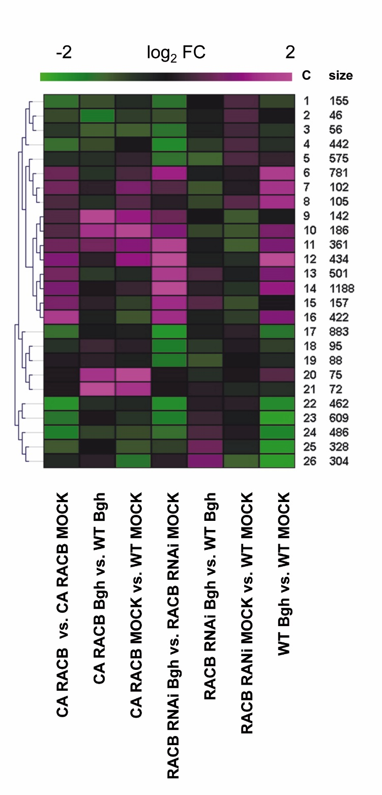

**Figure 1.** Dendogram of 26 gene clusters with sets of similarly regulated genes. A total of 9056 regulated genes were analyzed for sets of similarly regulated genes based on a self-organizing tree algorithm. For each cluster, expression of the representative centroid gene is displayed. Size (population size) shows the number of genes in the respective cluster. All clusters have a mean gene to centroid distance above 0.9.

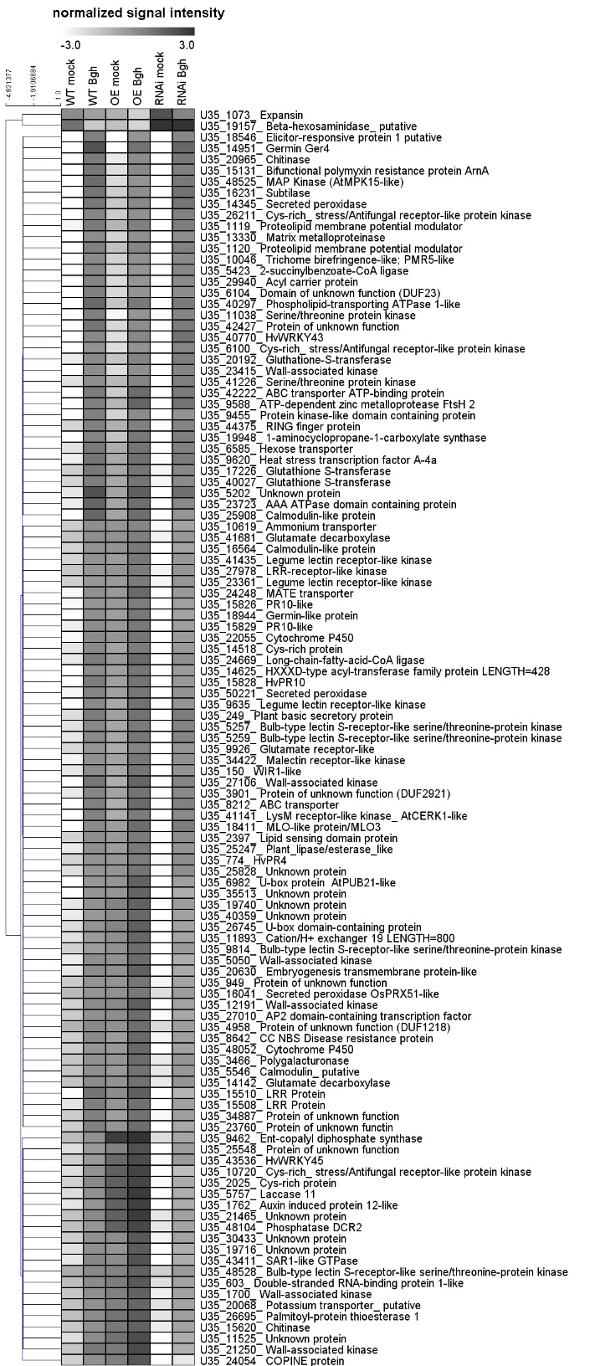

Figure 2. Hirarchical clustering of normalized signal intensities (virtual northern blot) of 113 genes that are significantly regulated by *Bgh*-inoculation in the WT (12 hpi) and significantly and oppositely regulated by both transgenes (*CA RACB* and *RACB RNAi*) when compared to WT (12 HAMI). Of 2015 genes regulated by CA RACB without *Bgh* (see Table 1), 142 were oppositely regulated by RACB RNAi without Bgh. Of these 142 genes, 113 were significantly regulated by Bgh in the WT. (FDR corr. P-value <0.05, cutoff 2-fold up- or down-regulation).

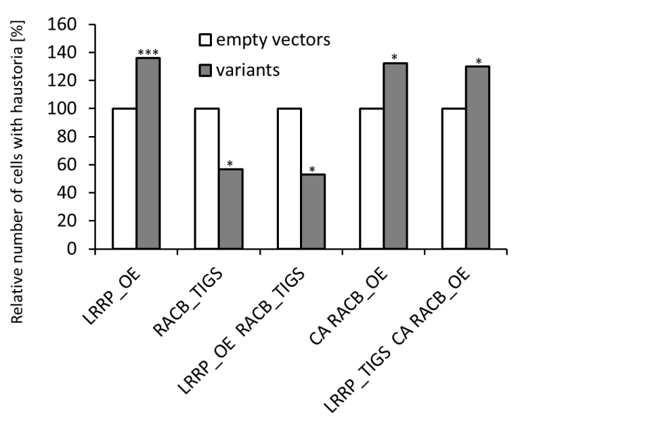

Figure 3. Simultaneous misexpression of *LRRP-U35_15510* (LRRP) and *RACB* suggest genetic interactions between corresponding gene functions. Transient induced gene silencing (TIGS) and overexpression (OE) experiments were performed in 7 days old WT Golden Promise leaf segments after gold particle delivery of the test constructs together with pGY1-GFP as transformation marker. In three independent experiments at least 100 cells were analysed 2 days after inoculation for the presense of haustoria as an indication of successful penetration. *, **, *** represent significance at p –value < 0.05, 0.01 and 0.001, according to a two-sided unpaired Student`s t-test performed on the non-transformed raw data.

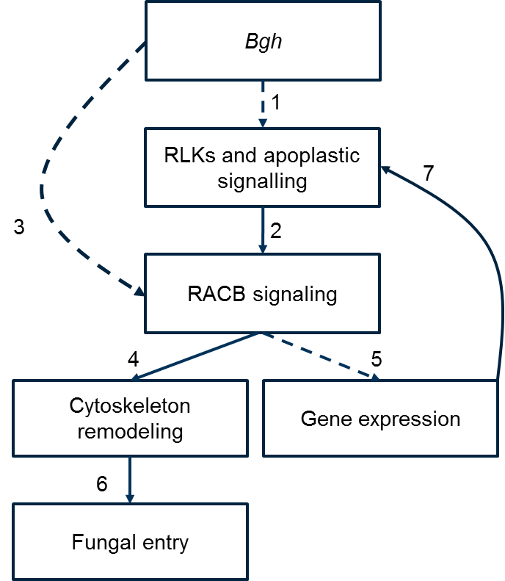

Figure 4: Hypothetical model of RACB signaling to cytoskeleton remodeling and gene expression. 1. Fungal attack activates cell surface RLK and apoplastic signaling. 2. RLK signaling is postulated to activate RACB by stimulating GDP-to-GTP exchange via guanidine nucleotide exchange factors. 3. Bgh might additionally address RACB via virulence effector functions. Activated RACB influences cytoskeleton (4.) and gene expression (5.). 6. Cytoskeleton remodeling facilitates fungal entry. 7. RACB-modulated gene expression supports expression of RLKs and apoplastic signaling components in a positive feedback loop.

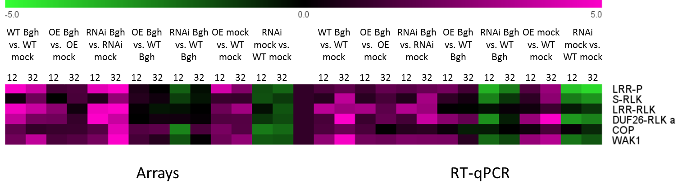

Figure S1. Verification of selected gene expression differences by RT-qPCR. Selected genes are LRR-P (U35_15510), encoding a leucine rich repeat protein, SD1-RLK (U35_7436), encoding a bulb type lectin S-domain RLK, LRR-RLK (U35_26520) encoding a leucine rich repeat RLK, DUF26-RLK (U35_6100) encoding a cysteine-rich stress/antifungal (DUF26) like RLK, COP (U35_24054), encoding a C2 domain copine like protein, and WAK (U35_21250), encoding a wall-associated kinase.