**Whole blood DNA methylation signatures of diet are associated with cardiovascular risk factors and all-cause mortality**

**Authors**: Jiantao Ma 1,2 *, Casey M. Rebholz 3 *, Kim V.E. Braun 4*, Lindsay M. Reynolds 5*, Stella Aslibekyan 6*, Rui Xia 7, Niranjan G. Biligowda 6, Tianxiao Huan 2, Chunyu Liu 2,8, Michael M. Mendelson 2,9, Roby Joehanes 2, Emily A. Hu 3, Mara Z. Vitolins 5, Alexis C. Wood 10, Kurt Lohman 11, Carolina Ochoa-Rosales 4, 12, Joyce van Meurs 4, Andre Uitterlinden 4, Yongmei Liu 5, Mohamed A. Elhadad 13,14,15, Margit Heier 13,16, Melanie Waldenberger 13,14,15, Annette Peters 13,14,15, Elena Colicino 17, Eric A. Whitsel 18,19, Antoine Baldassari 18, Sina A. Gharib 20, Nona Sotoodehnia 20, Jennifer A. Brody 20, Colleen M. Sitlani 20, Toshiko Tanaka 21, Hill W. David 22, 23, Janie Corley 22, 23, Ian J. Deary 22,23, Zhang Yan 24, Ben Schöttker 24,25, Brenner Hermann 24,25, Maura E. Walker 26, Shumao Ye 27, Steve Nguyen 28, Jim Pankow 28, Ellen W. Demerath 28, Yinan Zheng 29, Lifang Hou 29, Liming Liang 30,31, Alice H. Lichtenstein 27, Frank B. Hu 30,32, Myriam Fornage 7, Trudy Voortman 4, Daniel Levy 2

**Affiliations**:

1. Nutrition Data Science, Friedman School of Nutrition Science and Policy, Tufts University, Boston, Massachusetts, USA

2. Population Sciences Branch, National Heart, Lung, and Blood Institute, National Institutes of Health, Bethesda, Maryland and the Framingham Heart Study, Framingham, Massachusetts, USA

3. Department of Epidemiology, Bloomberg School of Public Health, Johns Hopkins University, Baltimore, Maryland, USA

4. Department of Epidemiology, Erasmus University Medical Center, Rotterdam, The Netherlands

5. Department of Epidemiology and Prevention, Wake Forest School of Medicine, Winston-Salem, North Carolina, USA

6. Department of Epidemiology, University of Alabama at Birmingham, Birmingham, Alabama, USA

7. Institute of Molecular Medicine, The University of Texas Health Science Center at Houston, Houston, Texas, USA

8. Department of Biostatistics, Boston University, Boston, Massachusetts, USA

9. Department of Cardiology, Boston Children's Hospital, Harvard Medical School, Boston, Massachusetts, USA

10. USDA/ARS Children’s Nutrition Research Center, Baylor College of Medicine, Houston, Texas, USA

11. Department of Biostatistics Department of Biostatistics, Wake Forest School of Medicine, North Carolina, USA

12. Centro de Vida Saludable de la Universidad de Concepción, Concepción, Chile

13. Institute of Epidemiology, Helmholtz Zentrum München, German Research Center for environmental Health, Neuherberg, Germany.

14. Research Unit of Molecular Epidemiology, Helmholtz Zentrum München, German Center for Environmental Health, D-85764 Neuherberg, Germany

15. DZHK (German Centre for Cardiovascular Research), partner site Munich Heart Alliance, Munich, Germany.

16. KORA Study Centre, University Hospital of Augsburg, Augsburg, Germany

17. Department of Environmental Health Sciences, Columbia University, New York City, New York, USA

18. Department of Epidemiology, Gillings School of Global Public Health, University of North Carolina, Chapel Hill, North Carolina, USA

19. Department of Medicine, School of Medicine, University of North Carolina, Chapel Hill, North Carolina, USA

20. The Cardiovascular Health Research Unit, University of Washington, Seattle, Washington, USA

21. Longitudinal Study Section, National Institute of Aging, National Institutes of Health, Bethesda, Maryland, USA

22. Lothian Birth Cohorts, University of Edinburgh, 7 George Square, Edinburgh EH8 9JZ, UK

23. Department of Psychology, University of Edinburgh, 7 George Square, Edinburgh, EH8 9JZ, UK

24. Division of Clinical Epidemiology and Aging Research, German Cancer Research Center (DKFZ), Heidelberg, Germany

25. Network Aging Research (NAR), University of Heidelberg, Heidelberg, Germany

26. Section of Preventive Medicine and Epidemiology, Boston University School of Medicine, Boston, Massachusetts, USA

27. Cardiovascular Nutrition Laboratory, USDA Human Nutrition Research Center on Aging at Tufts University, Boston, Massachusetts, USA

28. Division of Epidemiology and Community Health, School of Public Health, University of Minnesota, Minneapolis, Minnesota, USA

29. Center for Population Epigenetics, Robert H. Lurie Comprehensive Cancer Center and Department of Preventive Medicine, Northwestern University Feinberg School of Medicine, Chicago, Illinois, USA

30. Department of Epidemiology, Harvard T.H. Chan School of Public Health, Boston, Massachusetts, USA

31. Department of Biostatistics, Harvard T.H. Chan School of Public Health, Boston, Massachusetts, USA

32. Department of Nutrition, Harvard T.H. Chan School of Public Health, Boston, Massachusetts, USA

**\* These authors contributed equally**

**Word count**: 6,426

**Corresponding Author**s:

1. Jiantao Ma, PhD, Nutrition Data Science, Friedman School of Nutrition Science and Policy, Tufts University and Framingham Heart Study, Framingham, MA, and the Population Sciences Branch, National Heart, Lung, and Blood Institute, National Institutes of Health, Bethesda, MD.

Email: [Jiantao.ma@tufts.edu](mailto:Jiantao.ma@tufts.edu)

Mail address: 155 Harrison Street, Boston, MA, 02111

Phone: 6176363567

2. Trudy Voortman, PhD, Department of Epidemiology, Erasmus University Medical Center, Rotterdam, The Netherlands.

Email: [trudy.voortman@erasmusmc.nl](mailto:trudy.voortman@erasmusmc.nl)

Mail address: PO Box 2040, 3000 CA, Rotterdam, The Netherlands

Phone: +31107043536

3. Daniel Levy, MD, Framingham Heart Study, Framingham, MA, and the Population Sciences Branch, National Heart, Lung, and Blood Institute, National Institutes of Health, Bethesda, MD.

Email: [levyd@nhlbi.nih.gov](mailto:levyd@nhlbi.nih.gov)

Mail address: 73 Mt Wayte Ave Suite #2, Framingham MA 01702

Phone: 5086634080

**Abstract**

*Background.* DNA methylation patterns associated with habitual diet have not been well studied.

*Methods and results.* Diet quality was characterized using a Mediterranean-style diet score (MDS) and the Alternative Healthy Eating Index score (AHEI). We conducted ethnicity-specific and trans-ethnic epigenome-wide association analyses for diet quality and leukocyte-derived DNA methylation at over 400,000 cytosine-guanine dinucleotides (CpGs) in five population-based cohorts including 6,662 European ancestry (EA), 2,702 African ancestry (AA), and 360 Hispanic ancestry (HA) participants. For diet-associated CpGs identified in epigenome-wide analyses, we conducted Mendelian randomization (MR) analysis to examine their relations with cardiovascular disease (CVD) risk factors and examined their longitudinal associations with all-cause mortality. We identified 30 CpGs associated with either MDS or AHEI, or both, in EA participants. Among these CpGs, 12 CpGs were significantly associated with all-cause mortality after Bonferroni correction (p-value < 1.6×10-3). Hypermethylation of cg18181703 (*SOCS3*) was associated with higher scores of both MDS and AHEI and lower all-cause mortality (p-value = 5.7×10-15). Ten additional diet-associated CpGs were nominally associated with all-cause mortality (p-value < 0.05). MR analysis revealed eight putatively causal associations between six CpGs and four CVD risk factors (BMI, triglyceride and high-density lipoprotein cholesterol concentrations, and type 2 diabetes) after Bonferroni correction (MR p-value < 4.5×10-4). We also identified ten additional CpGs associated with either MDS or AHEI at a false discovery rate <0.05 in trans-ethnic meta-analysis.

*Conclusions.*  Habitual diet quality was associated with differential peripheral leukocyte DNA methylation levels of 30 CpGs, most of which were also associated with multiple health outcomes, in EA individuals. These findings demonstrate that integration of dietary information and genomic data may reveal molecular targets for disease prevention and treatment.

**Introduction**

Epigenetic alterations are involved in the pathogenesis of many human diseases.1 DNA methylation, which commonly occurs at cytosine–guanine dinucleotide (CpG) sites, is a well-studied epigenetic modification that may affect gene expression and contribute to the development of chronic diseases, including cardiovascular disease.2-4

Several lines of evidence suggest that diet may be actively involved in epigenetic regulation, which impacts disease risk.5-8 A study measured genome-wide DNA methylation profiles before and after a six-week supplementation of daily dose of 3 grams of omega-3 polyunsaturated fatty acids (n-3 FAs) in 36 participants with BMI between 25 to 40 kg/m2.9 This study showed that n-3 FAs supplementation caused differential DNA methylation of 308 CpGs, which could be linked to 16 cardiovascular disease (CVD) related pathways such as inflammatory response and lipid metabolism. While previous studies provide useful evidence to support the claim that diet plays an important role in regulating the human epigenome, studies of DNA methylation signatures for overall diet quality, however, are few in number and limited by small sample sizes. Diet quality is a crucial determinant for chronic diseases prevention.10-12 In cohort studies, diet quality is often assessed using a variety of diet scores, including the Mediterranean-style diet score (MDS) and the Alternative Healthy Eating Index (AHEI) score.13-18 These studies showed that a higher diet score was associated with lower disease burden. A thorough insight into the biological mechanisms underlying diet-disease associations is important for disease prevention and treatment.

To fill this knowledge gap, we conducted an epigenome-wide association study of diet quality, assessed by MDS and AHEI, with peripheral blood-derived DNA methylation in cohorts with representation of individuals of European as well as non-European ancestries.

**Methods**

The study design is presented in Figure 1. The datasets analyzed in the present study are available at the dbGAP repository phs000280.v5.p1 (ARIC), phs000007.v29.p10 (FHS), phs000741.v2.p1 (GOLDN), phs000209.v13.p3 (MESA), phs000853.v1.p1 (NAS), and phs000821.v1.p1 (LBC; phenotypic data). RS has a protocol for approving data requests (secretariat.epi@erasmusmc.nl). The KORA data can be requested at KORA Project Application Self-Service Tool from the Helmholtz Zentrum München German Research Center for Environmental Health. Methylation data of LBC have been submitted to the European Genome-phenome Archive under accession number EGAS00001000910. For ESTHER and InCHIANTI study, the datasets used and/or analyzed during the current study are available from the corresponding author on reasonable request. Data for WHI and CHS can be requested at https://www.whi.org/researchers/SitePages/Write%20a%20Paper.aspx and https://chs-nhlbi.org/node/6222 and, respectively. The protocol was approved by all participating institutions’ Institutional Review Board. All participants provided written informed consent. Full description of the study population, phenotypic definitions, DNA methylation profiling, and statistical analyses are available in the Supplemental Material.

**Results**

*Epigenome-wide association analysis in European Ancestry (EA) participants*. We analyzed 403,087 autosomal CpGs. MDS was associated with 13 CpGs at false discovery rate (FDR) < 0.05 (corresponding p-value = 1.5×10-6; Supplemental Table 3; Supplemental Figure 1 [Manhattan plot] and Supplemental Figure 2 [Quantile-Quantile plot]) in the discovery cohort. Of these CpGs, three replicated in the replication samples after Bonferroni correction (corresponding p-value < 0.004; Supplemental Table 3) in the two-step analysis. The one-step analysis identified 12 CpGs associated with MDS at FDR < 0.05 (corresponding p-value = 1.2×10-6; Supplemental Table 4; Supplemental Figure 3 [Manhattan plot] and Supplemental Figure 2 [Quantile-Quantile plot]). Overall, the two analyses identified 14 CpGs associated with MDS using models adjusted for sex, age, and energy intake. After further adjustment for smoking status, physical activity, and BMI, ten CpGs remained significant (p-value < 0.05/14; Figure 2).

For AHEI, in the two-step analysis, the discovery step identified 41 CpGs at FDR < 0.05 (corresponding p-value = 6×10-6; Supplemental Table 5; Supplemental Figure 1 [Manhattan plot] and Supplemental Figure 2 [Quantile-Quantile plot]). Two CpGs replicated after Bonferroni correction (corresponding p-value < 0.001; Supplemental Table 5). The one-step analysis identified 24 CpGs at FDR < 0.05 (corresponding p-value = 3.1×10-6; Supplemental Table 6; Supplemental Figure 3 [Manhattan plot] and Supplemental Figure 2 [Quantile-Quantile plot]). Overall, the two analyses identified 24 CpGs associated with AHEI using models adjusted for sex, age, and energy intake. All 24 CpGs remained significant with additional adjustment for smoking status, physical activity, and BMI (p-value < 0.05/24; Figure 2).

Overall, after adjustment for multiple confounders, we identified 30 CpGs associated with either MDS or AHEI, or both (Table 1). Pairwise correlations of the 30 CpGs were low to moderate, absolute Pearson *r* ranging from 0 to 0.66 (Supplemental Table 7). As shown in Supplemental Figure 4, regression coefficients in meta-analyses of all EA participants using MDS and AHEI were highly correlated, e.g., Pearson *r* was 0.97 for the regression coefficients of the top 500 CpGs in MDS versus AHEI. We therefore combined the CpGs identified using the two diet scores in the subsequent analyses.

*Functional and regulatory annotation of diet-associated CpGs*. Relative to the whole set of CpGs analyzed, the 30 diet-associated CpGs were enriched in gene body regions (p-value = 9.3×10-4). The mean whole blood-derived DNA methylation levels of the 30 CpGs were moderately associated with those measured in muscle, omentum, and spleen (Supplemental Figure 5), with Spearman ranked *r* = 0.56 (n=6), 0.60 (n=6), and 0.62 (n=3); p-value = 1.5×10-3, 6.1×10-4, and 3.5×10-4, respectively.19

Among the 30 CpGs, 26 CpGs were annotated to 27 protein-coding genes (Supplemental Table 8). Based on the GTEx expression dataset,20 the annotated genes were differentially expressed in several tissues (Supplemental Figure 6 and Supplemental Table 9), e.g., differential expression was reported for 17 genes in muscle and 12 genes in small intestine (Bonferroni corrected p-value = 0.03 and 0.04, respectively). Gene set analyses did not reveal significant enrichment of pathways. Several genes, however, have important biological functions relevant to diet-associated diseases, e.g., *SORBS1* (annotated to cg03190891) and *FADS2* (annotated to cg11250194) play crucial roles in insulin signaling and fatty acids metabolism, respectively.

*GWAS analysis*. We identified 4,925 *cis*-meQTL variants for 23 of the 30 CpGs in the FHS (Supplemental Material). We found that 68 *cis*-meQTL variants for ten CpGs exactly matched a GWAS reported single nucleotide polymorphism (SNP) in the NHGRI-EBI GWAS Catalog21 (p-value < 5×10-8; Supplemental Table 10). For example, rs174550 for cg11250194 (*FADS2*) was associated with plasma omega-6 polyunsaturated fatty acid concentrations.22 Overall, these ten CpGs were linked to 35 unique traits, of which many are also diet-associated, such as lipid levels and chronic kidney disease.23,24

*Associations of diet-associated CpGs with CVD risk factors*. In the EWAS catalog (Supplemental Table 11), we found that 26 (of 30) CpGs have been reported to be associated with one or more CVD risk factors, e.g., hypermethylation of cg18181703 (*SOCS3*) was associated with lower BMI and lower risk of type 2 diabetes. 25-27 We conducted bidirectional Mendelian Randomization (MR) analysis to examine the potential causal relations between diet-associated CpGs and CVD risk factors, i.e., CpG 🡪 CVD trait and CVD trait 🡪 CpG. The MR analysis in direction of CpG to CVD trait was performed for 22 (of 30) CpGs that had *cis*-meQTL variants and summary results from the selected GWAS. We found significant putatively causal association for eight CpG-trait pairs after Bonferroni correction for 22 CpGs and five traits (corresponding MR p-value < 4.5×10-4) and nominally significant putatively causal association for 14 CpG-trait pairs (MR p-value < 0.05; Supplemental Table 12). For example, as shown in Figure 3, hypermethylation of cg11250194 (*FADS2*) was associated with lower triglyceride concentrations (MR p-value = 1.5×10-14) and hypermethylation of cg02079413 (*SNORA54*; *NAP1L4*) was associated with higher BMI (MR p-value = 1×10-6). We also observed unexpected associations in the MR analysis. For example, hypermethylation of cg26470501 (*BCL3*) was positively associated with BMI (MR p-value = 6.5×10-5; Supplemental Table 12; Figure 3), which was not consistent with the positive association that we observed between diet and this CpG and the inverse association between this CpG and BMI.25,28 In MR analysis in direction of CVD trait to CpG, we observed no significant putative causal association after correction for multiple testing (p-value < 0.002; 0.05/30 diet-associated CpGs; Supplemental Table 13). Nevertheless, we observed two nominally significant associations, higher BMI was associated with hypomethylation of cg18181703 (p-value = 0.04) and higher waist-to-hip ratio adjusted for BMI (WHRadjBMI) was associated with hypomethylation of cg25953130 (p-value = 0.02).

*Relations of diet-associated CpGs with mortality*. Of the 30 diet score-associated CpGs, the relations of 27 CpGs with all-cause mortality were examined in ten EA cohorts (N up to 10,083). Three CpGs were excluded because of missing data. After adjusting for multiple covariates (Figure 4), we found that 12 CpGs were significantly associated with all-cause mortality following Bonferroni correction (corresponding p-value < 1.6×10-3). In addition, ten additional CpGs were nominally associated with all-cause mortality (p-value < 0.05). The direction of the associations between CpGs and mortality was concordant with that for the diet-CpG associations, e.g., hypermethylation of cg18181703 (*SOCS3*), which was associated with higher scores of both AHEI and MDS, was associated with lower all-cause mortality (p-value = 5.7×10-15).

*Multiethnic analysis*. Although we observed largely consistent directions of effect in AA and HA participants for the 30 CpGs identified in EA participants, none of these CpGs was significant after Bonferroni correction (Supplemental Table 14). The transethnic meta-analysis identified 21 CpGs at FDR < 0.05 including 13 CpGs for AHEI with corresponding p-value of 1.1×10-6 and 10 CpGs for MDS with corresponding p-value of 7×10-7 (Supplemental Table 15). Of the 21 CpGs, ten CpGs were not among the 30 CpGs identified in EA participants and the correlations of the ten CpGs with the 30 CpGs were low to moderate, |*r*| ranging from 0 to 0.49 (Supplemental Table 17). The annotated genes for these ten CpGs (Supplemental Table 18) showed enrichment of lipid metabolism-related pathways (Supplemental Table 18). Nine of the ten CpGs were associated with nine unique traits in the EWAS catalog including serum triglyceride and HDL concentrations 29 (Supplemental Table 19).

**Discussion**

In participants of EA ancestry, we identified 30 CpGs whose methylation in whole blood was associated with both diet scores assessed, MDS and AHEI. Aligning *cis*-meQTL variants for these CpGs with GWAS catalog reported variants revealed that diet-associated differential DNA methylation can be linked to a series of metabolic and inflammatory disorders. Importantly, we also observed associations between these CpGs and all-cause mortality, which may reflect the importance of diet-induced epigenetic changes on health and disease. Our study provides novel evidence that integration of dietary information with epigenomic data may be useful to highlight molecular targets for disease prevention and treatment.

Accumulating evidence has shown that epigenetic profiles may be regulated by dietary factors.6 A recent study found that women who had better adherence to the Mediterranean diet had greater DNA methylation levels at long interspersed nucleotide elements 1 (LINE-1), a surrogate marker of global genomic DNA methylation.8 In a small subgroup (n=36) of the Prevención con Dieta Mediterránea (PREDIMED) study, genome-wide methylation levels in peripheral blood derived DNA were assessed at baseline and again five years later.7 This study revealed that adherence to the Mediterranean diet may impact DNA methylation levels of several inflammation-related genes. None of the CpGs identified in this PREDIMED report, however, showed statistically significant differential DNA methylation in the meta-analysis in the present study.

Higher MDS and AHEI scores have been reported to be associated with lower body weight.17,18 Our observation that diet scores were positively associated with DNA methylation levels of cg18181703 (*SOCS3*) is therefore consistent with the inverse association of cg18181703 and BMI identified in multiple studies.25,28,30 Overall, by integrating association analysis and MR analysis, our data indicate diet quality may affect BMI and subsequently alter DNA methylation of cg18181703 and impact long-term health. The association between cg18181703 and all-cause mortality also was consistent with observations in a small-scale epigenome-wide study.31 *SOCS3* is a well characterized gene involved in immune system regulation, which suggests that the association of diet scores and cg18181703 may be relevant to inflammation and may partly explain the association of cg18181703 with all-cause mortality.

Several diet score-associated CpGs, such as cg19693031 (*TXNIP*) and cg02716826 (*SUGT1P1*; *AQP3*), have been reported to be associated with CVD risk factors.26,27 TXNIP, thioredoxin-interacting protein, is a key regulator of energy metabolism and a therapeutic candidate for type 2 diabetes.32 AQP3, aquaporin 3, is a member of water channel proteins that are associated with a number of diseases such as hypertension and congestive heart failure.33 Our MR analyses also support a causal link between methylation levels of diet-associated CpGs and CVD risk factors, e.g., hypermethylation of cg11250194 (*FADS2*) was associated with lower triglyceride concentrations. *FADS2* is a key member of the fatty acid desaturase (FADS) family.34 This observation is consistent with the role of diet in the regulation of enzyme activity relevant to fatty acid desaturation.35 Therefore, the present study provides key evidence that diet may interact with the human genome via epigenetic mechanisms to impact health outcomes.

A major strength of the present study is its large sample size, which includes data from five US and European population-based cohorts, and the use of two common and well-studied diet scores. Several limitations warrant discussion. The diet scores were based on different versions of FFQs, which are prone to measurement errors due to self-reported diet data. In addition, although the associations remained significant for the majority of CpGs after adjustment for lifestyle factors, we cannot rule out the possibility of residual confounding. Although we showed a moderate correlation between peripheral blood-derived DNA methylation profiles and those from other tissues, we lacked data to analyze tissue-specific diet-associated DNA methylation changes which may be more directly related to the development of chronic diseases.

In conclusion, the present study demonstrates that diet quality is associated with differential DNA methylation levels of 30 CpGs in leukocyte-derived DNA among EA participants. Our findings demonstrate that integration of dietary information and genomic data may reveal useful insights into the molecular effects at the intersection of diet, risk factors, and chronic diseases. Future studies with larger sample sizes, deeper coverage of DNA methylation, and more precise dietary measurement are needed to validate our findings and to investigate diet-associated DNA methylation patterns in larger ethnically diverse samples.

**Competing interest statement**: All authors have completed the Unified Competing Interest form (available on request from the corresponding author) and declare: no support from any organization for the submitted work; no financial relationships with any organizations that might have an interest in the submitted work in the previous three years, no other relationships or activities that could appear to have influenced the submitted work.

**Disclaimer**: The views expressed in this manuscript are those of the authors and do not necessarily represent the views of the National Heart, Lung, and Blood Institute; the National Institutes of Health; or the U.S. Department of Health and Human Services.

**Funding**: Infrastructure for the CHARGE Consortium is supported in part by the National Heart, Lung, and Blood Institute grant R01HL105756. This work was supported in part by the Intramural Research Program of the National Institutes of Health (NIH): National Heart Lung and Blood Institute, National Institute on Aging and the National Institute of Environmental Health Sciences.

The FHS (Framingham Heart Study) is funded by National Institutes of Health contract N01-HC-25195. The laboratory work for this investigation was funded by the Division of Intramural Research, National Heart, Lung, and Blood Institute, National Institutes of Health, Bethesda, MD. The analytical component of this project was funded by the Division of Intramural Research, National Heart, Lung, and Blood Institute, and the Center for Information Technology, NIH, Bethesda, MD. JM is supported by the National Heart, Lung, and Blood Institute career transition award (1K22HL135075-01). MW is supported by NIH T32 (5T32HL125232).

The generation and management of the Illumina 450K methylation array data (EWAS data) for the Rotterdam Study (RS) was executed by the Human Genotyping Facility of the Genetic Laboratory of the Department of Internal Medicine, Erasmus MC, the Netherlands. The EWAS data was funded by the Genetic Laboratory of the Department of Internal Medicine, Erasmus MC, and by the Netherlands Organization for Scientific Research (NWO; project number 184021007) and made available as a Rainbow Project (RP3; BIOS) of the Biobanking and Biomolecular Research Infrastructure Netherlands (BBMRI-NL). We thank Mr. Michael Verbiest, Ms. Mila Jhamai, Ms. Sarah Higgins, Mr. Marijn Verkerk, and Lisette Stolk PhD for their help in creating the methylation database. The Rotterdam Study is funded by Erasmus Medical Center and Erasmus University, Rotterdam, Netherlands Organization for the Health Research and Development (ZonMw), the Research Institute for Diseases in the Elderly (RIDE), the Ministry of Education, Culture and Science, the Ministry for Health, Welfare and Sports, the European Commission (DG XII), and the Municipality of Rotterdam. The authors are grateful to the study participants, the staff from the Rotterdam Study and the participating general practitioners and pharmacists. CR reports receiving grant support from CONICYT PAI/INDUSTRIA 72170524.

MESA (Multi-Ethnic Study of Atherosclerosis) and the MESA SHARe project are conducted and supported by the National Heart, Lung, and Blood Institute (NHLBI) in collaboration with MESA investigators. Support for MESA is provided by contracts N01-HC-95159, N01-HC-95160, N01-HC-95161, N01-HC-95162, N01-HC-95163, N01-HC-95164, N01-HC-95165, N01-HC-95166, N01-HC-95167, N01-HC-95168, N01-HC-95169, UL1-TR-001079, UL1-TR-000040, and DK063491. The MESA Epigenomics & Transcriptomics Study was funded by NIA grant 1R01HL101250-01 to Wake Forest University Health Sciences. Analysis of MESA data reported in this publication was also supported by NIA grant R03AG056959.

The Atherosclerosis Risk in Communities (ARIC) study has been funded by federal funds from the National Heart, Lung, and Blood Institute, National Institutes of Health, Department of Health and Human Services (HHSN268201700001I, HHSN268201700002I, HHSN268201700003I, HHSN268201700004I, HHSN268201700005I). The authors thank the staff and participants of the ARIC study for their important contributions.

Genetics of Lipid Lowering Drugs and Diet Network (GOLDN) epigenetics data were generated with support from NIH NHLBI R01HL104135 (PI: Arnett) and analyzed with NIH NHLBI K01HL136700 (PI: Aslibekyan).

The ESTHER study was funded by grants from the Saarland state Ministry for Social Affairs, Health, Women and Family Affairs (Saarbrücken, Germany), the Baden-Württemberg state Ministry of Science, Research and Arts (Stuttgart, Germany), the Federal Ministry of Education and Research (Berlin, Germany) and the Federal Ministry of Family Affairs, Senior Citizens, Women and Youth (Berlin, Germany).

Cardiovascular Health Study (CHS) Infrastructure for the CHARGE Consortium is supported in part by the National Heart, Lung, and Blood Institute grant R01HL105756. The CHS research was supported by NHLBI contracts HHSN268201200036C, HHSN268200800007C, HHSN268201800001C, N01HC55222, N01HC85079, N01HC85080, N01HC85081, N01HC85082, N01HC85083, N01HC85086; and NHLBI grants U01HL080295, U01HL130114, K08HL116640, R01HL087652, R01HL092111, R01HL103612, R01HL105756, R01HL103612, R01HL111089, R01HL116747 and R01HL120393 with additional contribution from the National Institute of Neurological Disorders and Stroke (NINDS). Additional support was provided through R01AG023629 from the National Institute on Aging (NIA), Merck Foundation / Society of Epidemiologic Research as well as Laughlin Family, Alpha Phi Foundation, and Locke Charitable Foundation. A full list of principal CHS investigators and institutions can be found at [CHS-NHLBI.org](http://chs-nhlbi.org/). The provision of genotyping data was supported in part by the National Center for Advancing Translational Sciences, CTSI grant UL1TR000124, and the National Institute of Diabetes and Digestive and Kidney Disease Diabetes Research Center (DRC) grant DK063491 to the Southern California Diabetes Endocrinology Research Center.

The KORA study was initiated and financed by the Helmholtz Zentrum München – German Research Center for Environmental Health, which is funded by the German Federal Ministry of Education and Research (BMBF) and by the State of Bavaria. Furthermore, KORA research has been supported within the Munich Center of Health Sciences (MC-Health), Ludwig-Maximilians-Universität, as part of LMUinnovativ. The work was supported by the German Federal Ministry of Education and Research (BMBF) within the framework of the EU Joint Programming Initiative ‘A Healthy Diet for a Healthy Life’ (DIMENSION grant number 01EA1902A).

The Women’s Health Initiative (WHI) is funded by the National Heart, Lung and Blood Institute, U.S. Department of Health and Human Services, through contracts HHSN268201100046C, HHSN268201100001C, HHSN268201100002C, HHSN268201100003C, HHSN268201100004C, and HHSN271201100004C. The Epigenetic Mechanisms of PM-Mediated CVD Risk (WHI-EMPC) was supported by National Institute of Environmental Health Science grant R01-ES020836. All contributors to WHI science are listed at https://www.whi.org/researchers/Documents%20%20Write%20a%20Paper/WHI%20Investigator%20Long%20List.pdf.

**Author contributions**: JM and DL designed the analysis; JM, CR, KB, LR, SA, RX, NB, TH, RJ, EH, KL, COR, ME, EC, TT, RM, HD, EW, SG, MH, BS, ZY, MW, SY, SN and JP analyzed the data; JM, CR, KB, LR, and SA wrote the manuscript; CL, MM, MV, AW, JM, AU, YL, MW, AP, AB, NS, JB, CS, ID, BH, ED, LL, AL, FH, MF, TV and DL provide critical editorial comments; JM,TV and DL had primary responsibility for the final content. All authors read and approved the final manuscript.

**References**

1. Smith R, Mill J. Epigenetics and Chronic Diseases: An Overview. In: Roach HI, Bronner F, Oreffo ROC, eds. *Epigenetic Aspects of Chronic Diseases.* London: Springer London; 2011:1-20.

2. Klutstein M, Nejman D, Greenfield R, Cedar H. DNA Methylation in Cancer and Aging. *Cancer Res.* 2016;76(12):3446-3450.

3. Zhong J, Agha G, Baccarelli AA. The Role of DNA Methylation in Cardiovascular Risk and Disease: Methodological Aspects, Study Design, and Data Analysis for Epidemiological Studies. *Circ Res.* 2016;118(1):119-131.

4. Agha G, Mendelson MM, Ward-Caviness CK, Joehanes R, Huan T, Gondalia R, et al. Blood Leukocyte DNA Methylation Predicts Risk of Future Myocardial Infarction and Coronary Heart Disease. *Circulation*. 2019;140(8):645-657.

5. Ferguson JF, Allayee H, Gerszten RE, et al. Nutrigenomics, the Microbiome, and Gene-Environment Interactions: New Directions in Cardiovascular Disease Research, Prevention, and Treatment: A Scientific Statement From the American Heart Association. *Circ Cardiovasc Genet.* 2016;9(3):291-313.

6. Zhang Y, Kutateladze TG. Diet and the epigenome. *Nat Commun.* 2018;9(1):3375.

7. Arpon A, Riezu-Boj JI, Milagro FI, et al. Adherence to Mediterranean diet is associated with methylation changes in inflammation-related genes in peripheral blood cells. *J Physiol Biochem.* 2016;73(3):445-455.

8. Barchitta M, Maugeri A, Quattrocchi A, et al. Mediterranean Diet and Particulate Matter Exposure Are Associated With LINE-1 Methylation: Results From a Cross-Sectional Study in Women. *Front Genet.* 2018;9:514.

9. Tremblay BL, Guénard F, Rudkowska I, Lemieux S, Couture P, Vohl MC. Epigenetic changes in blood leukocytes following an omega-3 fatty acid supplementation. *Clin Epigenetics*. 2017;9:43

10. Kris-Etherton P, Eckel RH, Howard BV, et al. AHA Science Advisory: Lyon Diet Heart Study. Benefits of a Mediterranean-style, National Cholesterol Education Program/American Heart Association Step I Dietary Pattern on Cardiovascular Disease. *Circulation.* 2001;103(13):1823-1825.

11. Appel LJ, Moore TJ, Obarzanek E, et al. A clinical trial of the effects of dietary patterns on blood pressure. DASH Collaborative Research Group. *N Engl J Med.* 1997;336(16):1117-1124.

12. Sacks FM, Svetkey LP, Vollmer WM, et al. Effects on blood pressure of reduced dietary sodium and the Dietary Approaches to Stop Hypertension (DASH) diet. DASH-Sodium Collaborative Research Group. *N Engl J Med.* 2001;344(1):3-10.

13. Trichopoulou A, Costacou T, Bamia C, Trichopoulos D. Adherence to a Mediterranean diet and survival in a Greek population. *N Engl J Med.* 2003;348(26):2599-2608.

14. Sotos-Prieto M, Bhupathiraju SN, Mattei J, et al. Association of Changes in Diet Quality with Total and Cause-Specific Mortality. *N Engl J Med.* 2017;377(2):143-153.

15. Fung TT, Rexrode KM, Mantzoros CS, Manson JE, Willett WC, Hu FB. Mediterranean diet and incidence of and mortality from coronary heart disease and stroke in women. *Circulation.* 2009;119(8):1093-1100.

16. Chiuve SE, Fung TT, Rimm EB, et al. Alternative dietary indices both strongly predict risk of chronic disease. *J Nutr.* 2012;142(6):1009-1018.

17. Fung TT, Pan A, Hou T, et al. Long-Term Change in Diet Quality Is Associated with Body Weight Change in Men and Women. *J Nutr.* 2015;145(8):1850-1856.

18. Ma J, Hennein R, Liu C, et al. Improved Diet Quality Associates With Reduction in Liver Fat, Particularly in Individuals With High Genetic Risk Scores for Nonalcoholic Fatty Liver Disease. *Gastroenterology.* 2018;155(1):107-117.

19. Slieker RC, Bos SD, Goeman JJ, et al. Identification and systematic annotation of tissue-specific differentially methylated regions using the Illumina 450k array. *Epigenetics Chromatin.* 2013;6(1):26.

20. Consortium GT. The Genotype-Tissue Expression (GTEx) project. *Nat Genet.* 2013;45(6):580-585.

21. Galperin MY, Fernandez-Suarez XM, Rigden DJ. The 24th annual Nucleic Acids Research database issue: a look back and upcoming changes. *Nucleic Acids Res.* 2017;45(D1):D1-D11.

22. Guan W, Steffen BT, Lemaitre RN, et al. Genome-wide association study of plasma N6 polyunsaturated fatty acids within the cohorts for heart and aging research in genomic epidemiology consortium. *Circ Cardiovasc Genet.* 2014;7(3):321-331.

23. Estruch R, Camafort M. The Mediterranean diet and plasma lipid profile. *Rev Esp Cardiol (Engl Ed).* 2015;68(4):279-281.

24. Ma J, Jacques PF, Hwang SJ, et al. Dietary Guideline Adherence Index and Kidney Measures in the Framingham Heart Study. *Am J Kidney Dis.* 2016;68(5):703-715.

25. Wahl S, Drong A, Lehne B, et al. Epigenome-wide association study of body mass index, and the adverse outcomes of adiposity. *Nature.* 2017;541(7635):81-86.

26. Chambers JC, Loh M, Lehne B, et al. Epigenome-wide association of DNA methylation markers in peripheral blood from Indian Asians and Europeans with incident type 2 diabetes: a nested case-control study. *Lancet Diabetes Endocrinol.* 2015;3(7):526-534.

27. Ligthart S, Marzi C, Aslibekyan S, et al. DNA methylation signatures of chronic low-grade inflammation are associated with complex diseases. *Genome Biol.* 2016;17(1):255.

28. Mendelson MM, Marioni RE, Joehanes R, et al. Association of Body Mass Index with DNA Methylation and Gene Expression in Blood Cells and Relations to Cardiometabolic Disease: A Mendelian Randomization Approach. *PLoS Med.* 2017;14(1):e1002215.

29. Hedman AK, Mendelson MM, Marioni RE, et al. Epigenetic Patterns in Blood Associated With Lipid Traits Predict Incident Coronary Heart Disease Events and Are Enriched for Results From Genome-Wide Association Studies. *Circ Cardiovasc Genet.* 2017;10(1).

30. Xu K, Zhang X, Wang Z, Hu Y, Sinha R. Epigenome-wide association analysis revealed that SOCS3 methylation influences the effect of cumulative stress on obesity. *Biol Psychol.* 2018;131:63-71.

31. Zhang Y, Wilson R, Heiss J, et al. DNA methylation signatures in peripheral blood strongly predict all-cause mortality. *Nat Commun.* 2017;8:14617.

32. Alhawiti NM, Al Mahri S, Aziz MA, Malik SS, Mohammad S. TXNIP in Metabolic Regulation: Physiological Role and Therapeutic Outlook. *Curr Drug Targets.* 2017;18(9):1095-1103.

33. Jeyaseelan K, Sepramaniam S, Armugam A, Wintour EM. Aquaporins: a promising target for drug development. *Expert Opin Ther Targets.* 2006;10(6):889-909.

34. Lattka E, Illig T, Koletzko B, Heinrich J. Genetic variants of the FADS1 FADS2 gene cluster as related to essential fatty acid metabolism. *Curr Opin Lipidol.* 2010;21(1):64-69.

35. Matthan NR, Ooi EM, Van Horn L, Neuhouser ML, Woodman R, Lichtenstein AH. Plasma phospholipid fatty acid biomarkers of dietary fat quality and endogenous metabolism predict coronary heart disease risk: a nested case-control study within the Women's Health Initiative observational study. *J Am Heart Assoc.* 2014;3(4).

|  |  |  |  |  |  |  |  |  |  |
| --- | --- | --- | --- | --- | --- | --- | --- | --- | --- |
| Table 1. Diet scores-associated CpGs in European Ancestry (EA) meta-analysis | | | | | | | | | |
| CpG | CHR | Position | Gene | Diet | Meta-analysis in all EA participants | | | | |
| Beta | SE | P | Direction | I-squared |
| cg04885881 | 1 | 11123118 |  | MDS | 0.004 | 0.001 | 3.2E-07 | +, +, +, +, + | 0.12 |
| cg24735226 | 1 | 65096537 | *CACHD1* | AHEI | -0.004 | 0.001 | 1.6E-06 | -, -, -, -, - | 0 |
| cg07805029 | 1 | 92953256 | *GFI1* | AHEI | 0.003 | 0.001 | 3.1E-06 | +, +, +, +, + | 0 |
| cg19693031 | 1 | 145441552 | *TXNIP* | MDS | 0.003 | 0.001 | 3.1E-07 | +, +, +, +, + | 0.14 |
| cg24694018 | 1 | 145457621 | *POLR3GL* | AHEI | 0.002 | 0.0003 | 8.3E-07 | +, +, +, +, + | 0 |
| cg01940273 | 2 | 233284934 |  | MDS | 0.005 | 0.001 | 1.6E-12 | +, +, +, +, + | 0 |
| cg20842915 | 7 | 39665132 | *RALA* | AHEI | 0.003 | 0.001 | 8.1E-08 | +, +, +, +, + | 0 |
| cg02508743 | 8 | 56903623 | *LYN* | AHEI | -0.002 | 0.001 | 2.5E-06 | -, -, -, -, - | 0 |
| cg27039118 | 8 | 116575902 | *TRPS1* | AHEI | 0.004 | 0.001 | 1.2E-06 | +, +, +, +, + | 0 |
| cg02716826 | 9 | 33447032 | *SUGT1P1;AQP3* | MDS | 0.002 | 0.0005 | 5.6E-07 | +, +, +, +, + | 0 |
| cg25953130 | 10 | 63753550 | *ARID5B* | AHEI | 0.004 | 0.001 | 1.2E-08 | +, +, +, +, + | 0 |
| cg03190891 | 10 | 97201172 | *SORBS1* | AHEI | -0.003 | 0.0005 | 9.0E-08 | -, -, -, -, - | 0 |
| cg02079413 | 11 | 2986505 | *SNORA54;NAP1L4* | MDS | -0.002 | 0.0004 | 3.1E-07 | -, -, -, -, - | 0.14 |
| cg11250194 | 11 | 61601937 | *FADS2* | AHEI | 0.003 | 0.001 | 1.5E-06 | +, +, +, +, + | 0 |
| cg11468085 | 11 | 67435577 | *ALDH3B2* | AHEI | -0.002 | 0.0005 | 1.4E-06 | -, -, -, -, - | 0.06 |
| cg25909064 | 11 | 120082805 | *OAF* | AHEI | 0.002 | 0.0004 | 8.0E-07 | +, +, +, +, + | 0 |
| cg03646329 | 13 | 48987165 | *LPAR6;RB1* | AHEI | 0.003 | 0.001 | 1.5E-06 | +, +, +, +, + | 0 |
|  |  |  |  | MDS | 0.004 | 0.001 | 1.1E-06 | +, +, +, +, + | 0 |
| cg16969872 | 13 | 79968324 | *RBM26* | AHEI | 0.003 | 0.001 | 3.0E-09 | +, +, +, +, + | 0 |
|  |  |  |  | MDS | 0.003 | 0.001 | 1.2E-06 | +, +, +, +, + | 0.25 |
| cg09940677 | 14 | 103415458 | *CDC42BPB* | AHEI | -0.001 | 0.0003 | 2.9E-06 | -, -, -, -, - | 0 |
| cg13074055 | 14 | 106329206 |  | AHEI | 0.005 | 0.001 | 1.3E-06 | +, +, +, +, + | 0 |
| cg27118035 | 16 | 31891978 | *ZNF267* | AHEI | -0.003 | 0.0005 | 4.9E-09 | -, -, -, -, - | 0 |
| cg08732950 | 16 | 89023389 | *CBFA2T3* | MDS | -0.003 | 0.0005 | 2.8E-08 | -, -, -, -, - | 0 |
| cg02097604 | 17 | 17750910 | *TOM1L2* | AHEI | 0.002 | 0.0003 | 6.6E-09 | +, +, +, +, + | 0 |
|  |  |  |  | MDS | 0.002 | 0.0003 | 3.6E-08 | +, +, +, +, + | 0 |
| cg16936953 | 17 | 57915665 | *VMP1* | AHEI | 0.004 | 0.001 | 1.5E-08 | +, +, +, +, + | 0 |
| cg18181703 | 17 | 76354621 | *SOCS3* | AHEI | 0.004 | 0.001 | 2.0E-12 | +, +, +, +, + | 0 |
|  |  |  |  | MDS | 0.004 | 0.001 | 3.5E-10 | +, +, +, +, + | 0 |
| cg19202384 | 17 | 79894511 | *PYCR1* | AHEI | 0.002 | 0.0004 | 9.9E-07 | +, +, +, +, + | 0.04 |
| cg01294327 | 19 | 2291373 | *LINGO3* | AHEI | 0.005 | 0.001 | 1.4E-06 | +, +, +, +, + | 0 |
| cg26470501 | 19 | 45252955 | *BCL3* | AHEI | 0.002 | 0.0004 | 2.4E-06 | +, +, +, +, + | 0.03 |
| cg08884571 | 19 | 45901453 | *PPP1R13L* | AHEI | -0.004 | 0.001 | 4.6E-07 | -, -, -, -, - | 0 |
| cg05232694 | 20 | 48809539 |  | AHEI | 0.004 | 0.001 | 3.1E-08 | +, +, +, +, + | 0 |
| Genome build 37. Regression coefficients are DNA methylation change for per standard deviation change in diet scores from analyses using sex, age, and energy intake adjusted models. Direction order (from left to right): FHS, ARIC, GOLDN, MESA, and RS. AHEI: Alternative Healthy Eating Index. MDS: Mediterranean-style diet score. | | | | | | | | | |

**One-step analysis**

***Discovery***

3,266 EA participants

400K autosomal CpGs

2 Diet scores (AHEI & MDS)

FDR<0.05

***Replication***

3,396 EA participants

Bonferroni corrected p-values

5 Replicated CpGs

3 CpGs by MDS & 2 CpGs by AHEI

***Meta-analysis*** in EA (Discovery + Replication)

N=6,662

FDR<0.05

***Internal Replication***

P-value < 0.05 in both Discovery and Replication with identical direction

32 CpGs

12 CpGs by MDS

24 CpGs by AHEI

* GWAS catalog (*cis*-meQTLs) & EWAS catalog lookups
* Enrichment analysis (e.g., KEGG pathway & GO analysis)
* Comparison of DNA methylation levels in multiple tissues (GEO: GSE48472)
* Genes expression in multiple tissues in GTEx
* Association between diet-associated CpGs and mortality and cardiovascular risk factors
* Mendelian Randomization analysis to test potential causal relation of diet-associated CpGs with cardiovascular risk factors

34 CpGs

***Multiethnic Analysis***

N=9,724 (EA, AA, & HA)

EA: N=6,662 (Discovery + Replication samples)

AA: N=2,702

HA: N= 360

21 significant CpGs

(FDR < 0.05)

11 overlapping CpGs

10 unique transethnic significant CpGs

43 Discovered CpGs

13 CpGs by MDS & 41 CpGs by AHEI

**Two-step analysis**

30 Diet-associated CpGs (10 by MDS and 24 by AHEI)

Adjustment for lifestyle (smoking status and physical activity level) and BMI

**Figure 1**. Study design flow chart. AA: African ancestry. EA: European ancestry. HA: Hispanic ancestry. CpGs: cytosine-guanine dinucleotides (DNA methylation sites). AHEI: Alternative Healthy Eating Index. MDS: Mediterranean-style diet score. FDR: false discovery rate. GWAS: genome-wide association study. cis-meQTLs: cis methylation quantitative loci. EWAS: epigenome-wide association study. GEO: Gene Expression Omnibus. GTEx: Genotype-Tissue Expression database. Discovery cohort: Framingham Heart Study (FHS). Replication cohorts: Atherosclerosis Risk in Communities (ARIC) Study, Genetics of Lipid Lowering Drugs and Diet Network (GOLDN), Multi-Ethnic Study of Atherosclerosis (MESA), and Rotterdam Study (RS). Cohorts for all-cause mortality includes: ARIC, FHS, ESTHER study, InChianti Study, Lothian Birth Cohort (LBC) Study 1921 and 1936, Cardiovascular Health Study (CHS), KORA F4 Study, Normative Aging Study (NAS), and Women's Health Initiative (WHI).

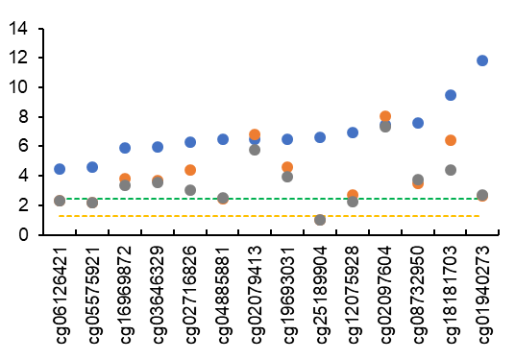

-log10(p-value)

B

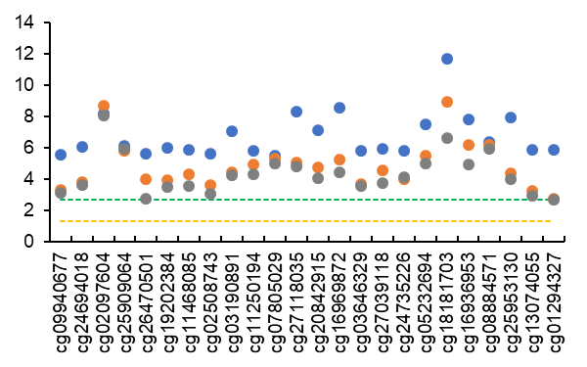

-log10(p-value)

D

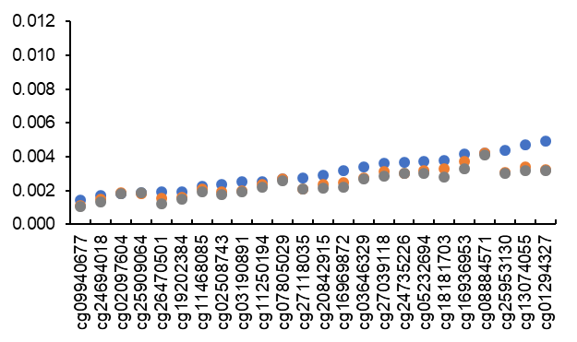

Absolute regression coefficients

C

Absolute regression coefficients

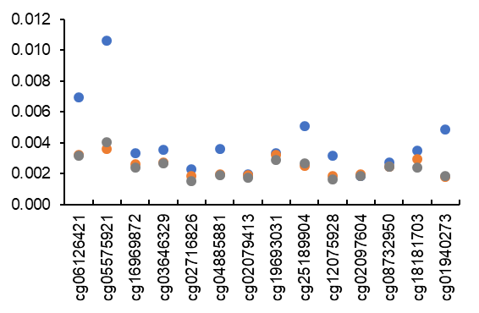

A

Additional adjustment for lifestyle factors

Additional adjustment for lifestyle factors and BMI

Sex, age, & energy intake-adjusted

**Figure 2**. Effect of additional adjustment for lifestyle factors (smoking and physical activity) and BMI in European ancestry participants. A and B are 14 CpGs identified using the Mediterranean-style diet score (MDS). C and D are 24 CpGs identified using the Alternative Healthy Eating Index (AHEI). CpGs highlighted in red-colored rectangle are those identified in the two-step analysis alone and CpGs highlighted in green-colored rectangle are those identified in both one-step and two-step analyses. Orange colored dash line represents -log10 of 0.05 and green colored dash line represents -log10 of Bonferroni corrected p-value threshold, i.e., 0.05/14 for MDS and 0.05/24 for AHEI. Four CpGs (cg05575921, cg06126421, cg12075928, and cg25189904) in MDS analysis became non-significant after Bonferroni correction in models with adjustment for lifestyle factors and BMI, whereas all 24 CpGs in AHEI analysis remained significant.

SNP Effect on TG

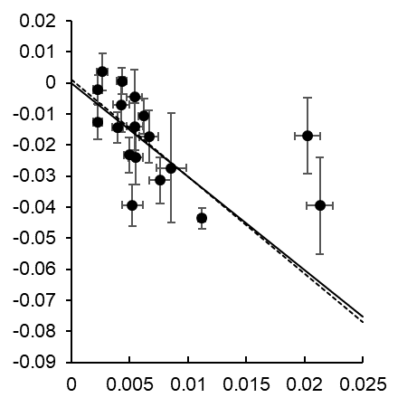

SNP effect on cg11250194

P MR-IVW: 1.5×10-14

P MR-Egger: 0.0009

P MR-Egger Intercept: 0.86

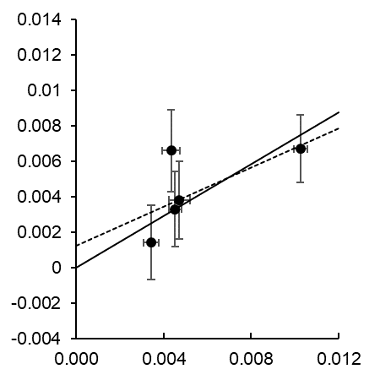

SNP Effect on BMI

SNP effect on cg02079413

P MR-IVW: 1.0×10-6

P MR-Egger: 0.22

P MR-Egger Intercept: 0.62

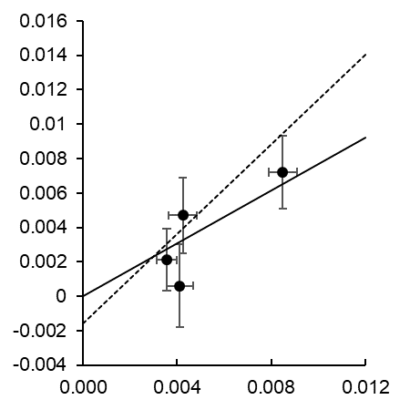

SNP Effect on BMI

SNP effect on cg26470501

P MR-IVW: 6.5×10-5

P MR-Egger: 0.19

P MR-Egger Intercept: 0.63

**Figure 3**. Mendelian Randomization (MR) analyses for associations between cg11250194 (FADS2) and triglycerides (TG), between cg02079413 (SNORA54; NAP1L4) and BMI, and between cg26470501 (BCL3) and BMI. IVW: inverse variance weighted. Symbols and bars represent effects size and standard errors of instruments variables (cis-meQTL variants) used in MR analysis. Solid line is for MR-IVW analysis and dashed line is for MR-Egger analysis. No horizontal pleiotropy effect was detected for all MR analyses.

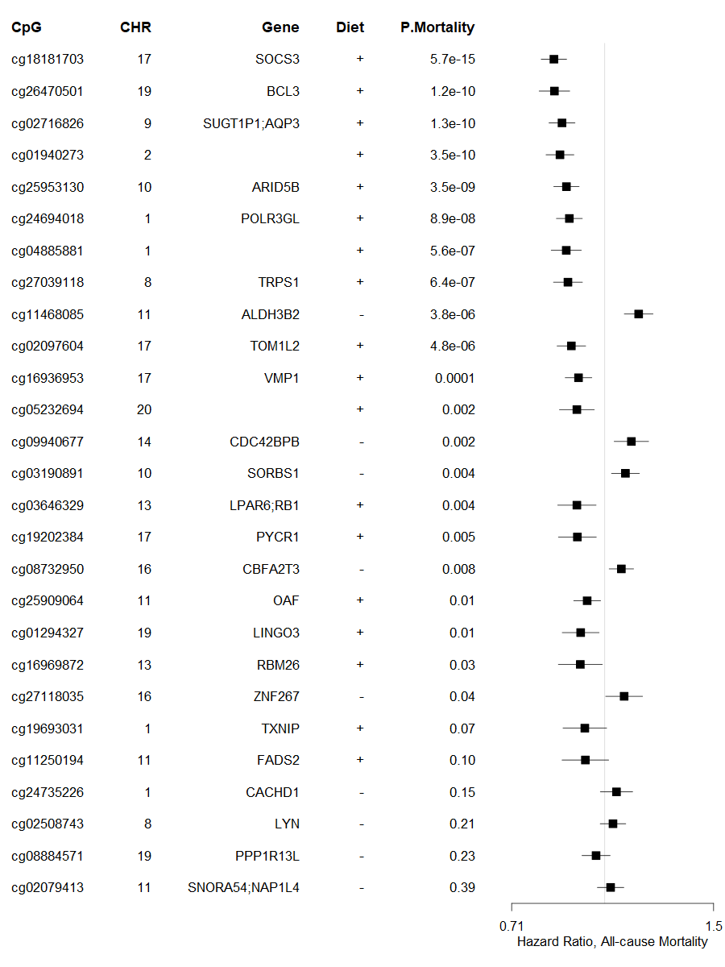

0.71 1.0 1.5

**Figure 4**. Meta-analysis of association between 30 diet-associated CpGs and all-cause mortality in 10 cohorts of European ancestry participants (n≈10,000). A positive sign for diet indicates that a higher dietary scores (MDS or AHEI, or both) were associated with DNA hypermethylation, whereas, a hazard ratio of over 1.0 indicates that DNA hypermethylation was associated with increased all-cause mortality. Models were adjusted for baseline covariates including sex, age, smoking status, physical activity level, alcohol intake, BMI, and prevalence disease status of hypertension, type 2 diabetes, cardiovascular disease, and cancer. Estimated leukocyte counts, technical variables, and kinship (for related study samples) were also considered. Hazard ratios and 95% confidence interval were estimated using Cox proportional hazard models and meta-analyzed using random effect models. X-axis is in logarithmic scale.