Supplement-R2

Supplementary Table S1

PCR Primers
Name | Sequence 5’ 3’* | Annealing temperature [ºC] | Product  size [bp]
Aey69-L1 | TACCAGAAGTCGACCGAGCTGC | 67 | 463
Aey69-R1 | TCACTGCGCTCGCAATTGC
Hist2h3c1-L1 | CTTGCCTTAGTTAACACCCTCA | 60 | 100
Hist2h3c1-R1 | TTCAAGATTCTCCTTCTAGATTGTTAC
H3-all-L1 | TAAATCCACTGTGATATCGACTTCAAGACCGACCTGCGCTT | 60 | 100
H3-all-R1 | ATTATGCTGAGTGATATCTCGTGTGTGGCTCTGAAAAGAGCCT
Hist1h3b-L1 | GCAGGACTTCAAGACCGACC | 60 | 195
Hist1h3b-R1 | GCACTTTGTTTCGTTTAAGCCC
Hist1h3c-L1 | ACTTTTGTGTATCTCCTCCCAAG | 60 | 150
Hist1h3c-R1 | GTAGCGGTGAGGCTTCTTCA
Hist1h3d -L1 | ACCGTTCTCATTCCCTGAGAC | 60 | 165
Hist1h3d-R1 | GTAGCGGTGAGGCTTCTTCA
Hist1h3f-L1 | CCGCTGTGGTATCGCCAA | 60 | 109
Hist1h3f-R1 | ACTATTGCTTCCTCAGCCAC
Hist2h3c2-R1 | CACATTATCCCGCTCCATAGCTCTAG | 60 | 118
Hist2h3c2-L1 | CAAGCTAGGAGTCTGAATAAGACCGC
Hist2h3b-L1 | GTATGGCCACTTGGCGTCTG | 60 | 166
Hist2h3b-R1 | GTAGCGGTGCGGCTTCTTC
Rplp0-L1 | ACTGGTCTAGGACCCGAGAAG | 60 | 77
Rplp0-R1 | TCAATGGTGCCTCTGGAGATT

Morpholino Oligomers
histMO | CGGTCTGCTTGGTTCTTGCCATAGC
mismMO | CGcTCTcCTTcGTTgTTcCCATAGC
Lower-case bases indicate the five mutated bases in the non-functional mismMO, to be compared with the correct sequence of the working histMO morpholino.

Supplementary Table S2

Antibodies
Antibody | Company (catalog number) | Dilution
AP-2α | Santa Cruz (sc-12726) | 1:100
BRN3 | Santa Cruz (sc-6026) | 1:100
Calbindin | Swant (CB38a) | 1:500
Cleaved Caspase-3 | Cell signalling (9661S) | 1:100
Crystallin, αA | Dr. Ales Cvekl, NY/USA  (Xie et al., 2016) | 1:500
Crystallin, γD | Santa Cruz (sc-22746) | 1:500
Cx50/GJA8 | Thermo Scientific (PA511644) | 1:500
FOXE3 | Santa Cruz (sc-134536) | 1:100
Glial Fibrillary Acidic Protein | Sigma (G9269) | 1:100
Ki67 | Abcam (ab15580) | 1:100
OTX2 | Abcam (ab114138) | 1:100
PITX3 | Santa Cruz (sc-19307) | 1:100
Protein Kinase Cα | Abcam (ab11723) | 1:200
TH | Pel Freez (P40101-150) | 1:1000
Alexa Fluor® 488 Rabbit | Invitrogen (A-21206) | 1:250
CY3 Goat | Jackson immuno (705-165-147) | 1:250
CY3 Mouse | Jackson immuno (715-165-150) | 1:250
Xie,Q., McGreal,R., Harris,R., Gao,C.Y., Liu,W., Reneker,L.W., Musil,L.S., Cvekl,A. (2016) Regulation of c-Maf and αA-crystallin in ocular lens by fibroblast growth factor signaling. J. Biol. Chem. 291, 3947-3958.

Supplementary Table S3

Relevant Significant Parameters of GMC investigation

Depicted are the number of animals, the mean and the standard deviation of the observations and the p-value of the statistical tests. The Fishers exact test deals with categorical data and the number of attributes and the p-values are listed.

Parameters analyzed by linear model with sex, genotype and body weight as predictors
test | parameter | f.muts | f.cons | m.muts | m.cons | sex | genotype | weight | sex.genotype | sex.weight | genotype. weight | sex.genotype_weight
Calorimetry | body_temp (°C) | 7 (38 ± 0.4 ) | 7 (37 ± 0.4 ) | 7 (37 ± 0.75 ) | 7 (37 ± 0.36 ) | 0.442 | 0.388 | 0.041 | 0.029 | 0.583 | 0.325 | 0.043

Parameters analyzed by linear model with sex and genotype as predictors

test | parameter | f.muts | f.cons | m.muts | m.cons | sex | genotype | sex.genotype
Clinical_ Chemistry | Albumin_ mean | 10 (28 ± 0.96 ) | 10 (29 ± 0.63 ) | 10 (28 ± 0.76 ) | 10 (27 ± 0.79 ) | <0.001 | 0.081 | 0.008
Clinical_ Chemistry | Cl_mean | 10 (111 ± 0.68 ) | 10 (109 ± 0.5 ) | 10 (108 ± 1.1 ) | 10 (108 ± 0.95 ) | <0.001 | 0.001 | 0.001
Clinical_ Chemistry | GOT_mean | 10 (53 ± 19 ) | 10 (44 ± 3.2 ) | 10 (71 ± 21 ) | 10 (47 ± 6.1 ) | 0.041 | 0.001 | 0.116
Clinical_ Chemistry | LDH_mean | 10 (200 ± 57 ) | 10 (158 ± 20 ) | 10 (368 ± 114 ) | 10 (253 ± 27 ) | <0.001 | 0.001 | 0.09
SHIRPA | locomotor_ activity | 10 (15 ± 7.4 ) | 10 (12 ± 7.9 ) | 10 (21 ± 11 ) | 10 (12 ± 8.6 ) | 0.377 | 0.049 | 0.232
OPEN_FIELD | DisTTot | 10 (15033 ± 2321 ) | 10 (9978 ± 2689 ) | 10 (14056 ± 2451 ) | 10 (8889 ± 1725 ) | 0.169 | <0.001 | 0.94
OPEN_FIELD | NRTot | 10 (78 ± 24 ) | 10 (52 ± 37 ) | 10 (71 ± 34 ) | 10 (27 ± 20 ) | 0.112 | 0.001 | 0.343
OPEN_FIELD | PcTiCenTot | 10 (11 ± 6.3 ) | 10 (2.4 ± 2.1 ) | 10 (10 ± 10 ) | 10 (3.4 ± 3.5 ) | 0.849 | 0.001 | 0.776

Parameters analyzed by Wilcoxon test

tests |  | parameter |  | Number.f.muts |  |  | Number.f.cons |  | Number.m.muts |  | Number.m.cons |  | p.female |  | p.male |  | p.overall
IMMUNOGLOBULIN |  | IgA |  | 8 (340 ± 132 ) |  |  | 9 (612 ± 369 ) |  | 10 (236 ± 83 ) |  | 10 (239 ± 162 ) |  | 0.036 |  | 0.315 |  | 0.62
FACS_BLOOD |  | CD8+ T cells (% of all living leukocytes) |  | 9 (12 ± 1.9 ) |  |  | 8 (10 ± 1.8 ) |  | 10 (12 ± 1.7 ) |  | 10 (11 ± 1.7 ) |  | 0.044 |  | 0.447 |  | 0.074
FACS_BLOOD |  | Granulocytes (% of all living leukocytes) |  | 9 (20 ± 4.1 ) |  |  | 8 (24 ± 3.9 ) |  | 10 (18 ± 5.8 ) |  | 10 (24 ± 7.1 ) |  | 0.059 |  | 0.105 |  | 0.008
FACS_BLOOD |  | Monocytes (% of all living leukocytes) |  | 9 (1.8 ± 0.54 ) |  |  | 8 (1.2 ± 0.24 ) |  | 10 (2.2 ± 0.55 ) |  | 10 (2 ± 0.48 ) |  | 0.007 |  | 0.353 |  | 0.074
FACS_BLOOD |  | CD11+ NK cells (% of NK cells) |  | 9 (64 ± 6.2 ) |  |  | 8 (58 ± 3.5 ) |  | 10 (63 ± 13 ) |  | 10 (59 ± 6 ) |  | 0.034 |  | 0.436 |  | 0.038
FASTED_BLOOD |  | Glycerol_fasting |  | 10 (0.35 ± 0.074 ) |  |  | 10 (0.38 ± 0.052 ) |  | 10 (0.25 ± 0.042 ) |  | 10 (0.31 ± 0.045 ) |  | 0.353 |  | 0.019 |  | 0.034
FASTED_BLOOD |  | HDL_fasting |  | 10 (2.3 ± 0.2 ) |  |  | 10 (2.7 ± 0.23 ) |  | 10 (3.5 ± 0.18 ) |  | 10 (3.4 ± 0.21 ) |  | 0.002 |  | 0.238 |  | 0.525
FASTED_BLOOD |  | Non_HDL_chol_fasting |  | 10 (0.52 ± 0.11 ) |  |  | 10 (0.64 ± 0.11 ) |  | 10 (0.76 ± 0.084 ) |  | 10 (0.75 ± 0.071 ) |  | 0.041 |  | 1 |  | 0.227
FASTED_BLOOD |  | TG_fasting |  | 10 (1.3 ± 0.69 ) |  |  | 10 (2.3 ± 0.32 ) |  | 10 (1.7 ± 0.49 ) |  | 10 (1.9 ± 0.45 ) |  | 0.002 |  | 0.399 |  | 0.001
FASTED_BLOOD |  | Total_chol_fasting |  | 10 (2.9 ± 0.29 ) |  |  | 10 (3.3 ± 0.24 ) |  | 10 (4.3 ± 0.22 ) |  | 10 (4.2 ± 0.24 ) |  | 0.002 |  | 0.229 |  | 0.541
IPGTT_201311 |  | Glucose_conc_0 |  | 10 (4.5 ± 0.58 ) |  |  | 10 (3.9 ± 0.43 ) |  | 8 (5.8 ± 0.42 ) |  | 9 (5.1 ± 0.68 ) |  | 0.012 |  | 0.069 |  | 0.046
STEROID |  | DHEA |  | 10 (46 ± 20 ) |  |  | 9 (80 ± 56 ) |  | 10 (215 ± 88 ) |  | 10 (125 ± 63 ) |  | 0.133 |  | 0.023 |  | 0.667
DEXA |  | bw_pDEXA |  | 10 (27 ± 3.1 ) |  |  | 10 (30 ± 3.2 ) |  | 10 (34 ± 2.1 ) |  | 10 (33 ± 4.1 ) |  | <0.001 |  | 0.201 |  | 0.083
DEXA |  | FAT_MASS |  | 10 (3.7 ± 2 ) |  |  | 10 (7.9 ± 1.6 ) |  | 10 (9.7 ± 4 ) |  | 10 (9.6 ± 5.5 ) |  | 0.002 |  | 0.087 |  | 0.075
Fisher's Exact test

test/ parameter | Male |  |  |  | Female |  |  | Both
SHIRPA | Control |  | Mutant |  | Control | Mutant |  | Control |  | Mutant |  | Control |  | Mutant |  | p value
 | n=10 |  | n=10 |  | n=10 | n=10 |  | n=20 |  | n=20 |  | 50% |  | 50%
Palpebral Closure |  |  |  |  |  |  |  |  |  |  |  |  |  |  |  | <0.001
Eyes open | 10 |  | 0 |  | 10 | 2 |  | 20 |  | 2 |  | 100% |  | 10%
Eyes closed | 0 |  | 10 |  | 0 | 8 |  | 0 |  | 18 |  | 0% |  | 90%
Tail Elevation |  |  |  |  |  |  |  |  |  |  |  |  |  |  |  | <0.001
Dragging | 9 |  | 2 |  | 8 | 3 |  | 17 |  | 5 |  | 85% |  | 25%
Horizontally extension | 1 |  | 8 |  | 2 | 7 |  | 3 |  | 15 |  | 15% |  | 75%
Elevated/Straub tail | 0 |  | 0 |  | 0 | 0 |  | 0 |  | 0 |  | 0% |  | 0%

Abbreviations:
Bw | Bodyweight
Cl | Chloride
DHEA | Dehydroepiandrosteron
DisT | Distance traveled
GOT | Glutamate oxaloacetate transaminase
HP | Heat production
HDL | High-density lipoprotein
Ig | Immunoglobulin
IpGTT | Intraperitoneal Glucose Tolerance Test
LDH | Lactate-dehydrogenase
MV | Minute ventilation
NEFA | Non-esterified fatty acid
NR | Number of rears
PcTiCen | Percentage time in centre
pDEXA | peripheral dual-energy x-ray absorptiometry
PEF | Peak expiratory flow rate
RER | Respiratory exchange ratio
SHIRPA | SmithKline Beecham, Harwell, Imperial College, Royal London Hospital, phenotype assessment
TG | Trigyceride
TV | Tidal volume
VO2 | Oxygen consumption

Supplementary Table S4

Summary of hist2h3ca1 knock-down experiments in zebrafish transgenic lines
The table includes raw data on mortality and phenotype after hist2h3ca1-specific antisense morpholino (MO) injection in zebrafish transgenic lines.
mMO = control mismatched MO; hMO = anti-hist2h3ca1 MO; n.e.=not evaluable.
Transgenic line | Condition | # embryos | Mortality  at 48 hpf | Morphology of survivors | Retinal organization
pax6b:GFP | mMO 100 μM | 50 | 15% | 90% normal  10% apoptotic eyes and brain, short trunk | 90% normal  10% n.e.
 | hMO 100 μM | 50 | 100% | Lethality during gastrulation | n.e.
ptf1a:EGFP | Not injected | 170 | 11% | 100% normal | 100% normal
 | mMO 50 μM | 155 | 14% | 100% normal | 100% normal
 | hMO 50 μM | 230 | 98% | Lethality during gastrulation | n.e.
Notch:mCherry | Not injected | 60 | 0% | 100% normal | 100% normal
 | mMO 10 μM | 39 | 3.5% | 100% normal | 100% normal
 | hMO 10 μM | 44 | 62% | Delayed, malformed | Delayed but layered
ptf1a:EGFP | Not injected | 48 | 24% | 100% normal | 100% normal
 | mMO 10 μM | 160 | 39% | 100% normal | 100% normal
 | hMO 10 μM | 203 | 49% | Delayed, malformed | Delayed but layered
pax6b:GFP / ptf1a:DsRed | Not injected | 7 | 0% | 100% normal | 100% normal
 | mMO 10 μM | 45 | 2.5% | 100% normal | 100% normal
 | hMO 10 μM | 59 | 75% | Delayed, malformed | Delayed but layered
neurod1:GFP / ptf1a:DsRed | Not injected | 50 | 20% | 100% normal | 100% normal
 | mMO 10 μM | 110 | 35% | 100% normal | 100% normal
 | hMO 10 μM | 150 | 78% | Delayed, malformed | Delayed but layered

Supplementary Table S5
Rescue experiments in zebrafish
The table includes raw data on mortality and phenotype of zebrafish embryos injected with control, morpholino, mRNA and rescuing solutions. Data derive from three independent experiments and correspond to the chart of Supplementary Fig. S1.

Condition | # embryos | Mortality  at 48 hpf | Phenotype of survivors  at 48 hpf
Not injected | 135 | 0 % | Normal
mismMO 10 μM +  C3H mRNA 25 ng/µl | 136 | 3 % | Normal
AEY69 mRNA  25 ng/µl | 60 | 23 % | Delayed and/or  malformed (cyclopia)
histMO 10 μM | 146 | 50 % | Blocked at somitogenesis
histMO 10 μM +  AEY69 mRNA 25 ng/µl | 129 | 57 % | Blocked at somitogenesis, malformed
histMO 10 μM +  C3H mRNA 25 ng/µl | 95 | 8 % | 84% normal,  16% delayed
histMO 10 μM +  C3H mRNA 50 ng/µl | 77 | 24 % | 75% normal,  25% delayed

Supplementary figures:
Fig. S1
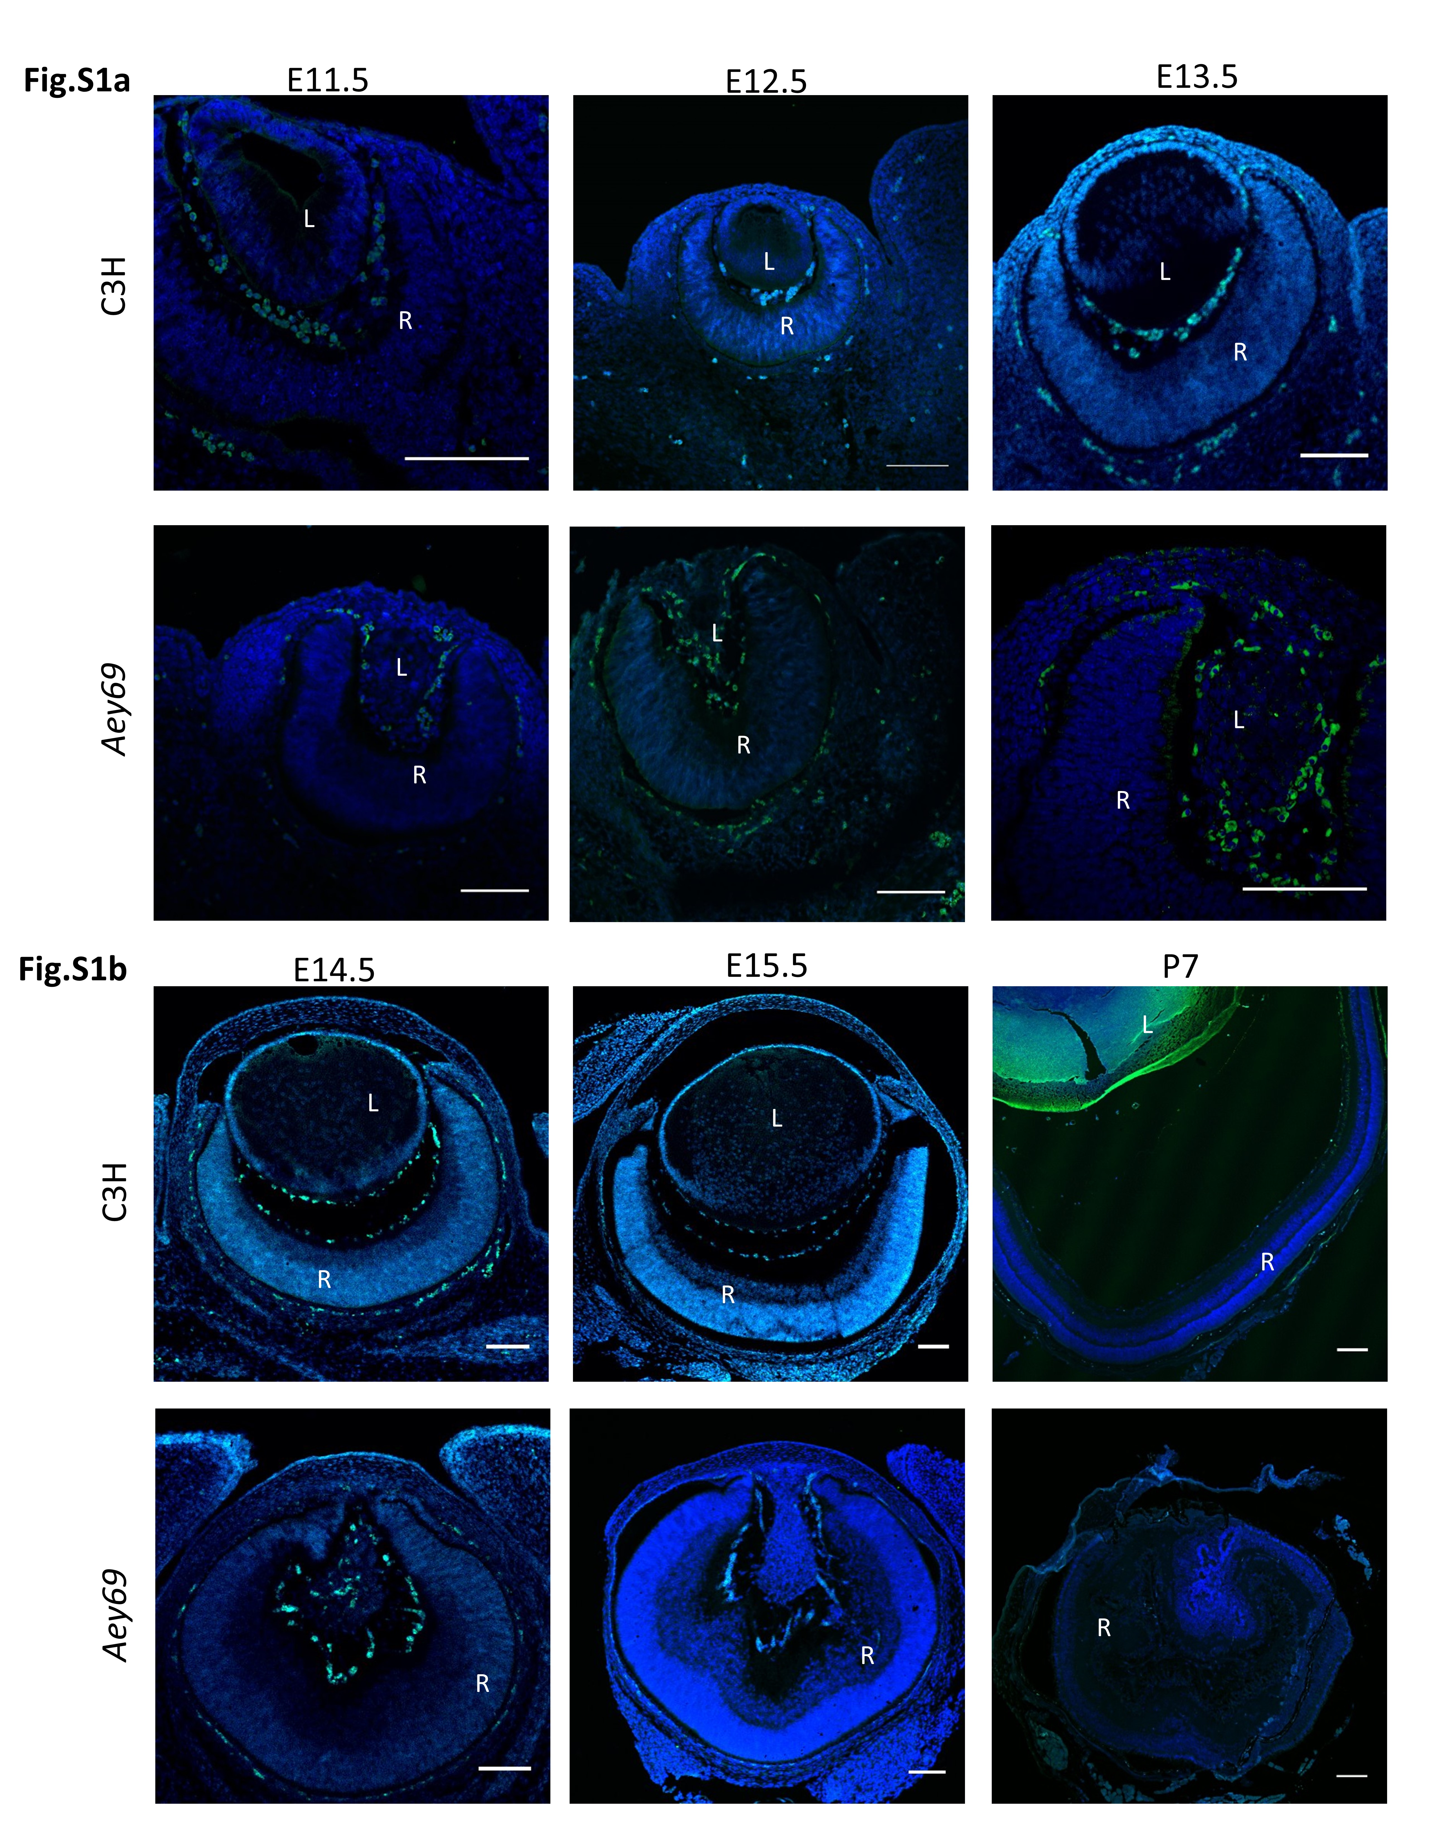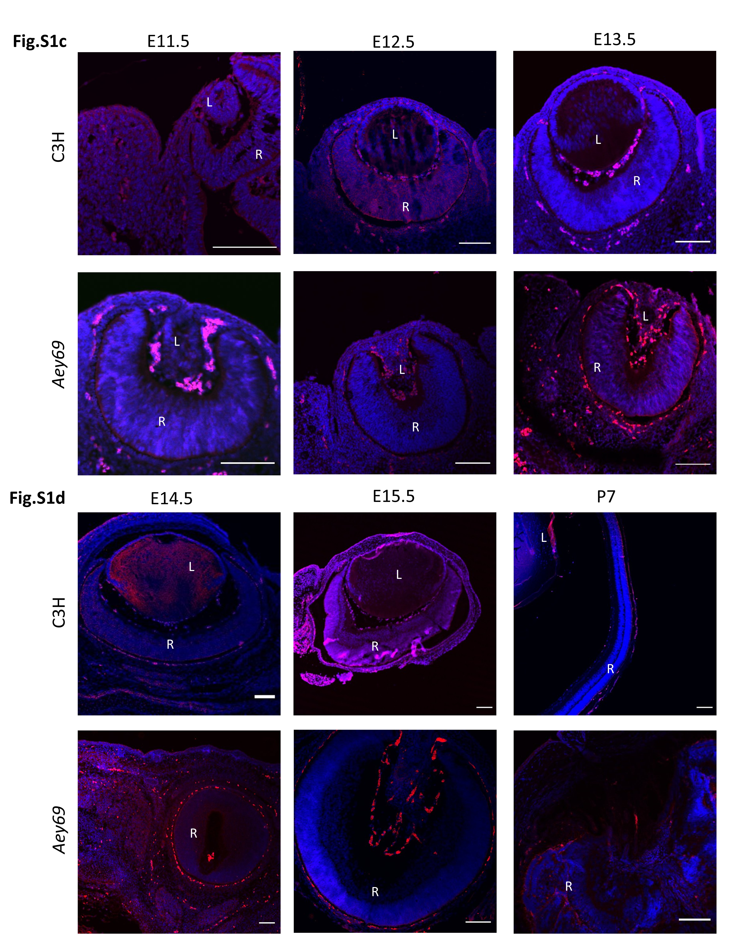
Fig. S1: Representative negative controls.

The negative controls represent the staining without the addition of any primary antibody. This could help in identification of any possible autofluorescent area (e.g. RPE, disrupted mesodermal cells and blood vessels). Any conclusion from the antibody staining was made in comparison to the respective negative control (a: E11.5-E13.5; b: E14.5-P7); no analysis was done in regions showing autofluorescence. DAPI (blue) was used for counterstaining. The bars indicate 100 µm. L, lens; R, retina. Fig. S1a and b represent the autofluorescent areas stained by the secondary A488 antibody, and Fig. S1c and d represent the autofluorescent areas stained by the Cy3 antibody.

Fig. S2
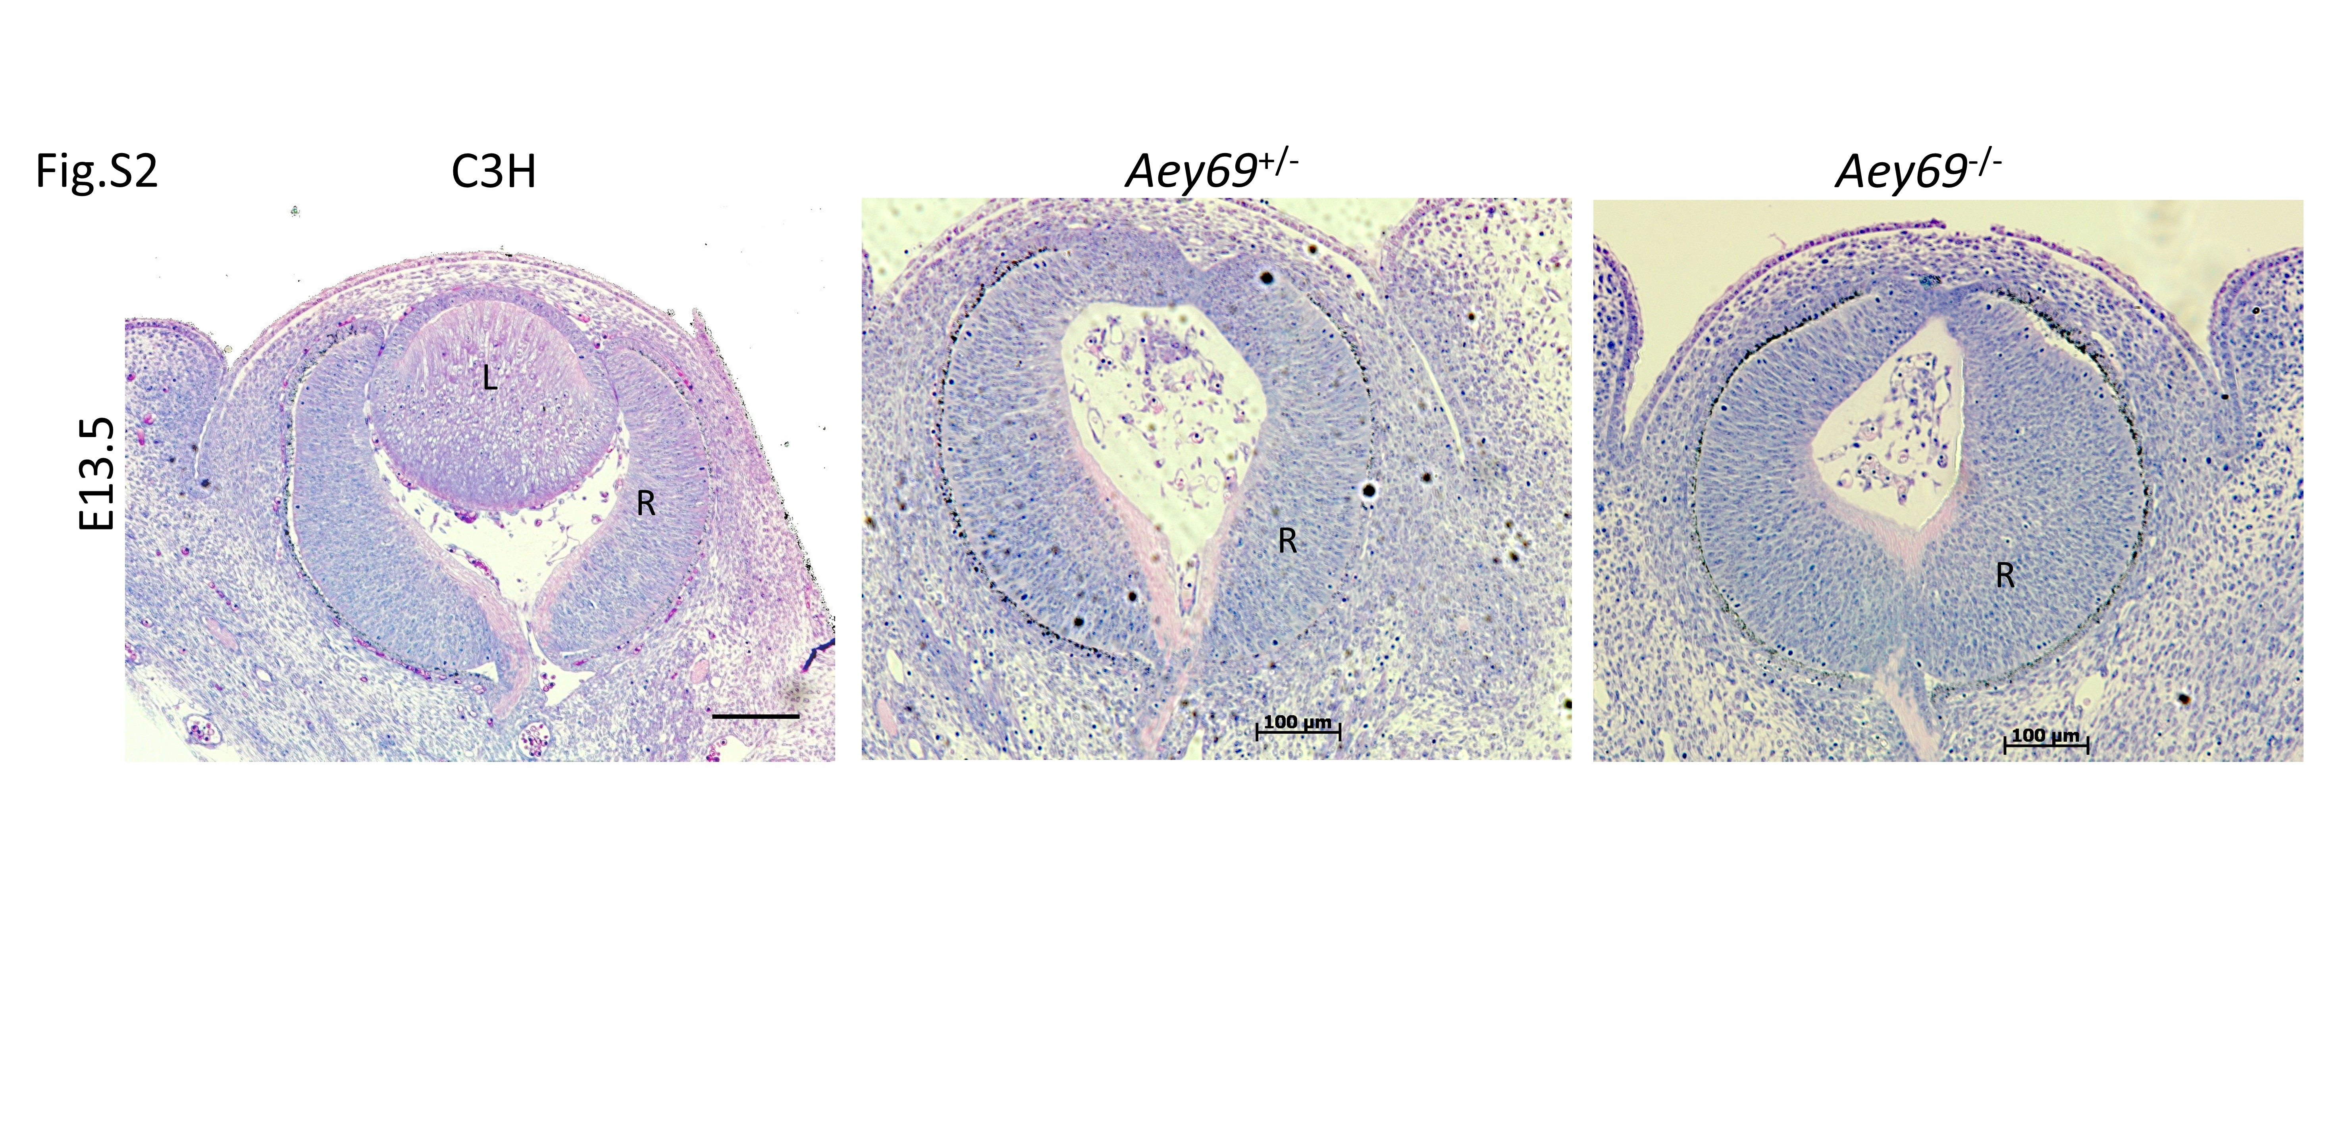

Fig.S2: Histological characterization of ocular defects in wild type, heterozygous and homozygous mutant eye

The comparative histological staining between the wild type, heterozygous and homozygous mutant eye at E13.5 is shown. No lens is present neither in heterozygous nor in homozygous mutant eyes. Bars indicate 100 µm; L, lens; R, retina; ON, optic nerve.

Fig. S3
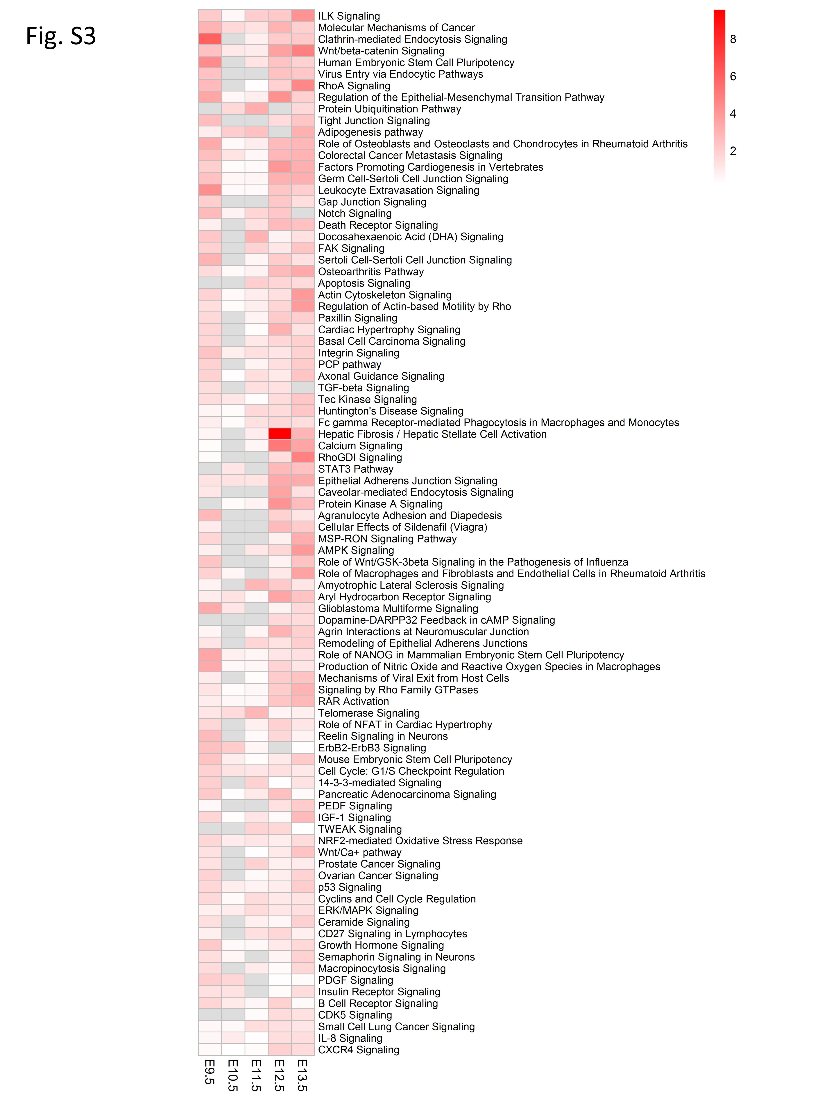
Fig. S3. Heatmap represents enrichment p-values from the Ingenuity Pathway Analysis software for canonical pathways. Grey boxes indicate instances were no p-value was calculated. Pathways shown are ordered by the number of embryonic stages were they are significantly enriched (at least two stages) and by the average of -log(p-value).

Fig. S4

Fig. S4: Delayed but still layered retina upon knock-down of zebrafish hist2h3ca1
a-c: After MO-mediated knockdown of zebrafish hist2h3ca1 in a double Ptf1a/NeuroD transgenic line, zebrafish morphant embryos (hMO) display a strongly delayed but still layered retina (c,d), compared to controls (mMO) (a,b). neurod1-positive cells are specifically detectable in the inner retina (c), occupying the areas of the prospective ganglion cell (GCL) and inner plexiform (IPL) layer, while ptf1a-positive cells are arranged in both inner and outer retina (d), in the prospective IPL and outer plexiform layer (OPL). All panels display lateral views of zebrafish eyes at 72 hpf (hours post-fertilization), with anterior to the left. Displayed phenotypes are representative of n=50 embryos per condition. The scale bar (in a) is 50 µm and applies to all images.

Fig. S5
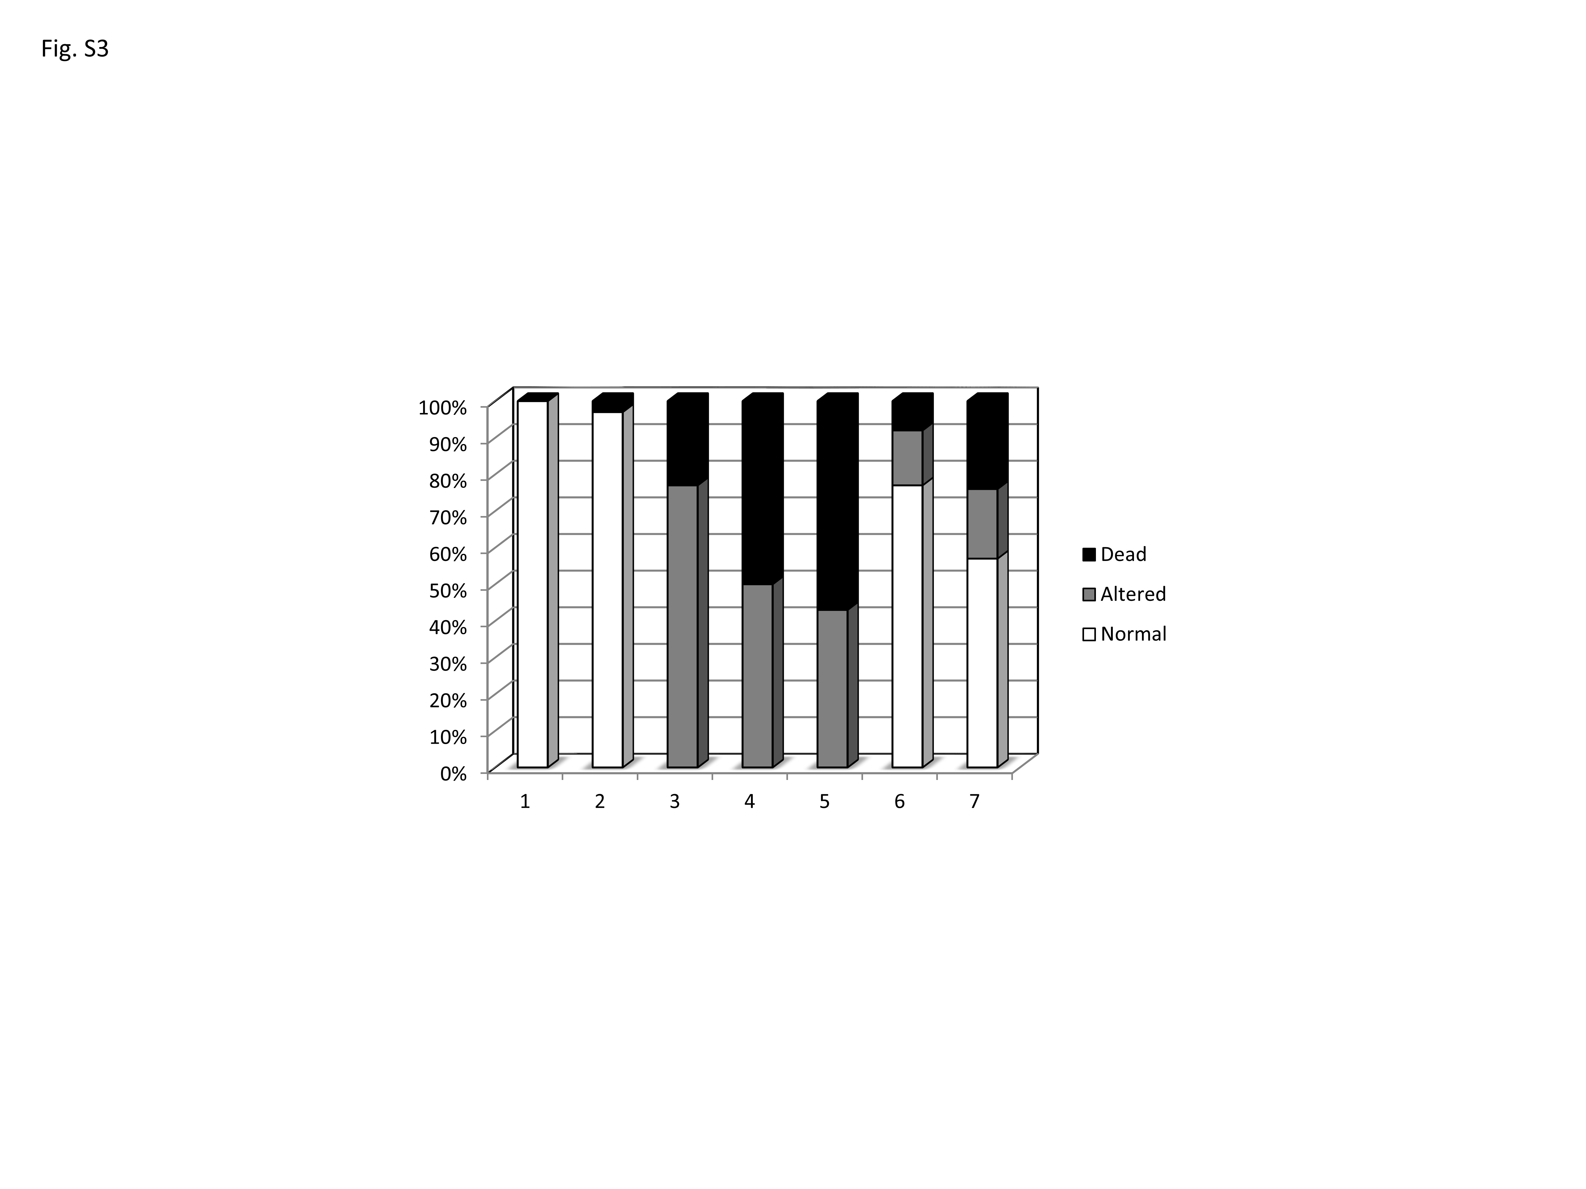

Fig. S5: Rescue experiments in zebrafish embryos
The chart summarizes the results from rescue experiments using control (mismMO) or anti-hist2h3ca1 (histMO) morpholino oligos, injected either alone or in combination with normal (C3H) or mutated (AEY69) mouse mRNAs. Injected controls (2) do not significantly differ from not injected embryos (1). The morphant (histMO) rescue is obtained using normal C3H mRNA (6, 7), while the mutated mRNA is exacerbating the phenotype (5) compared to AEY69 or histMO alone (3, 4). The rescue is more efficient with C3H mRNA at 25 ng/μl (6) than at 50 ng/μl (7). Altered phenotypes include delayed development, malformation and cyclopia. Phenotypes are evaluated at 2 dpf. Conditions: 1) Not injected; 2) mismMO 10 μM + C3H mRNA 25 ng/μl (injected controls); 3) AEY69 mRNA 25 ng/μl (over-expressed); 4) histMO 10 μM (morphants); 5) histMO 10 μM + AEY69 mRNA 25 ng/μl (no rescue); 6) histMO 10 μM + C3H mRNA 25 ng/μl (>70% rescue); 7) histMO 10 μM + C3H mRNA 50 ng/μl (>50% rescue). Sample size: n=778 (raw data available in Suppl. Tab. S1

Analysis of TH-positive cells in the brain of the Aey69 mice.
Mice were perfused with phosphate buffered saline (PBS), followed by 4% paraformaldehyde (PFA) in PBS and incubated at 4°C overnight. The brains were transferred into 25% sucrose in PBS for cyroprotection and horizontally cut with a cryostat at 40 µm. Slides were washed in PBS over-night and incubated in 0.1% H₂O₂ in PBS to reduce background signal by endogenous peroxidases. 2% FCS in PBS containing 0.1% Triton was used for blocking. For staining, an anti-TH antibody from Pel-Freez (1:1000) was used visualized by a DAB peroxidise-based detection system. Dopaminergic and noradrenergic neurons were quantified by unbiased stereology using the optical fractionator method and analyzed with the Stereoinvestigator software (MicroBrightField Inc., USA). The innervation into the striatum was analyzed using the ImageJ program (Schneider et al., 2012).

Reference:
Schneider, C.A., Rasband, W.S., Eliceiri, K.W., 2012. NIH Image to ImageJ: 25 years of image analysis. Nature Methods 9, 671-675.
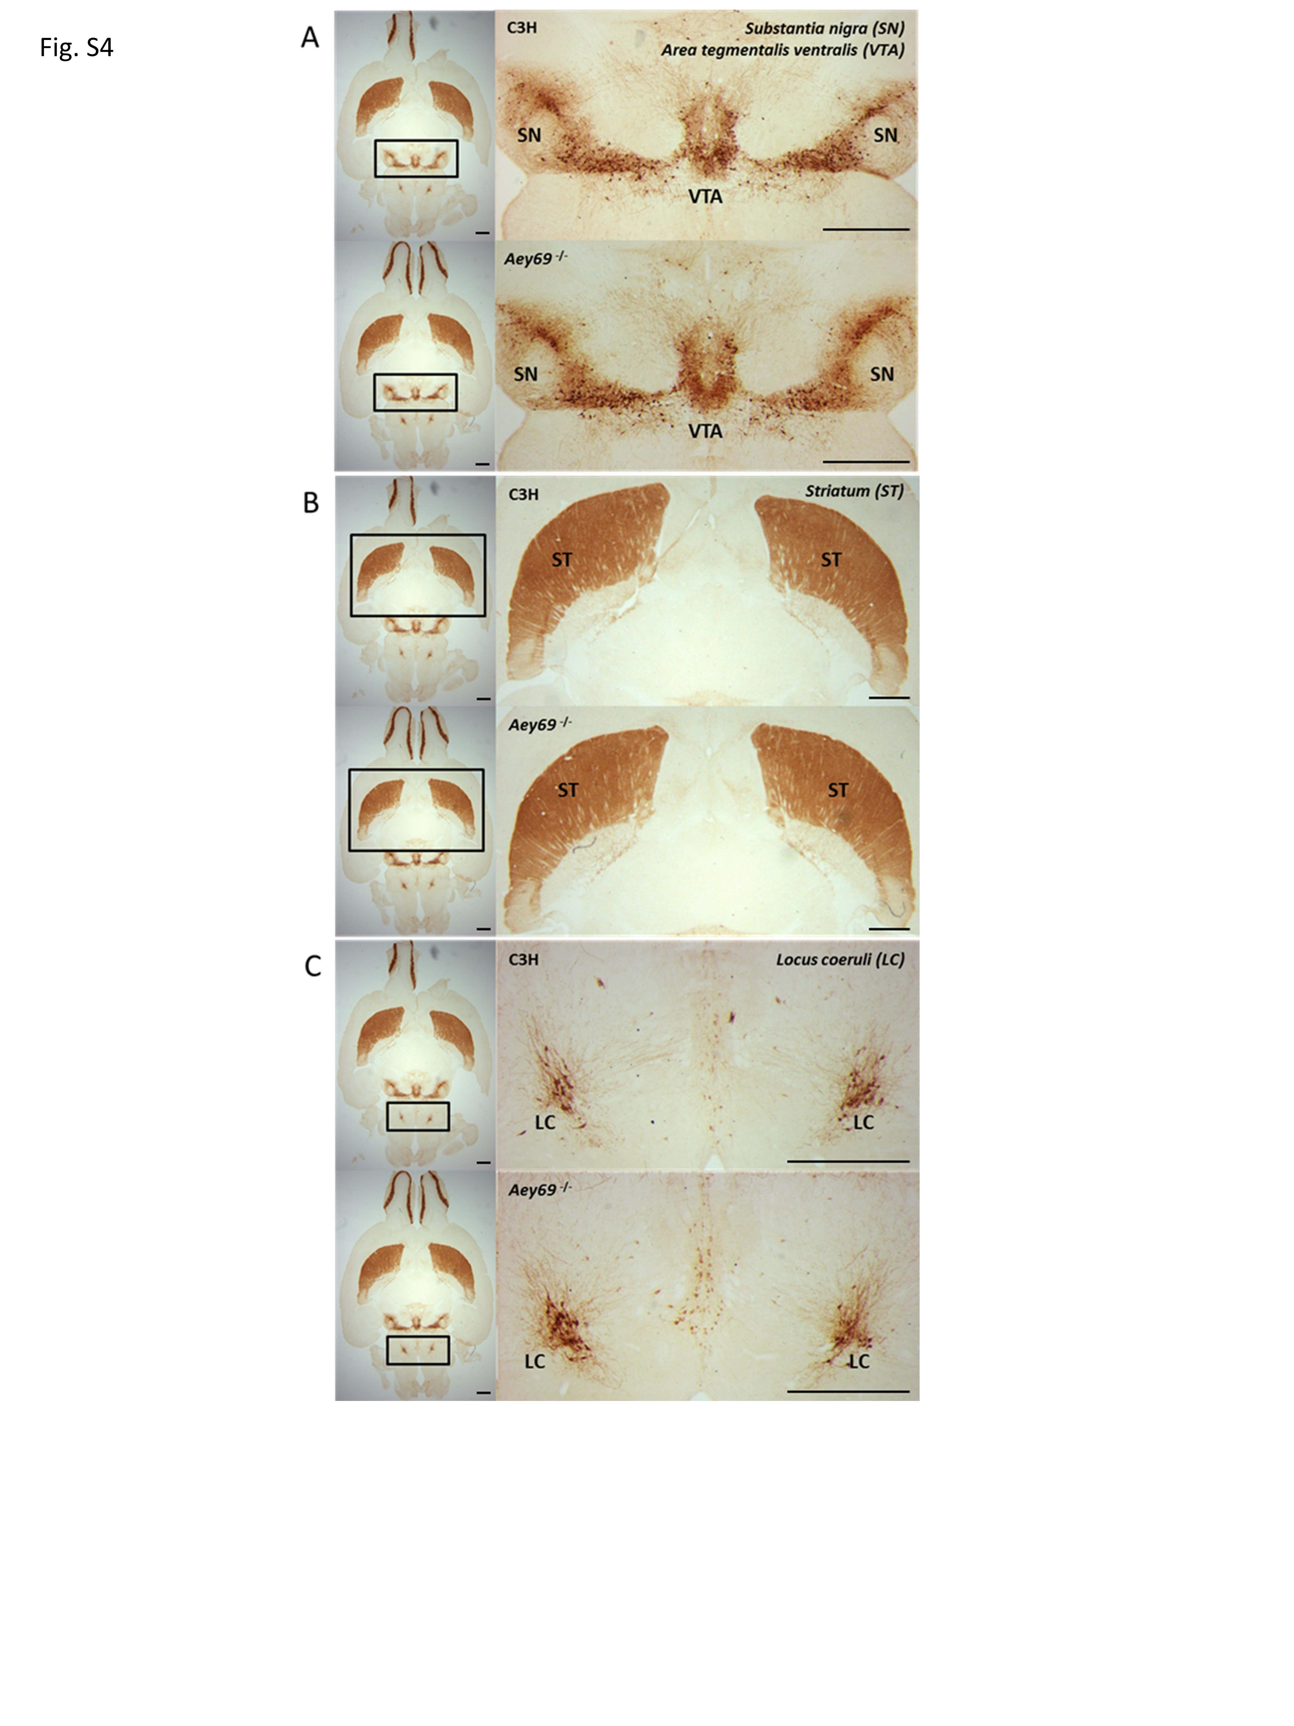
Fig. S6: The Aey96 mutation does not affect tyrosine hydroxylase (TH) expression in the adult mouse brain.
The DAB staining represents immunohistological label of tyrosine hydroxylase (TH) positive cells in the brain of the wild-type and the mutant mouse at the age of 9-10 weeks. (a) Stereological counting did not show significant differences in the number of TH-positive cells in the substantia nigra (SN) (wild type 10960±766 counts, mutant 10248±1170 counts) and the area tegmentalis ventralis (VTA) (wild type 15968±1455 counts, mutant 15257±616 counts). (b) The intensity of the innervation of the dopaminergic neurons from the SN into the striatum (ST) did no differ between the groups. (c) TH-labeled noradrenergic neurons showed no quantitative difference in the mutant brains compared to the wild-type brains (wild type 3738±334 counts, mutant 3720±472 counts; n=6); scale bar = 1 mm.

