HDAC inhibition protects degenerating cone photoreceptors in vivo in the cpfl1 mouse
Dragana Trifunović, Blanca Arango-Gonzalez, Antonella Comitato, Melanie Barth, Eva M. del Amo, Manoj Kulkarni, Ayse Sahaboglu, Stefanie M. Hauck, Arto Urtti, Yvan Arsenijevic, Marius Ueffing, Valeria Marigo, François Paquet-Durand
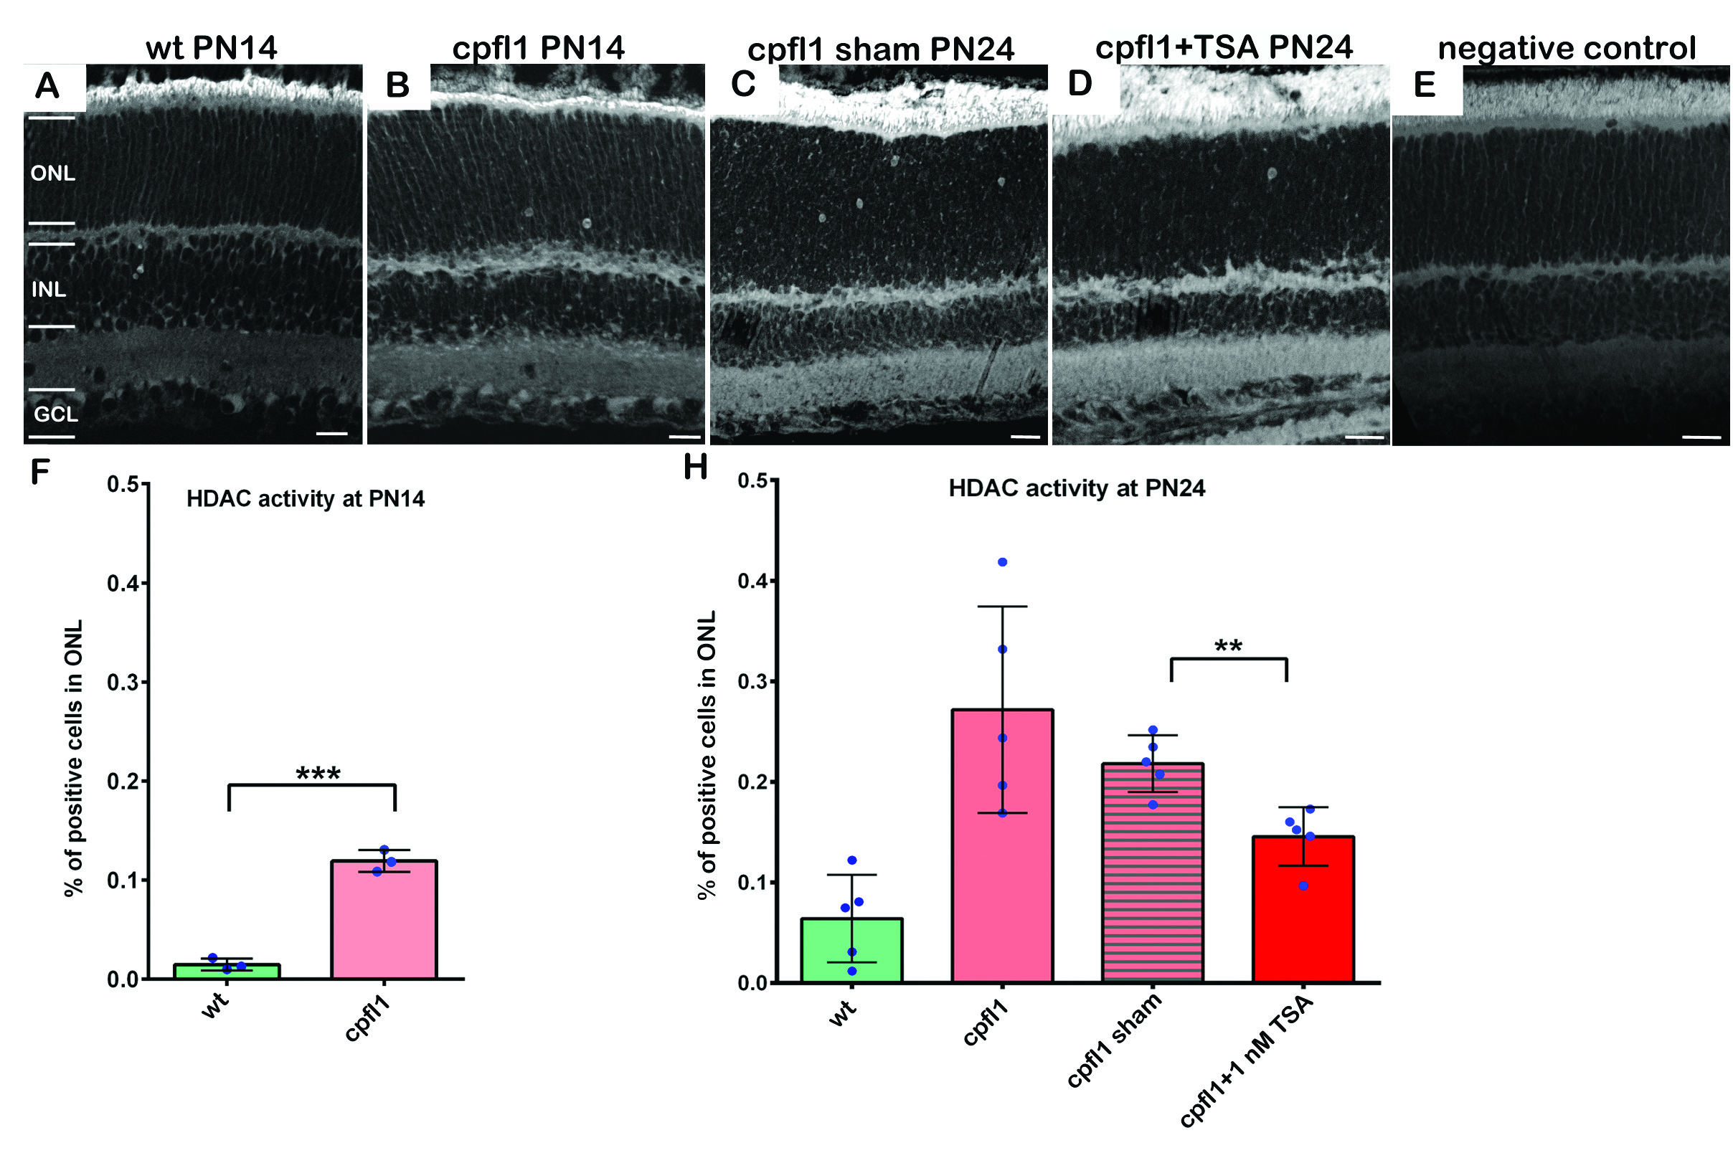
Figure S1. HDAC activity was assessed in vivo in wild-type (wt) and cpfl1 photoreceptors at PN14 by an in situ activity assay (a, b). The percentage of photoreceptors positive for HDAC activity in the wt ONL was negligible, (0.021%), and in cpfl1 retina the number of HDAC positive cells was significantly increased to 0.12% (f). High numbers of HDAC positive cells were also present in sham treated retinas (c), similar to previously published data for cpfl1 retina (1). TSA treatment in vivo led to a significant decrease in HDAC positive cells 10 days post-treatment (d, g). The specificity of the HDAC in situ activity assay was confirmed by omitting the assay substrate (e). ONL-outer nuclear layer, INL-inner nuclear layer, GCL-ganglion cell layer. Scale bars are 20 µm.
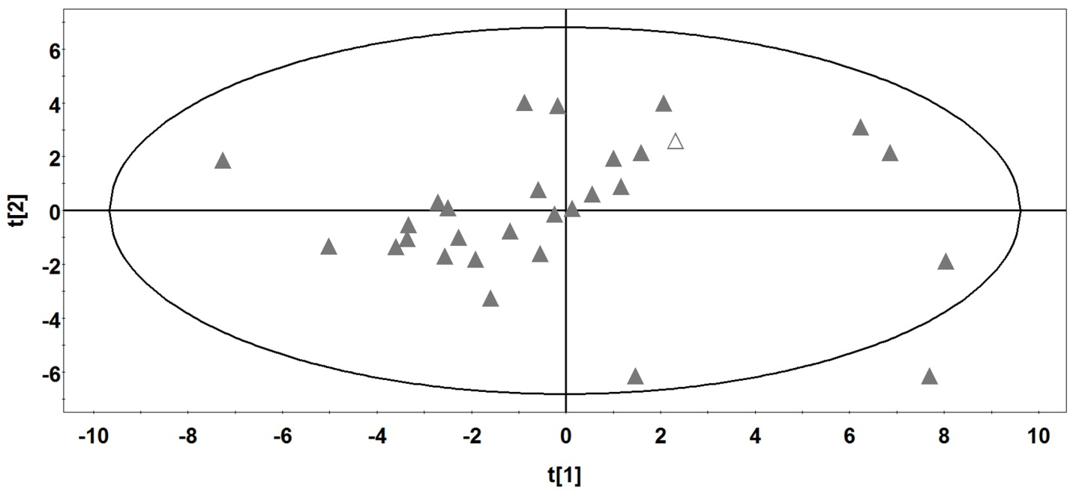
Figure S2. The PCA score plot of the training set of the intravitreal clearance model (2). The full triangles represent the position in the chemical space of the compounds that trained the model, while the ellipse indicates the model applicability domain. The open triangle represents Trichostatin A, a position that falls inside the ellipse and therefore inside the range of the model.

Note 1
Small lipophilic compounds are eliminated from the vitreous primarily through retinal pigment epithelium (RPE) (3). The intravitreal clearance (CL) of small lipophilic compounds in mice is expected to be 30 times smaller than in the rabbit. This is based on the equation CL = P x S, where P is the drug permeability in the RPE and S is the surface area of the RPE. The surface areas of the RPE in mice and rabbit are 16.5 mm (2, 4) and 520 mm (2, 5), respectively. Assuming similar permeability in the RPE of mouse and rabbit, the intravitreal clearance in mouse would be 0.015 ml/h (rabbit value: 0.478 ml/h). The expected half-life in the vitreous can be calculated using the equation: t_{1/2} = ln2 V_{d} / CL (V_{d} = volume of distribution close to the anatomical volume of the vitreous; in mouse 5 µl). The expected half-life in the mouse is 17.4 minutes, so one order magnitude shorter than the half-life in the rabbit eye (1.7-3.3 hours; CL= 0.478 ml/h and V_{d} of 1.18-2.18 ml (2) range that covers 80% of the rabbit compound data set)..

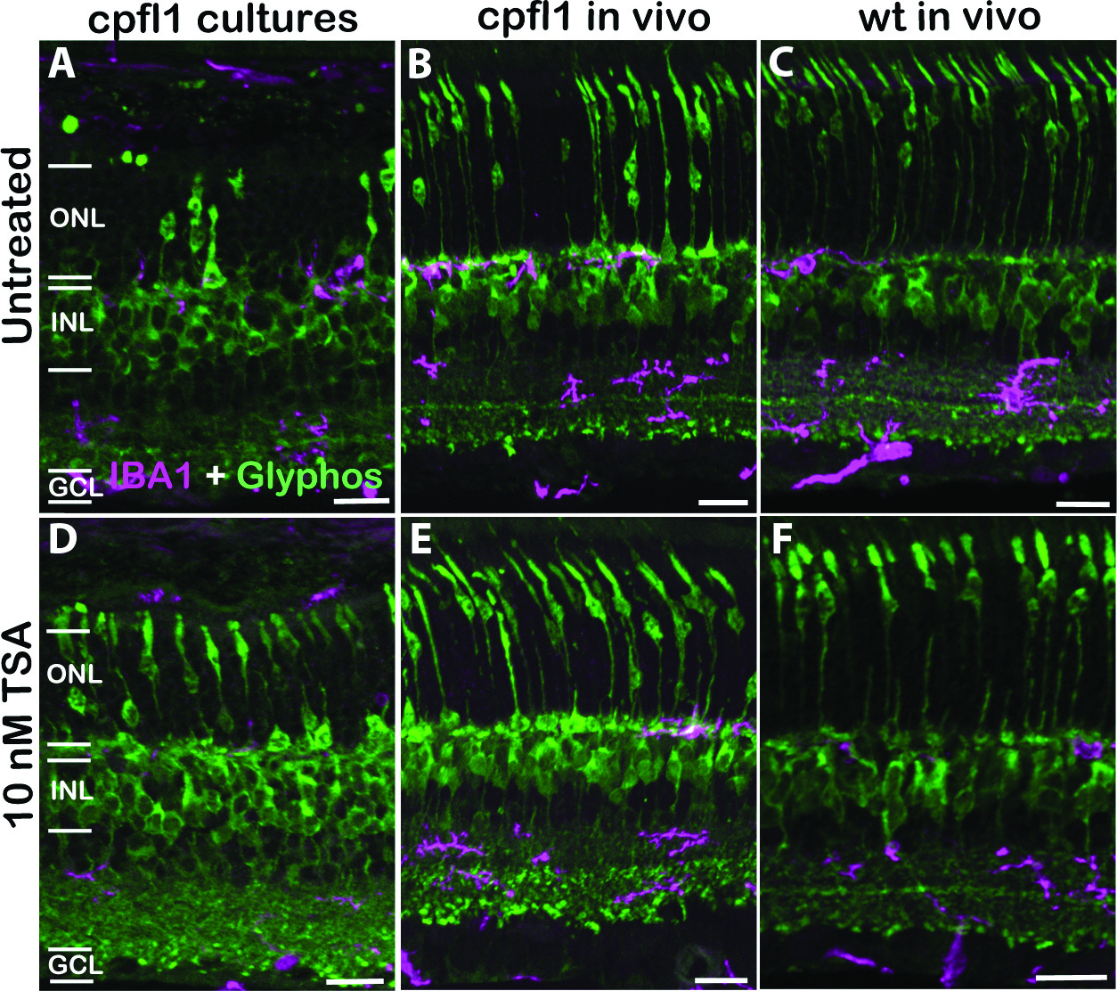
Figure S3. To assess if HDAC inhibition had an effect on activated microglia, we performed co-labeling of IBA1 (magenta) and Glyphos (green). Although some activated microglia were present in INL and GCL, no sign of microglial invasion into the ONL was visible, neither in cpfl1 retinas after in vitro (a, d), and in vivo treatments (b, e), nor in wt retina (c, f). Importantly, no change in microglia activity was observed after TSA treatment (a-c vs. d-f), suggesting that cone survival was not related to changes in microglia. ONL-outer nuclear layer, INL-inner nuclear layer, GCL-ganglion cell layer. Scale bars are 20 µm.

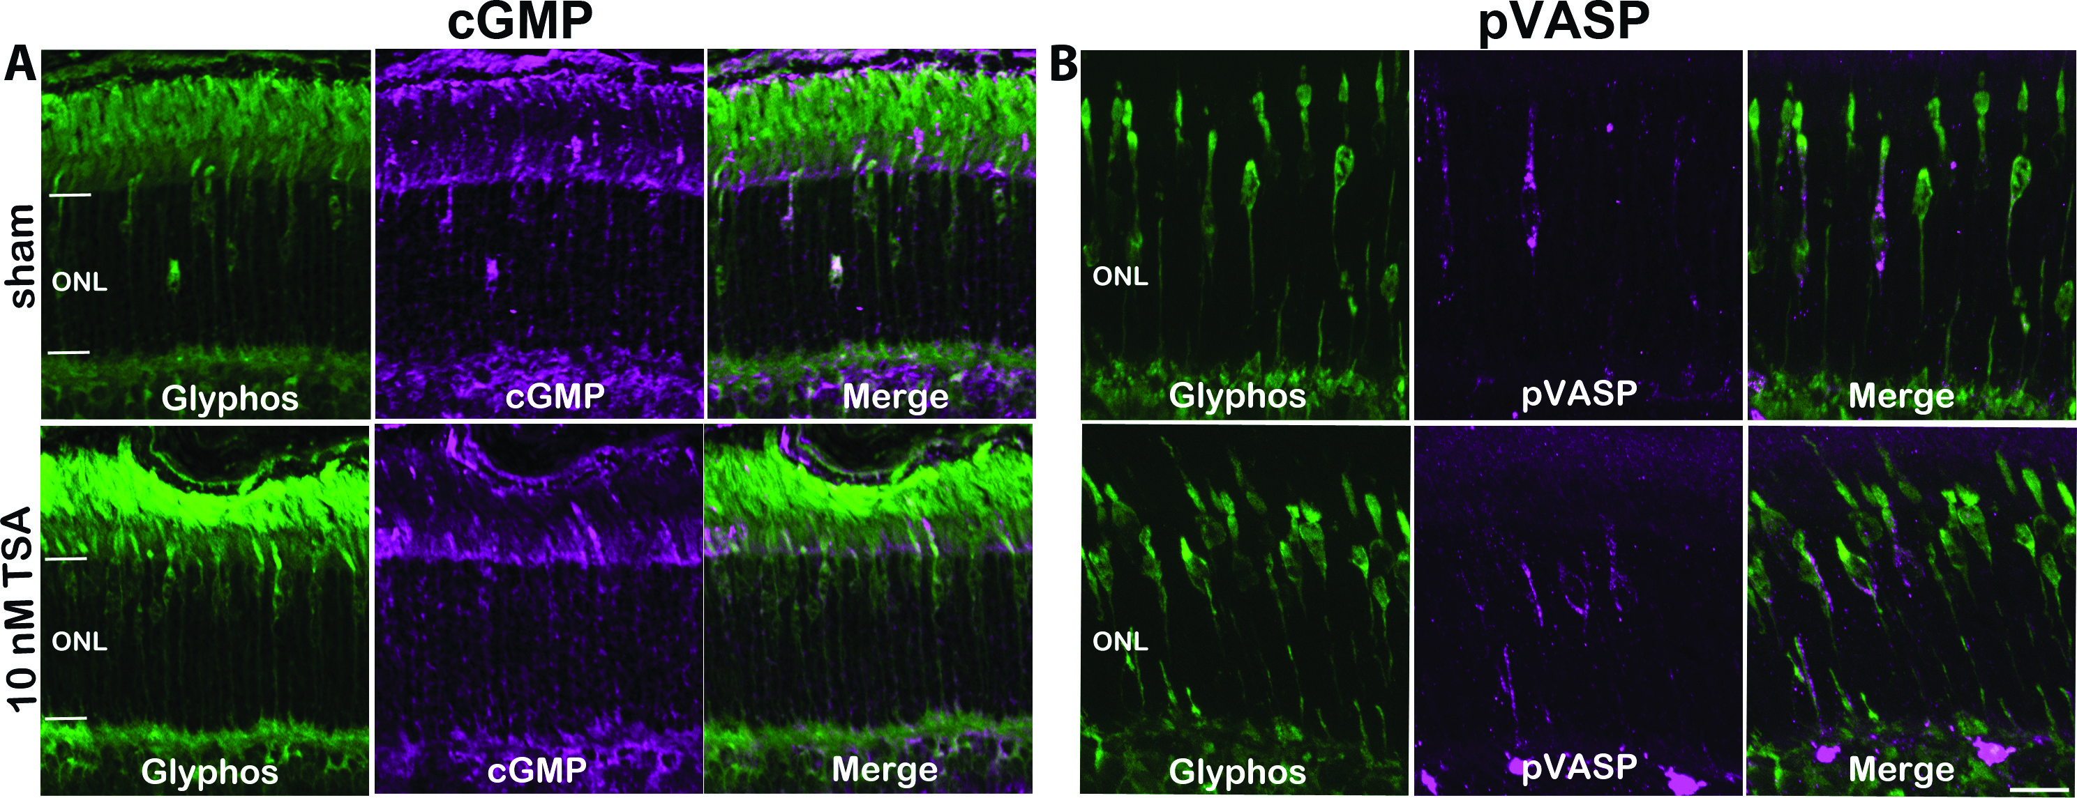
Figure S4. Co-labeling of cGMP (magenta) and Glyphos (green) in sham-treated and TSA treated retinas showed no quantitative difference in cGMP accumulation (a). While in untreated retinas cGMP accumulation was detectable in cpfl1 cone segments and cell bodies, in TSA treated retinas, cGMP was detectable mostly in cone segments. A staining for pVASP (magenta), as a measure of PKG activity, was combined with Glyphos staining (green), showing no obvious differences with and without TSA treatment (b). ONL-outer nuclear layer. Scale bar is 20 µm.

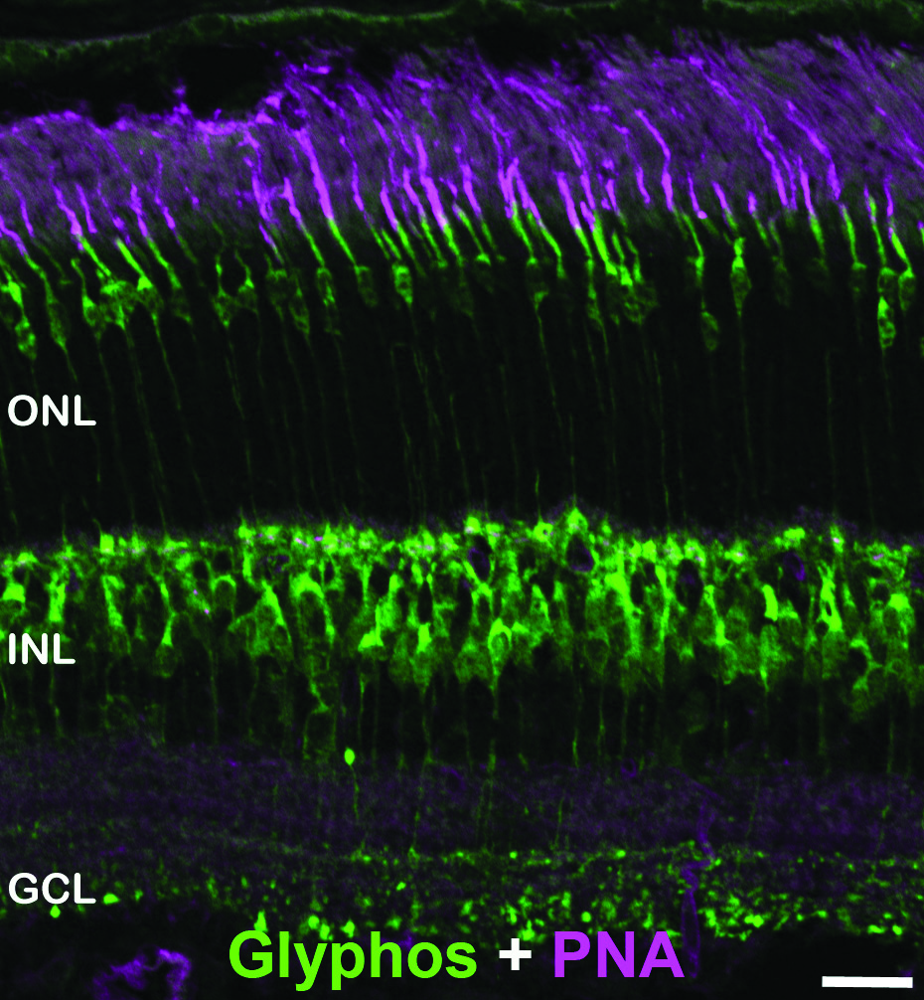
Figure S5. Glycogen phosphorylase (Glyphos) is a cone-specific marker as evidenced by co-labeling of cones by Glyphos (in green) and peanut-agglutinin (PNA), another well-established cone marker (magenta). In wild-type retina, at PN24, all Glyphos-labeled cone photoreceptors were also positive for PNA, and vice versa. ONL-outer nuclear layer, INL-inner nuclear layer, GCL-ganglion cell layer. Scale bar is 20 µm.

References for supplementary material
1. Arango-Gonzalez, B., Trifunovic, D., Sahaboglu, A., Kranz, K., Michalakis, S., Farinelli, P., Koch, S., Koch, F., Cottet, S., Janssen-Bienhold, U. et al. (2014) Identification of a common non-apoptotic cell death mechanism in hereditary retinal degeneration. PLoS.ONE., 9, e112142.
2. del Amo, E.M., Vellonen, K.S., Kidron, H. and Urtti, A. (2015) Intravitreal clearance and volume of distribution of compounds in rabbits: In silico prediction and pharmacokinetic simulations for drug development. Eur J Pharm Biopharm, 95, 215-226.
3. Del Amo, E.M. and Urtti, A. (2015) Rabbit as an animal model for intravitreal pharmacokinetics: Clinical predictability and quality of the published data. Experimental eye research, 137, 111-124.
4. Jeon, C.J., Strettoi, E. and Masland, R.H. (1998) The major cell populations of the mouse retina. J.Neurosci., 18, 8936-8946.
5. Reichenbach, A., Ziegert, M., Schnitzer, J., Pritz-Hohmeier, S., Schaaf, P., Schober, W. and Schneider, H. (1994) Development of the rabbit retina. V. The question of 'columnar units'. Brain Res Dev Brain Res, 79, 72-84.

