**SUPPLEMENTAL MATERIAL**

**Data supplement**

**Expanded methods**

**QTc-interval measurement**

ECGs were digitalized and analyzed using ImageJ (http://rsb.info.nih.gov/ij/) blinded to genotype. Only sinus rhythm complexes were analyzed. The QT-interval was measured manually on-screen using the tangent method.19 Lead II was used whenever possible. The average QT-interval from up to 3 consecutive beats with similar preceding RR-intervals was calculated and the QTc-interval was expressed using Bazett’s formula (QTc= QT/√RR).

**Genotyping**

*Candidate gene SNPs*

SNP genotyping was performed using a custom assay (Illumina GoldenGate) on an Illumina-BeadStation500GX. The Illumina BeadStudio software clustering algorithm was used for initial data analysis. Thereafter, intensity plots of all variants were examined individually and manual genotype calling was performed if necessary. Monomorphic SNPs and SNPs with a MAF < 1%, as well as SNPs with call rates <95% were removed from further analyses. A total of 1,201 SNPs had sufficient quality for analysis. All patients included in the association analysis had call rates ≥95%.

*SNPs from QTc-interval GWAS*

Genotyping was performed on the MassARRAY system using MALDI-TOF mass spectrometry with the iPLEX Gold chemistry (Sequenom Inc, San Diego, CA, USA). Primers were designed using Assay Designer 4.0.0.2 with iPLEX Gold default parameters. Automated genotype calling was done with Typer Analyzer 4.0.22.67. An experienced evaluator checked genotype clustering visually. The 3 SNPs (rs16847548, rs1935778, rs956642) from the candidate gene study genotyped in patient Set 2 were also typed in this way.

**Statistical significance thresholds**

For the candidate gene study, the Bonferroni-corrected statistical significance threshold was set at p=4.2×10-5 (0.05/1,201) and p=0.016 (0.05/3), for the discovery and the replication phase, respectively. In testing the SNPs from GWAS, the Bonferroni-corrected significance threshold was set at p=2.27×10-3 (0.05/22), both for the quantitative effect analysis on QTc-interval as well as in the case-control analysis. In the analysis for effects on cardiac events, a p-value threshold of 0.004 (0.05/12) was used.

**Power statement**

With the present sample sizes, QTc effect sizes of 28, 19 and 17 ms could be detected in the candidate gene study with 80% power for SNPs with minor allele frequencies of 0.1, 0.25 and 0.5, respectively. For the SNPs from the GWAS, effect sizes of 17, 12 and 10 ms could be detected with 80% power for SNPs with minor allele frequencies of 0.1, 0.25 and 0.5, respectively. For both, we assumed a mean (±SD) QTc of 465 ± 45 ms. For the cardiac events, we could detect hazard ratios of 1.9, 1.6 and 1.5 for SNPs with minor allele frequencies of 0.1, 0.25 and 0.5, respectively, assuming an event rate of 32%. For the case-control study, we could detect odds ratios of 2.1, 1.8 and 1.70 for SNPs with minor allele frequencies of 0.1, 0.25 and 0.5, respectively. For all calculations, we assumed a (log) additive genetic model and two sided significance thresholds as described in the previous section.

**Additional figures and tables**

**Supplementary Table 1.** Overview of candidate genes and SNPs tested

|  |  |  |
| --- | --- | --- |
| **Gene** | **Chromosome** | **Tag SNPs passing QC** |
| *AKAP9* | 7q21-q22 | 14 |
| *ANK2* | 4q25-q27 | 103 |
| *CACNA1C* | 12p13.3 | 150 |
| *CASQ2* | 1p13.3-p11 | 59 |
| *CAV3* | 3p25 | 55 |
| *FKBP1B* | 2p23.3 | 12 |
| *GPD1L* | 3p22.3 | 40 |
| *KCNE1* | 21q22.1-q22.2 | 57 |
| *KCNE2* | 21q22.1 | 24 |
| *KCNH2* | 7q35-q36 | 58 |
| *KCNJ2* | 17q23.1-q24.2 | 37 |
| *KCNQ1* | 11p15.5 | 112 |
| *NOS1AP* | 1q23.3 | 110 |
| *RYR2* | 1q42.1-q43 | 201 |
| *SCN1B* | 19q13.1 | 22 |
| *SCN4A* | 17q23.1-q25.3 | 22 |
| *SCN4B* | 11q23 | 45 |
| *SCN5A* | 3p21 | 70 |
| Total |  | 1191 |

Tag SNP, haplotype-tagging SNP

**Supplementary Table 2** which lists the effect of all SNPs from the 18 candidate genes on the QTc-interval in Patient Set 1 is available online as a separate data file.



**Supplementary Figure 1.** **Location of the 128 different missense mutations in the Kv11.1 (HERG) potassium channel encoded by the *KCNH2* gene.** The transmembrane S1-S4 region was defined as amino acid residues 404 to 547. The transmembrane loop region was defined as residues 548 to 659. Residues 1-403 were defined as N-terminus, while residues 660 to 1159 were defined as the C-terminus. The cylinders represent putative α-helical segments, and the bars represent putative β-sheets. These annotations are based on the Uniprot database (<http://www.uniprot.org/uniprot/Q12809>, accessed January 2012).

**Supplemental Figure 2A**

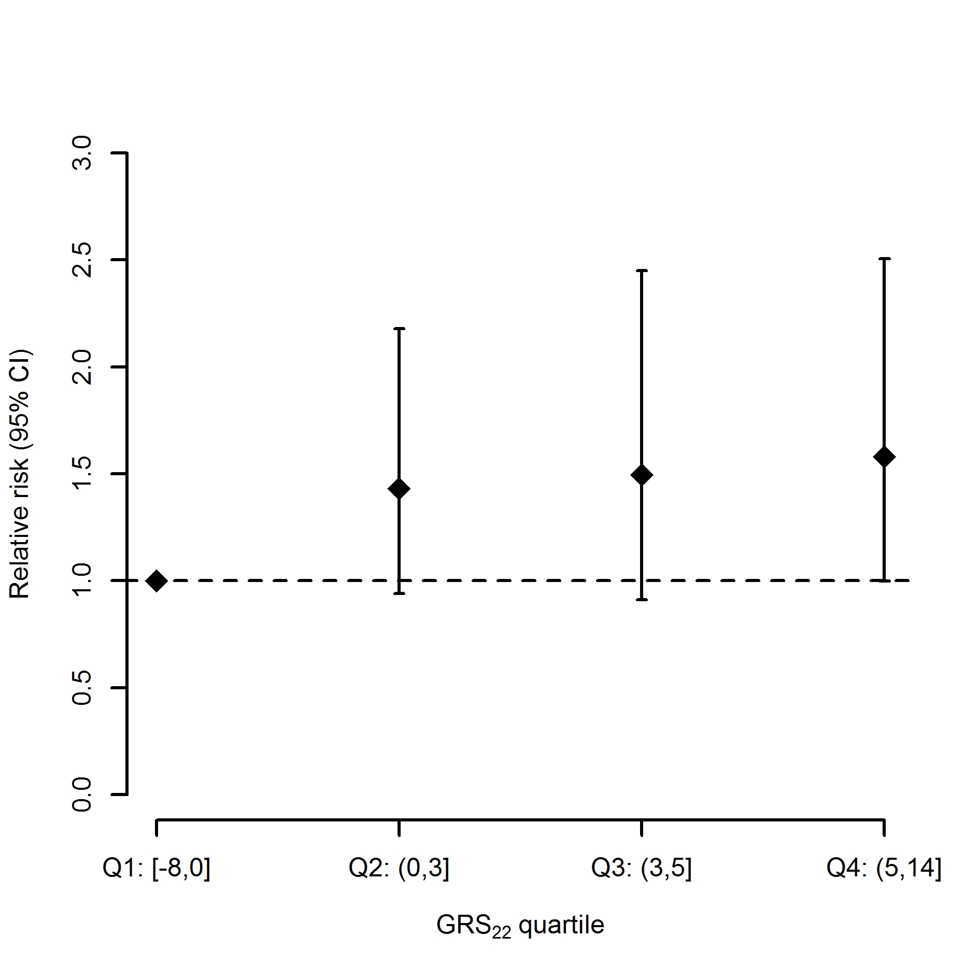

**Supplemental Figure 2B**

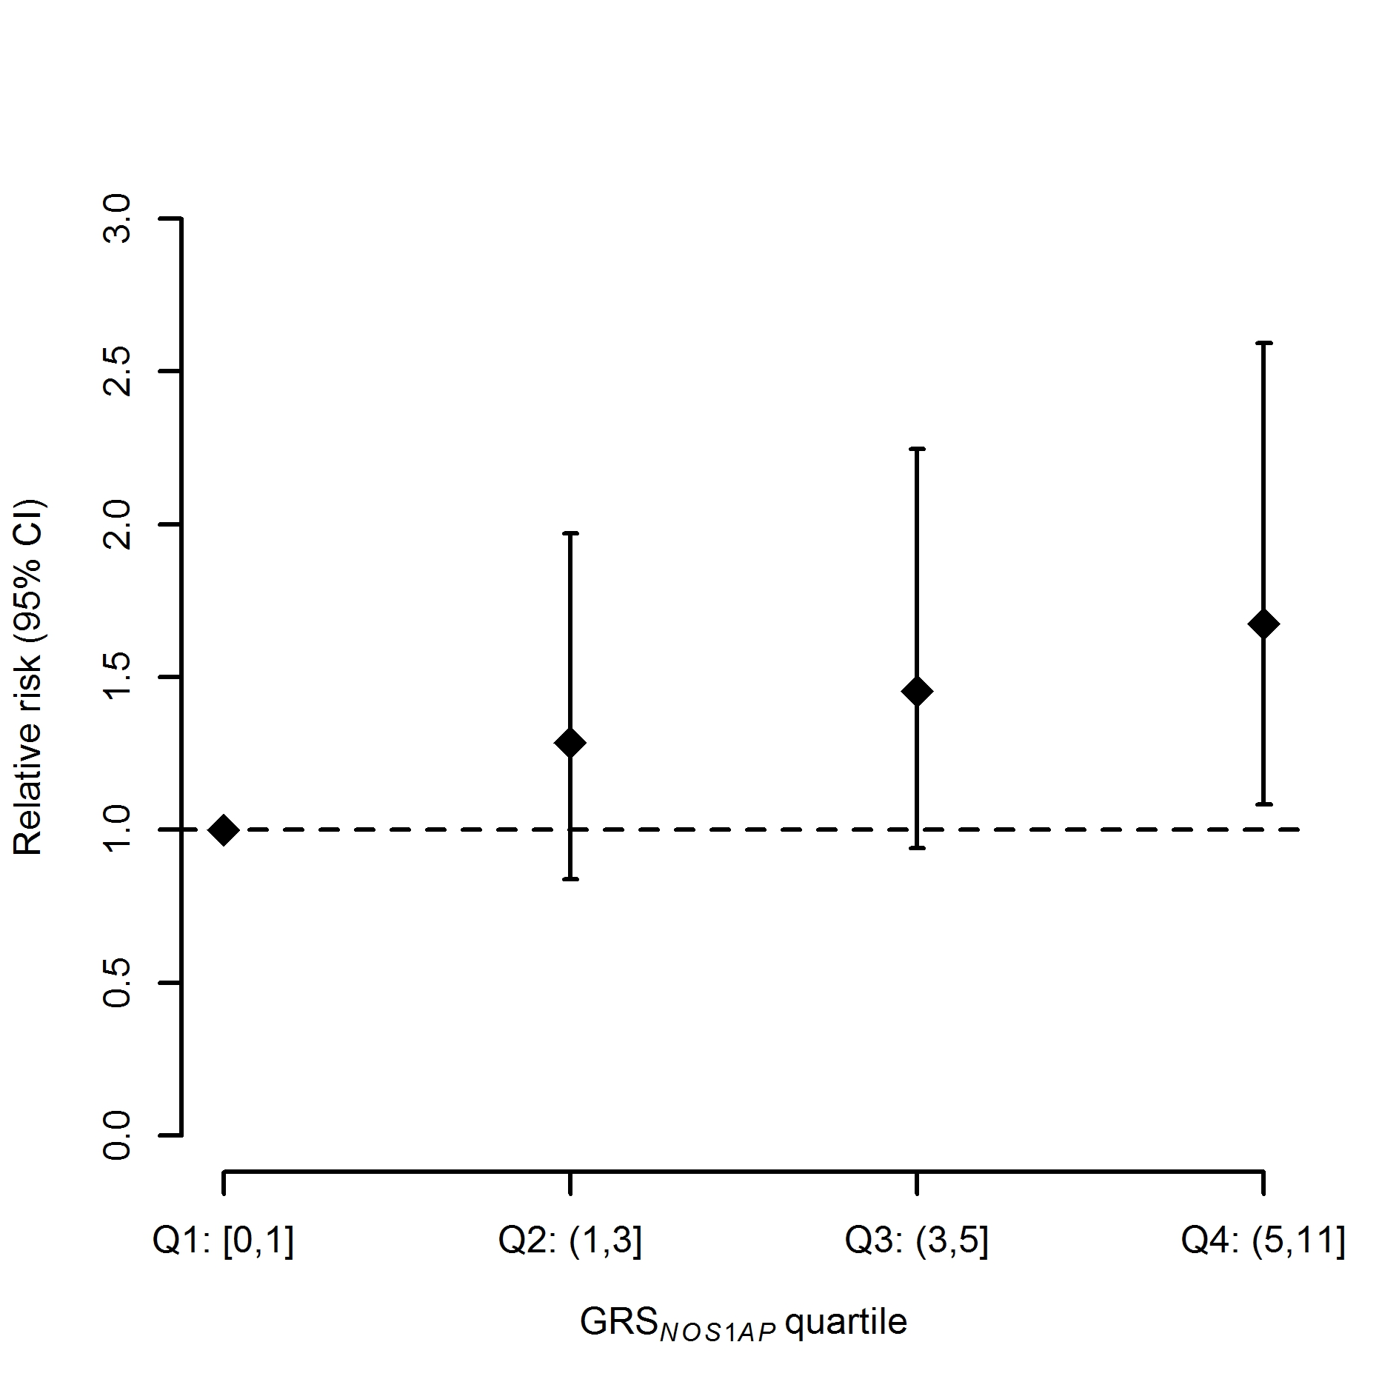

**Supplementary Figure 2A, B:** Relative risks (95% CI) of GRS quartiles 2, 3 and 4 vs. quartile 1 for GRS22 and GRS*NOS1AP*.

**Supplemental Figure 3A**

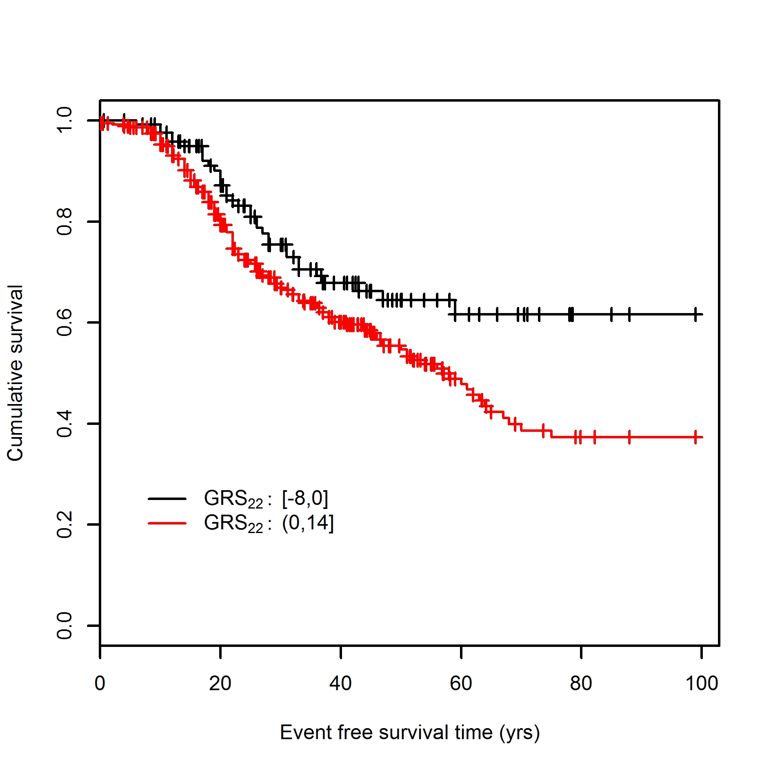

**Supplemental Figure 3B**

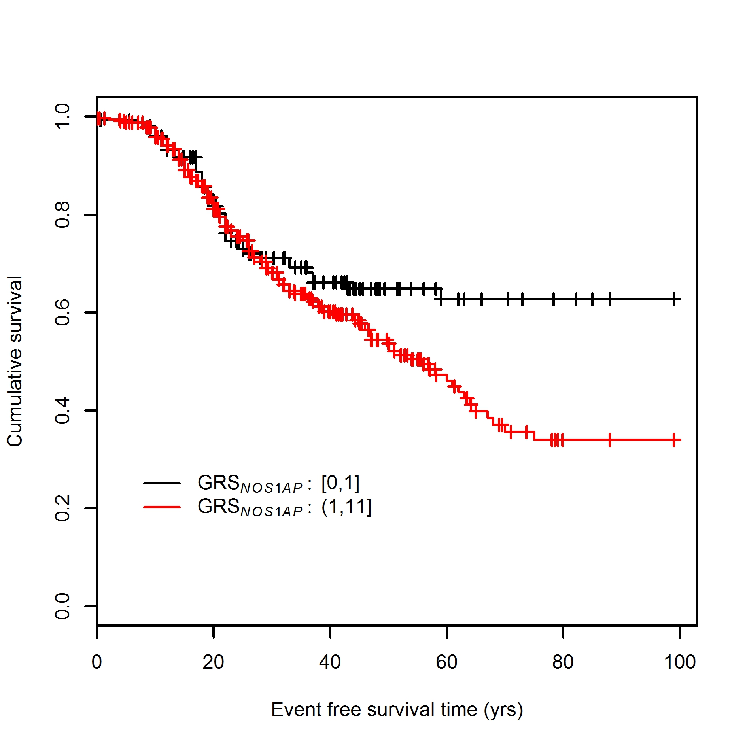

**Supplementary Figure 3A, B:** Cumulative event-free survival in LQTS patients with GRS scores in quartile 1 vs quartiles 2, 3 and 4 combined for GRS22 and GRS*NOS1AP*.

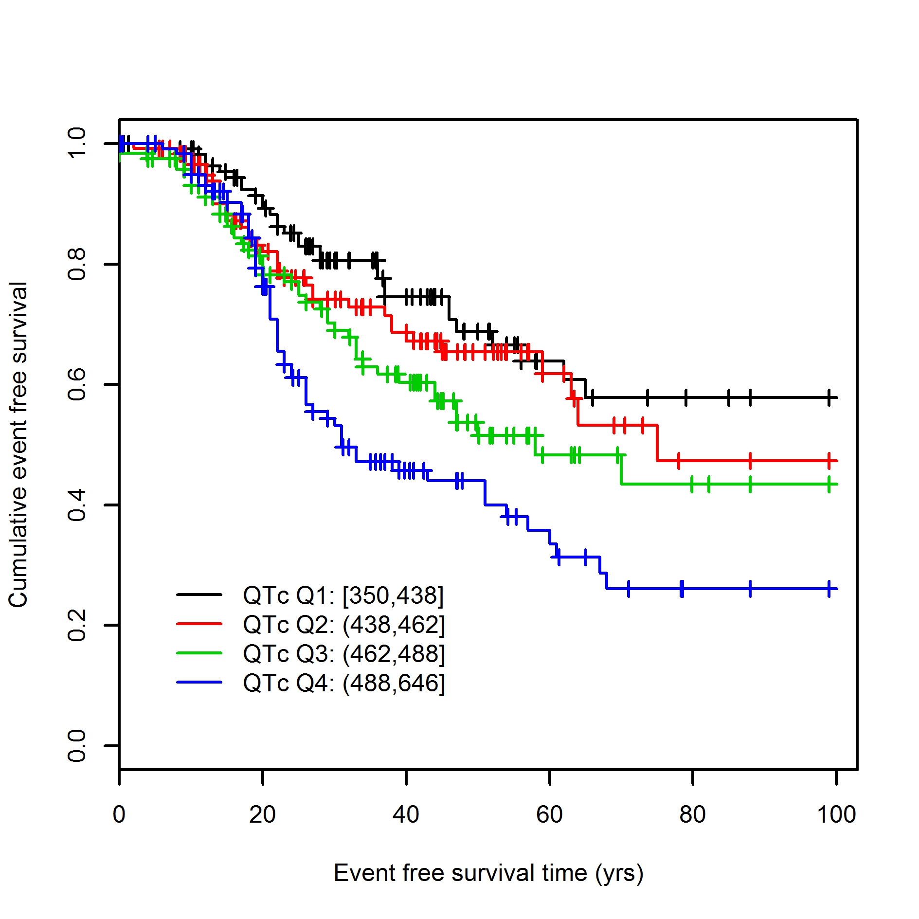

**Supplementary Figure 4:** Association between the QTc-interval and event-free survival. The QTc-interval was a strong predictor of cardiac events with patients with a QTc-interval in the highest quartile (Q4) having a RR of 2.11 (95% C.I. 1.35-3.30) as compared to patients in the lowest QTc-interval quartile (p=7.9 ×10‑7).