Exploring yeast interactions through metabolic profiling

C Roullier-Gall, V David, D Hemmler, P Schmitt-Kopplin and H Alexandre

Supporting information

Table of contents

Supplemental figure 1 2
Supplemental figure 2 3
Supplemental figure 3 4
Supplemental figure 4 5
Supplemental figure 5 6
Supplemental figure 6 7
Supplemental figure 7 7
Supplemental figure 8 8
Supplemental figure 9 8
Supplemental table 1 9
Supplemental table 2 14

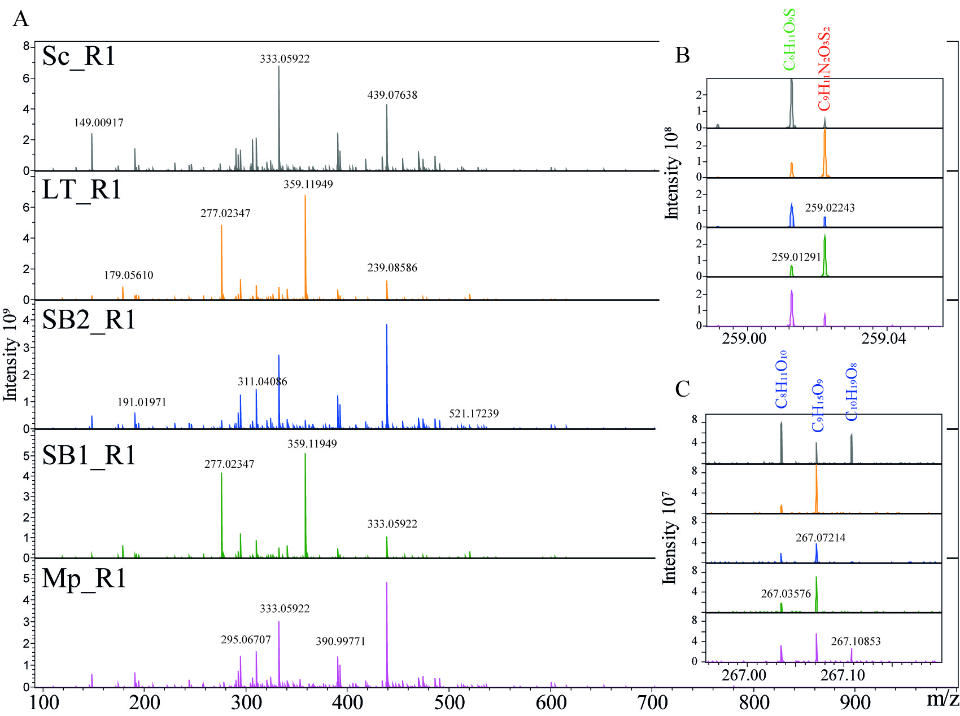
Supplemental figure 1: Visualization of ESI(-) FT-ICR-MS spectra of five wine samples which only differ in the yeast strain used for alcoholic fermentation (mass range: 100–1,000 Da). Enlargements of the nominal masses at m/z 259 and m/z 267 illustrate the molecular formula assignments.

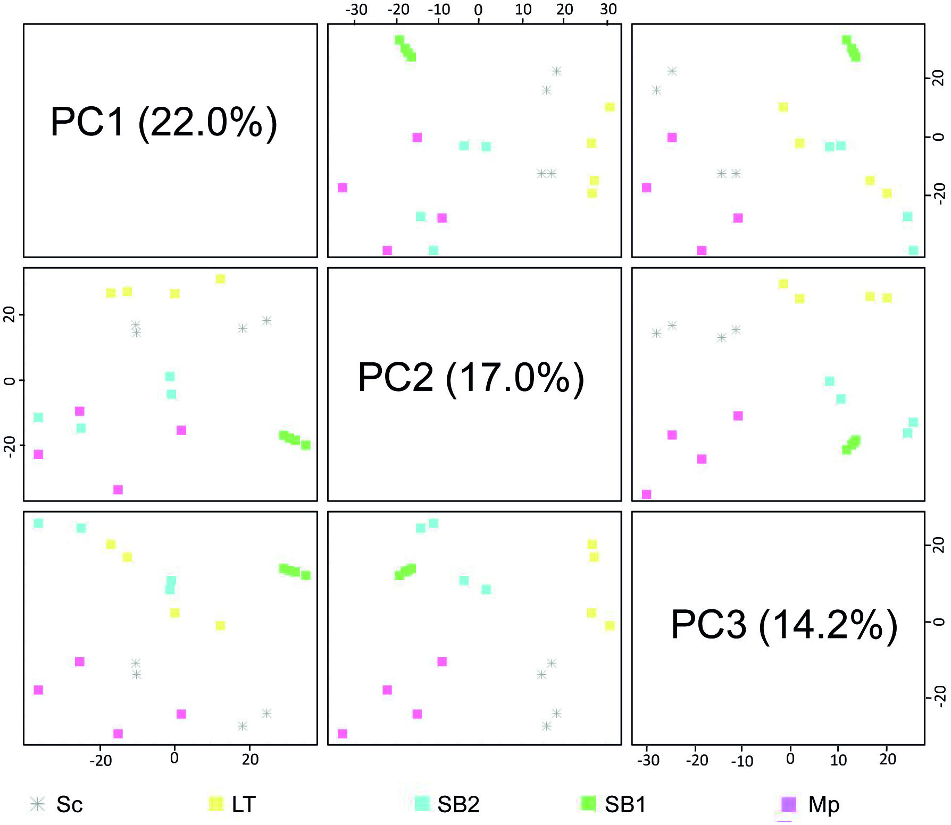
Supplemental figure 2: Scores plots of the first three principal components computed from the samples fermented with Sc, LT, SB1, SB2 and Mp. The three first components explained 53.2% of the total variability.

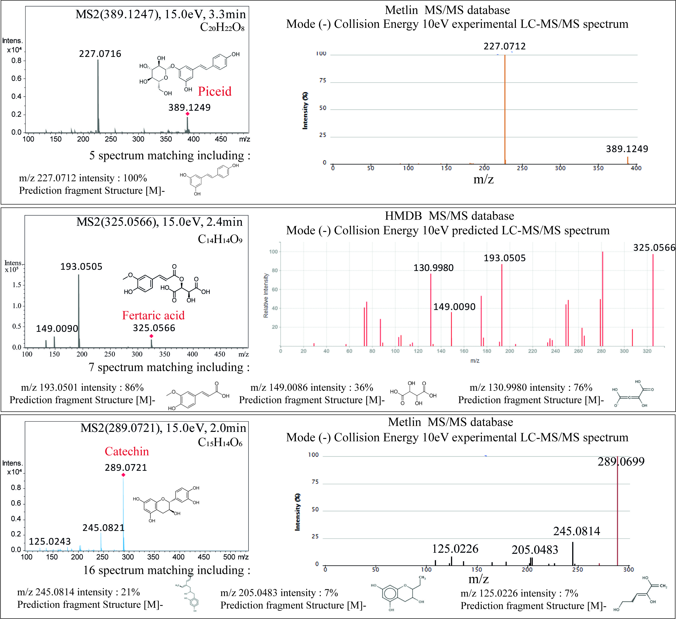
Supplemental figure 3: Piceid, Fertaric acid and catechin comparison of MS/MS spectra (15eV) from wine samples and MS/MS databases.
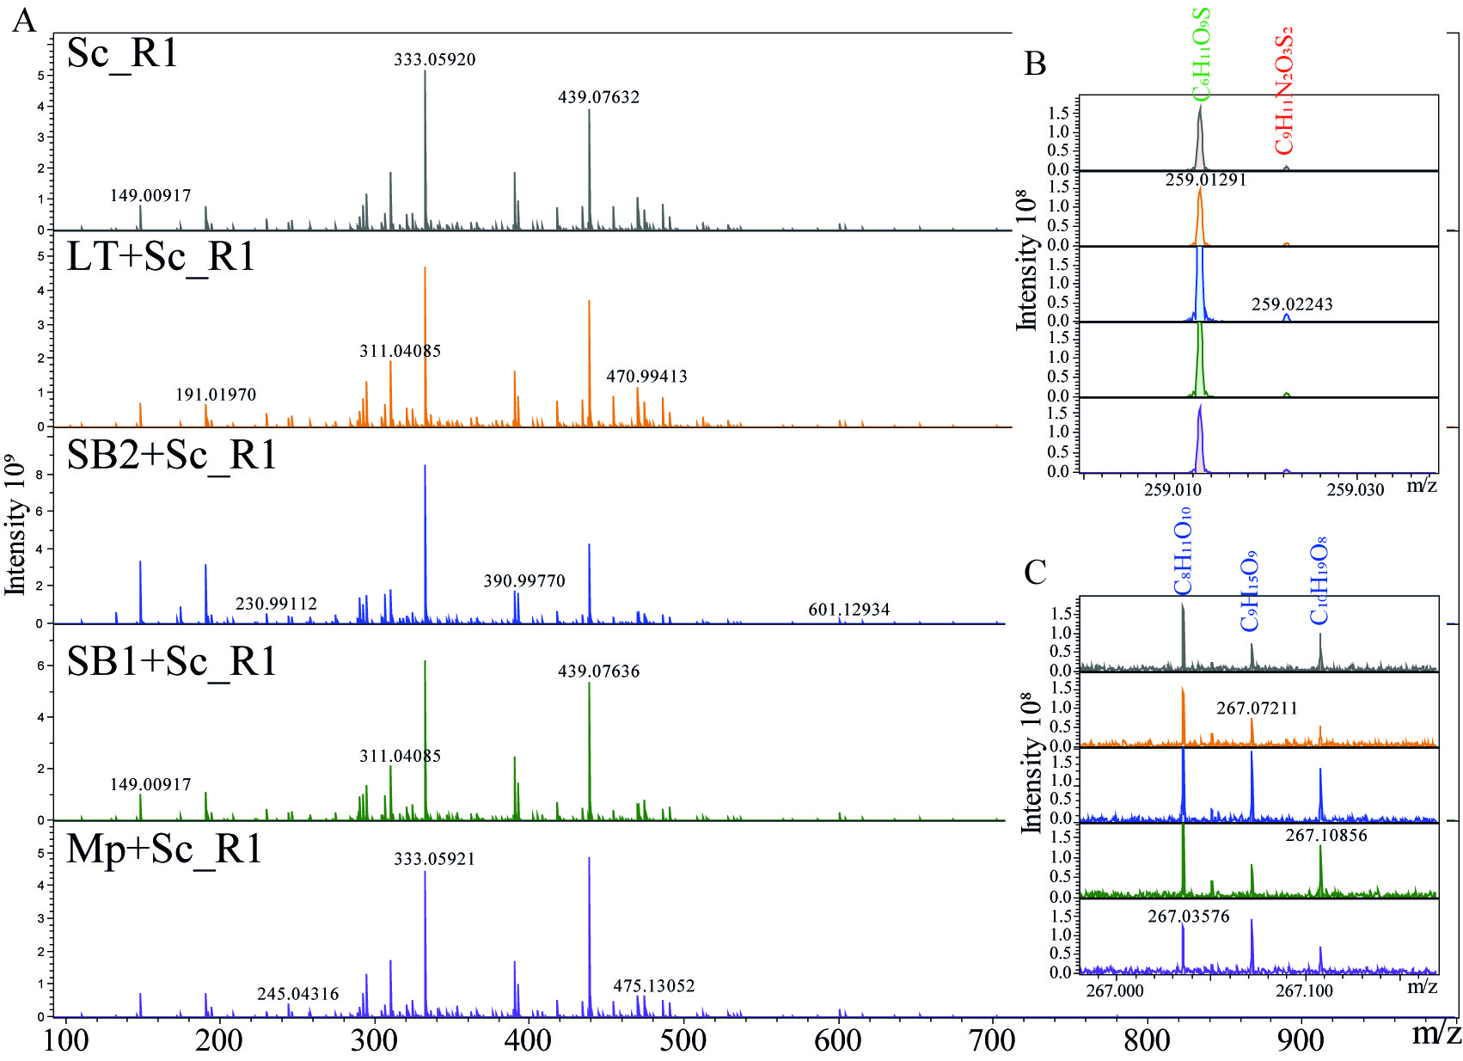
Supplemental figure 4: Visualization of ESI(-) FT-ICR-MS spectra of five wine samples which only differ by the yeast used for alcoholic fermentation (Sc alone, LT+Sc, SB2+Sc, SB1+Sc and Mp+Sc), in the mass range from 100–1,000 Da together with enlargements of the nominal masses m/z 259 and m/z 267 showing the molecular formula assignments.
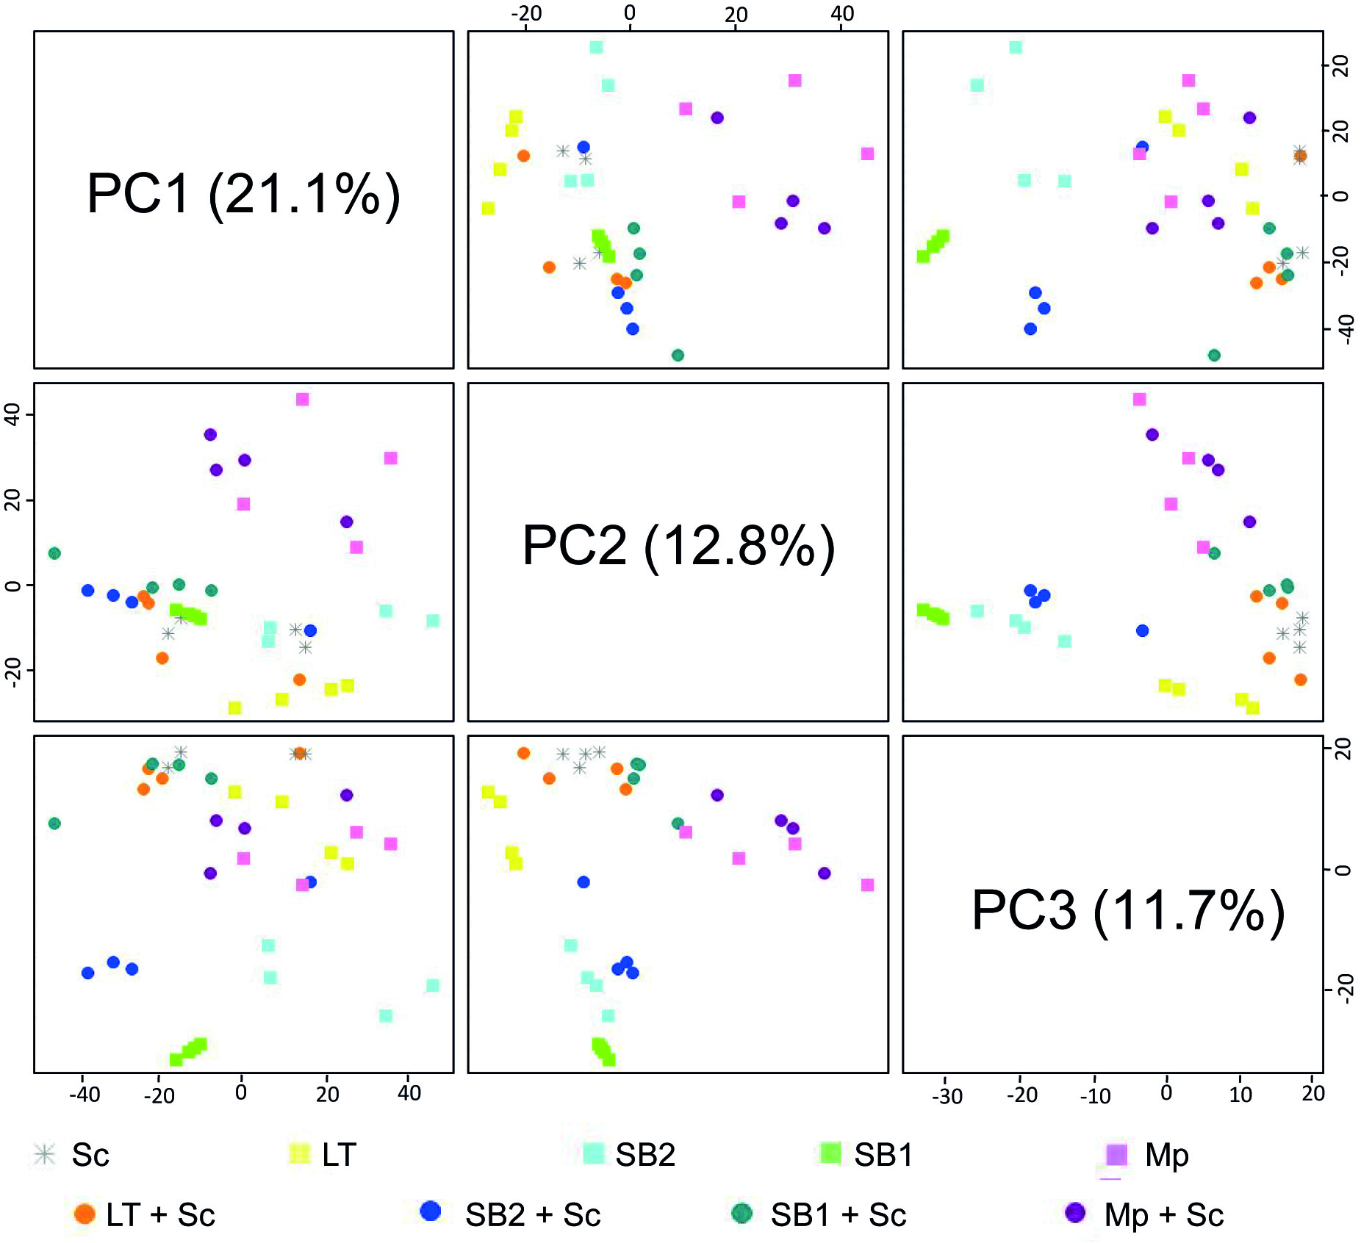
Supplemental figure 5: Scores plots of the first three principal component analysis (PCA) of the samples from Sc, LT, SB1, SB2, Mp, LT+Sc, SB1+Sc, SB2+Sc and Mp+Sc fermentations using direct methanol dilution. The three first components explained 45.6% of the total variability.

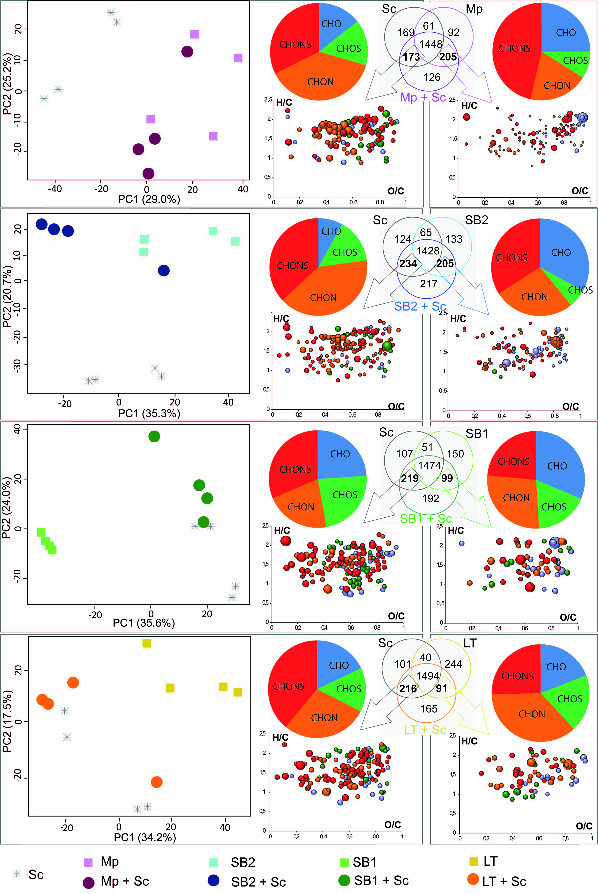
Supplemental figure 6 : Principal component analysis of single fermentations and mixed fermentation with Venn diagrams for each NS yeast. Markers of Sc and each NS yeast in sequential fermentation are highlight in the van Krevelen diagrams. Bubble sizes indicate relative intensities of corresponding peaks in the spectra. Color code: CHO, blue; CHOS, green; CHON, red; CHONS, orange.

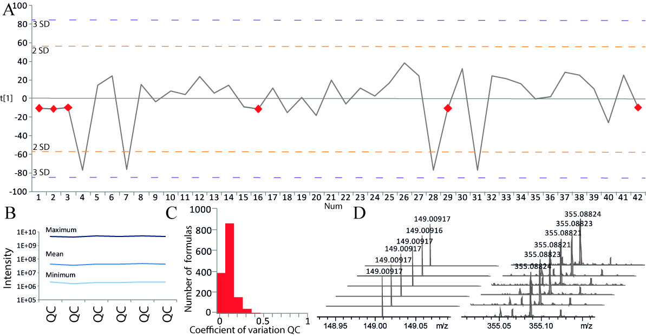
Supplemental figure 7: (A) Time series plot of the first principal component (t(1) vs. sample run order). QCs are highlighted as red diamonds. (B) Plot representing the maximum, the mean and the minimum of peak intensity for each of the 6 QCs. (C) Histogram of all coefficient of variation vaues computed from the peak intensities from all dectected molecular compositions in the FT-ICR-MS data. (D) Extracted ion chromatograms of m/z 149.00917 and 355.08821 in 6 sequential QCs samples.

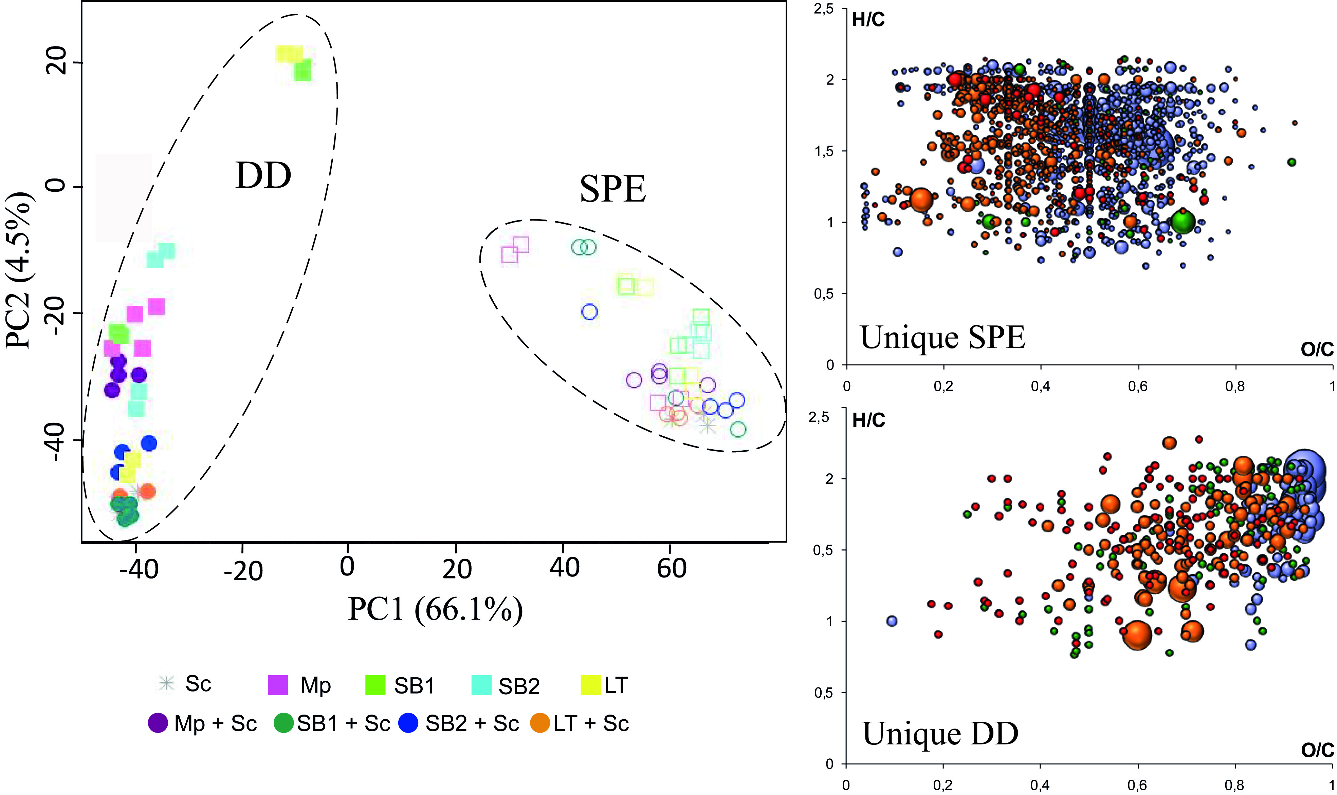
Supplemental figure 8: Comparison of samples depending on the sample preparation : direct methanol dilution with methanol (DD, open symbols) and purification by C18 SPE c (C18, solid symbols). Van Krevelen diagrams show molecular formulae only found after methanol dilution (DD) or C18 purification (C18).

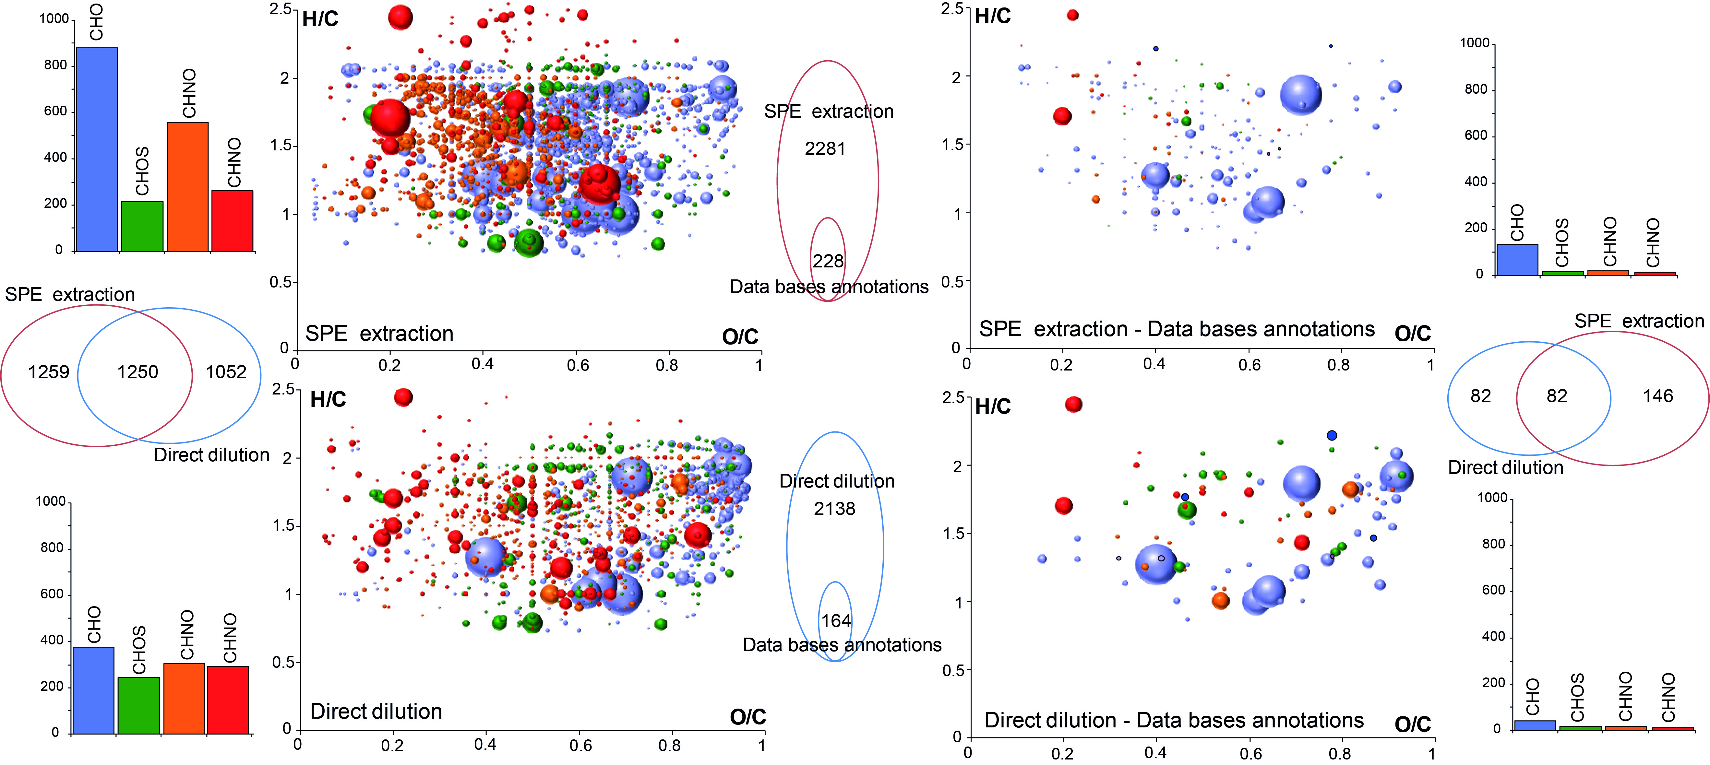
Supplemental figure 9: Common and unique compounds detected after methanol dilution (Direct Dilution) or C18 purification (SPE extraction).

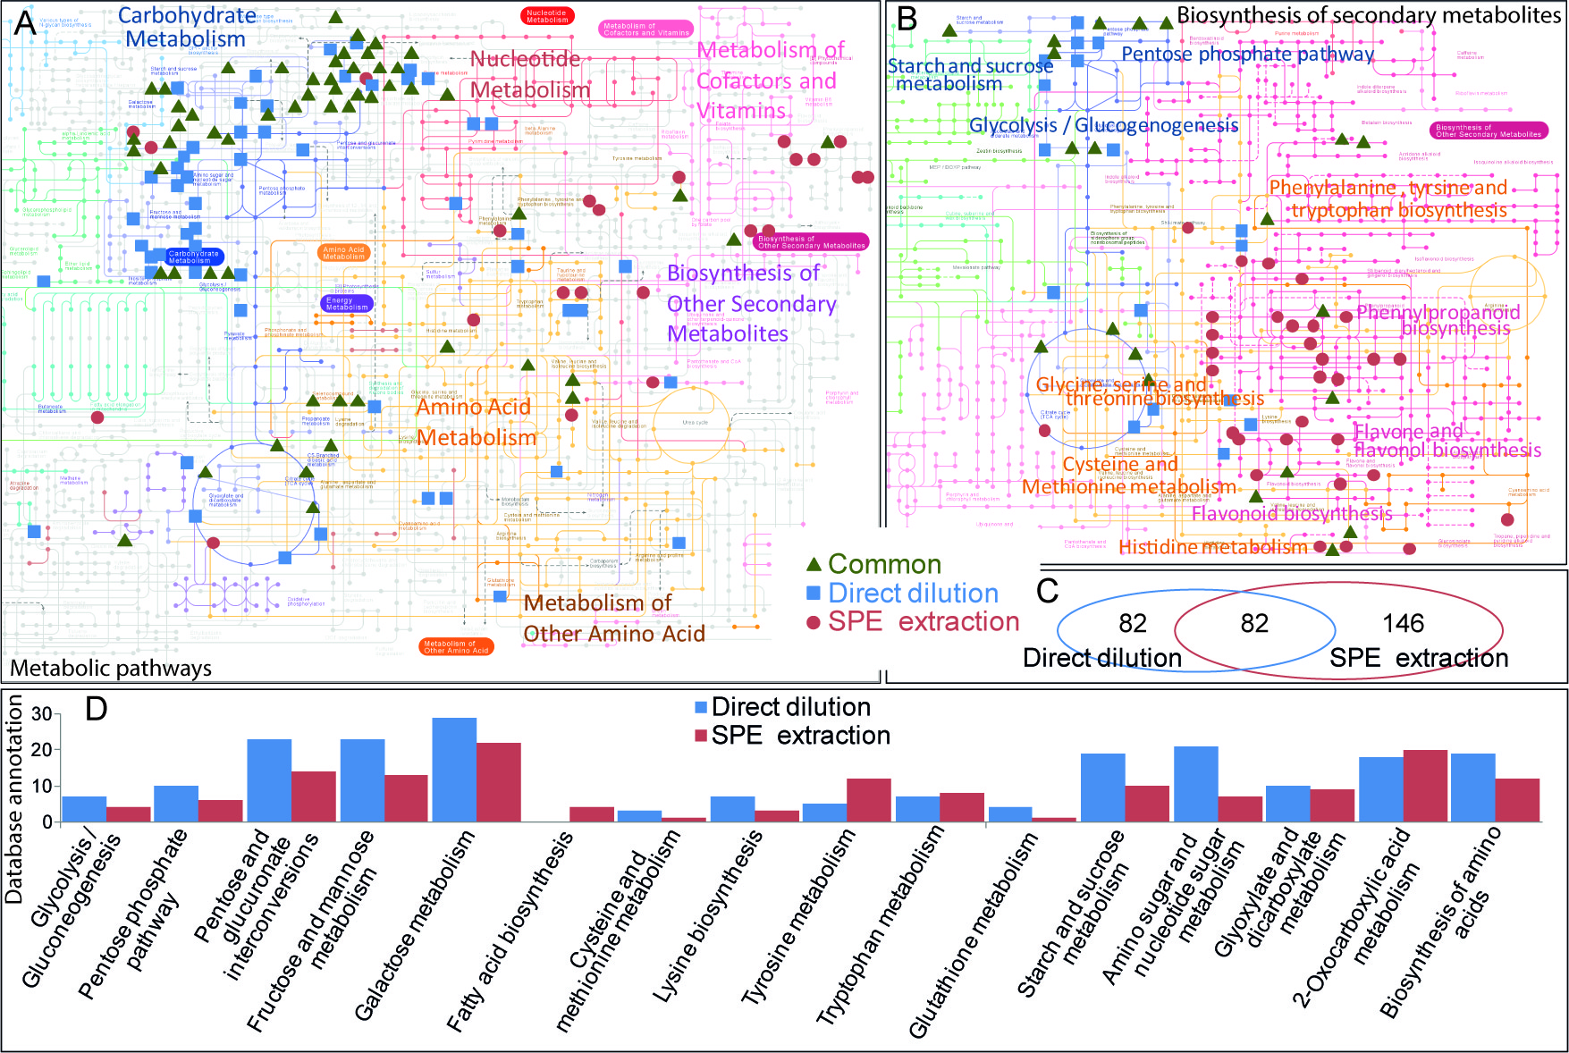
Supplemental figure 10: KEGG representation showing an overview of (A) metabolic pathways and a zooming into (B) biosynthesis pathways of secondary metabolites. Metabolites identified in the samples after direct dilution are indicated as blue squares and after SPE purification as red circles. (C) Venn diagrams of the number of annotations in databases using direct dilution and SPE.(D) Number of database annotations in 16 pathways found for the direct dilution (blue) and SPE extraction (red) method.

Supplemental table 1: Database annotations of markers from SB1, SB2, LT, Mp and Sc fermentations
Mass (avg.) | Yeast | Formulas [M] | Database annotations
103.003694 | SB1 | C3H4O4 | Malonate
111.008782 | SB1 | C5H4O3 | 2-Furoic acid
115.00369 | SB1 | C4H4O4 | 2-Butenedioic acid (2E)-; (Fumaric acid)
124.99141 | SB1 | C2H6O4S | 2-Hydroxyethanesulfonate
125.024425 | SB1 | C6H6O3 | Pyrogallol (8CI); 1,2,3-Benzenetriol; 1,3,5-Benzenetriol; 2-Furancarboxaldehyde, (hydroxymethyl)-; 2-Furancarboxaldehyde, 5-(hydroxymethyl)-; 4H-Pyran-4-one, 3-hydroxy-2-methyl- ; phloroglucinol; 1,2,3-Trihydroxybenzene
129.019338 | SB1 | C5H6O4 | Glutaconic acid
133.014253 | SB1 | C4H6O5 | Malic acid;L-(-)-Malic acid
133.050637 | SB1 | C5H10O4 | 2,3-Dihydroxyvaleric acid
143.034988 | SB1 | C6H8O4 | 4H-Pyran-4-one, 2,3-dihydro-3,5-dihydroxy-6-methyl-;3-Hexenedioic acid
145.01425 | Mp | C5H6O5 | Glutaric acid, 2-oxo- (8CI);alpha-Ketoglutaric acid
147.0299 | SB1 | C5H8O5 | Citramalic acid
149.009167 | SB1 | C4H6O6 | L-(+)-Tartaric acid; Butanedioic acid, 2,3-dihydroxy-; Tartaric acid
149.045551 | SB1 | C5H10O5 | D-Xylose; D-Ribose; Xylose; Arabinose; L-Arabinose
151.061198 | Mp | C5H12O5 | Xylitol;Arabinitol
154.998599 | SB1 | C6H4O5 | 2,5-Furandicarboxylic acid
157.050636 | SB1 | C7H10O4 | 3-Furancarboxylic acid, tetrahydro-5-oxo-, ethyl ester; 2-Furancarboxylic acid, tetrahydro-5-oxo-, ethyl ester; Succinylacetone
159.0299 | SB1 | C6H8O5 | Oxoadipic acid
161.045549 | SB1 | C6H10O5 | Dicarbonic acid, diethyl ester (9CI);1,6-Anhydroglucose
163.040068 | SB1 | C9H8O3 | 2-Propenoic acid, 3-(hydroxyphenyl)-,3-(4-hydroxyphenyl)-; trans-p-Coumaric acid; 4-Coumarate
165.040463 | SB1 | C5H10O6 | Arabinonic acid
169.014247 | SB1 | C7H6O5 | Gallate;Benzoic acid, 3,4,5-trihydroxy-
171.066282 | SB2 | C8H12O4 | 2-Octenedioic acid
173.00916 | SB1 | C6H6O6 | cis-Aconitic acid
175.024809 | SB1 | C6H8O6 | L-Ascorbic acid (8CI,9CI); erythorbic acid
175.061195 | SB1 | C7H12O5 | 2-Isopropylmalic acid
177.04046 | SB1 | C6H10O6 | D-Gluconic acid, d-lactone (9CI); Fructose, 5-dehydro-, D- (6CI); L-Galactono-1,4-lactone
179.034979 | SB1 | C9H8O4 | caffeic acid; 2-Propenoic acid, 3-(3,4-dihydroxyphenyl)-; Caffeate
179.03835 | SB1 | C6H12O4S | 5-Methylthioribose
179.056109 | SB1 | C6H12O6 | D-Glucose; D-Mannose; D-Fructose; D-Galactose; myo-Inositol
181.05063 | SB2 | C9H10O4 | 2',6'-Dihydroxy-4'-methoxyacetophenone; Hydrocinnamic acid, 3,4-dihydroxy- (6CI,7CI,8CI); Syringaldehyde; Benzaldehyde, 4-hydroxy-3,5-dimethoxy-; Methyl vanillate
181.071759 | Mp | C6H14O6 | D-Glucitol , Sorbitol; Galactitol; Mannitol ; D-Mannitol
187.024806 | SB1 | C7H8O6 | cis-2-Methylaconitate
188.05644 | SB1 | C7H11NO5 | Glutarylglycine
189.004069 | SB1 | C6H6O7 | Oxalosuccinic acid
189.040455 | SB1 | C7H10O6 | 4-Hydroxy-2-oxo-heptandioic acid
189.07684 | SB1 | C8H14O5 | Butanedioic acid, hydroxy-, diethyl ester; 3-Hydroxysuberic acid; Diethyl malate
191.019719 | SB1 | C6H8O7 | 1,2,3-Propanetricarboxylic acid, 2-hydroxy-; citric acid; Isocitric acid; 2,5-Diketo-D-gluconic acid
191.056105 | SB1 | C7H12O6 | Quinic acid
191.107742 | SB1 | C12H16O2 | Thymyl acetate;Propanoic acid, 2-methyl-, 2-phenylethyl ester
193.035369 | SB1 | C6H10O7 | D-arabino-5-Hexulosonic acid (7CI,8CI,9CI);D-arabino-Hexonic acid, 2-keto- (6CI); D-Galacturonic acid;D-Galacturonic acid, homopolymer (9CI); 5-Oxo-D-gluconic acid; D-glucuronate
193.050625 | SB1 | C10H10O4 | Ferulic acid; 2-Propenoic acid, 3-(4-hydroxy-3-methoxyphenyl)-; Ferulate; 2-Propenoic acid, 3-(4-hydroxy-3-methoxyphenyl)-; Ferulic acid; Vanilloylacetyl; 1,2-Propanedione, 1-(4-hydroxy-3-methoxyphenyl)-; Vanilloyl methyl ketone
195.051019 | SB1 | C6H12O7 | D-Gluconic acid ;D-Gluconate
197.045539 | SB1 | C9H10O5 | Syringic acid (6CI); Benzoic acid, 4-hydroxy-3,5-dimethoxy-;Ethyl gallate
203.019718 | SB1 | C7H8O7 | 2-Oxaloglutaric acid
205.035368 | SB1 | C7H10O7 | 2-Methylcitric acid
206.045873 | SB1 | C10H9NO4 | 4-(2-Aminophenyl)-2,4-dioxobutanoic acid
211.024802 | SB1 | C9H8O6 | 5-carboxyvanillic acid
213.017048 | SB1 | C5H11O7P | D-threo-2-Pentulose, 1-deoxy-, 5-(dihydrogen phosphate) (9CI);1-Deoxy-D-xylulose 5-phosphate
214.048588 | Mp | C5H14NO6P | Glycerylphosphorylethanolamine
215.032678 | SB1 | C5H13O7P | 1,2,3,4-Butanetetrol, 2-methyl-, 4-(dihydrogen phosphate), (2S,3R)- (9CI); 2-C-Methyl-D-erythritol 4-phosphate; Methylerythritol phosphate
216.981226 | SB1 | C7H6O6S | 5-Sulfosalicylic acid
218.066992 | SB1 | C8H13NO6 | O-Succinyl-L-homoserine
243.062252 | SB1 | C9H12N2O6 | Uridine (8CI,9CI)
253.092888 | SB1 | C9H18O8 | Galactosylglycerol
255.232949 | SB1 | C16H32O2 | Tetradecanoic acid, ethyl ester; Palmitic acid; Hexadecanoic acid; Hexadecanoic acid
257.077908 | SB1 | C10H14N2O6 | Ribothymidine
258.038425 | Mp | C6H14NO8P | Glucosamine-1P
261.007446 | Sc | C9H10O7S | Homovanillic acid sulfate
261.038089 | Mp | C6H15O9P | Mannitol 1-phosphate
261.072819 | SB1 | C9H14N2O7 | L-glutamic acid, L-a-aspartyl;L-beta-aspartyl-L-glutamic acid
262.039076 | LT | C9H13NO6S | Epinephrine sulfate
267.072151 | SB1 | C9H16O9 | 3-Deoxy-D-glycero-D-galacto-2-nonulosonic acid
274.104454 | SB1 | C10H17N3O6 | Norophthalmic acid
275.088476 | SB1 | C10H16N2O7 | L-glutamic acid, L-a-glutamyl;Gamma Glutamylglutamic acid
275.092502 | SB1 | C15H16O5 | Dihydromethysticin
275.124856 | Sc | C11H20N2O6 | Saccharopine
277.122749 | SB2 | C11H22N2O4S | Pantetheine
284.125185 | SB1 | C12H19N3O5 | Glycylprolylhydroxyproline
288.120109 | SB1 | C11H19N3O6 | Ophthalmic acid
289.033011 | SB1 | C7H15O10P | D-Sedoheptulose 7-phosphate
289.071762 | SB1 | C15H14O6 | (-)-Epicatechin; 2H-1-Benzopyran-3,5,7-triol, 2-(3,4-dihydroxyphenyl)-3,4-dihydro-, (2R,3R)-; (+)-Catechin; 2H-1-Benzopyran-3,5,7-triol, 2-(3,4-dihydroxyphenyl)-3,4-dihydro-, (2R,3S)-
289.115348 | LT s | C10H18N4O6 | Argininosuccinic acid
295.04594 | SB1 | C13H12O8 | trans-Coumaroyltartaric acid; trans-Coutaric acid; Butanedioic acid, 2-hydroxy-3-[[(2E)-3-(4-hydroxyphenyl)-1-oxo-2-propenyl]oxy]-, (2R,3R)-; 2-hydroxy-3-[[3-(4-hydroxyphenyl)-1-oxo-2-propenyl]oxy]-, (2R,3R)-; cis-Coumaroyltartaric acid; cis-Coutaric acid; Butanedioic acid, 2-hydroxy-3-[[(2Z)-3-(4-hydroxyphenyl)-1-oxo-2-propenyl]oxy]-, (2R,3R)-
299.077244 | SB1 | C13H16O8 | Pseudolaroside A
300.048993 | Mp | C8H16NO9P | N-Acetyl-D-Glucosamine 6-Phosphate
302.135758 | Sc | C12H21N3O6 | nicotianamine
303.083375 | SB1 | C11H16N2O8 | N-Acetylaspartylglutamic acid
305.018007 | Sc | C9H11N2O8P | Uridine 2',3'-cyclic phosphate
306.07653 | Sc | C10H17N3O6S | L-Glutathione; Glycine, L-g-glutamyl-L-cysteinyl-
308.09871 | SB1 | C11H19NO9 | N-Acetylneuraminic acid
311.040858 | SB1 | C13H12O9 | trans-Caftaric acid; Caftaric acid; Monocaffeoyl tartrate; Caftaric acid;Butanedioic acid, 2-[[(2E)-3-(3,4-dihydroxyphenyl)-1-oxo-2-propenyl]oxy]-3-hydroxy-, (2R,3R)-; Butanedioic acid, 2-[[(2Z)-3-(3,4-dihydroxyphenyl)-1-oxo-2-propenyl]oxy]-3-hydroxy-, (2R,3R)-
311.098374 | Mp | C11H20O10 | Galactose-beta-1,4-xylose
311.11363 | SB1 | C15H20O7 | 4-Hydroxycinnamyl alcohol 4-D-glucoside
313.056507 | SB1 | C13H14O9 | 1-Salicylate glucuronide
315.072158 | SB2 | C13H16O9 | Protocatechuic acid 4-O-glucoside
315.108545 | SB1 | C14H20O8 | Hydroxytyrosol 4-O-glucoside
317.027935 | SB1 | C8H15O11P | 3-deoxy-D-manno-octulosonate 8-phosphat
321.005311 | Sc | C14H6O8 | ellagic acid
322.044574 | Sc | C9H14N3O8P | Cytidine monophosphate;3'-Cytidylic acid (8CI,9CI)
323.028595 | Sc | C9H13N2O9P | UMP;2'-Uridylic acid (8CI,9CI)
325.056511 | SB1 | C14H14O9 | t-Feruloyl tartaric acid; trans-Fertaric acid;Monoferuloyl tartrate
325.092896 | SB2 | C15H18O8 | (Z)-; 4-O-b-D-Glucopyranosyl-cis-p-coumaric acid; trans-beta-D-Glucosyl-2-hydroxycinnamate; p-Hydroxy-trans-cinnamic acid b-D-glucosyl ester; (E)-; 4-O-b-D-Glucopyranosyl-p-trans-coumaric acid
325.11403 | Mp | C12H22O10 | 2-O-a-L-Fucopyranosyl-galactose
327.108543 | SB1 | C15H20O8 | Anisatin
329.087812 | SB2 | C14H18O9 | Pseudolaroside B;D-Glucose 1-vanillate; Vanillic acid 1-O-b-D-glucopyranosyl ester
331.067076 | SB2 | C13H16O10 | gallate + glucose;b-D-Glucose, 1-gallate (6CI)
333.059226 | LT | C9H19O11P | 1-(sn-Glycero-3-phospho)-1D-myo-inositol
339.072157 | LT | C15H16O9 | Sinapoyl malate; Butanedioic acid, 2-[[(2E)-3-(3,4-dihydroxyphenyl)-1-oxo-2-propenyl]oxy]-3-hydroxy-, 1-ethyl ester, (2R,3R)- (9CI); , 4-ethyl ester, (2R,3R)- (9CI); 2H-1-Benzopyran-2-one, 6-(b-D-glucopyranosyloxy)-7-hydroxy-
339.093292 | SB1 | C12H20O11 | 3'-Ketolactose
341.087815 | SB2 | C15H18O9 | Caffeic acid 3-glucoside
341.108943 | Mp | C12H22O11 | Maltose; D-Glucopyranose, 4-6-O-a-D-galactopyranosyl-; D-Glucose, 4-O-a-D-glucopyranosyl-,D-Glucose, 4-O-b-D-galactopyranosyl-,6-O-a-D-galactopyranosyl-; D-melibiose; Trehalose (8CI); a-D-Glucopyranoside, a-D-glucopyranosyl; a-D-Glucopyranoside, b-D-fructofuranosyl
343.12459 | Mp | C12H24O11 | Maltitol
344.040168 | Sc | C10H12N5O7P | Cyclic GMP
345.119114 | SB1 | C15H22O9 | Aucubin
346.055818 | Sc | C10H14N5O7P | Adenosine phosphate; 3'-Adenylic acid (8CI,9CI); Adenosine monophosphate
347.038554 | Sc | C9H17O12P | 2-O-(6-Phospho-alpha-mannosyl)-D-glycerate
357.119121 | SB1 | C16H22O9 | 10-Deoxygeniposidic acid
359.098382 | SB2 | C15H20O10 | 3-Methoxy-4-hydroxyphenylglycol glucuronide
359.134766 | SB1 | C16H24O9 | 7-Deoxyloganate
361.114027 | SB2 | C15H22O10 | Antirrhinoside
362.050727 | Sc | C10H14N5O8P | 3'-2'-Guanylic acid (8CI,9CI); Guanosine monophosphate
366.140542 | SB1 | C14H25NO10 | N-Acetyl-6-O-L-fucosyl-D-glucosamine
367.018473 | Mp | C10H13N2O11P | Orotidine 5'-phosphate
369.140246 | Mp | C14H26O11 | Amylose
373.114039 | SB2 | C16H22O10 | Geniposidic acid
377.130072 | Mp | C12H26O13 | Galactinol dihydrate
382.135505 | SB1 | C14H25NO11 | N-Acetyllactosamine
387.166078 | SB1 | C18H28O9 | Tuberonic acidglucoside
389.10897 | SB2 | C16H22O11 | Monotropein
389.124212 | SB2 | C20H22O8 | Resveratrol 3-O-b-glucopyranoside; trans-Piceid; cis-Piceid; D-Glucitol, 1,5-anhydro-1-C-[2,4-dihydroxy-6-[(1E/ Z)-2-(4-hydroxyphenyl)ethenyl]phenyl]-, (1S)- (9CI)
414.118606 | Sc | C15H22N5O7P | Isopentenyl adenosine monophosphate
421.075299 | Mp | C12H23O14P | alpha,alpha-Trehalose 6-phosphate
430.11354 | Sc | C15H22N5O8P | cis-zeatin riboside monophosphate
439.106851 | Sc | C20H24O9S | Hallactone B
444.129187 | Sc | C16H24N5O8P | O-Hexanoyl-adnosine monophosphate
449.108977 | SB2 | C21H22O11 | 2',3,4,4',6'-Peptahydroxychalcone 4'-O-glucoside; 2R,3R-Dihydrokaempferol 3-O-b-D-glucoside; Arthromerin B; Astilbin (6CI,7CI,8CI); Taxifolin 3-O-rhamnoside
464.096244 | SB1 | C21H21O12 | Delphinidin 3-O-glucoside
480.981928 | LT | C10H17N2O14P3 | Thymidine 5'-triphosphate
487.166901 | Sc | C18H32O15 | 3-Fucosyllactose
503.161807 | LT | C18H32O16 | Raffinose;a-D-Glucopyranoside, b-D-fructofuranosyl O-a-D-galactopyranosyl-(1½6)-
535.15165 | Mp | C18H32O18 | 1,4-beta-D-Glucan
551.177065 | LT | C26H32O13 | cis-Resveratrol-3,4'-O-beta-diglucoside
599.104352 | LT | C28H24O15 | Kaempferol 3-(6''-galloylgalactoside)
616.109115 | SB1 | C23H27N3O15S | Glycine, L-g-glutamyl-S-[6-[(1E)-3-[(1R,2R)-1,2-dicarboxy-2-hydroxyethoxy]-3-oxo-1-propenyl]-2,3-dihydroxyphenyl]-L-cysteinyl- (9CI)
683.225315 | Mp | C24H44O22 | Maltulose

Supplemental table 2 : MS/MS identifications
Yeast | Precurseur ion | Retention time (min) | Experimental fragments ; 15 eV Mode (-) | Spectrum matching | Elemental formula [M] | Annotation YMDB / Metlin / Metfrag
SB1 | 149.0091 | 0.6 | 130.9988 | 1 | C4H6O6 | Tartaric acid
SB1 | 175.0611 | 2.2 | 113.061; 115.0401; 129.0558; 131.0715 | 4 | C7H12O5 | isopropylmalate
SB2 | 181.0507 | 1.5 | 117.0338; 119.0502; 132.0212; 133.0296;  134.0373; 135.0452; 137.0605; 163.0402 | 8 | C9H10O4 | Syringaldehyde / Homovanillic acid
SB1 | 189.0768 | 2.9 | 127.0763; 129.0557; 143.0712; 145.0873;  171.0661 | 5 | C8H14O5 | Diethyl malate
SB1 | 191.0199 | 0.7 | 111.0091; 129.0194; 130.9983; 143.0357;  147.0299; 154.9987; 173.0093 | 7 | C6H8O7 | citric acid
SB1 | 289.0719 | 2 | 123.0446; 125.025; 137.0241; 151.0403;  164.012; 165.0187; 167.0346; 179.0346;  187.04; 188.0485; 202.065; 203.0714;  205.0508; 221.082; 245.0821; 247.0627 | 16 | C15H14O6 | Catechin
Sc | 321.0053 | 3.6 | 125.9518; 134.0017; 147.0449; 151.0276;  152.0353; 162.0193; 164.0349; 176.0353;  179.0465; 194.046; 196.0502; 197.9743;  207.0413; 219.0417; 221.0561; 237.0516;  249.0517; 257.0336 | 18 | C14H6O8 | ellagic acid
SB1 | 325.0569 | 2.4 | 112.9874; 130.999; 134.0373; 149.0092;  149.0609; 178.0276; 193.0508 | 7 | C14H14O9 | Fertaric acid
LT | 333.0594 | 0.6 | 153.999; 241.0121; 242.0157; 259.0214 | 4 | C9H19O11P | 1-(glycero-3-phospho)-1-myo-inositol
SB2 | 389.1249 | 3.3 | 179.1082; 185.0612; 223.0983; 227.0716;  311.1024 | 5 | C20H22O8 | Piceid

