**Genome-wide Association Study in Takotsubo Syndrome –**

**Preliminary Results and Future Directions**

Ingo Eitel, MD1,2; Christian Moeller, MD1,2; Matthias Munz2-4; Thomas Stiermaier, MD1,2; Thomas Meitinger5, Holger Thiele, MD1,2; Jeanette Erdmann, PhD1-3

1University Heart Center of Lübeck, Medical Clinic II, Department of Cardiology, Angiology, Intensive Care Medicine, Lübeck, Germany

2German Center for Cardiovascular Research (DZHK), partner site Hamburg/Kiel/Lübeck, Lübeck, Germany

3Institute for Integrative and Experimental Genomics, University of Lübeck, Lübeck, Germany

4Dept. of Periodontology and Synoptic Dentistry, Institute of Dental, Oral and Maxillary Medicine, CC 03, Charité – University Medicine Berlin, Germany

5Institute of Human Genetics, Helmholtz Zentrum München, German Research Center for Environmental Health, 85764 Neuherberg, Germany

Short title Genetics in Takotsubo Syndrome

Manuscript word count: 776

References: 5

Disclosures None

Funding sources None

Author of correspondence: Ingo Eitel, MD

Medical Clinic II

University of Lübeck

University Hospital Schleswig-Holstein

Ratzeburger Allee 160

23538 Lübeck

Germany

Tel. +49 451 500 2501

Fax. +49 451 500 6437

E-mail: [ingoeitel@gmx.de](mailto:ingoeitel@gmx.de)

**To the editor:** Takotsubo syndrome (TS) is an acute non-ischemic cardiomyopathy characterized by transient regional systolic dysfunction of the left and/or right ventricle with still unknown etiology (1). The clinical presentation is indistinguishable from an acute coronary syndrome, but coronary angiography reveals no obstructive coronary artery disease in patients with TS. Other hallmarks of TS are the occurrence of a triggering stressful event in approximately two thirds of patients and the predominant occurrence in elderly postmenopausal women. Catecholamine excess and/or toxicity, coronary artery spasm, microvascular dysfunction and/or dynamic left ventricular (LV) outflow tract obstruction are the most widely proposed mechanisms that may contribute to the distinct LV dysfunction (1). However, the link between preceding stressful events, the following stress response of the myocardium and the occurrence of TS is still missing.

Stressful events are frequently occurring stimuli/trigger in daily life for almost all people. Nevertheless, the prevalence and incidence of TS is relatively low. Therefore, an increased vulnerability or genetic predisposition of the affected individuals against stressful stimuli or against catecholamines is conceivable. Few studies have explored the possibility of genetic risk factors for TS. A genetic predisposition has been suggested based on several familial TS cases (2), whereas conflicting results have been published in small studies regarding the presence or absence of functional polymorphisms in relevant candidate genes, such as 𝛼1-, 𝛽1-, and 𝛽2-adrenergic receptors, G-protein coupled receptor kinase (GRK)-5, and estrogen receptors (3, 4). The aim of the current study was to conduct for the first time a genome-wide association study (GWAS) in a cohort of TS patients to identify potential genetic risk variants.

This single-center study was conducted at the University Heart Center Lübeck from 2008 to 2016. TS was diagnosed according to the Mayo Clinic criteria ([1](#_ENREF_1" \o "Eitel, 2011 #476)). All subjects were Caucasian of European origin and gave written informed consent before participating. The local Ethical Committee approved the study. Blood samples were drawn directly after coronary angiography in the catheterization laboratory. DNA isolation was done at the Institute for Integrative and Experimental Genomics at the University of Lübeck according to standard protocols. Genotyping was performed in cooperation with the Helmholtz-Zentrum Munich, Germany. Data were processed as previously described ([5](#_ENREF_5" \o "Erdmann, 2009 #490)). Imputation of genotypes were performed at the Michigan Imputation Server (<https://imputationserver.sph.umich.edu>) using the 1000G Phase 3 reference panel. SNPs were filtered out using the following criteria: call rate <98%; minor allele frequency (MAF) <1%; Hardy-Weinberg equilibrium (HWE) p <10^-4. Association tests were performed with PLINK v1.07 using an additive model, resulting in a genomic inflation factor (λ) of 0.998 as measured with R package GenABEL. All analyses were performed by investigators unaware of patient characteristics and outcome.

The study population consisted of 96 TS patients (91 females, 5 males) with a mean age of 71.9 ± 10.4 years and 475 healthy controls (268 males, 207 females). A stressful trigger could be identified in 72% of TS patients, and the majority exhibited the typical apical ballooning pattern (71%). The results of GWAS analysis showed several promising candidate loci (68 clusters/loci after applying threshold of p <5*10-5 and MAF > 5%). Of these, 18 of 68 clusters had a recognizable peak in the locus plot (see Figure as example).

Two out of the 18 clusters contained single nucleotide polymorphisms (SNP) with hits in the GWAS catalog (traits: blood pressure, thyroid stimulating hormone) (https://www.ebi.ac.uk/gwas/). Moreover, several interesting and promising GWAS catalog traits could be found around the top SNPs of our TS cohort including obesity, visceral fat, different cancer types, heart rate, blood pressure and psychiatric disorders and others.

The genetic determinants of TS are currently unknown. However, nearly all complex diseases have a genetic component, which influences an individual’s disease risk. GWAS studies are a powerful tool for investigating the genetic architecture of human disease including coronary artery disease and cardiomyopathies.(6) Our reported preliminary GWAS results of the largest genotyped TS cohort to date is an important step forward to further elucidate a potential genetic predisposition for the development of TS. Although none of the identified loci reach genome-wide significance (p<5*10-8) yet, we are confident that with increasing numbers of patients we will identify robust association signals.

The here reported results have to be interpreted with caution as our GWAS analysis has a too small sample size to draw definite conclusions. Larger TS cohorts are mandatory to confirm and/or replicate our preliminary results.

In conclusion, we were able to perform the first GWAS analysis in a larger cohort of patients with TS with promising preliminary results. Further intensive research efforts of national/international collaborators are now necessary to enable deep-phenotyping of TS patients with comprehensive DNA genotyping/sequencing to ultimately assess a potential genetic cause of the intriguing disease of TS.

**Figure**

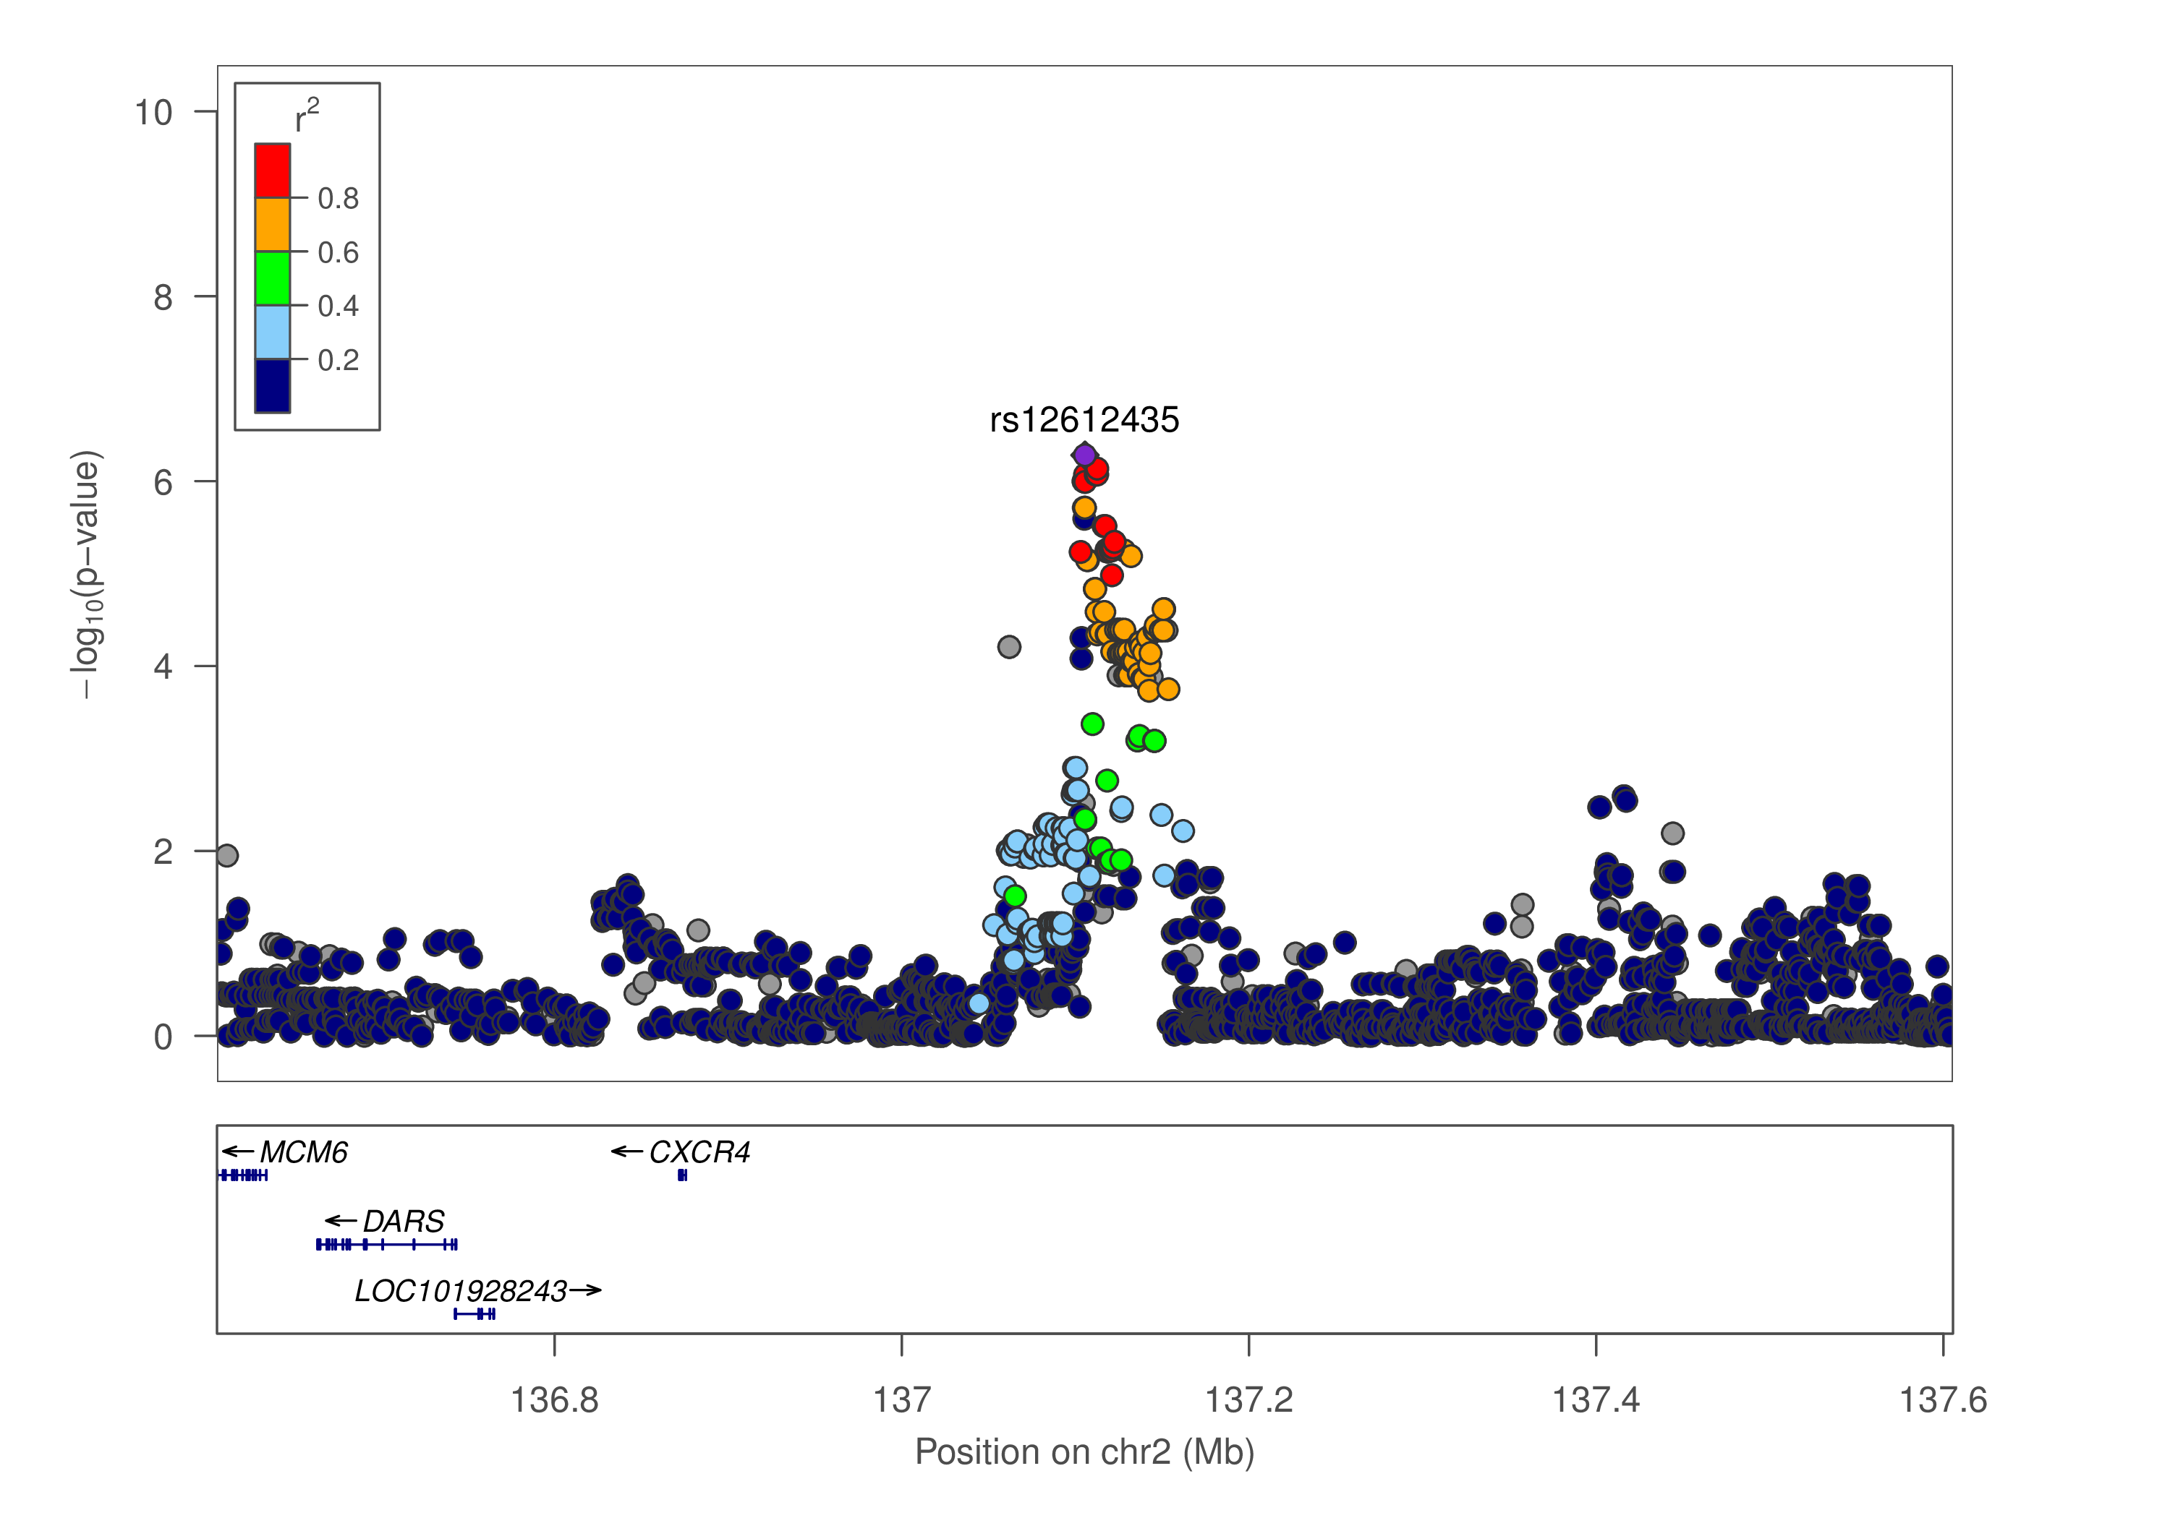

Association plot for rs12612435 on chromosome 2 located nearby CXCR4. Variants in low LD with rs12612435 show eQTL effects for CXCR4 based on HaploReg v4.1. Gene CXCR4 is involved in hematopoiesis and in cardiac ventricular septum formation.

**REFERENCES**

1. Eitel I, von Knobelsdorff-Brenkenhoff F, Bernhardt P, et al. Clinical characteristics and cardiovascular magnetic resonance findings in stress (takotsubo) cardiomyopathy. JAMA. 2011;306(3):277-86.

2. Kumar G, Holmes DR, Jr., Prasad A. "Familial" apical ballooning syndrome (Takotsubo cardiomyopathy). Int J Cardiol. 2010;144(3):444-5.

3. Spinelli L, Trimarco V, Di Marino S, et al. L41Q polymorphism of the G protein coupled receptor kinase 5 is associated with left ventricular apical ballooning syndrome. Eur J Heart Fail. 2010;12(1):13-6.

4. Figtree GA, Bagnall RD, Abdulla I, et al. No association of G-protein-coupled receptor kinase 5 or beta-adrenergic receptor polymorphisms with Takotsubo cardiomyopathy in a large Australian cohort. Eur J Heart Fail. 2013;15(7):730-3.

5. Erdmann J, Grosshennig A, Braund PS, et al. New susceptibility locus for coronary artery disease on chromosome 3q22.3. Nat Genet. 2009;41(3):280-2.