**Short term effects of climate change and intensification of management on the abundance of microbes driving nitrogen turnover in montane grassland soils**

Diana R. Andrade-Linaresa, Marcus Zistl-Schlingmann b, Baerbel Foesela, Michael Dannenmannb, Stefanie Schulz Sa, Michael Schlotera, c*

a Research Unit Comparative Microbiome Analysis, Helmholtz Zentrum München, Neuherberg, Germany

b Institute of Meteorology and Climate Research, Atmospheric Environmental Research, Karlsruhe Institute of Technology, Garmisch-Partenkirchen, Germany

c Chair of Soil Science, Technical University of Munich, Freising, Germany

*corresponding author

Research Unit Comparative Microbiome Analysis, Helmholtz Zentrum München, Ingolstädter Landstraße 1, D-85764 Neuherberg, Germany

Email: schloter@helmholtz-muenchen.de

Phone: +49 893187-2304

Table S1. Thermal profiles and primers used for real-time PCR quantification of different functional genes.



Table S2. Gene abundances in spring and summer for mineralizing bacteria (*apr*, *chiA*), ammonia-oxidizers (archaeal *amoA* (AOA) and bacterial *amoA* (AOB)), nitrite oxidizers (*Nitrospira*-like 16S rRNA (NS) and *nxrA* (NB)), nitrite reducers (*nirK*, *nirS*), nitrous oxide reducers (*nosZ*) and N2-fixing bacteria (*nifH*). Units based on the gene copy numbers per gram of soil dry weight (sdw).



* Significant fixed factors (CC, T) and their interaction (CC*T) are given after ANOVA of nlme models. NSD: not significant difference. Values are means ± standard error. Nitrifiers:Denitrifiers indicates the ratios of AOA+AOB+NS+NB to *nirK+nirS+nosZ*.

Table S3. Correlation matrix between gene abundances and soil/plant properties. Coefficients of determination (R2) are given respectively for extensive and intensive agricultural management at each climate change effect (CC). Significant (*P* < 0.05) Spearman correlations are indicated in bold (n= 9). 

FG: functional group (AOA: archaea *amoA* gene, AOB: bacteria *amoA* gene, NS: *Nitrospira*-like 16S rRNA gene and NB: *Nitrobacter-*like *nxrA* gene). TDN: total dissolve nitrogen (mg N kg-1 sdw), BD: bulk density (g cm-3), PB: plant biomass (g), PNC: plant N content (%), Nmic: microbial N biomass (mg N kg-1 sdw), Cmic: microbial C biomass (mg N kg-1 sdw), DOC:TDN: dissolved organic carbon to total dissolved nitrogen, (C:N)mic: ratio microbial C to microbial N biomass.

Table S4. Multiple stepwise regression analysis of the dependency of mineralizers, nitrifiers and denitrifiers gene abundances to potential control factors in soil under climate change effects (temperature and moisture) at short-term. Significant factors and regression equations are indicated in bold (n=18).



Factors included in the model: TDN: total dissolve nitrogen (mg N kg-1 sdw), DOC:TDN: dissolved organic carbon to total dissolved nitrogen, BD: bulk density (g cm-3), PNC: plant N content (%), Cmic: microbial C biomass (mg N kg-1 sdw), Nmic: microbial N biomass (mg N kg-1 sdw), pH, temp: soil temperature (oC), moisture: soil moisture (cm3 cm-3).

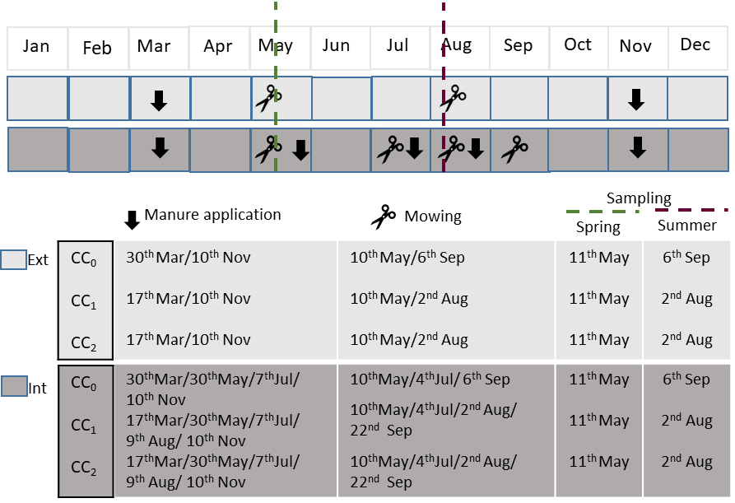

Fig. S1. Scheme of the timing of extensive (Ext) and intensive (Int) agricultural management in 2017 at the sites CC0, CC1 and CC2. Dashed lines are used to illustrate sampling time points in spring (green) and summer (purpura). Black arrows and scissors indicate manure application and mowing, respectively.

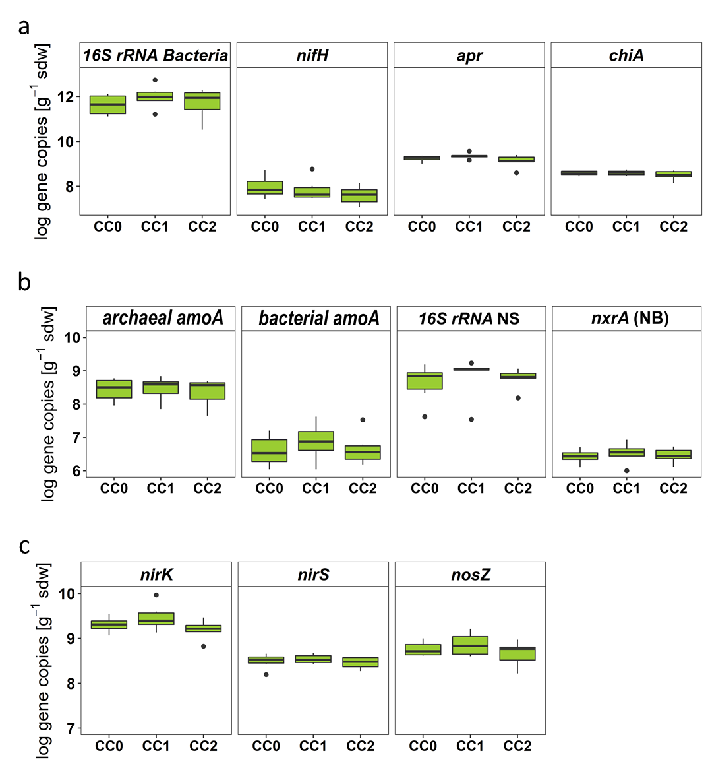

Fig. S2. Gene abundances per gram of soil dry weight (sdw) in spring for: total (16S rRNA ), N2-fixing (*nifH*) and N mineralizing (*apr* and *chiA*) bacteria (a); Nitrifiers (b): ammonia oxidizing archaea (archaeal *amoA*) and bacteria (bacterial *amoA*), nitrite oxidizing (*Nitrospira*-like16S rRNA (NS) and *nxrA* (NB)) bacteria; and denitrifying bacteria (c): nitrite (*nirK* and *nirS*) and nitrous oxide reducing (*nosZ*) bacteria. The mesocosms at the high-elevation (CC0) were translocated to CC0 (Esterberg, 1260 m a.s.l.), CC1 (Graswang, 860 m a.s.l.) and CC2 (Fend, 600 m a.s.l.) and treated similarly by an extensive agricultural management. Boxplots represent soil gene copy numbers (on a log10 scale), medians (black lines inside the box), maximal and minimal values (whiskers) and outliers (black dots) (n=6).

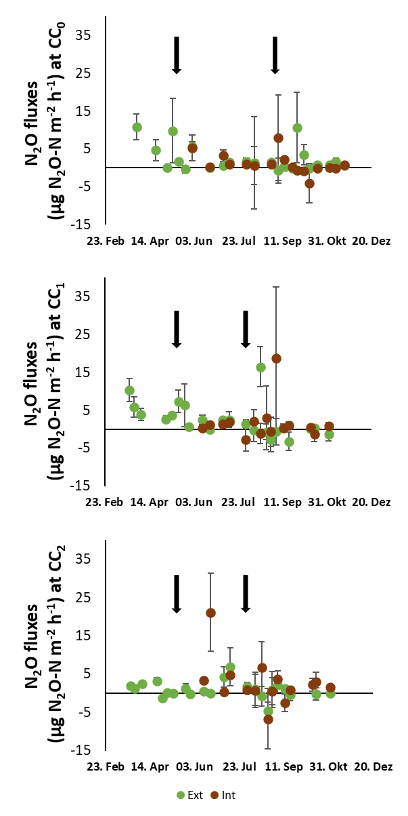

Fig. S3. N2O gas emissions (µg N2O-N m-2 h-1) measured over spring, summer and fall 2017 in the transplanted plan-soil mesocosms similarly treated by an extensive (Ext) and intensive (Int) agricultural management. Values are means ± standard error (n=3). Rows indicate the sampling dates.

**References**

H.J. Bach, A. Hartmann, M. Schloter, J.C. Munch. **PCR primers and functional probes for amplification and detection of bacterial genes for extracellular peptidases in single strains and in soil**. J. Microbiol. Methods, 44 (2001), pp. 173-182, 10.1016/S0167-7012(00)00239-6

H.J. Bach, J. Tomanova, M. Schloter, J.C. Munch. **Enumeration of total bacteria and bacteria with genes for proteolytic activity in pure cultures and in environmental samples by quantitative PCR mediated amplification**. J. Microbiol. Methods, 49 (2002), pp. 235-245, 10.1016/S0167-7012(01)00370-0

G. Braker, A. Fesefeldt, K.-P. Witzel. **Development of PCR primer systems for amplification of nitrite reductase genes (*nirK* and *nirS*) to detect denitrifying bacteria in environmental samples**. Appl. Environ. Microbiol., 64 (1998), pp. 3769-3775, 10.1128/AEM.64.10.3769-3775.1998

D.W. Graham, C.W. Knapp, E.S. Van Vleck, K. Bloor, T.B. Lane, C.E. Graham. **Experimental demonstration of chaotic instability in biological nitrification**. ISME J., 1 (2007), pp. 385-393, 10.1038/ismej.2007.45

S. Henry, E. Baudoin, J.C. López-Gutiérrez, F. Martin-Laurent, A. Brauman, L. Philippot. **Quantification of denitrifying bacteria in soils by *nirK* gene targeted real-time PCR**. J. Microbiol. Methods, 59 (2004), pp. 327-335, 10.1016/j.mimet.2004.07.002

S. Henry, D. Bru, B. Stres, S. Hallet, L. Philippot. **Quantitative detection of the *nosZ* gene, encoding nitrous oxide reductase, and comparison of the abundances of 16S rRNA, *narG*, *nirK*, and *nosZ* genes in soils**. Appl. Environ. Microbiol., 72 (2006), pp. 5181-5189, 10.1128/AEM.00231-06

S. Leininger, T. Urich, M. Schloter, L. Schwark, J. Qi, G.W. Nicol, et al. **Archaea predominate among ammonia-oxidizing prokaryotes in soils**. Nature, 442 (2006), pp. 806-809, 10.1038/nature04983

V. Michotey, V. Méjean, P. Bonin. **Comparison of methods for quantification of cytochrome cd(1)-denitrifying bacteria in environmental marine samples**. Appl. Environ. Microbiol., 66 (2000), pp. 1564-1571, 10.1128/aem.66.4.1564-1571.2000

F. Poly, S. Wertz, E. Brothier, V. Degrange. **First exploration of *Nitrobacter* diversity in soils by a PCR cloning-sequencing approach targeting functional gene *nxrA***. FEMS Microbiol. Ecol., 63 (2008), pp. 132-40, 10.1111/j.1574-6941.2007.00404.x

C. Rösch, A. Mergel, H. Bothe. **Biodiversity of denitrifying and dinitrogen-fixing bacteria in an acid forest soil**. Appl. Environ. Microbiol., 68 (2002), pp. 3818-3829, 10.1128/AEM.68.8.3818-3829.2002

J.H. Rotthauwe, K.P. Witzel, W. Liesack. **The ammonia monooxygenase structural gene *amoA* as a functional marker: molecular fine-scale analysis of natural ammonia-oxidizing populations**. Appl. Environ. Microbiol., 63 (1997), pp. 4704-4712, 10.1128/AEM.63.12.4704-4712.1997

K. Schauss, A. Focks, S. Leininger, A. Kotzerke, H. Heuer, S. Thiele-Bruhn, et al. **Dynamics and functional relevance of ammonia-oxidizing archaea in two agricultural soils**. Environ. Microbiol., 11 (2009), pp. 446-56, 10.1111/j.1462-2920.2008.01783.x

I.N. Throbäck, K. Enwall, Å. Jarvis, S. Hallin. **Reassessing PCR primers targeting *nirS*, *nirK* and *nosZ* genes for community surveys of denitrifying bacteria with DGGE**. FEMS Microbiol. Ecol., 49 (2004), pp. 401-417, 10.1016/j.femsec.2004.04.011

S. Wertz, F. Poly, X. Le Roux, V. Degrange. **Development and application of a PCR-denaturing gradient gel electrophoresis tool to study the diversity of *Nitrobacter*-like *nxrA* sequences in soil**. FEMS Microbiol. Ecol., 63 (2008), pp. 261-71, 10.1111/j.1574-6941.2007.00416.x

X. Xiao, X. Yin, J. Lin, L. Sun, Z. You, P. Wang, et al. **Chitinase genes in lake sediments of Ardley Island, Antarctica**. Appl. Environ. Microbiol., 71 (2005), pp. 7904-7909, 10.1128/AEM.71.12.7904-7909.2005