**New insight into the mechanisms of ectopic fat deposition improvement after bariatric surgery**

1Giulia Angelini, 2Lidia Castagneto Gissey, 2Giulia Del Corpo, 3Carla Giordano, 3Bruna Cerbelli, 1Anna Severino, 4Melania Manco, 2Nicola Basso, 5,6,7,8Andreas L. Birkenfeld 5,6,7,8Stefan R. Bornstein, 2Alfredo Genco, 1,7Geltrude Mingrone, 2Giovanni Casella

1Fondazione Policlinico Universitario A. Gemelli IRCCS, Rome, Italy and Università Cattolica del S. Cuore, Rome, Italy.

2Department of Surgical Sciences, Sapienza University of Rome, Rome, Italy

3Department of Radiological, Oncological and Pathological Sciences, Sapienza University of Rome, Italy

4 Research Unit for Multi-factorial Diseases, Obesity and Diabetes, Istituti di Ricovero e Cura a Carattere Scientifico, Bambino Gesù Children's Hospital, Rome, Italy.

5Department of Medicine III, Universitätsklinikum Carl Gustav Carus an der Technischen Universität Dresden, Dresden, Germany.

6 Paul Langerhans Institute Dresden of the Helmholtz Center Munich at University Hospital and Faculty of Medicine, TU Dresden, Dresden, Germany

7Diabetes and Nutritional Sciences, King's College London, London, United Kingdom.

8 Deutsches Zentrum für Diabetesforschung, DZD e.V., Neuherberg, Germany

Corresponding author:

Professor Giovanni Casella

Department of Surgery

University of Rome “La Sapienza”

Email: giovanni.casella@uniroma1.it

**Table 1.** Statistical data of Plin2-clinical parameters linear regression in monocytes

|  |  |  |  |
| --- | --- | --- | --- |
| Subjects | R2 | P value | |
| HOMA-IR |  | |  |
| Before Sleeve Gastrectomy | 0.55 | | 0.002 |
| After Sleeve Gastrectomy | 0.71 | | <0.0001 |
| Controls | 0.79 | | 0.003 |
|  |  | |  |
| LDL-Cholesterol |  | |  |
| Before Sleeve Gastrectomy | 0.42 | | 0.008 |
| After Sleeve Gastrectomy | 0.38 | | 0.01 |
| Controls | 0.69 | | 0.01 |
|  |  | |  |
| AST |  | |  |
| Before Sleeve Gastrectomy | 0.40 | | 0.02 |
| After Sleeve Gastrectomy | 0.45 | | 0.005 |
| Controls | 0.87 | | 0.0002 |
|  |  | |  |
| ALT |  | |  |
| Before Sleeve Gastrectomy | 0.47 | | 0.004 |
| After Sleeve Gastrectomy | 0.33 | | 0.02 |
| Controls | 0.59 | | 0.01 |
|  |  | |  |

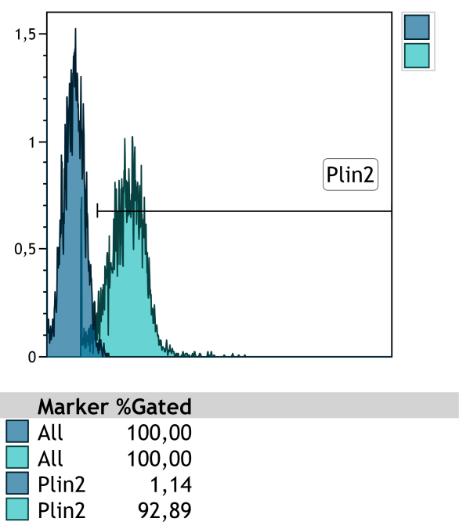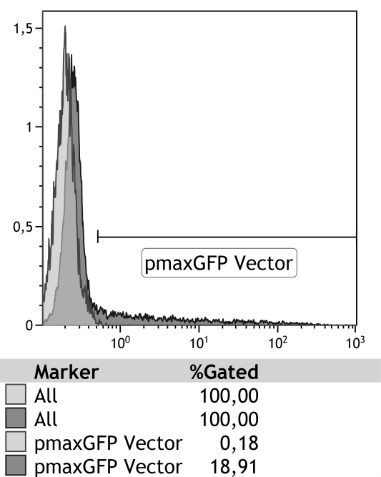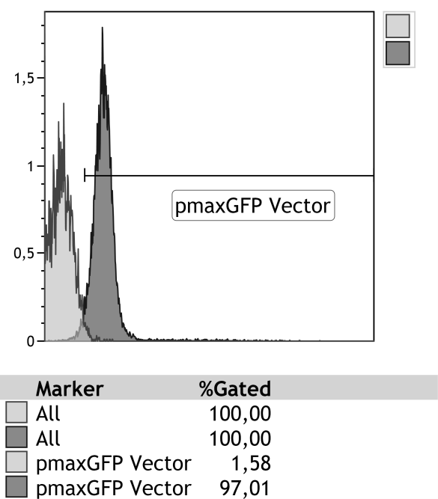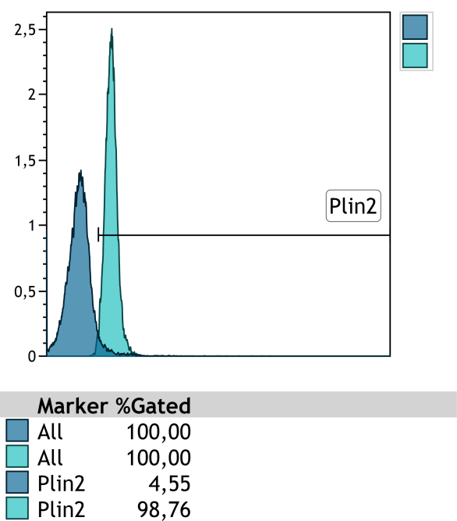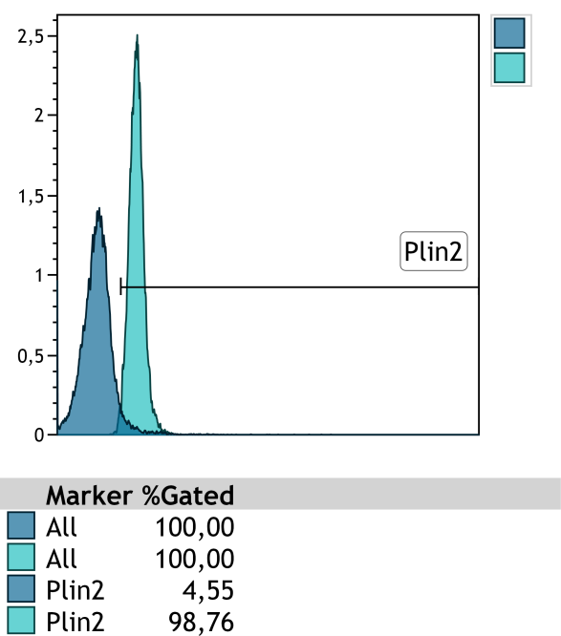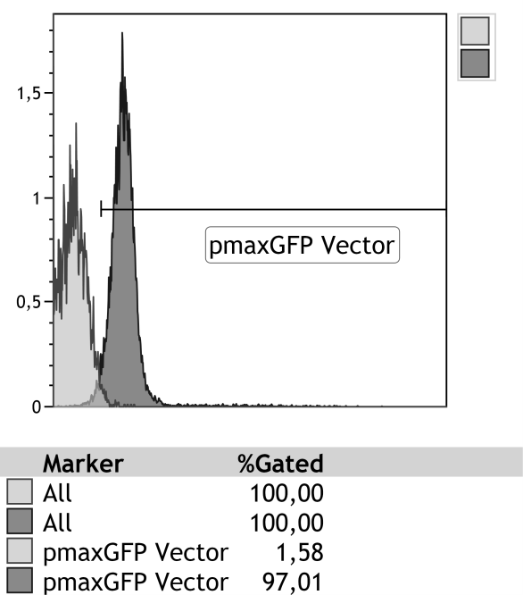

NT

NT

+ pmaxGFP Vector

+ Plin2-GFP Vector

A

B

C

D

**Primary Cultures**

**of monocytes**

**Primary cultures**

**of hepatocytes**



**Supplementary Figure 1. Cell transfection**

**Panels A and C:** Cell transfection efficiency quantified with pmaxGFP vector.

**Panel B and D:** Plin2 quantification by flow cytometry after transfection.

**Uncropped Gels**

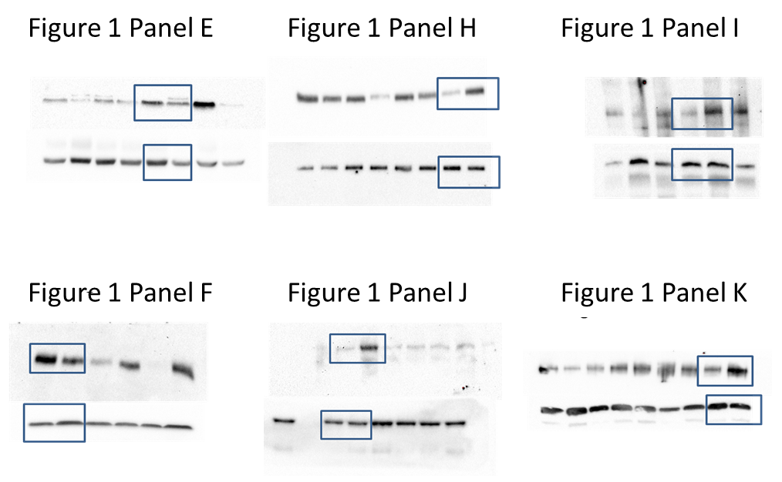

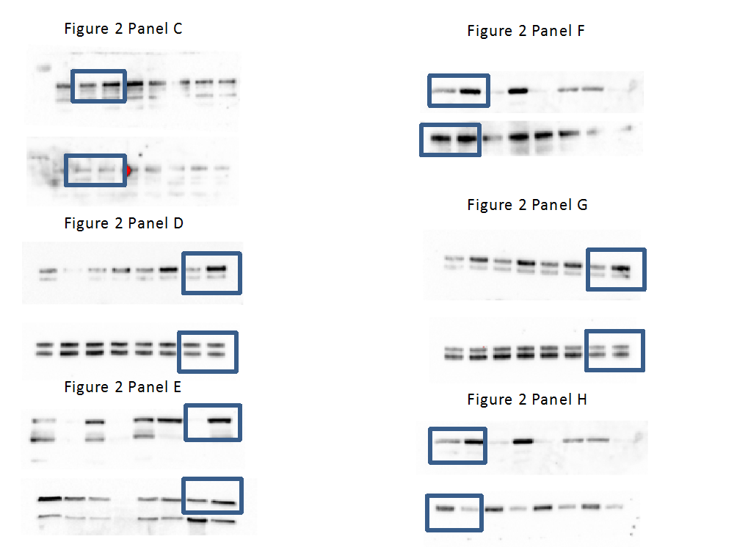

Figure 2 Panel C

Figure 2 Panel F

Figure 2 Panel D

Figure 2 Panel G

Figure 2 Panel E

Figure 2 Panel H

