Risk bases can complement dose bases for implementing and optimizing a radiological protection strategy in urgent and transition emergency phases

Linda Walsha, Alexander Ulanowskib,c, Jan Christian Kaiserb, Clemens Wodab, Wolfgang Raskobd.

a Department of Physics, Science Faculty, University of Zürich, Winterthurerstrasse 190, CH-8057 Zürich, Switzerland

b Institute of Radiation Protection, Helmholtz Zentrum München ­– German Research Center for Environmental Health, Ingolstädter Landstraße 1, D-85764 Neuherberg, Germany

c International Atomic Energy Agency, IAEA Laboratories, A-2444 Seibersdorf, Austria

dKarlsruhe Institute of Technology, Institute for Nuclear and Energy Technologies, Hermann-von-Helmholtz Platz 1, 76344 Eggenstein-Leopoldshafen, Germany

Abstract

Current radiological emergency response recommendations have been provided by the International Commission on Radiological Protection and adopted by the International Atomic Energy Agency (IAEA) in comprehensive Safety Standards. These standards provide dose basis guidance for decisions making (e.g., on sheltering or relocation) via generic criteria in terms of effective dose in the range from 20 mSv per year, during transition from emergency to existing exposure situation, to 100 mSv, acute or annual, in the urgent phase of a nuclear accident.

The purpose of this paper is to examine how such IAEA dose reference levels directly translate into radiation related risks of stochastic detrimental health effects (cancer). Methodologies, provided by the World Health Organization after the Fukushima accident, for calculating the lifetime and 20 year cancer risks, and for calculating relevant organ doses from effective doses, have been applied here for this purpose with new software, designed to be available for use immediately after a nuclear accident. A new feature in this software, is a comprehensive uncertainty accounting via simulation technique, so that the risks may now be presented with realistic confidence intervals. The types of cancer risks considered here are time integrated over lifetime and the first twenty years after exposure for all solid cancer and either the most radiation sensitive types of cancer, i.e., leukaemia, and female breast cancer, or the most radiation relevant type of cancer occurring in childhood, i.e., thyroid. It is demonstrated here how reference dose levels translate differently into specific cancer risk levels (with varying confidence interval sizes), depending on age at exposure, gender, time-frame at-risk and type of cancer considered. A discussion is provided here on the potential for such risk-based information to be used by decision makers, in the urgent and transition phases of nuclear emergencies, to identify protective measures (e.g., sheltering, evacuation) in a differential way (i.e., for particularly susceptible sub-groups of a population).

Introduction

In general, published safety recommendations address requirements for preparedness and response for a nuclear or radiological emergency in: an emergency i.e., in the urgent phase; and also for the transition to an existing exposure situation, i.e., in a transition phase. During the urgent and transition phases of a nuclear emergency, important decisions on implementing measures aimed at protecting affected populations, such as sheltering or relocation, need to be made quickly, effectively and incisively. Such decision making is currently supported by recent publications on safety standard recommendations from the International Atomic Energy Agency (IAEA 2015). IAEA give generic reference levels for use in conjunction with the goals of emergency response in terms of dosimetric bases of reference levels in ranges of effective dose (IAEA 2015). IAEA recommendations, based on publications from the International Commission on Radiological Protection (ICRP 2007), are for a typical band of 20 mSv to 100 mSv for the effective dose to be set for emergency planning in the first year after an incident. Although the IAEA recommendations are based on the 2007 ICRP recommendations, national radiation protection commissions can select other dose limits. The aim of this paper is to show that, in taking decisions aimed at protecting affected populations from stochastic effects (cancer), risk bases can complement dosimetric bases in the decision making process.

Unfortunately, in the past, cancer risk assessment software was not designed to be available for use immediately after a nuclear accident. After the Fukushima nuclear accident on 11th March 2011 (Wakeford 2011), for example, there was a time interval of just under 2 years, between accident occurrence and the publication of the World Health Organization (WHO) health risk assessment (WHO 2013) report. This long time interval was due to the work-load, after the event, in assessing doses, developing a risk assessment framework and developing the risk assessment software (and that was without a full explicit mathematical treatment of risk uncertainties). In order to close such potential future time gaps between accidents and health risk assessments, by implementing lesson learned after Fukushima (Walsh 2016), the European Union-CONFIDENCE (Coping with uncertainty for improved modelling and decision making in nuclear emergencies) project provided funding to develop a risk assessment software (the EU-CONFIDENCE software tool) designed to be immediately available after a nuclear accident. The tool encompasses the risk assessment methodological framework for assessing cancer risks after the Fukushima accident as suggested by a WHO expert group (WHO 2013, Walsh et al 2014) and by the German software tool ProZES (Jacob et al, 2017; Ulanovsky et al, 2016).

The WHO methodology has been applied to: convert the reference levels of effective doses to the organ equivalent doses that are relevant for radiation risk assessment; and to calculate risk of all solid, leukaemia, breast and thyroid cancers from current published risk to dose response models for an illustrative modern European population (i.e., the population data for Germany are applied here) at these converted reference levels of dose.

One new feature of the tool, is a full mathematical treatment of uncertainties in the calculated risks, so that the risks can now be given with confidence intervals. Although German population data are considered here for illustration of the dose to risk conversions, the software tool also implements population data for Scandinavian countries and data for other countries can quickly and easily be included in the future.

It is this new software tool, which has been applied for the calculations presented here to show how reference dosimetric levels can translate into cancer risk estimates and risk uncertainty. It is shown here that any one particular reference dose level will translate differently into risks from stochastic effects depending on age at exposure, gender, the at-risk time-frame considered and cancer risk type. The potential of risk assessment tools that have been fully developed and ready for operation, before any nuclear accident actually takes place, is discussed here along with the idea to incorporate such a tool into currently available dosimetric large-area monitoring systems e.g., the Java based real-time on-line decision support system (JRODOS), (Ehrhardt and Weis 2000 and Ievdin et al. 2010). The JRODOS system has been developed for general application worldwide for use in national or regional nuclear emergency centres. JRODOS provides coherent support at all stages of an accident (i.e., before, during and after a radiological release), including the long term management and restoration of contaminated areas. The system is able to support decisions about the introduction of a wide range of potentially useful countermeasures (e.g., sheltering and evacuation of people, distribution of iodine tablets, food restrictions, agricultural countermeasures, relocation, decontamination, restoration, etc.) mitigating the consequences of an accident with respect to detrimental health effects, the environment, and the economy. JRODOS can be applied to accidental releases into the atmosphere and into various aquatic environments. Appropriate interfaces exist with local and national radiological monitoring data, meteorological measurements and forecasts, and for adaptation to local, regional and national conditions.

Detailed discussions are provided on how such risk information, and the relevant uncertainty levels in this risk information, could potentially be useful for integrating into the radiation protective decision making processes after a nuclear accident.

Materials and Methods

Radiation-related cancer risks were estimated for both males and females initially exposed as infants (age 1 year), children (age 10 years) or adults (age 20 years). Models for specific cancer sites were applied to calculate risks attributable to radiation over a lifetime and over the initial 20 years after the nuclear accident, based on generic recommended reference levels of effective dose converted to organ/tissue dose, and using health statistics data from a contemporary illustrative European population (i.e., for Germany).

*Effective dose conversion to organ/tissue dose*

Current IAEA safety standards in their part 7 (IAEA 2015, p. 64) give generic criteria for use in conjunction with the goals of emergency response in terms of effective dose in the range 20–100 mSv, acute or annual, that includes dose contributions via all exposure pathways.

The ICRP has expressed caution in the use of effective dose for purposes of estimating risks to individuals or populations exposed to ionizing radiation, especially for very heterogeneous exposures in medical procedures (ICRP 2007, paragraph 151). Therefore, in order to calculate the risks corresponding to these IAEA reference levels of 100 mSv, acute or annual, in the urgent phase and an effective dose of 20 mSv per year in the transition phase it is necessary to convert these levels into organ/tissue doses for each of the target organs for the types of cancers evaluated (i.e. colon, red bone marrow, thyroid and breast organ/tissue doses for all solid cancer, leukemia, thyroid and breast cancer, respectively).

A methodology that can be applied to calculate organ doses from effective doses for the general population has already been presented (WHO 2013, Annex G, p 133). In an emergency situation, the organ doses could result from four possible contributions: external exposures from ground deposition; external exposures from the release plume; internal exposures from the inhalation of radionuclides in the release plume; and internal exposures from ingestion of radionuclides in foodstuff. However, the relative contributions to the organ doses from each of these four sources will be highly dependent on the nature of the accident and so it is difficult to generalize a conversion from all of these sources for a generic consideration here. Therefore, in order to simplify and illustrate this general consideration of risk bases for decision making, it is assumed here that either an acute or annual (first-year) effective dose just comes from external exposures in a situation like the Fukushima release (the limitations of such an important assumption are fully given in the discussion section). Under this assumption, with only external exposure and photons being relevant, the radiation weighting factor is 1 and thus the protection quantity effective dose (in mSv) is either: very similar to the physical measured organ absorbed dose (in mGy); or equal; or assumed to be equal (for child and infant breast tissue for which no dose coefficients have been given) . With such assumptions the ratio of organ to effective dose from external exposures can be taken from Table 19 of the WHO Report (WHO 2013, Annex G, p. 134). The organ dose ranges corresponding to an effective dose range of 20 to 100 mSv, may then be calculated using these ratios.

*Health statistics data*

Population cancer incidence and mortality rates, given by sex, cancer site and 5-year age group, for 2014, are available from the German cancer register (RKI-GEKID, 2017). All-cause mortality rates for 2013/2015 and general survival data from life tables for Germany are available from the German Federal Office for Statistics (Statistisches Bundesant, 2016).

*Risk models for specific cancer sites*

The cancer incidence types considered with ICD 10 classifications were: all leukemia plus lymphoma (ICD10:C81-C96), excluding CLL (C91.1 & .4) and excluding ATL (C91.5), and female breast cancer (C50), due to the known radio-sensitivity of these two cancer groupings; and thyroid cancer (C73) which is the most radiation relevant type of cancer occurring in childhood. These three groupings have been demonstrated to show a radiation risk effect modification by age-at-exposure (*UNSCEAR 2013*). The grouping “all solid cancer” (C00-C80, all cancers except leukemia, lymphoma and multiple myeloma) was included to: provide the overall cancer risk from radiation; to acknowledge that radiation can cause cancer in most organs/tissues of the body; and to provide risk estimates based on a large outcome grouping with a higher statistical power than otherwise obtainable just from analyses on individual cancer sites.

The risk to dose response models in terms of excess relative risk (*ERR*) and excess absolute risk (*EAR*) for these four cancer incidence site groupings were mostly taken from current publications: the Japanese A-bomb survivor Life Span Study (LSS) cohort with a follow-up 1958–2001 (Hsu et al. 2013) for leukaemia; the LSS cohort with a follow-up1958–1999 (Jacob et al. 2014) for thyroid cancer; a pooled study of eight cohorts (Preston et al. 2002) for breast cancer; and the LSS cohort with a follow-up 1958–2009 (Grant et al. 2017) for all solid cancer (although Grant et al. 2017 did not publish an EAR model unadjusted for smoking, that would have been suitable for this application, – the authors have provided such a model in Appendix A). These models have: the form of a linear dose-response function for all solid cancers, thyroid cancer and female breast cancer; a linear-quadratic dose-response function for leukemia; and include risk effect modification by age-at-exposure (*e*), sex (*s*) and attained age (*a*). The combined excess risk (*ER*) model, *ER* (*d*, *e*, *a, s*) is given by

|  |  |  |
| --- | --- | --- |
|  |  | (1) |

where: *f* is the weighting factor between an additive (*EAR*) and a multiplicative (*ERR*) transfer of risk; *m*(*a*, *s*) is the age- and sex-specific baseline cancer incidence rate. To allow for modelling uncertainty associated with unknown type of risk transfer mechanism the value of the factor *f* has been assumed uniformly distributed in the range from 0 to 1. Computations in this paper have been performed using contemporary cancer incidence rates for an illustrative European population (Germany) in 2014.

*Risk quantities*

The conventional lifetime attributable risk (*LAR*) (Thomas et al. 1992, Vaeth et al. 1990) was selected as the risk quantity for application here. *LAR* is equivalent to the risk of exposure-induced death or incidence of, cancer (*REID*) and other similar measures (Kellerer et al. 2001) at the doses relevant to protecting populations from stochastic effects under organ doses of about 0.5 Gy.

The central estimate for the attributable risk from either one annual dose or one acute dose, , specifies the sex (*s*) and age-at-exposure (*e*) specific cumulative probability of a specific cancer attributable to radiation exposure with dose *d*. The AR involves integrating over time, *t*, from *e* up to an age *a*:-

|  |  |  |
| --- | --- | --- |
|  |  | (2) |

Here *d* is the dose delivered to the organ/tissue at age-at-exposure *e*, and is a function varying from 0 to 1 which accounts for latent time between the delivery of the dose to the organ and the expression of the radiation-induced cancer risk.

If integration of risk is performed over the whole lifetime, then eq. (2) converges to a conventional definition of *LAR*:

|  |  |  |
| --- | --- | --- |
|  | . | (3) |

The latency function, , for all solid cancers, including breast and thyroid cancers, grow from zero to one in the range, approximately, from 1.5 to 7 years since exposure, while reaching the value 0.5 at time 3.5 years since exposure (where these values were chosen with a consideration of recommended values (UNSCEAR 2006 Report, BEIR VII – Phase 2 Report, Heidenreich1999)). For leukemia, the latency period is shorter, and the corresponding latency function varies in range from 1 to 3 years since exposure, while having the value of 0.5 at time 1.5 years after exposure (again values were chosen to be consistent with recommended values (*UNSCEAR 2013, Annex B))*.

The conditional survival curve , is the probability of surviving cancer-free to age *t* conditional on the probability to be alive and disease-free at the age of exposure. was calculated from the German life tables as well as cause-specific incidence and mortality rates in 2015, as described above*.* *LAR* or *AR* were also considered by comparisons with the lifetime or age-specific baseline risk (*BR* or *LBR*, correspondingly) in order to put radiation-related cancer risks into perspective of risk of spontaneous cancer in Germany (i.e., the risk in the absence of radiation exposure from an accident). Applying the same notation as for definition of *AR* (eq. 2), the *BR* and *LBR* conditional on disease-free survival to age *e* are calculated as:

|  |  |  |
| --- | --- | --- |
|  |  | (4) |

The duration of any lifetime segment at-risk considered, depends on the age at exposure (i.e., the higher the ages at initial exposure the shorter the lifetime segment up to old age). This causes any comparisons of results among different ages at exposure to be complicated. Therefore, the cumulative risks over 20 years-at-risk after the initial exposure (*AR*20, *BR*20) were also calculated. *AR*20 can be a suitable representation to satisfy interest in early risks of cancer from a short-term public health perspective and also for comparisons between calculated risks and risks potentially provided by any epidemiological studies initiated after an emergency. *AR*20 is particularly relevant for cancer types such as leukaemia and thyroid cancer where the relative increase in risk is expected to be stronger during the first few decades after exposure during childhood. It is pertinent to note that these risk quantities, although they can be based on individual doses, cannot represent an individual’s risk due in-part to a lack of knowledge on other individual risk factors (see discussion). The forms given in the equations (2)–(4), which result in probability values for the various risk measures, are therefore more appropriate to consider in the results section, when simply converted into number of cases per 10,000 persons.

*Treatment of uncertainties in the risk calculations.*

Such lifetime risk estimates are associated with large uncertainties that were quantified here with stochastic simulation following a methodology that has recently been described for non-time integrated risks (Ulanowski et al. 2016) and time integrated thyroid cancer risks (Jacob et al. 2014, with full details in the supplementary material for this cited reference). The following uncertainties were included here in the simulation of overall risk uncertainties:

1. The radiation risk model parameters from the A-bomb LSS cohort and the pooled breast cancer cohorts were sampled from a multivariable normal distribution using best estimates of the parameters and respective covariance matrices, including parameters specifying baseline incidence in the LSS cohort.

2. The transfer factors *f* (i.e., from Equation 1, for apportioning additive and multiplicative radiation risk contributions) were sampled from a uniform distribution: .

3. Dose rate effects were sampled from a lognormal distribution with a geometric mean of 1.0 and geometric standard deviation varying as a linear function of dose rate (Jacob et al, 2014, 2017) with value of 1.5 at dose rate 1.5 mGy d−1 and value of 1 at dose rate equal to or higher than 6 mGy h−1.

4. The minimum latency periods were sampled from a sigmoid distribution with parameters suggested by I. Apostoaei (ORRISK, USA) and found in Jacob et al. (2017).

5. Uncertainty of incidence data was sampled from Poisson distributions of the reported number of cancer cases in a country in the corresponding 5-year age interval.

6. The doses were sampled from a log-normal distribution, with arithmetic means of 20 and 100 mSv (converted into organ doses appropriate to the cancer outcome type considered, Table 1). The geometric standard deviations were assumed here to be 1.5 (see e.g., Harada 2014) and the arithmetic mean organ dose values were converted to geometric means to account for the known inequality between these two quantities.

Results

Table 1 gives the organ dose ranges corresponding to an effective dose range of 20 to 100 mSv, calculated with the ratios of organ to effective dose from external exposures, taken from Table 19 of the WHO report (WHO, 2013, Annex G, p. 134).

The *LAR*, *LBR*, *AR*20 and *BR*20 risks (i.e., integrated over lifetime and the first 20 years at-risk since exposure) which have been simply converted from probabilities to numbers of excess cases and number of baseline cases per 10,000 persons, for age at exposure 1, 10 and 20 years, are given in Tables 2–5, and Figures 1–4, for all solid cancers, leukaemia, thyroid and female-breast cancers, respectively.

Considering the risk of all solid cancers (Table 2 and Figure 1), it can be seen that adult females have a larger radiation risk than adult males, over the first 20 years-at-risk since exposure and over lifetime, but male adults have a lower baseline risk over the first 20 years-at-risk since exposure, but a higher lifetime baseline risk than females. For children and infants the lifetime and 20 year radiation risk is higher for females than for males. Given that the grouping “all solid cancer” will provide risk estimates with higher statistical power than obtainable with individual cancer sites it is noteworthy that the 95% confidence intervals on the numbers of cases expected per 10,000 persons at 100 mSv over lifetime are still large e.g., 416 (95%CI: 164; 1200), 350 (95%CI: 149; 895) and 257 (95%CI: 112; 618) for females exposed as infants, children and adults respectively.

The trends apparent from Table 3 and Figure 2 for leukaemia, in the radiation risk sex differences, reflect those differences reported in the *ERR* and *EAR* LSS risk models (Hsu et al. 2013) i.e., the *ERR* model did not support a gender effect but the *EAR* did, with a female to male ratio of 0.66. Due to the equal probability of additive and multiplicative transfer types in the *LAR* calculations applied here, it can be seen that the male radiation risks are consistently slightly higher than the female risks at the same doses and for all ages at exposure considered. The male leukaemia baseline risk over the first 20 years-at-risk since exposure and over lifetime are also consistently higher than the female risks for all three ages at exposure considered. It can also be seen from Table 3, by comparing the numbers of cases per 10,000 persons after 20 years-at-risk since exposure with the numbers of cases per 10,000 during lifetime, that a substantial proportion of the overall radiation risk is accumulated in the first 20 years-at-risk since exposure: for adults and children, just under half of the lifetime risk from 100 mSv is accumulated in the first 20 years-at-risk; and for infants about two-thirds of the lifetime risk from 100 mSv is accumulated in the first 20 years-at-risk.

Considering the risks for thyroid cancer given in Table 4 and Figure 3, it can be seen that females have higher radiation risks at the same dose and higher baseline risks than males. The numbers of cases expected per 10,000 at 100 mSv over lifetime is 41, 20 and 9 for females exposed as infants, children and adults respectively. The numbers of cases expected per 10,000 at 100 mSv over lifetime is 9, 5 and 3 for males exposed as infants, children and adults respectively. However, it can be seen from Table 4 and Figure 3 that the uncertainties on these expected numbers of cases are large.

Table 5 and Figure 4 show, for female breast cancer, that the numbers of cases expected per 10,000 for an exposure of 100 mSv over lifetime is 173, 109 and 65 for exposure as infants, children and adults respectively.

Compared to the numbers of cases for female all solid cancers expected per 10,000 at 100 mSv over lifetime of 416, 350 and 257 for exposure as infants, children and adults respectively – the breast cancer risk represents a substantial fraction of the total all solid cancer risk. This feature of the results can also be seen from Figure 5 which shows the expected number of cases per 10,000 persons for different types of cancer, calculated from the LAR for 100 mSv effective dose for age at exposure of 1 year. From Figure 5 it can also be seen that in absolute terms, the risks for thyroid cancer and leukaemia are much smaller than for all solid cancer and female breast cancer.

Discussion

In the past, cancer risk assessment software was not designed to be fully developed and ready for operation, before a nuclear accident actually took place. Therefore, after the Fukushima nuclear accident in March 2011 there was no suitable software available for immediate use. The time intervals between the Fukushima nuclear accident on 11th March 2011 and the publication of various international health risk assessments, such as those from the WHO (WHO, 2013) or UNSCEAR (UNSCEAR, 2014), of just under two years and just over three and a half years respectively, is illustrative of this situation. Such long time intervals are generally due to the work-load, after the event, in assembling expert groups, assessing doses, developing a risk assessment framework and developing the risk assessment software.

There is therefore a great potential for risk assessment tools that have been fully developed and are ready for operation, before any nuclear accident actually takes place. The probability for such an accident to happen in the next decades is not negligible (Kaiser 2012). Such potential is even greater, if the risk assessment tools can be either directly integrated into, or used in tandem with, currently available dosimetric large-area monitoring systems (e.g., JRODOS, Ehrhardt and Weis 2000 and Ievdin et al. 2010).

JRODOS so far provides only dose based results as input to the decision making process. Doses might be either based on prognostic calculations applying an estimated source term and numerical weather prognosis data or on available monitoring information. The monitoring information is point based but, within the EU-CONFIDENCE project, interpolation schemes are under development to provide aerial information from the prognostic calculations. However, as discussed above, risk based assessments are important for estimating health effects and deciding on interventions e.g., on medical screening actions. Effective medical screening has to be initiated early after the emergency and thus risk based approaches, complementary to monitoring and prognosis results, will improve the potential in decision making.

In providing a framework and a software for use in health risk assessment, it is important to stress the necessity of avoiding any misunderstandings in the interpretation of the risks calculated. Risks in terms of lifetime attributable risks, LAR, calculated here, although they could be based on individual doses, cannot represent an individual’s cancer risks. This is because there is generally no information on important co-factors that influence a particular individual’s cancer risk such as: individual radiation sensitivity; any genetic pre-disposition to cancer development; lifestyle factors such as smoking status and alcohol intake; occupational risk factors; and past medical conditions treated with chemotherapy or radiation. Furthermore, population-based incidence and survival curves, used in the integration of risks over time, only represent average values for the national population considered. With all of these factors considered, LAR and AR20 should therefore be interpreted as an average risk for specific ages at exposure and genders. So, for example, an all solid cancer incidence LAR of 0.0264 (probability) for a male exposed to 100 mSv at age 1 year old, should not be interpreted as an individual’s risk, but must be seen statistically - out of 10,000 males exposed at age 1 year old to 100mSv effective dose, there is a probability that, on average, 264 (note the wide 95% confidence intervals ranging from 88 to 1097) will develop radiation related all solid cancer during their lifetimes - and on average, 4002 will develop "baseline/spontaneous" cancers during their lifetimes. These risks, computed using the procedure defined above, are mathematical expectations of the number of new radiation-attributed and baseline cases. Their uncertainty ranges (CIs) only reflect uncertainty of the estimates. The number of cases observed in future would have additional sources of variability (uncertainty), dependent on e.g., the size of the population group, or future developments in the secular trends in population statistics (on which the risks are based) which are not accounted for here. Further work is currently being done on methods that reduce the dependence, of radiation related risk assessments, on population statistics and survival curves (Ulanowski et al 2019).

In developing the risk assessment framework applied in the WHO Fukushima Health Risk Assessment Report (WHO 2013), the WHO expert panel considered that risk assessment should be based on a comprehensive assessment of all current evidence from all of radiation epidemiology and not only on the epidemiological evidence available from past nuclear accidents such as Chernobyl. Similarly, the authors consider that the risk assessment framework applied in the software tool described here, should also be based on comprehensive assessment of all current evidence from radiation epidemiology. There are several disadvantages to considering only radiation epidemiological evidence from past nuclear accidents. Many of these studies have risks that are compatible with risks from other types of studies (e.g., Thyroid cancer risks in post-Chernobyl studies and the LSS studies, see e.g., Fig 4 of Jacob et al. 2014) – so other types of studies can provide added weight of evidence to risk-levels determined from post nuclear accident studies. Generally, the ecological study designs that can be applied after nuclear accidents, are not as reliable as other cohort-type study designs applied in other types (e.g., occupational) of studies. Also there have been several meta-analytical studies looking into the effects of low-dose and low dose rates on cancer risks from a broad range of epidemiological studies (e.g., Shore et al. 2017), evidence from studies such as these, would be ignored, if only studies from past-nuclear accidents were considered.

In order to simplify and illustrate this general consideration of applying risk bases for decision making, it is assumed here that either an acute or annual (first-year) effective dose just comes from external exposures in a situation comparable to the Fukushima release. This assumption is unfortunately not fully applicable in a real post-accident situation because the acute dose could, in practice, be dominated by the inhalation contribution. Only in the case of rain, is inhalation not the dominant pathway in the early phase. Longer term total doses might be more influenced by the external dose contribution to the total dose. It is important to stress that unfolding the effective dose back to organ doses (as in table 1) would reasonably work for external exposure only. For internal exposure, the effective dose is the committed dose for 50 to 70 years, so for longer living (137Cs, 90Sr, actinides) or non-uniformly distributed radionuclides (131I, bone-seeking radionuclides) such an unfolding may be regarded as implausible. However, the aim here was to illustrate how risk bases can be applied to complement decision making based on dose bases, not necessarily to reproduce fully realistic post-accident dosimetric situations which will depend heavily on the type of accident and local conditions at the time of the accident and immediately following.

In deciding on the types on uncertainties to apply to the dosimetric reference levels, it should be considered that a reference level is an operational intervention level, above which, an action is taken. In that sense, reference levels are deterministic values, with no uncertainties per definition. The uncertainty in the decision making is introduced by comparing assessed or measured doses (that do have uncertainty) with the reference level (without uncertainty). Consequently, an uncertainty has been assigning here to the reference levels in order to consider the uncertainty in the actually assessed doses. The question then is, whether these assessed doses are log-normally distributed or normally distributed. On the one hand, measured doses for an individual (e.g. thyroid absorbed dose) could be expected to follow a normally distributed error, but doses calculated from simulations and estimated source term or assessed from monitoring data could be better represented by log-normally distributed uncertainties. For the purpose of the main results given here, a log-normal distribution was applied with GSD=1.5 ( see e.g. Harada et al. 2014) but all tables were also calculated for a normal distribution with a SD which is 20% of the dose reference level (these results tables are not shown but are available on request from the first author). The differences between the risk factors when calculated for both types of dose uncertainties was found to be quite small. As examples of this if one considers the all solid cancer number of lifetime cancers from exposure to 100 mSv at 1 year (i.e., as given in Figure 5) for males and females the values are 264 (88; 1097) and 416 (164; 1200) respectively, these are 279 (119; 898) and 455 (224; 975) respectively, when calculated assuming that dosimetric errors follow a normal distribution with a SD which is 20% of the dose reference level. In the calculations presented here, the dosimetric reference levels have been assumed to be at the center of the dosimetric uncertainty treatment. In practice, the reference levels could pertain to maximum doses. In this situation, and based on real life dosimetric data, the confidence tool could then be applied treating the dosimetric uncertainties with a realistic dose distribution with the reference levels taken to be the upper 90% or 95% confidence level of the dose distribution. Such an application of the software tool will be considered for further work.

Although current radiological emergency response recommendations have been provided in safety standards and requirements published by the IAEA (IAEA, 2015) and based on the 2007 Recommendations of ICRP (ICRP 2007), not all countries will adopt the recommendations exactly. Currently accepted dosimetric reference levels vary in different European countries. For example, the UK uses reference levels that are higher than recommended by IAEA of 30–300 mSv whole body dose for evacuation (Ashley et al 2017). In Germany, the national Commission on Radiological Protection (SSK, 2014) has decided to adopt the 2007 ICRP recommendations, and the IAEA safety requirements. Similarly, in Switzerland, the ICRP recommendations and the IAEA safety documents have been adopted (Swiss RPO, 2017 - Art 123).

Such differences in national currently accepted dosimetric reference levels can broadly be translate linearly into risk differences, for the same dose metric, for the all solid cancer, breast cancer and thyroid cancer risks presented in this paper– because the LAR estimates are calculated from linear ERR and EAR models. However the leukaemia risks would need to be recalculated for other reference doses due to the parabolic shape of the leukaemia ERR and EAR dose response applied here (Hsu et al. 2013). Based on current epidemiological data, the assumption of linearity in the risk to dose response for solid cancers (i.e., Linear Non-Threshold, LNT), appears to be the most practical and prudent choice for radiation protection purposes (NCRP 2018, Shore et al. 2018).

The results given in Tables 2–5 (and the Figures 1–5), show how reference dose levels can translate differently into risks depending on age at exposure, gender, the length of the at-risk time-frame considered and cancer risk type. These results illustrate the potential for such risk-based information to be used by decision makers, in the urgent and transition phases of nuclear emergencies, to identify protective measures (e.g., sheltering, evacuation) in a differential way (i.e., for particularly susceptible sub-groups of a population). For example, sensitive sub-groups of the population can be identified, such as children, for priority consideration. Application of nominal risks provided by ICRP 103 (ICRP, 2007), could in theory also be applied for this purpose, but due to the method of calculation, which involves averaging lifetime risks calculated in 5 year intervals of age at exposure, over age at exposure, and averaging over sex, differential risk information is lost. Also the new software tool presented here may be applied with directly relevant population data for the geographical area at risk. Another advantage of applying risk-bases similar to those presented here, is that they include realistic 95% confidence intervals, allowing decision makers to consider best case and worst case scenarios, before implementing protective measures.

Conclusions

Due to long delays, in the past, between the occurrence of nuclear accident and the publications of relevant radiation related health risk assessments, it is useful to have a software tool ready and available, before future accidents occur. The EU-CONFIDENCE tool, described here, is a software that can provide risk based assessments (with uncertainties) potentially important for estimating health effects and deciding on interventions such as medical screening actions. Effective medical screening has to be initiated early after the emergency and so risk based results are recommended for consideration and to be complementary to monitoring and prognosis results. Such a joint consideration of risk bases and dose bases, should improve the overall evidence bases on which important radiation protection decisions will need to be made after a nuclear accident.

Acknowledgements

This project has received funding from the Euratom research and training programme 2014–2018 under grant agreement No 662287. The EU-CONFIDENCE project is part of the CONCERT project.

This publication reflects only the author's view. Responsibility for the information and views expressed therein lies entirely with the authors. The European Commission is not responsible for any use that may be made of the information it contains.

This paper makes use of data obtained from the Radiation Effects Research Foundation (RERF), Hiroshima and Nagasaki, Japan. RERF is a public interest incorporated foundation funded by the Japanese Ministry of Health, Labour and Welfare (MHLW) and the U.S. Department of Energy (DOE). The data include information obtained from the Hiroshima City, Hiroshima Prefecture, Nagasaki City, and Nagasaki Prefecture Tumor Registries and the Hiroshima and Nagasaki Tissue Registries. The conclusions in this paper are those of the authors and do not necessarily reflect the scientific judgment of RERF or its funding agencies.

Appendix

Supplementary model fitting results are given here for the LSS all solid cancer incidence Excess Absolute Risk (*EAR*) risk model applied in the software tool. This was necessary because the original publication (for follow-up 1958–2009, Grant et al 2017) did not provide an *EAR* model without smoking adjustment (i.e., an *EAR* model with the same adjustments as the *ERR* model given as the first entry in Table 5 of Grant et al (2017)). Such a model is analogous to the earlier *EAR* all solid cancer incidence model (for follow-up 1958 to 1998, Preston et al 2007) that was found to be very appropriate for and used in the WHO Fukushima risk assessment (WHO 2014). The fit parameters (see Table A1) and parameter covariance matrix for this EAR model, unadjusted for smoking, were obtained by using the publicly available data set (rerf.or.jp) and the EPICURE software with the AMFIT module (Preston et al 1993) for Poisson regression on grouped data.

Table A1. Fit parameters for the LSS EARmodel considered with the general form , where is the total incidence rate, is the baseline incidence rate, *e* is age at exposure, *a* is attained age (both in years), *s* is sex, *d* is the dose (Gy) delivered to the organ/tissue, i.e., colon dose, at age *e*.

|  |  |
| --- | --- |
| **All solid cancer** This model was fitted by the current authors using the dataset  sol_col_2017ext_v1.csv  from <http://www.rerf.or.jp>,  as recently applied (*Grant et al 2017*) |  |
| fit parameters with standard errors are:  *t* = 0.1385±0.06223,  *kd* = 53.31±4.772,  = 0.03195±0.005086,  = 2.350±0.2097  (deviance = 57405.1, df = 185095) |

References

Ashley SF, Vaughan GJ, Nuttall WJ, Thomas PJ (2017) Considerations in relation to off-site emergency procedures and responses for nuclear accidents. Process Safety and Environmental Protection 112:77–95

Ehrhardt J, Weis A (eds.) (2000) RODOS: Decision Support System for Off-Site Nuclear Emergency Management in Europe, Final report of the RODOS project, European Commission, Brussels. Report EUR 19144, ISBN No. 92-828-9773-7, includes 2 CDs with all the technical details of the RODOS Systems

Grant EJ, Brenner A, Sugiyama H, Sakata R, Sadakane A, Utada M, Cahoon EK, Milder CM, Soda M, Cullings HM, Preston DL, Mabuchi K, Ozasa K (2017) Solid Cancer Incidence among the Life Span Study of Atomic Bomb Survivors: 1958–2009. Radiat Res 187(5):513-537

Harada KH, Niisoe T, Imanaka M, Takahashid T, Amakoe K, Fujiia Y, Kanameishia M, Ohsef K, Nakaif Y, Nishikawaf T, Saitof Y, Sakamotog H, Ueyamah K, Hisakii K, Oharai E, Inouej T, Yamamotok K, Matsuokal Y, Ohatae H, Toshimam K, Okadan A, Satoo H, Kuwamorip T, Tanip H, Suzukiq R, Kashikuraq M, Nezur M, Miyachis Y, Arait F, Kuwamoriu M, Haradav S, Ohmoriv A, Ishikawab H, and Koizumia A (2014) Radiation dose rates now and in the future for residents neighboring restricted areas of the Fukushima Daiichi Nuclear Power Plant. PNAS 111 (10): E914-E923

Hsu WL, Preston DL, Soda M, Sugiyama H, Funamoto S, Kodama K, Kimura A, Kamada N, Dohy H, Tomonaga M, Iwanaga M, Miyazaki Y, Cullings H, Suyama A, Ozasa K, Shore R, Mabuchi K (2013) The Incidence of Leukemia, Lymphoma and Multiple Myeloma among Atomic Bomb Survivors: 1950–2001. Radiat Res 179(3):361-82

IAEA (2015) Preparedness and Response for a Nuclear or Radiological Emergency. IAEA Safety Standards Series (No.GSR Part 7)

Ievdin I, Trybushnyi D, Zheleznyak M, Raskob W (2010) RODOS re-engineering: aims and implementation details. In: Raskob W, Hugon M (eds) Enhancing nuclear and radiological emergency management and rehabilitation: Key results of the EURANOS European project. Radioprotection 45 (5 Supplement): S181-S189

International Commission on Radiological Protection (2007) The 2007 Recommendations of the International Commission on Radiological Protection, ICRP 2007, Annals of the ICRP 103(37):2–4

Jacob P, Kaiser JC, Ulanovsky A (2014) Ultrasonographic surveys and thyroid cancer in the Fukushima Prefecture. Radiat Environ Biophys 53:291-401 and 403 (erratum)

Jacob P, Kaiser C, Ulanovsky A (2017) ProZES – a tool for assessment of assigned share of radiation in probability of cancer development. Bundesamt für Strahlenschutz (BfS). Report BfS-RESFOR-120/17. URL: <http://doris.bfs.de/jspui/handle/urn:nbn:de:0221-2017032014253>

Kaiser JC (2012) Empirical risk analysis of severe reactor accidents in nuclear power plants after Fukushima. Sci. Tech. Nucl. Inst., Article ID 384987, doi:10.1155/2012/384987

Kellerer AM, Nekolla EA, Walsh L (2001) On the conversion of solid cancer excess relative risk into lifetime attributable risk. Radiat Environ Biophys 40:249-257

NCRP Commentary No. 27 (2018) Implications of recent epidemiologic studies for the linear nonthreshold model and radiation protection. NCRP

Preston DL, Lubin JH, Pierce DA (1993) Epicure User`s Guide. HiroSoft International Corp., Seattle

Preston DL, Mattsson A, Holmberg E, Shore R, Hildreth NG & Boice JD (2002) Radiation effects on breast cancer risk: A pooled analysis of eight cohorts. Radiat. Res. 158:220–235

Preston DL, Ron E, Tokuoka S, Funamoto S, Nishi N, Soda M, Mabuchi K, Kodama K (2007) Solid cancer incidence in atomic bomb survivors: 1958-1998. Radiat Res 168: 1-64

RKI-GEKID (2017) Krebs in Deutschland für 2013/2014. 11. Ausgabe. Robert Koch-Institut (Hrsg) und die Gesellschaft der epidemiologischen Krebsregister in Deutschland e.V. (Hrsg). Berlin

Shore RE, Beck HL, Boice JD, Caffrey EA, Davis S, Grogan HA, Mettler FA, Preston RJ, Till JE, Wakeford R, Walsh L, Dauer LT (2018) Memorandum, Implications of recent epidemiologic studies for the linear nonthreshold model and radiation protection. J Radiolo Prot 38:1212-1233

Shore R, Walsh L, Azizova T, Rühm W (2017) Risk of solid cancer in low dose-rate radiation epidemiological studies and the dose-rate effectiveness factor, International Journal of Radiation Biology 93(10):1064-1078

Statistisches Bundesamt (2016) Strebetafel 2013/2015, Methoden- und Ergebnisbericht zur laufenden Berechnung von Periodensterbetafeln für Deutschland und die Bundesländer. Statistisches Bundesamt, Wiesbaden(www.destatis.de/kontakt)

SSK (2014), Basic Radiological Principles for Decisions on Measures for the Protection of the Population against Incidents involving Releases of Radionuclides, Recommendation by the German Commission on Radiological Protection

Swiss RPO (2017) Radiological Protection Ordinance (RPO) – of 26 April 2017 (Status as of 5 June 2018) Art. 123, 2017 (<https://www.admin.ch/opc/en/classified-compilation/20163016/index.html>)

Thomas D, Darby S, Fagnani F, Hubert P, Vaeth M, Weiss K (1992) Definition and estimation of lifetime detriment from radiation exposures: principles and methods. Health Physics 63(3):259-272

Ulanowski A, Eidemüller M, Güthlin D, Kaiser JC, Shemiakina E, Jacob P (2016) ProZES: a tool for assessment of assigned share of radiation in probability of cancer development (Part II), Bundesamt für Strahlenschutz (BfS). Report BfS-RESFOR-116/16. URL: <http://doris.bfs.de/jspui/handle/urn:nbn:de:0221-2016112214169>

Ulanowski A, KaiserJ C, Schneider U, WalshL (2019) On the calculation of prognostic radiation risk estimates in medicine and radiation protection. In preparation

United Nations Effects of Ionizing Radiation (2008). United Nations Scientific Committee on the Effects of Atomic Radiation UNSCEAR 2006 Report. Volume I. Annex A: Epidemiological studies of radiation and cancer. United Nations, New York

United States National Research Council (2006) Committee to Assess Health Risks from Exposure to Low Levels of Ionizing Radiation, Health Risks from Exposure to Low Levels of Ionizing Radiation: BEIR VII – Phase 2. United States National Academy of Sciences. National Academy Press: Washington DC

United Nations Effects of Ionizing Radiation (2013) United Nations Scientific Committee on the Effects of Atomic Radiation UNSCEAR 2013 Report. Volume II. Annex B: Effects of radiation exposure of children, New York

United Nations Effects of Ionizing Radiation (2014) United Nations Scientific Committee on the Effects of Atomic Radiation UNSCEAR 2013 Report. Volume I. Annex A: Levels and effects of radiation exposure due to the nuclear accident after the 2011 great east-Japan earthquake and tsunami, New York

Vaeth M, Pierce DA (1990) Calculating excess lifetime risk in relative risk models. Environmental Health Prospectives, 87:83–94.

Wakeford R (2011) And now, Fukushima. J Radiol 31**:**167–176.

WHO (2013) Health risk assessment from the nuclear accident after the 2011 Great East Japan Earthquake and Tsunami based on a preliminary dose estimation. WHO (<http://www.who.int/ionizing_radiation/pub_meet/fukushima_risk_assessment_2013/en>)

Walsh L, Zhang W, Shore RE, Auvinen A, Laurier D, Wakeford R, Jacob P, Gent N, Anspaugh LR, Schüz J, Kesminiene A, van Deventer E, Tritscher A, del Rosario Pérez M (2014) A framework for estimating radiation-related cancer risks in Japan from the 2011 Fukushima Nuclear Accident. Radit. Res. 182, 556-572

Walsh L (2016) Fukushima Health Risk Assessment: Lessons Learned. EU Scientific Seminar 2014 Fukushima – Lessons learned and issues, Luxembourg, 18 November 2014, European commission publication

ZfKD (2016), RKI, (https://www.krebsdaten.de)

Figures

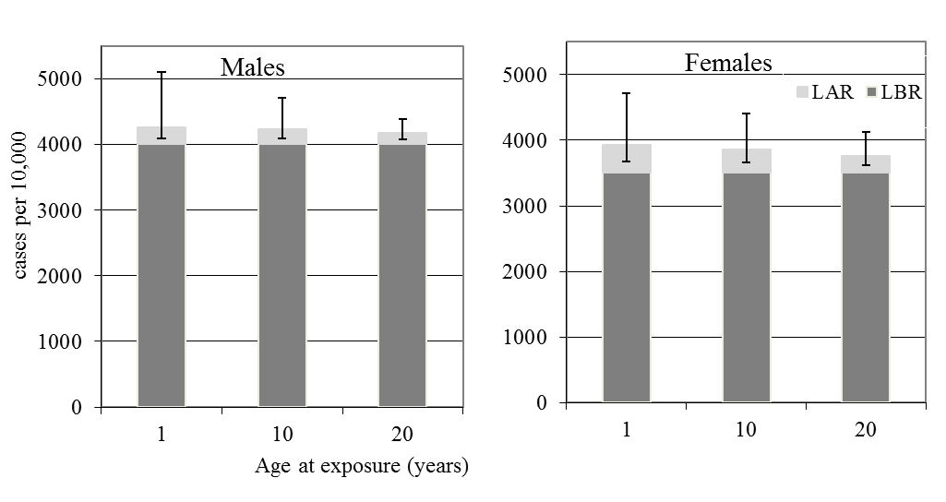

Fig. 1 Male and female all solid cancer baseline (dark grey) and radiation (light grey with error bars) risks in cases per 10,000 persons calculated from LBR and the LAR for 100 mSv effective dose. Error bars are for 95% confidence intervals.

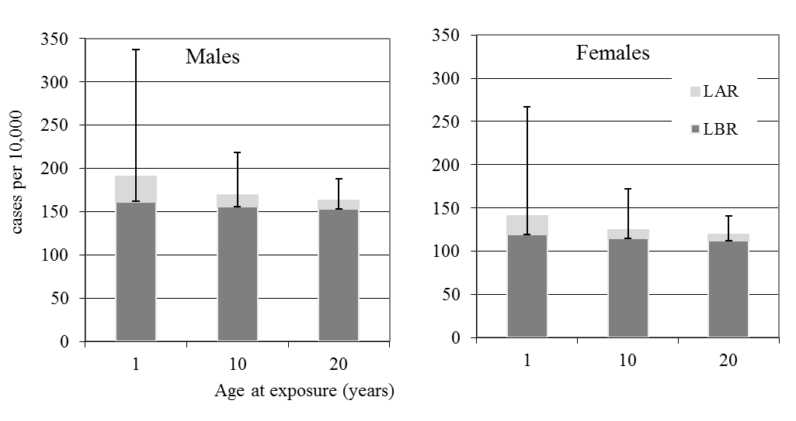

Fig. 2 Male and female leukaemia baseline (dark grey) and radiation (light grey with error bars) risks in cases per 10,000 persons calculated from LBR and the LAR for 100 mSv effective dose. Error bars are for 95% confidence intervals.

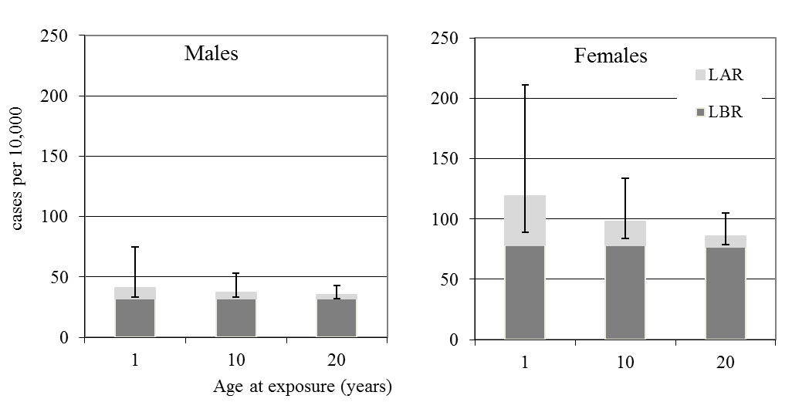

Fig. 3 Male and female thyroid cancer baseline (dark grey) and radiation (light grey with error bars) risks in cases per 10,000 persons calculated from LBR and the LAR for 100 mSv effective dose. Error bars are for 95% confidence intervals.

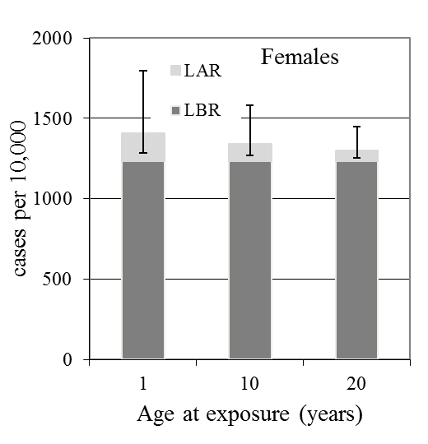

Fig. 4 Female breast cancer baseline (dark grey) and radiation (light grey with error bars) risks in cases per 10,000 persons calculated from LBR and the LAR for 100 mSv effective dose. Error bars are for 95% confidence intervals.

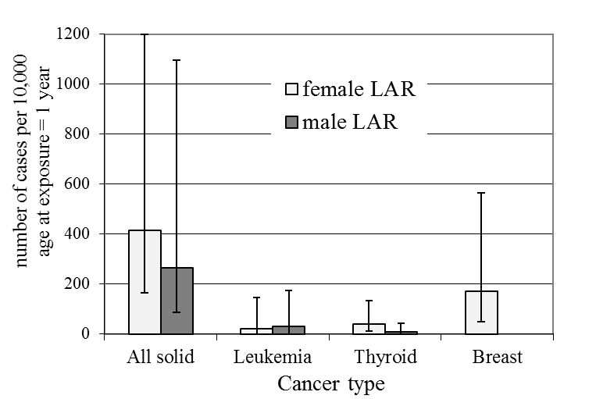

Fig. 5 Cases per 10,000 persons for females (light grey) and males (dark grey) for different types of cancer, calculated from the radiation risks, LAR for 100 mSv effective dose for age at exposure of 1 year. Error bars are for 95% confidence intervals.

Tables

Table 1 The organ dose ranges corresponding an effective dose range of 20 to 100 mSv, calculated with the ratio of organ to effective dose, from external exposures, for the situation after the Fukushima accident, as given in Table 19 of the WHO report (WHO, 2013, Annex G, p. 134)

|  |  |  |  |  |
| --- | --- | --- | --- | --- |
| Age at exposure, year | Organ dose ranges (mSv) corresponding to an  effective dose range of 20 - 100 mSv | | | |
| Breast | Colon | RBM | Thyroid |
| 20 (Adult) | 19.8–99 | 18.2–91 | 17.8–89 | 20–100 |
| 10 (Child) | 20–100 | 19.2–96 | 20–100 | 20–100 |
| 1 (Infant) | 20–100 | 18.2–91 | 18.8–94 | 20–100 |

Table 2 All solid cancer, ranges for median number of cases per 10,000 after 20 years and during lifetime based on German population data for 20–100 mSv effective dose range

|  |  |  |  |  |  |
| --- | --- | --- | --- | --- | --- |
|  |  | Ranges for median numbers of cases per 10,000 (with 95% CI) after 20 years-at-risk since exposure and during lifetime simply converted (10,000 times risk) from the risks in column 2. | | | |
| Age at exposure, year | Sex: | Male | | Female | |
| Effective dose: | 20 mSv | 100 mSv | 20 mSv | 100 mSv |
| 20 (Adult) | AR20 | 2(1; 14) | 11 (3; 70) | 5 (2; 13) | 25 (10; 63) |
|  | LAR | 33 (15; 76) | 166 (73; 381) | 51 (22; 123) | 257 (112; 618) |
|  | BR20 | 102 (90; 116) | | 164 (149; 181) | |
|  | LBR | 4005 (3878; 4140) | | 3509 (3385; 3639) | |
| 10 (Child) | AR20 | 2 (0; 40) | 10 (2; 200) | 3 (1; 9) | 17 (6; 43) |
|  | LAR | 46 (18; 143) | 229 (92; 716) | 70 (30; 179) | 350 (149; 895) |
|  | BR20 | 45 (37; 54) | | 50 (42; 60) | |
|  | LBR | 4002 (3873; 4140) | | 3509 (3383; 3643) | |
| 1 (Infant) | AR20 | 1 (0; 29) | 5 (0; 144) | 2 (1; 8) | 11 (3; 41) |
|  | LAR | 53 (18; 219) | 264 (88; 1097) | 83 (33; 240) | 416 (164; 1200) |
|  | BR20 | 20 (14; 27) | | 18 (13; 26) | |
|  | LBR | 4002 (3871; 4143) | | 3511 (3383; 3647) | |

Table 3 Leukaemia, ranges for median number of cases per 10,000 after 20 years and during lifetime based on German population data for 20–100 mSv effective dose range.

|  |  |  |  |  |  |
| --- | --- | --- | --- | --- | --- |
|  |  | Ranges for median numbers of cases per 10,000 (with 95% CI) after 20 years-at-risk since exposure and during lifetime simply converted (10,000 times risk) from the risks in column 2. | | | |
| Age at exposure, year | Sex: | Male | | Female | |
| Effective dose: | 20 mSv | 100 mSv | 20 mSv | 100 mSv |
| 20 (Adult) | AR20 | 1 (0; 3) | 4 (0; 14) | 0 (0; 2) | 2 (0; 11) |
|  | LAR | 2 (0; 7) | 10 (0; 35) | 1 (0; 5) | 7 (0; 29) |
|  | BR20 | 7 (4; 11) | | 5 (3; 8) | |
|  | LBR | 153 (129; 184) | | 112 (92; 138) | |
| 10 (Child) | AR20 | 1 (0; 6) | 6 (0; 33) | 1 (0; 5) | 4 (0; 29) |
|  | LAR | 2 (0; 11) | 13 (0; 62) | 2 (0; 10) | 10 (0; 57) |
|  | BR20 | 7 (4; 11) | | 4 (2; 8) | |
|  | LBR | 156 (131; 190) | | 115 (94; 143) | |
| 1 (Infant) | AR20 | 3 (0; 25) | 19 (0; 138) | 2 (0; 20) | 14 (0; 112) |
|  | LAR | 6 (0; 33) | 30 (1; 176) | 4 (0; 28) | 22 (0; 148) |
|  | BR20 | 9 (6; 14) | | 7 (4; 12) | |
|  | LBR | 161 (134; 197) | | 119 (96; 149) | |

Table 4 Thyroid cancer, ranges for median number of cases per 10,000 after 20 years and during lifetime based on German population data for 20–100 mSv effective dose range.

|  |  |  |  |  |  |
| --- | --- | --- | --- | --- | --- |
|  |  | Ranges for median numbers of cases per 10,000 (with 95% CI) after 20 years-at-risk since exposure and during lifetime simply converted (10,000 times risk) from the risks in column 2. | | | |
| Age at exposure, year | Sex: | Male | | Female | |
| Effective dose: | 20 mSv | 100 mSv | 20 mSv | 100 mSv |
| 20 (Adult) | AR20 | 0 (0; 1) | 1 (0; 3) | 0 (0; 2) | 2 (0; 9) |
|  | LAR | 1 (0; 2) | 3 (0; 11) | 2 (0; 6) | 9 (2; 28) |
|  | BR20 | 5 (3; 9) | | 19 (14; 25) | |
|  | LBR | 32 (22; 48) | | 77 (61; 101) | |
| 10 (Child) | AR20 | 0 (0; 1) | 1 (0; 4) | 0 (0; 2) | 2 (0; 10) |
|  | LAR | 1 (0; 4) | 5 (1; 21) | 4 (1; 11) | 20 (6; 56) |
|  | BR20 | 2 (1; 5) | | 8 (5; 12) | |
|  | LBR | 32 (22; 49) | | 78 (61; 103) | |
| 1 (Infant) | AR20 | 0 (0; 1) | 1 (0; 5) | 0 (0; 1) | 2 (0; 7) |
|  | LAR | 2 (0; 9) | 9 (1; 43) | 8 (2; 27) | 41 (11; 133) |
|  | BR20 | 1 (0; 2) | | 2 (1; 4) | |
|  | LBR | 32 (22; 50) | | 78 (61; 104) | |

Table 5 Breast cancer, ranges for median number of cases per 10,000 after 20 years and during lifetime based on German population data for 20–100 mSv effective dose range.

|  |  |  |  |  |  |  |
| --- | --- | --- | --- | --- | --- | --- |
|  |  | Ranges for median numbers of cases per 10,000 (with 95% CI) after 20 years-at-risk since exposure and during lifetime simply converted (10,000 times risk) from the risks in column 2. | | | | |
| Age at exposure, year | Sex: | Female | | | | |
| Effective dose: | 20 mSv | | | | 100 mSv |
| 20 (Adult) | AR20 | | 1 (0; 3) | | 4 (1; 14) | |
|  | LAR | | 13 (4; 42) | | 65 (20; 211) | |
|  | BR20 | | | 53 (45; 62) | | |
|  | LBR | | | 1235 (1161; 1313) | | |
| 10 (Child) | AR20 | | 0 (0; 2) | | 2 (1; 8) | |
|  | LAR | | 22 (7; 69) | | 109 (34; 345) | |
|  | BR20 | | | 7 (5; 10) | | |
|  | LBR | | | 1234 (1160; 1312) | | |
| 1 (Infant) | AR20 | | - | | - | |
|  | LAR | | 35 (10; 113) | | 173 (51; 566) | |
|  | BR20 | | | 0 (0; 1) | | |
|  | LBR | | | 1232 (1159; 1310) | | |