Supplemental Material:

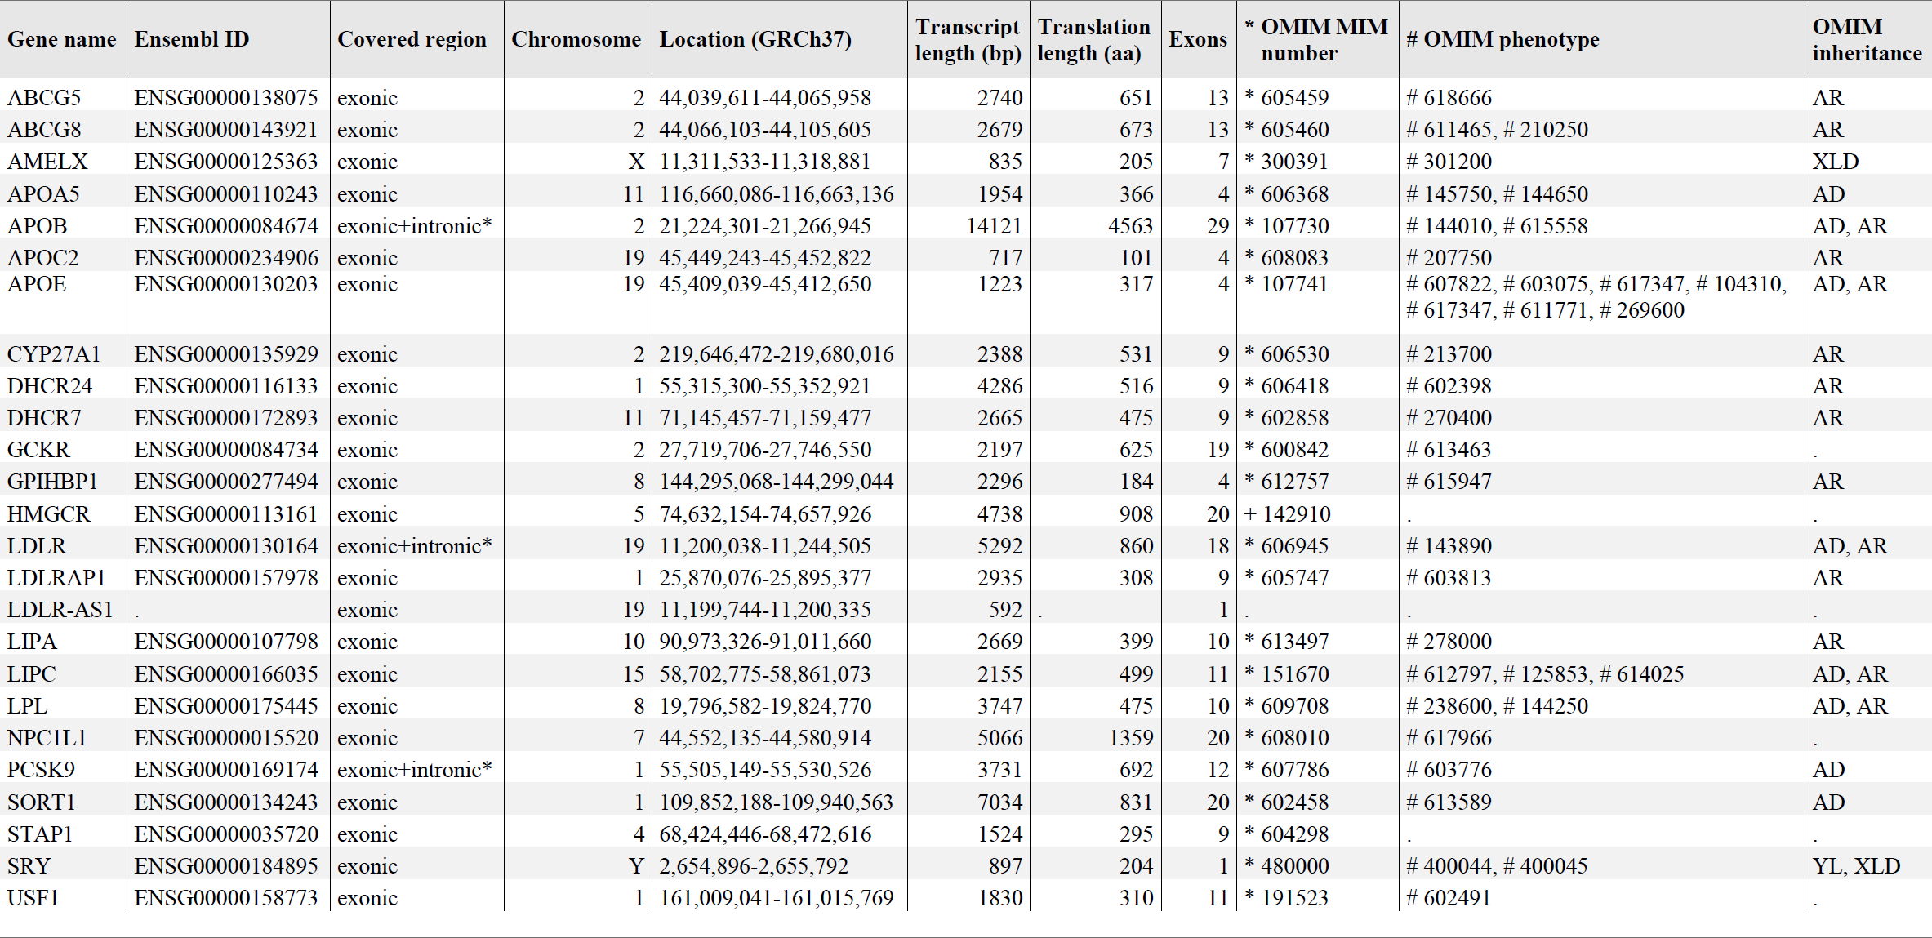Supp. Table 1: List of the 23 genes covered by the NGS targeted FH panel

Cohen's Kappa | Total cohort | Female | Male | Age <10 years | Age ≥10 years | BMI ≥90th percentile | BMI <90th percentile
SB | 0.57 | 0.60 | 0.55 | 0.60 | 0.56 | 0.42 | 0.59
MEDPED | 0.49 | 0.50 | 0.48 | 0.51 | 0.47 | 0.32 | 0.50
GL-EAS | 0.57 | 0.60 | 0.55 | 0.60 | 0.56 | 0.42 | 0.59
LDL-170 | 0.47 | 0.52 | 0.42 | 0.46 | 0.48 | 0.50 | 0.47
Supp. Table 2: Cohen’s Kappa values for all clinical scores in main cohort and all subgroups

Subgroup: Male | vs. Female
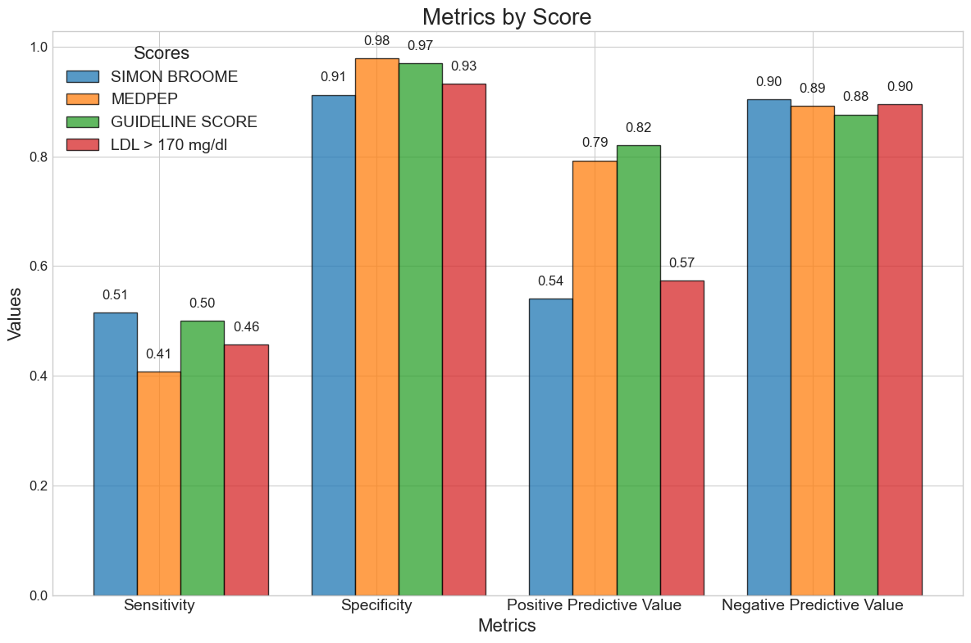 | 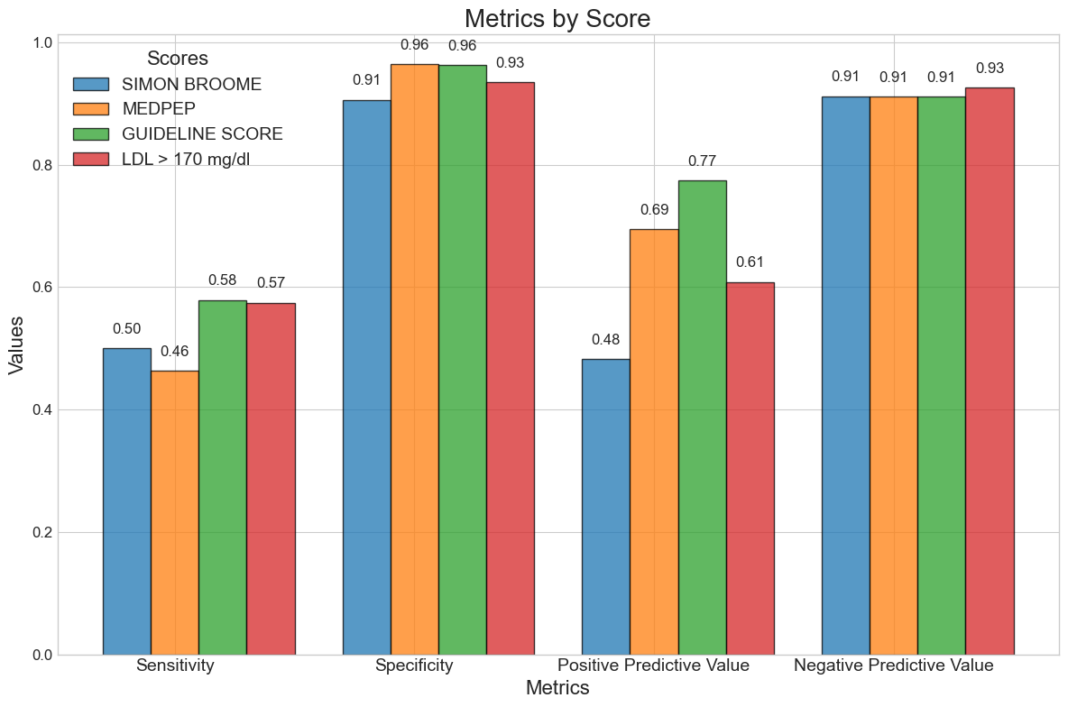

Supp. Figure 1: Bar graph of the test quality criteria in the subgroups male (left) vs. female (right). The graph shows the Sensitivity, Specificity, PPV and NPV for SB in blue, MP in orange and GL in green.

Subgroup: Male | vs. Female
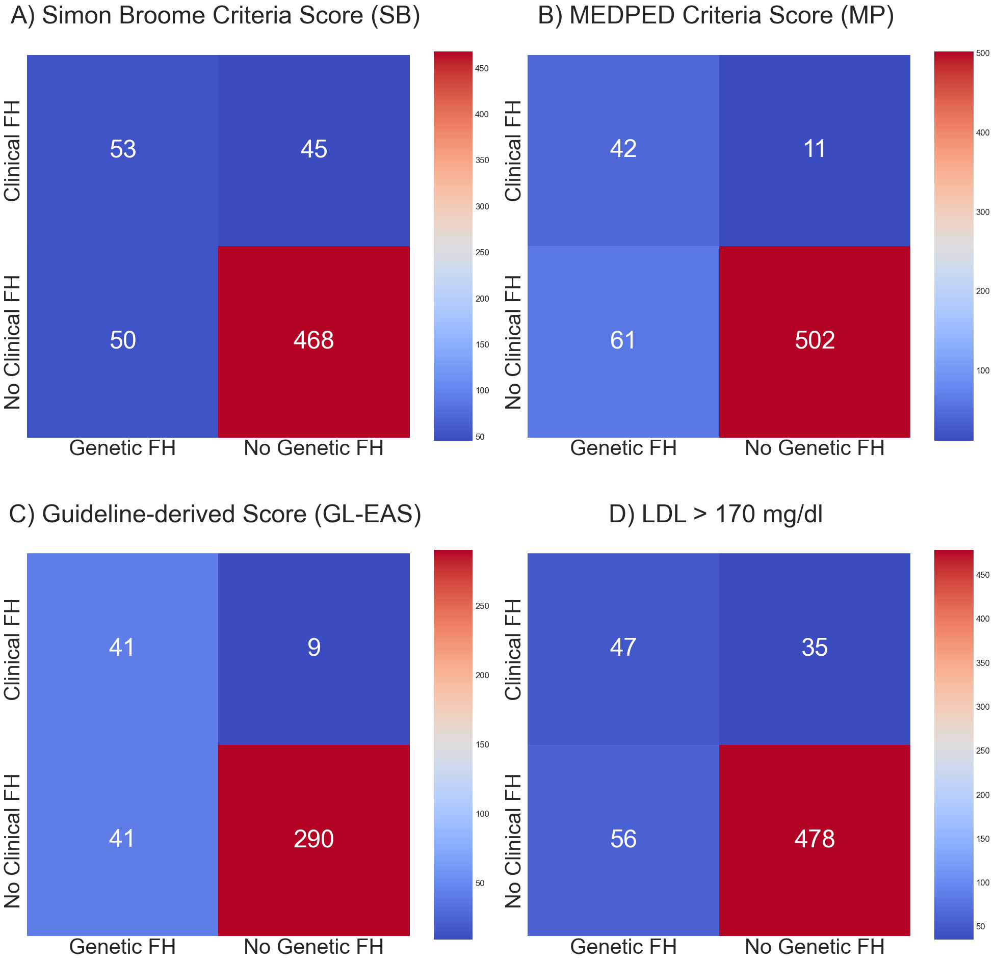 | 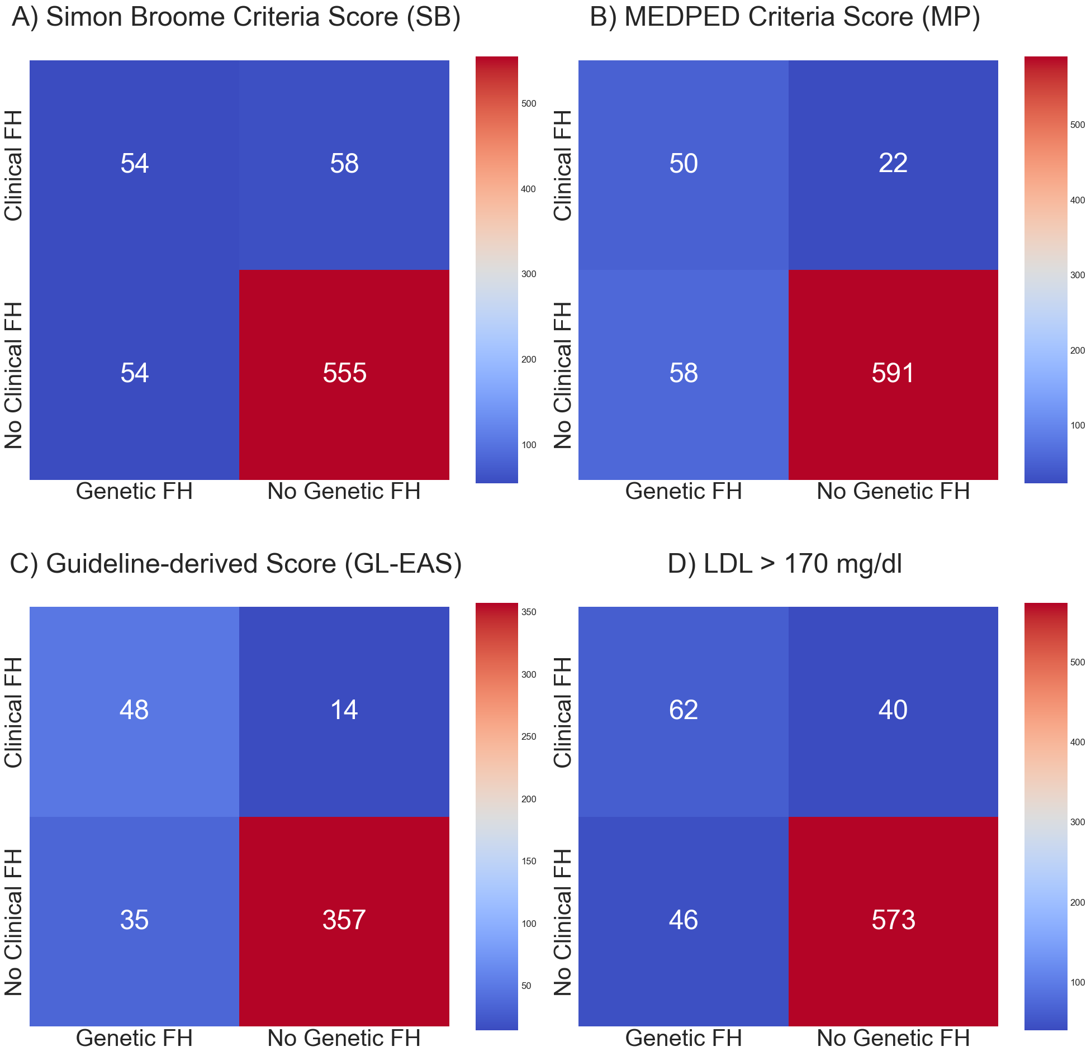

Supp. Figure 2: Heatmaps of SB, MP and GL (left to right) in the subgroups male (left) vs. female (right). Heatmaps compare HeFH vs Clinical FH according to the scoring system. HeFH cases are in the left column and cases without FH mutation in the right column. Clinical FH cases are in the upper row and cases not meeting clinical Criteria in the lower row.

Subgroup: <10 years old | vs. ≥10 years old
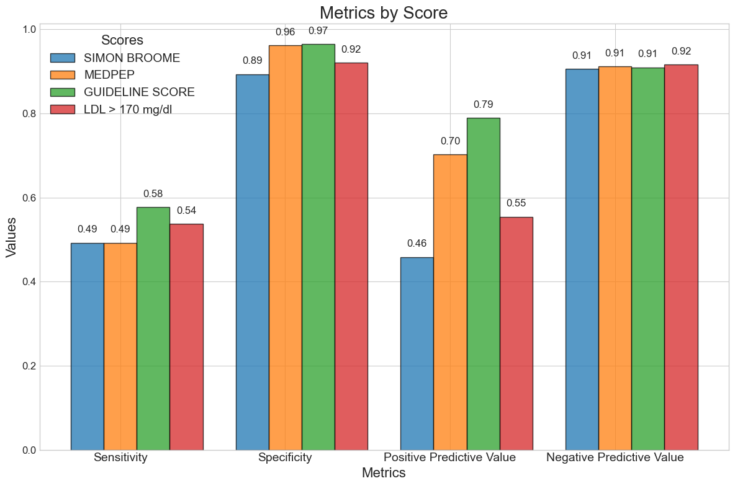 | 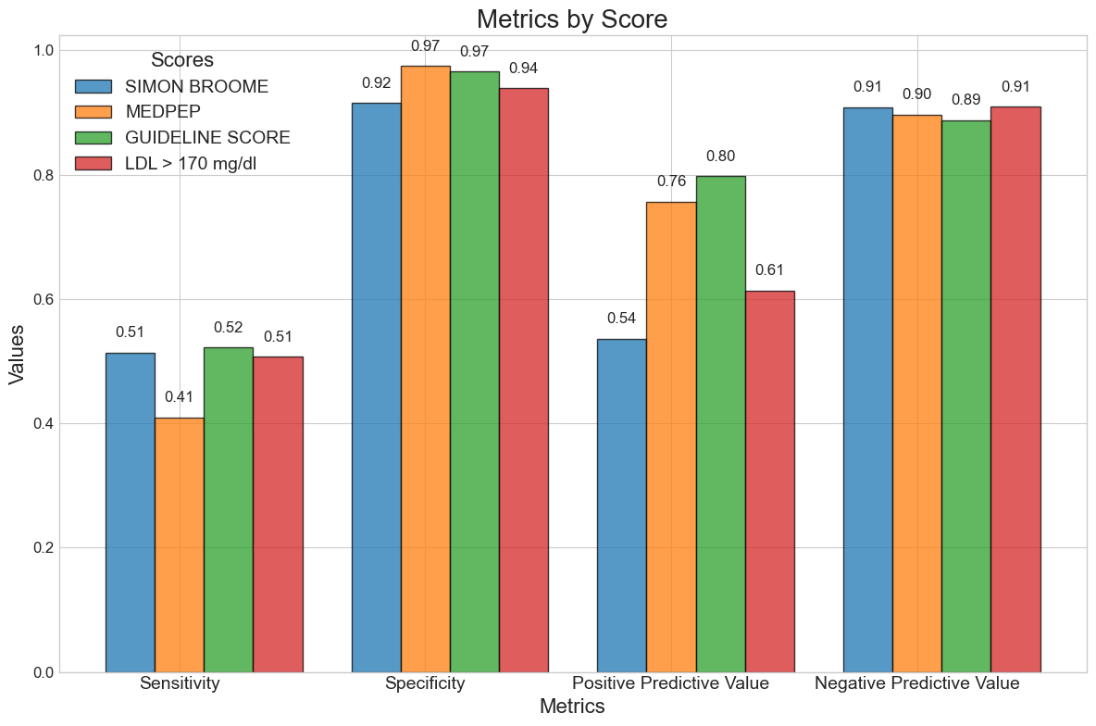

Supp. Figure 3: Bar graph of the test quality criteria in the subgroups <10 years (left) vs. ≥10 years (right). The graph shows the Sensitivity, Specificity, PPV and NPV for SB in blue, MP in orange and GL in green.

Subgroup: <10 years old | vs. ≥10 years old
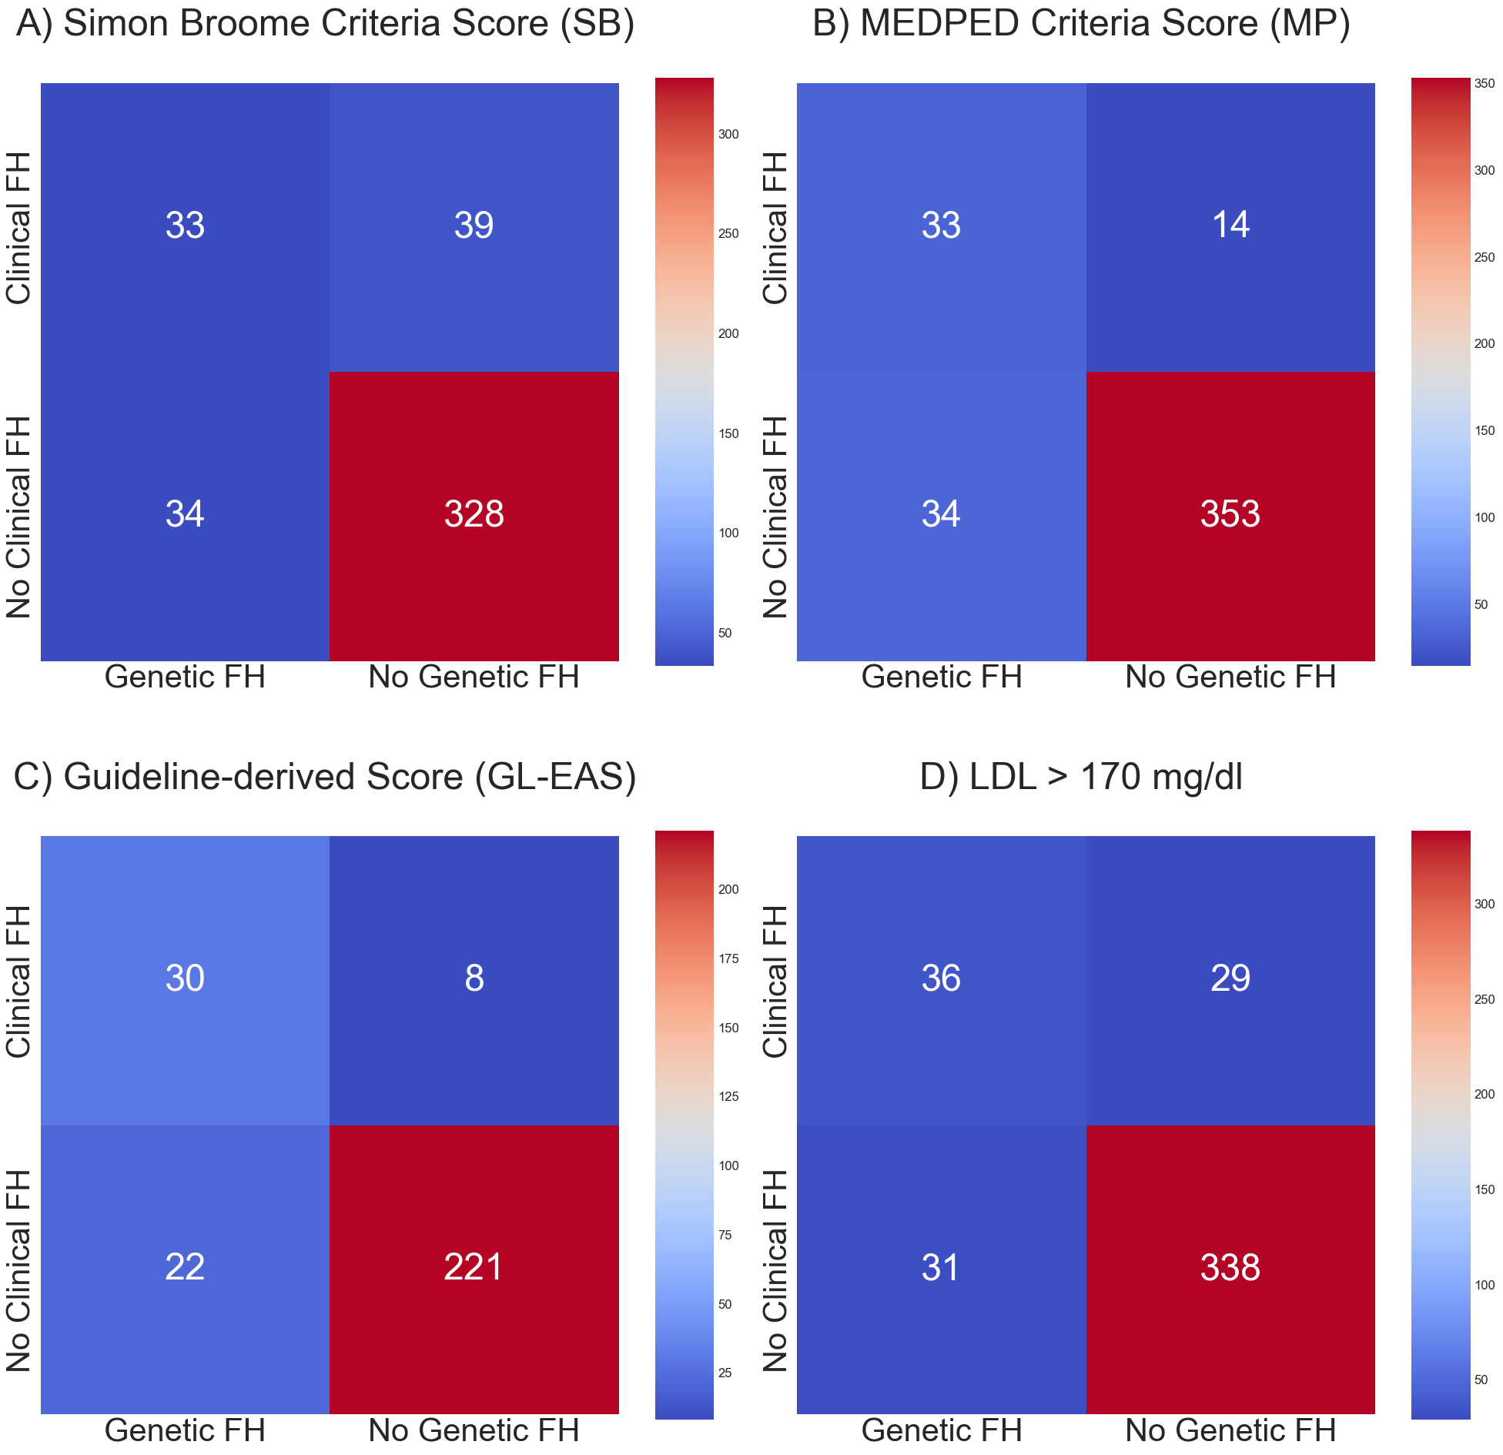 | 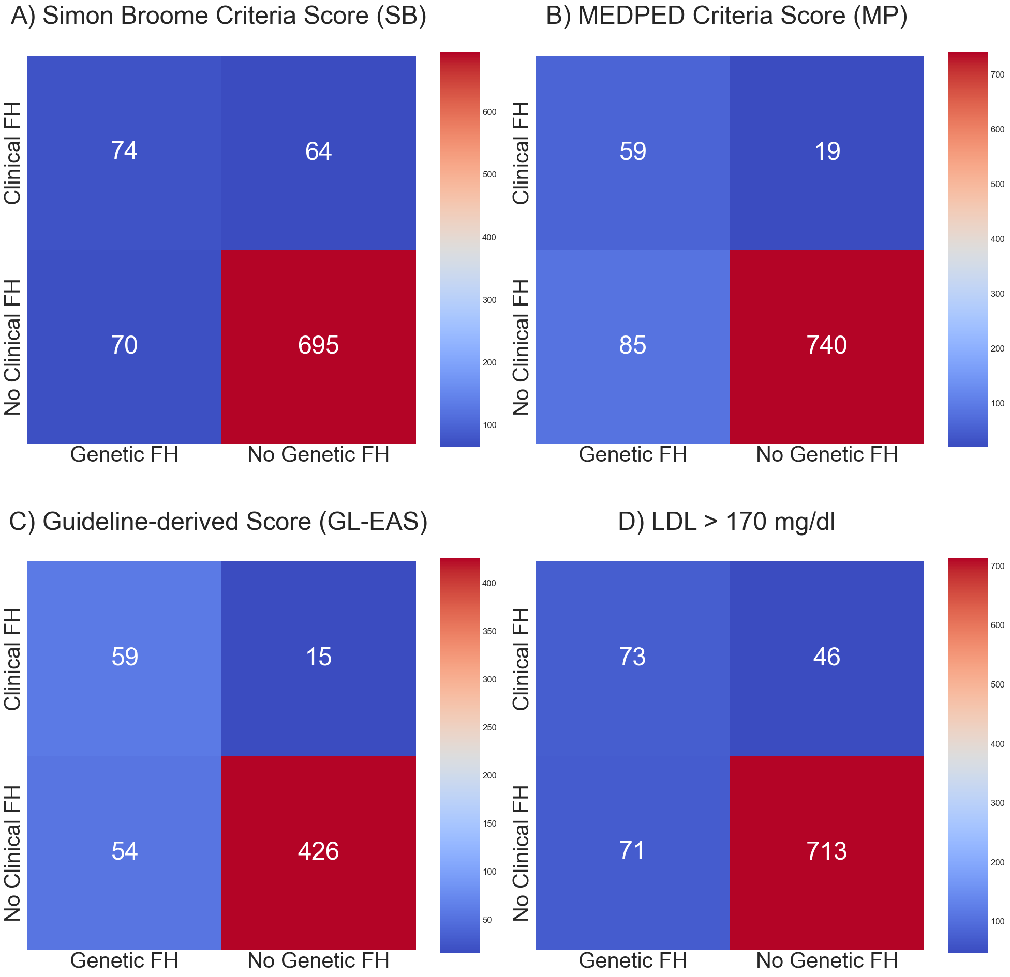

Supp. Figure 4: Heatmaps of SB, MP and GL (left to right) in the subgroups <10 years (left) vs. ≥10 years (right). Heatmaps compare HeFH vs Clinical FH according to the scoring system. HeFH cases are in the left column and cases without FH mutation in the right column. Clinical FH cases are in the upper row and cases not meeting clinical Criteria in the lower row.

Subgroup: <90th BMI-percentile | vs. ≥90th BMI-percentile
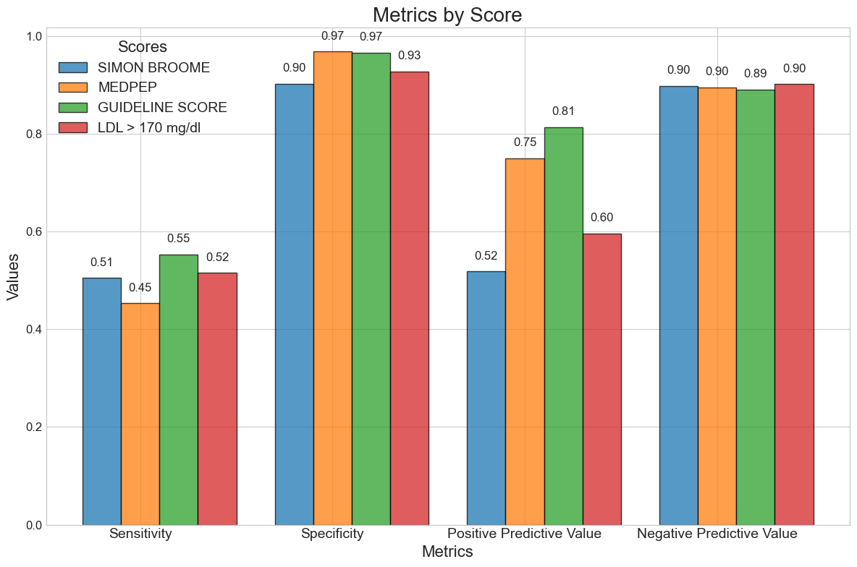 | 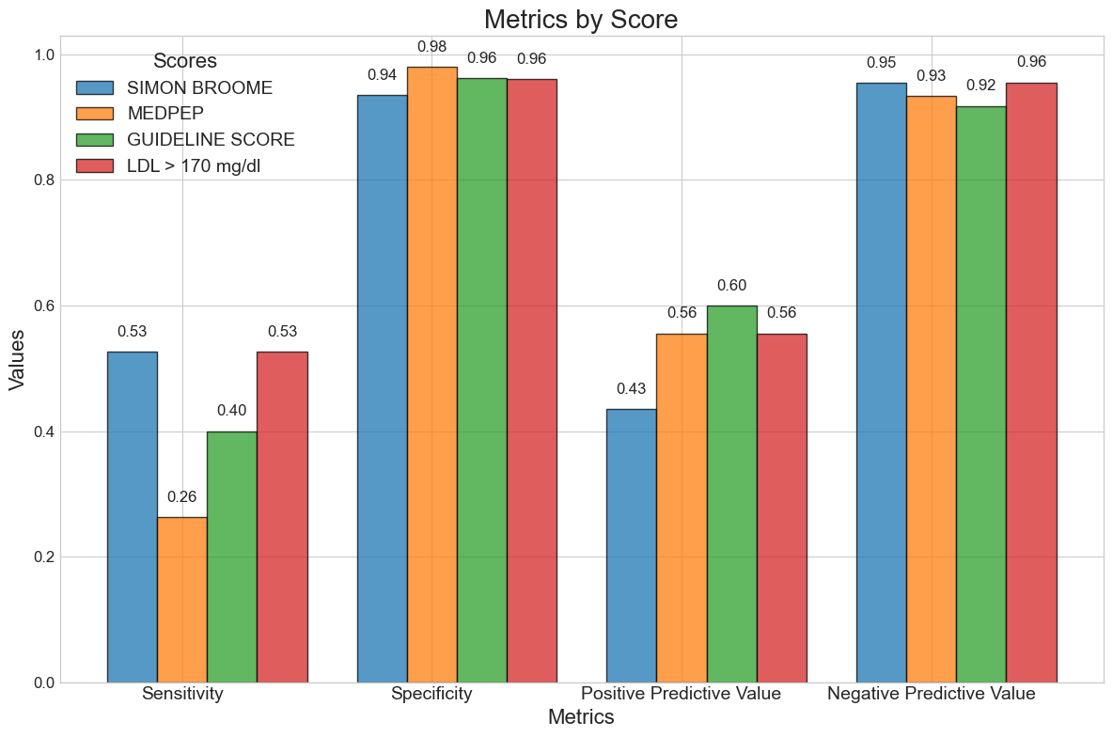

Supp. Figure 5: Bar graph of the test quality criteria in the subgroups <90th BMI-percentile (left) vs. ≥90th BMI-percentile (right). The graph shows the Sensitivity, Specificity, PPV and NPV for SB in blue, MP in orange and GL in green.

Subgroup: <90th BMI-percentile | vs. ≥90th BMI-percentile
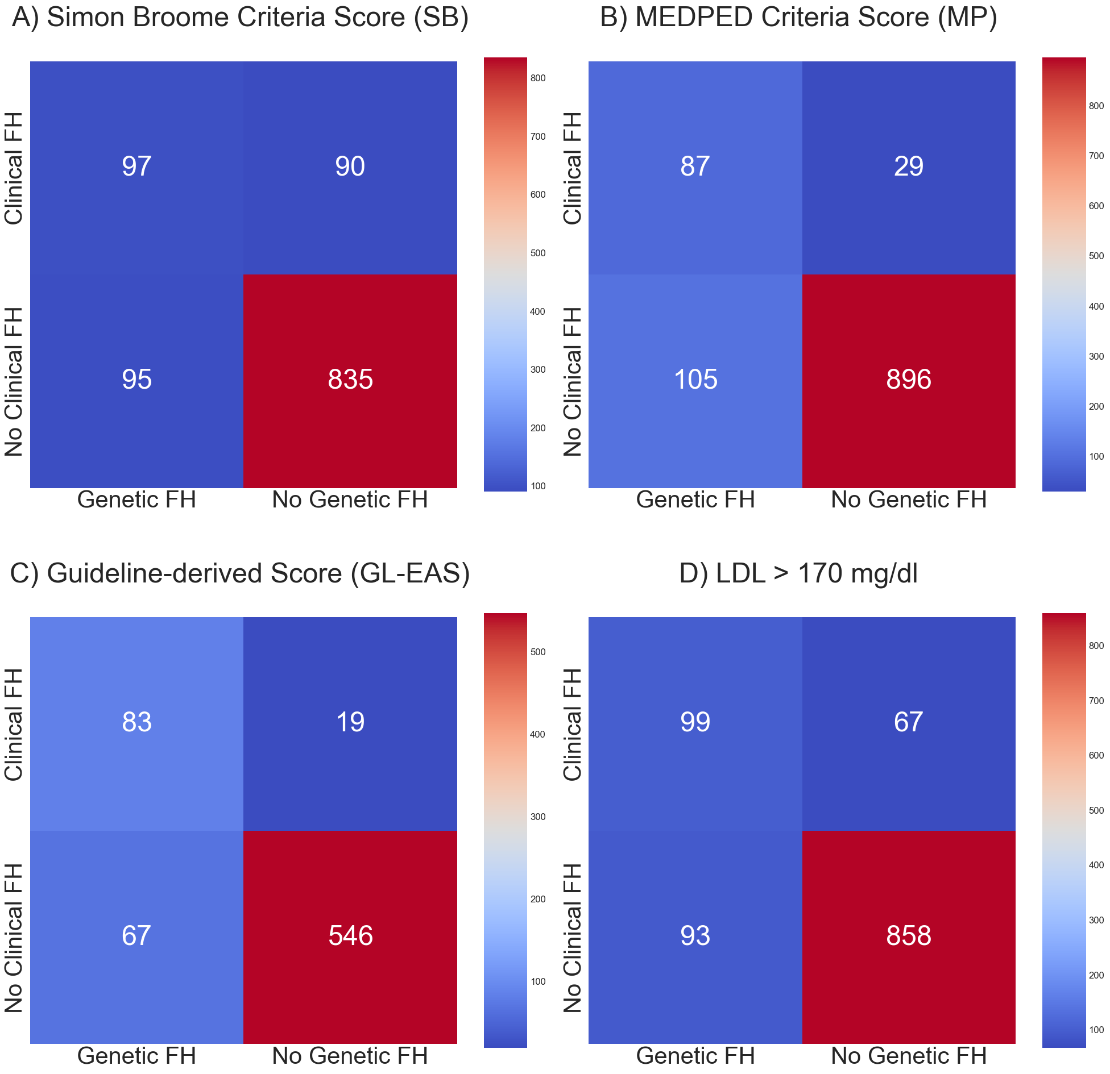 | 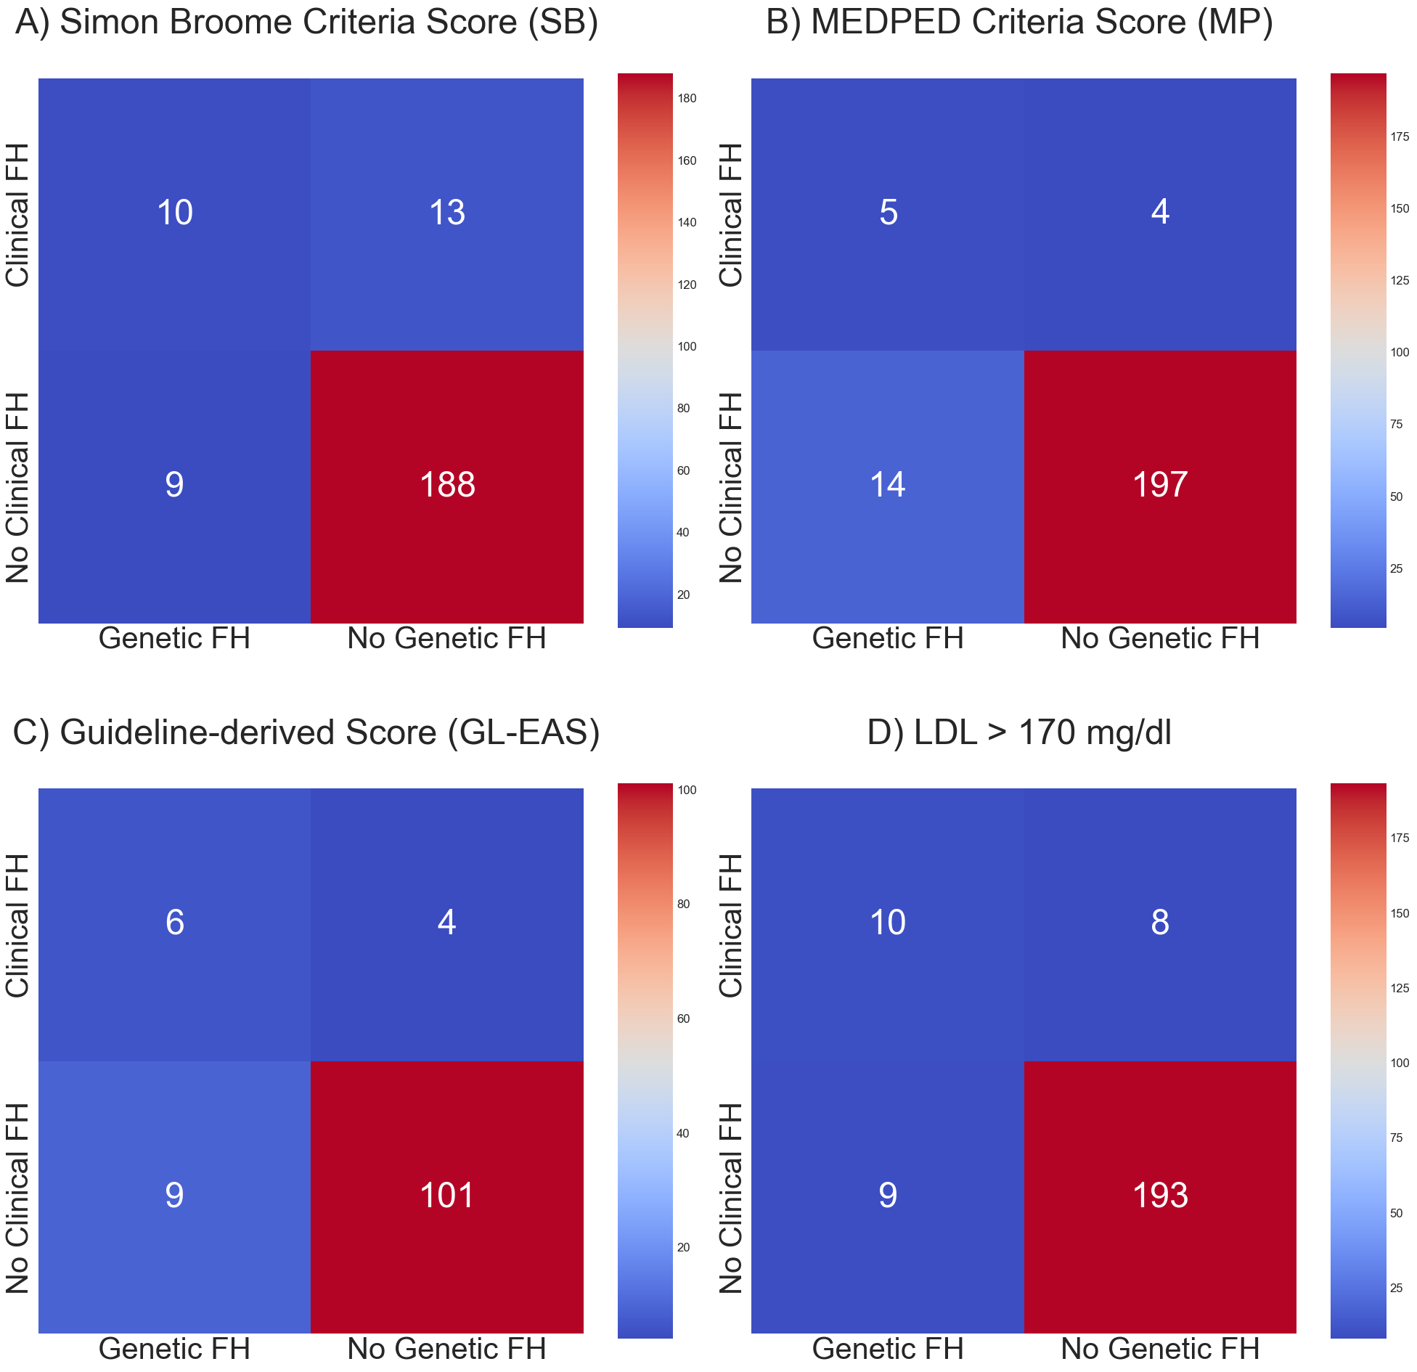

Supp. Figure 6: Heatmaps of SB, MP and GL (left to right) in the subgroups <90th BMI-percentile (left) vs. ≥90th BMI-percentile (right). Heatmaps compare HeFH vs Clinical FH according to the scoring system. HeFH cases are in the left column and cases without FH mutation in the right column. Clinical FH cases are in the upper row and cases not meeting clinical Criteria in the lower row.

