**Supplementary material for the manuscript entitled:**

Pollution from azithromycin-manufacturing promotes macrolide-resistance gene propagation and induces spatial and seasonal bacterial community shifts in receiving river sediments

Milena Milakovića, Gisle Vestergaardb[1], Juan J. González-Plazaa[2], Ines Petrića, Ana Šimatovićc, Ivan Sentaa, Susanne Kublikb, Michael Schloterb, Kornelia Smallad, Nikolina Udiković-Kolića,*

a Division for Marine and Environmental Research, Ruđer Bošković Institute, Bijenička 54, P.O. Box 180; 10 002 Zagreb, Croatia

b Research Unit Comparative Microbiome Analysis (COMI), Helmholtz Zentrum München, Ingolstädter Landstraße 1, D-85764 Neuherberg, Germany

c Division of Molecular Biology, Ruđer Bošković Institute, Bijenička 54, P.O. Box 180; 10 002 Zagreb, Croatia

d Julius Kühn-Institut Federal Research Centre for Cultivated Plants, Institute for Epidemiology and Pathogen Diagnostics, Messeweg 11-12, D-38104 Braunschweig, Germany

* Corresponding author: Dr. Nikolina Udiković-Kolić, Ruđer Bošković Institute, Division for Marine and Environmental Research, Bijenička 54, P.O. Box 180; 10 002 Zagreb, Croatia.

Phone:[+385-1-4680-944](tel:%2B385-1-4680-944)

E-mail address: [nudikov@irb.hr](mailto:nudikov@irb.hr)

**Table S1.** Physicochemical parameters and international standardized (ISO) methods used for the analysis of river sediments.

|  |  |  |
| --- | --- | --- |
| **Parameter** | **ISO standard** | **Methodology** |
| **pH (H2O )** | HRN ISO 10390 | Electrochemistry |
| **Conductivity** | HRN EN 27888:2008 | Electrochemistry |
| **Total organic carbon (TOC)** | HRN EN 1484:2002 | IR spectrometry |
| **Total carbon (TC)** | HRN EN 1484:2002 | IR spectrometry |
| **Total nitrogen (TN)** | HRN ISO 1871:1999 |  |
| **Total phosphorus (TP)** | HRN EN ISO 6878:2008 | Spectrophotometry |
| **Nitrite (NO2-)** | HRN EN ISO 10304-1:2009 | Ion chromatography |
| **Nitrate (NO3-)** | HRN EN ISO 10304-1:2009 | Ion chromatography |
| **Ammonium (NH4+)** | HRN EN ISO 14911:2001 | Ion chromatography |

**Table S2**. Primer pairs used to quantify 16S rRNA genes, macrolide-resistance genes, and class 1 integrons. Assay1/Assay2 represents amplification accuracy (R2) and efficiency (%) of samples within winter/summer sampling season.

|  |  |  |  |  |  |  |  |  |  |
| --- | --- | --- | --- | --- | --- | --- | --- | --- | --- |
| **Target gene** | **Primer name** | **Primer sequence 5’ 🡪 3’** | **Amplicon size (bp)** | **Tm °C\*** | **Accuracy (R2)** | | **Efficiency [%]** | | **Reference** |
| **Assay1** | **Assay2** | **Assay1** | **Assay2** |
| *mph*G | PrFW024 | GGTATAAGTGAGCAATTGGAAAC | 128 | 60 | 0.9946 | 0.9916 | 108.99 | 90.55 | this study** |
| PrFW025 | GCTCCATCCTTTGAAGCTAG |
| *mph*E | PrFW028 | CTGTTTTCGGTGAAGAAAGTC | 124 | 60 | 0.9931 | 0.9916 | 94.33 | 102.29 | this study** |
| PrFW029 | CCATAAGCTAGAGGTGCGG |
| *msr*E | PrFW030 | CAATGTTATCTCGCCTTGGTG | 127 | 60 | 0.9956 | 0.9945 | 85.47 | 98.61 | this study** |
| PrFW031 | GTTGGTTCATCCGCTAGAATG |
| *mef*C | PrFW036 | GCTTACAAGTTATGCTGTTCAG | 195 | 60 | 0.9970 | 0.9916 | 81.24 | 90.55 | this study** |
| PrFW037 | CAGAGAGCTATAAAAGCATCC |
| *erm*B | erm(B)-91f | GATACCGTTTACGAAATTGG | 364 | 58 | 0.9836 | 0.9916 | 94.71 | 105.15 | Chen et al*.*, 2007 |
| erm(B)-454r | GAATCGAGACTTGAGTGTGC |
| 16S rRNA | 534R | CCTACGGGAGGCAGCAG | 174 | 60 | 0.9997 | 0.9934 | 102.11 | 83.65 | Lopez et al*.*, 2004 |
|  | 341F | ATTACCGCGGCTGCTGGCA |
| *int*l1 | intl1_LC1 | GCCTTGATGTTACCCGAGAG | 196 | 60 | 0.9956 | 0.9970 | 83.02 | 86.56 | Barraud et al*.*, 2010 |
|  | intl1_LC5 | GATCGGTCGAATGCGTGT |

* annealing temperature

** primers were constructed based on sequences of identified macrolide-resistance genes (Gonzalez-Plaza et al*.*, 2018) by using the Geneious software (version 6.0.5.).

**Table S3.** Sediment physicochemical properties at sampling sites along the Sava river in winter and summer sampling campaign.

|  |  |  |  |  |  |  |  |
| --- | --- | --- | --- | --- | --- | --- | --- |
| **Parameter** | **Sampling campaign** | **Sampling site** | | | | | |
| **UP7500** | **DW0** | **DW300** | **DW700** | **DW4500** | **DW11000** |
| **pH (H2O)** | Winter | 8.63 | 8.53 | 8.80 | 8.41 | 9.12 | 8.37 |
| Summer | 8.76 | 7.67 | 8.78 | 8.35 | 8.58 | 8.28 |
| **T (°C)** | Winter | 9.5 | 9.5 | 10.1 | 8.5 | 9.8 | 9.7 |
| Summer | 24.8 | 24.1 | 24.0 | 23.5 | 25.0 | 24.7 |
| **Conductivity (KCl)**  **(mS)** | Winter | 48.3 | 115.2 | 223.0 | 52.7 | 115.0 | 56.9 |
| Summer | 59.5 | 951.0 | 56.5 | 122.6 | 65.5 | 162.8 |
| **Sand (%)** | Winter | 85.2 | 56.4 | 70.7 | 71.4 | 82.1 | 79.4 |
| Summer | 78.5 | 69.9 | 63.4 | 47.4 | 64.9 | 81.8 |
| **Silt (%)** | Winter | 12.8 | 37.9 | 25.5 | 25.2 | 13.3 | 17.6 |
| Summer | 18.1 | 27.9 | 32.2 | 47.3 | 30.3 | 15.7 |
| **Clay (%)** | Winter | 2.0 | 5.7 | 3.8 | 3.4 | 2.6 | 3.0 |
| Summer | 3.4 | 2.2 | 4.4 | 5.3 | 4.8 | 2.5 |
| **Total organic carbon (%)** | Winter | 0.97 | 1.35 | 0.93 | 2.10 | 3.70 | 0.78 |
| Summer | 0.90 | 2.83 | 0.54 | 1.65 | 1.49 | 1.12 |
| **Total carbon (%)** | Winter | 7.50 | 9.06 | 8.20 | 8.11 | 6.98 | 6.42 |
| Summer | 5.58 | 8.37 | 6.53 | 6.83 | 6.12 | 3.68 |
| **Total nitrogen (%)** | Winter | 0.04 | 0.12 | 0.05 | 0.10 | 0.04 | 0.04 |
| Summer | 0.05 | 0.26 | 0.02 | 0.22 | 0.07 | 0.06 |
| **Total phosphorus (%)** | Winter | 0.38 | 0.39 | 0.40 | 0.30 | 0.35 | 0.49 |
| Summer | 0.49 | 0.47 | 0.48 | 0.33 | 0.31 | 0.35 |
| **NO2- (mg/kg)** | Winter | <0.03 | 10 | <0.03 | <0.03 | <10 | <0.03 |
| Summer | 0.60 | 7.4 | 0.60 | 1.2 | <0.30 | 0.80 |
| **NO3- (mg/kg)** | Winter | 2.26 | <10 | 3.51 | 4.03 | <10 | 2.41 |
| Summer | 44.0 | 23.0 | 56.0 | <10 | 24.0 | 31.0 |
| **NH4+ (mg/kg)** | Winter | <0.05 | 25 | 0.05 | 0.23 | <10 | 0.26 |
| Summer | 0.50 | 296 | 1.60 | 1.90 | 1.50 | 11.0 |

Sampling sites: UP7500, 7500 m upstream of discharge; DW0, discharge; DW300, 300 m downstream of discharge; DW700, 700 m downstream; DW4500, 4500 m downstream; DW11000, 11000 m downstream; WW; effluent.

**Table S4**. Relative abundance of taxa (expressed as %) that were significantly increased at DW sites compared to the UP7500 site during winter season. Significant difference between each DW site and UP7500 site is given in bold (*p* < 0.05).

|  |  |  |  |  |  |  |  |  |  |  |  |
| --- | --- | --- | --- | --- | --- | --- | --- | --- | --- | --- | --- |
| **Phylum** | **Class** | **Order** | **Family** | **Genus** | **Sampling site** | | | | | | |
| **UP 7500** | **WW** | **DW0** | **DW 300** | **DW 700** | **DW 4500** | **DW 11000** |
| Bacteroidetes | Bacteroidetes vadinHA17 | Uncultured | Uncultured | Uncultured | 0.00± 0.00 | 0.00± 0.00 | **0.68± 0.23** | 0.00± 0.00 | 0.01± 0.02 | 0.00± 0.00 | 0.01± 0.01 |
| Bacteroidia | Bacteroidales | Bacteroidaceae | *Bacteroides* | 0.00± 0.00 | 7.16± 2.21 | **1.08± 0.60** | 0.00± 0.00 | 0.01± 0.03 | 0.00± 0.00 | 0.00± 0.00 |
| *Tannerellaceae* | *Macellibacteroidetes* | 0.00± 0.00 | 1.08± 0.14 | **2.66± 0.99** | 0.00± 0.00 | 0.06± 0.02 | 0.02± 0.01 | 0.01± 0.00 |
| *Paludibacteraceae* | *Paludibacter* | 0.00± 0.00 | 0.19± 0.10 | **1.35± 0.84** | 0.00± 0.00 | 0.02± 0.03 | 0.00± 0.00 | 0.00± 0.00 |
| Rikenellaceae | *vadinBC27* wastewater-sludge group | 0.00± 0.00 | 0.39± 0.04 | **1.20± 0.30** | 0.00± 0.00 | 0.02± 0.03 | 0.00± 0.00 | 0.00± 0.00 |
| *Anaerocella* | 0.00±  0.00 | 0.00±  0.00 | **0.47±**  **0.24** | 0.01±  0.01 | 0.01±  0.01 | 0.01±  0.01 | 0.00±  0.00 |
| Flavobacteriia | Flavobacteriales | Flavobacteriaceae | *Flavobacterium* | 0.79± 0.80 | 0.14± 0.06 | 1.29± 0.84 | 2.84± 2.92 | 0.95± 0.49 | 0.80± 0.16 | **12.55± 9.75** |
| Sphingobacteriia | Sphingobacteriales | WCHB1-69 | Uncultured *Sphingobacteirales* bacterium | 0.00± 0.00 | 0.00± 0.00 | **0.56± 0.30** | 0.03± 0.04 | 0.02± 0.01 | 0.03± 0.02 | 0.05± 0.04 |
| Uncultured bacterium | 0.00± 0.00 | 0.00± 0.00 | **0.62± 0.11** | 0.01± 0.00 | 0.01± 0.02 | 0.00± 0.00 | 0.00± 0.00 |
| Cyanobacteria | Oxyphotobacteria | Nostocales | Xenococcaceae | *Pleurocapsa* | 0.01± 0.03 | 0.00± 0.00 | 0.02± 0.03 | 0.02± 0.01 | 0.06± 0.08 | **1.20± 2.10** | 0.10± 0.12 |
| Firmicutes | Bacilli | Lactobacillales | Carnobacteriaceae | *Trichococcus* | 0.06± 0.03 | 1.09± 0.09 | **4.23± 1.20** | 0.19± 0.09 | 0.16± 0.08 | 0.37± 0.02 | 0.32± 0.28 |
| Clostridia | Clostridiales | Christensenellaceae | *Christensenellacae R-7* Group | 0.00± 0.00 | 0.92± 0.30 | **0.54± 0.11** | 0.00± 0.00 | 0.01± 0.02 | 0.00± 0.00 | 0.01± 0.01 |
| Family XII | *Guggenheimella* | 0.00± 0.0 | 0.00± 0.00 | **1.40± 0.54** | 0.00± 0.00 | 0.02± 0.02 | 0.00± 0.00 | 0.00± 0.00 |
| *Fusibacter* | 0.01±  0.00 | 0.09±  0.01 | **1.46±**  **0.88** | 0.02±  0.02 | 0.02±  0.02 | 0.02±  0.01 | 0.02±  0.01 |
| Family XIII | *Anaerovorax* | 0.00±  0.00 | 0.04±  0.01 | **0.48±**  **0.10** | 0.00±  0.00 | 0.01±  0.01 | 0.00±  0.00 | 0.00±  0.00 |
| Erysipelotrichia | Erysipelotrichales | Erysipelotrichaeae | *Erysipelothrix* | 0.01± 0.01 | 0.10± 0.01 | **0.94± 0.48** | 0.01± 0.01 | 0.02± 0.02 | 0.02± 0.01 | 0.06± 0.02 |

|  |  |  |  |  |  |  |  |  |  |  |  |
| --- | --- | --- | --- | --- | --- | --- | --- | --- | --- | --- | --- |
| Proteobacteria | Alphaproteobacteria | Caulobacterales | Caulobacteraceae | *Brevundimonas* | 0.16± 0.18 | 0.06± 0.02 | 0.49± 0.26 | 0.33± 0.26 | 0.52± 0.27 | 0.44± 0.20 | **0.88± 0.47** |
| Rhodobacterales | Rhodobacteraceae | *Gemmobacter* | 0.01± 0.01 | 0.57± 0.07 | **0.78± 0.32** | 0.03± 0.04 | 0.05± 0.02 | 0.06± 0.02 | 0.04± 0.02 |
| *Pseudorhodobacter* | 0.04± 0.02 | 0.03± 0.01 | 0.07± 0.07 | 0.23± 0.29 | 0.12± 0.07 | **0.59± 0.08** | 0.28± 0.18 |
| *Paracoccus* | 0.03±  0.02 | 0.13± 0.01 | **0.38±**  **0.14** | 0.07±  0.06 | 0.22±  0.14 | 0.07±  0.08 | 0.09±  0.07 |
| *Tabrizicola* | 0.12± 0.06 | 0.04± 0.01 | 0.12± 0.10 | 0.16± 0.11 | 0.25± 0.17 | 0.52± 0.10 | **0.63± 0.42** |
| Other | 0.10± 0.07 | 0.68± 0.19 | 0.34± 0.09 | 0.34± 0.12 | 0.22± 0.12 | **0.75± 0.22** | 0.64± 0.21 |
| Deltaproteobacteria | Desulfobacterales | Desulfobacteraceae | *Desulfobacter* | 0.00± 0.00 | 0.00± 0.00 | **1.21± 0.66** | 0.00± 0.00 | 0.01±  0.00 | 0.00± 0.00 | 0.00± 0.00 |
| *Desulfobulbus* | 0.00± 0.00 | 0.02± 0.00 | **0.85± 0.21** | 0.02± 0.02 | 0.03±  0.03 | 0.05± 0.04 | 0.07 ±0.05 |
| Desulfuromonadales | Geobacteraceae | *Geobacter* | 0.11±  0.04 | 0.02±  0.01 | **0.63±**  **0.46** | 0.04±  0.01 | 0.08±  0.01 | 0.20±  0.11 | 0.18±  0.06 |
| Gammaproteobacteria | Betaproteobacteriales | Comamonadaceae | *Comamonas* | 0.75± 0.17 | 6.06± 1.14 | **5.28± 1.54** | 0.77± 0.25 | 0.84±  0.19 | 1.06± 0.16 | 0.89± 0.11 |
| *Rhizobacter* | 0.14± 0.09 | 0.00± 0.00 | **0.58± 0.41** | 0.38± 0.25 | 0.25±  0.13 | 0.21± 0.09 | 0.15± 0.08 |
| *Variovorax* | 0.17± 0.11 | 2.19± 0.35 | **2.61± 1.08** | 0.57± 0.41 | 0.38±  0.16 | 0.24± 0.12 | 0.21± 0.14 |
| Hydrogenophilaceae | *Thiobacillus* | 0.03± 0.02 | 0.00± 0.00 | **1.36± 0.77** | 0.04± 0.04 | 0.09±  0.05 | 0.11± 0.04 | 0.12± 0.08 |
| Uncultured | 0.00± 0.00 | 0.02± 0.02 | **0.57± 0.28** | 0.00± 0.00 | 0.01±  0.01 | 0.02± 0.01 | 0.00± 0.00 |
| Methylophilaceae | *Methylotenera* | 0.12±  0.02 | 0.00±  0.00 | **0.52±**  **0.86** | 0.10±  0.04 | 0.04±  0.04 | 0.13±  0.04 | 0.03±  0.01 |
| Rhodocyclaceae | *Thauera* | 0.00± 0.01 | 1.03± 0.09 | **5.97± 1.66** | 0.13± 0.14 | 0.15±  0.17 | 0.15± 0.13 | 0.09± 0.03 |
| *Dechloromonas* | 0.37±  0.06 | 0.04±  0.01 | **1.07±**  **0.64** | 0.43±  0.37 | 0.30±  0.18 | 0.38±  0.14 | 0.72±  0.30 |
| *Propionivibrio* | 0.05±  0.02 | 0.16±  0.02 | **0.59±**  **0.06** | 0.02±  0.01 | 0.04±  0.02 | 0.15±  0.08 | 0.03±  0.02 |
| Methylococcales | Methylomonaceae | *Methylomonas* | 0.00± 0.00 | 0.00± 0.00 | **1.51± 1.05** | 0.00±  0.00 | 0.05±  0.08 | 0.00± 0.00 | 0.00± 0.00 |
| Pseudomonadales | Moraxellaceae | *Acinetobacter* | 0.01± 0.00 | 0.25± 0.02 | **0.97± 0.43** | 0.02±  0.01 | 0.03±  0.04 | 0.06± 0.04 | 0.02± 0.01 |
| Pseudomonadaceae | *Pseudomonas* | 0.63±  0.25 | 1.69±  0.12 | **3.61±**  **0.78** | 1.22±  1.40 | 0.77±  1.18 | 0.54±  0.17 | 0.22±  0.17 |
|  | Xanthomonadales | Xanthomonadaceae | *Arenimonas* | 0.81± 0.19 | 0.02± 0.00 | 0.96± 0.48 | 0.89±  0.28 | 1.15±  0.75 | 1.32± 0.24 | **1.56± 1.22** |
| Other | Other | Other | 0.28± 0.01 | 0.06± 0.04 | 0.34± 0.02 | 0.36± 0.20 | 0.37±  0.09 | 0.49± 0.09 | **0.61± 0.23** |
| Epsilonbacteraeota | Campylobacteria | Campylobacterales | Thiovulaceae | *Sulfuricurvum* | 0.00± 0.00 | 0.01± 0.01 | **2.37± 3.46** | 0.00±  0.00 | 0.07±  0.14 | 0.00± 0.00 | 0.00± 0.00 |
| Arcobacteraceae | *Arcobacter* | 0.01±  0.00 | 16.43±2.86 | **8.17±**  **3.62** | 0.02±  0.01 | 0.11±  0.17 | 0.14±  0.08 | 0.02±  0.01 |
| Spirochaetae | Spirochaetes | Spirochaetales | Spirochaetaecae | Uncultured | 0.00± 0.00 | 0.14± 0.04 | **0.92± 0.31** | 0.00±  0.00 | 0.01±  0.01 | 0.11± 0.10 | 0.00± 0.00 |
| *Sphaerochaeta* | 0.00±  0.00 | 0.32±  0.06 | **0.46±**  **0.22** | 0.00±  0.00 | 0.00±  0.00 | 0.00±  0.00 | 0.00±  0.00 |
| *Treponema* | 0.00±  0.00 | 0.01±  0.01 | **0.45±**  **0.27** | 0.00±  0.00 | 0.00±  0.00 | 0.01±  0.01 | 0.00±  0.00 |
| Synergistetes | Synergistia | Synergistales | Synergistaceae | Uncultured | 0.00± 0.00 | 1.13± 0.23 | **1.59± 0.04** | 0.00±  0.00 | 0.03±  0.01 | 0.00± 0.00 | 0.01± 0.00 |

Sampling sites: UP7500, 7500 m upstream of discharge; DW0, discharge; DW300, 300 m downstream of discharge; DW700, 700 m downstream; DW4500, 4500 m downstream; DW11000, 11000 m downstream; WW; effluent.

**Table S5**. Relative abundance of taxa (expressed as %) that were significantly increased at DW sites compared to the UP7500 site during summer. Significant difference between each DW site and UP7500 site is given in bold (*p* < 0.05).

|  |  |  |  |  |  |  |  |  |  |  |  |
| --- | --- | --- | --- | --- | --- | --- | --- | --- | --- | --- | --- |
| **Phylum** | **Class** | **Order** | **Family** | **Genus** | **Sampling site** | | | | | | |
| **UP 7500** | **WW** | **DW0** | **DW 300** | **DW 700** | **DW 4500** | **DW 11000** |
| Bacteroidetes | Bacteroidia | Bacteroidales | Bacteroidaceae | *Bacteroides* | 0.00±  0.00 | 4.59±  0.06 | **0.75±0.08** | 0.14±0.05 | 0.00±0.00 | 0.00±0.00 | 0.00±  0.00 |
| Paludibacteraceae | *Paludibacter* | 0.00±  0.00 | 0.19±  0.02 | **0.86±0.11** | 0.08±0.05 | 0.02±0.01 | 0.00±0.00 | 0.00±  0.00 |
| Rikenellaceae | *vadinBC27* wastewater-sludge group | 0.00±  0.00 | 0.50±  0.05 | **3.27±0.52** | 0.07±0.03 | 0.02±0.02 | 0.00±0.00 | 0.00±  0.00 |
| Flavobacteriales | Weeksellaceae | *Cloacibacterium* | 0.00±  0.00 | 0.00±0.00 | **0.68±**  **0.05** | 0.15±0.01 | 0.01±0.01 | 0.00±0.00 | 0.01±  0.01 |
| Sphinobacteriia | Sphingobacteriales | ST-12K33 | Uncultured | 0.00±  0.00 | 0.00±  0.00 | **2.34±0.14** | 0.05±0.02 | 0.04±0.02 | 0.00±0.00 | 0.00±  0.00 |
| WCHB1-69 | Uncultured | 0.00±  0.00 | 0.00±  0.00 | **0.78±0.13** | 0.02±0.02 | 0.01±0.02 | 0.00±0.00 | 0.01±  0.01 |
| Cloacimonetes | W27 | Uncultured | Uncultured | Uncultured | 0.00±  0.00 | 4.54±  0.00 | **2.88±0.56** | 0.05±0.02 | 0.02±0.02 | 0.00±0.00 | 0.00±  0.00 |
| Cyanobacteria | Oxyphotobacteria | Subsection I | Family I | *Cyanobacterium* | 0.00±  0.00 | 0.00±  0.00 | 0.00±0.00 | 0.00±0.00 | 0.00±0.00 | 0.00±0.00 | **0.60±**  **0.49** |
| Firmicutes | Bacilli | Lactobacillales | Carnobacteriaceae | *Trichococcus* | 0.06±  0.06 | 0.07±  0.01 | **2.06±0.73** | 0.39±0.19 | 0.03±0.01 | 0.04±0.01 | 0.07±  0.00 |
| Enterococcaceae | *Enterococcus* | 0.00±0.00 | 0.03±0.00 | **1.85±0.70** | 0.17±0.05 | 0.01±0.01 | 0.00±0.00 | 0.00±  0.00 |
| Family XIII | *Anaerovorax* | 0.00±0.00 | 0.05±0.00 | **1.06±0.05** | 0.02±0.01 | 0.02±0.02 | 0.00±0.00 | 0.01±  0.01 |
| Negativicutes | Selenomonadales | Veillonellaceae | Uncultured | 0.00±  0.00 | 0.08±  0.00 | **0.59±0.19** | 0.01±0.01 | 0.01±0.01 | 0.00±0.00 | 0.00±  0.00 |
| Uncultured | Bacterium enrichment | 0.00±  0.00 | 0.07±  0.00 | **1.25±0.18** | 0.00±0.00 | 0.01±0.00 | 0.00±0.00 | 0.00±  0.00 |

|  |  |  |  |  |  |  |  |  |  |  |  |
| --- | --- | --- | --- | --- | --- | --- | --- | --- | --- | --- | --- |
| Proteobacteria | Alphaproteobacteria | Rhodobacterales | Rhodobacteraceae | *Falsirhodobacter* | 0.00±  0.00 | 0.11±  0.01 | **1.32±1.45** | 0.01±0.01 | 0.01±0.01 | 0.00±0.00 | 0.00±  0.00 |
| *Gemmobacter* | 0.02±  0.01 | 0.49±0.08 | **0.42±**  **0.01** | 0.14±  0.03 | 0.02±  0.01 | 0.02±  0.02 | 0.01±  0.00 |
| Deltaproteobacteria | Desulfobacterales | Desulfobacteraceae | *Desulfatiferula* | 0.00±  0.00 | 0.00±  0.00 | **0.70±0.05** | 0.00±0.00 | 0.01±0.01 | 0.00±0.00 | 0.00±  0.00 |
| *Desulfobacter* | 0.00±  0.00 | 0.01±  0.00 | **2.09±0.34** | 0.00±0.00 | 0.00±0.00 | 0.00±0.00 | 0.00±  0.00 |
| Uncultured | 0.00±  0.00 | 0.00±  0.00 | **0.61±0.01** | 0.01±0.01 | 0.03±0.02 | 0.02±0.01 | 0.20±  0.09 |
| Desulfobulbaceae | *Desulfobulbus* | 0.01±  0.09 | 0.01±  0.01 | **1.21±0.18** | 0.14±0.06 | **0.77±0.25** | 0.23±0.13 | **0.59±**  **0.60** |
| Uncultured | 0.06±  0.02 | 0.00±  0.00 | 0.17±0.01 | 0.15±0.12 | 0.22±0.07 | 0.17±0.11 | **0.58±**  **0.41** |
| Nitrospinaceae | Uncultured | 0.06±  0.03 | 0.00±  0.00 | 0.00±0.00 | 0.09±0.07 | 0.05±0.04 | 0.05±0.03 | **0.54±**  **0.28** |
| Desulfuromonadales | Geobacteraceae | *Geobacter* | 0.19±  0.14 | 0.04±  0.01 | 0.23±0.07 | 0.14±0.11 | 0.27±0.06 | 0.26±0.08 | **0.55±**  **0.24** |
| Myxococcales | Cystobacteraceae | *Anaeromyxobacter* | 0.26±  0.11 | 0.00±  0.00 | 0.01±0.00 | 0.36±0.21 | **0.41±0.33** | **0.62±0.27** | **1.48±**  **0.71** |
| *Cystobacter* | 0.10±  0.08 | 0.00±  0.00 | 0.01±0.02 | 0.25±0.27 | **0.73±0.38** | 0.14±0.03 | 0.14±  0.09 |
| Gammaproteobacteria | Betaproteobacteriales | Burkholderiaceae | *Sphaerotilus* | 0.01±  0.00 | 0.04±  0.01 | 0.02±0.01 | **8.92±6.39** | 0.22±0.25 | 0.04±0.00 | 0.01±  0.00 |
| Hydrogenophilaceae | *Thiobacillus* | 0.04±  0.01 | 0.00±  0.00 | 0.11±0.01 | 0.13±0.10 | 0.06±0.06 | 0.08±0.05 | **0.74±**  **0.60** |
| Rhodocyclaceae | *Dechloromonas* | 0.75±  0.02 | 0.32±  0.04 | 0.96±0.19 | **2.01±0.39** | 1.82±0.21 | 0.94±0.27 | 1.65±  0.80 |
| *Thauera* | 0.01±  0.01 | 0.78±  0.03 | **13.26±2.54** | 0.87±0.16 | 0.46±0.22 | 0.05±0.01 | 0.09±  0.06 |
| *Propionivibrio* | 0.63±0.38 | 0.40±0.04 | **1.01±0.18** | 0.27±0.02 | 0.73±0.15 | 0.36±0.20 | 0.20±  0.21 |
| Xanthomonadales | Xanthomonadales Incertae Sedis | *Candidatus* Competibacer | 0.01±  0.01 | 0.00±0.00 | 0.02±0.01 | 0.03±0.01 | 0.03±0.03 | 0.03±0.01 | **0.51±**  **0.48** |
| Pseudomonadales | Pseudomonadaceae | *Pseudomonas* | 0.35±0.17 | 1.86±0.49 | **1.35±**  **0.16** | 0.60±  0.03 | 0.38±  0.11 | 0.38±  0.04 | 0.15±  0.04 |
| Epsilonbacteraeota | Campylobacteria | Campylobacterales | Arcobacteraceae | *Arcobacter* | 0.00±  0.00 | 44.39±1.43 | **6.30±0.71** | **1.46±0.65** | 0.09±0.05 | 0.01±0.00 | 0.03±  0.01 |
| Spirochaetae | Spirochaetes | Spirochaetales | PL-11B10 | Uncultured | 0.00±  0.00 | 0.00±  0.00 | **1.48±0.32** | 0.01±0.00 | 0.03±0.01 | 0.00±0.00 | 0.00±  0.00 |
| Spirochaetae | *Spirochaeta 2* | 0.09±  0.03 | 0.00±  0.00 | **0.59±0.04** | 0.18±0.01 | 0.19±0.14 | 0.13±0.09 | **0.83±**  **0.18** |
| Uncultured | 0.04±  0.02 | 0.04±  0.16 | **0.91±0.10** | 0.07±0.00 | 0.26±0.23 | 0.05±0.04 | **0.95±**  **0.07** |
| *Treponema* | 0.01±0.00 | 0.01±0.01 | **0.33±0.03** | 0.01±0.01 | 0.03±0.04 | 0.02±0.01 | 0.11±  0.08 |
| Synergistetes | Synergistia | Synergistales | Synergistaceae | Uncultured | 0.00±0.00 | 0.32±0.10 | **2.80**±**0.58** | 0.03±0.01 | 0.01±0.00 | 0.00±0.00 | 0.01±  0.01 |
| *Thermovirga* | 0.00±0.00 | 0.73±0.07 | **0.31±0.07** | 0.04±0.01 | 0.00±0.00 | 0.00±0.00 | 0.00±  0.00 |

Sampling sites: UP7500, 7500 m upstream of discharge; DW0, discharge; DW300, 300 m downstream of discharge; DW700, 700 m downstream; DW4500, 4500 m downstream; DW11000, 11000 m downstream; WW; effluent.

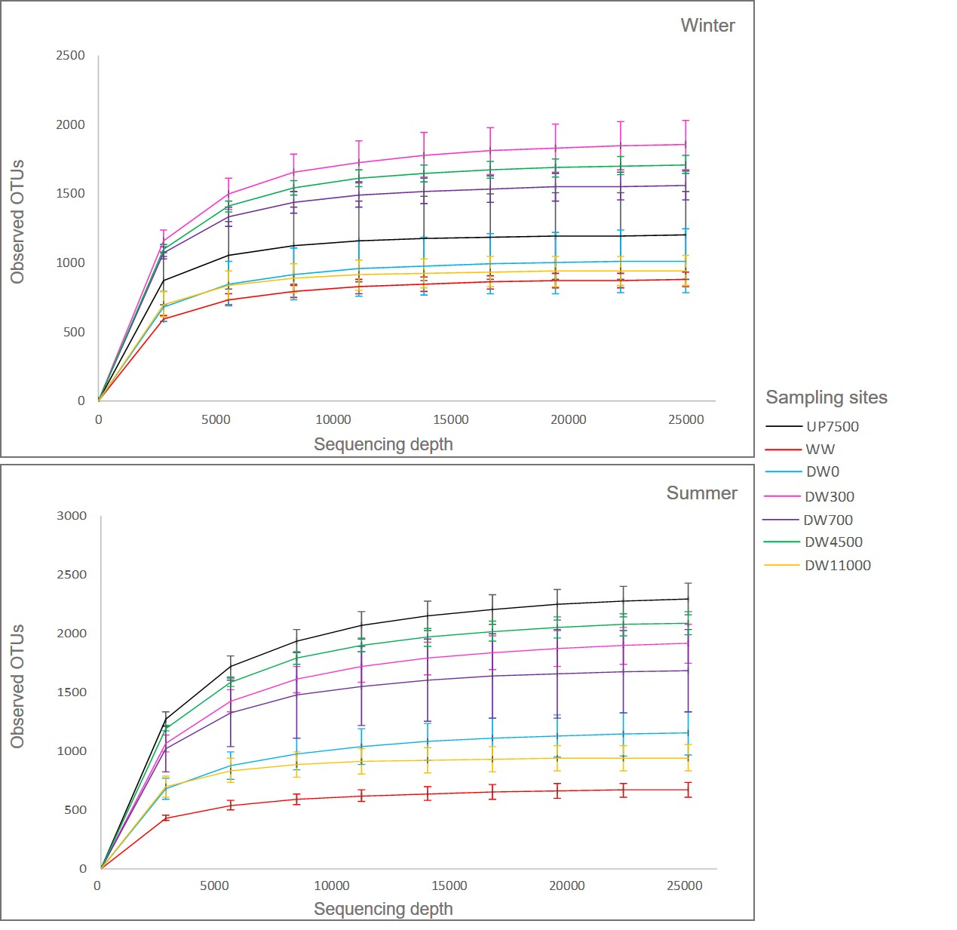

**Figure S1**. Rarefaction curves showing alpha diversity of samples of azithromycin-manufacturing effluents (WW) and sediments of receiving Sava river from different sites using the metrics of observed species (i.e. ASVs). Sampling sites: UP7500, 7500 m upstream of discharge; DW0, discharge; DW300, 300 m downstream of discharge; DW700, 700 m downstream; DW4500, 4500 m downstream; DW11000, 11000 m downstream; WW, effluent.



**Figure S2**. Shannon-Wiener diversity index of Sava river sediments from different sites during winter and summer. Sampling sites: UP7500, 7500 m upstream of discharge; DW0, discharge; DW300, 300 m downstream of discharge; DW700, 700 m downstream; DW4500, 4500 m downstream; DW11000, 11000 m downstream.

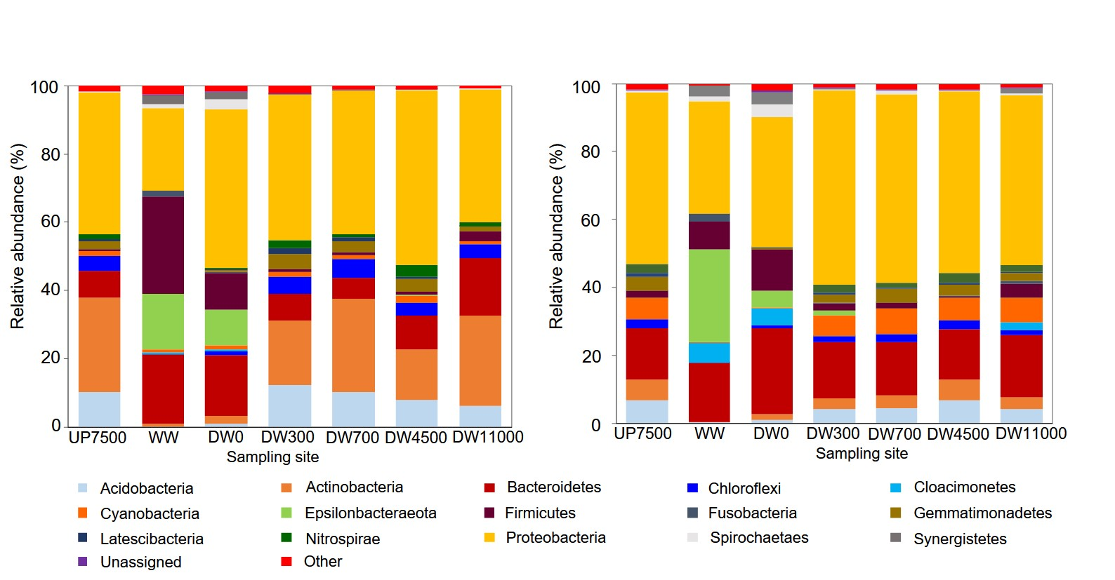

b)

a)

**Figure S3**. Taxonomic composition of bacterial communities at phylum level in samples of azithromycin-manufacturing effluent (WW) and sediments of receiving Sava river from different sites during a) winter and b) summer. Taxa with abundance below 1% in all samples were group into 'Other'. Sampling sites: UP7500, 7500 m upstream of discharge; DW0, discharge; DW300, 300 m downstream of discharge; DW700, 700 m downstream; DW4500, 4500 m downstream; DW11000, 11000 m downstream; WW, effluent.

1. Present address: Department of Biology, University of Copenhagen, Universitetsparken 15, 2100 Copenhagen Ø, Copenhagen, Denmark
2. Present address: Faculty of Forestry and Wood Sciences, Czech University of Life Sciences, Prague, Kamýcká 129, Prague 6 Suchdol, Czech Republic