**Supporting Information**

*Table S1: Number and age range of cases used for the Principal Component Analysis*

The number of cases is listed per Principal Component Analysis and subdivided for CW version (in columns) as well as sex and wild type vs mutants (in rows). In the last row the age range at CW testing, respectively OF testing for the IMPC data set, is given in months. Note that the cases from the CW OF VP Analysis are a subset of the CW Analysis cases. CW- CatWalk; OF- Open Field; VP- Vertical Pole

|  |  |  |  |  |  |  |  |
| --- | --- | --- | --- | --- | --- | --- | --- |
| **Number of cases** | **CW Analysis** | | | **CW OF VP Analysis** | | | **IMPC Analysis** |
|  | ***Total*** | **7.1** | **XT** | ***Total*** | **7.1** | **XT** | ***Total*** |
| **Total cases** | ***1499*** | *627* | *872* | ***1057*** | *358* | *399* | ***1327*** |
| female cases | *691* | 283 | 408 | *482* | 153 | 329 | *618* |
| male cases | *808* | 344 | 464 | *575* | 205 | 370 | *709* |
|  |  |  |  |  |  |  |  |
| **Wild type cases** | ***660*** | *276* | *384* | ***436*** | *157* | *279* | ***665*** |
| female cases | *316* | 136 | 180 | *197* | 71 | 126 | *312* |
| male cases | *344* | 140 | 204 | *239* | 86 | 153 | *353* |
| **Mutant cases** | ***838*** | *350* | *488* | ***620*** | *200* | *420* | ***662*** |
| female cases | *375* | 147 | 228 | *285* | 82 | 203 | *306* |
| male cases | *463* | 203 | 260 | *335* | 118 | 217 | *356* |
|  |  |  |  |  |  |  |  |
| Age range at CW (for IMPC at OF) testing (months) | *3-28* | 3-28 | 3-15 | *3-18* | 4-18 | 3-12 | *2* |

*Table S2: Parameters from CatWalk, Open Field and Vertical Pole*

Parameters used for the Principal Component Analysis for CatWalk, Open Field and Vertical Pole tests. For description of the abbreviations used in the parameter´s names please see below the listed parameters. For a more detailed description of CatWalk parameters please see the Methods and [3,11]. The numerics at the end of individual Open Field parameters refer to the time bins, e.g. OF_dist05 is the distance travelled in the first 5 minutes of the test, OF_dist10 is the distance travelled in the second 5 minutes of the test, OF_distTot is the total distance travelled in the whole 20 minutes of the test.

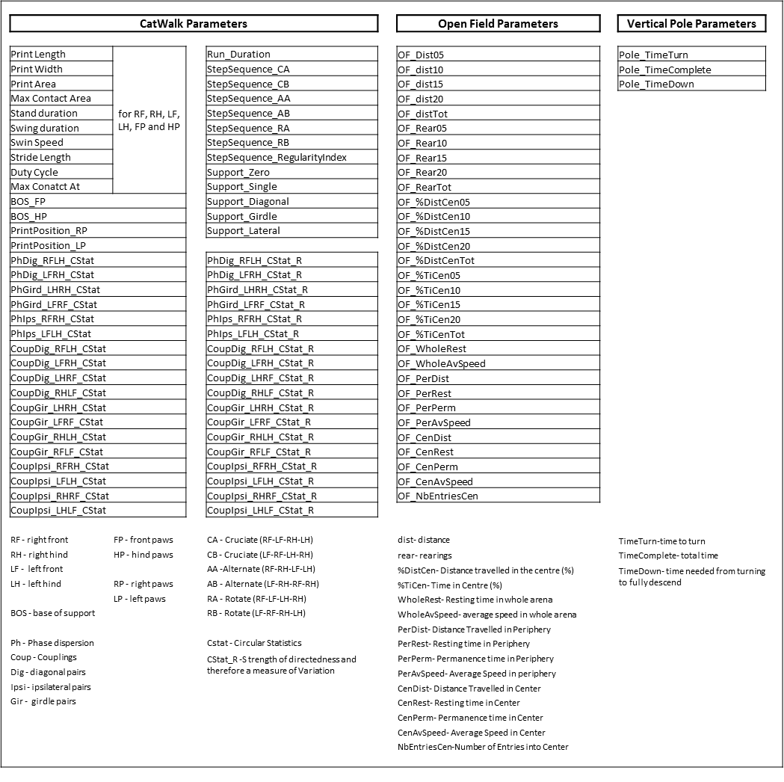

*Table S3: Structure matrix for CatWalk PCA*

The structure matrix of the CatWalk PCA for the 10 extracted components is presented. Parameters are sorted according to their major loadings. The loadings describe the correlation between parameter and component. For abbreviations used see Table S2

|  |  |  |  |  |  |  |  |  |  |  |
| --- | --- | --- | --- | --- | --- | --- | --- | --- | --- | --- |
|  | | | | | | | | | | |
|  | Component | | | | | | | | | |
| 1 | 2 | 3 | 4 | 5 | 6 | 7 | 8 | 9 | 10 |
| HP_PrintArea | **.965** | .005 | -.006 | .008 | .170 | .031 | -.244 | .083 | -.011 | -.306 |
| FP_MaxContactArea | **.963** | -.164 | -.017 | .094 | .106 | .053 | -.048 | .253 | -.015 | -.290 |
| FP_PrintArea | **.960** | -.179 | -.019 | .141 | .086 | .056 | -.037 | .296 | -.020 | -.283 |
| HP_MaxContactArea | **.958** | -.061 | -.004 | .008 | .189 | .039 | -.233 | .104 | -.017 | -.305 |
| RF_PrintArea | **.958** | -.167 | -.013 | .135 | .089 | .036 | -.044 | .294 | -.017 | -.284 |
| RF_MaxContactArea | **.957** | -.143 | -.016 | .083 | .104 | .024 | -.057 | .246 | -.010 | -.293 |
| LF_MaxContactArea | **.954** | -.182 | -.018 | .105 | .108 | .080 | -.038 | .256 | -.018 | -.284 |
| LF_PrintArea | **.952** | -.189 | -.025 | .147 | .083 | .076 | -.028 | .294 | -.022 | -.280 |
| LH_PrintArea | **.950** | -.040 | -.050 | .023 | .162 | .095 | -.214 | .091 | -.049 | -.290 |
| LH_MaxContactArea | **.941** | -.095 | -.047 | .016 | .181 | .084 | -.207 | .108 | -.053 | -.288 |
| RH_MaxContactArea | **.931** | -.019 | .036 | .000 | .190 | -.014 | -.251 | .094 | .025 | -.312 |
| RH_PrintArea | **.931** | .056 | .033 | -.010 | .171 | -.043 | -.266 | .070 | .033 | -.312 |
| FP_PrintLength | **.899** | -.115 | .012 | .149 | .027 | .065 | -.001 | .438 | -.080 | -.270 |
| RF_PrintLength | **.879** | -.110 | .020 | .145 | .036 | .041 | -.012 | .429 | -.071 | -.259 |
| HP_PrintLength | **.879** | .247 | .038 | -.049 | .066 | .001 | -.155 | .040 | -.046 | -.303 |
| LF_PrintLength | **.878** | -.116 | .003 | .148 | .018 | .088 | .013 | .427 | -.085 | -.270 |
| FP_PrintWidth | **.874** | .102 | .048 | -.021 | .015 | .044 | -.082 | .365 | -.105 | -.324 |
| LH_PrintLength | **.858** | .197 | -.014 | -.014 | .051 | .085 | -.135 | .057 | -.085 | -.277 |
| LF_PrintWidth | **.845** | .056 | .047 | .002 | -.002 | .104 | -.056 | .367 | -.127 | -.307 |
| RF_PrintWidth | **.841** | .139 | .044 | -.041 | .032 | -.018 | -.099 | .337 | -.074 | -.321 |
| RH_PrintLength | **.814** | .270 | .076 | -.079 | .075 | -.080 | -.160 | .022 | .000 | -.303 |
| LH_PrintWidth | **.787** | .329 | -.003 | -.116 | .084 | .053 | -.290 | -.072 | -.107 | -.267 |
| HP_PrintWidth | **.765** | .432 | .058 | -.169 | .078 | .002 | -.335 | -.098 | -.048 | -.280 |
| RH_PrintWidth | **.653** | .489 | .103 | -.206 | .064 | -.053 | -.345 | -.112 | .023 | -.266 |
| HP_Stand | -.049 | **.894** | -.188 | .287 | -.304 | -.061 | .038 | -.308 | .229 | .127 |
| RH_Stand | -.062 | **.891** | -.160 | .261 | -.294 | -.112 | .027 | -.299 | .256 | .112 |
| HP_DutyCycle | -.124 | **.888** | .009 | -.312 | -.141 | -.063 | -.050 | -.476 | .007 | -.114 |
| LH_Stand | -.034 | **.874** | -.217 | .306 | -.305 | -.008 | .047 | -.302 | .198 | .137 |
| RH_DutyCycle | -.142 | **.854** | .014 | -.320 | -.121 | -.193 | -.069 | -.444 | .044 | -.108 |
| LH_DutyCycle | -.090 | **.851** | -.004 | -.277 | -.151 | .088 | -.024 | -.471 | -.034 | -.116 |
| FP_DutyCycle | .012 | **.815** | .021 | -.113 | -.595 | -.009 | .103 | -.192 | -.042 | -.137 |
| RF_DutyCycle | .024 | **.789** | .033 | -.105 | -.575 | -.098 | .097 | -.185 | -.020 | -.141 |
| FP_Stand | .008 | **.789** | -.242 | .428 | -.418 | -.033 | .090 | -.148 | .263 | .102 |
| LF_DutyCycle | -.002 | **.784** | .008 | -.112 | -.573 | .081 | .103 | -.187 | -.060 | -.126 |
| LF_Stand | .009 | **.783** | -.244 | .428 | -.417 | -.009 | .095 | -.153 | .250 | .098 |
| RF_Stand | .012 | **.781** | -.236 | .428 | -.409 | -.056 | .085 | -.141 | .271 | .099 |
| Support_Diagonal | .309 | **-.751** | .208 | .110 | .438 | .095 | .027 | .448 | -.245 | -.219 |
| Run_Duration | -.195 | **.613** | -.254 | .322 | -.265 | -.037 | .089 | -.363 | .259 | .206 |
| Support_Single | -.064 | **-.527** | -.008 | .303 | .060 | .072 | .214 | .416 | -.040 | .071 |
| Support_Zero | -.160 | **-.358** | -.022 | .186 | -.035 | .045 | .064 | .250 | -.045 | .073 |
| Support_Girdle | -.112 | **-.340** | -.037 | .208 | -.057 | .025 | .212 | .201 | .066 | .085 |
| CoupIpsi_RFRH_CStat_R | .000 | -.052 | **.945** | -.079 | -.048 | .050 | .092 | .145 | -.502 | -.188 |
| PhIps_RFRH_CStat_R | .045 | -.058 | **.932** | -.057 | -.047 | .056 | .098 | .172 | -.501 | -.196 |
| PhDig_LFRH_CStat_R | -.040 | .034 | **.918** | -.053 | -.165 | .034 | .071 | .105 | -.432 | -.096 |
| CoupDig_LFRH_CStat_R | -.035 | .059 | **.918** | -.049 | -.135 | .036 | .079 | .109 | -.444 | -.130 |
| CoupIpsi_RHRF_CStat_R | -.003 | -.070 | **.915** | -.017 | -.037 | .045 | .049 | .176 | -.437 | -.173 |
| PhGird_LHRH_CStat_R | -.053 | -.021 | **.863** | -.035 | -.095 | .057 | .054 | .030 | -.712 | -.001 |
| CoupGir_RHLH_CStat_R | -.107 | -.021 | **.862** | -.030 | -.106 | .033 | .034 | .021 | -.685 | .047 |
| CoupGir_LHRH_CStat_R | -.086 | -.031 | **.844** | -.046 | -.101 | .039 | .037 | .019 | -.734 | .027 |
| StepSequence_RegularityIndex | -.180 | -.053 | **.615** | -.075 | -.118 | .041 | -.050 | -.107 | -.482 | .054 |
| CoupDig_RHLF_CStat_R | .191 | -.122 | **.600** | -.097 | .016 | .106 | .009 | .304 | -.556 | -.472 |
| StepSequence_RA | .006 | .100 | **-.451** | .071 | -.008 | -.012 | .090 | .141 | .174 | .073 |
| HP_SwingSpeed | .077 | .073 | .195 | **-.908** | .151 | -.028 | -.237 | .224 | -.230 | -.089 |
| RH_SwingSpeed | .042 | .103 | .198 | **-.880** | .142 | -.150 | -.241 | .205 | -.183 | -.085 |
| LH_SwingSpeed | .111 | .034 | .168 | **-.875** | .151 | .103 | -.219 | .230 | -.262 | -.092 |
| FP_Swing | .166 | .197 | -.030 | **.839** | .180 | .058 | .076 | .108 | .050 | -.199 |
| RF_Swing | .145 | .196 | -.051 | **.827** | .172 | .125 | .085 | .105 | .044 | -.177 |
| HP_Swing | .199 | -.279 | .100 | **.817** | -.100 | .115 | .185 | .440 | -.100 | -.063 |
| LF_Swing | .177 | .184 | -.012 | **.813** | .167 | -.019 | .071 | .097 | .056 | -.217 |
| LH_Swing | .195 | -.242 | .056 | **.801** | -.070 | -.026 | .182 | .444 | -.101 | -.078 |
| RH_Swing | .189 | -.276 | .114 | **.749** | -.108 | .213 | .174 | .375 | -.077 | -.049 |
| FP_SwingSpeed | .242 | -.318 | .194 | **-.714** | .023 | .022 | -.182 | .593 | -.276 | -.097 |
| LF_SwingSpeed | .231 | -.315 | .181 | **-.706** | .026 | .068 | -.173 | .584 | -.280 | -.093 |
| RF_SwingSpeed | .246 | -.313 | .204 | **-.704** | .023 | -.023 | -.184 | .584 | -.263 | -.103 |
| BOS_HP | .299 | .077 | -.102 | **.339** | .209 | .031 | .259 | -.108 | .156 | -.242 |
| StepSequence_AB | -.136 | .290 | .074 | .056 | **-.864** | -.088 | -.092 | -.164 | -.026 | .083 |
| PhIps_RFRH_CStat | -.038 | .404 | .158 | .016 | **-.827** | .102 | .113 | .121 | -.142 | -.066 |
| CoupIpsi_RFRH_CStat | -.038 | .411 | .152 | .021 | **-.823** | .093 | .117 | .126 | -.137 | -.046 |
| StepSequence_AA | .024 | -.132 | -.088 | -.082 | **.816** | .025 | -.051 | .113 | .028 | -.069 |
| CoupIpsi_LFLH_CStat | -.059 | .420 | .121 | -.013 | **-.798** | -.083 | .052 | .100 | -.252 | -.037 |
| PhIps_LFLH_CStat | -.058 | .414 | .101 | -.013 | **-.798** | -.092 | .071 | .092 | -.247 | -.049 |
| CoupIpsi_RHRF_CStat | .171 | -.185 | .101 | .011 | **.794** | .001 | .112 | .137 | -.218 | -.369 |
| CoupIpsi_LHLF_CStat | .214 | -.229 | .173 | .007 | **.784** | .203 | .148 | .150 | -.152 | -.418 |
| CoupDig_LFRH_CStat | .141 | -.058 | -.117 | .013 | **.708** | -.417 | .033 | .137 | .015 | -.175 |
| CoupDig_RHLF_CStat | -.075 | .091 | .105 | .047 | **-.704** | .425 | .008 | -.115 | -.061 | .084 |
| PhDig_LFRH_CStat | .111 | -.030 | -.113 | .011 | **.703** | -.404 | .027 | .101 | .021 | -.170 |
| CoupDig_LHRF_CStat | -.093 | .155 | .121 | .003 | **-.671** | -.512 | -.014 | -.050 | -.019 | -.047 |
| CoupDig_RFLH_CStat | .138 | -.121 | -.121 | .054 | **.663** | .544 | .049 | .085 | .035 | -.044 |
| PhDig_RFLH_CStat | .101 | -.100 | -.104 | .054 | **.657** | .538 | .044 | .062 | .018 | -.050 |
| BOS_FP | -.185 | .420 | -.108 | -.125 | **-.469** | -.044 | .047 | -.374 | .125 | .067 |
| CoupGir_LHRH_CStat | .129 | .068 | .264 | .034 | -.038 | **.785** | .183 | .145 | -.200 | -.329 |
| PhGird_LHRH_CStat | .128 | .048 | .270 | .028 | -.030 | **.783** | .162 | .143 | -.231 | -.339 |
| StepSequence_CA | .140 | -.240 | .008 | .038 | .191 | **.750** | .113 | .043 | -.037 | .024 |
| StepSequence_CB | .056 | -.085 | .078 | -.054 | .209 | **-.709** | .091 | .064 | -.008 | -.114 |
| CoupGir_LFRF_CStat | .083 | .145 | .156 | .066 | -.003 | **.616** | .212 | .200 | -.389 | -.367 |
| PhGird_LFRF_CStat | .089 | .150 | .160 | .062 | .005 | **.615** | .199 | .197 | -.391 | -.369 |
| CoupGir_RHLH_CStat | .104 | .250 | .038 | .008 | .041 | **-.605** | .171 | .233 | -.251 | -.313 |
| CoupGir_RFLF_CStat | .161 | .209 | .272 | .011 | .004 | **-.438** | .191 | .291 | -.285 | -.429 |
| HP_MaxContactAt | -.304 | .010 | .121 | .059 | .091 | .062 | **.812** | .024 | -.144 | .128 |
| LH_MaxContactAt | -.309 | .021 | .095 | .047 | .066 | .095 | **.723** | .030 | -.109 | .133 |
| FP_MaxContactAt | .073 | .021 | -.039 | .129 | -.079 | .042 | **.719** | -.065 | .054 | -.394 |
| RH_MaxContactAt | -.226 | -.005 | .122 | .057 | .097 | .010 | **.718** | .012 | -.145 | .090 |
| RF_MaxContactAt | .201 | -.083 | .014 | .191 | -.022 | -.007 | **.620** | .036 | -.005 | -.330 |
| LF_MaxContactAt | -.080 | .120 | -.082 | .022 | -.112 | .078 | **.583** | -.144 | .097 | -.330 |
| RF_StrideLength | .552 | -.466 | .179 | -.072 | .284 | .078 | -.159 | **.788** | -.263 | -.276 |
| FP_StrideLength | .556 | -.469 | .181 | -.076 | .282 | .077 | -.159 | **.787** | -.266 | -.279 |
| HP_StrideLength | .516 | -.462 | .323 | -.115 | .240 | .075 | -.152 | **.783** | -.373 | -.188 |
| LF_StrideLength | .555 | -.471 | .182 | -.080 | .282 | .077 | -.155 | **.781** | -.267 | -.283 |
| RH_StrideLength | .504 | -.453 | .380 | -.110 | .231 | .068 | -.146 | **.780** | -.313 | -.198 |
| LH_StrideLength | .519 | -.460 | .243 | -.117 | .246 | .081 | -.155 | **.768** | -.414 | -.182 |
| Support_Lateral | .106 | -.306 | -.100 | .324 | .173 | .116 | .215 | **.379** | .038 | .067 |
| CoupIpsi_LFLH_CStat_R | .044 | -.047 | .540 | -.100 | -.020 | .073 | .062 | .146 | **-.926** | -.117 |
| PhIps_LFLH_CStat_R | .088 | -.089 | .533 | -.091 | -.017 | .080 | .069 | .174 | **-.921** | -.145 |
| CoupDig_RFLH_CStat_R | .015 | -.022 | .501 | -.079 | -.070 | .071 | .019 | .104 | **-.919** | -.114 |
| PhDig_RFLH_CStat_R | .020 | -.016 | .483 | -.074 | -.115 | .040 | .013 | .105 | **-.914** | -.077 |
| CoupIpsi_LHLF_CStat_R | .074 | -.136 | .545 | -.087 | .017 | .080 | .034 | .166 | **-.889** | -.177 |
| CoupDig_LHRF_CStat_R | .152 | -.164 | .497 | -.087 | .056 | .073 | -.039 | .266 | **-.718** | -.481 |
| CoupGir_LFRF_CStat_R | .273 | -.219 | .429 | -.072 | .150 | .136 | .054 | .375 | -.564 | **-.677** |
| PhGird_LFRF_CStat_R | .276 | -.224 | .406 | -.048 | .120 | .159 | .095 | .385 | -.549 | **-.659** |
| CoupGir_RFLF_CStat_R | .260 | -.229 | .449 | -.114 | .146 | .138 | .075 | .344 | -.596 | **-.638** |
| PrintPos_LP | .325 | -.029 | -.002 | .250 | .122 | .084 | .130 | -.083 | .219 | **-.613** |
| PrintPos_RP | .341 | -.033 | -.102 | .219 | .143 | .034 | .106 | -.108 | .073 | **-.586** |

*Table S4: Component correlation matrix for CatWalk PCA*

Correlations between the extracted components of the CatWalk PCA. There is a moderate correlation between component 3 and 9, both containing measures of variation in interlimb coordination. There are weaker correlations between component 1 and 10 as well as 2 and 8. Correlations above |0.250| are marked in bold.

|  |  |  |  |  |  |  |  |  |  |  |  |
| --- | --- | --- | --- | --- | --- | --- | --- | --- | --- | --- | --- |
| **Component** | | **1** | **2** | **3** | **4** | **5** | **6** | **7** | **8** | **9** | **10** |
|  | **1** | 1.000 |  |  |  |  |  |  |  |  |  |
| **2** | -.009 | 1.000 |  |  |  |  |  |  |  |  |
| **3** | .012 | -.060 | 1.000 |  |  |  |  |  |  |  |
| **4** | .033 | -.016 | -.092 | 1.000 |  |  |  |  |  |  |
| **5** | .111 | -.206 | -.046 | -.027 | 1.000 |  |  |  |  |  |
| **6** | .040 | -.053 | .036 | .043 | .010 | 1.000 |  |  |  |  |
| **7** | -.133 | .000 | .001 | .183 | -.023 | .053 | 1.000 |  |  |  |
| **8** | .198 | **-.252** | .088 | .029 | .050 | .028 | .040 | 1.000 |  |  |
| **9** | -.034 | .047 | **-.490** | .118 | .012 | -.070 | -.026 | -.210 | 1.000 |  |
| **10** | **-.306** | -.050 | -.138 | .000 | -.094 | -.029 | -.120 | -.090 | .153 | 1.000 |

*Table S5: Structure matrix for CatWalk- Open Field- Vertical Pole PCA*

The structure matrix of the CatWalk-Open Field-Vertical Pole PCA for the 13 extracted components is presented. Parameters are sorted according to their major loadings. The loadings describe the correlation between parameter and component. Each component contains parameters from one test only. For abbreviations used see Table S2

|  |  |  |  |  |  |  |  |  |  |  |  |  |  |
| --- | --- | --- | --- | --- | --- | --- | --- | --- | --- | --- | --- | --- | --- |
|  | | | | | | | | | | | | | |
|  | **Component** | | | | | | | | | | | | |
| **1** | **2** | **3** | **4** | **5** | **6** | **7** | **8** | **9** | **10** | **11** | **12** | **13** |
| OF_WholeAvSpeed | **.950** | -.162 | .163 | -.037 | -.197 | .046 | -.631 | .105 | -.236 | .263 | .085 | -.076 | -.097 |
| OF_PerAvSpeed | **.944** | -.154 | .177 | -.029 | -.187 | .042 | -.627 | .108 | -.230 | .265 | .082 | -.069 | -.094 |
| OF_PerDist | **.934** | -.173 | .160 | -.054 | -.172 | .044 | -.444 | .114 | -.228 | .253 | .068 | -.044 | -.129 |
| OF_distTot | **.932** | -.169 | .161 | -.044 | -.181 | .045 | -.627 | .112 | -.232 | .262 | .074 | -.058 | -.117 |
| OF_RearTot | **.926** | -.094 | .169 | -.038 | -.198 | .053 | -.597 | .064 | -.240 | .245 | .089 | -.120 | .040 |
| OF_dist10 | **.903** | -.143 | .172 | -.046 | -.169 | .048 | -.604 | .101 | -.206 | .256 | .076 | -.055 | -.130 |
| OF_Rear10 | **.884** | -.087 | .169 | -.033 | -.187 | .057 | -.575 | .052 | -.220 | .235 | .091 | -.114 | .041 |
| OF_dist15 | **.883** | -.128 | .171 | -.062 | -.164 | .032 | -.585 | .127 | -.193 | .221 | .078 | -.033 | -.111 |
| OF_dist20 | **.870** | -.110 | .149 | -.083 | -.150 | .035 | -.557 | .104 | -.183 | .202 | .051 | -.043 | -.083 |
| OF_Rear15 | **.864** | -.073 | .145 | -.041 | -.162 | .054 | -.571 | .060 | -.214 | .214 | .090 | -.110 | .057 |
| OF_Dist05 | **.858** | -.232 | .122 | .008 | -.193 | .045 | -.608 | .097 | -.270 | .291 | .063 | -.069 | -.106 |
| OF_Rear20 | **.852** | -.035 | .113 | -.063 | -.165 | .025 | -.551 | .043 | -.198 | .211 | .071 | -.113 | .047 |
| OF_Rear05 | **.842** | -.148 | .197 | -.007 | -.217 | .063 | -.523 | .084 | -.253 | .245 | .077 | -.100 | .012 |
| OF_WholeRest | **.752** | -.119 | .060 | .009 | -.230 | .044 | -.480 | -.029 | -.214 | .176 | .143 | -.200 | .150 |
| OF_PerRest | **.743** | -.145 | .074 | .003 | -.206 | .053 | -.360 | -.029 | -.218 | .161 | .144 | -.184 | .150 |
| OF_CenAvSpeed | **.452** | -.018 | .007 | -.102 | -.237 | .074 | .131 | .069 | -.071 | .112 | -.001 | -.097 | -.211 |
| HP_PrintArea | -.153 | **.962** | .024 | -.180 | -.012 | -.010 | .118 | -.061 | .102 | -.127 | -.071 | -.046 | -.376 |
| FP_MaxContactArea | -.074 | **.960** | .016 | -.105 | -.201 | .029 | .066 | .050 | .103 | -.153 | -.061 | -.089 | -.360 |
| FP_PrintArea | -.040 | **.957** | .052 | -.079 | -.252 | .039 | .048 | .050 | .099 | -.153 | -.055 | -.099 | -.365 |
| RF_PrintArea | -.042 | **.955** | .053 | -.079 | -.244 | .033 | .040 | .039 | .104 | -.149 | -.087 | -.090 | -.357 |
| HP_MaxContactArea | -.150 | **.954** | -.015 | -.188 | -.056 | -.010 | .118 | -.050 | .086 | -.123 | -.060 | -.069 | -.394 |
| RF_MaxContactArea | -.085 | **.953** | .014 | -.101 | -.186 | .011 | .063 | .039 | .108 | -.150 | -.093 | -.077 | -.352 |
| LF_MaxContactArea | -.064 | **.951** | .019 | -.107 | -.211 | .047 | .069 | .060 | .097 | -.154 | -.029 | -.098 | -.361 |
| LF_PrintArea | -.038 | **.949** | .051 | -.078 | -.256 | .046 | .056 | .061 | .094 | -.157 | -.023 | -.107 | -.368 |
| LH_PrintArea | -.145 | **.944** | .021 | -.173 | -.045 | .045 | .124 | -.037 | .047 | -.189 | -.026 | -.064 | -.366 |
| LH_MaxContactArea | -.150 | **.934** | -.020 | -.182 | -.080 | .028 | .131 | -.031 | .035 | -.183 | -.026 | -.083 | -.381 |
| RH_PrintArea | -.157 | **.930** | .025 | -.180 | .026 | -.072 | .107 | -.084 | .161 | -.063 | -.118 | -.024 | -.368 |
| RH_MaxContactArea | -.144 | **.928** | -.009 | -.187 | -.026 | -.053 | .099 | -.070 | .141 | -.061 | -.095 | -.050 | -.390 |
| FP_PrintLength | .002 | **.910** | .083 | -.036 | -.321 | .054 | .032 | -.008 | .091 | -.131 | -.044 | -.094 | -.342 |
| HP_PrintLength | -.183 | **.905** | .074 | -.110 | .136 | -.009 | .127 | -.054 | .135 | -.095 | -.092 | .044 | -.229 |
| LF_PrintLength | .008 | **.896** | .065 | -.032 | -.310 | .062 | .038 | .006 | .078 | -.127 | -.010 | -.099 | -.352 |
| FP_PrintWidth | -.208 | **.891** | -.035 | -.014 | -.090 | .048 | .116 | -.143 | .117 | -.117 | -.093 | .000 | -.287 |
| RF_PrintLength | -.003 | **.888** | .098 | -.038 | -.318 | .045 | .026 | -.022 | .100 | -.130 | -.075 | -.086 | -.319 |
| LH_PrintLength | -.167 | **.881** | .090 | -.095 | .073 | .073 | .118 | -.043 | .070 | -.165 | -.032 | .026 | -.222 |
| LF_PrintWidth | -.172 | **.862** | -.036 | .003 | -.125 | .074 | .106 | -.118 | .075 | -.102 | .010 | -.038 | -.297 |
| RF_PrintWidth | -.229 | **.849** | -.030 | -.029 | -.047 | .020 | .118 | -.156 | .151 | -.124 | -.187 | .038 | -.254 |
| RH_PrintLength | -.183 | **.842** | .051 | -.116 | .183 | -.089 | .124 | -.059 | .191 | -.031 | -.142 | .055 | -.217 |
| LH_PrintWidth | -.276 | **.802** | .044 | -.107 | .284 | .014 | .197 | -.199 | .049 | -.169 | -.064 | .093 | -.219 |
| HP_PrintWidth | -.327 | **.796** | .032 | -.107 | .376 | -.028 | .206 | -.260 | .143 | -.077 | -.102 | .136 | -.212 |
| RH_PrintWidth | -.342 | **.682** | .013 | -.093 | .422 | -.071 | .190 | -.291 | .230 | .014 | -.129 | .162 | -.182 |
| FP_Swing | .183 | .150 | **.883** | -.016 | -.077 | .042 | -.078 | -.047 | .218 | -.131 | -.026 | .009 | -.018 |
| RF_Swing | .182 | .138 | **.864** | -.008 | -.074 | .027 | -.078 | -.049 | .220 | -.130 | .135 | .012 | -.022 |
| FP_SwingSpeed | -.179 | .190 | **-.863** | -.114 | -.360 | -.003 | .038 | -.343 | -.162 | .093 | -.071 | -.042 | -.227 |
| LF_SwingSpeed | -.178 | .184 | **-.858** | -.114 | -.351 | -.017 | .034 | -.339 | -.161 | .090 | .032 | -.046 | -.225 |
| LF_Swing | .186 | .158 | **.857** | -.022 | -.074 | .054 | -.070 | -.031 | .204 | -.124 | -.178 | .002 | -.027 |
| HP_SwingSpeed | -.326 | .046 | **-.856** | -.253 | .123 | -.062 | .140 | -.383 | -.118 | .116 | -.100 | .098 | -.036 |
| RF_SwingSpeed | -.177 | .192 | **-.846** | -.112 | -.359 | .012 | .039 | -.336 | -.159 | .094 | -.173 | -.038 | -.222 |
| LH_SwingSpeed | -.295 | .078 | **-.840** | -.260 | .093 | .090 | .127 | -.365 | -.168 | .057 | -.049 | .072 | -.045 |
| RH_SwingSpeed | -.336 | .017 | **-.816** | -.229 | .141 | -.200 | .145 | -.372 | -.060 | .151 | -.140 | .113 | -.032 |
| LF_Stand | -.191 | .057 | **.740** | .441 | .478 | .087 | .126 | -.120 | .359 | -.142 | -.014 | .328 | .300 |
| FP_Stand | -.195 | .051 | **.733** | .442 | .469 | .098 | .129 | -.134 | .370 | -.153 | -.083 | .322 | .314 |
| RF_Stand | -.196 | .047 | **.721** | .436 | .453 | .103 | .127 | -.140 | .373 | -.161 | -.139 | .317 | .318 |
| LH_Stand | -.230 | -.006 | **.660** | .325 | .638 | .108 | .148 | -.166 | .272 | -.151 | -.072 | .345 | .394 |
| Run_Duration | -.111 | -.137 | **.655** | .338 | .553 | .025 | .103 | -.002 | .275 | -.133 | -.036 | .280 | .342 |
| LH_Swing | .363 | .139 | **.652** | .210 | -.534 | -.040 | -.218 | .050 | -.072 | .045 | .003 | -.121 | -.146 |
| HP_Swing | .405 | .149 | **.651** | .219 | -.555 | .138 | -.260 | .077 | -.071 | .103 | .055 | -.128 | -.151 |
| RH_Swing | .397 | .151 | **.594** | .200 | -.509 | .260 | -.259 | .108 | -.056 | .129 | .080 | -.127 | -.141 |
| BOS_HP | .038 | .274 | **.365** | -.128 | .092 | .067 | -.003 | .338 | .218 | -.176 | -.113 | .074 | -.117 |
| CoupIpsi_LFLH_CStat | -.142 | -.105 | .209 | **.901** | .096 | -.134 | .037 | -.089 | -.018 | .096 | .118 | .261 | .147 |
| CoupIpsi_LHLF_CStat | .156 | .145 | -.180 | **-.883** | -.099 | .162 | -.046 | .144 | -.017 | -.059 | -.098 | -.267 | -.191 |
| PhIps_LFLH_CStat | -.127 | -.093 | .168 | **.880** | .082 | -.159 | .034 | -.043 | -.083 | .136 | .132 | .235 | .094 |
| StepSequence_AB | .003 | -.126 | .291 | **.864** | .142 | .067 | -.020 | .032 | -.036 | .119 | -.021 | .174 | .065 |
| CoupIpsi_RFRH_CStat | -.097 | -.080 | .225 | **.855** | .092 | .401 | .039 | -.043 | .006 | .108 | -.133 | .214 | .162 |
| PhIps_RFRH_CStat | -.098 | -.075 | .222 | **.851** | .092 | .404 | .043 | -.036 | -.008 | .114 | -.126 | .210 | .155 |
| CoupIpsi_RHRF_CStat | .101 | .131 | -.183 | **-.824** | -.060 | -.379 | -.066 | .094 | -.020 | -.032 | .136 | -.201 | -.179 |
| StepSequence_AA | -.061 | .019 | -.195 | **-.816** | -.066 | -.080 | .039 | -.102 | .031 | -.090 | -.038 | -.103 | -.098 |
| CoupDig_RFLH_CStat | .029 | .093 | -.016 | **-.706** | -.066 | .348 | -.003 | -.022 | .060 | -.175 | .359 | -.133 | -.073 |
| PhDig_RFLH_CStat | .049 | .065 | -.011 | **-.705** | -.061 | .331 | -.002 | -.033 | .032 | -.150 | .349 | -.139 | -.070 |
| CoupDig_LHRF_CStat | -.029 | -.057 | .086 | **.705** | .066 | -.324 | .019 | .051 | .032 | .135 | -.355 | .127 | .035 |
| CoupDig_LFRH_CStat | -.037 | .166 | -.050 | **-.668** | -.070 | -.459 | .028 | .017 | .082 | -.137 | -.338 | -.049 | -.104 |
| CoupDig_RHLF_CStat | .050 | -.101 | .117 | **.668** | .072 | .429 | -.028 | .034 | -.073 | .086 | .355 | .048 | .062 |
| PhDig_LFRH_CStat | -.050 | .131 | -.042 | **-.665** | -.046 | -.447 | .040 | .033 | .078 | -.128 | -.334 | -.045 | -.077 |
| HP_DutyCycle | -.391 | -.109 | .077 | .071 | **.931** | -.044 | .234 | -.129 | .166 | -.015 | -.087 | .358 | .321 |
| LH_DutyCycle | -.335 | -.080 | .103 | .066 | **.893** | .137 | .200 | -.100 | .100 | -.058 | -.021 | .334 | .314 |
| RH_DutyCycle | -.408 | -.122 | .048 | .069 | **.880** | -.200 | .243 | -.143 | .211 | .015 | -.137 | .346 | .295 |
| Support_Diagonal | .320 | .236 | -.290 | -.354 | **-.774** | .002 | -.228 | .081 | -.299 | .117 | .063 | -.388 | -.418 |
| FP_DutyCycle | -.323 | .019 | .257 | .585 | **.719** | .092 | .178 | -.009 | .197 | .001 | -.069 | .388 | .286 |
| RF_StrideLength | -.018 | .508 | -.339 | -.267 | **-.699** | .028 | -.041 | -.334 | -.096 | .006 | -.087 | -.175 | -.471 |
| FP_StrideLength | -.014 | .511 | -.350 | -.270 | **-.699** | .025 | -.042 | -.329 | -.101 | .010 | -.081 | -.176 | -.478 |
| LF_StrideLength | -.011 | .511 | -.358 | -.271 | **-.695** | .022 | -.044 | -.322 | -.105 | .014 | -.074 | -.177 | -.482 |
| HP_StrideLength | .018 | .449 | -.395 | -.218 | **-.685** | .022 | -.075 | -.384 | -.270 | .211 | -.071 | -.150 | -.393 |
| RF_DutyCycle | -.306 | .029 | .255 | .552 | **.684** | .108 | .171 | -.007 | .191 | -.004 | -.292 | .367 | .279 |
| LF_DutyCycle | -.308 | .009 | .234 | .559 | **.682** | .067 | .167 | -.010 | .185 | .005 | .165 | .371 | .264 |
| LH_StrideLength | .007 | .450 | -.390 | -.224 | **-.675** | .016 | -.069 | -.385 | -.337 | .087 | -.051 | -.153 | -.389 |
| RH_StrideLength | .022 | .437 | -.385 | -.208 | **-.671** | .028 | -.073 | -.364 | -.178 | .303 | -.090 | -.142 | -.392 |
| HP_Stand | -.251 | -.018 | .647 | .329 | **.652** | .046 | .162 | -.174 | .321 | -.112 | -.091 | .355 | .397 |
| RH_Stand | -.265 | -.027 | .618 | .321 | **.648** | -.013 | .172 | -.182 | .362 | -.078 | -.110 | .357 | .387 |
| Support_Single | .340 | -.135 | .093 | -.038 | **-.598** | .023 | -.133 | .151 | -.012 | -.067 | .082 | -.242 | -.068 |
| Support_Lateral | .269 | .141 | .146 | -.238 | **-.532** | .067 | -.153 | .079 | .003 | -.083 | .102 | -.091 | -.046 |
| BOS_FP | -.225 | -.116 | .124 | .390 | **.434** | .026 | .173 | .186 | .122 | -.046 | -.016 | .264 | .197 |
| Support_Zero | .166 | -.187 | .055 | .049 | **-.382** | .038 | -.075 | .051 | -.060 | -.048 | .069 | -.155 | -.054 |
| Support_Girdle | .222 | -.161 | .062 | .077 | **-.330** | -.028 | -.136 | .187 | .016 | -.006 | .111 | -.186 | -.033 |
| CoupGir_LHRH_CStat | .087 | .039 | .045 | -.014 | -.012 | **.937** | -.025 | .090 | .019 | .056 | .312 | -.035 | -.019 |
| PhGird_LHRH_CStat | .084 | .040 | .041 | -.017 | -.025 | **.937** | -.024 | .083 | -.011 | .038 | .323 | -.047 | -.033 |
| CoupGir_RHLH_CStat | -.079 | .080 | -.019 | -.032 | .023 | **-.879** | .010 | .008 | -.024 | .001 | -.284 | .023 | -.058 |
| StepSequence_CB | -.042 | .075 | -.127 | -.089 | -.013 | **-.631** | .026 | .070 | .038 | .081 | -.571 | -.023 | .011 |
| OF_CenPerm | .525 | -.106 | .075 | -.003 | -.105 | .000 | **-.988** | .064 | -.170 | .199 | .067 | -.080 | -.011 |
| OF_PerPerm | -.525 | .106 | -.075 | .003 | .105 | .000 | **.988** | -.064 | .170 | -.199 | -.067 | .080 | .011 |
| OF_PerTiCenTot | .525 | -.107 | .075 | -.003 | -.106 | .000 | **-.988** | .064 | -.170 | .199 | .067 | -.080 | -.011 |
| OF_PerDistCenTot | .512 | -.119 | .005 | -.070 | -.146 | .017 | **-.966** | .063 | -.183 | .176 | .068 | -.118 | -.042 |
| OF_PerDistCen15 | .480 | -.106 | .038 | -.090 | -.117 | .012 | **-.885** | .045 | -.178 | .129 | .075 | -.102 | -.035 |
| OF_PerTiCen15 | .472 | -.092 | .085 | -.030 | -.090 | .003 | **-.883** | .047 | -.160 | .144 | .072 | -.076 | -.008 |
| OF_PerTiCen10 | .399 | -.118 | .025 | .003 | -.091 | .006 | **-.877** | .031 | -.118 | .174 | .066 | -.103 | -.022 |
| OF_PerDistCen10 | .425 | -.151 | -.037 | -.066 | -.117 | .013 | **-.876** | .041 | -.149 | .168 | .067 | -.120 | -.043 |
| OF_CenDist | .770 | -.133 | .136 | -.019 | -.167 | .039 | **-.869** | .089 | -.200 | .236 | .074 | -.075 | -.075 |
| OF_PerDistCen20 | .510 | -.065 | .026 | -.099 | -.095 | -.015 | **-.846** | .093 | -.128 | .160 | .034 | -.043 | .009 |
| OF_PerTiCen20 | .493 | -.051 | .081 | -.039 | -.065 | -.036 | **-.837** | .089 | -.112 | .160 | .043 | -.013 | .029 |
| OF_NbEntriesCen | .802 | -.137 | .119 | -.010 | -.178 | .037 | **-.824** | .094 | -.214 | .244 | .078 | -.076 | -.082 |
| OF_PerDistCen05 | .429 | -.142 | -.002 | .038 | -.172 | .031 | **-.815** | .045 | -.219 | .197 | .053 | -.130 | -.047 |
| OF_PerTiCen05 | .439 | -.121 | .064 | .074 | -.131 | .039 | **-.811** | .051 | -.204 | .216 | .047 | -.086 | -.041 |
| OF_CenRest | .542 | -.008 | -.002 | .023 | -.230 | .004 | **-.683** | -.021 | -.135 | .164 | .092 | -.185 | .104 |
| FP_MaxContactAt | -.074 | .057 | .088 | .059 | .040 | .018 | .018 | **.715** | .146 | -.070 | -.022 | .140 | .095 |
| RF_MaxContactAt | .011 | .163 | .134 | .019 | -.076 | -.077 | -.022 | **.612** | .086 | -.026 | -.015 | .074 | .017 |
| LF_MaxContactAt | -.134 | -.072 | .009 | .079 | .145 | .110 | .052 | **.561** | .158 | -.092 | -.024 | .156 | .141 |
| PrintPositions_LP | .189 | .318 | .276 | -.108 | -.010 | .124 | -.133 | **.448** | .306 | -.050 | -.048 | -.065 | -.438 |
| PhIps_LFLH_CStat_R | .216 | -.070 | -.163 | .019 | -.077 | .001 | -.194 | -.057 | **-.940** | .385 | .075 | -.059 | -.044 |
| CoupIpsi_LFLH_CStat_R | .197 | -.101 | -.157 | .032 | -.030 | -.001 | -.184 | -.082 | **-.936** | .388 | .072 | -.014 | -.011 |
| CoupDig_RFLH_CStat_R | .185 | -.130 | -.110 | .094 | -.024 | -.007 | -.165 | -.103 | **-.928** | .340 | .074 | -.017 | .038 |
| PhDig_RFLH_CStat_R | .185 | -.126 | -.099 | .128 | -.032 | -.017 | -.165 | -.103 | **-.925** | .337 | .051 | -.031 | .029 |
| CoupIpsi_LHLF_CStat_R | .197 | -.075 | -.145 | -.008 | -.100 | -.009 | -.194 | -.073 | **-.920** | .377 | .086 | -.088 | -.091 |
| CoupDig_LHRF_CStat_R | .121 | .024 | -.209 | -.051 | -.266 | -.058 | -.096 | -.029 | **-.632** | .285 | .051 | -.222 | -.366 |
| StepSequence_RB | -.141 | .031 | .142 | .090 | .025 | .016 | .022 | -.127 | **.367** | -.288 | -.030 | .033 | .101 |
| CoupIpsi_RFRH_CStat_R | .246 | -.155 | -.100 | .091 | -.018 | .027 | -.206 | -.006 | -.368 | **.960** | -.007 | .002 | .002 |
| CoupDig_LFRH_CStat_R | .212 | -.164 | -.048 | .144 | .020 | .034 | -.173 | -.021 | -.325 | **.949** | .000 | .033 | .036 |
| PhIps_RFRH_CStat_R | .254 | -.115 | -.087 | .090 | -.040 | .041 | -.198 | -.003 | -.369 | **.947** | -.008 | -.002 | -.015 |
| PhDig_LFRH_CStat_R | .217 | -.172 | -.059 | .166 | .019 | .039 | -.175 | -.017 | -.338 | **.945** | .013 | .034 | .025 |
| CoupIpsi_RHRF_CStat_R | .228 | -.132 | -.036 | .087 | -.065 | .037 | -.194 | -.052 | -.306 | **.916** | -.013 | -.031 | -.026 |
| CoupGir_RHLH_CStat_R | .277 | -.220 | -.024 | .129 | .063 | .013 | -.225 | -.084 | -.674 | **.837** | .037 | .019 | .114 |
| PhGird_LHRH_CStat_R | .289 | -.194 | -.021 | .123 | .059 | .035 | -.225 | -.057 | -.702 | **.826** | .048 | .008 | .075 |
| CoupGir_LHRH_CStat_R | .284 | -.223 | -.036 | .131 | .053 | .011 | -.232 | -.080 | -.735 | **.799** | .052 | .001 | .097 |
| StepSequence_RegularityIndex | .150 | -.213 | -.040 | .103 | .045 | .027 | -.157 | -.035 | -.550 | **.619** | .075 | .022 | .041 |
| StepSequence_RA | -.108 | .079 | .028 | -.056 | -.061 | .050 | .104 | -.040 | .131 | **-.532** | .059 | -.009 | .034 |
| CoupDig_RHLF_CStat_R | .081 | .084 | -.226 | -.056 | -.270 | .030 | -.117 | .025 | -.398 | **.480** | .070 | -.166 | -.341 |
| CoupGir_LFRF_CStat | .070 | -.002 | .030 | -.004 | -.029 | .287 | -.078 | .030 | -.098 | .011 | **.936** | -.003 | -.051 |
| PhGird_LFRF_CStat | .056 | .005 | .041 | -.002 | -.018 | .295 | -.057 | .010 | -.085 | .000 | **.924** | .015 | -.032 |
| CoupGir_RFLF_CStat | -.008 | .090 | .039 | -.024 | -.008 | -.243 | .010 | .066 | .023 | .044 | **-.913** | -.057 | -.055 |
| StepSequence_CA | .137 | .088 | -.078 | -.154 | -.109 | .582 | -.061 | .035 | -.074 | -.050 | **.604** | -.107 | -.003 |
| Pole_TimeComplete | .063 | -.105 | .010 | .113 | .041 | -.001 | -.005 | .130 | .000 | .038 | .040 | **.909** | .061 |
| Pole_TimeTurn | .126 | -.066 | .053 | .105 | .070 | .011 | -.065 | .171 | .005 | .055 | .037 | **.829** | .037 |
| Pole_TimeDown | -.055 | -.126 | -.052 | .112 | -.016 | -.019 | .087 | .033 | -.006 | .002 | .040 | **.798** | .080 |
| HP_MaxContactAt | .153 | -.461 | -.014 | -.059 | -.027 | .039 | -.101 | .421 | -.101 | .097 | .040 | .022 | **.678** |
| CoupGir_LFRF_CStat_R | .140 | .224 | -.307 | -.219 | -.415 | .046 | -.133 | .136 | -.350 | .208 | .044 | -.218 | **-.648** |
| PhGird_LFRF_CStat_R | .164 | .220 | -.265 | -.190 | -.421 | .061 | -.156 | .171 | -.341 | .201 | .060 | -.227 | **-.634** |
| RH_MaxContactAt | .119 | -.369 | -.008 | -.050 | -.026 | -.004 | -.052 | .386 | -.086 | .078 | .000 | .022 | **.616** |
| CoupGir_RFLF_CStat_R | .138 | .178 | -.353 | -.241 | -.367 | .008 | -.161 | .178 | -.410 | .234 | .050 | -.212 | **-.589** |
| LH_MaxContactAt | .150 | -.445 | -.017 | -.056 | -.023 | .070 | -.122 | .362 | -.089 | .093 | .065 | .017 | **.587** |
| PrintPositions_RP | .209 | .349 | .249 | -.132 | -.011 | .000 | -.132 | .431 | .126 | -.190 | .019 | -.084 | **-.437** |

*Table S6: Component correlation matrix for CatWalk- Open Field- Vertical Pole PCA*

Correlations between the 13 extracted components of the CatWalk- Open Field- Vertical Pole PCA. There is a moderate correlation between component 1 and 7, both consisting of the Open Field parameters. There are weaker correlations between component 2 and 13, 6 and 11 as well as 9 and 10. All these components contain CatWalk parameters only. Correlations above |0.250| are marked in bold.

|  |  |  |  |  |  |  |  |  |  |  |  |  |  |  |
| --- | --- | --- | --- | --- | --- | --- | --- | --- | --- | --- | --- | --- | --- | --- |
| **Component** | **1** | **2** | **3** | **4** | **5** | **6** | **7** | **8** | **9** | **10** | **11** | **12** | **13** |  |
| **1** | 1.000 |  |  |  |  |  |  |  |  |  |  |  |  |  |
| **2** | -.129 | 1.000 |  |  |  |  |  |  |  |  |  |  |  |  |
| **3** | .155 | .023 | 1.000 |  |  |  |  |  |  |  |  |  |  |  |
| **4** | -.065 | -.106 | .183 | 1.000 |  |  |  |  |  |  |  |  |  |  |
| **5** | -.235 | -.076 | .115 | .102 | 1.000 |  |  |  |  |  |  |  |  |  |
| **6** | .048 | .021 | .049 | .053 | -.017 | 1.000 |  |  |  |  |  |  |  |  |
| **7** | **-.477** | .075 | -.050 | .016 | .117 | -.004 | 1.000 |  |  |  |  |  |  |  |
| **8** | .124 | -.076 | .105 | -.013 | -.030 | .007 | -.043 | 1.000 |  |  |  |  |  |  |
| **9** | -.186 | .094 | .190 | .001 | .126 | -.001 | .152 | .048 | 1.000 |  |  |  |  |  |
| **10** | .190 | -.101 | -.102 | .087 | -.006 | .000 | -.166 | -.034 | **-.378** | 1.000 |  |  |  |  |
| **11** | .084 | -.076 | .010 | -.010 | -.041 | **.256** | -.059 | .023 | -.086 | -.027 | 1.000 |  |  |  |
| **12** | -.128 | -.019 | .059 | .157 | .232 | -.006 | .080 | -.010 | .085 | .011 | -.043 | 1.000 |  |  |
| **13** | -.057 | **-.323** | .104 | .129 | .223 | .008 | .013 | .004 | .071 | -.037 | .007 | .135 | 1.000 |  |

*Table S7: Parameters of the IMPC data set*

List of the parameters used in the PCA of the IMPC data set. These include parameters of the Open Field (OF), home cage (HC) during indirect Calorimetry, SHIRPA, Grip Strength (GS) and Rotarod (RR).

|  |  |  |
| --- | --- | --- |
|  |  |  |
|  | **IMPC parameters** |  |
|  |  |  |
|  | OF_Distance |  |
|  | OF_Rearings |  |
|  | OF_ArenaAverageSpeed |  |
|  | OF_ArenaRestingTime |  |
|  | OF_PeripheryDistance |  |
|  | OF_PeripheryAverageSpeed |  |
|  | OF_PeripheryRestingTime |  |
|  | OF_CenterAverageSpeed |  |
|  | OF_%CenterTime |  |
|  | OF_%CenterDistance |  |
|  | OF_CenterRestingTime |  |
|  | OF_CenterEntries |  |
|  | HC_Speed_mean |  |
|  | HC_Distance_mean |  |
|  | HC_Rearings_mean |  |
|  | GS_FP_bw_ratio |  |
|  | GS_4paws_bw_ratio |  |
|  | SHIRPA_activity |  |
|  | RR_PassiveRotations |  |
|  | RR_mean_Latency |  |
|  |  |  |
|  | FP- front paws  bw- body weight |  |
|  |  |  |

*Fig. S1: Scree plot for the IMPC data set*

The Scree plot depicts the amount of variation explained (Eigenvalue) by each component in a descending order. The Scree plot for the IMPC data set suggests retaining 6 components.

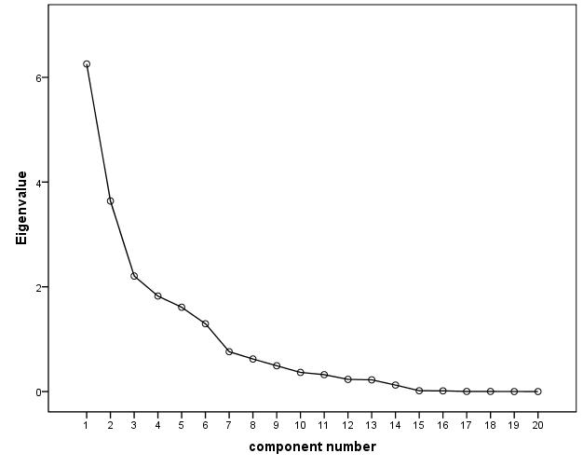

*Table S8: Structure matrix for the IMPC data set*

The structure matrix of the PCA for the IMPC data set with the extraction of 6 components is presented. Parameters are sorted according to their major loadings. The loadings describe the correlation between parameter and component. The different components include only parameters of one test respectively. An exception to this is the activity measure of SHIRPA, which is clustered in component 5 with a fairly low loading. For abbreviations see Table S7.

|  |  |  |  |  |  |  |
| --- | --- | --- | --- | --- | --- | --- |
|  | **Component** | | | | | |
| **1** | **2** | **3** | **4** | **5** | **6** |
| OF_Distance | **.982** | .150 | .181 | .393 | .214 | .125 |
| OF_ArenaAverageSpeed | **.945** | .247 | .446 | .418 | .282 | .158 |
| OF_PeripheryAverageSpeed | **.895** | .328 | .449 | .416 | .316 | .162 |
| OF_CenterAverageSpeed | **.830** | -.303 | .293 | .271 | .099 | .068 |
| OF_PeripheryDistance | **.776** | -.574 | .073 | .212 | .067 | .050 |
| OF_%CenterTime | .004 | **.986** | .126 | .128 | .189 | .081 |
| OF_%CenterDistance | .058 | **.977** | .117 | .151 | .166 | .080 |
| OF_CenterRestingTime | .029 | **.757** | .612 | .095 | .258 | .108 |
| OF_CenterEntries | .586 | **.702** | .133 | .311 | .203 | .112 |
| OF_ArenaRestingTime | .179 | .368 | **.950** | .191 | .300 | .156 |
| OF_PeripheryRestingTime | .245 | -.116 | **.894** | .205 | .224 | .141 |
| OF_Rearings | .380 | .082 | **.832** | .095 | .135 | .086 |
| HC_Speed_mean | .257 | .059 | .087 | **.963** | .154 | .024 |
| HC_Distance_mean | .257 | .060 | .088 | **.963** | .154 | .025 |
| HC_Rearings_mean | .291 | .131 | .162 | **.671** | .238 | .123 |
| GS_FP_bw_ratio | .116 | .155 | .181 | .170 | **.933** | .182 |
| GS_4paws_bw_ratio | .132 | .050 | .157 | .182 | **.924** | .145 |
| SHIRPA_activity | .364 | .277 | .271 | .369 | **.386** | .188 |
| RR_PassiveRotations | -.009 | -.012 | -.004 | -.064 | .068 | **.858** |
| RR_mean_Latency | .147 | .096 | .189 | .172 | .232 | **.847** |

*Table S9: Component correlation matrix for the IMPC data set*

Correlations between the 6 extracted components of the PCA from the IMPC data set. Only between component 1 and 4, both containing the activity measures from OF and HC respectively, there is a mild correlation. Correlations above |0.250| are marked in bold.

|  |  |  |  |  |  |  |
| --- | --- | --- | --- | --- | --- | --- |
| **Component** | **1** | **2** | **3** | **4** | **5** | **6** |
| **1** | 1.000 |  |  |  |  |  |
| **2** | .031 | 1.000 |  |  |  |  |
| **3** | .238 | .142 | 1.000 |  |  |  |
| **4** | **.327** | .116 | .148 | 1.000 |  |  |
| **5** | .171 | .159 | .221 | .232 | 1.000 |  |
| **6** | .100 | .068 | .119 | .080 | .192 | 1.000 |

*Fig. S2: Histogram for age in the 7.1 (A) and XT CW version (B)*

Differences in the age range and number of animals per age in the two CW versions. The age range of the 627 cases in the 7.1 CW version is from 3 to 28 months and in the XT version from 3 to 15 months including 872 cases.

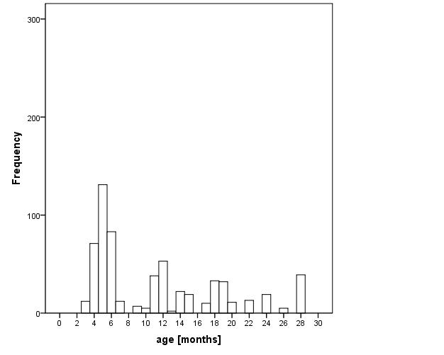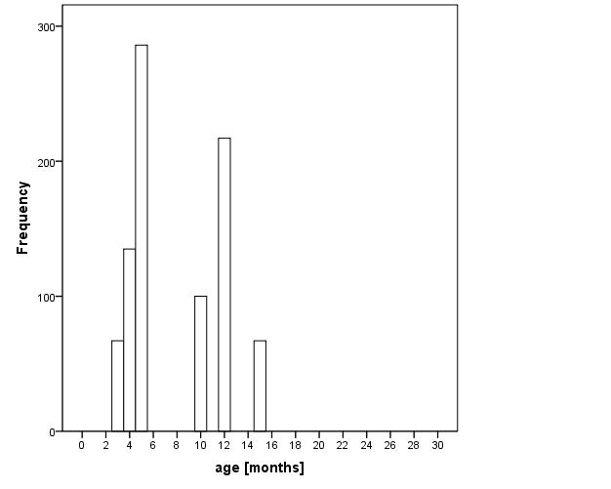

**A**

**B**