**SUPPORTING INFORMATION**

Consequences of cathepsin C inactivation on membrane exposure of proteinase 3, the target antigen in autoimmune vasculitis

**Seda Seren1, Maha Rashed Abouzaid2#, Claudia Eulenberg-Gustavus3#, Josefine Hirschfeld4#, HalaSoliman5, Uwe Jerke3, Koffi N’Guessan1, Sandrine Dallet-Choisy1, Adam Lesner6, Conni Lauritzen7, Beate Schacher8, Peter Eickholz8, Nikoletta Nagy9, Marta Szell9, Cécile Croix10, Marie-Claude Viaud-Massuard10, Abdullah Al Farraj Aldosari11, Shivanna Ragunatha12, Mostafa Ibrahim Mostafa2, Francesca Giampieri13, Maurizio Battino13, Hélène Cornillier14, Gérard Lorette15, Jean-Louis Stephan16, Cyril Goizet17, John Pedersen7, Francis Gauthier1, Dieter E. Jenne18, Sylvain Marchand-Adam1, Iain L. Chapple4, Ralph Kettritz3,19 and Brice Korkmaz1\***

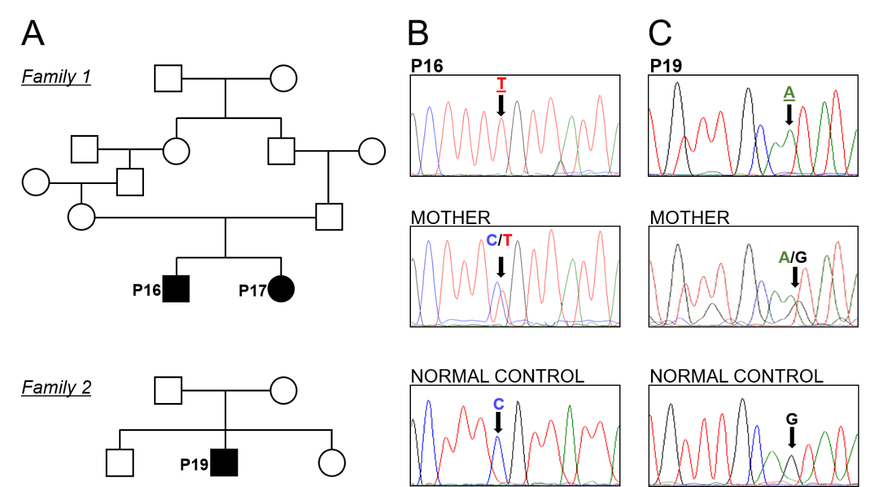

**Supp.Figure 1.** Pedigrees and genetic analysis of PLS patients. (A) Pedigree chart for family 1 and family 2. Multigenerational pedigree of family 1 showing two affected siblings (P16 and P17) of consanguineous parents. Family tree 2 shows one affected son of consanguineous parents. (B) *CTSC* gene exon 7a sequence, the upper chromatogram showing the homozygous missense mutation 1015C→T (R339C) in patient 16 (P16), the middle chromatogram shows the heterozygous mutation of the healthy mother and the lower chromatogram shows the normal sequence of an unrelated individual. (C) CTSC gene exon 3 sequence. DNA sequence of exon 3 showing the homozygous missense mutation 1015C→T (R339C) in patient 19 (P19), the middle chromatogram shows the heterozygous genotype of the healthy mother and the lower chromatogram shows the normal sequence of an unrelated individual.

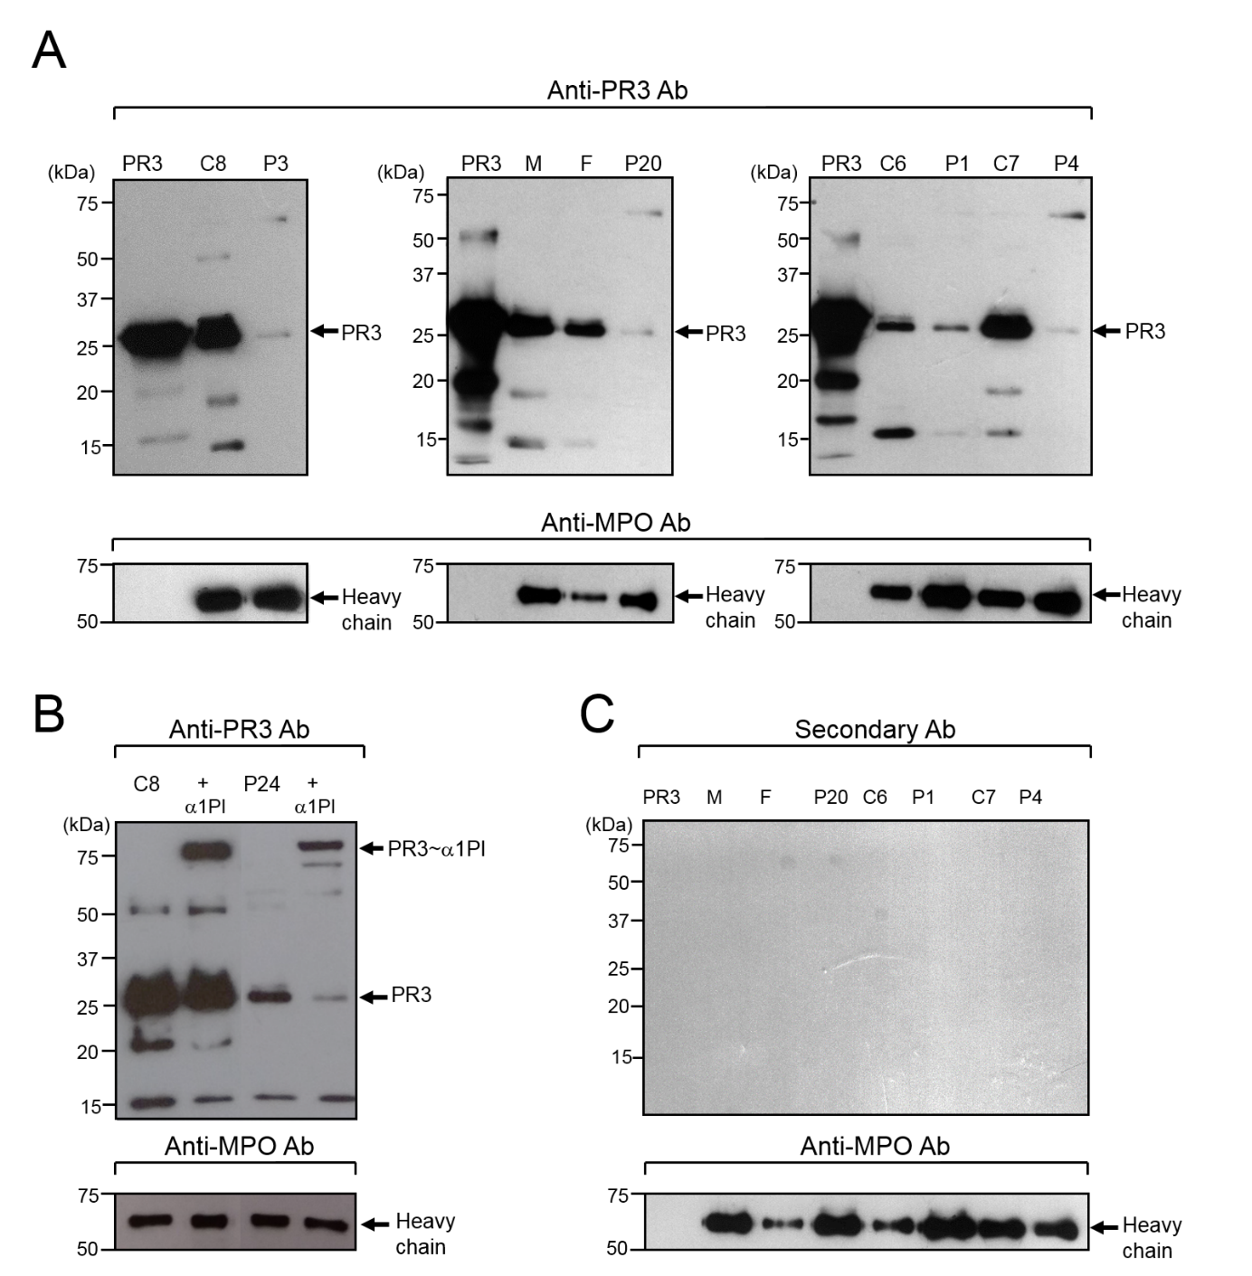

**Supp.Figure 2.** PR3 in PLS blood samples. (A) Western-blotting of WBC lysates (10 µg of protein) from PLS and healthy controls using a primary anti-PR3 Ab and a secondary HRP-labelled Ab. Amounts of PR3 were highly reduced in PLS cells compared to healthy controls or parents. (B) Western-blotting of WBC lysates (10 µg of protein) from a representative PLS patient and a healthy control incubated with 1PI (5 µM) in 50 mM HEPES buffer, 750 mM NaCl, 0.05% NP40, pH 7.4 during 3 h at 37°C. The de novo formation of irreversible 1PI-PR3 complexes of about 75 kDa reveals that PR3 is proteolytically active in spite of the absence of active CatC. Similar results were obtained with WBC lysates from PLS patients P1, P4 and P23. (C) Western-blotting of WBC lysates (10 µg of protein) from PLS and healthy controls developed with the HRP-labelled secondary antibody. NounspecificAbbinding was observed. We used an anti-MPO antibody as a positive control for the unaltered levels of MPO. C: control, P: PLS patient, M: mother, F, father.

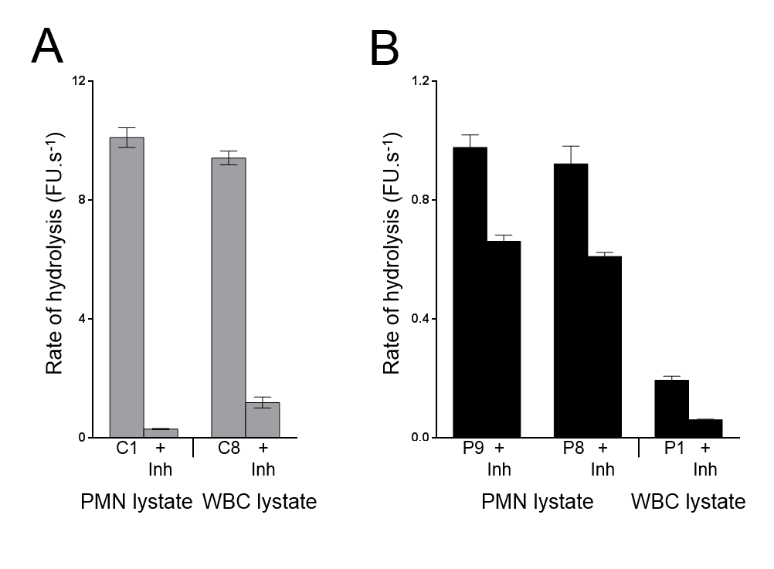

**Supp.Figure 3.** CG activity in PLS blood samples. CG activities were assessed with the selective substrate ABZ-TPFSGQ-EDDnp in purified neutrophil or in WBC lysates from (A) healthy controls and (B) 10 PLS patients. Samples were also incubated for 30 min with the CG inhibitor Bt-AAFP(O-C6H6)2 (0.5 µM) to distinguish CG activity and nonspecific signal. Low levels of active CG were found in cell lysates (10 µg) from PLS patients P1, P8, P9 compared to control cell lysates (1 µg). Data represent mean S.D. of experiments performed in triplicates. Similar results were found in two independent experiments. PMN, polymorphonuclear neutrophil; C: control, Inh: inhibitor, P: PLS patient, FU: fluorescence unit.

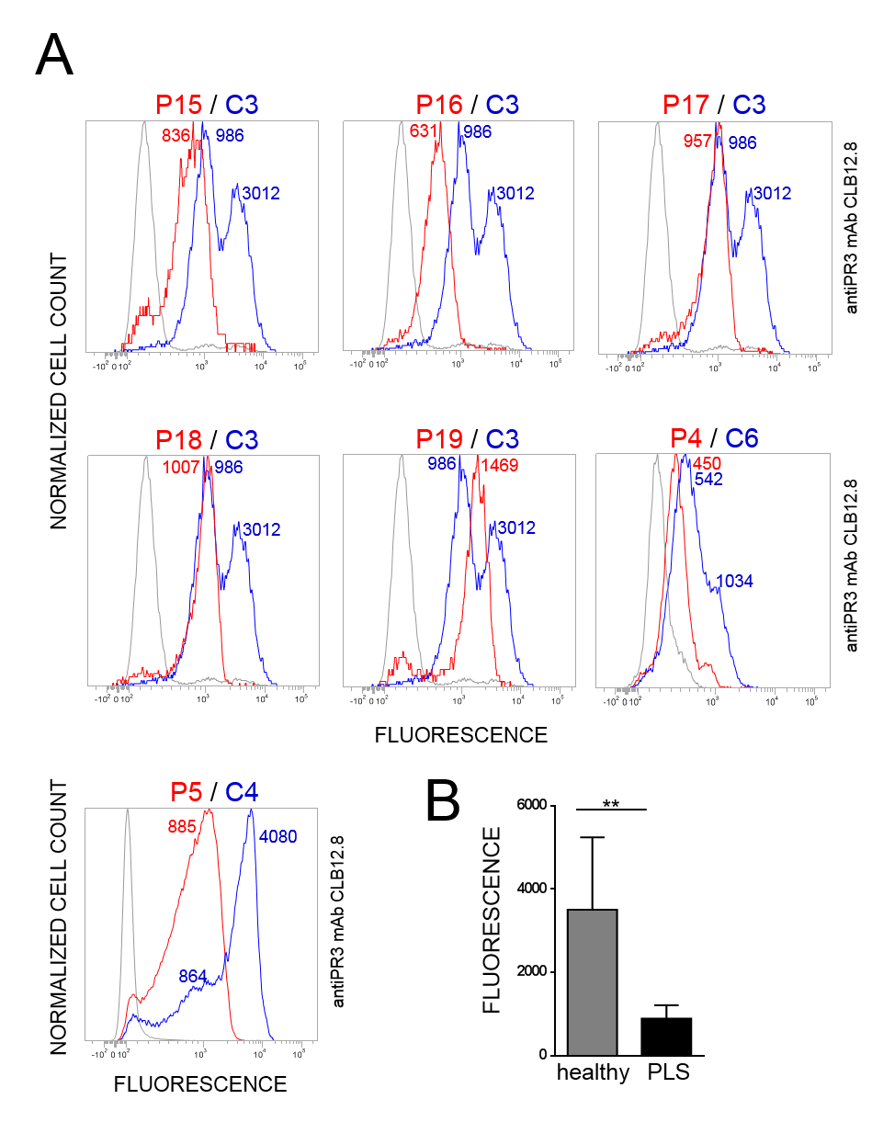

**Supp.Figure 4.** Membrane exposure of PR3 on transported PLS neutrophils. PLS blood samples from various foreign countries that were available only after a 24-72h transit following their collection were used. (A) PR3 exposure on neutrophils was investigated by flow cytometry. Controls were randomly selected in the local environment of the patient. (B) Mean fluorescence intensity values for PR3m on PLS and healthy neutrophils. Bar indicates mean ± S.D. value of each condition and asterisks the p-value of *t* test (p< 0.05,**). C: control (n=3), P: PLS patient (n=7).

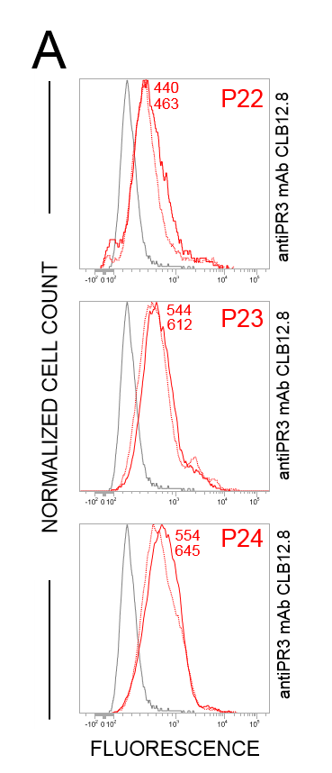**Supp.Figure 5.** Flow cytometry analysis of the membrane exposure of PR3 on transported PLS (P) neutrophils before and after activation. The unimodal distribution of PR3 at the surface of transported PLS neutrophils (*dotted line*) and the absence of further significant PR3 exposure following A23187 treatment (*continuous line*).

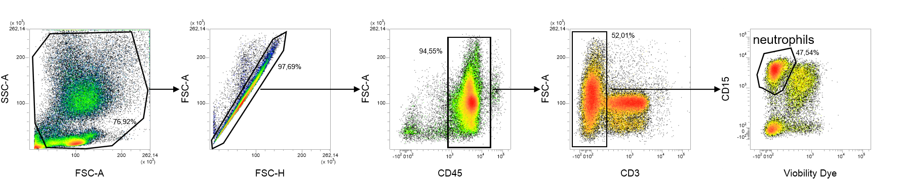

**Supp.Figure 6.** Gating strategies. WBC were isolated from EDTA-whole blood by red blood cells lysis. T cells and dead cells were excluded using anti-CD3 Ab and Viobility 405/520 Fixable Dye. The remaining cells were analyzed for the expression of CD15, a neutrophil marker. The percentages of cells in each of the specified gates are indicated.