Supplemental Table

Table S1.

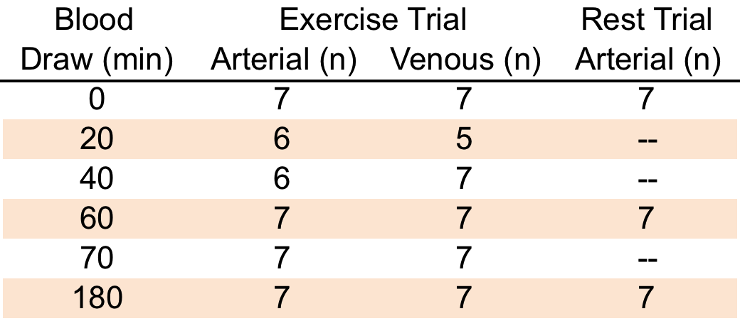

Overview of blood samples analyzed during the two experimental trials.