**SUPPLEMENTARY INFORMATION**

**to**

**In vitro optoacoustic flow-cytometry with light scattering referencing**

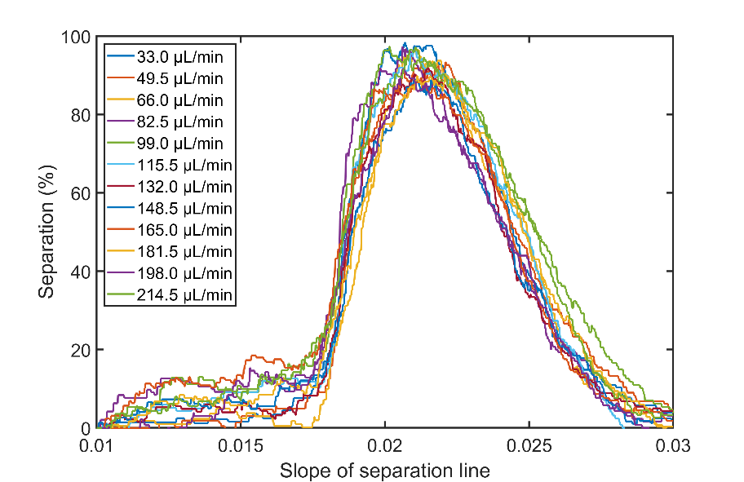Markus Seeger, Andre C. Stiel and Vasilis Ntziachristos

***Supplementary Fig. 1 Separation slope at different flow rates.*** *The slope for separating mkO and mCherry was individually optimized for 3 measurements per flow rate at 12 different flow rates whith each measurement lasting 1 min. In all cases, a separation of ~90% was achieved.*

***Supplementary Tab. 1 Separation slope at different flow rates.*** *An optimum separation slope was generated for each of the 12 data sets individually. When combining all data sets, a total mean value 0.0209 with a standard deviation of 0.0003757 was achieved.*

|  |  |  |
| --- | --- | --- |
| **Flow rate** | **Slope** | **R** |
| 33.0 µL/min | 0.02059 | 0.965 |
| 49.5 µL/min | 0.02082 | 0.962 |
| 66.0 µL/min | 0.02093 | 0.964 |
| 82.5 µL/min | 0.02127 | 0.936 |
| 99.0 µL/min | 0.02081 | 0.945 |
| 115.5 µL/min | 0.02171 | 0.967 |
| 132.0 µL/min | 0.02062 | 0.970 |
| 148.5 µL/min | 0.02067 | 0.971 |
| 165.0 µL/min | 0.02142 | 0.955 |
| 181.5 µL/min | 0.02098 | 0.980 |
| 198.0 µL/min | 0.02152 | 0.975 |
| 214.5 µL/min | 0.02081 | 0.978 |

***Supplementary Fig. 2 Exemplary 10s-trajectories of E.coli cells expressing mkO at flow rates between 33.0 and 214.5 µL/min.***

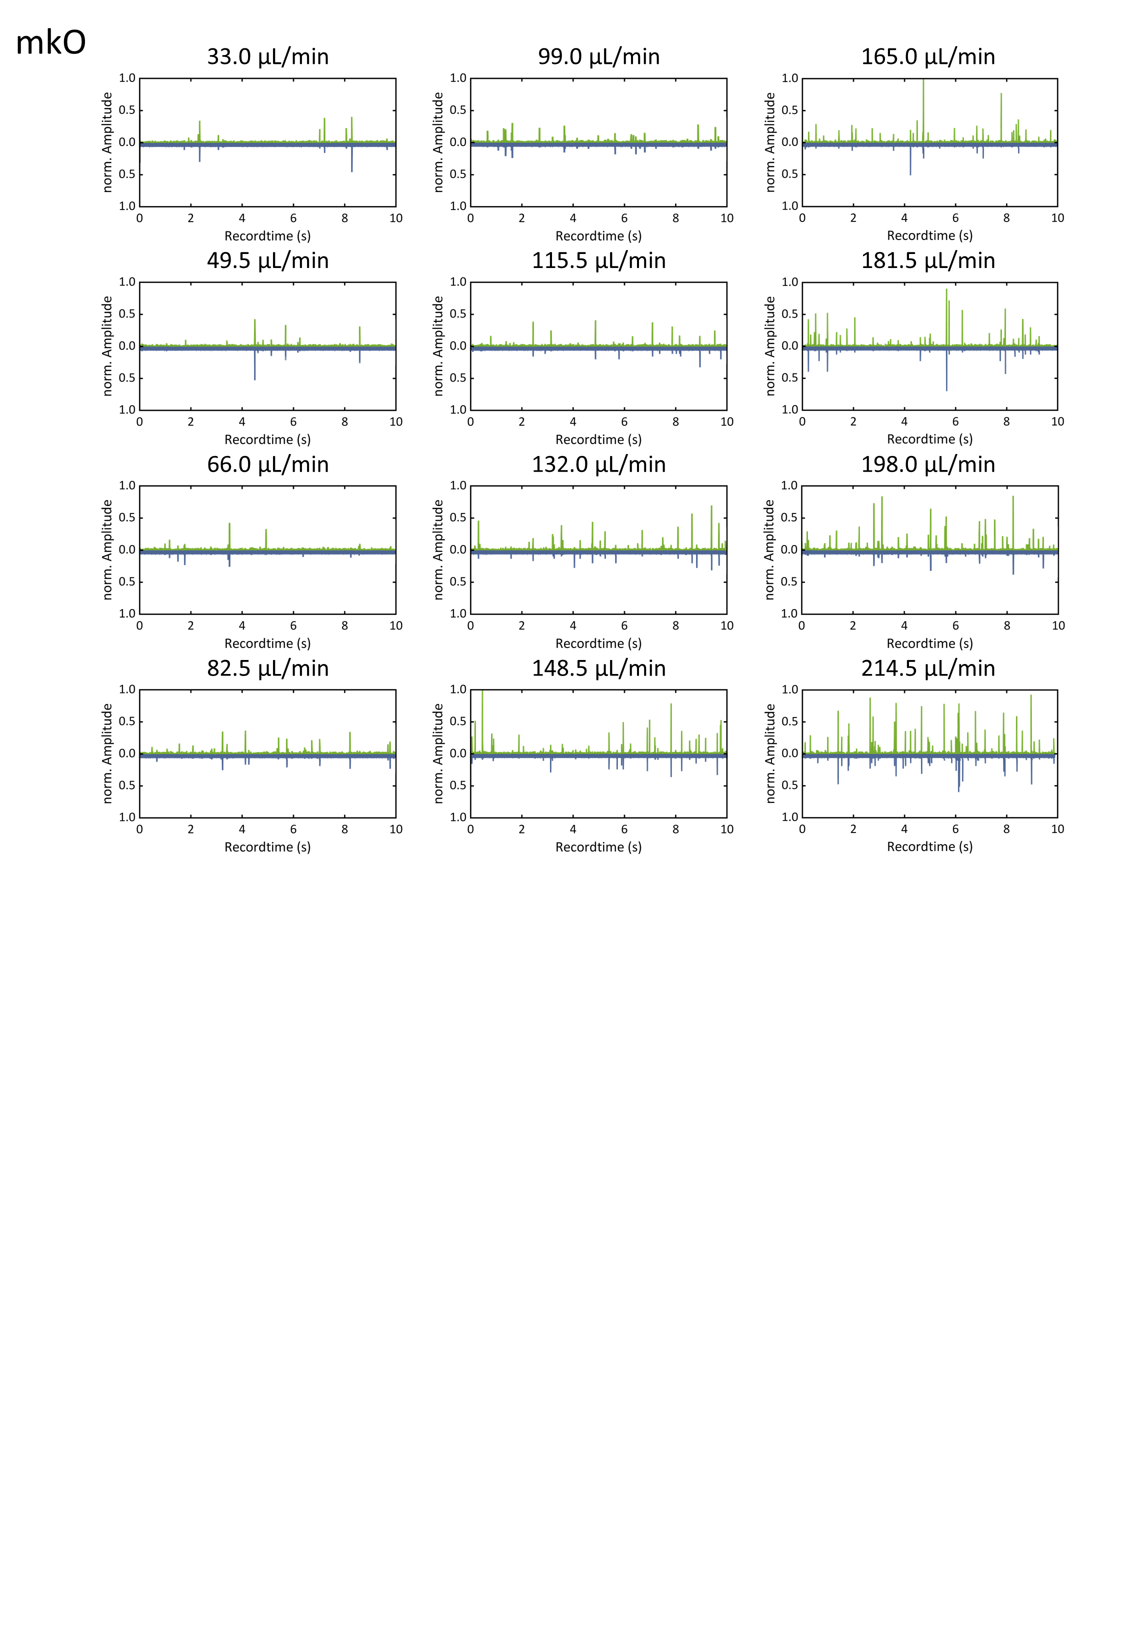

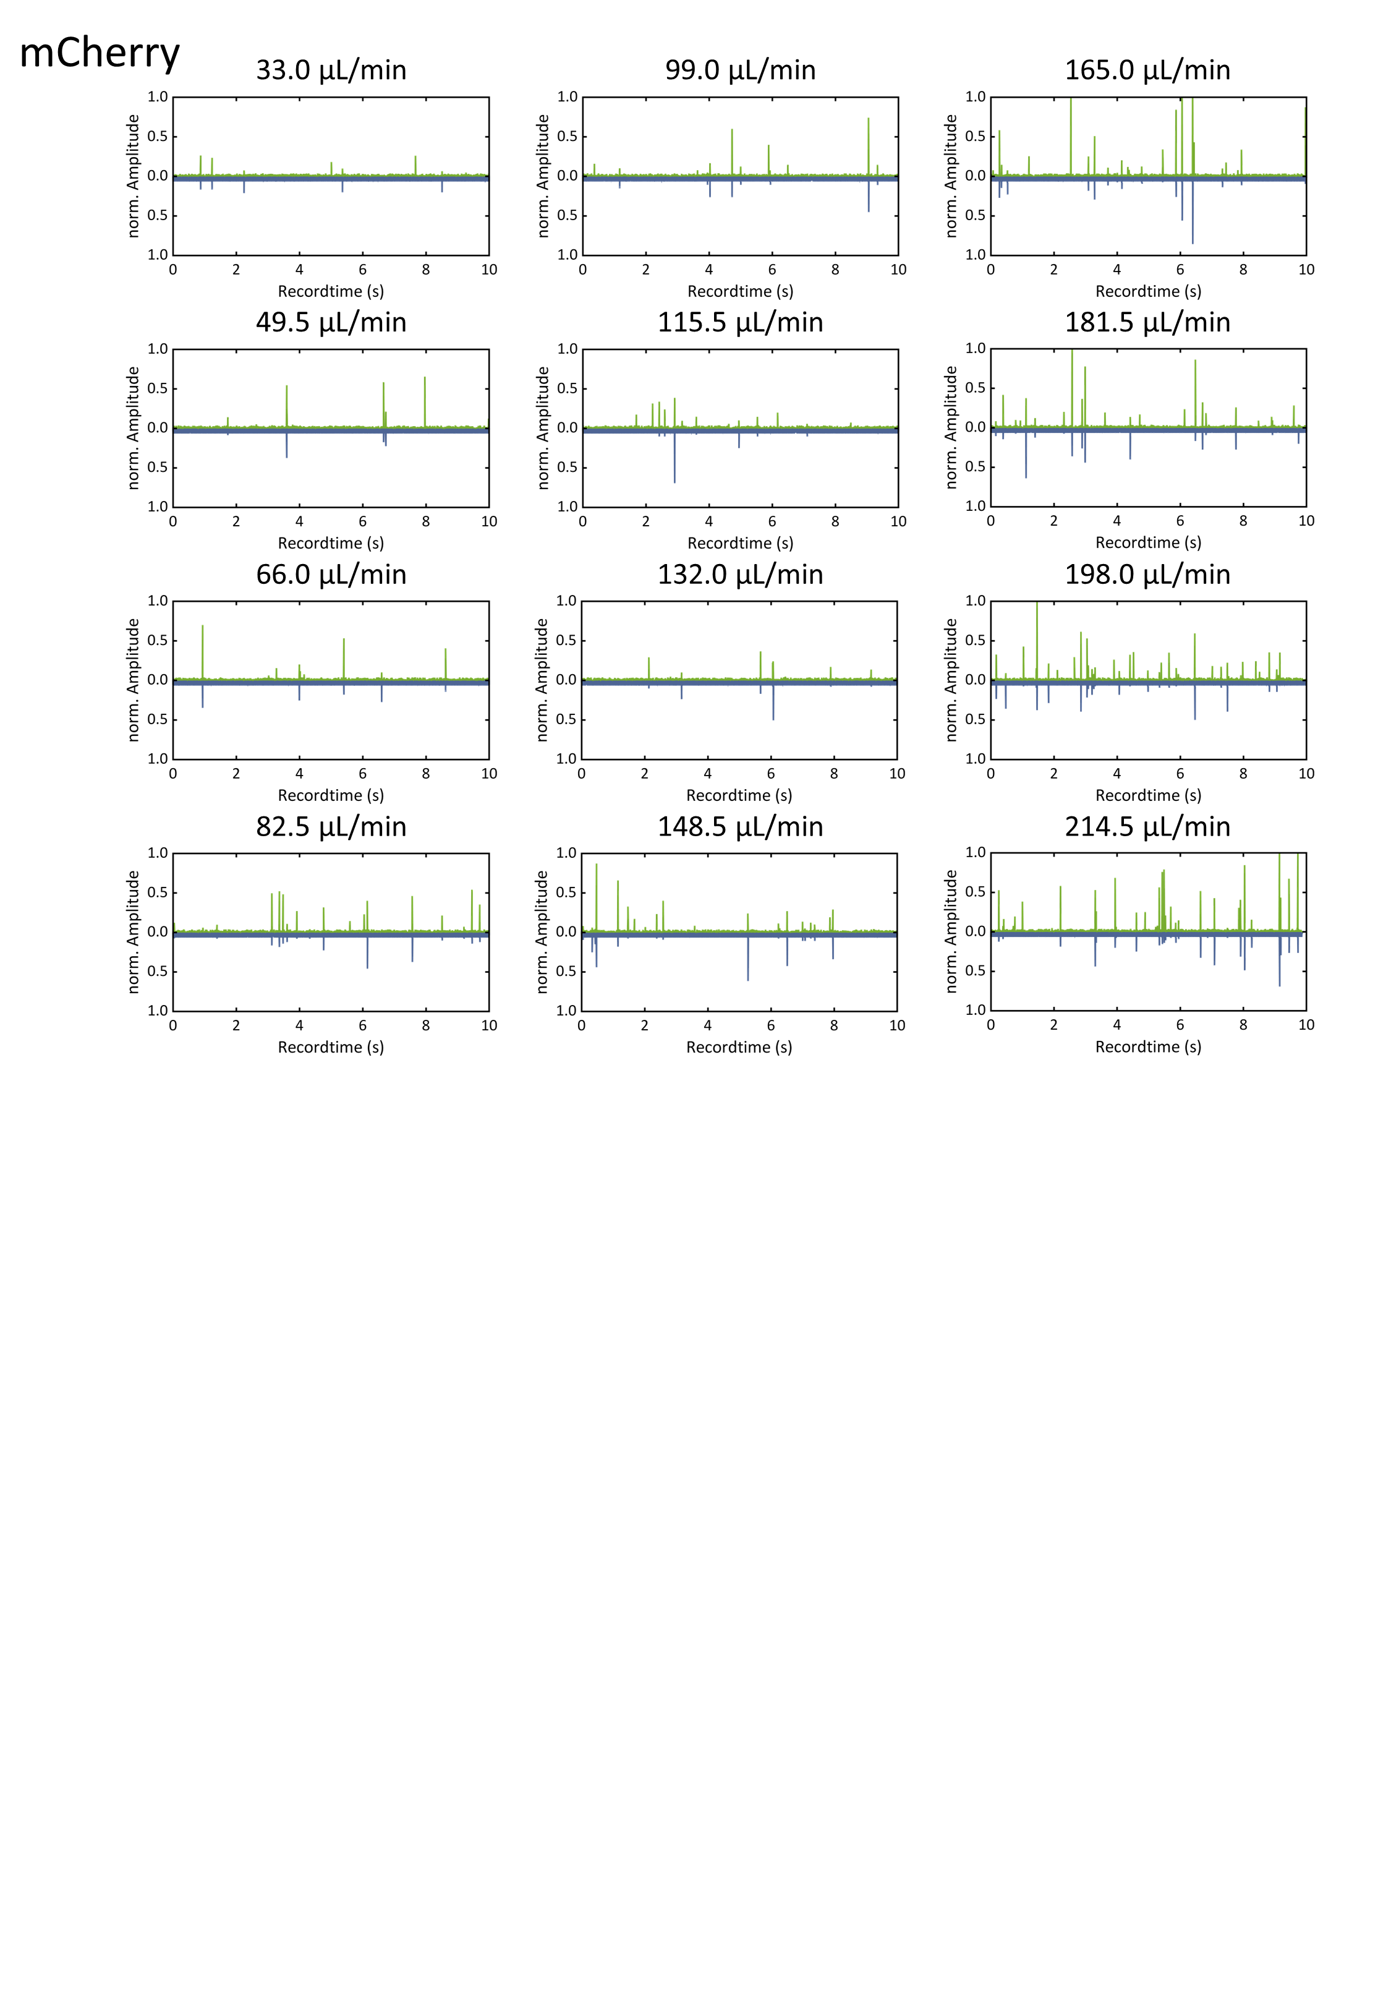

***Supplementary Fig. 2 Exemplary 10s-trajectories of E.coli cells expressing mCherry at flow rates between 33.0 and 214.5 µL/min.***

***Supplementary Fig. 2 Exemplary 10s-trajectories of a mixture of E.coli cells expressing mkO or mCherry at flow rates between 33.0 and 214.5 µL/min.***

