Supplementary material

Impact of lung morphology on clinical outcomes with riociguat in patients with pulmonary hypertension and idiopathic interstitial pneumonia: A post hoc subgroup analysis of the RISE-IIP study

Steven D. Nathan, MD, Vincent Cottin, MD, Juergen Behr, MD, Marius M. Hoeper, MD, Fernando J. Martinez, MD, Tamera J. Corte, MD, Anne M. Keogh, MD, Hanno Leuchte, MD, Nesrin Mogulkoc, MD, Silvia Ulrich, MD, Wim A. Wuyts, MD, Zhen Yao, MD, Julia Ley-Zaporozhan, MD, Ullrich G. Müller-Lisse, MD, Frank-Detlef Scholle, PhD, Günther Brüggenwerth, MD, Dennis Busse, Dipl Stat, Sylvia Nikkho, MD, and Athol U. Wells, MD

Table of Contents

Statistical analysis: deaths, data statistical summaries, and correlations between HRCT scores and efficacy parameters. 3

Figure S1 Example HRCT scans.. 4

Figure S2 Three-dimensional plot showing emphysema and fibrosis scores by FVC (%) and mPAP in all patients with HRCT data available. 5

Figure S3 Three-dimensional plots showing separate emphysema and fibrosis scores by FVC (%) and mPAP in all patients with HRCT data available. 6

Statistical analysis: deaths, data statistical summaries, and correlations between HRCT scores and efficacy parameters.

“Fatal/deaths” includes patients who died during the main treatment phase, the open-label long-term extension (LTE), or the 4-month safety follow-up. Summary statistics are presented using observed data. Numerical variables are presented as means, and categorical variables as percentages. Sample correlations between HRCT scores and efficacy parameters at baseline were based on Pearson’s correlation coefficient, including 95% confidence interval (CI). *p*-values are stated for the null hypothesis that the population correlation coefficient is 0 and there is no association (H0:Rho = 0), with two-tailed significance testing.

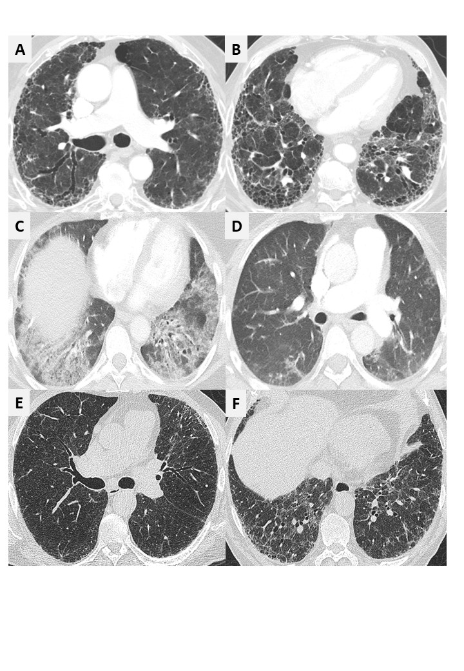

Figure S1 Example HRCT scans. (A and B) Usual interstitial pneumonia (peripheral traction bronchiectasis/bronchiolectasis [A]; honeycombing, subpleural dominant, heterogeneous [B]). Scoring: (16 fibrosis/12 emphysema/28 overall score). (C and D) Non-specific interstitial pneumonia (fibrotic type: ground-glass opacities [C]; subpleural sparing, pulmonary volume loss [D]). Scoring: (16 fibrosis/0 emphysema/16 overall score). (E and F) CPFE (severe emphysema > fibrosis [E]; UIP pattern lower lobes [F]). Scoring: (10 fibrosis/24 emphysema/34 overall score). CPFE, combined pulmonary fibrosis and emphysema; HRCT, high-resolution computed tomography.

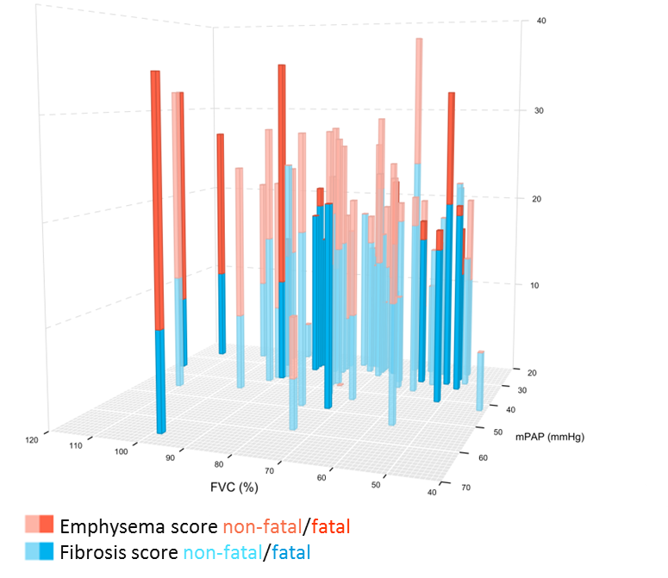

mPAP (mm Hg)

Figure S2 Three-dimensional plot showing emphysema and fibrosis scores by FVC (%) and mPAP in all patients with HRCT data available. Each bar represents an individual patient; bars with red and blue represent patients with CPFE and the extent of emphysema vs fibrosis. Bars in bold represent fatal cases; non-fatal cases are depicted unbolded. Bars representing patients with higher FVC at baseline are toward the left side of the x-axis, and bars representing patients with lower mPAP at baseline are toward the rear of the z-axis. Death was more common in patients with CPFE and in patients with more emphysema than fibrosis. CPFE, combined pulmonary fibrosis and emphysema; FVC, forced vital capacity; HRCT, high-resolution computed tomography; mPAP, mean pulmonary artery pressure.

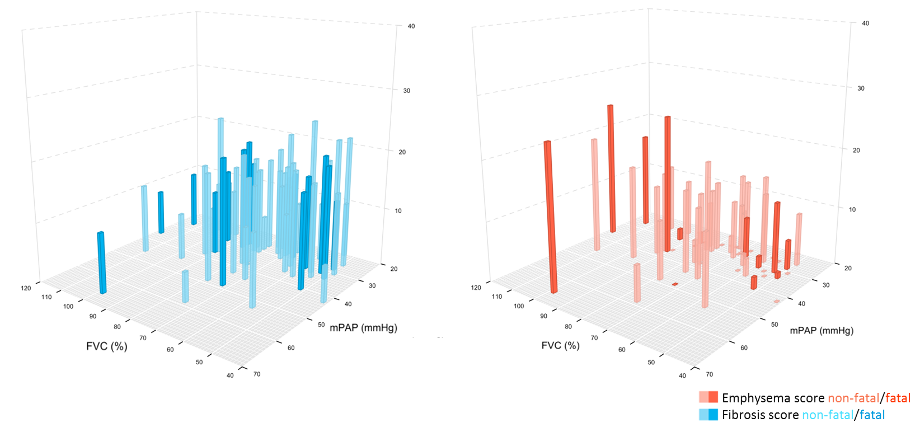

mPAP (mm Hg)

mPAP (mm Hg)

Figure S3 Three-dimensional plots showing separate emphysema and fibrosis scores by FVC (%) and mPAP in all patients with HRCT data available. Each bar represents an individual patient; bars with red and blue represent patients with CPFE and the extent of emphysema vs fibrosis. Bars in bold represent fatal cases; non-fatal cases are depicted unbolded. Bars representing patients with higher FVC at baseline are toward the left side of the x-axis, and bars representing patients with lower mPAP at baseline are toward the rear of the z-axis. There was a trend toward higher fibrosis scores in patients with low FVC and low mPAP at baseline, whereas FVC and mPAP were higher in patients with high emphysema scores. CPFE, combined pulmonary fibrosis and emphysema; FVC, forced vital capacity; HRCT, high-resolution computed tomography; mPAP, mean pulmonary artery pressure.