**Spatial metabolomics for evaluating response to neoadjuvant therapy in non-small cell lung cancer patients**

Jian Shen1*, Na Sun1*, Philipp Zens2, 3, Thomas Kunzke1, Achim Buck1, Verena M. Prade1, Jun Wang1, Qian Wang1, Ronggui Hu4, Annette Feuchtinger1, Sabina Berezowska2, 5#, Axel Walch1#

1 Research Unit Analytical Pathology, Helmholtz Zentrum München – German Research Center for Environmental Health, Neuherberg 85764, Germany

2 Institute of Pathology, University of Bern, Bern 3008, Switzerland

3 Graduate School for Health Sciences, University of Bern, Mittelstrasse 43, Bern 3012, Switzerland

4 Center for Excellence in Molecular Cell Science, Chinese Academy of Sciences, Shanghai 200031, P. R. China

5 Department of Laboratory Medicine and Pathology, Institute of Pathology, Lausanne University Hospital and University of Lausanne, Lausanne 1011, Switzerland

* These authors contributed equally to this work

# Corresponding authors:

Axel Walch, MD

Address: Research Unit Analytical Pathology, Helmholtz Zentrum München – German Research Center for Environmental Health, Ingolstädter Landstraße 1, Neuherberg 85764, Germany

Phone: +49 89 3187-3349

E-mail: [axel.walch@helmholtz-muenchen.de](mailto:axel.walch@helmholtz-muenchen.de)

Sabina Berezowska, MD

Address: Department of Laboratory Medicine and Pathology, Institute of Pathology, Lausanne University Hospital and University of Lausanne, Bugnon 25, Lausanne 1011, Switzerland;

Phone: +41 31 632-4937

E-mail: [sabina.berezowska@chuv.ch](mailto:sabina.berezowska@chuv.ch)

**Supplementary Figures and Tables**

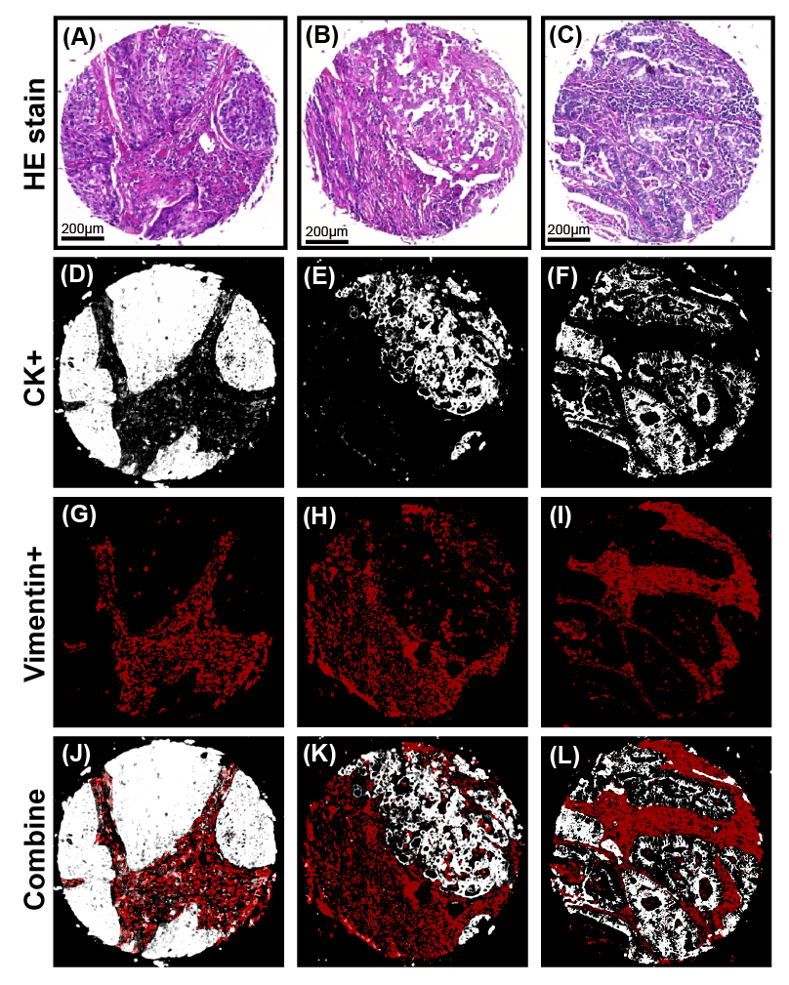

**Supplementary Figure S1.** Immunoﬂuorescence staining of lung tumor tissue sections for metabolic analysis of tumor and tumor stroma. A-C: Hematoxylin and eosin stains of the tissue cores. D-F and G-I showed single-channel images of tissue cores fluorescently stained with the tumor marker pan-cytokeratin (white) and the stroma marker vimentin (red), which were used to annotate and separate tumor and stroma tissues by fluorescence imaging. J-L: Representative double-channel images of tissue cores fluorescently stained with pan-cytokeratin (white) and vimentin (red).

Abbreviations: HE, hematoxylin and eosin; CK, pan-cytokeratin.

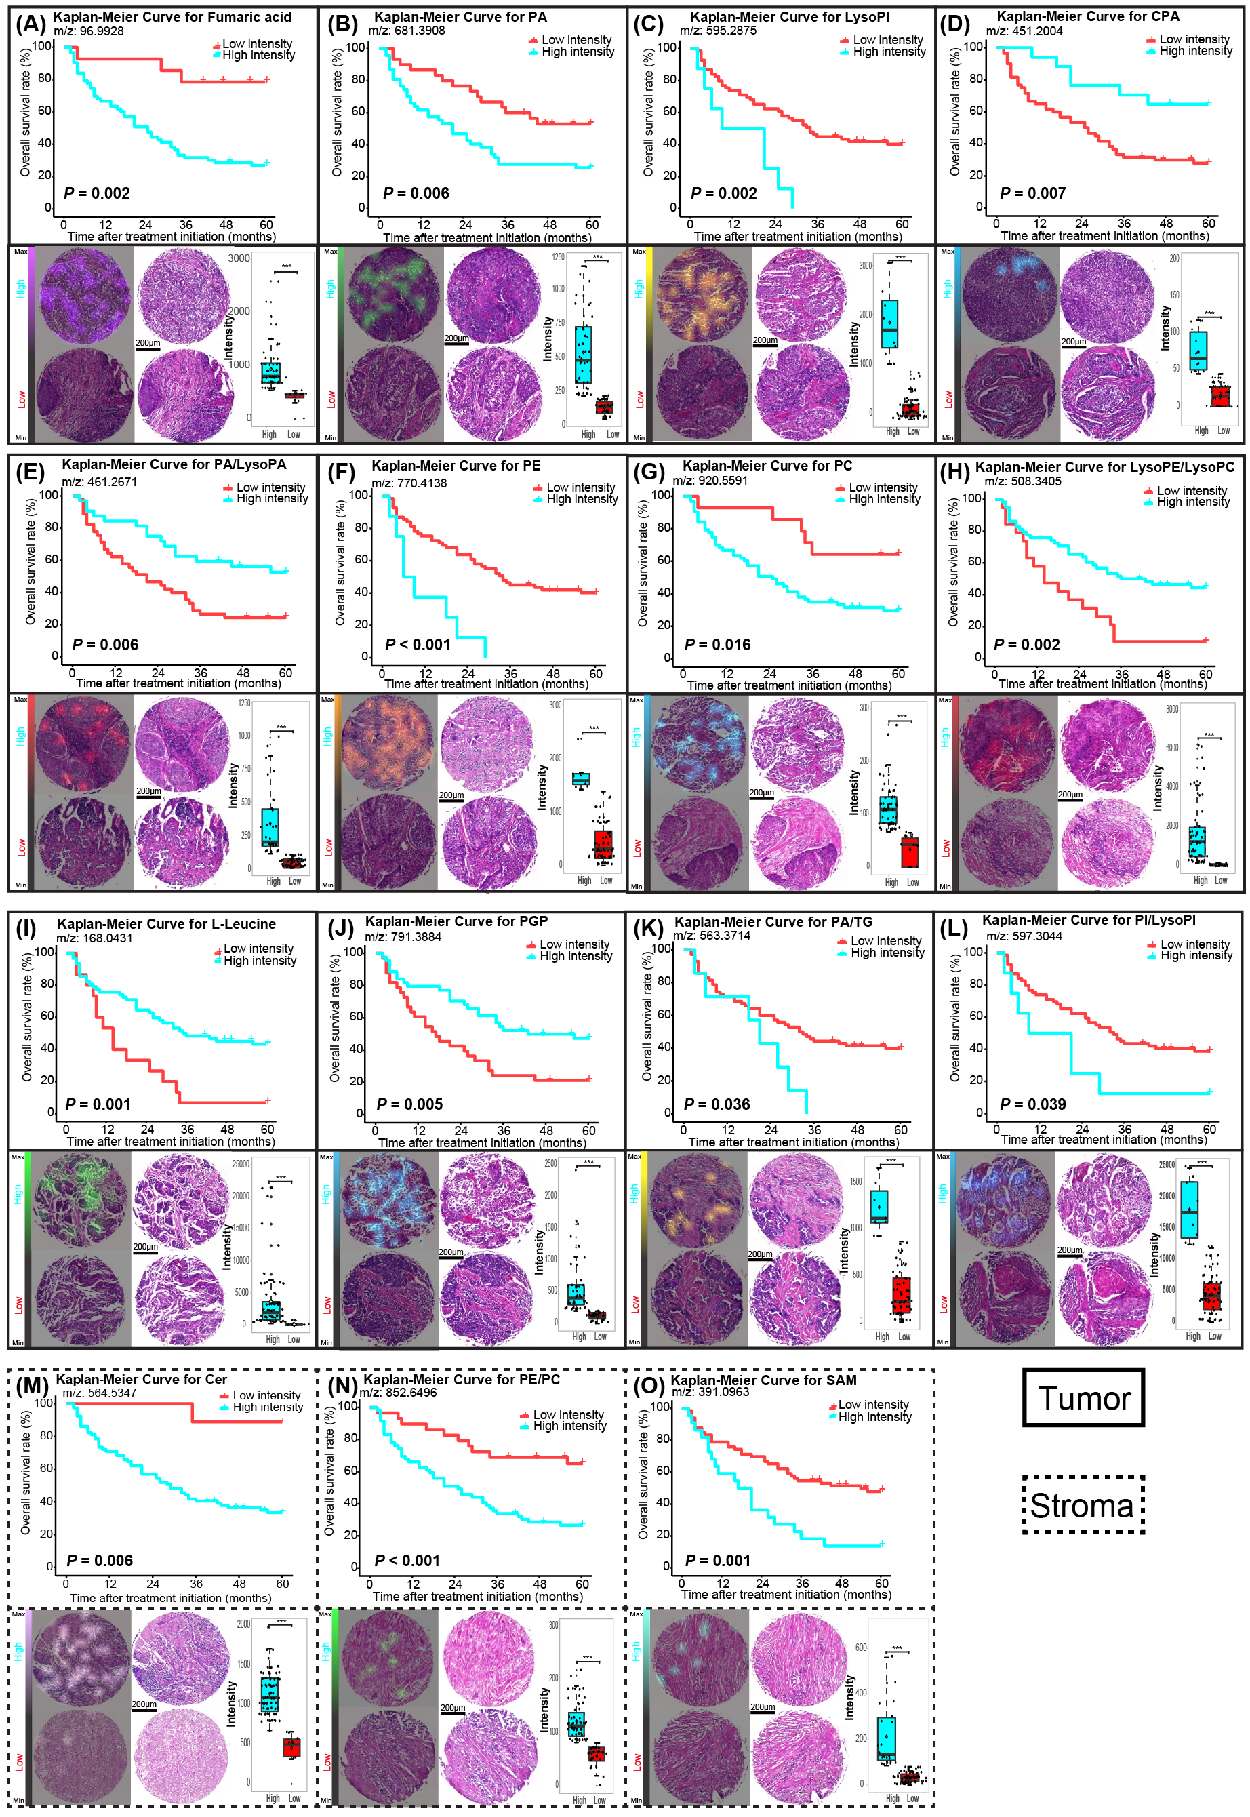

**Supplementary Figure S2.** The most important endogenous metabolites included in the classifiers were used to distinguish between good and poor prognosis groups of NSCLC patients treated with NAC. Kaplan-Meier survival analyses of endogenous metabolites. Ion distribution maps show the specific localizations of the metabolites in tumor cell regions or stroma regions for high and low mass intensities. The corresponding HE stains of the same patient tissue cores are shown to the right. Boxplots with individual points are shown for variance in different groups. \**P* < 0.05, \*\**P* < 0.01, \*\*\**P* < 0.001

Abbreviations: NSCLC, non-small cell lung cancer; NAC, neoadjuvant therapy; HE, hematoxylin and eosin; PA, phosphatidic acid; LysoPI, lysophosphatidylinositol; CPA, cyclic phosphatidic acid; LysoPA, lysophosphatidic acid; PE, phosphatidylethanolamine; PC, phosphatidylcholine; LysoPE, lysophosphatidylethanolamine; LysoPC, lysophosphatidylcholine; PGP, phosphatidylglycerophosphate; TG, triglyceride; PI, phosphoinositol; Cer, ceramide; SAM, S-adenosylmethioninamine.

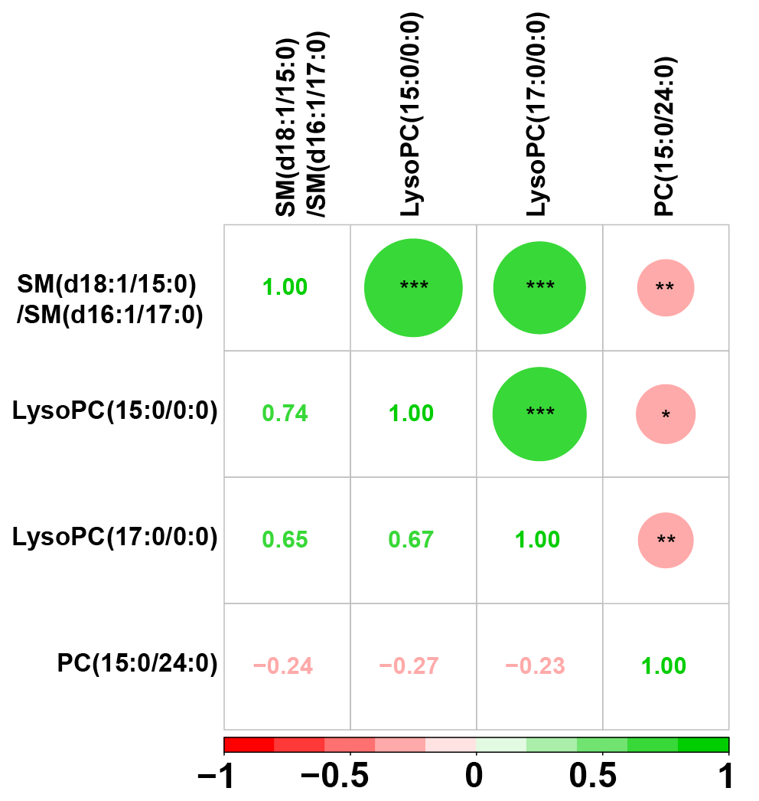

**Supplementary Figure S3.** Correlation analysis among odd-chain fatty acids. Significant correlations were observed between LysoPC (17:0/0:0), SM (d18:1/15:0 or d16:1/17:0), and LysoPC (15:0/0:0), whereas PC (15:0/24:0) was negatively correlated with SM (d18:1/15:0 or d16:1/17:0) and LysoPC (15:0/0:0). The green represents positive relationships, and the pink represents negative relationships. The numbers in the boxes represent the correlation coefficients. \**P* < 0.05, \*\**P* < 0.01, \*\*\**P* < 0.001

Abbreviations: SM, sphingomyelin; LysoPC, lysophosphatidylcholine; PC, phosphatidylcholine.

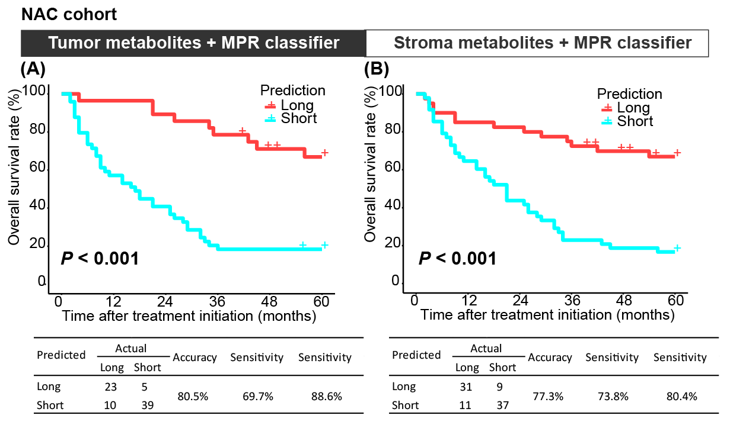

**Supplementary Figure S4.** A combined classifier based on MPR and metabolites stratifies patients with NSCLC into prognostic risk groups. A and B: Kaplan-Meier survival analyses show the performances of combined classifiers for predicting overall survival. The accuracy, sensitivity, and specificity values of the tumor and stroma prediction models are summarized in the tables below each graph. Each row in a confusion matrix represents a predicted class, whereas each column represents an actual class.

Abbreviations: NSCLC, non-small cell lung cancer; NAC, neoadjuvant chemotherapy; MPR, major pathological response.

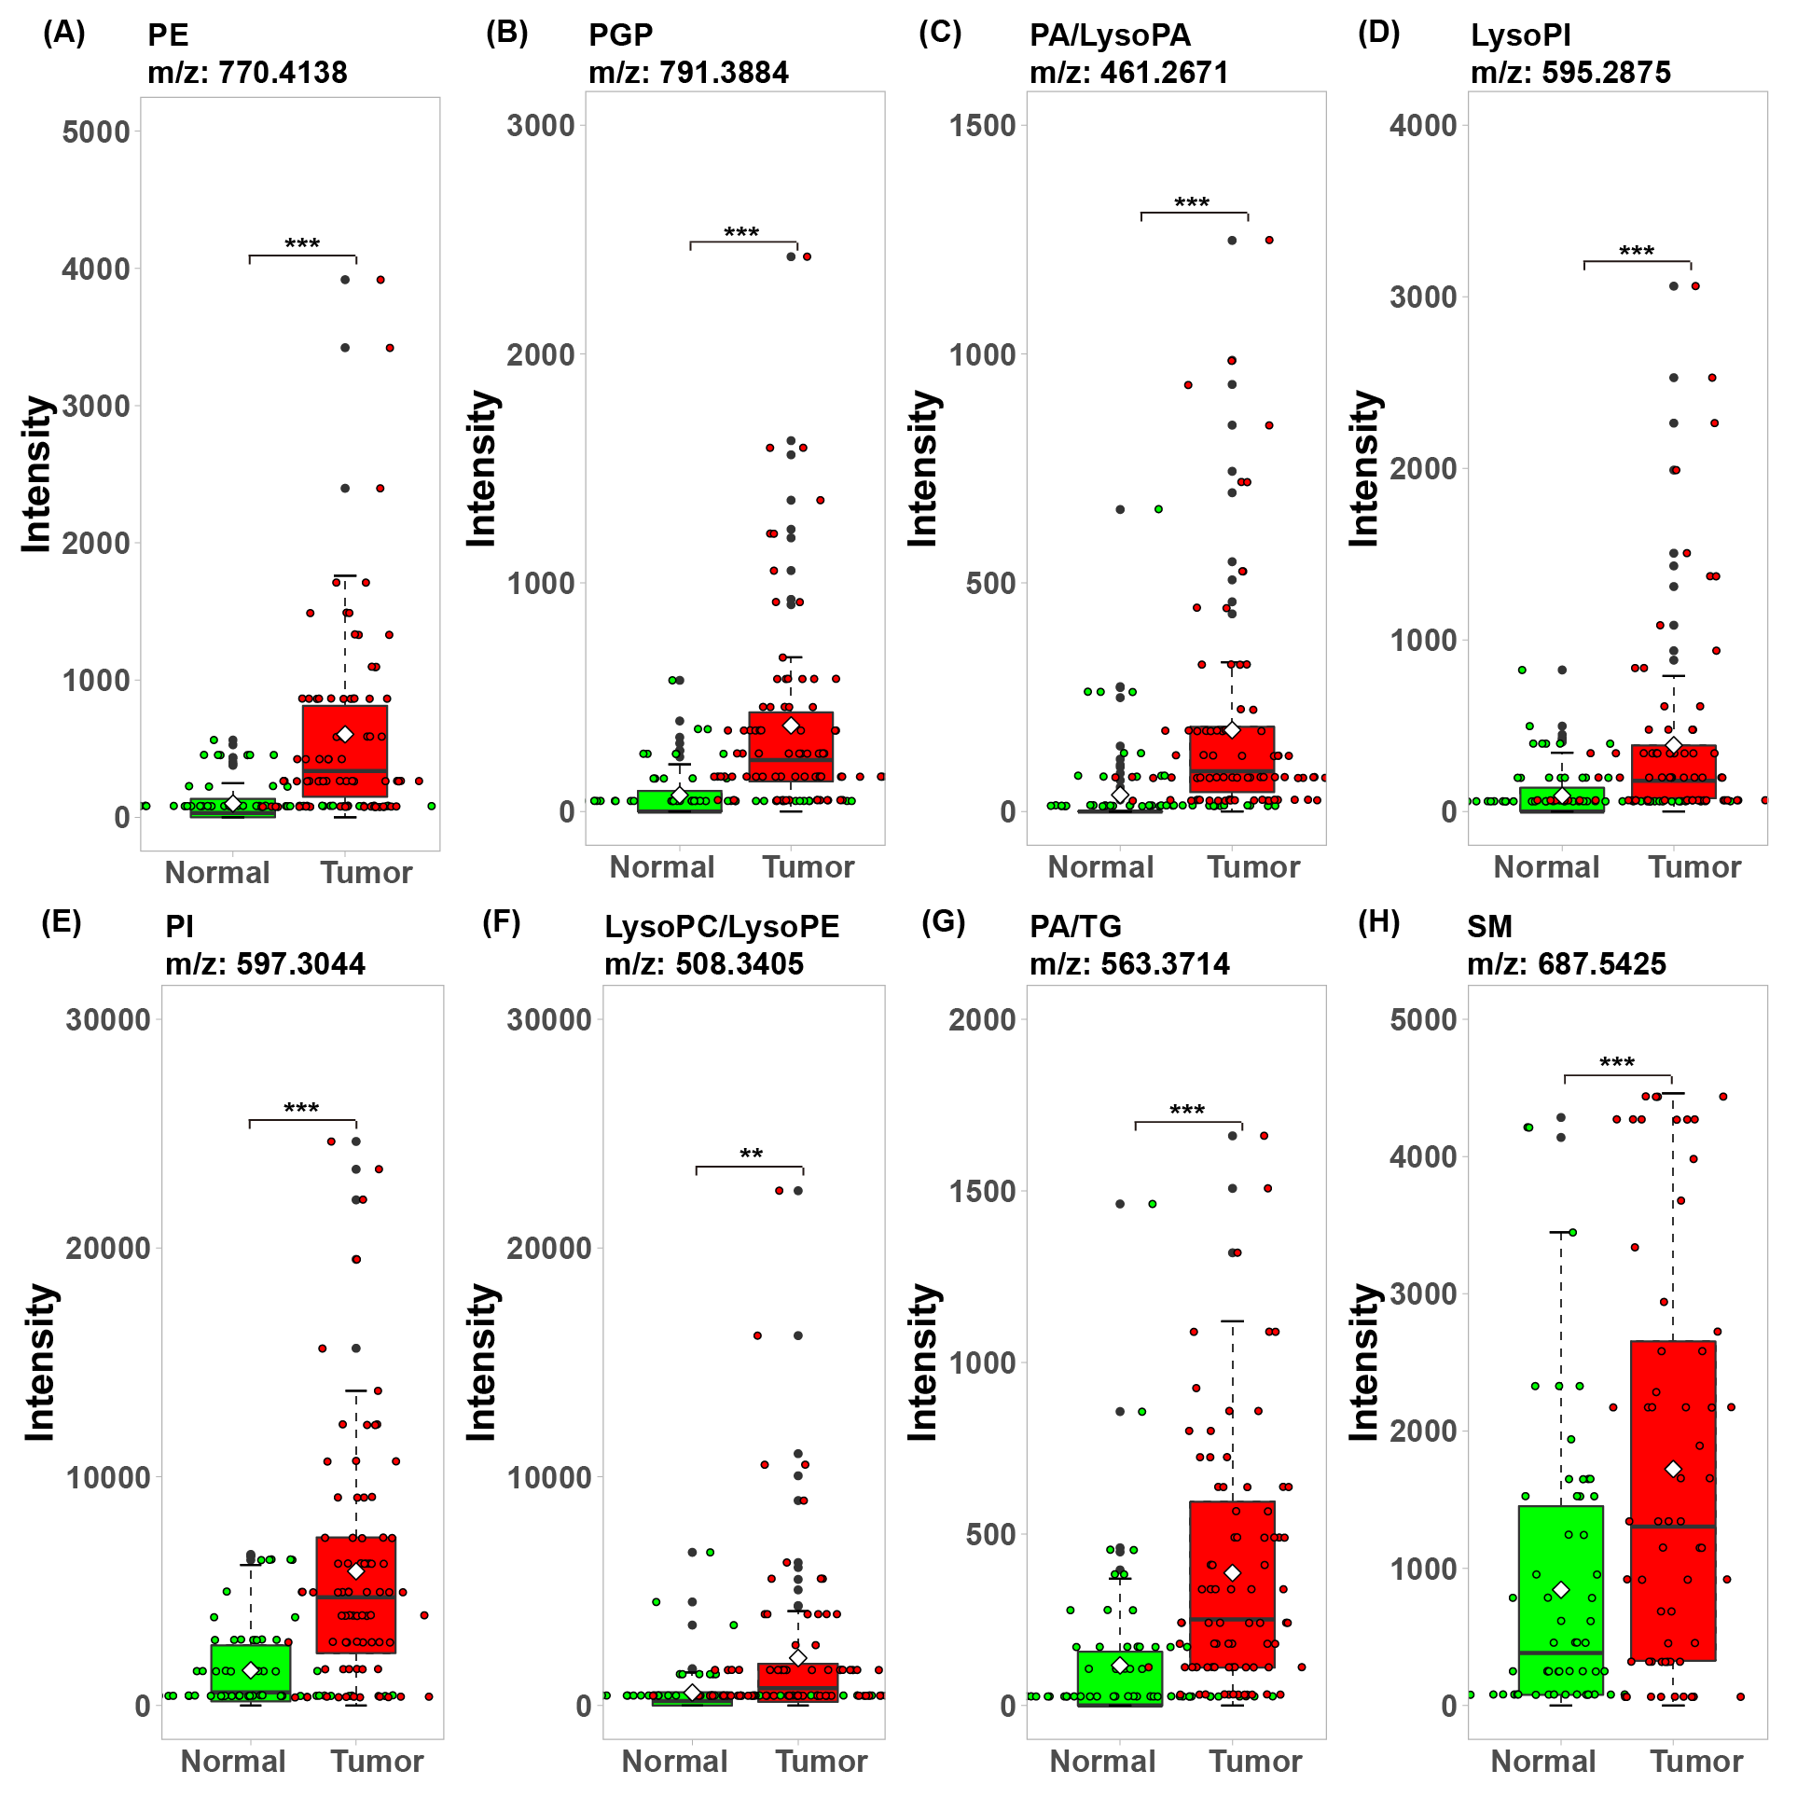

**Supplementary Figure S5.** Upregulated metabolites were identified in the comparison between tumor and normal tissues. Above each boxplot, the metabolites and m/z are shown. Comparisons of metabolites between tumor and normal tissues were performed using rank-based Mann-Whitney *U*-test. \*\**P* < 0.01, \*\*\**P* < 0.001

Abbreviations: PE, phosphatidylethanolamine; PGP, phosphatidylglycerophosphate; PA, phosphatidic acid; LysoPA, lysophosphatidic acid; LysoPI, lysophosphatidylinositol; PI, phosphoinositol; LysoPC, lysophosphatidylcholine; LysoPE, lysophosphatidylethanolamine; TG, triglyceride; SM, sphingomyelin.

**Supplementary Table S1.** List of the annotated metabolites from the most important features of the classifiers.

|  |  |  |  |  |  |  |  |  |
| --- | --- | --- | --- | --- | --- | --- | --- | --- |
| m/z | Postulated identity | Class | Chemical formula | Compound id | Monoisotopic mass | Adduct | Adduct m/z | Mass error (ppm) |
| 96.9928 | Fumaric acid | Carboxylic acids | C4H4O4 | HMDB0000134 | 116.0110 | M-H20-H | 96.9926 | 2 |
| 681.3908 | PA(18:2(9Z,12Z)/14:0) | Glycerophospholipids | C35H65O8P | HMDB0114946 | 644.4417 | M+K-2H | 681.3903 | 1 |
| 681.3908 | PA(18:1(9Z)/14:1(9Z)) | Glycerophospholipids | C35H65O8P | HMDB0114922 | 644.4417 | M+K-2H | 681.3903 | 1 |
| 681.3908 | PA(18:1(11Z)/14:1(9Z)) | Glycerophospholipids | C35H65O8P | HMDB0114897 | 644.4417 | M+K-2H | 681.3903 | 1 |
| 681.3908 | PA(14:0/18:2(9Z,12Z)) | Glycerophospholipids | C35H65O8P | HMDB0114779 | 644.4417 | M+K-2H | 681.3903 | 1 |
| 595.2875 | LysoPI(18:2(9Z,12Z)/0:0) | Glycerophospholipids | C27H49O12P | HMDB0240597 | 596.2962 | M-H | 595.2889 | 2 |
| 451.2004 | CPA(18:2(9Z,12Z)/0:0) | Fatty Acyls | C21H37O6P | HMDB0007007 | 416.2328 | M+Cl | 451.2022 | 4 |
| 461.2671 | LysoPA(20:2(11Z,14Z)/0:0) | Glycerophospholipids | C23H43O7P | HMDB0114758 | 462.2746 | M-H | 461.2674 | 1 |
| 461.2671 | PA(8:0/i-12:0) | Glycerophospholipids | C23H45O8P | HMDB0115685 | 480.2852 | M-H20-H | 461.2668 | 1 |
| 461.2671 | PA(8:0/12:0) | Glycerophospholipids | C23H45O8P | HMDB0115483 | 480.2852 | M-H20-H | 461.2668 | 1 |
| 770.4138 | PE(18:3(6Z,9Z,12Z)/18:4(6Z,9Z,12Z,15Z)) | Glycerophospholipids | C41H68NO8P | HMDB0009129 | 733.4683 | M+K-2H | 770.4169 | 4 |
| 770.4138 | PE(18:3(9Z,12Z,15Z)/18:4(6Z,9Z,12Z,15Z)) | Glycerophospholipids | C41H68NO8P | HMDB0009162 | 733.4683 | M+K-2H | 770.4169 | 4 |
| 770.4138 | PE(18:4(6Z,9Z,12Z,15Z)/18:3(6Z,9Z,12Z)) | Glycerophospholipids | C41H68NO8P | HMDB0009193 | 733.4683 | M+K-2H | 770.4169 | 4 |
| 770.4138 | PE(18:4(6Z,9Z,12Z,15Z)/18:3(9Z,12Z,15Z)) | Glycerophospholipids | C41H68NO8P | HMDB0009194 | 733.4683 | M+K-2H | 770.4169 | 4 |
| 770.4138 | PE(22:6(4Z,7Z,10Z,13Z,16Z,19Z)/14:1(9Z)) | Glycerophospholipids | C41H68NO8P | HMDB0009680 | 733.4683 | M+K-2H | 770.4169 | 4 |
| 770.4138 | PE(14:1(9Z)/22:6(4Z,7Z,10Z,13Z,16Z,19Z)) | Glycerophospholipids | C41H68NO8P | HMDB0008880 | 733.4683 | M+K-2H | 770.4169 | 4 |
| 687.5425 | SM(d18:1/15:0) | Sphingolipids | C38H77N2O6P | HMDB0240608 | 688.5519 | M-H | 687.5447 | 3 |
| 687.5425 | SM(d16:1/17:0) | Sphingolipids | C38H77N2O6P | HMDB0240617 | 688.5519 | M-H | 687.5447 | 3 |
| 920.5591 | PC(22:5(7Z,10Z,13Z,16Z,19Z)/22:4(7Z,10Z,13Z,16Z)) | Glycerophospholipids | C52H86NO8P | HMDB0008712 | 883.6091 | M+K-2H | 920.5577 | 2 |
| 920.5591 | PC(22:5(4Z,7Z,10Z,13Z,16Z)/22:4(7Z,10Z,13Z,16Z)) | Glycerophospholipids | C52H86NO8P | HMDB0008679 | 883.6091 | M+K-2H | 920.5577 | 2 |
| 920.5591 | PC(22:4(7Z,10Z,13Z,16Z)/22:5(4Z,7Z,10Z,13Z,16Z)) | Glycerophospholipids | C52H86NO8P | HMDB0008647 | 883.6091 | M+K-2H | 920.5577 | 2 |
| 920.5591 | PC(22:4(7Z,10Z,13Z,16Z)/22:5(7Z,10Z,13Z,16Z,19Z)) | Glycerophospholipids | C52H86NO8P | HMDB0008648 | 883.6091 | M+K-2H | 920.5577 | 2 |
| 508.3405 | LysoPE(0:0/20:0) | Glycerophospholipids | C25H52NO7P | HMDB0011481 | 509.3481 | M-H | 508.3409 | 1 |
| 508.3405 | LysoPE(20:0/0:0) | Glycerophospholipids | C25H52NO7P | HMDB0011511 | 509.3481 | M-H | 508.3409 | 1 |
| 508.3405 | LysoPC(17:0/0:0) | Glycerophospholipids | C25H52NO7P | HMDB0012108 | 509.3481 | M-H | 508.3409 | 1 |
| 168.0431 | L-Leucine | Amino acids | C6H13NO2 | HMDB0062203 | 131.0946 | M+K-2H | 168.0432 | 1 |
| 791.3884 | PGP(i-12:0/18:2(9Z,11Z)) | Glycerophospholipids | C36H68O13P2 | HMDB0116530 | 770.4135 | M+Na-2H | 791.3882 | 0 |
| 563.3714 | PA(8:0/i-18:0) | Glycerophospholipids | C29H57O8P | HMDB0115691 | 564.3791 | M-H | 563.3718 | 1 |
| 563.3714 | PA(a-13:0/a-13:0) | Glycerophospholipids | C29H57O8P | HMDB0115698 | 564.3791 | M-H | 563.3718 | 1 |
| 563.3714 | PA(a-13:0/i-13:0) | Glycerophospholipids | C29H57O8P | HMDB0115704 | 564.3791 | M-H | 563.3718 | 1 |
| 563.3714 | PA(i-12:0/i-14:0) | Glycerophospholipids | C29H57O8P | HMDB0115783 | 564.3791 | M-H | 563.3718 | 1 |
| 563.3714 | PA(i-13:0/a-13:0) | Glycerophospholipids | C29H57O8P | HMDB0115794 | 564.3791 | M-H | 563.3718 | 1 |
| 563.3714 | PA(i-13:0/i-13:0) | Glycerophospholipids | C29H57O8P | HMDB0115800 | 564.3791 | M-H | 563.3718 | 1 |
| 563.3714 | PA(i-14:0/i-12:0) | Glycerophospholipids | C29H57O8P | HMDB0115814 | 564.3791 | M-H | 563.3718 | 1 |
| 563.3714 | PA(10:0/i-16:0) | Glycerophospholipids | C29H57O8P | HMDB0115615 | 564.3791 | M-H | 563.3718 | 1 |
| 563.3714 | PA(8:0/18:0) | Glycerophospholipids | C29H57O8P | HMDB0115489 | 564.3791 | M-H | 563.3718 | 1 |
| 563.3714 | TG(12:0/8:0/8:0) | Triradyglycerols | C31H58O6 | HMDB0094820 | 526.4233 | M+K-2H | 563.3720 | 1 |
| 563.3714 | TG(8:0/8:0/i-12:0) | Triradyglycerols | C31H58O6 | HMDB0071469 | 526.4233 | M+K-2H | 563.3720 | 1 |
| 563.3714 | TG(10:0/10:0/8:0) | Triradyglycerols | C31H58O6 | HMDB0071580 | 526.4233 | M+K-2H | 563.3720 | 1 |
| 563.3714 | TG(8:0/10:0/10:0) | Triradyglycerols | C31H58O6 | HMDB0072044 | 526.4233 | M+K-2H | 563.3720 | 1 |
| 563.3714 | TG(i-12:0/8:0/8:0) | Triradyglycerols | C31H58O6 | HMDB0094819 | 526.4233 | M+K-2H | 563.3720 | 1 |
| 563.3714 | TG(8:0/8:0/12:0) | Triradyglycerols | C31H58O6 | HMDB0072057 | 526.4233 | M+K-2H | 563.3720 | 1 |
| 597.3044 | PI(18:1(9Z)/0:0) | Glycerophospholipids | C27H51O12P | HMDB0256522 | 597.3045 | M-H | 597.3045 | 0 |
| 597.3044 | LysoPI(18:1(9Z)/0:0) | Glycerophospholipids | C27H51O12P | HMDB0061693 | 597.3045 | M-H | 597.3045 | 0 |
| 480.3091 | LysoPC(15:0/0:0) | Glycerophospholipids | C23H48NO7P | HMDB0010381 | 481.3168 | M-H | 480.3096 | 1 |
| 480.3091 | LysoPE(18:0/0:0) | Glycerophospholipids | C23H48NO7P | HMDB0011130 | 481.3168 | M-H | 480.3096 | 1 |
| 564.5347 | Cer(d18:0/18:1(9Z)) | Sphingolipids | C36H71NO3 | HMDB0011763 | 565.543 | M-H | 564.5361 | 3 |
| 564.5347 | Cer(d18:0/18:1(11Z)) | Sphingolipids | C36H71NO3 | HMDB0011762 | 565.5434 | M-H | 564.5361 | 3 |
| 564.5347 | Cer (d18:1/18:0) | Sphingolipids | C36H71NO3 | HMDB0004950 | 565.5434 | M-H | 564.5361 | 3 |
| 852.6496 | PE-NMe2(22:1(13Z)/20:2(11Z,14Z)) | Glycerophospholipids | C49H92NO8P | HMDB0114451 | 853.6561 | M-H | 852.6488 | 1 |
| 852.6496 | PE-NMe2(18:2(9Z,12Z)/24:1(15Z)) | Glycerophospholipids | C49H92NO8P | HMDB0114093 | 853.6561 | M-H | 852.6488 | 1 |
| 852.6496 | PE-NMe2(18:3(6Z,9Z,12Z)/24:0) | Glycerophospholipids | C49H92NO8P | HMDB0114121 | 853.6561 | M-H | 852.6488 | 1 |
| 852.6496 | PE-NMe2(18:3(9Z,12Z,15Z)/24:0) | Glycerophospholipids | C49H92NO8P | HMDB0114150 | 853.6561 | M-H | 852.6488 | 1 |
| 852.6496 | PE-NMe2(20:2(11Z,14Z)/22:1(13Z)) | Glycerophospholipids | C49H92NO8P | HMDB0114260 | 853.6561 | M-H | 852.6488 | 1 |
| 852.6496 | PE-NMe2(24:1(15Z)/18:2(9Z,12Z)) | Glycerophospholipids | C49H92NO8P | HMDB0114639 | 853.6561 | M-H | 852.6488 | 1 |
| 852.6496 | PE-NMe2(24:0/18:3(6Z,9Z,12Z)) | Glycerophospholipids | C49H92NO8P | HMDB0114613 | 853.6561 | M-H | 852.6488 | 1 |
| 852.6496 | PE-NMe2(24:0/18:3(9Z,12Z,15Z)) | Glycerophospholipids | C49H92NO8P | HMDB0114614 | 853.6561 | M-H | 852.6488 | 1 |
| 852.6496 | PE-NMe2(22:0/20:3(8Z,11Z,14Z)) | Glycerophospholipids | C49H92NO8P | HMDB0114426 | 853.6561 | M-H | 852.6488 | 1 |
| 852.6496 | PE-NMe2(22:2(13Z,16Z)/20:1(11Z)) | Glycerophospholipids | C49H92NO8P | HMDB0114479 | 853.6561 | M-H | 852.6488 | 1 |
| 852.6496 | PE-NMe2(22:0/20:3(5Z,8Z,11Z)) | Glycerophospholipids | C49H92NO8P | HMDB0114425 | 853.6561 | M-H | 852.6488 | 1 |
| 852.6496 | PE-NMe2(20:3(8Z,11Z,14Z)/22:0) | Glycerophospholipids | C49H92NO8P | HMDB0114316 | 853.6561 | M-H | 852.6488 | 1 |
| 852.6496 | PE-NMe2(20:3(5Z,8Z,11Z)/22:0) | Glycerophospholipids | C49H92NO8P | HMDB0114288 | 853.6561 | M-H | 852.6488 | 1 |
| 852.6496 | PE-NMe2(20:1(11Z)/22:2(13Z,16Z)) | Glycerophospholipids | C49H92NO8P | HMDB0114232 | 853.6561 | M-H | 852.6488 | 1 |
| 852.6496 | PE(20:2(11Z,14Z)/24:1(15Z)) | Glycerophospholipids | C49H92NO8P | HMDB0009311 | 853.6561 | M-H | 852.6488 | 1 |
| 852.6496 | PE(20:3(5Z,8Z,11Z)/24:0) | Glycerophospholipids | C49H92NO8P | HMDB0009343 | 853.6561 | M-H | 852.6488 | 1 |
| 852.6496 | PE(20:3(8Z,11Z,14Z)/24:0) | Glycerophospholipids | C49H92NO8P | HMDB0009376 | 853.6561 | M-H | 852.6488 | 1 |
| 852.6496 | PE(22:1(13Z)/22:2(13Z,16Z)) | Glycerophospholipids | C49H92NO8P | HMDB0009536 | 853.6561 | M-H | 852.6488 | 1 |
| 852.6496 | PE(22:2(13Z,16Z)/22:1(13Z)) | Glycerophospholipids | C49H92NO8P | HMDB0009568 | 853.6561 | M-H | 852.6488 | 1 |
| 852.6496 | PE(24:0/20:3(5Z,8Z,11Z)) | Glycerophospholipids | C49H92NO8P | HMDB0009727 | 853.6561 | M-H | 852.6488 | 1 |
| 852.6496 | PE(24:0/20:3(8Z,11Z,14Z)) | Glycerophospholipids | C49H92NO8P | HMDB0009728 | 853.6561 | M-H | 852.6488 | 1 |
| 852.6496 | PE(24:1(15Z)/20:2(11Z,14Z)) | Glycerophospholipids | C49H92NO8P | HMDB0009759 | 853.6561 | M-H | 852.6488 | 1 |
| 852.6496 | PE-NMe2(22:0/18:0) | Glycerophospholipids | C47H94NO8P | HMDB0114415 | 831.6717 | M+Na-2H | 852.6488 | 4 |
| 852.6496 | PE(18:0/24:0) | Glycerophospholipids | C47H94NO8P | HMDB0009013 | 831.6717 | M+Na-2H | 852.6488 | 4 |
| 852.6496 | PE(20:0/22:0) | Glycerophospholipids | C47H94NO8P | HMDB0009237 | 831.6717 | M+Na-2H | 852.6488 | 4 |
| 852.6496 | PE-NMe2(18:0/22:0) | Glycerophospholipids | C47H94NO8P | HMDB0114002 | 831.6717 | M+Na-2H | 852.6488 | 4 |
| 852.6496 | PE-NMe2(20:0/20:0) | Glycerophospholipids | C47H94NO8P | HMDB0114193 | 831.6717 | M+Na-2H | 852.6488 | 4 |
| 852.6496 | PE-NMe2(24:0/16:0) | Glycerophospholipids | C47H94NO8P | HMDB0114607 | 831.6717 | M+Na-2H | 852.6488 | 4 |
| 852.6496 | PE(22:0/20:0) | Glycerophospholipids | C47H94NO8P | HMDB0009493 | 831.6717 | M+Na-2H | 852.6488 | 4 |
| 852.6496 | PE-NMe2(16:0/24:0) | Glycerophospholipids | C47H94NO8P | HMDB0113960 | 831.6717 | M+Na-2H | 852.6488 | 4 |
| 852.6496 | PE(24:0/18:0) | Glycerophospholipids | C47H94NO8P | HMDB0009717 | 831.6717 | M+Na-2H | 852.6488 | 4 |
| 852.6496 | PC(15:0/24:0) | Glycerophospholipids | C47H94NO8P | HMDB0007959 | 831.6717 | M+Na-2H | 852.6488 | 4 |
| 391.0963 | SAM | 5'-Deoxyribonucleosides | C14H23N6O3S | HMDB0000988 | 355.1552 | M+K-2H | 391.0966 | 1 |

Only endogenous molecules are listed.

Abbreviations: PA, phosphatidic acid; LysoPI, lysophosphatidylinositol; CPA, cyclic phosphatidic acid; LysoPA, lysophosphatidic acid; PA, phosphatidic acid; PE, phosphatidylethanolamine; SM, sphingomyelin; PC, phosphatidylcholine; LysoPE, lysophosphatidylethanolamine; LysoPC, lysophosphatidylcholine; PGP, phosphatidylglycerophosphate; TG, triglyceride; PI, phosphoinositol; LysoPI, lysophosphatidylinositol; Cer, ceramide; SAM, S-adenosylmethioninamine.