Increased particle mass deposition on lung tissue due to industrial and waste-burning activities
Anusmita Das, Erwin W. Karg, George A. Ferron, Jürgen Schnelle-Kreis, Anil Kumar Mandariya, Gazala Habib, Alfred Wiedensohler, Mira L. Pöhlker, Ralf Zimmermann, Ajit Ahlawat*

*Correspondence to: a.s.ahlawat@tudelft.nl

Table of Contents

- The “incomplete” mass deposition data
Figure SF1. Tissue-deposited particle number (TD_{n}) and mass (TD_{m}) during the 4 investigative cases: BB, Cl, HOA and RC. Number distributions are printed in solid, and mass distributions are in dashed lines. The mass distributions are incomplete due to the analyzer's upper metering limit.
Figure SF2. Lognormal functions can fit the TD data of the cases
Table ST1. Fit parameters for the TD_{n} and TD_{m} distribution data
- The Hygroscopic Particle Lung Deposition (HPLD) Model
- Particle density
Figure SF3. The particle's effective density depends on particle size; data are from Zhou et al. (2022) for the effective density measured in an industrial area in China
Figure SF4. Sensitivity of Tissue Deposited number (TD_{n}) and mass (TD_{m}) to particle effective density for the total lung surface area (TLSA) during the BB investigative case
- Particle hygroscopicity
Figure SF5. The hygroscopicity of particles beyond the H-TDMA size range is continued as a constant to lower and higher diameters, respectively.
Figure SF6. Sensitivity of Tissue Deposited number (TD_{n}) and mass (TD_{m}) to particle hygroscopicity for the total lung surface area (TLSA) during the BB investigative case.
Table ST2. Correlation between κ and GF for the H-TDMA analyzer.
Figure SF7. Interrelation between GF and k.
- Consideration of day- and nighttime
Table ST3. Ratio of tissue deposition TD_{n} and TD_{m} for the day-night crossover at 6 o’clock to the crossover at 8 o’clock.
- Tissue deposition factors TD_{f} of the four investigative cases
Table ST4 a-d. Tissue deposited particle factors (TD_{f}). TD_{f} are given for the 4 investigative cases
Table ST4a. Tissue deposited particle factors (TD_{f}) for BB.
Table ST4b. Tissue deposited particle factors (TD_{f}) for Cl.
Table ST4c. Tissue deposited particle factors (TD_{f}) for HOA.
Table ST4d. Tissue deposited particle factors (TD_{f}) for RC.

The “incomplete” mass deposition data
The mobility particle size analyzer (DMA, MPSS instrument) used in the campaign had a limited metering range from 8.7 to 836 nm. The range is suitable for measuring particle number concentration in the ultrafine (D_{p} ≤ 100 nm) and submicron (D_{p} ≤ 1 µm) size range. However, the size distribution is cut by the upper sizing limit for the mass concentration.
Figure SF1 shows the number and corresponding mass distribution for the 4 investigative cases. Due to the DMA's upper sizing limit, the mass distributions are truncated at 836 nm.
Figure SF1. Tissue-deposited particle number (TD_{n}; star lines) and -mass (TD_{m}; triangle lines) during the four investigative cases: biomass-burning (BB), industrial chloride emission (Cl), traffic-dominated emission (HOA) and the relatively clean periods (RC). The mass distributions are incomplete due to the analyzer's upper metering limit.

The incomplete mass data can be used for case-comparison
Lognormal functions are fitted to the measured data to determine how much concentration is missing. The size distributions are assumed to be complete, and no emission source contributes to the size range D_{p} > 836 nm. This assumption is reasonable, as micron-sized coarse particles are subjected to rapid sedimentation and are not transported over long distances, and coarse particles are effectively filtered by the nose and hardly penetrate the respiratory tract.
We fit three lognormal functions representing i) the nano-, ii) the ultrafine- and iii) the fine-particle size range to the data (Figure SF2a-d). The individual fits‘ modal diameter, geometric standard deviation, and total concentration are varied until their sum best fits the measured data and until the fit quality indicator is close to 1. Fit quality is calculated from the squared differences between fitted and measured data. It is 1 for the perfect fit and 0 for no fit.
The lognormal fit functions can be extrapolated to D_{p} > 836 nm particle diameters. According to equation 2 in the main text, we calculate the lognormal mass fits directly from the lognormal number fits. By varying the fit parameters, both number and mass are optimized concurrently.
The lognormal fit functions’ integrals (1) are well known over the total size range (0 < D_{p} < +∞) and yield the theoretically achievable total number and mass concentration. The fits for the HOA investigative case are displayed in Figure SF2 as an example. The fit parameters and results for all investigative cases are listed in Table ST1.
The results show that the measured DMA data are suitable for fitting, as the shape of the measured distribution is similar to a lognormal function. A lognormal function allows us to calculate the median of the higher moments (volume is the moment q = 3) from the number-median (number is the moment q = 1) (2). The geometric standard deviation σ_{g}, is identical for all moments (e.g. N1 and M1, …). The integral I_{q} of any moment q is related to the median value F_{mq} (3) as:
$I_{q}= F_{mq} \sqrt{2 π} \ln{σ_{g}}$
In other words, as the TD_{m} data are lognormally shaped and the mode of the mass distribution is within the instrument’s metering range, F_{mq} can be used instead of the integral I_{q} to compare the mass distributions.

The “amount of incompleteness” can be estimated from the lognormal fits
From the lognormal fits, the theoretically possible total concentration can be integrated. The ratio of the measured concentration to the theoretically possible concentration yields the „amount of incompleteness“ of the measured data set.
Figure SF2 shows the measured TD_{n} and TD_{m} data, the 3 fit functions and their sum. Fit parameters and quality are listed in Table ST1. The table's ratio “measured: fit” is the integral concentration of the measured and fitted data. It is the metric for the “amount of incompleteness” of our data set. It is 1 if both measured and fitted concentrations are identical and ≪1 if the measured data are incomplete. It is ≫ 1 if the fits are misaligned.
As a result, the ”measured: fit” ratio in Table ST1 is between 0.97 and 1.02 for the deposited particle number TD_{n} of the investigative cases. Both the measured and the fitted number concentrations are nearly identical. The TDm is between 0.76 and 0.93. Due to the DMA's metering limitation, the measured integral is smaller than the fitted one. The measured TD_{m} holds only 76%, 92%, 93% and 92% of the fitted one for each the BB, Cl, HOA, and RC case, respectively. Except for the BB investigative case, the measured TD_{m} data are more than 90% complete, and the “amount of incompleteness” is lower than 8%. It is 24% for the BB case.

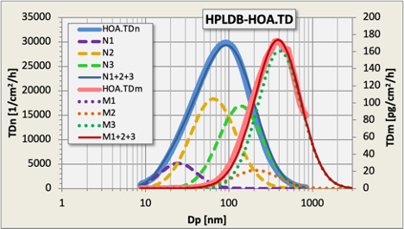
Figure SF2. The TD data of the HOA case (TD_{n} measured: thick-blue-solid; TD_{m} “measured” (i.e. calculated from TD_{n}): thick-red-solid) are represented by fitting 3 lognormal distribution functions (N) to the measured data set. Their sum (N1+N2+N3 blue-thin-solid and M1+M2+M3 red-thin-solid) best fits the measured data. Fit N1 (N1, nanoparticles, violet-dashed) contributes only a little to TD_{n} and nothing to TD_{m} (fit M1 violet-dotted is missing). Fit N2+N3 together represent the measured TD_{n} (N2 yellow-dashed and N3 green-dashed). Fit M2 contributes only a minor part to TD_{m} (M2 yellow-dotted), while fit M3 represents nearly the whole particle mass (M3 green-dotted). The measured mass data (HOA.TD_{m}) ends at 836 nm. The fit sum M1+M2+M3 can be extrapolated and integrated beyond 1000 nm.

All our measured TD can be represented by three lognormal fits
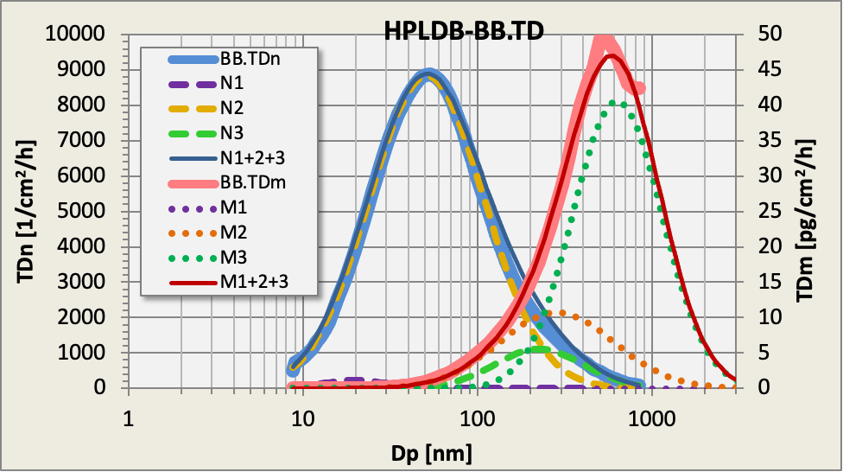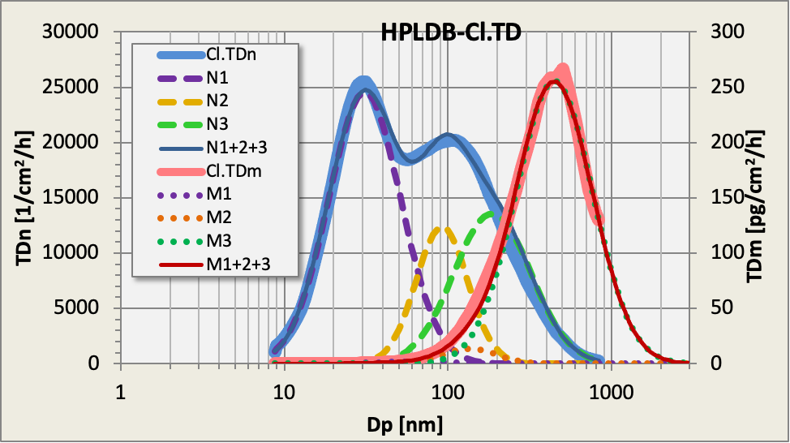
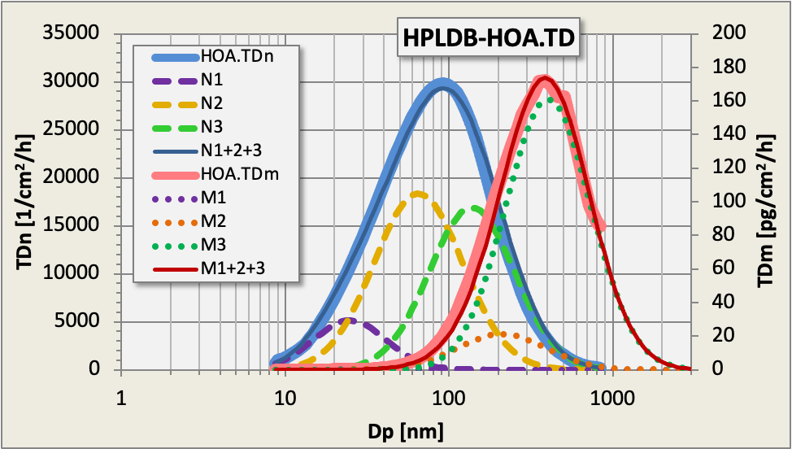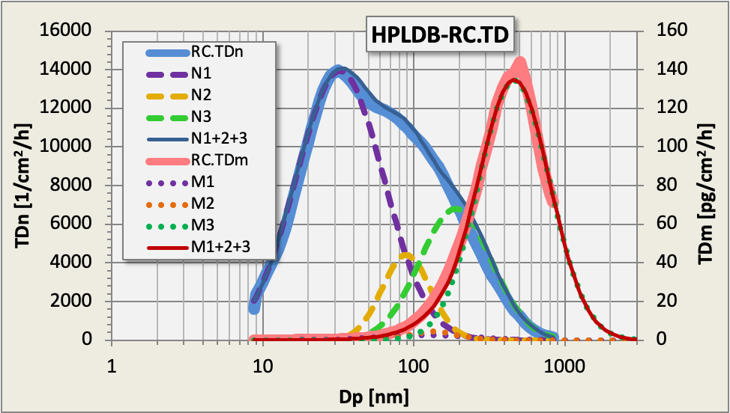
Figure SF2a-d shows that all our measured TD data (thick solid lines) can be represented by the sum of three lognormal distributions (N1+N2+N3): a “nanoparticle” distribution (N1, violet, 20 < CMD < 32 nm), an ultrafine distribution (N2, yellow, 51 < CMD < 109 nm) and a fine distribution (N3, green, 138 < CMD < 268 nm). The mass distributions M1, M2 and M3 are calculated from N1, N2 and N3 using equation 2 of the main text and the effective density of the respective case. The fit parameters and integrals are listed in Table ST1.

Table ST1. Fit parameters for the TD_{n} and TD_{m} distribution data. The TD_{n} fit functions are adjusted to the measured data by varying CMD, wt and σ_{g} parameters. The fit quality is 1 if N1+N2+N3 perfectly represent the measured data. The fit parameters are varied to achieve the optimum fit quality for TD_{n} and TD_{m}. The TD_{m} data are calculated channel-wise from the number TD_{n} using particle density, -diameter and -concentration. The fit median is derived from number data using the Hatch-Choate-equations (2,3) for lognormal distributions. The parameters are: CMD – count median particle diameter; wt – weight, i.e. total concentration of the fit function, integrated for 0 < D_{p} <∞; σ_{g} – geometric standard deviation; N1, N2, N3 – three lognormal fit functions for TD_{n}; measured – data modeled from airborne measurement data; measured: fit – the ratio of measured and fitted sum, i.e. the “amount of completeness”; fit quality – metric for the differences between measured and fitted data; it is 0 for no and 1 for perfect congruency; density – the effective density for the investigative cases ρ_{eff, ACSM}.

 |  | TD_{n}
 |  |  | BB | Cl | HOA | RC | unit
fits for TD_{n} | N1 | CMD | 19.9 | 30.9 | 24.7 | 31.8 | nm
 |  | wt | 100 | 13612 | 2851 | 9426 | particles/cm²/h
 |  | s_{g} | 1.50 | 1.66 | 1.67 | 1.95 | -
 | N2 | CMD | 51 | 92 | 65 | 109 | nm
 |  | wt | 7 270 | 4 902 | 12 500 | 4 182 | particles/cm²/h
 |  | s_{g} | 2.13 | 1.44 | 1.87 | 0.66 | -
 | N3 | CMD | 224 | 186 | 138 | 268 | nm
 |  | wt | 706 | 7 965 | 11 000 | 1 795 | particles/cm²/h
 |  | s_{g} | 1.80 | 1.71 | 1.82 | 1.58 | -
 |  | N1+N2+N3 | 8 076 | 26 397 | 26 351 | 15 165 | particles/cm²/h
 |  | Measured TD_{n} | 8 006 | 26 480 | 25 682 | 15 403 | particles/cm²/h
 |  | measured: fitted | 0.99 | 1.00 | 0.97 | 1.02 | -
 |  | fit-quality | 0.91 | 0.93 | 0.92 | 0.94 | 0 ... 1
 |  | TD_{m} – calculated from TDn, N1, N2 and N3
 |  | Eff. density | 1.33 | 1.50 | 1.38 | 1.45 | g/cm³
fits for TDm | M1 | MMD | 32 | 67 | 54 | 121 | nm
 |  | wt | 1.1✕10⁻³ | 1.04 | 0.101 | 1.70 | pg/cm²/h
 | M2 | MMD | 283 | 136 | 211 | 236 | nm
 |  | wt | 8.82 | 5.4 | 14.4 | 13.1 | pg/cm²/h
 | M3 | MMD | 629 | 446 | 405 | 499 | nm
 |  | wt | 26.0 | 150 | 105 | 66.7 | pg/cm²/h
 |  | M1+M2+M3 | 34.8 | 156 | 119 | 81.5 | pg/cm²/h
 |  | Measured TD_{m} | 26.5 | 143 | 111 | 75 | pg/cm²/h
 |  | measured: fitted | 0.76 | 0.92 | 0.93 | 0.92 | -
 |  | fit-quality | 0.90 | 0.86 | 0.88 | 0.85 | 0 ... 1

The Hygroscopic Particle Lung Deposition (HPLD) Model
The ICRP model is an empirical model based on experimental data. It is, therefore, a kind of reference for lung deposition modeling. Models based thereon use the fit equations of the ICRP or interpolate tabled data. Other deposition models have been developed using a mathematical structure of the human lung, made up of tubes, and equations for particle deposition within these tubes by sedimentation, diffusion, and impaction, e.g., the MPPD and the HPLD models.
Our simulation is for a sitting man breathing with a tidal volume of 750 cm³ (Q = 0.54 m³h⁻ ¹) and 12 respirations per minute via the nose. The particle density of the investigative cases is used with an assumed shape factor of 1. A list of particle diameters is pre-defined and matches the size bins of the MPSS particle sizer.
The model runs are performed on a Unix system. A shell script repeatedly starts the runs with appropriate density, hygroscopicity, and particle size, and with the breathing parameters, the appropriate model output is added after the run ends. All runs are added to a file containing all DMA spectrum deposition data. The deposition file is post-processed by AWK-scripts, which yield the TD_{f}. table (ST4). TD_{f} table and airborne particle size distribution data (C_{n}) are combined in a spreadsheet for TD_{n} and TD_{m} by mathematical convolution (equations 5a and 5b in the main text, respectively).

Particle density

The effective density commonly depends on particle size
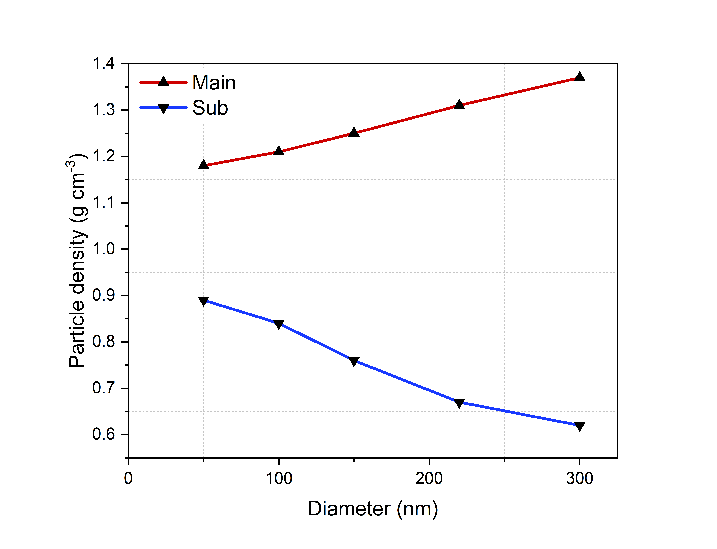
Figure SF3. The particle's effective density depends on particle size; data are from Zhou et al. (2022) (4) for the effective density measured in an industrial area in China. The " Main " particle population is the average of all density data analyzed in 5 diameter classes (dots). The particle population named „Sub“ is the non-hygroscopic subpopulation of aggregated combustion emission particles.
We show the particle density from Zhou et al. (2022) (4) as an example. They analyze the density for the particle diameter classes 50, 100, 150, 220, and 300 nm. The particles in the “Sub” population hardly contribute to airborne particle mass as their density decreases noticeably with rising particle size.
The particle fraction marked “Main” can be fitted by a straight line, which is extrapolated until 400 nm. Beyond the density is constant and continued up to our DMA's sizing limit (836 nm). Figure SF3 gives the range for our sensitivity test: To cover the whole range, we use the particle density range from 0.6 to 1.8 g cm⁻³ for sensitivity analysis.

The average effective density for our investigative cases comes from chemical speciation data
From the Delhi campaign, no size-dependent particle density data are available. An average density is therefore derived from the chemical species data of the ACSM instrument. Particle effective density r_{eff, ACSM} is averaged for the 4 investigative cases (biomass burning, BB; industrial emission, Cl; traffic emission, HOA; relatively clean air, RC) using the method of Zhou et al. (2022)(4), their equation 3:
(SE1)
where f_{m,i} is the fraction of the chemical species i with bulk density ρ_{i}. Bulk density data are from the literature. The effective density ρ_{eff, ACSM} for the 4 investigative cases is listed in Table ST1.

The sensitivity of the HPLD model output to particle density
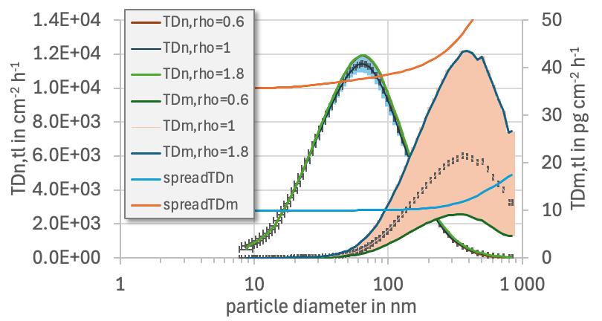
Figure SF4. Sensitivity of Tissue Deposited number (TD_{n}, left ordinate) and mass (TD_{m}, right ordinate) to particle effective density for the total lung surface area (TLSA) during the BB investigative case. Density varied from 0.6 to 1.8 g cm⁻³, as argued before. The sensitivity range is marked in blue (TDn) and orange (TD_{m}) colour. The ratio TD_{n} (ρ_{p}=1.8 g cm⁻³): TD_{n}(ρ_{p}=0.6 g cm⁻³) is printed as blue line, the ratio TD_{m}(ρ_{p}=1.8 g cm⁻³): TD_{m} (ρ_{p}=0.6 g cm⁻³) as orange line (right ordinate×10⁻¹).
Particle density accounts for sedimentation and impaction processes during the transport in the respiratory tract. Only the particles of the “aerodynamic regime” (commonly fine particles with diameters > 100 nm) are affected. Particles of the “thermodynamic regime” are merely transported by diffusive processes with no influence from particle density. The influence of particle density rises with particle size.
Particle density span is chosen from 0.6 to 1.8 g cm⁻³, i.e. from the non-hygroscopic aggregated emission particle density to aged atmospheric background particles. Figure SF4 shows nearly no influence for particle number deposition TD_{n} as these particles are mainly transported by diffusion. The spread factor (TD_{n} (ρ_{p}=1.8 g cm⁻³): TD_{n} (ρ_{p}=0.6 g cm⁻³); blue line) is close to 1 from 10 to 200 nm and rises to 1.7 at 836 nm. For the deposited particle mass, however, density yields a higher range of variation (orange area). The spread factor (TD_{m} (ρ_{p}=1.8 g cm⁻³): TD_{m} (ρ_{p}=0.6 g cm⁻³) rises from 3.3 at 10 nm to 6.2 at 836 nm.

Particle hygroscopicity
Particle hygroscopicity depends on particle size. Nanoparticles commonly emitted from vehicle tailpipes are non-hygroscopic. Aged particles in the submicron size range underwent numerous transformation processes, which made them more hygroscopic. Hygroscopicity data were measured via the H-TDMA system in the 20 to 200 nm diameter range.

The hygroscopicity of particles outside the H-TDMA size range
The DMA size range is 8.75 nm to 836 nm. As no information on particle hygroscopicity is available outside the H-TDMA size range, hygroscopicity simply continues for all lower and higher diameters (Figure SF5). Arguments for continuing are:
- The nanoparticles are commonly addressed as the primaries of soot aggregates with a low GF close to 1. Except for the Cl case, the measured GF is close to 1 and continuing the lowest measured value for all particles, D_{p} < 20 nm, seems ok.
- For the submicron particles in the size range 200 nm to 836 nm, a part of the GF variation is due to the curvature effect, which does not change significantly anymore for particles with D_{p} > 200 nm. Additionally, particles with D_{p} > 200 nm are in the accumulation mode, with a relatively uniform composition and no significant change with increasing particle size. Setting the GF constant will result in errors which are assumed to be acceptable.
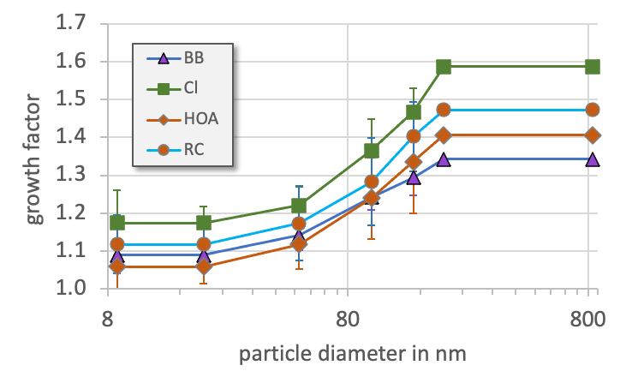
Figure SF5. The hygroscopicity of particles beyond the H-TDMA size range (20, 50, 100, 150 and 200 nm) continues as a constant for lower and higher diameters, respectively.

The sensitivity of the HPLD model output to particle hygroscopicity
The sensitivity of the modeled TD_{n} and TD_{m} to particle hygroscopicity is analyzed in Figure SF5. The growth factor GF in our data set varies from about GF = 1 to about GF = 1.6. Example calculations are performed here for the BB case. TD for GF = 1.6 differs between 0.4 and 3.8-fold from TD with GF = 1.
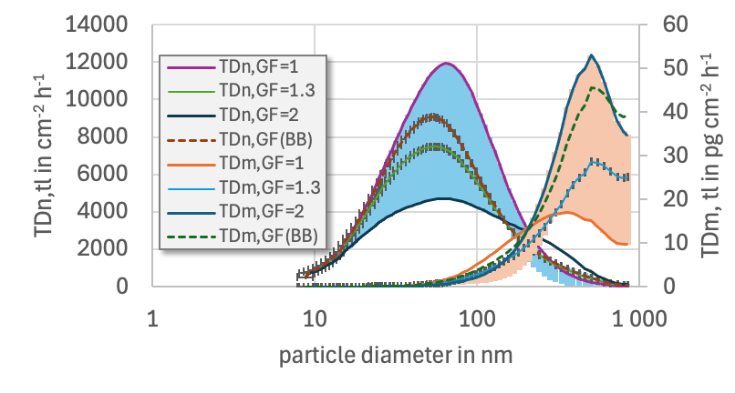
Figure SF6. Sensitivity of Tissue Deposited number (TD_{n}, left ordinate, blue) and mass (TD_{m}, right ordinate, red) to particle hygroscopicity for the total lung surface area (TLSA) during the BB investigative case. Particle hygroscopicity varies between GF = 1 and GF = 1.6.

Relationship between growth factor and kappa
Both growth factor GF and hygroscopicity parameter κ can be used to characterize hygroscopicity. The relation between GF and κ, is given by the following equation
(SE2)
The validity of the equation is checked by comparing both k and GF obtained from the hygroscopic growth data during the Delhi 2020 campaign by varying RH. The optimum RH was 0.89 for all investigative cases (Table ST2). This perfectly coincides with the RH of 0.90, which was set in the humidified tandem differential mobility analyzer (H-TDMA) for particle growth analysis. The comparison quality is given by the coefficient of determination, R², which is 1 for perfect and 0 for no interrelation. R² is close to 1 for the relatively clean period (RC) and the traffic-dominated case (HOA); it is lower for both the biomass burning (BB) and chloride (Cl) investigative cases. We hypothesize that the primary emission particles during RC and HOA were non-hygroscopic ultrafine (≤100 nm) particles, leaving the hygroscopic background particles unchanged. During both the BB and Cl cases, emissions also occurred in the fine particle range (> 100 nm).

Table ST2. Correlation between κ and GF for the H-TDMA analyzer. For all GF and k pairs available for an investigative case, equation (2) was solved by adjusting RH for the best fit. The average RH_{avg} and the coefficient of determination R² are listed here. The humidity in the H-TDMA analyzer was 0.90.
case | RH_{avg} | R²
BB | 0.89 | 0.95
Cl | 0.89 | 0.95
HOA | 0.89 | 0.99
RC | 0.89 | 0.99
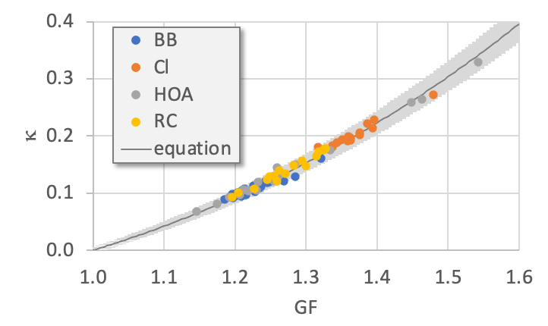

Figure SF7. Interrelation between GF and k. The dark grey line represents k calculated from the GF by equation SE2; the grey region is the ± 5% range from the line. The dots are the measured k and GF data during the investigative cases.

Consideration of day- and nighttime
Hygroscopicity data are available at night and during the day. To account for potential differences, we comprehensively performed model runs for day and night separately and then for all data.
In chapter 2.3 of the main text, we define daytime from 8 a.m. to 8 p.m., as we assume that the boundary layer has already started to develop at that time. Human activities change from night to day, and boundary layer turbulence also expects additional dilution. From the astronomical point of view, however, the change from night to day is at 6 a.m. and from day to night at 6 p.m.
We also performed additional model runs for the 6 a.m. to 6 p.m. day-night schedule. The results are listed in Table ST3. It says differences of up to 3% for the hygroscopic number deposition TD_{n} and 19% for the hygroscopic mass deposition during the BB case. In the Cl case, the 6 o’clock data are 7% lower, as industrial emissions begin after 6 a.m. They are higher for the BB case, as there are commonly more truck emissions during the night.
Table ST3. Ratio of tissue deposition TD_{n} and TD_{m} for the day-night crossover at 6 o’clock to the crossover at 8 o’clock. The ratio is >1 if the 6 o’clock numbers are higher and <1 if the 8 o’clock numbers are higher.
 | 6 till 6 related to 8 till 8
 | day | night | day | night
Case | hp TD_{n} |  | hp TD_{m}
BB | 1.03 | 1.01 | 1.10 | 1.19
Cl | 1.02 | 1.00 | 0.94 | 0.93
HOA | 1.02 | 1.02 | 1.05 | 1.00
RC | 1.00 | 1.00 | 0.99 | 1.05

Tissue deposition factors TD_{f} of the four investigative cases
Table ST4 a-d. Tissue deposited particle factors (TD_{f}). TD_{f} are given for the four investigative cases: a) BB – high concentration of organic aerosol from biomass-burning, b) Cl – high concentration of chloride from industrial processes and trash burning, c) HOA – high concentration of hydrocarbon-like organic aerosol from traffic emission, and d) RC – relatively clean air conditions. TD_{f} is given for the extra-thoracic (EX), tracheobronchial (TB) and alveolar (AL) lung region and the total lung surface area (TLSA). The TD_{f} depend on particle diameter (D_{p} in nm), particle effective density (ρ_{p}), and the size-dependent hygroscopicity growth factor (GF(D_{p})). GF(D_{p}) is the ratio of the grown particle size at relative humidity RH = 0.90 to the initially dry particle diameter. The GF were measured in the size range 20 nm < Dp < 200 nm, so their size dependency is only within this size range. All GF(D_{p} < 20 nm) are set to GF(D_{p} = 20 nm), and all GF(D_{p} > 200 nm) are set to GF(D_{p} = 200 nm). The particle hygroscopicity parameter kappa (κ(D_{p})) is given additionally. κ(D_{p})) is calculated from GF(D_{p}) by equation SE2. According to equations 5a and 5b in the main text, the TD_{f} can be used to calculate the number of particles deposited hourly on 1 cm² of inner lung tissue (TD_{n} in particles cm⁻² h⁻¹) or of the mass of particles deposited hourly on 1 cm² of lung tissue (TD_{m} in pg cm⁻² h⁻¹) directly from the airborne particle concentration. When using the TD_{f}, the airborne particle number concentration C_{n} must be given in particles per cc and the airborne particle mass concentration C_{m} in µg m⁻³. All TD_{f} are modeled for a person at rest, breathing calmly at 12 breaths min⁻¹ via the nose with a tidal volume of 750 ml and no pause between in- and exhalation. Both breathing conditions and inner lung surface area are described in more detail by Karg et al. (2020) (5).

TD_{f} for the biomass burning case (BB)
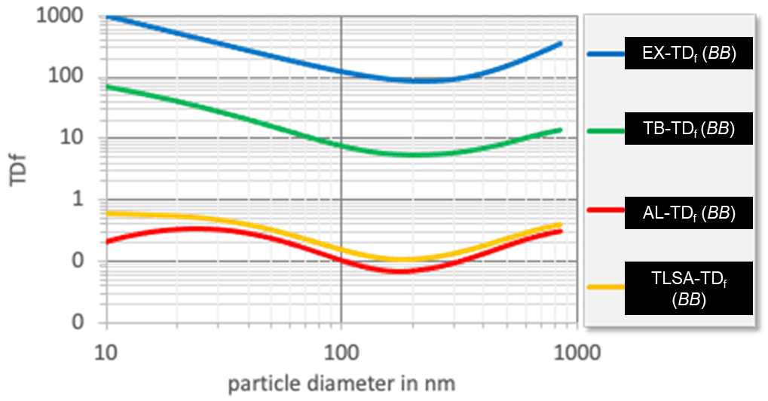
Table ST4a. Tissue deposited particle factors (TD_{f}) for BB.
D_{p} | ρ_{p} | GF(D_{p}) | κ(D_{p}) | TD_{f}(EX) | TD_{f}(TB) | TD_{f}(AL) | TD_{f}(TLSA)
8.75 | 1.33 | 1.085 | 0.0309 | 1092 | 71.7 | 0.178 | 0.623
9.00 | 1.33 | 1.085 | 0.0309 | 1065 | 70.6 | 0.185 | 0.622
9.52 | 1.33 | 1.085 | 0.0309 | 1012 | 68.2 | 0.199 | 0.619
10.1 | 1.33 | 1.085 | 0.0309 | 962 | 65.8 | 0.212 | 0.616
10.7 | 1.33 | 1.085 | 0.0309 | 915 | 63.3 | 0.225 | 0.612
11.3 | 1.33 | 1.085 | 0.0309 | 869 | 60.9 | 0.238 | 0.609
11.9 | 1.33 | 1.085 | 0.0309 | 825 | 58.4 | 0.251 | 0.605
12.6 | 1.33 | 1.085 | 0.0309 | 784 | 56.0 | 0.262 | 0.601
13.3 | 1.33 | 1.085 | 0.0309 | 744 | 53.6 | 0.273 | 0.597
14.1 | 1.33 | 1.085 | 0.0309 | 707 | 51.3 | 0.284 | 0.593
14.9 | 1.33 | 1.085 | 0.0309 | 671 | 49.0 | 0.294 | 0.588
15.8 | 1.33 | 1.085 | 0.0309 | 637 | 46.7 | 0.302 | 0.583
16.7 | 1.33 | 1.085 | 0.0309 | 604 | 44.6 | 0.310 | 0.577
17.7 | 1.33 | 1.085 | 0.0309 | 573 | 42.5 | 0.317 | 0.571
18.7 | 1.33 | 1.085 | 0.0309 | 544 | 40.5 | 0.322 | 0.564
19.8 | 1.33 | 1.085 | 0.0309 | 516 | 38.5 | 0.327 | 0.557
21.0 | 1.33 | 1.087 | 0.0318 | 489 | 36.6 | 0.330 | 0.548
22.2 | 1.33 | 1.090 | 0.0328 | 464 | 34.7 | 0.332 | 0.538
23.5 | 1.33 | 1.093 | 0.0339 | 440 | 32.9 | 0.332 | 0.528
24.9 | 1.33 | 1.096 | 0.0351 | 417 | 31.1 | 0.331 | 0.516
26.4 | 1.33 | 1.099 | 0.0364 | 396 | 29.4 | 0.328 | 0.504
27.9 | 1.33 | 1.102 | 0.0377 | 375 | 27.8 | 0.324 | 0.490
29.6 | 1.33 | 1.106 | 0.0391 | 356 | 26.3 | 0.319 | 0.476
31.3 | 1.33 | 1.110 | 0.0406 | 337 | 24.8 | 0.312 | 0.460
33.2 | 1.33 | 1.113 | 0.0422 | 320 | 23.4 | 0.304 | 0.444
35.2 | 1.33 | 1.117 | 0.0439 | 303 | 22.1 | 0.295 | 0.427
37.3 | 1.33 | 1.122 | 0.0457 | 287 | 20.8 | 0.284 | 0.409
39.5 | 1.33 | 1.126 | 0.0476 | 272 | 19.6 | 0.273 | 0.391
41.9 | 1.33 | 1.131 | 0.0497 | 258 | 18.4 | 0.262 | 0.372
44.4 | 1.33 | 1.136 | 0.0518 | 245 | 17.3 | 0.249 | 0.354
47.1 | 1.33 | 1.141 | 0.0541 | 232 | 16.2 | 0.237 | 0.335
50.0 | 1.33 | 1.147 | 0.0566 | 220 | 15.2 | 0.224 | 0.316
53.1 | 1.33 | 1.153 | 0.0591 | 209 | 14.3 | 0.211 | 0.298
56.3 | 1.33 | 1.159 | 0.0619 | 198 | 13.4 | 0.198 | 0.280
59.8 | 1.33 | 1.166 | 0.0648 | 188 | 12.6 | 0.186 | 0.263
63.5 | 1.33 | 1.172 | 0.0679 | 178 | 11.8 | 0.174 | 0.246
67.5 | 1.33 | 1.179 | 0.0712 | 169 | 11.1 | 0.162 | 0.230
71.8 | 1.33 | 1.187 | 0.0747 | 161 | 10.4 | 0.151 | 0.215
76.3 | 1.33 | 1.195 | 0.0784 | 153 | 9.77 | 0.140 | 0.201
81.2 | 1.33 | 1.203 | 0.0823 | 145 | 9.20 | 0.130 | 0.188
86.4 | 1.33 | 1.212 | 0.0865 | 138 | 8.68 | 0.121 | 0.175
92.0 | 1.33 | 1.221 | 0.0909 | 131 | 8.21 | 0.112 | 0.164
98.1 | 1.33 | 1.230 | 0.0956 | 125 | 7.78 | 0.105 | 0.153
105 | 1.33 | 1.240 | 0.1005 | 119 | 7.39 | 0.097 | 0.144
112 | 1.33 | 1.250 | 0.1057 | 114 | 7.05 | 0.091 | 0.135
119 | 1.33 | 1.260 | 0.1111 | 109 | 6.74 | 0.086 | 0.128
127 | 1.33 | 1.270 | 0.1167 | 105 | 6.47 | 0.081 | 0.121
136 | 1.33 | 1.281 | 0.1226 | 101 | 6.24 | 0.077 | 0.116
145 | 1.33 | 1.292 | 0.1287 | 97 | 6.03 | 0.073 | 0.111
156 | 1.33 | 1.303 | 0.1349 | 94 | 5.87 | 0.071 | 0.108
167 | 1.33 | 1.314 | 0.1411 | 91 | 5.73 | 0.069 | 0.105
179 | 1.33 | 1.325 | 0.1473 | 89 | 5.63 | 0.068 | 0.104
192 | 1.33 | 1.335 | 0.1532 | 87 | 5.57 | 0.069 | 0.103
207 | 1.33 | 1.340 | 0.1562 | 86 | 5.53 | 0.070 | 0.104
223 | 1.33 | 1.340 | 0.1562 | 86 | 5.53 | 0.071 | 0.106
240 | 1.33 | 1.340 | 0.1562 | 86 | 5.56 | 0.074 | 0.109
259 | 1.33 | 1.340 | 0.1562 | 88 | 5.63 | 0.078 | 0.113
280 | 1.33 | 1.340 | 0.1562 | 90 | 5.73 | 0.083 | 0.118
303 | 1.33 | 1.340 | 0.1562 | 93 | 5.87 | 0.089 | 0.126
329 | 1.33 | 1.340 | 0.1562 | 98 | 6.07 | 0.097 | 0.135
357 | 1.33 | 1.340 | 0.1562 | 104 | 6.32 | 0.106 | 0.146
388 | 1.33 | 1.340 | 0.1562 | 112 | 6.64 | 0.117 | 0.159
423 | 1.33 | 1.340 | 0.1562 | 122 | 7.04 | 0.131 | 0.176
461 | 1.33 | 1.340 | 0.1562 | 135 | 7.52 | 0.146 | 0.195
503 | 1.33 | 1.340 | 0.1562 | 152 | 8.11 | 0.164 | 0.217
550 | 1.33 | 1.340 | 0.1562 | 172 | 8.81 | 0.184 | 0.243
602 | 1.33 | 1.340 | 0.1562 | 197 | 9.65 | 0.206 | 0.271
660 | 1.33 | 1.340 | 0.1562 | 227 | 10.6 | 0.230 | 0.303
725 | 1.33 | 1.340 | 0.1562 | 264 | 11.6 | 0.253 | 0.335
797 | 1.33 | 1.340 | 0.1562 | 310 | 12.5 | 0.275 | 0.366
836 | 1.33 | 1.340 | 0.1562 | 337 | 13.0 | 0.286 | 0.382

TD_{f} for the high chloride case (Cl)

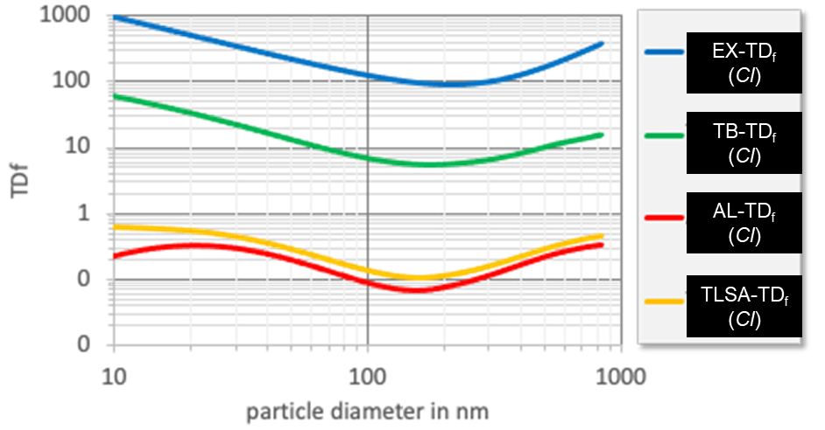
Table ST4b. Tissue deposited particle factors (TD_{f}) for Cl

D_{p} | ρ_{p} | GF(D_{p}) | κ(D_{p}) | TD_{f}(EX) | TD_{f}(TB) | TD_{f}(AL) | TD_{f}(TLSA)
8.75 | 1.38 | 1.17 | 0.0200 | 1090 | 67.6 | 0.194 | 0.621
9.00 | 1.38 | 1.17 | 0.0200 | 1063 | 66.4 | 0.201 | 0.619
9.52 | 1.38 | 1.17 | 0.0200 | 1011 | 63.9 | 0.215 | 0.616
10.1 | 1.38 | 1.17 | 0.0200 | 961 | 61.4 | 0.228 | 0.612
10.7 | 1.38 | 1.17 | 0.0200 | 913 | 59.0 | 0.241 | 0.609
11.3 | 1.38 | 1.17 | 0.0200 | 868 | 56.5 | 0.254 | 0.605
11.9 | 1.38 | 1.17 | 0.0200 | 824 | 54.0 | 0.265 | 0.600
12.6 | 1.38 | 1.17 | 0.0200 | 783 | 51.6 | 0.277 | 0.596
13.3 | 1.38 | 1.17 | 0.0200 | 743 | 49.2 | 0.287 | 0.591
14.1 | 1.38 | 1.17 | 0.0200 | 706 | 46.9 | 0.296 | 0.586
14.9 | 1.38 | 1.17 | 0.0200 | 670 | 44.7 | 0.305 | 0.580
15.8 | 1.38 | 1.17 | 0.0200 | 636 | 42.5 | 0.312 | 0.574
16.7 | 1.38 | 1.17 | 0.0200 | 603 | 40.4 | 0.318 | 0.567
17.7 | 1.38 | 1.17 | 0.0200 | 572 | 38.4 | 0.323 | 0.559
18.7 | 1.38 | 1.17 | 0.0200 | 543 | 36.5 | 0.327 | 0.551
19.8 | 1.38 | 1.17 | 0.0200 | 515 | 34.7 | 0.329 | 0.542
21.0 | 1.38 | 1.17 | 0.0208 | 489 | 32.8 | 0.329 | 0.531
22.2 | 1.38 | 1.17 | 0.0217 | 463 | 31.1 | 0.329 | 0.519
23.5 | 1.38 | 1.17 | 0.0227 | 440 | 29.4 | 0.326 | 0.507
24.9 | 1.38 | 1.18 | 0.0237 | 417 | 27.8 | 0.322 | 0.493
26.4 | 1.38 | 1.18 | 0.0249 | 395 | 26.2 | 0.317 | 0.478
27.9 | 1.38 | 1.18 | 0.0261 | 375 | 24.8 | 0.310 | 0.463
29.6 | 1.38 | 1.19 | 0.0274 | 355 | 23.4 | 0.303 | 0.447
31.3 | 1.38 | 1.19 | 0.0288 | 337 | 22.0 | 0.293 | 0.429
33.2 | 1.38 | 1.19 | 0.0303 | 319 | 20.7 | 0.283 | 0.412
35.2 | 1.38 | 1.20 | 0.0320 | 303 | 19.5 | 0.273 | 0.394
37.3 | 1.38 | 1.20 | 0.0338 | 287 | 18.4 | 0.261 | 0.375
39.5 | 1.38 | 1.21 | 0.0357 | 272 | 17.3 | 0.249 | 0.357
41.9 | 1.38 | 1.21 | 0.0378 | 258 | 16.2 | 0.237 | 0.338
44.4 | 1.38 | 1.22 | 0.0400 | 245 | 15.2 | 0.224 | 0.320
47.1 | 1.38 | 1.22 | 0.0425 | 232 | 14.3 | 0.212 | 0.301
50.0 | 1.38 | 1.23 | 0.0451 | 220 | 13.4 | 0.199 | 0.284
53.1 | 1.38 | 1.24 | 0.0480 | 209 | 12.6 | 0.187 | 0.266
56.3 | 1.38 | 1.24 | 0.0511 | 198 | 11.8 | 0.175 | 0.250
59.8 | 1.38 | 1.25 | 0.0545 | 188 | 11.1 | 0.163 | 0.234
63.5 | 1.38 | 1.26 | 0.0582 | 179 | 10.4 | 0.152 | 0.218
67.5 | 1.38 | 1.27 | 0.0623 | 170 | 9.82 | 0.141 | 0.204
71.8 | 1.38 | 1.28 | 0.0667 | 161 | 9.25 | 0.131 | 0.191
76.3 | 1.38 | 1.29 | 0.0715 | 153 | 8.72 | 0.122 | 0.178
81.2 | 1.38 | 1.30 | 0.0768 | 146 | 8.24 | 0.113 | 0.166
86.4 | 1.38 | 1.32 | 0.0825 | 139 | 7.80 | 0.105 | 0.156
92.0 | 1.38 | 1.33 | 0.0888 | 132 | 7.41 | 0.098 | 0.146
98.1 | 1.38 | 1.34 | 0.0956 | 126 | 7.05 | 0.091 | 0.137
105 | 1.38 | 1.36 | 0.103 | 121 | 6.73 | 0.085 | 0.129
112 | 1.38 | 1.38 | 0.111 | 115 | 6.45 | 0.080 | 0.122
119 | 1.38 | 1.40 | 0.120 | 111 | 6.21 | 0.076 | 0.116
127 | 1.38 | 1.42 | 0.129 | 106 | 6.00 | 0.073 | 0.112
136 | 1.38 | 1.44 | 0.139 | 102 | 5.83 | 0.070 | 0.108
145 | 1.38 | 1.46 | 0.150 | 99 | 5.69 | 0.069 | 0.105
156 | 1.38 | 1.49 | 0.161 | 96 | 5.59 | 0.068 | 0.104
167 | 1.38 | 1.51 | 0.172 | 94 | 5.54 | 0.069 | 0.104
179 | 1.38 | 1.54 | 0.182 | 92 | 5.52 | 0.071 | 0.106
192 | 1.38 | 1.57 | 0.192 | 90 | 5.56 | 0.074 | 0.109
207 | 1.38 | 1.58 | 0.196 | 90 | 5.64 | 0.078 | 0.114
223 | 1.38 | 1.58 | 0.196 | 90 | 5.74 | 0.083 | 0.119
240 | 1.38 | 1.58 | 0.196 | 91 | 5.89 | 0.089 | 0.126
259 | 1.38 | 1.58 | 0.196 | 93 | 6.08 | 0.097 | 0.134
280 | 1.38 | 1.58 | 0.196 | 95 | 6.32 | 0.106 | 0.145
303 | 1.38 | 1.58 | 0.196 | 100 | 6.62 | 0.117 | 0.157
329 | 1.38 | 1.58 | 0.196 | 105 | 7.00 | 0.129 | 0.172
357 | 1.38 | 1.58 | 0.196 | 113 | 7.45 | 0.144 | 0.190
388 | 1.38 | 1.58 | 0.196 | 122 | 8.00 | 0.161 | 0.210
423 | 1.38 | 1.58 | 0.196 | 134 | 8.66 | 0.180 | 0.233
461 | 1.38 | 1.58 | 0.196 | 149 | 9.44 | 0.200 | 0.259
503 | 1.38 | 1.58 | 0.196 | 168 | 10.36 | 0.223 | 0.288
550 | 1.38 | 1.58 | 0.196 | 191 | 11.33 | 0.247 | 0.318
602 | 1.38 | 1.58 | 0.196 | 220 | 12.20 | 0.269 | 0.348
660 | 1.38 | 1.58 | 0.196 | 254 | 13.15 | 0.291 | 0.378
725 | 1.38 | 1.58 | 0.196 | 297 | 14.18 | 0.311 | 0.407
797 | 1.38 | 1.58 | 0.196 | 349 | 15.29 | 0.328 | 0.436
836 | 1.38 | 1.58 | 0.196 | 379 | 15.87 | 0.335 | 0.449

TD_{f} for the hydrocarbon-like organic aerosol case (HOA)

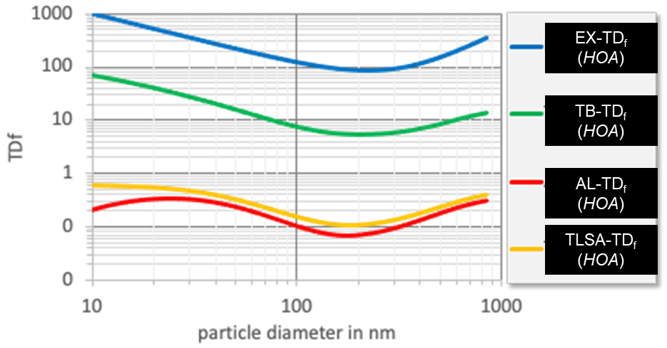

Table ST4c. Tissue deposited particle factors (TD_{f}) for HOA.
D_{p} | ρ_{p} | GF(D_{p}) | κ(D_{p}) | TD_{f}(EX) | TD_{f}(TB) | TD_{f}(AL) | TD_{f}(TLSA)
8.75 | 1.14 | 1.06 | 0.0216 | 1092 | 72.9 | 0.173 | 0.624
9.00 | 1.14 | 1.06 | 0.0216 | 1065 | 71.8 | 0.180 | 0.623
9.52 | 1.14 | 1.06 | 0.0216 | 1013 | 69.5 | 0.194 | 0.620
10.1 | 1.14 | 1.06 | 0.0216 | 963 | 67.1 | 0.207 | 0.617
10.7 | 1.15 | 1.06 | 0.0216 | 915 | 64.7 | 0.221 | 0.613
11.3 | 1.15 | 1.06 | 0.0216 | 869 | 62.2 | 0.233 | 0.610
11.9 | 1.15 | 1.06 | 0.0216 | 826 | 59.8 | 0.246 | 0.606
12.6 | 1.15 | 1.06 | 0.0216 | 784 | 57.4 | 0.258 | 0.603
13.3 | 1.15 | 1.06 | 0.0216 | 745 | 55.0 | 0.269 | 0.599
14.1 | 1.15 | 1.06 | 0.0216 | 707 | 52.7 | 0.280 | 0.595
14.9 | 1.15 | 1.06 | 0.0216 | 671 | 50.4 | 0.289 | 0.590
15.8 | 1.15 | 1.06 | 0.0216 | 637 | 48.1 | 0.299 | 0.585
16.7 | 1.15 | 1.06 | 0.0216 | 605 | 45.9 | 0.307 | 0.580
17.7 | 1.15 | 1.06 | 0.0216 | 574 | 43.8 | 0.314 | 0.574
18.7 | 1.15 | 1.06 | 0.0216 | 544 | 41.8 | 0.320 | 0.568
19.8 | 1.15 | 1.06 | 0.0216 | 516 | 39.9 | 0.325 | 0.561
21.0 | 1.15 | 1.06 | 0.0222 | 490 | 37.9 | 0.329 | 0.553
22.2 | 1.15 | 1.06 | 0.0231 | 465 | 36.0 | 0.332 | 0.544
23.5 | 1.16 | 1.06 | 0.0240 | 441 | 34.1 | 0.333 | 0.534
24.9 | 1.16 | 1.07 | 0.0249 | 418 | 32.3 | 0.333 | 0.524
26.4 | 1.16 | 1.07 | 0.0259 | 396 | 30.6 | 0.331 | 0.512
27.9 | 1.16 | 1.07 | 0.0271 | 376 | 29.0 | 0.328 | 0.499
29.6 | 1.16 | 1.08 | 0.0283 | 356 | 27.4 | 0.323 | 0.485
31.3 | 1.16 | 1.08 | 0.0296 | 338 | 25.9 | 0.318 | 0.471
33.2 | 1.16 | 1.08 | 0.0310 | 320 | 24.5 | 0.310 | 0.455
35.2 | 1.16 | 1.09 | 0.0325 | 303 | 23.1 | 0.302 | 0.438
37.3 | 1.17 | 1.09 | 0.0342 | 288 | 21.7 | 0.292 | 0.421
39.5 | 1.17 | 1.10 | 0.0360 | 273 | 20.4 | 0.282 | 0.403
41.9 | 1.17 | 1.10 | 0.0380 | 259 | 19.2 | 0.270 | 0.385
44.4 | 1.17 | 1.11 | 0.0402 | 245 | 18.0 | 0.258 | 0.366
47.1 | 1.17 | 1.11 | 0.0425 | 232 | 16.9 | 0.245 | 0.347
50.0 | 1.18 | 1.12 | 0.0451 | 220 | 15.9 | 0.232 | 0.328
53.1 | 1.18 | 1.13 | 0.0479 | 209 | 14.9 | 0.219 | 0.309
56.3 | 1.18 | 1.13 | 0.0509 | 198 | 13.9 | 0.206 | 0.290
59.8 | 1.18 | 1.14 | 0.0543 | 188 | 13.0 | 0.193 | 0.272
63.5 | 1.19 | 1.15 | 0.0580 | 179 | 12.2 | 0.180 | 0.254
67.5 | 1.19 | 1.16 | 0.0620 | 169 | 11.4 | 0.167 | 0.237
71.8 | 1.19 | 1.17 | 0.0664 | 161 | 10.6 | 0.155 | 0.220
76.3 | 1.20 | 1.18 | 0.0713 | 153 | 9.95 | 0.143 | 0.205
81.2 | 1.20 | 1.19 | 0.0766 | 145 | 9.33 | 0.133 | 0.190
86.4 | 1.21 | 1.20 | 0.0825 | 138 | 8.76 | 0.122 | 0.177
92.0 | 1.21 | 1.22 | 0.0889 | 132 | 8.24 | 0.113 | 0.165
98.1 | 1.22 | 1.23 | 0.0960 | 126 | 7.77 | 0.104 | 0.153
105 | 1.22 | 1.24 | 0.1037 | 120 | 7.36 | 0.097 | 0.143
112 | 1.23 | 1.26 | 0.1121 | 114 | 6.98 | 0.090 | 0.134
119 | 1.23 | 1.28 | 0.1213 | 110 | 6.66 | 0.084 | 0.126
127 | 1.24 | 1.29 | 0.1312 | 105 | 6.37 | 0.079 | 0.119
136 | 1.25 | 1.31 | 0.1418 | 101 | 6.13 | 0.075 | 0.114
145 | 1.25 | 1.33 | 0.1529 | 97.6 | 5.93 | 0.072 | 0.109
156 | 1.26 | 1.35 | 0.1645 | 94.5 | 5.77 | 0.070 | 0.106
167 | 1.27 | 1.37 | 0.1761 | 91.9 | 5.65 | 0.068 | 0.104
179 | 1.28 | 1.38 | 0.1872 | 89.8 | 5.57 | 0.068 | 0.103
192 | 1.29 | 1.40 | 0.1971 | 88.3 | 5.53 | 0.069 | 0.104
207 | 1.30 | 1.40 | 0.2014 | 87.3 | 5.53 | 0.071 | 0.106
223 | 1.32 | 1.40 | 0.2014 | 87.1 | 5.56 | 0.074 | 0.108
240 | 1.33 | 1.40 | 0.2014 | 87.6 | 5.62 | 0.078 | 0.112
259 | 1.34 | 1.40 | 0.2014 | 89.0 | 5.72 | 0.082 | 0.118
280 | 1.36 | 1.40 | 0.2014 | 91.4 | 5.86 | 0.088 | 0.125
303 | 1.38 | 1.40 | 0.2014 | 95.0 | 6.05 | 0.096 | 0.133
329 | 1.40 | 1.40 | 0.2014 | 100 | 6.29 | 0.105 | 0.144
357 | 1.42 | 1.40 | 0.2014 | 106 | 6.60 | 0.116 | 0.157
388 | 1.45 | 1.40 | 0.2014 | 115 | 6.98 | 0.129 | 0.173
423 | 1.46 | 1.40 | 0.2014 | 126 | 7.44 | 0.144 | 0.191
461 | 1.46 | 1.40 | 0.2014 | 139 | 8.01 | 0.161 | 0.212
503 | 1.46 | 1.40 | 0.2014 | 156 | 8.69 | 0.181 | 0.237
550 | 1.46 | 1.40 | 0.2014 | 177 | 9.50 | 0.202 | 0.264
602 | 1.46 | 1.40 | 0.2014 | 203 | 10.5 | 0.225 | 0.295
660 | 1.46 | 1.40 | 0.2014 | 235 | 11.4 | 0.249 | 0.326
725 | 1.46 | 1.40 | 0.2014 | 274 | 12.3 | 0.271 | 0.357
797 | 1.46 | 1.40 | 0.2014 | 322 | 13.3 | 0.293 | 0.388
836 | 1.46 | 1.40 | 0.2014 | 349 | 13.8 | 0.302 | 0.404

TD_{f} for the relatively clean air periods (RC)

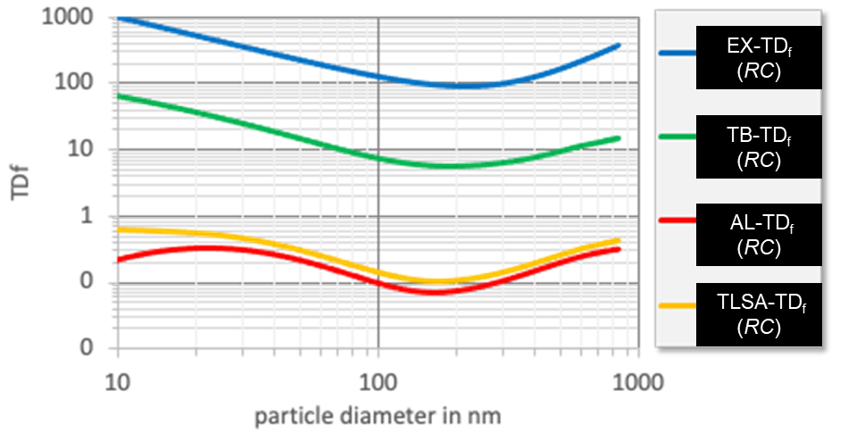

Table ST4d. Tissue deposited particle factors (TD_{f}) for RC
D_{p} | ρ_{p} | GF(D_{p}) | κ(D_{p}) | TD_{f}(EX) | TD_{f}(TB) | TD_{f}(AL) | TD_{f}(TLSA)
8.75 | 1.45 | 1.12 | 0.0455 | 1091 | 69.8 | 0.185 | 0.622
9.00 | 1.45 | 1.12 | 0.0455 | 1064 | 68.6 | 0.192 | 0.621
9.52 | 1.45 | 1.12 | 0.0455 | 1012 | 66.2 | 0.206 | 0.617
10.1 | 1.45 | 1.12 | 0.0455 | 962 | 63.8 | 0.220 | 0.614
10.7 | 1.45 | 1.12 | 0.0455 | 914 | 61.3 | 0.233 | 0.611
11.3 | 1.45 | 1.12 | 0.0455 | 868 | 58.8 | 0.246 | 0.607
11.9 | 1.45 | 1.12 | 0.0455 | 825 | 56.4 | 0.258 | 0.603
12.6 | 1.45 | 1.12 | 0.0455 | 783 | 53.9 | 0.269 | 0.599
13.3 | 1.45 | 1.12 | 0.0455 | 744 | 51.5 | 0.280 | 0.594
14.1 | 1.45 | 1.12 | 0.0455 | 706 | 49.2 | 0.290 | 0.590
14.9 | 1.45 | 1.12 | 0.0455 | 670 | 46.9 | 0.299 | 0.584
15.8 | 1.45 | 1.12 | 0.0455 | 636 | 44.7 | 0.307 | 0.579
16.7 | 1.45 | 1.12 | 0.0455 | 604 | 42.6 | 0.314 | 0.572
17.7 | 1.45 | 1.12 | 0.0455 | 573 | 40.5 | 0.320 | 0.566
18.7 | 1.45 | 1.12 | 0.0455 | 544 | 38.6 | 0.325 | 0.558
19.8 | 1.45 | 1.12 | 0.0455 | 516 | 36.7 | 0.328 | 0.550
21.0 | 1.45 | 1.12 | 0.0460 | 489 | 34.8 | 0.330 | 0.540
22.2 | 1.45 | 1.12 | 0.0468 | 464 | 33.0 | 0.331 | 0.530
23.5 | 1.45 | 1.13 | 0.0475 | 440 | 31.3 | 0.330 | 0.519
24.9 | 1.45 | 1.13 | 0.0484 | 417 | 29.6 | 0.328 | 0.507
26.4 | 1.45 | 1.13 | 0.0493 | 396 | 28.0 | 0.324 | 0.493
27.9 | 1.45 | 1.13 | 0.0504 | 375 | 26.5 | 0.319 | 0.479
29.6 | 1.45 | 1.14 | 0.0515 | 356 | 25.0 | 0.313 | 0.464
31.3 | 1.45 | 1.14 | 0.0527 | 337 | 23.7 | 0.305 | 0.448
33.2 | 1.45 | 1.14 | 0.0541 | 320 | 22.3 | 0.296 | 0.431
35.2 | 1.45 | 1.14 | 0.0555 | 303 | 21.1 | 0.286 | 0.414
37.3 | 1.45 | 1.15 | 0.0572 | 287 | 19.8 | 0.276 | 0.396
39.5 | 1.45 | 1.15 | 0.0589 | 272 | 18.7 | 0.265 | 0.378
41.9 | 1.45 | 1.16 | 0.0609 | 258 | 17.6 | 0.253 | 0.360
44.4 | 1.45 | 1.16 | 0.0631 | 245 | 16.5 | 0.240 | 0.341
47.1 | 1.45 | 1.17 | 0.0654 | 232 | 15.5 | 0.228 | 0.323
50.0 | 1.45 | 1.17 | 0.0681 | 220 | 14.6 | 0.215 | 0.305
53.1 | 1.45 | 1.18 | 0.0710 | 209 | 13.7 | 0.202 | 0.287
56.3 | 1.45 | 1.19 | 0.0742 | 198 | 12.8 | 0.190 | 0.269
59.8 | 1.45 | 1.19 | 0.0777 | 188 | 12.0 | 0.177 | 0.252
63.5 | 1.45 | 1.20 | 0.0816 | 179 | 11.3 | 0.165 | 0.236
67.5 | 1.45 | 1.21 | 0.0860 | 170 | 10.6 | 0.154 | 0.220
71.8 | 1.45 | 1.22 | 0.0908 | 161 | 9.91 | 0.143 | 0.205
76.3 | 1.45 | 1.23 | 0.0961 | 153 | 9.31 | 0.132 | 0.191
81.2 | 1.45 | 1.24 | 0.1020 | 146 | 8.76 | 0.122 | 0.178
86.4 | 1.45 | 1.26 | 0.1086 | 139 | 8.26 | 0.113 | 0.166
92.0 | 1.45 | 1.27 | 0.1158 | 132 | 7.80 | 0.105 | 0.155
98.1 | 1.45 | 1.28 | 0.1238 | 126 | 7.39 | 0.097 | 0.145
105 | 1.45 | 1.30 | 0.1327 | 120 | 7.02 | 0.091 | 0.136
112 | 1.45 | 1.32 | 0.1424 | 115 | 6.69 | 0.085 | 0.128
119 | 1.45 | 1.33 | 0.1531 | 110 | 6.41 | 0.080 | 0.121
127 | 1.45 | 1.35 | 0.1647 | 106 | 6.16 | 0.075 | 0.115
136 | 1.45 | 1.37 | 0.1771 | 102 | 5.96 | 0.072 | 0.110
145 | 1.45 | 1.39 | 0.1903 | 98.4 | 5.79 | 0.070 | 0.107
156 | 1.45 | 1.42 | 0.2040 | 95.4 | 5.67 | 0.069 | 0.105
167 | 1.45 | 1.44 | 0.2177 | 92.9 | 5.58 | 0.068 | 0.104
179 | 1.45 | 1.45 | 0.2308 | 90.9 | 5.53 | 0.069 | 0.104
192 | 1.45 | 1.47 | 0.2421 | 89.5 | 5.53 | 0.071 | 0.106
207 | 1.45 | 1.48 | 0.2468 | 88.7 | 5.56 | 0.074 | 0.109
223 | 1.45 | 1.48 | 0.2468 | 88.7 | 5.62 | 0.077 | 0.112
240 | 1.45 | 1.48 | 0.2468 | 89.4 | 5.72 | 0.082 | 0.118
259 | 1.45 | 1.48 | 0.2468 | 91.1 | 5.85 | 0.088 | 0.124
280 | 1.45 | 1.48 | 0.2468 | 93.8 | 6.03 | 0.095 | 0.133
303 | 1.45 | 1.48 | 0.2468 | 97.7 | 6.27 | 0.104 | 0.143
329 | 1.45 | 1.48 | 0.2468 | 103 | 6.57 | 0.115 | 0.156
357 | 1.45 | 1.48 | 0.2468 | 110 | 6.94 | 0.127 | 0.170
388 | 1.45 | 1.48 | 0.2468 | 119 | 7.39 | 0.142 | 0.188
423 | 1.45 | 1.48 | 0.2468 | 131 | 7.93 | 0.159 | 0.209
461 | 1.45 | 1.48 | 0.2468 | 145 | 8.59 | 0.178 | 0.232
503 | 1.45 | 1.48 | 0.2468 | 163 | 9.37 | 0.199 | 0.259
550 | 1.45 | 1.48 | 0.2468 | 185 | 10.3 | 0.221 | 0.288
602 | 1.46 | 1.48 | 0.2468 | 213 | 11.3 | 0.245 | 0.319
660 | 1.46 | 1.48 | 0.2468 | 246 | 12.2 | 0.268 | 0.349
725 | 1.46 | 1.48 | 0.2468 | 287 | 13.1 | 0.289 | 0.380
797 | 1.46 | 1.48 | 0.2468 | 337 | 14.1 | 0.309 | 0.410
836 | 1.46 | 1.48 | 0.2468 | 366 | 14.7 | 0.318 | 0.425

References
1. Heintzenberg J. Properties of the Log-Normal Particle Size Distribution. Aerosol Sci Technol. Januar 1994;21(1):46–8.
2. Hatch T, Choate SP. Statistical description of the size properties of non-uniform particulate substances. J Frankl Inst. 1. März 1929;207(3):369–87.
3. Heintzenberg J. Properties of the Log-Normal Particle Size Distribution. Aerosol Sci Technol. Januar 1994;21(1):46–8.
4. Zhou Y, Ma N, Wang Q, Wang Z, Chen C, Tao J, u. a. Bimodal distribution of size-resolved particle effective density: results from a short campaign in a rural environment over the North China Plain. Atmospheric Chem Phys. 14. Februar 2022;22(3):2029–47.
5. Karg EW, Ferron GA, Bauer S, Di Bucchianico S, Zimmermann R. Is the particle deposition in a cell exposure facility comparable to the lungs? A computer model approach. Aerosol Sci Technol. 2. Juni 2020;54(6):668–84.

Surplus data
Not a part of the supplement

