*Supplement of*

**Black carbon and particle lung deposited surface area in residential wood combustion emissions: effects of an electrostatic precipitator and photochemical ageing**

by A. Mukherjee1, A. Hartikainen1, J. Joutsensaari2, S. Basnet1, A. Mesceriakovas1, M. Ihalainen1, P. Yli-Pirilä1, J. Leskinen1 ,M.Somero1, J. Louhisalmi1, Z. Fang3, M. Kalberer4, Y. Rudich3, J. Tissari1, H. Czech5,6, R. Zimmermann5,6, and O. Sippula1,7

1Department of Environmental and Biological Science, University of Eastern Finland, Kuopio, 70210, Finland

2Department of Technical Physics, University of Eastern Finland, Kuopio, 70210, Finland

3Department of Earth and Planetary Science, Weizmann Institute of Science, Rehovot, 7610001, Israel

4Department of Environmental Sciences, University of Basel, Basel, Switzerland

5Group of Comprehensive Molecular Analytics, Helmholtz Zentrum München, Neuherberg, 85764, Germany

6Department of Technical and Analytical Chemistry, University of Rostock, Rostock, 18056, Germany

7Department of Chemistry, University of Eastern Finland, Joensuu, 80101, Finland

**Supplementary section S1.** **Particle effective density (ρeff) measurement**.  
Particle effective density (ρeff) is defined as the ratio of the particle mass (mp) to the volume of a spherical particle with the same mobility diameter (dem) (Eq. S1) (McMurry et al., 2002, DeCarlo et al., 2004,Park et al., 2004).

(S1)

For spherical particles without internal voids, ρeff is equal to its material density. Combustion generated particles are, however, typically agglomerates, for which ρeff is always smaller than material density (McMurry et al., 2002). The ρeff of agglomerated particles is typically size dependent and has a power-law relation with the particle electrical mobility diameter (dem) and the mass mobility exponent (Dfm) (Eq. S2).

(S2)

ρeff assessment was performed similarly to previous work (Leskinen et al., 2014, 2023). In short, the pre-diluted combustion aerosol was first collected into a stabilizing chamber, from where a sample was directed through a house-built aerosol neutralizer with a Ni 60 radioactive source to the Aerosol Particle Mass Analyzer (APM, Model 3602; Kanomax Inc.), which classifies the particles based on their mass-to-charge ratio with classification accuracy within ±10% of the center mass. The electrical mobility size distribution of the mass classified particles was then measured by a scanning mobility particle sizer (SMPS, with CPC 3776 and DMA 3081; TSI Inc.). The measurements were performed separately for each of the three combustion phases, with specific sampling periods available in Supplementary Table S3.

**Supplementary Figure S1**. Timeseries of (a-b) OH exposures (OHexp) in all short and medium aged experiments and (c-d) the external OH reactivities (OHRext) in the PEAR, estimated based on FTIR measurements similarly to Hartikainen et al., 2020. The ratios of exposure to photolysis at 254nm (F254exp) to OHexp during the experiments are shown in (e-f), where ratios of 4×105 cm s-1 and 1×107 cm s-1 are highlighted in red as lower limits for ‘risky’ and ‘bad’ oxidative flow reaction conditions, respectively, as defined by Peng & Jimenez (2017). The F254exp was 7.1 × 1015 for the short aged experiments with 4×6V lamps, and 1.2 × 1016 photons/cm2s for the medium aged experiments with 4×10V lamps in use. Vertical lines denote the additions of new batches.

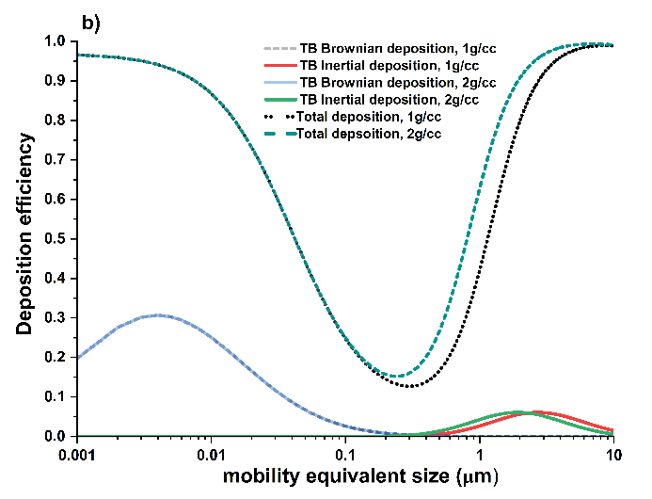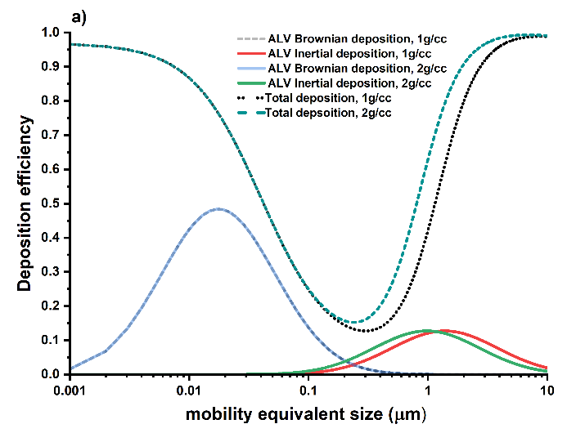

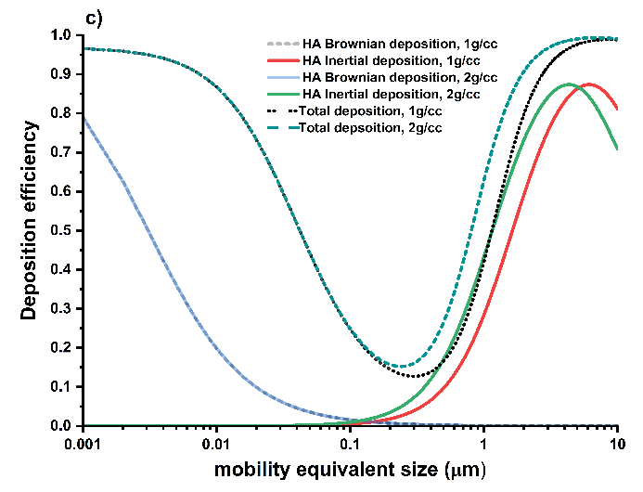

**Supplementary Figure S2.** Exemplary particle deposition in the human respiratory tract as the function of particle aerodynamic diameter with nose breathing for a healthy male individual in resting position according to ICRP model (1994) as described by Hinds (1999) for (a) alveolar region (ALV), (b) tracheo-bronchial region (TB), and (c) head airways (HA) for two different effective densities of depositing particle. The figures illustrate how the inertial deposition fractions shift towards the left with higher particle density, suggesting more inertial deposition for smaller particles.

**Supplementary Figure S3**. Mobility size-resolved particle number distributions (a-d) and geometric mean mobility diameters (GMD) (e) of fresh (a) without and (b) with ESP, (c) short aged, and (d) medium aged particles measured by SMPS over the whole experiment duration, averaged over the experiments (n=3 for each). The error bars in (e) denote the standard deviation of the three experiments. Vertical lines represent the addition of a new batch.

**Supplementary Figure S4.** Mobility size-resolved particle number distributions converted from aerodynamic size distributions measured by ELPI using the densities resolved by APM-SMPS measurements, for (a) fresh exhaust, (b) fresh with ESP on, (c) short aged, and (d) medium aged emission over the whole experiment duration and averaged over all experiments days (n=3 for each). Vertical lines represent the addition of a new batch.



**Supplementary Figure S5.** Effective densities and mobility exponents of RWC emitted particles during different combustion phases for (a) fresh emission, (b) fresh emission in presence of ESP, and (c) short and (d) medium aged conditions.

**Supplementary Figure S6.** Scanning electron microscopy images of the RWC emitted particles from different combustion phases for fresh emission, fresh emission in presence of ESP, and short and medium aged conditions.

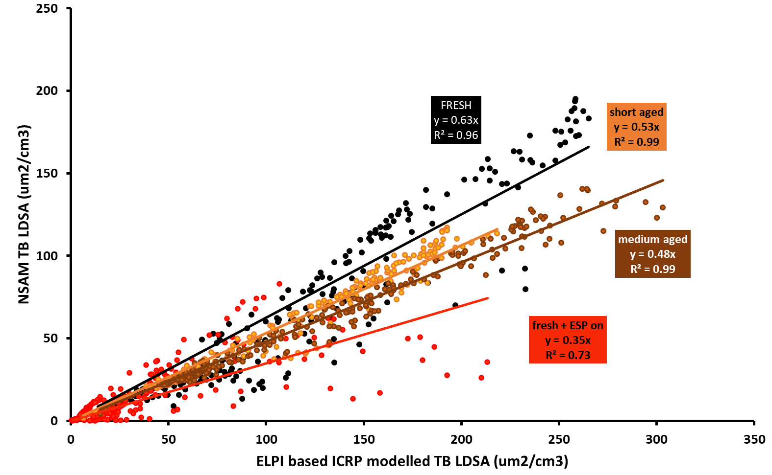

**Supplementary Figure S7.** Correlation between the tracheo-bronchial (TB) LDSA concentrations in the diluted exhaust measured by NSAM to those calculated with ELPI-ICRP method.

**Supplementary Figure S8.** Size-resolved, dilution corrected total LDSA concentrations for (a) fresh, (b) fresh with ESP on, (c) short aged and (d) medium-aged exhaust emissions estimated by ELPI-ICRP method. The vertical white lines denote the addition of new batch of logwood.

**

**Supplementary Figure S9**. Temporal trends and overall correlations of eBC and NSAM-measured tracheo-bronchial (TB) LDSA EFs for (a-b) fresh, (c-d) fresh with ESP on, (e-f) short aged, and (g-h) medium aged emissions for different combustion phases.



**Supplementary Figure S10.** Temporal trends of experiment-wise averaged eBC and total LDSA emission factors for (a) fresh, (b) fresh with ESP on, (c) short aged, and (d) medium aged particles. The shaded area denotes the standard deviation over the experiments (n=3 for each case).

**Supplementary Figure S11**. Overall correlations between eBC and ELPI-ICRP method based total LDSA emission factors of fresh, fresh with ESP on, short aged, and medium aged emissions, for all combustion phases and all replicates (n=3)



**Supplementary Figure S12**. Correlations between eBC and ELPI-ICRP method based total LDSA emission factors for (a) fresh, (b) fresh with ESP on, (c) short aged, and (d) medium aged emissions from the different combustion phases.

**

**Supplementary Figure S13**. Average temporal trends of mass-normalized eBC-fraction and average total LDSA concentrations per PM0.9 mass for (a) fresh, (b) fresh with ESP on, (c) short aged, and (d) medium aged particles. The shaded areas denote the standard deviation over all experiment days (n=3 for each case).

**Supplementary Figure S14.** Exemplary timeseries for (a) time-resolved particle size distributions, measured by an SMPS, (b) time-resolved particle size distributions, measured by an ELPI, (c) ESP power and flue gas temperature measured from the stack for the last replicate of ESP-on experiments consisting of six 35 minute long batches. The decrease in ESP power resulted in increase in the sub-50nm particle number concentration for the last batches of combustion.

**Supplementary Table S1.** Fuel analysis results (measured value ± measurement accuracy) of dry beech wood in use for the experiments. Elemental composition is given in dry, ash-free mass basis.

|  |  |  |  |
| --- | --- | --- | --- |
| *Quantity* | *Method* | *Unit* | *Value* |
| Moisture | SFS-EN ISO 18134-2 | wt. % | 5.9±0.5 |
| Net calorific value | SFS-EN ISO 18125 | MJ/kg | 18.42±0.18 |
| Ash (550 °C) | SFS-EN ISO 18122 | wt. % | 0.4±0.2 |
| C | SFS-EN ISO 16948 | wt. % | 49.6±1.0 |
| H | SFS-EN ISO 16948 | wt. % | 6.0±0.3 |
| N | SFS-EN ISO 16948 | wt. % | 0.24±0.10 |
| S | SFS-EN ISO 11885:2009; SFS-EN ISO 16968:2015 | mg/kg | 110±35 |
| Cl | SFS-EN ISO 16994 mod. | wt. % | 0.002±0.00 |
| F | SFS-EN ISO 16994 mod. | wt. % | <0.001 |
| Br | SFS-EN ISO 16994 mod. | wt. % | <0.001 |
| Ca | SFS-EN ISO 11885:2009; SFS-EN ISO 16968:2015 | mg/kg | 1000±100 |
| Mg | SFS-EN ISO 11885:2009; SFS-EN ISO 16968:2015 | mg/kg | 300±59 |
| Na | SFS-EN ISO 11885:2009; SFS-EN ISO 16968:2015 | mg/kg | <50 |
| K | SFS-EN ISO 11885:2009; SFS-EN ISO 16968:2015 | mg/kg | 870±120 |
| P | SFS-EN ISO 11885:2009; SFS-EN ISO 16968:2015 | mg/kg | 60±10 |
| Fe | SFS-EN ISO 11885:2009; SFS-EN ISO 16968:2015 | mg/kg | <30 |
| Al | SFS-EN ISO 11885:2009; SFS-EN ISO 16968:2015 | mg/kg | <100 |
| Si | SFS-EN ISO 11885:2009; SFS-EN ISO 16968:2015 | mg/kg | 560±280 |
| Ti | SFS-EN ISO 11885:2009; SFS-EN ISO 16968:2015 | mg/kg | <50 |
| Mn | SFS-EN ISO 11885:2009; SFS-EN ISO 16968:2015 | mg/kg | <2 |
| Ba | SFS-EN ISO 11885:2009; SFS-EN ISO 16968:2015 | mg/kg | <2 |
| Zn | SFS-EN ISO 11885:2009; SFS-EN ISO 16968:2015 | mg/kg | <2 |
| Cu | SFS-EN ISO 11885:2009; SFS-EN ISO 16968:2015 | mg/kg | <2 |
| V | SFS-EN ISO 11885:2009; SFS-EN ISO 16968:2015 | mg/kg | <2 |
| Pb | SFS-EN ISO 11885:2009; SFS-EN ISO 16968:2015 | mg/kg | <2 |
| Cr | SFS-EN ISO 11885:2009; SFS-EN ISO 16968:2015 | mg/kg | <2 |
| Ni | SFS-EN ISO 11885:2009; SFS-EN ISO 16968:2015 | mg/kg | <1 |

**Supplementary Table S2.** Components measured by the FTIR and the grouping applied for the gaseous organic compounds the instrument was calibrated towards.

|  |  |  |  |  |
| --- | --- | --- | --- | --- |
| ***Component*** | ***Formula*** | ***Calibration range*** | ***Unit*** | ***VOC group*** |
| Water vapor | H2O | 20 | % |  |
| Carbon dioxide | CO2 | 25 | % |  |
| Carbon monoxide | CO | 5000 | ppm |  |
|  | CO | 10000 | ppm |  |
| Nitrous oxide | N2O | 200 | ppm |  |
| Nitrogen monoxide | NO | 1000 | ppm |  |
| Nitrogen dioxide | NO2 | 200 | ppm |  |
| Sulfur dioxide | SO2 | 1000 | ppm |  |
| Carbonyl sulfide | COS | 100 | ppm |  |
| Ammonia | NH3 | 500 | ppm |  |
| Hydrogen chloride | HCl | 200 | ppm |  |
| Hydrogen cyanide | HCN | 100 | ppm |  |
| Hydrogen fluoride | HF | 100 | ppm |  |
| Oxygen | O2 | 25 | % |  |
| Methane | CH4 | 1000 | ppm | Methane |
| Ethane | C2H6 | 100 | ppm | Aliphatic hydrocarbon |
| Propane | C3H8 | 100 | ppm | Aliphatic hydrocarbon |
| Butane | C4H10 | 100 | ppm | Aliphatic hydrocarbon |
| Pentane | C5H12 | 100 | ppm | Aliphatic hydrocarbon |
| Hexane | C6H14 | 100 | ppm | Aliphatic hydrocarbon |
| Heptane | C7H16 | 100 | ppm | Aliphatic hydrocarbon |
| Octane | C8H18 | 100 | ppm | Aliphatic hydrocarbon |
| Acetylene | C2H2 | 500 | ppm | Aliphatic hydrocarbon |
| Ethylene | C2H4 | 500 | ppm | Aliphatic hydrocarbon |
| Propene | C3H6 | 500 | ppm | Aliphatic hydrocarbon |
| 1,3-Butadiene | C4H6 | 500 | ppm | Aliphatic hydrocarbon |
| Benzene | C6H6 | 500 | ppm | Aromatic |
| Toluene | C7H8 | 100 | ppm | Aromatic |
| m-Xylene | C8H10 | 100 | ppm | Aromatic |
| o-Xylene | C8H10 | 200 | ppm | Aromatic |
| p-Xylene | C8H10 | 100 | ppm | Aromatic |
| 1,2,3-Trimethylbenzene | C9H12 | 100 | ppm | Aromatic |
| 1,2,4-Trimethylbenzene | C9H12 | 100 | ppm | Aromatic |
| 1,35-Trimethylbenzene | C9H12 | 100 | ppm | Aromatic |
| Phenol | C6H6O | 200 | ppm | Aromatic |
| Furan | C4H4O | 200 | ppm | Aromatic |
| Furfural | C5H4O2 | 200 | ppm | Aromatic |
| Formic acid | CH2O | 100 | ppm | Non-aromatic oxygenated |
| Acetic acid | C2H4O2 | 200 | ppm | Non-aromatic oxygenated |
| Formaldehyde | CHOH | 500 | ppm | Non-aromatic oxygenated |
| Acetaldehyde | C2H4O | 100 | ppm | Non-aromatic oxygenated |
| Methanol | CH4O | 200 | ppm | Non-aromatic oxygenated |
| Ethanol | C2H6O | 200 | ppm | Non-aromatic oxygenated |
| Propanol | C3H8O | 100 | ppm | Non-aromatic oxygenated |
| Methyl tert-butyl ether (MTBE) | C5H12O | 100 | ppm | Non-aromatic oxygenated |

**Supplementary Table S3.** Sampling times to the stabilizing chamber for the APM-SMPS measurements.

|  |  |  |  |  |
| --- | --- | --- | --- | --- |
| ***Emission type*** | ***Combustion phase*** | ***Exp. no.*** | ***Batch no.*** | ***Sampling interval (min from start of the batch)*** |
| fresh | cold ignition | 1 | 1 | 2-12 |
| fresh | flaming | 1 | 4 | 17-23 |
| fresh | flaming | 1 | 5 | 15-25 |
| fresh | residual char burning | 1 | 6 | 30-38 |
| fresh | cold ignition | 2 | 1 | 4-10 |
| fresh | flaming | 2 | 3 | 16-25 |
| fresh | early flaming | 2 | 5 | 10-16 |
| fresh | residual char burning | 2 | 6 | 40-48 |
|  |  |  |  |  |
| fresh+ESP | cold ignition | 1 | 1 | 2-8 |
| fresh+ESP | residual char burning | 1 | 2 | 26-33 |
| fresh+ESP | flaming | 1 | 5 | 14-23 |
| fresh+ESP | cold ignition | 2 | 1 | 2-8 |
| fresh+ESP | flaming | 2 | 2 | 4-12 |
| fresh+ESP | flaming | 2 | 3 | 3-11 |
| fresh+ESP | residual char burning | 2 | 6 | 30-37 |
|  |  |  |  |  |
| short aged | cold ignition | 1 | 1 | 4-12 |
| short aged | flaming | 1 | 2 | 17-23 |
| short aged | flaming | 1 | 4 | 11-18 |
| short aged | residual char burning | 1 | 6 | 34-41 |
| short aged | flaming | 2 | 2 | 16-23 |
| short aged | flaming | 2 | 5 | 3-8 |
| short aged | residual char burning | 2 | 6 | 33-39 |
|  |  |  |  |  |
| long aged | cold ignition | 1 | 1 | 4-10 |
| long aged | flaming | 1 | 2 | 10-16 |
| long aged | flaming | 1 | 4 | 15-21 |
| long aged | residual char burning | 1 | 6 | 51-59 |
| long aged | cold ignition | 2 | 1 | 2-8 |
| long aged | flaming | 2 | 3 | 12-19 |
| long aged | flaming | 2 | 4 | 21-28 |
| long aged | warm ignition | 2 | 6 | 2-7 |
| long aged | residual char burning | 2 | 6 | 35-42 |

**References:**

DeCarlo, P. F., Slowik, J. G., Worsnop, D. R., Davidovits, P., & Jimenez, J. L. (2004). Particle Morphology and Density Characterization by Combined Mobility and Aerodynamic Diameter Measurements. Part 1: Theory. *Aerosol Science and Technology*, *38*(12), 1185–1205. <https://doi.org/10.1080/027868290903907>

Hartikainen, A., Tiitta, P., Ihalainen, M., Yli-Pirilä, P., Orasche, J., Czech, H., Kortelainen, M., Lamberg, H., Suhonen, H., Koponen, H., Hao, L., Zimmermann, R., Jokiniemi, J., Tissari, J., & Sippula, O. (2020). Photochemical transformation of residential wood combustion emissions: Dependence of organic aerosol composition on OH exposure. *Atmospheric Chemistry and Physics*, *20*(11), 6357–6378. <https://doi.org/10.5194/acp-20-6357-2020>

Hinds, W. C. (1999). Aerosol technology, properties, behaviour, and measurement of airborne particles. New York: John Wiley & Sons Inc.

ICRP. (1994). Human respiratory tract model for radiological protection. *ICRP Publication 66. Ann. ICRP, 24* (1-3).

Leskinen, J., Hartikainen, A., Väätäinen, S., Ihalainen, M., Virkkula, A., Mesceriakovas, A., Tiitta, P., Miettinen, M., Lamberg, H., Czech, H., Yli-Pirilä, P., Tissari, J., Jakobi, G., Zimmermann, R., & Sippula, O. (2023). Photochemical Aging Induces Changes in the Effective Densities, Morphologies, and Optical Properties of Combustion Aerosol Particles. *Environmental Science and Technology*, *57*(13), 5137–5148. <https://doi.org/10.1021/acs.est.2c04151>

Leskinen, J., Ihalainen, M., Torvela, T., Kortelainen, M., Lamberg, H., Tiitta, P., Jakobi, G., Grigonyte, J., Joutsensaari, J., Sippula, O., Tissari, J., Virtanen, A., Zimmermann, R., & Jokiniemi, J. (2014). Effective density and morphology of particles emitted from small-scale combustion of various wood fuels. *Environmental Science and Technology*, *48*(22), 13298–13306. <https://doi.org/10.1021/es502214a>

McMurry, P. H., Wang, X., Park, K., & Ehara, K. (2002). The Relationship between Mass and Mobility for Atmospheric Particles: A New Technique for Measuring Particle Density. *Aerosol Science and Technology*, *36*(2), 227–238. <https://doi.org/10.1080/027868202753504083>

Park, K., Kittelson, D. B., Zachariah, M. R., & McMurry, P. H. (2004). Measurement of Inherent Material Density of Nanoparticle Agglomerates. *Journal of Nanoparticle Research*, *6*(2/3), 267–272. <https://doi.org/10.1023/B:NANO.0000034657.71309.e6>

Peng, Z., & Jimenez, J. L. (2017). Modeling of the chemistry in oxidation flow reactors with high initial NO. *Atmospheric Chemistry and Physics*, *17*(19), 11991–12010. <https://doi.org/10.5194/acp-17-11991-2017>