Supplementary Materials for

**Toxicological effects of long-term continuous exposure to ambient air on human bronchial epithelial Calu-3 cells exposed at the air-liquid interface**

Elias J. Zimmermann1,2, Anusmita Das1,2, Anja Huber1,2, Nadine Gawlitta1, Evelyn Kuhn1, Christoph Schlager3, Bastian Gutmann3, Tobias Krebs3, Jürgen Schnelle-Kreis1, Mathilde N. Delaval1*, Ralf Zimmermann1,2

* corresponding author.

[mathilde.delaval@helmholtz-munich.de](mailto:mathilde.delaval@helmholtz-munich.de)

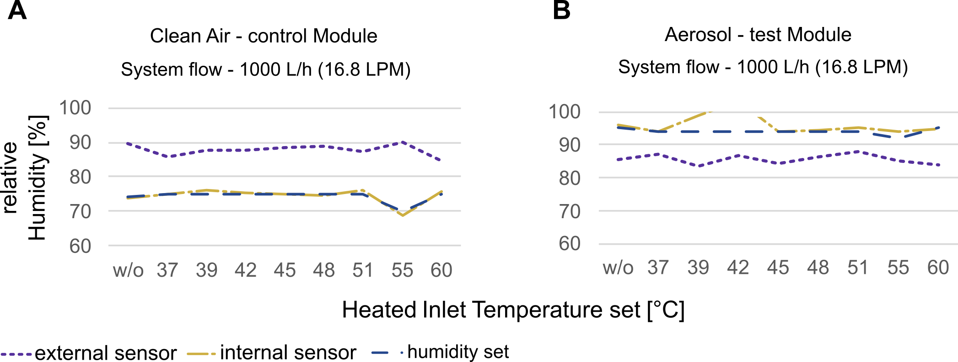**Figure S1.** Evaluation of internal sensor accuracy with external (module) sensor following different heated inlet temperatures. Each temperature was evaluated after 30 min of adaptation to the new setting**.** (A) Clean air control module (B) Aerosol test module.

**Figure S2. Air quality measurements at Munich Stachus** (distance to experimental site approx. 6km). Data derived from the Bavarian state office for environment. Data are shown as average per hour. CO: Carbon monoxide, NO: Nitrogen monoxide, NO2: Nitrogen dioxide, O3: Ozone, PM2.5: Particulate matter ≤ 2.5 µm

**Figure S3. Thermal desorption–comprehensive two-dimensional gas chromatography–time-of-flight mass spectrometry analysis of thermal desorbable organic chemical loading of the particles on quartz fiber filters.**

**Figure S4. Biological comparison of the incubator controls and clean air controls.** (A) Cytotoxicity measured by LDH release. (B) Transepithelial electrical resistance measurements. (C) Metabolic activity measurement by resazurin assay. (D) MDA release as oxidative stress indicator. (E, F) IL6 and IL8 release as indicators for proinflammatory response. Data is shown as mean ± SD in bars, and n ≥ 3 for A, B, D, E, F, n ≥.2 in C. Each biological replicate (one insert) is indicated with an dots. MDA: Malondialdehyde; Inc: Incubator control; CA: Clean air control. WE: Weekend; WW: Work week; WWH: Work week with one holiday. Statistical tests were performed when n ≥ 3. *** p ≤ 0.001).

**Figure S5. Representative pictures of the immunostaining of Calu-3 bronchial epithelial cells after exposure.** Tight junctions were stained with 2.5 µg mL-1 AlexaFluor 647 conjugated ZO-1 antibody (red), and the nuclei with DAPI (1 µg mL-1) nuclei stain (blue). Scalebar: 200 µm. Inc: Incubator control; CA: Clean air control; AA: Ambient Air exposed cells.

**Table S1. Flow settings of inlet system.** Helium was used as carrier gas.

|  |  |  |
| --- | --- | --- |
| **Column flow**  [mL min-1] | **Split flow**  [mL min-1] | **t**  [s] |
| 1.0 | 100 | 90 |
| 2.6 | 0 | 910 |
| 1.0 | 100 | until end of analysis |

**Table S2. Temperature settings of inlet system.**

|  |  |  |
| --- | --- | --- |
| **T rate**  [°C s-1] | **T**  [°C] | **t**  [s] |
| - | 40 | 100 |
| 2 | 300 | 1600 |
| - | 280 | until end of analysis |

**Table S3. Column setup of GC×GC-analysis.** Columns were purchased from SGE, Australia.

|  |  |  |  |  |
| --- | --- | --- | --- | --- |
| **Location** | **Phase** | **Length**  [m] | **Inner Diameter**  [mm] | **Film Thickness**  [µm] |
| Pre-column | BPX5 | 1.3 | 0.25 | 0.25 |
| 1st dimension Oven | BPX5 | 60 | 0.25 | 0.25 |
| 2nd dimension Oven | BPX50 | 1.5 | 0.1 | 0.1 |

**Table S4. GC oven temperature profile of GC×GC analysis of PM samples.** The secondary oven was used with a temperature offset of 5 °C relative to the GC oven temperature. The modulator temperature offset was 15 °C relative to the secondary oven temperature. The modulation time was set to 5 s. Hot pulse time was 1.5 s. Cool time between stages 1.0 s.

|  |  |  |
| --- | --- | --- |
| **T rate**  [°C min-1] | **T**  [°C] | **Hold time**  [min] |
| - | 50 | 5 |
| 5 | 150 | - |
| 3 | 340 | 15 |

**Table S5. Classification settings.** Retention time range and mass spectral filter for each class are summarized in the table below.

|  |  |  |  |
| --- | --- | --- | --- |
| **Class** | **Retention time 1**  [s] | **Retention time 2**  [s] | **Most prominent m/z** |
| 4-Ring PAHs | 4200-4600 | 4.0-5.2 | 228, 114; 226 |
| Alk 4-Ring PAHs | 4000-4700 | 3.6-5.0 | 242, 121 |
| 5-& 6-Ring PAHs | 4800-5100;  4700-5500;  5300-5600 | 4.7-6.0;  4.6-6.5;  1.5-3.0 | 252; 276; 278; |
| Alk 5-Ring PAHs | 4700-5300 | 4.4-6.0 | 266, 133 |
| Oxy-PAHs | 4100-4700;  4800-5100 | 4.2-5.4;  4.8-5.4 | 268, 134 |
| Hopanes | 4800-5700 | 3.2-5.2 | 191, 95 |

**Table S6. Genes assessed by qPCR with corresponding name and Taqman Assay product number.**

|  |  |  |
| --- | --- | --- |
| Gene | Name | Taqman Assay –  product number |
| *CXCL8* | Interleukin 8 | Hs00174103_m1 |
| *IL6* | Interleukin 6 | [Hs00174131_m1](https://www.thermofisher.com/taqman-gene-expression/product/Hs00174131_m1?CID=&ICID=&subtype=) |
| *IL1B* | Interleukin 1 beta | Hs01555410_m1 |
| *TLR2* | Toll like receptor 2 | [Hs02621280_s1](https://www.thermofisher.com/taqman-gene-expression/product/Hs02621280_s1?CID=&ICID=&subtype=) |
| *HMOX1* | Heme oxygenase 1 | [Hs01110250_m1](https://www.thermofisher.com/taqman-gene-expression/product/Hs01110250_m1?CID=&ICID=&subtype=) |
| *CYP1A1* | Cytochrome P450 family 1 subfamily A member 1 | Hs01054796_g1 |
| *CYP1B1* | Cytochrome P450 family 1 subfamily B member 1 | Hs00164383_m1 |
| *CYP2C9* | Cytochrome P450 family 2 subfamily C member 9 | Hs02383631_s1 |
| *GAPDH* | Glyceraldehyde 3-phophate dehydrogenase | Hs2758991_g1 |
| *RPL13A* | Ribosomal protein L13a | Hs04194366_g1 |

**Table S7. Gene expression in fold change following ambient air exposure compared to clean air exposed cells.** SD: Standard deviation, SE: Standard error, CI: Confidence interval

|  |  |  |  |  |  |  |
| --- | --- | --- | --- | --- | --- | --- |
| **Genes** | **Experiment** | **n** | **Fold change** | **SD** | **SE** | **CI** |
|
| *CXCL2* | WE | 2 | -1.199055824 | 0.0596926 | 0.042209 | 0.5363164 |
| WW | 2 | -1.211342403 | 0.1866698 | 0.1319955 | 1.6771613 |
| WWH | 4 | -0.627171837 | 1.2092339 | 0.6046169 | 1.9241609 |
| *CXCL8* | WE | 2 | -0.135373823 | 1.7145175 | 1.2123469 | 15.404328 |
| WW | 2 | -1.049442556 | 0.0224119 | 0.0158476 | 0.2013625 |
| WWH | 4 | 0.146766657 | 1.3984836 | 0.6992418 | 2.2252995 |
| *CYP1A1* | WE | 2 | 1.532080732 | 0.2014538 | 0.1424493 | 1.8099905 |
| WW | 2 | 1.190804182 | 0.0641384 | 0.0453527 | 0.5762604 |
| WWH | 4 | 0.439958442 | 1.9936858 | 0.9968429 | 3.172399 |
| *CYP1B1* | WE | 2 | 1.463899797 | 0.1250804 | 0.0884452 | 1.1238029 |
| WW | 2 | 1.38760005 | 0.2134097 | 0.1509034 | 1.9174099 |
| WWH | 4 | -0.557576358 | 1.3589814 | 0.6794907 | 2.1624426 |
| *CYP2C9* | WE | 2 | -0.034294872 | 1.8736343 | 1.3248595 | 16.833936 |
| WW | 2 | 0.019207989 | 1.870292 | 1.3224962 | 16.803907 |
| WWH | 4 | 0.791178836 | 1.2223872 | 0.6111936 | 1.9450908 |
| *HMOX1* | WE | 2 | -1.245597833 | 0.1783799 | 0.1261336 | 1.6026794 |
| WW | 2 | -0.060927298 | 1.5820723 | 1.118694 | 14.214355 |
| WWH | 4 | -0.030811841 | 1.8190016 | 0.9095008 | 2.8944375 |
| *IL1B* | WE | 2 | 1.47226739 | 0.1757545 | 0.1242772 | 1.5790919 |
| WW | 2 | 1.460980829 | 0.2891501 | 0.20446 | 2.5979105 |
| WWH | 4 | 1.780174236 | 0.5779757 | 0.2889878 | 0.9196883 |
| *IL6* | WE | 2 | -1.382630218 | 0.3337953 | 0.2360289 | 2.9990317 |
| WW | 2 | -1.490825736 | 0.3278332 | 0.2318131 | 2.9454645 |
| WWH | 4 | -0.358166432 | 2.6021808 | 1.3010904 | 4.1406504 |
| *PELI2* | WE | 2 | -0.001163761 | 1.6063345 | 1.13585 | 14.432343 |
| WW | 2 | -1.160637756 | 0.0038991 | 0.0027571 | 0.0350322 |
| WWH | 4 | -0.746952005 | 1.2927874 | 0.6463937 | 2.0571132 |
| *TLR2* | WE | 2 | 0.927162743 | 2.8927269 | 2.0454668 | 25.99012 |
| WW | 2 | 0.001910911 | 1.4739326 | 1.0422278 | 13.242759 |
| WWH | 4 | -0.439355985 | 1.426048 | 0.713024 | 2.2691606 |
| *UGT2B7* | WE | 2 | 0.690056903 | 2.4870997 | 1.7586451 | 22.345704 |
| WW | 2 | 1.405317161 | 0.1050716 | 0.0742969 | 0.944031 |
| WWH | 4 | 1.156693056 | 0.1394541 | 0.0697271 | 0.2219026 |