**Appendix S1**

**Online Repository**

**Predicting persistence of atopic dermatitis in children using clinical attributes and serum proteins**

**Short title**: Predicting atopic dermatitis persistence in infants

1Felix Lauffer*, MD, PhD, 1Veronika Baghin*, 2Marie Standl, PhD, 3Sebastian P Stark, PhD, 1Manja Jargosch, PhD, 4,5Julius Wehrle, MD, 3Jenny Thomas, PhD, 3,6Carsten Schmidt-Weber, PhD, 1Tilo Biedermann, MD, 3Stefanie Eyerich, PhD, 1,7Kilian Eyerich, MD, PhD,1,7Natalie Garzorz-Stark , MD, PhD∇

Affiliations:

1Technical University of Munich, Department of Dermatology and Allergy, Munich, Germany

2Institute of Epidemiology, Helmholtz Zentrum München - German Research Center for Environmental Health, Neuherberg, Germany.

3Center of Allergy and Environment (ZAUM), Technical University of Munich and Helmholtz Zentrum Munich, Munich and Neuherberg, Germany

4Department of Medicine I, Medical Center – University of Freiburg, Freiburg, Germany

5German Cancer Consortium (DKTK), Freiburg, Germany and German Cancer Research Center (DKFZ), Heidelberg, Germany

6Member of the German Center of Lung Research (DZL)

7Division of Dermatology and Venereology, Department of Medicine Solna, and Center for molecular medicine, Karolinska Institutet; Stockholm, Sweden

*=both authors contributed equally

∇=Corresponding author:

Natalie Garzorz-Stark, MD, PhD

Department of Dermatology and Allergy

Biedersteiner Strasse 29

80802 Munich, Germany

**Supplemental information on the LISA Study cohort**

The LISA Study group consists of the following: Helmholtz Center Munich, German Research Center for Environmental Health, Institute of Epidemiology, Munich (Heinrich J, Schnappinger M, Brüske I, Ferland M, Schulz H, Zeller C, Standl M, Thiering E, Tiesler C, Flexeder C); Department of Pediatrics, Municipal Hospital “St. Georg”, Leipzig (Borte M, Diez U, Dorn C, Braun E); Marien Hospital Wesel, Department of Pediatrics, Wesel (von Berg A, Berdel D, Stiers G, Maas B); Pediatric Practice, Bad Honnef (Schaaf B); Helmholtz Center of Environmental Research – UFZ, Department of Environmental Immunology/Core Facility Studies Leipzig (Lehmann I, Bauer M, Röder S, Schilde M, Nowak M, Herberth G , Müller J); Technical University Munich, Department of Pediatrics, Munich (Hoffmann U, Paschke M, Marra S); Clinical Research Group Molecular Dermatology, Department of Dermatology and Allergy, Technische Universität München (TUM), Munich (Ollert M, J. Grosch). The LISA study was mainly supported by grants from the Federal Ministry for Education, Science, Research and Technology, in addition to Helmholtz Center Munich (former GSF), Helmholtz Centre for Environmental Research - UFZ, Leipzig, Research Institute at Marien-Hospital Wesel, Pediatric Practice, and Bad Honnef for the first 2 years. The 4 year, 6 year, 10 year and 15 year follow-up examinations of the LISA study were covered from the respective budgets of the involved partners (Helmholtz Zentrum Munich (former GSF), Helmholtz Centre for Environmental Research - UFZ, Leipzig, Research Institute at Marien-Hospital Wesel, Pediatric Practice, Bad Honnef, IUF – Leibniz-Research Institute for Environmental Medicine at the University of Düsseldorf) and in addition by a grant from the Federal Ministry for Environment (IUF Düsseldorf, FKZ 20462296). Further, the 15-year follow-up examination of the LISA study was supported by the Commission of the European Communities, the 7th Framework Program: MeDALL Project.

Details on the cohorts’ recruitment and follow-up strategies have been described previously 1. Briefly, healthy, full-term newborns (n = 3094) were recruited from obstetric clinics in Munich, Wesel, Leipzig, and Bad Honnef, between 1997 and 1999. Information on selected exposures and health outcomes were obtained using questionnaires and medical examinations carried out at various follow-up assessments. The study was approved by the local ethics committees (Bavarian Board of Physicians, University of Leipzig, Board of Physicians of North-Rhine-Westphalia), and written consent was obtained from all participants’ families.

**Supplemental methods**

**IgE analysis in the LISA cohort**

Total IgE and specific IgE levels in sera of LISA participants at age of 2 years were determined by the Pharmacia CAP System (Pharmacia Diagnostics, Freiburg, Germany). Sera were screened for sIgE against seasonal aero- (RX1) allergens by a multiallergen panel. RX1 includes timothy, mugwort, ribwort, glass herb and birch.FX5 includes hen’s egg, milk protein, codfish, soybean, peanut, and wheat; with egg white, peanut and milk protein being tested separately when the food allergen panel exceeded >0.35kU/l. For the feature “Specific IgE ≥ 0.35 kU/l to common pollen and environmental inhalant allergens”, the allergens from panel MX1(= mould fungus), RX1, HX2 (= mites and cockroach) and E1 (=cat dander) were combined. Samples with specific IgE concentrations >0.35 kU/l were regarded as positive.

**Clinical variables used from the LISA cohort**

To compare the results from the study cohort with LISA Munich, following variables were extracted (categorial or continuous): female sex (categorial), family history for allergic diseases (atopic dermatitis of mother and/or father; categorial), exposure to pets (keeping of dogs, cats, hamster, guinea pigs, birds in the first 3 years of children’s life, categorial), siblings (categorial), maternal smoking (smoking in one and/or two and/or three trimesters; categorial) maternal infection (maternal infection during pregnancy; categorial), C-section delivery (categorial), breast feeding (breast feeding for a period of minimum one month between the first 1-6 months, categorial), milk crust (categorial), allergic rhinitis (doctor diagnosed, at age 3-10; categorial), allergic asthma (doctor diagnosed, at age 3-10 years, categorial)

**Clinical questionnaire**

**Patient data:**

first name: _______________

last name: _______________

date of birth: _______________

current age: _______________ (years)

* Female
* Male

**Please mark the correct answer for each question!**

Are other family members affected by following diseases?

|  |  |  |  |
| --- | --- | --- | --- |
|  | **atopic dermatitis** | **allergic rhinoconjuctivitis (ARC)** | **allergic asthma** |
| **mother** | * yes * no | * yes * no | * yes * no |
| **father** | * yes * no | * yes * no | * yes * no |
| **siblings** | * yes * no | * yes * no | * yes * no |

|  |  |
| --- | --- |
| **Active maternal smoking during pregnancy** | * yes * no |
| **Maternal infection during pregnancy** | * yes * no |
| **Pregnancy week at children’s birth (p.m.)** | ______ week (post menstruationem) |
| **Spontaneous vaginal delivery** | * yes * no |
| **Caesarean section** | * yes * no |
| **Birth weight** | __________ (gram) |
| **Maternal breast feeding** | * yes, for: ______ (months) * no |
| **Preventive cream application before onset of atopic dermatitis** | * yes * no |
| **Did your child suffer from milk crust? Was it rather mild or severe?** | * Yes, for: ______ (months) * no * mild * severe |
| **Age of your child at onset of atopic dermatitis** | __________ (months) |

**SCORAD at onset of atopic dermatitis**: ________ if known, otherwise:

Which body parts were affected by atopic dermatitis when the **disease** appeared for the **first time**?

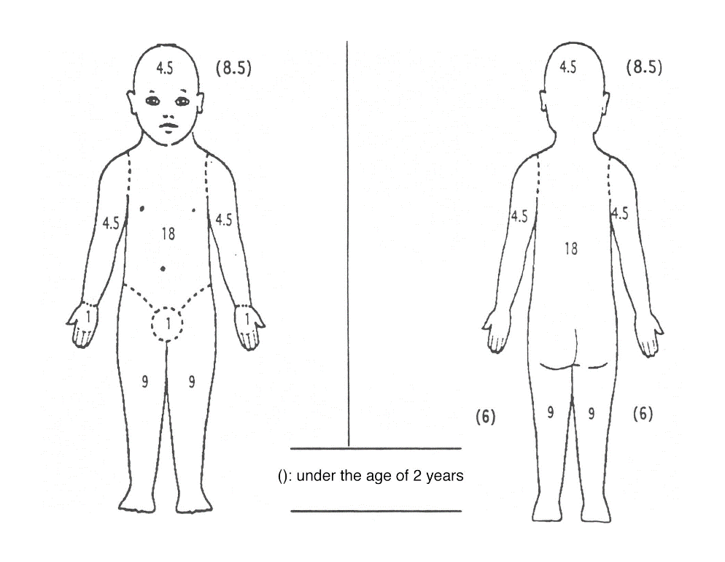

Try to remember a representative area of the dermatitis when the disease appeared for the first time.

Please asses the intensity of each of the following signs in this area.

|  |  |  |  |  |
| --- | --- | --- | --- | --- |
|  | none | mild | moderate | severe |
| redness |  |  |  |  |
| scratch marks |  |  |  |  |
| swelling |  |  |  |  |
| skin thickening |  |  |  |  |
| oozing/crusting |  |  |  |  |
| dryness  (in an area where there is no inflammation) |  |  |  |  |

How intense was the itch when the disease appeared for the first time?

(no itch) 0 -------------------------------------------------------------------- 10 (worst imaginable itch)

How bad was the sleeplessness of your child when the disease appeared for the first time?

(no sleeplessness) 0 ----------------------------------------------------------------- 10 (sleeplessness)

**SCORAD of atopic dermatitis at age 3 years**: ________ if known, otherwise:

Which body parts were affected by atopic dermatitis when your child was **3 years old**?

Ein Bild, das Zeichnung enthält.

Try to remember a representative area of the dermatitis when your child was 3 years old.

Please asses the intensity of each of the following signs in this area.

|  |  |  |  |  |
| --- | --- | --- | --- | --- |
|  | none | mild | moderate | severe |
| redness |  |  |  |  |
| scratch marks |  |  |  |  |
| swelling |  |  |  |  |
| skin thickening |  |  |  |  |
| oozing/crusting |  |  |  |  |
| dryness  (in an area where there is no inflammation) |  |  |  |  |

How intense was the itch caused by the atopic dermatitis when your child was 3 years old?

(no itch) 0 -------------------------------------------------------------------- 10 (worst imaginable itch)

How bad was the sleeplessness caused by the atopic dermatitis when your child was 3 years old?

(no sleeplessness) 0 ----------------------------------------------------------------- 10 (sleeplessness)

**SCORAD of atopic dermatitis at age 7 years**: ________ if known, otherwise:

Which body parts were affected by atopic dermatitis when your child was 7 years old?

Ein Bild, das Zeichnung enthält.

Try to remember a representative area of the dermatitis when your child was 7 years old.

Please asses the intensity of each of the following signs in this area.

|  |  |  |  |  |
| --- | --- | --- | --- | --- |
|  | none | mild | moderate | severe |
| redness |  |  |  |  |
| scratch marks |  |  |  |  |
| swelling |  |  |  |  |
| skin thickening |  |  |  |  |
| oozing/crusting |  |  |  |  |
| dryness  (in an area where there is no inflammation) |  |  |  |  |

How intense was the itch caused by the atopic dermatitis when your child was 7 years old?

(no itch) 0 -------------------------------------------------------------------- 10 (worst imaginable itch)

How bad was the sleeplessness caused by the atopic dermatitis when your child was 7 years old?

(no sleeplessness) 0 ----------------------------------------------------------------- 10 (sleeplessness)

|  |  |
| --- | --- |
| **Did your child have regular contact to pets?** | * yes * no |
| **Does your child have siblings?** | * yes * no   How old are they? ____________ |

Did or do following factors cause acute flares/ exacerbation of the disease?

*If you mark yes please comment at which age of your child the factor caused a worsening of the atopic dermatitis.*

|  |  |
| --- | --- |
| **Stress** | * yes, _____________________ * no |
| **Change in the weather (temperature/humidity)** | * yes, _____________________ * no |
| **Pollen exposure** | * yes, _____________________ * no |
| **Infectious diseases/ sickness** | * yes, _____________________ * no |
| **Vaccination** | * yes, _____________________ * no |

How did you treat the skin lesions of your child?

|  |  |
| --- | --- |
| **Basic therapy** | * never * daily * multiple times a week |
| **Topical corticosteroids** | * never * proactive * if needed |

Does your child have one of the following diseases?

|  |  |
| --- | --- |
| **Allergic rhinoconjunctivits** | * yes (since he/she was ___ years old) * no   Against which allergen(-s) does your child show allergic rhinoconjunctivits?   * Birch * Mixed grass * House dust mite * Cat dander |
| **Allergic asthma** | * yes (since he/she was ___ years old) * no |

|  |  |  |  |  |
| --- | --- | --- | --- | --- |
| **Food allergy** | **allergen** | **onset (months)** | **end (months)** | **still persistent** |
| egg |  |  | * yes * no |
| cow’s milk |  |  | * yes * no |
| nuts |  |  | * yes * no |

Summary disease course:

Does your child still suffer from atopic dermatitis?

* yes
* no (since he/she was _____ years old)

Comments:

- Thank you for providing the requested informations-

**Supplemental Figure**

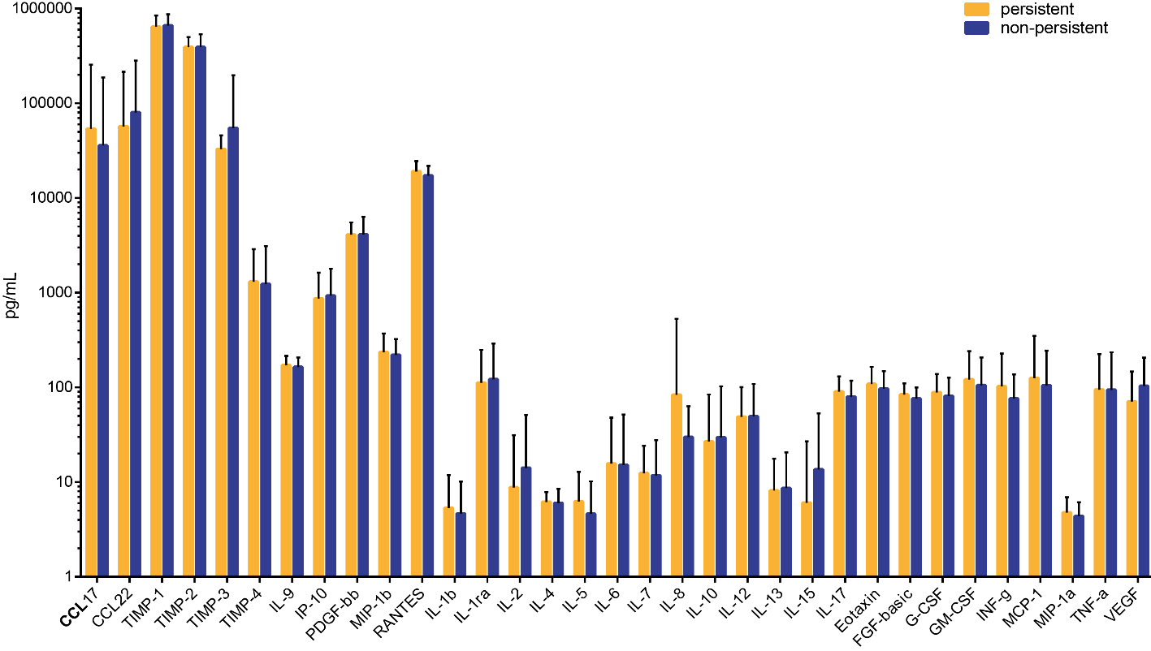

Figure E1: Cytokine levels measured by Luminex between the two groups of patients showing either remission (non-persistent) or no remission (persistent) of disease by the age of seven years.

**Supplemental Tables**



Table E1: Variables assed in the study cohort. Variables are listed according to category (categorial or continuous). All 76 variables used for clustering and prediction model are highlighted in bold, the response variable (persistence of disease) for the prediction model is shown in bold red font.



Table E2: Variables presented for each of the 3 clusters. Categorial variables are shown as percentages, continuous variables as means ± SD or SEM. All significantly different variables between clusters are highlighted in bold. Small numbers in italics behind calculated values indicate clusters that are significantly different (p value ≤ 0.05).

|  |  |  |  |
| --- | --- | --- | --- |
| Training cohort | | | |
| No. Patient | True Class | Predicted class | Probability |
| 1 | 0 | 0 | 0.1550 |
| 2 | 1 | 1 | 0.9731 |
| 3 | 1 | 1 | 0.9297 |
| 4 | 1 | 1 | 0.9116 |
| 5 | 0 | 0 | 0.1750 |
| 6 | 1 | 1 | 0.9657 |
| 7 | 0 | 0 | 0.1778 |
| 8 | 1 | 1 | 0.9647 |
| 9 | 0 | 0 | 0.0297 |
| 10 | 0 | 0 | 0.0763 |
| 11 | 1 | 1 | 0.7495 |
| 12 | 0 | 0 | 0.0166 |
| 13 | 1 | 1 | 0.9224 |
| 14 | 0 | 0 | 0.1042 |
| 15 | 1 | 1 | 0.6722 |
| 16 | 1 | 1 | 0.9773 |
| 17 | 1 | 1 | 0.9654 |
| 18 | 1 | 1 | 0.6185 |
| 19 | 1 | 1 | 0.8274 |
| 20 | 1 | 1 | 0.9449 |
| 21 | 1 | 1 | 0.5854 |
| 22 | 1 | 1 | 0.8932 |
| 23 | 1 | 1 | 0.8642 |
| 24 | 1 | 1 | 0.9838 |
| 25 | 0 | 0 | 0.1913 |
| 26 | 1 | 1 | 0.7104 |
| 27 | 1 | 1 | 0.9524 |
| 28 | 1 | 1 | 0.6173 |
| 29 | 1 | 1 | 0.8471 |
| 30 | 1 | 1 | 0.9619 |
| 31 | 0 | 1 | 0.5413 |
| 32 | 1 | 1 | 0.9426 |
| 33 | 0 | 0 | 0.2992 |
| 34 | 1 | 1 | 0.8598 |
| 35 | 1 | 1 | 0.8939 |
| 36 | 1 | 1 | 0.9825 |
| 37 | 1 | 1 | 0.9401 |
| 38 | 1 | 1 | 0.9920 |
| 39 | 1 | 1 | 0.8281 |
| 40 | 0 | 0 | 0.1922 |
| 41 | 1 | 1 | 0.9759 |
| 42 | 0 | 0 | 0.0081 |
| 43 | 1 | 1 | 0.9798 |
| 44 | 0 | 0 | 0.1338 |
| 45 | 1 | 1 | 0.8904 |
| 46 | 0 | 0 | 0.0759 |
| 47 | 1 | 1 | 0.9448 |
| 48 | 1 | 1 | 0.7953 |
| 49 | 1 | 1 | 0.9296 |
| 50 | 0 | 0 | 0.0178 |
| 51 | 0 | 0 | 0.0265 |
| 52 | 1 | 1 | 0.9666 |
| 53 | 0 | 0 | 0.1090 |
| 54 | 1 | 1 | 0.9795 |
| 55 | 1 | 1 | 0.9300 |
| 56 | 0 | 0 | 0.1599 |
| 57 | 1 | 1 | 0.9273 |
| 58 | 0 | 0 | 0.0963 |
| 59 | 1 | 1 | 0.9349 |
| 60 | 0 | 0 | 0.1495 |
| 61 | 1 | 1 | 0.9242 |
| 62 | 1 | 1 | 0.7571 |
| 63 | 1 | 1 | 0.8779 |
| 64 | 1 | 1 | 0.7973 |
| 65 | 0 | 0 | 0.4475 |
| 66 | 1 | 1 | 0.9348 |
| 67 | 0 | 0 | 0.2381 |
| 68 | 1 | 1 | 0.8904 |
| 69 | 0 | 0 | 0.3516 |
| 70 | 1 | 1 | 0.6059 |
| 71 | 0 | 0 | 0.0476 |
| 72 | 1 | 1 | 0.7422 |
| 73 | 0 | 0 | 0.1943 |
| 74 | 1 | 1 | 0.8411 |
| 75 | 1 | 1 | 0.9221 |
| 76 | 0 | 0 | 0.2532 |
| 77 | 1 | 1 | 0.9557 |
| 78 | 1 | 1 | 0.8864 |
| 79 | 0 | 0 | 0.0108 |
| 80 | 1 | 1 | 0.9517 |
| 81 | 0 | 0 | 0.1744 |
| 82 | 1 | 1 | 0.7493 |
| Test cohort | | | |
| No. Patient | True Class | Predicted class | Probability |
| 1 | 0 | 0 | 0.1617 |
| 2 | 1 | 0 | 0.4654 |
| 3 | 0 | 0 | 0.4264 |
| 4 | 1 | 0 | 0.2977 |
| 5 | 1 | 1 | 0.9659 |
| 6 | 1 | 1 | 0.6400 |
| 7 | 0 | 0 | 0.0204 |
| 8 | 1 | 1 | 0.6483 |
| 9 | 1 | 0 | 0.1716 |
| 10 | 1 | 1 | 0.9179 |
| 11 | 0 | 1 | 0.5291 |
| 12 | 1 | 1 | 0.9490 |
| 13 | 0 | 0 | 0.0195 |
| 14 | 1 | 0 | 0.1328 |
| 15 | 0 | 1 | 0.5915 |
| 16 | 1 | 1 | 0.9876 |
| 17 | 0 | 0 | 0.0763 |
| 18 | 1 | 1 | 0.6182 |
| 19 | 0 | 0 | 0.0424 |
| 20 | 1 | 1 | 0.8399 |
| 21 | 0 | 0 | 0.1774 |
| 22 | 1 | 1 | 0.7964 |
| 23 | 0 | 1 | 0.6325 |
| 24 | 1 | 1 | 0.7854 |
| 25 | 0 | 0 | 0.0689 |
| 26 | 1 | 1 | 0.9186 |
| 27 | 0 | 1 | 0.7455 |
| 28 | 1 | 0 | 0.0223 |
| 29 | 0 | 0 | 0.1297 |
| 30 | 1 | 1 | 0.9821 |
| 31 | 0 | 0 | 0.3363 |
| 32 | 1 | 1 | 0.9411 |
| 33 | 0 | 0 | 0.0346 |
| 34 | 1 | 1 | 0.8208 |
| 35 | 1 | 1 | 0.8828 |
| 36 | 1 | 1 | 0.9787 |
| 37 | 1 | 1 | 0.9890 |
| 38 | 0 | 0 | 0.4303 |
| 39 | 1 | 1 | 0.9555 |
| 40 | 0 | 0 | 0.2086 |
| 41 | 1 | 1 | 0.5426 |
| 42 | 0 | 0 | 0.0773 |
| Training cohort | | | |
| No. Patient | True Class | Predicted class | Probability |
| 1 | 1 | 1 | 0.9516 |
| 2 | 1 | 1 | 0.7676 |
| 3 | 1 | 1 | 0.7100 |
| 4 | 1 | 1 | 0.9767 |
| 5 | 1 | 0 | 0.1018 |
| 6 | 0 | 0 | 0.4122 |
| 7 | 1 | 0 | 0.3753 |
| 8 | 1 | 0 | 0.4787 |
| 9 | 1 | 1 | 0.5632 |
| 10 | 0 | 0 | 0.4491 |
| 11 | 1 | 1 | 0.7579 |
| 12 | 0 | 0 | 0.2124 |
| 13 | 1 | 1 | 0.8472 |
| 14 | 1 | 1 | 0.9216 |
| 15 | 0 | 0 | 0.1900 |
| 16 | 1 | 1 | 0.8097 |
| 17 | 0 | 1 | 0.8762 |
| 18 | 1 | 1 | 0.8857 |
| 19 | 0 | 0 | 0.4661 |
| 20 | 1 | 1 | 0.9075 |

Table E3: Probabilities of patients in training cohort (n=82), test cohort (n=42) and validation cohort (n=19) for persistence of AE at the age of 7 years. 1= persistence, 0=remission.

1. Heinrich J, Bolte G, Holscher B, Douwes J, Lehmann I, Fahlbusch B, et al. Allergens and endotoxin on mothers' mattresses and total immunoglobulin E in cord blood of neonates. Eur Respir J 2002; 20:617-23.