# Supplementary Material

**The chemodiversity of Algal Dissolved Organic Matter from lysed *Microcystis aeruginosa* cells and its ability to from disinfection by-products during chlorination**

Michael Gonsiora*, Leanne C. Powersa, Ernest Williamsb, Allen Placeb, Feng Chenb, Alexander Rufc,d,e, Norbert Hertkornc and Philippe Schmitt-Kopplinc,d

a *University of Maryland Center for Environmental Science, Chesapeake Biological Laboratory, Solomons, USA*

*b**University of Maryland Center for Environmental Science, Institute of Marine and Environmental Technology, Baltimore, USA*

*c**Helmholtz Zentrum Muenchen, Research Unit Analytical BioGeoChemistry, Neuherberg, Germany*

*d**Technische Universität München, Chair of Analytical Food Chemistry, Freising-Weihenstephan, Germany*

*e Université Aix-Marseille, Laboratoire de Physique des Interactions Ioniques et Moléculaires (PIIM), UMR CNRS 7345, 13397 Marseille, France*

Table S1: Molecular formulas of all 41 chlorinated C18 presumed fatty acids.

|  |  |  |  |
| --- | --- | --- | --- |
| **measured *m/z*** | **TIC** | **neutral mass** | **molecular formula** |
| 349.21512 | 21904895 | 350.22239 | C18H35O4Cl1 |
| 351.23078 | 4833754 | 352.23804 | C18H37O4Cl1 |
| 381.20489 | 9402381 | 382.21222 | C18H35O6Cl1 |
| 393.16853 | 27090275 | 394.17583 | C18H31O7Cl1 |
| 367.18124 | 5003631 | 368.18850 | C18H34O3Cl2 |
| 369.19686 | 30384318 | 370.20415 | C18H36O3Cl2 |
| 379.14485 | 20328627 | 380.15212 | C18H30O4Cl2 |
| 383.17612 | 639398656 | 384.18342 | C18H34O4Cl2 |
| 397.15536 | 664969824 | 398.16268 | C18H32O5Cl2 |
| 399.17106 | 72141024 | 400.17833 | C18H34O5Cl2 |
| 401.18668 | 4857404 | 402.19398 | C18H36O5Cl2 |
| 411.13458 | 87690564 | 412.14195 | C18H30O6Cl2 |
| 415.16595 | 246175968 | 416.17325 | C18H34O6Cl2 |
| 429.14519 | 34645780 | 430.15251 | C18H32O7Cl2 |
| 431.16088 | 11335774 | 432.16816 | C18H34O7Cl2 |
| 443.12445 | 9161966 | 444.13178 | C18H30O8Cl2 |
| 401.14221 | 15815448 | 402.14953 | C18H33O3Cl3 |
| 415.12147 | 169154752 | 416.12879 | C18H31O4Cl3 |
| 417.13714 | 29267569 | 418.14444 | C18H33O4Cl3 |
| 419.1528 | 49112082 | 420.16009 | C18H35O4Cl3 |
| 429.10076 | 21421813 | 430.10806 | C18H29O5Cl3 |
| 431.1164 | 58713152 | 432.12371 | C18H31O5Cl3 |
| 433.13207 | 1688373632 | 434.13936 | C18H33O5Cl3 |
| 447.11136 | 196472032 | 448.11862 | C18H31O6Cl3 |
| 449.12697 | 66707936 | 450.13427 | C18H33O6Cl3 |
| 461.09064 | 11757384 | 462.09789 | C18H29O7Cl3 |
| 463.10627 | 21793849 | 464.11354 | C18H31O7Cl3 |
| 465.12194 | 50542892 | 466.12919 | C18H33O7Cl3 |
| 475.06988 | 6723980 | 476.07715 | C18H27O8Cl3 |
| 449.08254 | 11953602 | 450.08982 | C18H30O4Cl4 |
| 451.09814 | 128759488 | 452.10547 | C18H32O4Cl4 |
| 465.07743 | 74053904 | 466.08474 | C18H30O5Cl4 |
| 467.0931 | 45866500 | 468.10039 | C18H32O5Cl4 |
| 469.10887 | 29758198 | 470.11604 | C18H34O5Cl4 |
| 479.05673 | 7378232 | 480.06400 | C18H28O6Cl4 |
| 481.07236 | 19789842 | 482.07965 | C18H30O6Cl4 |
| 483.08798 | 446301408 | 484.09530 | C18H32O6Cl4 |
| 485.05922 | 7700371 | 486.06650 | C18H31O4Cl5 |
| 499.03859 | 4633994 | 500.04577 | C18H29O5Cl5 |
| 501.0541 | 19215851 | 502.06142 | C18H31O5Cl5 |
| 517.04919 | 5004257 | 518.05633 | C18H31O6Cl5 |



Figure S1: Optical properties of ADOM lysate (left panel) and media (right panel) before and after chlorination with 10 mg/L HOCl. (A-B) Absorbance (A) spectra before (black line) and after (blue line) chlorination. (C-D) excitation-emission matrix (EEM) fluorescence spectra before chlorination normalized to the fluorescence of a 1 ppm quinine sulfate standard (Starna). (E-F) EEM spectra after chlorination. (G-F) Integrated fluorescence intenstity (F­int) normalized to A for each excitation wavelength before (black line) and after (blue line) chlorination.

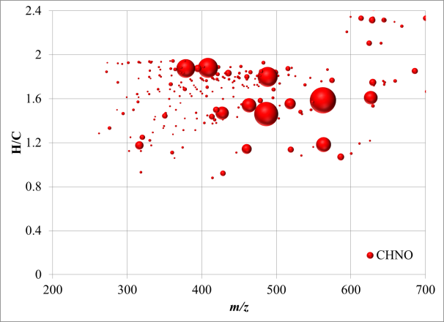 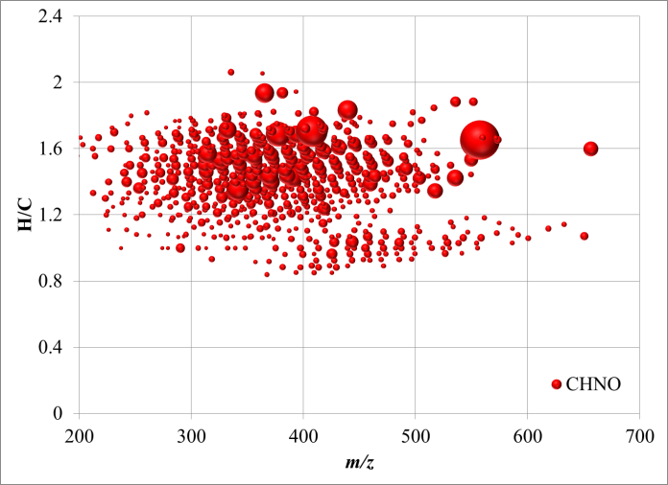

Figures S2: Molecular weight distribution of the CHNO pool before (left) and after chlorination (right)

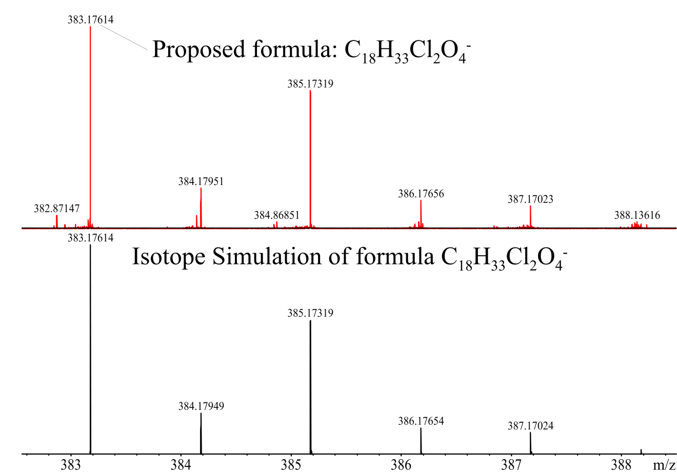

Figure S3: Isotope simulation of the negatively charged ion C18H33Cl2O4- and a very close match between all expected isotopologues. Note; Isotope simulation was generated by Bruker Daltonics software 4.4 and using the measured intensity and assigned formula of the parent *m/z* ion.

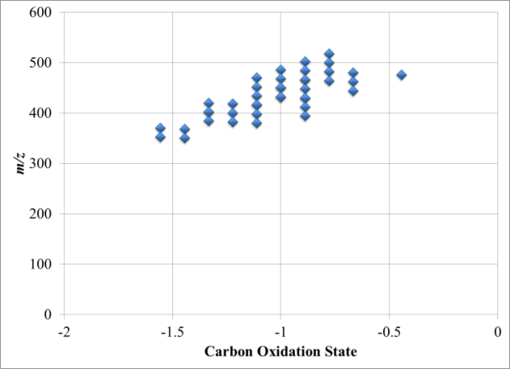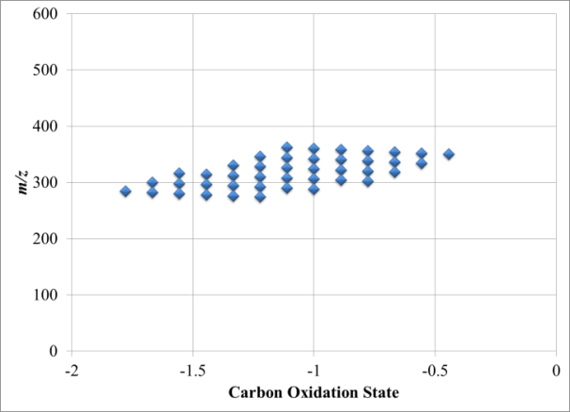

Figure S4: Carbon oxidation state of assigned molecular formulas with 18 carbon before (left) and after (right) chlorination.

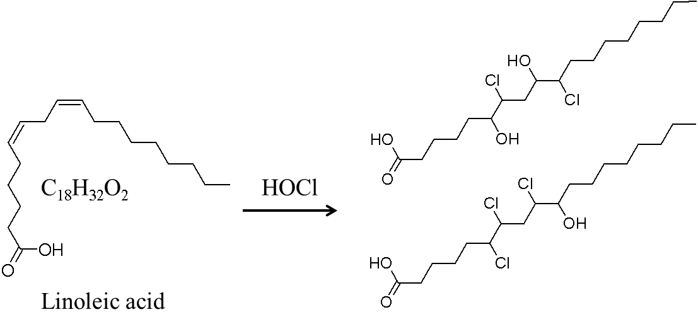

Figure S5: Proposed structures of detected products resulting from the reaction of linoleic acid with HOCl.

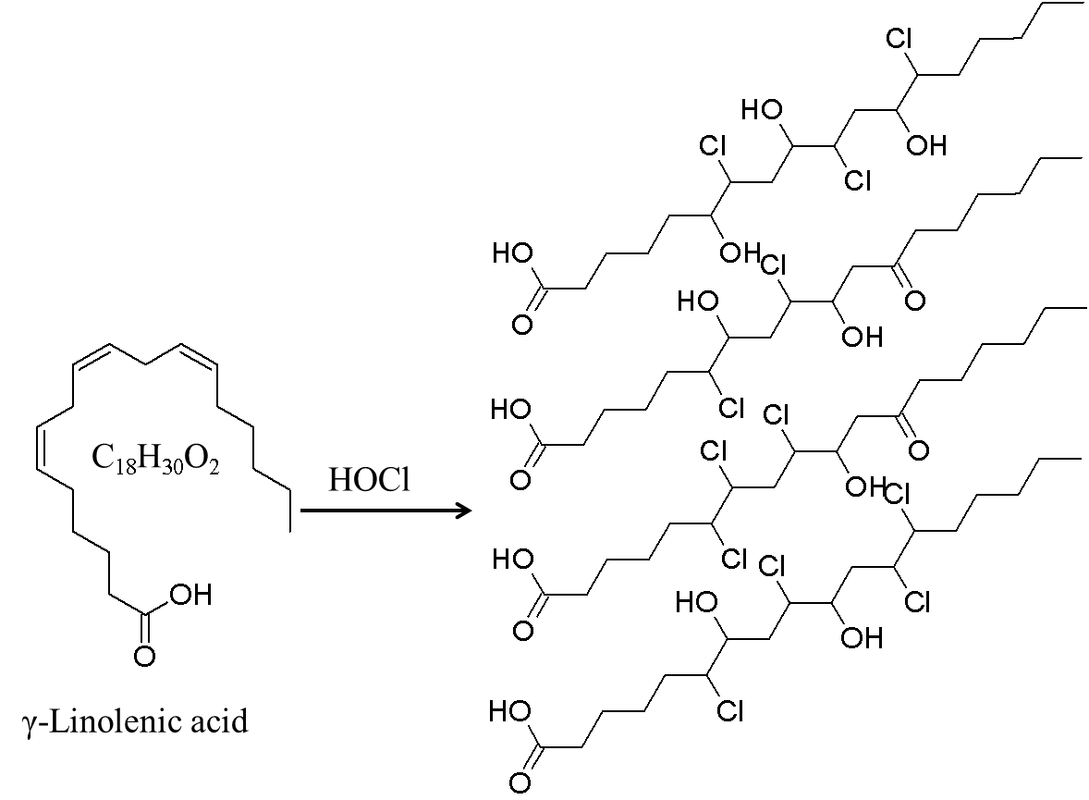

Figure S6: Proposed structures of detected products resulting from the reaction of γ-linolenic acid with HOCl.

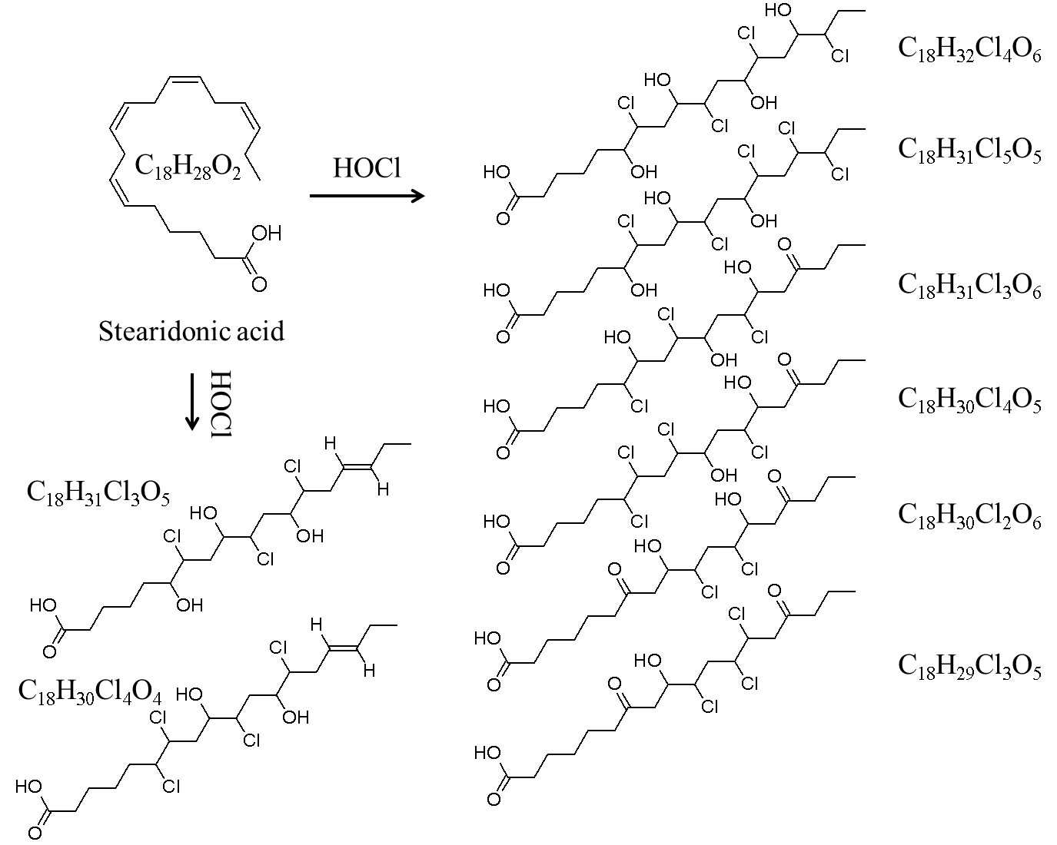

Figure S7 Proposed structures of detected products resulting from the reaction of stearidonic acid with HOCl.

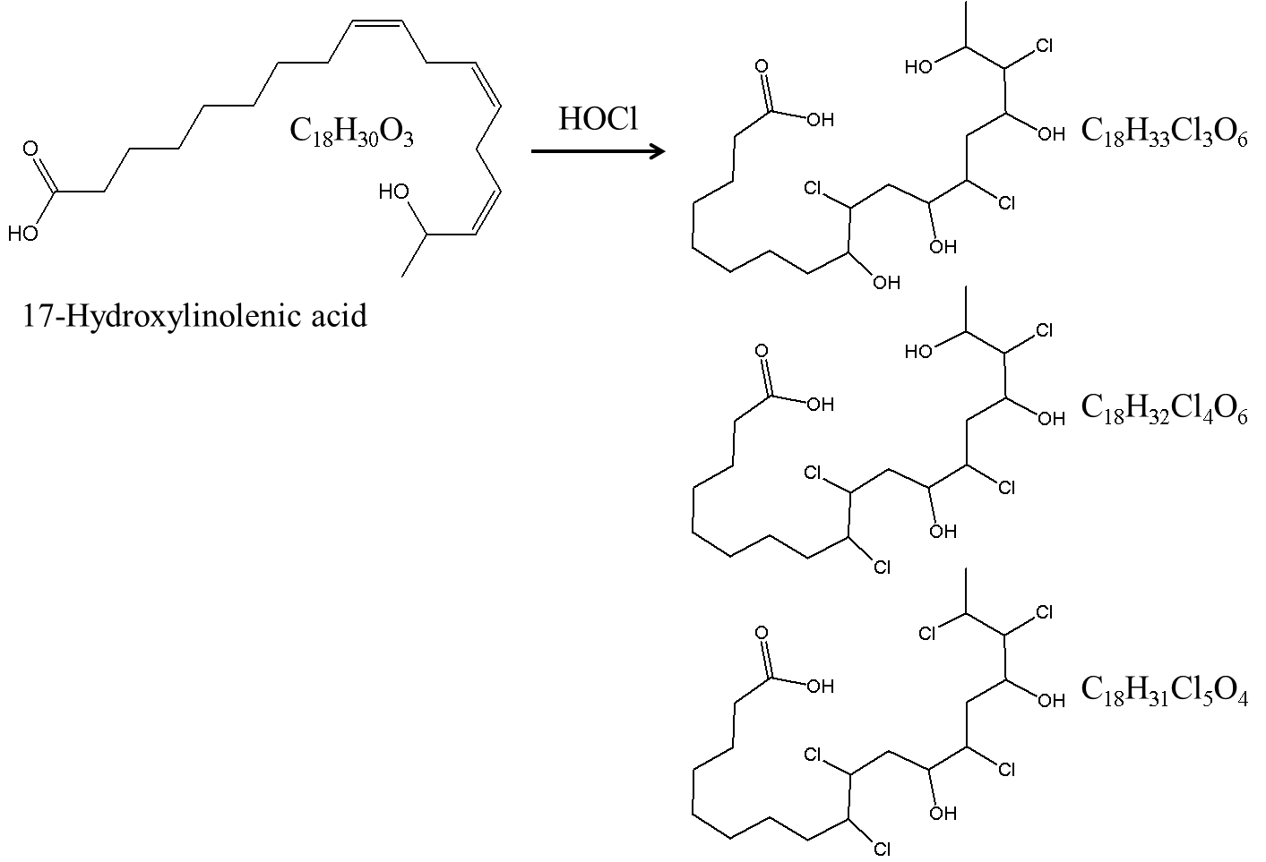

Figure S8: Possible reaction products resulting from the reaction of 17-hydroxylinolenic acid with HOCl.

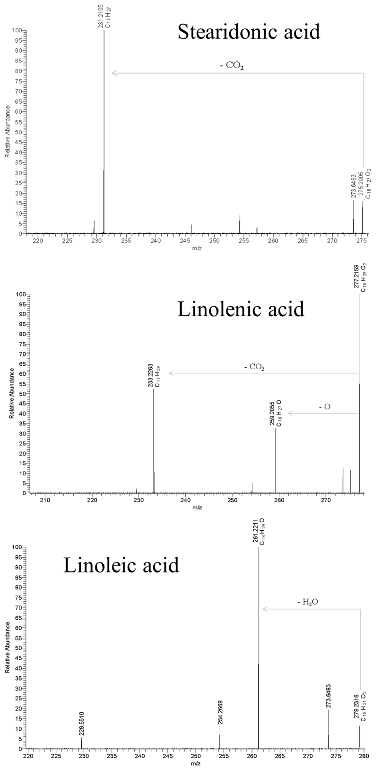

Figure S9: Collision induced dissociation MS-MS spectra of *m/z* 275.2 (stearidonic acid negative ion C18H27O2-), *m/z* 277.2 (linolenic acid negative ion C18H29O2-) and *m/z* 279.2 (linoleic acid negative ion C18H31O2-) at mass resolution 100,000 using direct infusion of ADOM and a Thermo LTQ Orbitrap XL instrument.