**Added sensitivity of component-resolved diagnosis in hymenoptera venom-allergic patients with elevated serum tryptase and/or mastocytosis**

**Short title: Diagnostics of venom-allergic mastocytosis patients**

Jana Michel1, Knut Brockow1, Ulf Darsow1, Johannes Ring1, Carsten B. Schmidt-Weber2, Thomas Grunwald3, Simon Blank2,6*, Markus Ollert 4,5,6*

1Department of Dermatology and Allergy Biederstein, Technische Universität München, Munich, Germany; 2Center of Allergy and Environment (ZAUM), Technical University of Munich and Helmholtz Center Munich, Munich, Germany; 3PLS-Design GmbH Hamburg, Hamburg, Germany; 4Department of Infection and Immunity, Luxembourg Institute of Health (LIH), Esch-sur-Alzette, Luxembourg; 5Department of Dermatology and Allergy Center, Odense Research Center for Anaphylaxis, University of Southern Denmark, Odense, Denmark

5To whom correspondence should be addressed; *S.B. and M.O. contributed equally as senior authors

**Address correspondence to:**

Markus Ollert, M.D.

Department of Infection and Immunity, Luxembourg Institute of Health (LIH)

29, rue Henri Koch, L-4354 Esch-sur-Alzette, Luxembourg

Phone: +352-269-70-829

Fax: +352-269-70-390

Email: markus.ollert@lih.lu

Simon Blank, Ph.D.

Center of Allergy and Environment (ZAUM), Helmholtz Center Munich

Ingolstädter Landstraße 1, D-85764 Munich, Germany

phone: +49-89-318-726-25

fax: +49-89-318-725-40

Email: simon.blank@helmholtz-muenchen.de

**Word count: 3379**

**Figures: 4**

**Tables: 2**

**Suppl. tables: 1**

**References: 40**

**Key words**

Component-resolved diagnosis, diagnostic sensitivity, hymenoptera venom allergy, mastocytosis, serum tryptase

**Abbreviations**

BM, bone marrow

CCD, cross-reactive carbohydrate determinant

CM, cutaneous mastocytosis

CRD, component-resolved diagnosis

HBV, honeybee venom

MIS, mastocytosis in the skin

sBT, baseline serum tryptase

sIgE, specific IgE

SM, systemic mastocytosis

YJV, yellow jacket venom

**Author contributions**

JM: performed the experiments, analyzed the data

KB: coordinated the recruitment of mastocytosis patients, collected and analyzed the data, provided critical revision of the manuscript

UD: coordinated the recruitment of hymenoptera venom-allergic patients, collected and analyzed the data, provided critical revision of the manuscript

JR: coordinated the recruitment of patients, revised the final version of the manuscript

CS-W: contributed to the interpretation of data, revised the final version of the manuscript

TG: produced recombinant allergens, provided critical revision of the manuscript

SB: supervised the study, analyzed the data, designed the figures, wrote the manuscript

MO: initiated and supervised the study, analyzed the data, wrote the manuscript

**Abstract**

**Background:** Anaphylaxis caused by hymenoptera venom allergy is associated with elevation of baseline serum tryptase (sBT) and/or mastocytosis in about 5% of patients. Up to now, no information has become available on single venom allergen sIgE reactivity and the usefulness of component-resolved approaches to diagnose this high risk patient group.To address the component-resolved sIgE sensitization pattern and diagnostic sensitivity in hymenoptera venom-allergic patients with elevated sBT levels and/or mastocytosis a panel of yellow jacket and honeybee venom allergens was applied on a widely used IgE immunoassay platform.

**Methods:** 53 patients with mastocytosis and/or elevated sBT tryptase level and systemic reactions to hymenoptera venoms were analyzed for their IgE reactivity to recombinant yellow jacket and honeybee venom allergens by Immulite3g.

**Results:** sIgE reactivity to Ves v 1, Ves v 5, Api m 1 to Api m 4 and Api m 10 was found at a similar frequency in hymenoptera venom-allergic patients with and without elevated sBT levels and/or mastocytosis. However, the use of the recombinant allergens and a diagnostic cut-off of 0.1 kUA/L allowed the diagnosis of patients with otherwise undetectable IgE to venom extract. The diagnostic sensitivity of yellow jacket venom allergy using the combination of Ves v 1 and Ves v 5 was 100%.

**Conclusions:** In high risk patients with elevated sBT levels and/or mastocytosis the use of molecular components and decreasing the threshold sIgE level to 0.1 kUA/L may be needed to avoid otherwise undetectable IgE to hymenoptera venom extracts in about 8% of such patients.

**Introduction**

Hymenoptera venom allergy is a potentially life-threatening disease mediated by the cross-linking of receptor-bound IgE antibodies on the surface of mast cells and basophils in allergic individuals. In recent large studies on patients with mastocytosis a higher incidence of severe anaphylaxis following hymenoptera stings than in the general population was documented (1-3).

Mastocytosis is a heterogeneous disorder characterized by proliferation and accumulation of mast cells in the skin, bone marrow (BM) and other tissues (4). In recent years, an association of hymenoptera venom allergy, especially of severe allergic sting reactions, with mastocytosis was documented in 1 - 7.9% of patients with hymenoptera venom allergy and mastocytosis (1, 3, 5-10). The most frequent type of sensitization in patients with clonal mast cell disorders is to *Vespidae* (5). In addition, the level of baseline serum tryptase (sBT) in patients with hymenoptera venom is associated with more-severe reactions following hymenoptera stings (1, 2).

Tryptase is a mast cell mediator, present in two major forms: alpha and beta. The beta-tryptase is stored in mast cell granulae and released during mast cell activation (11). The baseline level of tryptase in serum is closely related to the total load of mast cells in the body (12).

There are several inherent problems in the management of patients with hymenoptera venom-allergic patients with elevated sBT levels and/or mastocytosis, both in diagnosis and in applying immunotherapy.

Patients with elevated sBT levels and/or mastocytosis have lower total IgE levels as compared to the general population (13, 14). When these patients have hymenoptera allergy, negative IgE and negative skin tests appears to be quite common, restricting them from otherwise indicated hymenoptera venom immunotherapy (VIT).

During hymenoptera venom immunotherapy side-effects are more frequent in patients with mastocytosis, especially in those with yellow jacket venom (YJV) allergy, compared with the general hymenoptera venom-allergic population (15). According to different studies in which sting challenge and/or field sting reactions of yellow jacket venom-allergic patients who have underwent VIT were analyzed, the protection rate of VIT in patients with mastocytosis and/or elevated sBT level varies from 15 to 85% (1, 3, 7, 9, 17, 18), with an average protection rate of 72%. This is a much lower success rate compared to 95% for yellow jacket venom-allergic patients without mastocytosis (19), These findings indicate a lower efficacy of VIT, especially in yellow jacket venom-allergic patients with mastocytosis and/or elevated sBT compared to yellow jacket venom-allergic patients without this diagnosis.

So far, no information has been available on the sIgE reactivity pattern to hymenoptera venom allergen components in patients with elevated sBT levels and/or mastocytosis and history of systemic sting reactions. Since special reactivity pattern might be a potential explanation of the higher susceptibility to develop hymenoptera venom allergy and of reduced efficacy of VIT in mastocytosis patients, here we analyzed the sensitization profiles of those patients with a panel of cross-reactive carbohydrate determinant-(CCD-)free yellow jacket and honeybee venom (HBV) allergens on an established sIgE immunoassay platform (20). Component-resolution revealed no obvious differences in the reactivity profiles of hymenoptera venom-allergic patients with and without elevated sBT levels and/or mastocytosis. However, increased diagnostic sensitivity was observed when a threshold of 0.1 kUA/L was used on an allergen-resolved level in patients with increased sBT or mastocytosis and undetectable or low sIgE to hymenoptera venom extract or unclear skin test results.

**Methods**

Patients

The study group contained 53 patients (26 male/27 female, age 18-76, median age 55) with allergy to hymenoptera venom and increased sBT level and/or mastocytosis and the control group 26 hymenoptera venom-allergic patients (11 male/15 female, age 24-80, median age 57) without increased sBT level and/or mastocytosis.

Diagnosis of hymenoptera venom allergy was based on a combination of a clinical history of an anaphylactic sting reaction, a positive intradermal skin test and/or positive sIgE levels to hymenoptera venom extracts (HBV, i1 and YJV, i3).

The diagnosis of mastocytosis was made according to WHO criteria (4). The measurement of serum tryptase was performed at least two weeks after a sting event using a commercial fluorimetric assay (Thermo Fisher Scientific, Uppsala, Sweden) and the threshold set at 11.4 ng/mL. Bone marrow biopsies were conducted in 24 patients and smears examined for the presence of atypical mast cells according to guidelines (21). Bone marrow mast cells were analyzed for expression of CD25 by immunofluorescence as described previously (4) and the activating c-kit mutation D816V detected by PCR (22). All patients had given informed written consent, and the study was approved by the local ethics committee.

Allergens

Api m 1, Api m 2, Api m 3, Api m 10, Ves v 1 and Ves v 5 were recombinantly produced as secreted full-length CCD-free proteins in *Spodoptera frugiperda* (Sf9) insect cells and purified by nickel-chelating affinity chromatography as previously described (23-27). Api m 4 was generated by peptide synthesis. All allergens were used for the generation of research prototype allergen immunoassays (Siemens Healthcare Diagnostics, Tarrytown, NY).

Immunoreactivity of patient sera

sIgE reactivity was analyzed on an Immulite2000 platform (Siemens Healthcare Diagnostics) using commercially available assays for HBV (i1) and YJV (i3) (Siemens Healthcare Diagnostics) and clinical research prototype immunoassays for Api m 1, Api m 2, Api m 3, Api m 4, Api m 10, Ves v 1 and Ves v 5 (Siemens Healthcare Diagnostics).

**Results**

Clinical data of patients

The study group contained 53 patients with elevated sBT levels and/or mastocytosis and a history of hymenoptera venom allergy. Of those, 49 had a history of YJV and 4 patients a history of HBV hypersensitivity. The demographic and clinical data of patients are summarized in table 1. Fifty-one of the patients had sBT levels of higher than 11.4 ng/mL. The other two were included into the study group due to a clear diagnosis of cutaneous mastocytosis (CM). Seventeen patients were diagnosed with systemic mastocytosis (SM) and one who exhibited an activating c-KIT mutation with monoclonal mast cell activation syndrome (MMAS). Nine additional patients were diagnosed with CM or mastocytosis in the skin (MIS). BM biopsy was performed in 24 patients. The clinical characteristics of the patients of the study group are shown in detail in table 2.

Diagnostic sensitivity of sIgE to YJV allergens Ves v 1 and Ves v 5

The study group and the control group contained 49 and 25 patients, respectively, for whom yellow jackets were clearly identified as the culprit insect eliciting a systemic allergic reaction. For these patients the diagnostic sensitivity of YJV extract and of the allergens Ves v 1 and Ves v 5 was addressed (Fig. 2). Using YJV extract, the diagnostic sensitivity in the study group was 91.8% using a cut-off of 0.1 kUA/L and 87.8% using a cut-off of 0.35 kUA/L, respectively. Four patients showed sIgE levels below 0.1 kUA/L. In contrast, in the control group all patients could be diagnosed using YJV extract and a cut-off of 0.1 kUA/L (92% with the cut-off of 0.35 kUA/L).

When using the cut-off of 0.35 kUA/L, the diagnostic sensitivity of the allergens was unexpectedly low in the study group (63.3% for Ves v 1 and 85.7% for Ves v 5). Decreasing the cut-off to 0.1 kUA/L, sIgE reactivity with the allergens Ves v 1 and Ves v 5 was found in the study group at a prevalence of 81.6% and 98%, respectively. In stark contrast, in the control group the diagnostic sensitivity of Ves v 1 and Ves v 5 was 72% and 92%, respectively, regardless of which cut-off was used. Interestingly, in the group of patients with elevated sBT levels and/or mastocytosis there is a relevant portion of patients exhibiting sIgE levels against the allergens in the range between 0.1 and 0.35 kUA/L compared to none in the control group. However, by using the combination of the two major YJV allergens Ves v 1 and Ves v 5 and a cut-off of 0.1 kUA/L the diagnostic sensitivity could be raised to 100% in the study group and the control group, respectively. Using the traditional cut-off of 0.35 kUA/L four patients in the study group (8.2%) with severe systemic reactions would have been completely negative in in vitro sIgE measurement, while none in the control group would have been missed.

IgE reactivity to YJV and HBV allergens in patients with and without elevated sBT levels and/or mastocytosis

To examine whether patients of the study group and the control group differ in their IgE reactivity profile to individual allergens, the patients were divided into different groups based on a combination of clinical history, skin test and sIgE to HBV and YJV extract. Although, most of the patients had a systemic reaction after a yellow jacket sting, patients with a double positive skin test and/or detectable specific IgE to YJV and HBV were classified as double positive. For sIgE measurements a cut-off of 0.1 kUA/L was used, which has previously been established as a suitable lower-end cut-off on the Immulite2000 immunoassay platform (20). The study group contained 29 patients, who were sensitized to YJV only, whereby three patients without detectable sIgE were included due to an anaphylactic reaction of grade II or III after sting by an YJ. 20 patients were double-positive to YJV and HBV and only 4 patients were monosensitized to HBV. The control group consisted of 9 patients monosensitized to YJV and 17 with double-positive test results.

All patient populations exhibited comparable reactivity with the YJV major allergens Ves v 1 and Ves v 5. Using the cut-off of 0.1 kUA/L, 82.8% of the YJV-monosensitized and 80% of the double-positive patients of the study group showed IgE reactivity with Ves v 1 (Fig. 3A and B) which was comparable with 77.8 and 70.6% in the control group (Fig. 3D and E). IgE reactivity to Ves v 5 was detected in 96.6 and 100% of the patients of the study group (Fig. 3A and B) and in 88.9 and 94.1% of patients of the control group (Fig. 3D and E). The IgE reactivity of the different patient groups with the YJV allergens using the cut-offs of 0.1 and of 0.35 kUA/L is summarized in Figure 3F. The detailed reactivity profiles of the patients are shown in supplemental data table 1.

Moreover, the IgE-reactivity with the HBV allergens Api m 2, Api m 3, Api m 4 and Api m 10 (Fig. 3B and E) was comparable to that described in a former study for patients with a primary sensitization to HBV (28). Except for the HBV major allergen Api m 1 the reactivity was lower compared to other studies most likely reflecting the different patient selection (28-30).

Reactivity profiles of patients with low or undetectable sIgE to hymenoptera venom extract

Among the patients of the study group four patients (Fig. 4A, patients 12, 27, 28 and 29) with grade II to IV systemic reactions to yellow jacket stings had sIgE levels to YJV below 0.1 kUA/L. Three of these patients were diagnosed with a mastocytosis disorder and two additionally exhibited negative intracutaneous skin tests with YJV. All these patients showed sIgE to Ves v 5 (one additionally to Ves v 1) in the range between 0.1 and 0.35 kUA/L. Two patients with systemic mastocytosis exhibited YJV-specific IgE in the range between 0.1 and 0.35 kUA/L (Fig. 4A, patients 21 and 25). One of them showed sIgE reactivity to Ves v 1 above 0.35 kUA/L and one with Ves v 5, respectively. Additionally, one patient of the control group with sIgE to YJV below 0.35 kUA/L could be clearly diagnosed using Ves v 5 and another one by using Ves v 5 and Ves v 1 (Fig 4A, patients 55 and 62).

We additionally analyzed the reactivity profile with HBV allergens of patients of the study group (Fig. 4B) and control group (Fig. 4C) double-positive for YJV and HBV and low or undetectable sIgE to HBV. One patient (patient 49), who had HBV-specific IgE of <0.1 kUA/L (but in a former measurement 0.5 kUA/L) exhibited significant reactivity with Api m 3 and Api m 10. Five additional patients (patients 32, 39, 48, 65, 71) with sIgE to HBV between 0.1 and 0.35 kUA/L also exhibited reactivity with Api m 3 and/or Api m 10 with values above 0.35 kUA/L (except patient 39). Interestingly, patient 71 in 2010 had sIgE to HBV of 0.93 kUA/L and patient 48 in 2008 and 2010 of 5.64 and 0.51 kUA/L, respectively, hinting to a history of HBV allergy. Three patients (45, 77 and 78) reacted with Api m 2 only, which might be explained by cross-reactivity with Ves v 2, the homologue from YJV. One patient (44) with low sIgE to HBV and two (46 and 79) with a positive skin test to HBV showed no reactivity with any of the HBV allergens and only two patients (69 and 76) exhibited slight reactivity with Api m 1. Patient 69 additionally showed reactivity with Api m 2 above 0.35 kUA/L and in addition to a history of YJV allergy showed a mild reaction (grade I) after a honeybee sting, indicating that low-level sIgE reactivity might also be of clinical relevance.

**Discussion**

In this study we addressed, for the first time, the component-resolution of sIgE reactivity to a broad panel of recombinant YJV and HBV allergens of hymenoptera venom-allergic patients with elevated sBT levels and/or mastocytosis. Hymenoptera venom allergy represents the most common trigger for anaphylaxis in patients with mastocytosis (6) and moreover mastocytosis patients and those with increased sBT levels are at risk for more severe sting reactions (10, 32, 33). The frequency of mastocytosis in patients with hymenoptera venom allergy is in the range between 1 and 7.9% (1, 3, 5, 7) which is substantially higher than in the general population with a range between 0.00125 and 0.07% (7). Five to 19% of patients with mastocytosis suffer from hymenoptera venom allergy (6, 34).

The only causative treatment which is effective in reducing the risk of subsequent systemic reactions in hymenoptera venom-allergic patients is venom immunotherapy (VIT). A prerequisite for VIT is the demonstration of a sensitization by sIgE or skin test. However, proper diagnosis of hymenoptera venom allergy in mastocytosis patients is in some cases problematic since total IgE levels are lower (13) and sIgE and skin tests might be more often negative compared to hymenoptera venom-allergic patients without mastocytosis.

To date there is only scarce knowledge about the pathogenic mechanisms underlying the association between mastocytosis and hymenoptera venom allergy. In addition, there is a well-documented reduced therapeutic efficacy of VIT in mastocytosis patients (19). One potential hypothesis is that specific sIgE sensitization patterns in addition to special characteristics of the disease account for these phenotypes of higher susceptibility to develop hymenoptera venom allergy and of reduced efficacy of VIT in mastocytosis patients. To date no data about the sIgE reactivity profiles with particular allergenic components has become available for patients with elevated sBT levels and/or mastocytosis.

Hence in this study we examined hymenoptera venom-allergic patients with elevated sBT levels and/or mastocytosis for their sIgE reactivity profiles with recombinant YJV (Ves v 1 and Ves v 5) and HBV (Api m 1-4 and Api m 10) allergens. For the analysis of the particular sIgE reactivity we used venom allergens which were recombinantly produced in *Spodoptera frugiperda* (Sf9) insect cells, and which therefore allow the detection of allergen-specific IgE without the interference of cross-reactive carbohydrate determinants (23, 24, 26, 35) which represent a major concern for the specificity of diagnostic tests in hymenoptera venom allergy (36-38). The recombinant allergens were used for the generation of clinical research prototype immunoassays and analyzed on random-access automated immunoassay platform capable of measuring sIgE (Immulite2000 system, Siemens Healthcare Diagnostics) (20).

The analyses of sIgE reactivity on a component-resolved level revealed no obvious differences in the reactivity profiles of hymenoptera venom-allergic patients with and without elevated sBT levels and/or mastocytosis. This was true not only for the reactivity with the YJV major allergens Ves v 1 and Ves v 5 but also for the reactivity with the HBV allergens Api m 1-4 and Api m 10, thus pointing to the conclusion that the immunologic specificity does not account for the observed differential phenotypic aspects of disease risk, severity and VIT outcome.

Since most of the patients included in this study had a clinical history of a systemic reaction to YJV (only few to HBV) their reactivity to YJV allergens was of special interest. Interestingly, we found that in stark contrast to the control group a large portion of patients with elevated sBT levels and/or mastocytosis had sIgE levels against the allergenic components in the range between 0.1 and 0.35 kUA/L. Only by applying a diagnostic cut-off of 0.1 kUA/L and a combination of the major allergens Ves v 1 and Ves v 5, we were able to reach a diagnostic sensitivity of 100% in the both patient groups. In contrast using the cut-off of 0.35 kUA/L, four patients of the elevated sBT levels and/or mastocytosis group (8.2%, none in the control group) would have been completely negative in sIgE diagnostics and two of these patients also with negative intradermal skin test would not meet the inclusion criteria for VIT, despite having a history of a severe systemic reactions after stings by YJ. This demonstrates the added value of component-resolved diagnosis for patients with undetectable sIgE to venom extract as already shown previously (39). Such an added value of increased sIgE assay sensitivity might be especially important for patients with elevated sBT levels and/or mastocytosis. It is a common finding in those patients that hymenoptera venom extract-specific IgE are negative, which has been primarily attributed to an increased adsorption of IgE to the high affinity IgE receptors on the surface of the large number of mast cells (1, 14). In addition, we also observed an incomplete representation of Ves v 5-specific IgE by the YJV extract as compared to the recombinant allergen component Ves v 5, a finding that has been described previously by others for measurements of sIgE in YJV-allergic patients on the ImmunoCAP system (31). Moreover, in two patients with a sIgE level to YJV extract of <0.35 kUA/L, we observed a similar finding for Ves v 1-specific IgE (patients 21 and 62).

Admittedly, it is a matter of debate which diagnostic cut-off is reasonable for the detection of relevant sIgE sensitization. Our data, however, indicate that it might be advantageous to use the cut-off of 0.1 kUA/L in patients with low amounts of circulating sIgE due to an overload of mast cells in the body and which are at a particular high risk to suffer from severe or even fatal anaphylactic reaction to another insect sting. It has been demonstrated previously that sIgE concentrations above the 0.1 kUA/L lower end threshold value can be measured reproducibly on major sIgE immunoassay platforms such as the ImmunoCAP system or the Immulite2000 system, which was used in this study (20).

In this study we were also able to detect significant sIgE reactivity to HBV allergens in patients with low or undetectable sIgE to HBV extract, especially to the allergens Api m 3 and Api m 10, which were previously shown to be underrepresented in several therapeutic venom preparations (24) and induce lower levels of sIgG4 under VIT with honey bee venom extract (28).These therapeutic venom preparations are also commonly used for skin testing, a fact that even might explain the negative skin test with HBV of most of the patients who are sensitized to those allergens exclusively. However, due to the fact that the vast majority of the study patients were only stung by yellow jackets, the clinical relevance of these sensitizations remains unclear.

In summary, our data demonstrate that although no obvious differences can be found in the sIgE reactivity profile itself with routine or research prototype hymenoptera venom allergens available so far when comparing hymenoptera venom-allergic patients with or without elevated sBT levels and/or mastocytosis, that there is a diagnostic advantage and added value of recombinant allergens in combination with a lower end assay cut-off of 0.1 kUA/L for the diagnosis of patients with low or undetectable sIgE to venom extract or unclear skin test results, especially for patients with elevated sBT levels and/or mastocytosis.

**Acknowledgements**

We thank Debra Hovanec-Burns (Siemens Healthcare Diagnostics) for preparing the prototype allergen immunoassays and moreover, gratefully acknowledge the technical assistance of Beate Heuser, Birgit Halter and Erika Arnold.

**References**

1. Haeberli G, Bronnimann M, Hunziker T, Muller U. Elevated basal serum tryptase and hymenoptera venom allergy: relation to severity of sting reactions and to safety and efficacy of venom immunotherapy. *Clin Exp Allergy* 2003;**33**(9):1216-1220.

2. Ludolph-Hauser D, Rueff F, Fries C, Schopf P, Przybilla B. Constitutively raised serum concentrations of mast-cell tryptase and severe anaphylactic reactions to Hymenoptera stings. *Lancet* 2001;**357**(9253):361-362.

3. Rueff F, Placzek M, Przybilla B. Mastocytosis and Hymenoptera venom allergy. *Curr Opin Allergy Clin Immunol* 2006;**6**(4):284-288.

4. Valent P, Akin C, Escribano L, Fodinger M, Hartmann K, Brockow K, et al. Standards and standardization in mastocytosis: consensus statements on diagnostics, treatment recommendations and response criteria. *Eur J Clin Invest* 2007;**37**(6):435-453.

5. Bonadonna P, Perbellini O, Passalacqua G, Caruso B, Colarossi S, Dal Fior D, et al. Clonal mast cell disorders in patients with systemic reactions to Hymenoptera stings and increased serum tryptase levels. *J Allergy Clin Immunol* 2009;**123**(3):680-686.

6. Brockow K, Jofer C, Behrendt H, Ring J. Anaphylaxis in patients with mastocytosis: a study on history, clinical features and risk factors in 120 patients. *Allergy* 2008;**63**(2):226-232.

7. Dubois AE. Mastocytosis and Hymenoptera allergy. *Curr Opin Allergy Clin Immunol* 2004;**4**(4):291-295.

8. Florian S, Krauth MT, Simonitsch-Klupp I, Sperr WR, Fritsche-Polanz R, Sonneck K, et al. Indolent systemic mastocytosis with elevated serum tryptase, absence of skin lesions, and recurrent severe anaphylactoid episodes. *Int Arch Allergy Immunol* 2005;**136**(3):273-280.

9. Fricker M, Helbling A, Schwartz L, Muller U. Hymenoptera sting anaphylaxis and urticaria pigmentosa: clinical findings and results of venom immunotherapy in ten patients. *J Allergy Clin Immunol* 1997;**100**(1):11-15.

10. Oude Elberink JN, de Monchy JG, Kors JW, van Doormaal JJ, Dubois AE. Fatal anaphylaxis after a yellow jacket sting, despite venom immunotherapy, in two patients with mastocytosis. *J Allergy Clin Immunol* 1997;**99**(1 Pt 1):153-154.

11. Bonadonna P, Zanotti R, Muller U. Mastocytosis and insect venom allergy. *Curr Opin Allergy Clin Immunol* 2010;**10**(4):347-353.

12. Schwartz LB, Metcalfe DD, Miller JS, Earl H, Sullivan T. Tryptase levels as an indicator of mast-cell activation in systemic anaphylaxis and mastocytosis. *N Engl J Med* 1987;**316**(26):1622-1626.

13. Potier A, Lavigne C, Chappard D, Verret JL, Chevailler A, Nicolie B, et al. Cutaneous manifestations in Hymenoptera and Diptera anaphylaxis: relationship with basal serum tryptase. *Clin Exp Allergy* 2009;**39**(5):717-725.

14. Muller U, Helbling A, Hunziker T, Wuthrich B, Pecoud A, Gilardi S, et al. Mastocytosis and atopy: a study of 33 patients with urticaria pigmentosa. *Allergy* 1990;**45**(8):597-603.

15. Niedoszytko M, de Monchy J, van Doormaal JJ, Jassem E, Oude Elberink JN. Mastocytosis and insect venom allergy: diagnosis, safety and efficacy of venom immunotherapy. *Allergy* 2009;**64**(9):1237-1245.

16. Gonera RK, Oranje WA, Wolffenbuttel BH. Shock of unknown origin--think of mastocytosis! *Neth J Med* 1997;**50**(4):165-169.

17. Bonadonna P, Zanotti R, Caruso B, Castellani L, Perbellini O, Colarossi S, et al. Allergen specific immunotherapy is safe and effective in patients with systemic mastocytosis and Hymenoptera allergy. *J Allergy Clin Immunol* 2008;**121**(1):256-257.

18. Gonzalez de Olano D, Alvarez-Twose I, Esteban-Lopez MI, Sanchez-Munoz L, de Durana MD, Vega A, et al. Safety and effectiveness of immunotherapy in patients with indolent systemic mastocytosis presenting with Hymenoptera venom anaphylaxis. *J Allergy Clin Immunol* 2008;**121**(2):519-526.

19. Golden DB. Insect sting anaphylaxis. *Immunol Allergy Clin North Am* 2007;**27**(2):261-272, vii.

20. Ollert M, Weissenbacher S, Rakoski J, Ring J. Allergen-specific IgE measured by a continuous random-access immunoanalyzer: interassay comparison and agreement with skin testing. *Clin Chem* 2005;**51**(7):1241-1249.

21. Sperr WR, Escribano L, Jordan JH, Schernthaner GH, Kundi M, Horny HP, et al. Morphologic properties of neoplastic mast cells: delineation of stages of maturation and implication for cytological grading of mastocytosis. *Leuk Res* 2001;**25**(7):529-536.

22. Akin C. Molecular diagnosis of mast cell disorders: a paper from the 2005 William Beaumont Hospital Symposium on Molecular Pathology. *J Mol Diagn* 2006;**8**(4):412-419.

23. Blank S, Michel Y, Seismann H, Plum M, Greunke K, Grunwald T, et al. Evaluation of different glycoforms of honeybee venom major allergen phospholipase A2 (Api m 1) produced in insect cells. *Protein Pept Lett* 2011;**18**(4):415-422.

24. Blank S, Seismann H, Michel Y, McIntyre M, Cifuentes L, Braren I, et al. Api m 10, a genuine A. mellifera venom allergen, is clinically relevant but underrepresented in therapeutic extracts. *Allergy* 2011;**66**(10):1322-1329.

25. Grunwald T, Bockisch B, Spillner E, Ring J, Bredehorst R, Ollert MW. Molecular cloning and expression in insect cells of honeybee venom allergen acid phosphatase (Api m 3). *J Allergy Clin Immunol* 2006;**117**(4):848-854.

26. Seismann H, Blank S, Braren I, Greunke K, Cifuentes L, Grunwald T, et al. Dissecting cross-reactivity in hymenoptera venom allergy by circumvention of alpha-1,3-core fucosylation. *Mol Immunol* 2010;**47**(4):799-808.

27. Seismann H, Blank S, Cifuentes L, Braren I, Bredehorst R, Grunwald T, et al. Recombinant phospholipase A1 (Ves v 1) from yellow jacket venom for improved diagnosis of hymenoptera venom hypersensitivity. *Clin Mol Allergy* 2010;**8**:7.

28. Kohler J, Blank S, Muller S, Bantleon F, Frick M, Huss-Marp J, et al. Component resolution reveals additional major allergens in patients with honeybee venom allergy. *J Allergy Clin Immunol* 2014;**133**(5):1383-1389, 1389 e1381-1386.

29. Hofmann SC, Pfender N, Weckesser S, Huss-Marp J, Jakob T. Added value of IgE detection to rApi m 1 and rVes v 5 in patients with Hymenoptera venom allergy. *J Allergy Clin Immunol* 2011;**127**(1):265-267.

30. Jakob T, Kohler J, Blank S, Magnusson U, Huss-Marp J, Spillner E, et al. Comparable IgE reactivity to natural and recombinant Api m 1 in cross-reactive carbohydrate determinant-negative patients with bee venom allergy. *J Allergy Clin Immunol* 2012;**130**(1):276-278; author reply 278-279.

31. Vos B, Kohler J, Muller S, Stretz E, Rueff F, Jakob T. Spiking venom with rVes v 5 improves sensitivity of IgE detection in patients with allergy to Vespula venom. *J Allergy Clin Immunol* 2013;**131**(4):1225-1227, 1227 e1221.

32. Biedermann T, Rueff F, Sander CA, Przybilla B. Mastocytosis associated with severe wasp sting anaphylaxis detected by elevated serum mast cell tryptase levels. *Br J Dermatol* 1999;**141**(6):1110-1112.

33. Krishna MT, Fearby S, Annila I, Frew A. Hymenoptera stings and serum tryptase. *Lancet* 2001;**357**(9267):1527-1528.

34. Gonzalez de Olano D, de la Hoz Caballer B, Nunez Lopez R, Sanchez Munoz L, Cuevas Agustin M, Dieguez MC, et al. Prevalence of allergy and anaphylactic symptoms in 210 adult and pediatric patients with mastocytosis in Spain: a study of the Spanish network on mastocytosis (REMA). *Clin Exp Allergy* 2007;**37**(10):1547-1555.

35. Blank S, Bantleon FI, McIntyre M, Ollert M, Spillner E. The major royal jelly proteins 8 and 9 (Api m 11) are glycosylated components of Apis mellifera venom with allergenic potential beyond carbohydrate-based reactivity. *Clin Exp Allergy* 2012;**42**(6):976-985.

36. Aalberse RC, Akkerdaas J, van Ree R. Cross-reactivity of IgE antibodies to allergens. *Allergy* 2001;**56**(6):478-490.

37. Blank S, Neu C, Hasche D, Bantleon FI, Jakob T, Spillner E. Polistes species venom is devoid of carbohydrate-based cross-reactivity and allows interference-free diagnostics. *J Allergy Clin Immunol* 2013;**131**(4):1239-1242.

38. Ollert M, Blank S. Anaphylaxis to Insect Venom Allergens: Role of Molecular Diagnostics. *Curr Allergy Asthma Rep* 2015;**15**(5):527.

39. Cifuentes L, Blank S, Pennino D, Michel J, Darsow U, Ring J, et al. Reply: To PMID 24290287. *J Allergy Clin Immunol* 2014;**134**(2):494-495.

40. Ring J, Messmer K. Incidence and severity of anaphylactoid reactions to colloid volume substitutes. *Lancet* 1977;**1**(8009):466-469.

**Table 1. Demographic and clinical data of the hymenoptera venom-allergic patients.**

|  |  |  |
| --- | --- | --- |
|  | **Mastocytosis/sBT group** | **Normal tryptase group** |
| Total | 53 | 26 |
| Sex |  |  |
| Male | 26 | 11 |
| Female | 27 | 15 |
| Age |  |  |
| Mean (SD) | 54,4 (14.07) | 53.9 (15.7) |
| Median (range) | 55 (18-76) | 57 (24-80) |
| Tryptase ng/mL, mean (SD) | 31.9 (37.4) | 5.4 (2.1) |
| Total IgE kU/L, median (range) | 56.7 (2.3-8496) | 89 (10-2551) |
| Mastocytosis disorder |  |  |
| Systemic mastocytosis | 17 | 0 |
| Cutaneous mastocytosis | 5 | 0 |
| Mastocytosis in the skin | 4 | 0 |
| MMAS | 1 | 0 |
| Grade* of allergic reaction |  |  |
| I | 3 | 6 |
| II | 17 | 5 |
| III | 20 | 13 |
| IV | 9 | 2 |
| unknown | 4 | 0 |

*according to Ring and Messmer (40)

**Table 2. Characteristics of hymenoptera venom-allergic patients with mastocytosis and/or elevated baseline serum tryptase.**

|  |  |  |  |  |  |  |  |  |  |  |
| --- | --- | --- | --- | --- | --- | --- | --- | --- | --- | --- |
| Pt ID | Age | Sex | Grade of sting reaction* | Serum tryptase [ng/mL] | BM biopsy | BM mast cells CD25+ | Activating KIT mutation | spindle-shaped mast cells | Skin morphology | Mast cell disorder |
| 1 | 50 | M | II | 13.7 | Neg | Neg | Neg | Neg | Neg | - |
| 2 | 59 | M | IV | 14.8 | n.d. | n.d. | n.d. | n.d. | Neg | - |
| 3 | 26 | W | III | 22.2 | n.d. | n.d. | n.d. | n.d. | Pos | MIS |
| 41 | 59 | W | II | 20.4 | n.d. | n.d. | n.d. | n.d. | Neg | SM |
| 5 | 56 | W | I | 17.9 | Pos | Neg | n.d. | Pos | Neg | SM |
| 6 | 73 | W | II | 21.0 | n.d. | n.d. | n.d. | n.d. | Neg | - |
| 7 | 31 | W | II | 18.6 | Neg | Neg | Neg | Neg | Pos | CM |
| 8 | 55 | M | III | 28.7 | n.d. | n.d. | n.d. | n.d. | Neg | - |
| 9 | 44 | M | III | 73.8 | Pos | n.d. | n.d. | Neg | Pos | SM |
| 10 | 39 | W | n.d. | 4.8 | Neg | Neg | Neg | Neg | Pos | CM |
| 11 | 63 | W | II | 13.5 | n.d. | n.d. | n.d. | n.d. | Neg | - |
| 12 | 60 | M | IV | 27.4 | Pos | n.d. | n.d. | Neg | Pos | SM |
| 13 | 46 | W | III | 42.4 | Pos | n.d. | n.d. | Neg | Neg | SM |
| 14 | 62 | W | I | 61.3 | Pos | n.d. | n.d. | Neg | Pos | SM |
| 15 | 72 | W | n.d. | 14.3 | n.d. | n.d. | n.d. | n.d. | Neg | - |
| 16 | 76 | W | III | 11.6 | n.d. | n.d. | n.d. | n.d. | Neg | - |
| 17 | 44 | M | III | 13.0 | n.d. | n.d. | n.d. | n.d. | Neg | - |
| 18 | 66 | W | III | 18.9 | Pos | n.d. | n.d. | Pos | Pos | SM |
| 19 | 59 | W | III | 177.0 | Pos | Neg | Pos | Pos | Neg | SM |
| 20 | 42 | W | II | 11.7 | n.d. | n.d. | n.d. | n.d. | Neg | - |
| 21 | 41 | M | n.d. | 52.1 | Pos | Pos | Pos | Neg | Pos | SM |
| 22 | 42 | M | III | 24.2 | n.d. | n.d. | n.d. | n.d. | Pos | MIS |
| 23 | 55 | W | I | 11.7 | n.d. | n.d. | n.d. | n.d. | Neg | - |
| 24 | 69 | W | II | 13.1 | n.d. | n.d. | n.d. | n.d. | Neg | - |
| 25 | 55 | W | III | 11.7 | Pos | Pos | Pos | Pos | Neg | SM |
| 26 | 56 | M | II | 50.4 | Pos | Pos | Neg | Pos | Neg | SM |
| 27 | 66 | W | III | 149.0 | Pos | Neg | Neg | Neg | Pos | SM |
| 28 | 49 | M | III | 81.0 | n.d. | n.d. | n.d. | n.d. | Pos | MIS |
| 29 | 66 | W | II | 11.6 | n.d. | n.d. | n.d. | n.d. | Neg | - |
| 30 | 65 | W | III | 14.0 | Neg | Neg | Neg | Neg | Neg | - |
| 311 | 47 | M | IV | 13.2 | n.d. | n.d. | n.d. | n.d. | Neg | SM |
| 32 | 44 | M | II | 7.3 | Neg | Neg | Neg | Neg | Pos | CM |
| 33 | 64 | M | III | 23.3 | n.d. | n.d. | n.d. | n.d. | Neg | - |
| 34 | 68 | M | III | 11.8 | n.d. | n.d. | n.d. | n.d. | Neg | - |
| 35 | 19 | M | III | 13.6 | n.d. | n.d. | n.d. | n.d. | Neg | - |
| 36 | 73 | W | II | 25.9 | n.d. | n.d. | n.d. | n.d. | Neg | - |
| 37 | 53 | M | IV | 29.7 | Pos | Pos | Pos | Neg | Neg | SM |
| 38 | 46 | M | III | 14.9 | n.d. | n.d. | n.d. | n.d. | Neg | - |
| 39 | 68 | W | II | 17.4 | n.d. | n.d. | n.d. | n.d. | Neg | - |
| 401 | 46 | M | IV | 128.0 | n.d. | n.d. | n.d. | n.d. | Pos | SM |
| 41 | 75 | M | III | 27.5 | Neg | Neg | Pos | Neg | Neg | MMAS |
| 42 | 49 | M | IV | 12.6 | Neg | Neg | Neg | Pos | Neg | - |
| 43 | 70 | M | IV | 12.7 | n.d. | n.d. | n.d. | n.d. | Neg | - |
| 44 | 69 | W | III | 12.6 | n.d. | n.d. | n.d. | n.d. | Neg | - |
| 45 | 55 | W | II | 16.1 | Pos | Pos | Pos | Pos | Neg | SM |
| 46 | 66 | M | IV | 11.5 | n.d. | n.d. | n.d. | n.d. | Neg | - |
| 47 | 54 | M | III | 14.9 | n.d. | n.d. | n.d. | n.d. | Neg | - |
| 48 | 41 | M | II | 13.8 | Neg | Neg | Neg | Neg | Neg | - |
| 49 | 46 | W | II | 18.9 | Pos | Neg | Neg | Neg | Pos | CM |
| 50 | 76 | W | n.d. | 25.0 | Pos | Neg | n.d. | Pos | Pos | SM |
| 51 | 18 | M | II | 17.2 | n.d. | n.d. | n.d. | n.d. | Neg | - |
| 52 | 36 | M | IV | 38.8 | n.d. | n.d. | n.d. | n.d. | Pos | MIS |
| 53 | 56 | W | II | 140.0 | Pos | n.d. | n.d. | Neg | Pos | CM |

Patients 1 to 29 are monosensitized to YJV, patients 30 to 49 are sensitized to YJV and HBV and patients 50 to 53 are monosensitized to HBV.

*According to Ring and Messmer (40)

1The patient came to clinic with an existing diagnosis of mastocytosis

BM, bone marrow; CM, cutaneous mastocytosis; MIS, mastocytosis in the skin; MMAS, monoclonal mast cell activation syndrome; n.d., not determined; SM, systemic mastocytosis

**Figure legends**

**Figure 1.** Serum tryptase levels of hymenoptera venom-allergic patients.

Serum tryptase levels of the study group (n = 53) and the control group (n = 26) as measured at least two weeks after the last episode of a sting reaction. The mean of the study group is 31.93 +/- 37.43 ng/mL and of the control group 5.43 +/- 2.12 ng/mL. The assay threshold value set at 11.4 ng/mL is represented by a solid line.

**Figure 2.** sIgE reactivity of individual sera using extract or recombinant allergens from patients with systemic reactions after YJ stings.

IgE reactivity to YJV extract or recombinant YJV allergens (Ves v 1, Ves v 5) of sera from YJV-allergic patients with (study group) and without (control group) elevated sBT level and/or mastocytosis. The lower-end cut offs of 0.1 kUA/L and 0.35 kUA/L are presented as solid lines. Percentages in bold and in parentheses indicate the IgE reactivity of allergens using the cut-off of 0.1 kUA/L and 0.35 kUA/L, respectively.

**Figure 3.** Immunoreactivity of patient sera with individual allergens and venom extracts.

IgE reactivity to HBV and YJV allergens and venom extracts of sera from hymenoptera venom-allergic patients with (A-C) and without (D-E) elevated sBT level and/or mastocytosis. A and D, Patients monosensitized to YJV. B and E, patients sensitized to YJV and HBV. C, Patients monosenitized to HBV. The lower-end cut offs of 0.1 kUA/L and 0.35 kUA/L are presented as solid lines. Percentages in bold and in parentheses indicate the IgE reactivity of allergens using the cut-off of 0.1 kUA/L and 0.35 kUA/L, respectively. F, Diagnostic sensitivity of sIgE to YJV, Ves v 1 and Ves v 5 using the different cut-offs.

**Figure 4.** sIgE reactivity using recombinant allergens of individual patients with low or undetectable sIgE to hymenoptera venom extract.

A, Reactivity with YJV allergens (Ves v 1, Ves v 5) of patients with clear-cut clinical history of YJV allergy. B and C, Reactivity with HBV allergens (Api m 1, Api m 2, Api m 3, Api m 4, Api m 10) of patients with clinical history of YJV allergy and additional evidence for a sensitization to HBV. B, Patients of the study group with elevated sBT level and/or mastocytosis. C, Patients of the control group without elevated sBT level and/or mastocytosis. The lower-end cut offs of 0.1 kUA/L and 0.35 kUA/L are presented as solid lines.

**Figure 1**

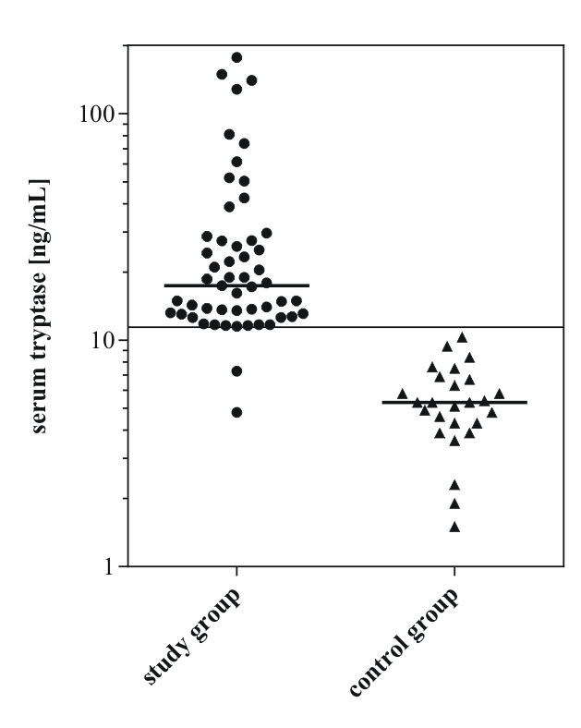

**Figure 2**

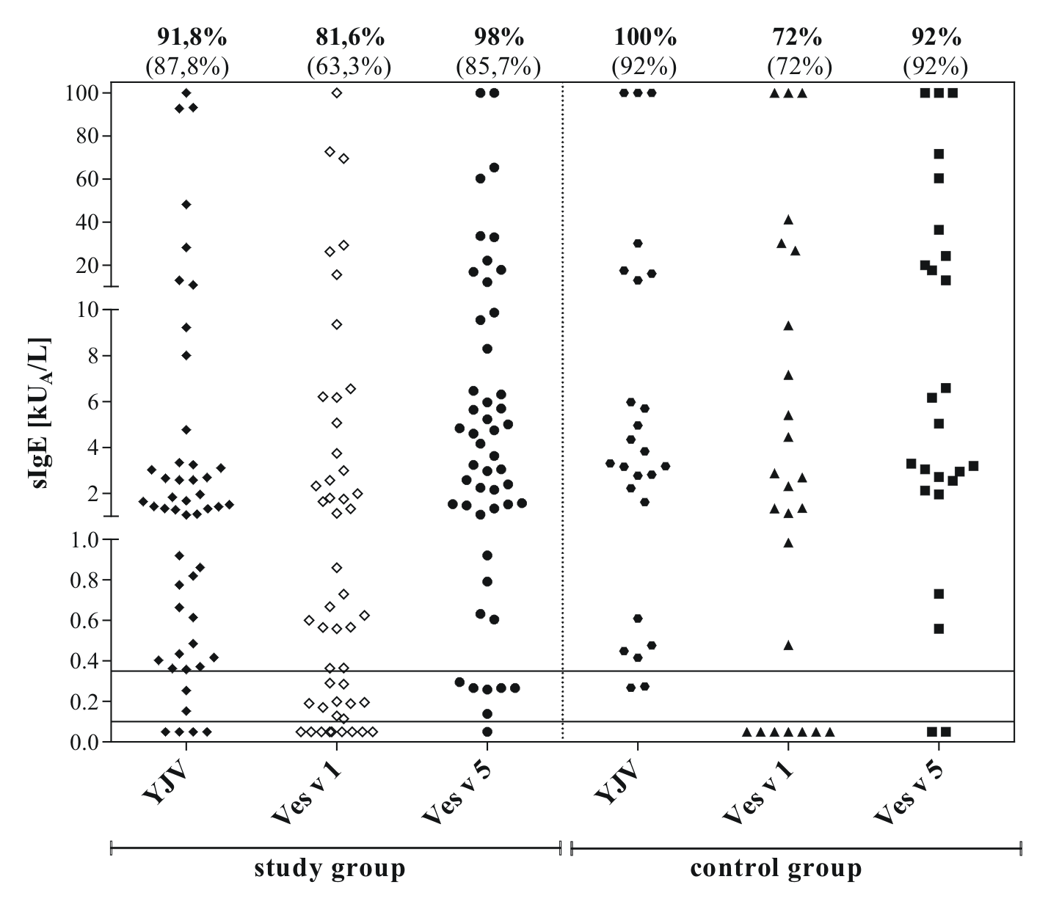

**Figure 3**

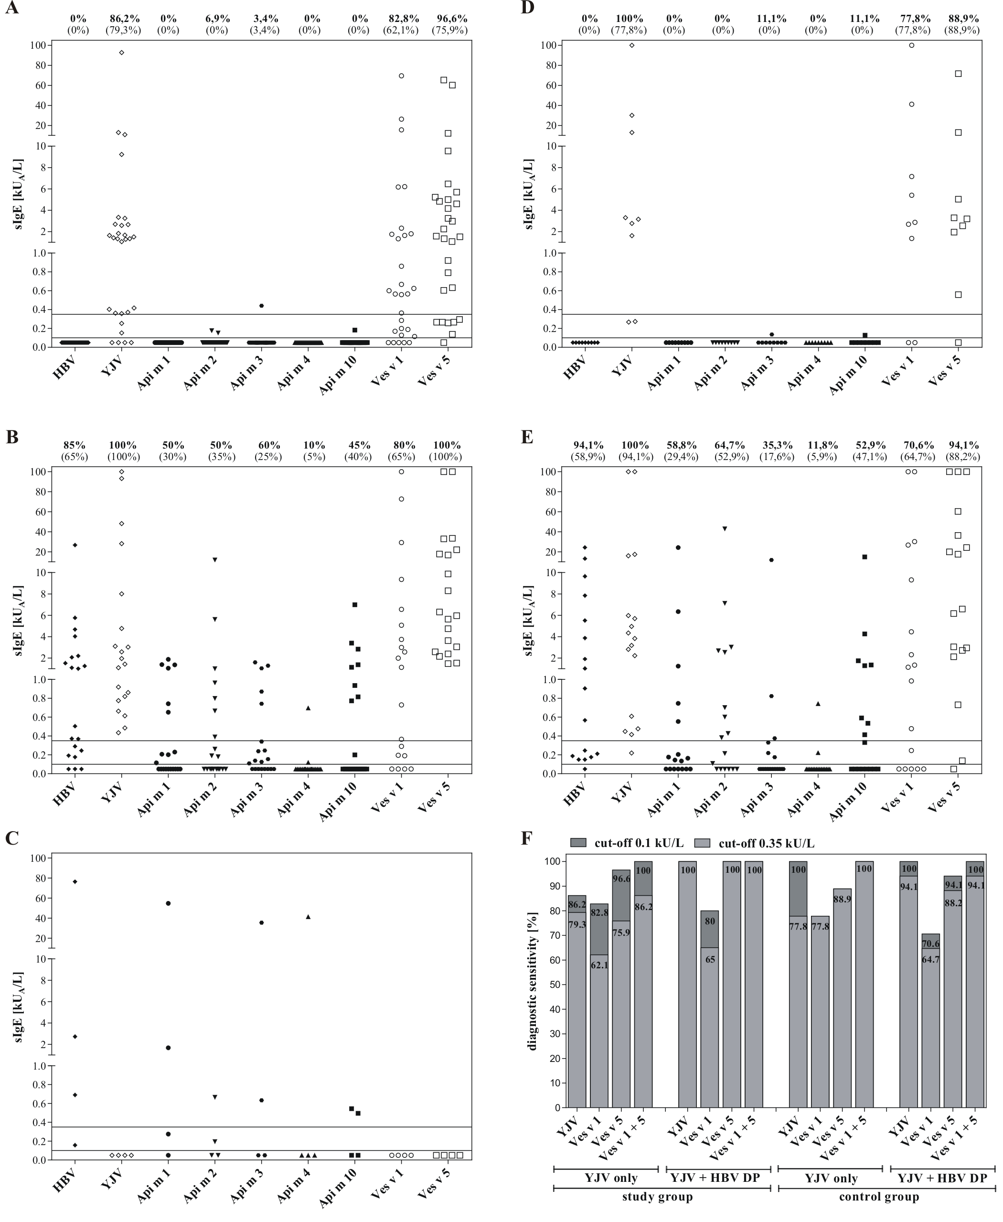

**Figure 4**

