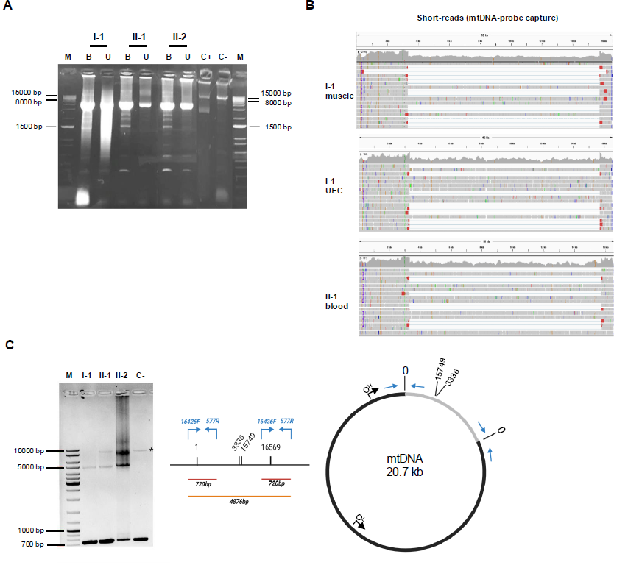

**Supplementary Figure S1. mtDNA analysis**A. LR-PCR revealed a large heteroplasmic mtDNA SLD (about 12 kb) in all three patients, both in blood and urine-derived DNA. Blood-derived DNA from a patient harboring a 6kb SLD was used as positive control.

B. Depth of coverage and alignment visualization, using IGV tool, of short-read NGS of libraries obtained by capture with mtDNA-probes. Different specimens and subjects were tested.

C. Gel electrophoresis (1% agarose) of LR-PCR for validating the complex mtDNA rearrangement. A schematic representation of the primers used, the expected amplicons and the duplicated molecule are reported.

B: blood; C+: positive control; C-: negative control; IGV: Integrative Genomics Viewer; LR-PCR: long-range polymerase chain reaction; M: marker; mtDNA: mitochondrial DNA; NGS: next-generation sequencing; SLD: single large-scale deletion; U: urine; UEC: urinary epithelial cells.

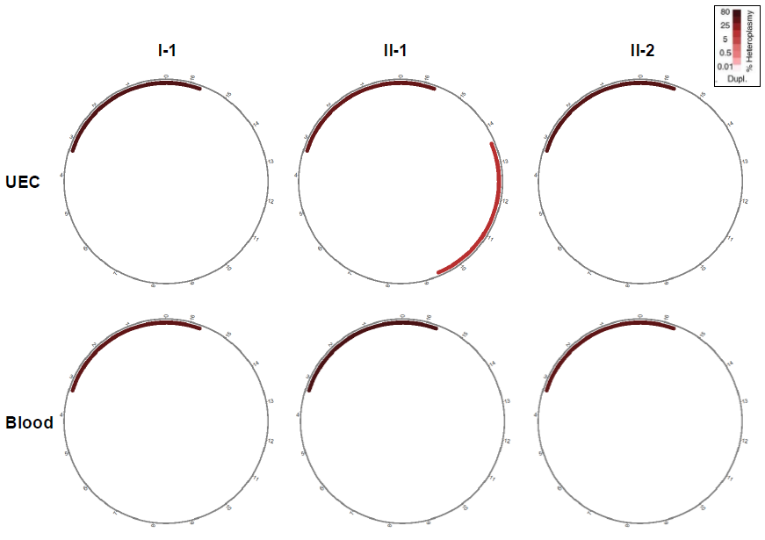

**Suppl Figure S2**. **MitoSAlt analysis**

Evaluation of mtDNA short-read NGS on patients’ samples by MitoSAlt. DNA from urinary epithelial cells (UEC, upper panels) and blood (lower panels) were analyzed. All circular plots show a duplicated segment (in dark red).