**Titanium and zirconium release from titanium- and zirconia implants in mini pig maxillae and their toxicity in vitro**

Xiuli Hea,b, Franz-Xaver Reichla,b, Stefan Milzc, Bernhard Michalked, Xiao Wue, Christoph M Sprecherf, Yang Yanga,g, Michael Gahlerth, Stefan Röhlingi, Heinz Knihah, Reinhard Hickela, Christof Högga,b,*

a Department of Conservative Dentistry and Periodontology, University Hospital, LMU Munich, Germany

b Walther Straub Institute of Pharmacology and Toxicology, Faculty of Medicine, LMU Munich, Germany

c Chair of Neuroanatomy, Institute of Anatomy, Faculty of Medicine, LMU Munich, Germany

d Research Unit Analytical Biogeochemistry, Helmholtz Zentrum München, German Research Center for Environmental Health, Germany

e Helmholtz Zentrum München, German Research Center for Environmental Health Cooperation Group of Comprehensive Molecular Analytics, Germany

f AO Research Institute, AO Foundation, Davos Platz, Switzerland

g Key Laboratory of Oral Medicine, Guangzhou Institute of oral Disease, Stomatology Hospital of Guangzhou Medical University, Guangzhou 510140, China

h Private Dental Clinic Drs. Kniha and Gahlert, Munich, Germany

i Clinic for Oral and Cranio-Maxillofacial Surgery, Hightech Research Center, University Hospital Basel, Switzerland

*Corresponding author:

Dr. Christof Högg

Department of Conservative Dentistry and Periodontology

University Hospital, LMU Munich, Germany

Goethestr. 70

80336 Munich

Germany

Email: christof.hoegg@lrz.uni-muenchen.de

Phone: +49-89-2180-73807

Fax: +49-89-7095-73817

1. Introduction

Currently, Titanium (Ti) and Ti alloys become the mostly used materials in implant manufacturing because of their high biocompatibility and favorable mechanical properties [1-3]. However, Ti materials have a principal disadvantage-the dark grayish color, which can be visible through the peri-implant mucosa and might lead to compromised esthetics [1, 4, 5]. Furthermore, Ti particles released from implants have been found in the regenerated bone and peri-implant tissues in both animals and humans [6-8]. It was also found that those released Ti particles could induce inflammatory response, bone resorption, bone marrow fibrosis and multinucleated cell occurrence in human individuals [8-10]. Although it is very rare for Ti to induce allergic reactions (the estimated prevalence is low (0.6%)), cellular sensitization caused by Ti has been demonstrated [11]. In addition, oral galvanism, or the creation of an electrical current will become an issue if there is already another type of metal in the mouth. This [electric current](https://en.wikipedia.org/wiki/Electric_current) is claimed to induce a variety of immediate symptoms, such as oral discomfort, [headaches](https://en.wikipedia.org/wiki/Headache), [skin irritation](https://en.wikipedia.org/wiki/Skin_irritation) and a metallic taste in the [mouth](https://en.wikipedia.org/wiki/Mouth) [12]. It might even be able to affect the [immune](https://en.wikipedia.org/wiki/Immune_system) and nervous system.

Due to those disadvantages, novel implant technologies producing ceramic implants have been developed [1, 13]. In recent years, high-strength zirconia (ZrO2) ceramics have become an attractive alternative for Ti implants [14-16]. Like the Ti materials, ZrO2 also provides high fracture toughness, high bending strength and good biocompatibility [17-19]. Meanwhile, promising osseous integration (direct osseous integration without any connective tissue formation at the bone–implant interface) of ZrO2 implants has been also demonstrated in animal studies [14, 20]. In an animal study, it has been demonstrated that ZrO2-implants showed no significant difference in bone-implant contact compared to Ti-implants after 10 months [21]. Moreover, it has been shown that ceramic particles (e.g. ZrO2 particles) induce less inflammatory response and bone resorption compared to Ti particles, which demonstrates the biocompatibility of ceramics [22, 23]. An in vivo human study also indicated that ZrO2 materials showed significantly reduced plaque affinity and lower risk of inflammatory changes in the adjacent soft tissue compared to Ti materials [24]. In addition, bacterial colonization on the surface of ZrO2 material is found to be less as compared to that on the surface of Ti material [25]. Particularly, ZrO2 implants display the tooth-like color, which can avoid the dark grayish color and offer outstanding aesthetics [1, 4, 5].

In our previous studies, we have detected the release of Ti from dental implants through post-mortem studies of human subjects with dental implants and made a toxicity risk assessment of released Ti using an in vitro toxicity test. This approach indicated that Ti dental implants might induce no adverse clinical effects, but the histological analysis showed that released Ti particles from dental implant also might be able to induce bone marrow fibrosis and multinucleated cells [8, 26]. However, comparable data regarding the same parameters for ZrO2 implants are still missing.

The aim of the present study was to compare ZrO2 implants and Ti implants with respect to ZrO2/Ti release into the bone tissue, resulting tissue response and potential toxicity. In the current study, Zr/Ti release from ZrO2 implants with special rough acid-etched surface was compared with that from Ti-SLA implants of exactly the same size and shape design. Bone tissue response caused by investigated ZrO2 implants was also compared with that caused by Ti-SLA implants. A comparison of toxicity induced by Ti particles and ZrO2 particles was also performed; a risk assessment for ZrO2 implants was conducted according to the detected ZrO2 release amount from ZrO2 implants and the in vitro toxicity results. This study is expected to be the first study where the metal release and toxicity of Ti- and ZrO2-implants are compared in mini pig maxillae.

2. Materials and method

**2.1 Analysis of Ti and Zr release from Ti-implants and ZrO2-implants in mini pig maxillae**

**2.1.1 Animals**

In this study, 18 female mini pigs (Goettinger mini pig) with an average age of 23.7 months and weight between 31 Kg and 51 Kg were studied. These animals were kept in cages and fed with a standard diet. The animals were not supplied with food 12 h before and after surgery, but with water accessible ad libitum. The protocol of the animal experiment was approved by the Swedish authorities in Malmö (ethical approval number: M 66/07).

**2.1.2 Implant and study design**

Threaded implants with a 6-cornered shaft, a diameter of 4.1 mm and length of 10 mm were manufactured using different techniques for Ti (Ti-SLA) and ZrO2 to generate nearly identical implant surfaces on the two different materials. Details of the implant manufacturing processes were given in a previous study [5]. Six months prior to implant insertion, the positions where the implants would be inserted in the maxillae were created as edentulous areas. For the present investigation animals were sacrificed after 12 weeks of healing. Surgical procedures and implant placement were described in detail in a previous study [5]. Each jawbone received both types of implants with an average distance of 1 cm between implants. After sacrifice, the jawbones were dissected and smaller specimens containing the individual implants were fixed in 4 % buffered paraformaldehyde. For removal of the paraformaldehyde the specimens were rinsed in tap water, and afterwards were dehydrated in ascending ethanol fractions (50%, 70%, 96% and 100%), defatted in xylene (Merck, Darmstadt, Germany) and embedded in methylmethacrylate (MMA) (Fluka, Switzerland) [8].

**2.1.3 Ti/Zr content measurements by ICP-OES/ICP-MS**

*Sample preparation*

Maxilla slices in the sagittal plane were prepared by cutting the MMA-blocks with a diamond band saw (cut-grinder macro, patho-service GmbH, Oststeinbek, Germany). One or two bone slices (approximately 1mm thick) immediately adjacent to the implant surface were cut from each embedded specimen from the 12-week group.

The bone slices were placed into 1ml Aceton for 24h to remove the embedding resin. The bone slices were then put onto a glass dish, allowed to dry and then were weighed. The bone slices without MMA had a weight between 0.09 and 0.19 g. After determination of their dry weight, the bone slices were dissolved in 1ml sub-boiled distilled nitric acid at 170°C for 12 h. The solution was subsequently diluted (1:3) in Milli-Q Water. The contents of the elements Ti and Zr in each slice were first analysed by ICP-MS. The content of elemental Zr was additionally measured by ICP-OES (Ciros Vision, Spectro-Ametec, Kleve, Germany), to verify Zr concentrations since the measurement with ICP-MS could be hampered by interferences.

***Calculations and statistics***

The results were presented as mean ± standard deviation (mean ± SD). Independent two-sample t-test was performed for statistical analysis. Differences were considered statistically significant if the p-value was less than 0.05 (p < 0.05) [25].

**2.1.4 Content distribution measured by Laser ablation-inductively coupled plasma-mass spectrometry (LA-ICP-MS) on resin embedded sections**

***Sample preparation***

After the cutting procedure in section 2.1.3, the polymerized methacrylate blocks were cut parallel to the long axis of the implants in the mesio-distal plane using a Leica SP1600 saw-microtome (Leica, Wetzlar, Germany). The obtained methacrylate blocks with implants in the center were then analyzed by LA-ICP-MS–NWR-213®(New Wave Research Co. Ltd.) coupled to a NexION®300 ICP-MS (PerkinElmer) in order to determine the spatial distribution of Ti and Zr in the bone and soft tissues adjacent to the implant surface.

***Analytical procedure***

The laser ablation started from the tissue region at a distance of around 4 mm from the implant surface and stopped immediately adjacent to the implant itself (the laser did not touch the implant surface in order to protect the detector from being flooded with implant elements). In this manner, the laser ablation in an area of approximately 4mm × 2.5mm was performed line by line, the interval between two lines being 50 µm, resulting in an average of 50 lines that were ablated.

Instrument settings and parameters are shown in detail in Table 1.

After the laser ablations, the data were analyzed with the software Iolite / IGOR PRO 6. A map of the ablated area exhibiting the elemental distribution of Ti, Zr and Ca was built from ICP-MS data.

**2.1.5 Histological analysis**

The bone sections with implants were glued (Cyanolit 201, Panacol LTD., Zürich, Switzerland) on opaque plastic slides, ground thinner, polished (EXAKT® 400CS grinding system, EXAKT Vertriebs GmbH, Norderstedt, Germany) and stained with Giemsa-Eosin stain (Sigma Aldrich, Steinheim, Germany). The stained sections were examined in transmitted light mode with an Axiophot microscope (Zeiss, Goettingen, Germany) that was equipped with Zeiss Plan-Neofluar objectives (5× and 10×). Images were recorded with am Axciocam HRc digital camera (Zeiss, Goettingen, Germany)

**2.2 Assessment of the toxicity of ZrO2-particles (cyto-toxicity and DNA damage) in PDL-hTERT cells**

**2.2.1 Cell culture**

Periodontal ligament cells with lentiviral gene transfer of human telomerase reverse transcriptase (PDL-hTERT) were obtained from the Experimental Surgery and Regenerative Medicine, Department of Surgery, Ludwig-Maximilians University (LMU), Munich, Germany [27].

PDL-hTERT cells were cultured in a 250 ml tissue culture flask (BD falcon, Franklin Lakes, USA) at 37◦C and 100% humidity with 5% CO2. The VLE (very low endotoxin) Dulbecco’s Minimum Essential Medium (MEM) with 4.5 g/l d-Glucose (Biochrom, Berlin, Germany) was supplemented with 1% penicillin/streptomycin (Biochrom, Berlin, Germany) and 10% Fetal Bovine Serum (Sigma–Aldrich, Munich, Germany) [26].

**2.2.2 Particle exposure and size measurement**

ZrO2-NPs (<100 nm) and ZrO2-MPs (<5 µm) were obtained from Sigma–Aldrich (St. Louis, USA). Fresh suspensions of investigated particles were prepared for each experiment. The stock solutions were prepared by adding investigated particles (batches of: 300 mg ZrO2-NPs, 30 mg ZrO2-NPs and 3 mg ZrO2-NPs; 1000 mg ZrO2-MPs and 150 mg ZrO2-MPs) into 3 ml of medium and mixed well. To determine the exact concentrations of particles in the resulting stock solutions, 200 µl of stock solution was evaporated at 70 °C to complete dryness and the average net weight of the particles was measured six times. The final exposure concentrations (particle weight/0.1ml) were obtained by adding different volumes of stock solution. Medium was then added or removed to obtain the equal volume of 0.1 ml in XTT test and 1ml in comet assay. The exposure concentrations of the investigated particles for each test are shown in Table 2.

The size of investigated particles was determined with Scanning Electron Microscopy (Hitachi S-4700 II (FESEM, Hitachi High Technologies, Germany) at an acceleration voltage of 3 kV with a current of 40 µA.

**2.2.3 XTT viability assay**

XTT-based cell viability assay was applied to determine the half- maximum effect concentration (EC50) values of ZrO2-NPs and ZrO2-MPs in PDL-hTERT cells. In the present study, 20000 cells per well were incubated with 0.1 ml medium for 24 h on a 96-well plate (BD falcon, Heidelberg, Germany). Then the cells were treated with different concentrations of ZrO2-NPs and ZrO2-MPs (Table 2). Negative control cells received only medium, while positive control cells were treated with 1% Triton X-100.

After exposure to ZrO2-NPs and ZrO2-MPs for 24 h, the XTT-test was performed according to our previous study [26]. The formazan formation was quantified spectrophotometrically at a wavelength of 450 nm (reference wavelength 670 nm) by using a microplate reader (Thermo Fisher Scientific (Shanghai) Instruments Co. Ltd, China). The formazan production in percentage was calculated referring to the negative and positive controls. EC50 values were obtained by fitting the data to a dose–effect sigmoidal curve using GraphPad prism 4 (GraphPad Software, Inc. La Jolla, USA). Each experiment was repeated four times (n = 4).

**2.2.4 Comet assay**

DNA damage of ZrO2-NPs and ZrO2-MPs was analyzed by the alkaline single-cell microgel electrophoresis (comet) assay. In this experiment, PDL-hTERT cells (2×105) were cultured in 1 ml medium in a 12-well plate (BD falcon, Heidelberg, Germany) for 24 h. Afterwards, the cells were exposed to different concentrations (Table 2) of ZrO2-NPs and ZrO2-MPs for further 24 h. Positive control cells were treated with 100 µM methyl methanesulfonate (MMS) (Sigma–Aldrich, Steinheim, Germany) and negative control cells were treated only with medium. Before the comet assay was performed, the cells were stained with trypan blue and a threshold level for cytotoxicity after exposure was set at 75% viable cells.

Further experimental details of comet assay were described in our previous study [26]. For each sample, about 50 cells were investigated in each test. The test was repeated five times (n = 5). Olive tail moment (OTM), as a product of the tail length and the fraction of total DNA in the tail, was taken to evaluate the DNA damage [28, 29].

The results were presented as mean ± standard deviation (SD). To analyse the effect of particles on cytotoxicity and DNA damage, a one-way ANOVA analysis followed by Tukey’s test was applied. Differences were considered statistically significant only when the p-value was less than 0.05 (p < 0.05) [30].

3. Results

**3.1.1 Ti/Zr content measured by ICP-MS and ICP-OES**

The content of Ti and Zr in the jawbone slices adjacent to Ti- and ZrO2- implants were measured by ICP-MS and ICP- OES, respectively. Bone slices from a location 2 cm distant to the closest Ti-/ZrO2- implant were taken as control. In the control bone sample adjacent to a Ti-implant, 0.99 mg/Kg-bone weight of Ti was detected, while in the control to a ZrO2-implant Zr concentration was below the detection limit (< 0.3 mg/kg).

The average Ti content across 11 bone slices from samples immediately adjacent to Ti-implants (Fig. 1a) was 1.67 ± 0.42 mg /kg-bone weight (mean± SD, n=11), which is higher than the value detected in the control; the highest Ti content (2.17 mg/kg-bone weight) was detected in slice 2 of sample Ti 22170. The average Ti content across 8 slices from samples close to ZrO2-implants (Fig. 1b) was 0.99 ± 0.62 mg/kg-bone weight. The average Ti content in the slices close to Ti-implants was significantly higher than that in slices from samples near ZrO2-implant (P<0.05).

Zr contents in each jawbone slice from samples with ZrO2-implants are shown in Fig. 1c, the highest Zr content (0.75 mg/kg-bone weight) was detected in slice 2 of sample Zr 22169. Among 8 slices that were measured, 4 slices from sample Zr 22176 and Zr 22177 showed Zr contents below the detection limit (< 0.3 mg/kg). The average value of the other 4 slices from samples with ZrO2-implant was 0.59 ± 0.13 mg/kg-bone weight. Zr contents in each jawbone slice from samples with Ti-implants were shown in Fig.1d, 3 of 11 slices showed Zr content below the detection limit. The average Zr content of the remaining 8 slices in this group was 0.71 ± 0.21 mg/kg-bone weight. There was no significant difference in average Zr content between slices from samples close to ZrO2-implants and those samples close to Ti-implants. The average Ti content or Zr content in slice 1 and slice 2 in each group also showed no significant difference.

**3.1.2 The spatial distribution of isotopes measured by LA-ICP-MS**

The spatial distribution of the isotopes 47Ti and 90Zr in bone slices with longitudinal cuts through the implants was detected by LA-ICP-MS. Fig.2 shows the distribution of 47Ti in the bone tissue close to a Ti-implant. The graph shows a higher intensity of 47Ti in a distance of 800 µm to the implant surface. Interestingly, increased intensity of Ti was also occasionally found in at distances up to 3300 µm. Fig.3 shows the distribution of 90Zr in the bone tissue next to a ZrO2-implant, with higher intensity of 90Zr in a distance of 900 µm to ZrO2-implant. These results also show that a higher intensity of 47Ti and 90Zr was mainly found close to the screw thread outer tip rather than in the deeper parts of the thread. Distances of first hotspots with increased Ti and Zr levels from the implant surfaces were listed in Table 3.

**3.1.3 Histological analysis**

The histologic image of the sample containing the highest level of Ti (with Ti-implant) is shown in Fig.4. As shown in Fig.4, black particles can be found in the bone marrow tissue near the implant and also bone marrow fibrosis can be detected. Fig. 5 shows the histologic image of the sample containing the highest level of Zr (with ZrO2-implant); no particles with the same color as ZrO2-implant were found in the bone marrow tissues near the implant. Slight bone marrow fibrosis can also be seen here.

**3.2.1 Particle size measurement**

The size of ZrO2 particles used for toxicity test was measured by using SEM. The results are shown in Table 4.

It was found that about 95% of ZrO2-NPs were sized below 100 nm and 5% of ZrO2-NPs were sized above 100 nm. ZrO2-MPs were sized between 70 nm and 900 nm：about 95% of the particles were sized between 100nm and 900 nm, 5% of ZrO2-MPs were below 100 nm.

**3.2.2 Cytotoxicity of ZrO2 particles**

The EC50 values of ZrO2-NPs and ZrO2-MPs in PDL-hTERT cells were determined; a relative toxicity was calculated according to those values. The results were shown in Table 5. The EC50 of ZrO2-NPs (13.96±1.16 mg/ml) was around 6 times lower compared to that of ZrO2-MPs (80.99±3.96 mg/ml).

**3.2.3 DNA damage of ZrO2-particles**

The Comet assay was used to assess the DNA damage caused by ZrO2-NPs and ZrO2-MPs in PDL-hTERT cells, the results are shown in Fig. 6. A significant increase in OTM value (compared to negative control) was detected after ZrO2-NP exposure at concentrations of 70 µg/ml (1/200 EC50), 280 µg/ml (1/50 EC50) and 1400 µg/ml (1/10 EC50) (p<0.05).

ZrO2-MPs induced a significant increase in OTM value at the concentrations of 810 µg/ml (1/100 EC50), 1620 µg/ml (1/50 EC50) and 8099 µg/ml (1/10 EC50) (p<0.05).

**4. Discussion**

In recent years, high-strength zirconia ceramics have become an attractive alternative for Ti implants [14-16]. In this study, zirconia/Ti released from surface-modified zirconia and Ti-SLA dental implants in mini pig maxillae was measured and identified with ICP-OES, ICP-MS and LA-ICP-MS. The in vitro toxicity of ZrO2 particles (ZrO2-NPs and ZrO2-MPs) was investigated in PDL cell culture, and the results were compared with the known toxicity of Ti particles (Ti-NPs and Ti-MPs) [26].

**4.1.1 Ti/Zr content measured by ICP-OES and ICP-MS**

The average Ti content from bone slices in samples with Ti-implants was about 60% higher than the Ti content in control bone, and was significantly higher than that in slices from samples with ZrO2-implant (P<0.05). The average Ti content in slices from samples with ZrO2-implant is 0.99 ± 0.62 mg/Kg-bone weight, which was similar to the Ti content in the control tissue. Therefore, we can conclude that Ti was released from Ti-implants within 12-weeks of implantation in mini pig maxillae. This is in line with a previous study, which reported that Ti particles can be released from implants into the surrounding bone tissues [7, 31, 32]. It should be noted that, in some slices from samples with ZrO2-implant we also found higher Ti content compared to control bone. One possible explanation can be the surgical procedure: equipment containing Ti surface coating has been used in the implantation process and this might have contaminated the bone during surgery. The other option would be a contamination by particles released from neighboring implants. Unfortunately, the present experimental setup does not allow us to discriminate between the two possibilities.

In samples with ZrO2-implants 4 of 8 slices showed Zr contents below the detection limit (<0.3mg/Kg) and here we cannot present a particular value other than the detection limit itself. The same applies to the Zr content in the control tissue which also was below the detection limit. Moreover, there was no significant difference in average Zr content between slices from samples with ZrO2-implants and those from samples with Ti-implants. Besides, the highest Ti content (2.17 mg/Kg-bone weight) was detected in bone slices near Ti-implants; the amount was three times higher than the highest Zr content detected in bone slices near ZrO2-implants. This highlights the observation that Ti-implants exhibited a higher material release to the surrounding tissue than ZrO2-implants.

**4.1.2 The spatial distribution of isotopes measured by LA-ICP-MS**

In a previous study the LA-ICP-MS was used to measure the spatial distribution of Mn, Fe, Zn and Cu in rat brains by laser scanning [33]. In the current study, the spatial distribution of the implant related isotopes Ti47 and Zr90 in mini pig maxillae with Ti- and ZrO2-implants were assessed with LA-ICP-MS. The results showed that first occurrence of increased intensity of Zr90 in the bone can be detected within a distance of 937±402 µm from the ZrO2-implant surface, and Ti47 can be detected within a distance of 807±402 µm from Ti-implants, but these values have no statistical difference (p>0.05). These results indicated that both ZrO2-implant and Ti-implant can induce material release into the surrounding bone tissue after 12 weeks of implantation. The release of Ti from Ti-implants has been already demonstrated in previous studies [6-8]. Particularly, we found that Ti-implants in human jawbones can release particles with a size of 0.5 and 5 µm into human jawbone tissues [8]. However, the release of Zr from ZrO2-implants has not been assessed in previous studies. Interestingly, increased intensity of Ti and Zr was mainly found in the location of the implant screw thread tip, and this might be explained by the fact that the bone adjacent to the implant screw thread tip bears more stress during insertion of the implants and immediately thereafter. These observations are consistent with reports in the literature showing increased Ti particle release during the insertion of a threaded implant [34].

**4.1.3 Histological analysis**

In order to observe the released particles and their influence on bone marrow tissues, a histological analysis was conducted with samples containing the highest contents of Ti and Zr. As suspected, Ti particles could be found in the bone marrow tissue near the Ti-implant, while no ZrO2-particles could be detected near the ZrO2-implant. Considering the results of LA-ICP-MS which showed that both Ti-and ZrO2-implants could cause material release into the surrounding bone, we may conclude that Ti-implants might cause more and perhaps larger material release compared to ZrO2-implants. The release of ZrO2-particles from ZrO2-implant might result in a size and magnitude too small to be observed by light microscopy. Traces of bone marrow fibrosis were found in bone marrow tissues near both types of implants. This is not surprising and goes in line with reports in the literature [8]. According to previous research, bone marrow fibrosis might have been caused by marrow injury or inflammation [35], which are reported to be associated with surgical trauma induced by implantation of implants [36].

**4.2.1 Particle size measurement of ZrO2-particles**

According to the manufacturer, the particle size of the commercially available ZrO2-NPs is below 100 nm and the size of ZrO2-MPs is below 5 µm. This was confirmed by our SEM results in the present study and is important, because particle size may influence the toxicity of metal particles [37, 38]. In previous studies, it was found that CuO- and ZnO-NPs induced higher cytotoxicity than their corresponding MPs [37, 38]. In our previous study, we could demonstrate that Ti-NPs induced higher cytotoxicity and more DNA damage than Ti-MPs in PDL cells [26], and Ti particles with size between 0.5 and 5 µm were be detected in the human bone marrow tissues near the implant surface [8].

**4.2.2 Cytotoxicity of ZrO2 particles**

According to previous studies, it is known that NPs could induce higher cytoxicity than their corresponding MPs due to the large surface area per mass, release of toxic ions and ability of NPs to pass the cell membrane [38, 39]. Moreover, it was found that CuO-NPs induced higher cytotoxicity than the corresponding MPs: the result of a trypan blue test showed that CuO-NPs induced a 2-fold increase in cytotoxicity in A549 cells compared to CuO-MPs at the exposure concentration of 40 µg/cm2 [37]. In our previous study, we also found that Ti-NPs induced higher cytotoxicity than Ti-MPs, and the EC50 value of Ti-NPs was more than 350 fold lower than the EC50 of Ti-MPs [26]. In the current study, it is shown that the EC50 of ZrO2-NPs (13.96 mg/ml) is 6 times lower than that of ZrO2-MPs (80.99 mg/ml), which also indicated that ZrO2-NPs are more cytotoxic than ZrO2-MPs. Therefore, the result of the current study on ZrO2-NPs and ZrO2-MPs is in line with the results of the previous studies cited above.

It was found that Ti-NPs (EC50 2.8 mg/ml [26]) are around 4 times more toxic than ZrO2-NPs (EC50 13.96 mg/ml). In the current study, we found significant Ti content in the samples with Ti-implants, and the highest Ti content detected was 2.17 mg/kg-bone weight. In order to make a rough risk assessment, we assume that Ti in 1 kg bone corresponds to Ti in 1 L body fluid, so a maximal Ti concentration of 2.17 µg/ml can be calculated; this is around 1000 times lower than the EC50 of Ti-NPs. This assessment is based on the “worst case situation” assuming that all the Ti detected in the bone contains only Ti-NPs. Therefore, the amount of Ti detected in the bone in this study would not be expected to cause significant cytotoxicity.

Similarly, another risk assessment could be performed on the samples with ZrO2-implants, here it is shown that the highest detected Zr content in the bone near ZrO2-implant is 0.75mg/kg bone; this is 18613 times lower than the EC50 of ZrO2-NPs. Considering the fact that no significant higher Zr content was detected in the bone near a ZrO2-implant, we can conclude that the cytoxicity of ZrO2-implants would not be a concern at all and should virtually be absent.

It was already shown that Ti-NPs are 350 times more toxic than Ti-MPs [26], while in the present study we observed the toxicity of ZrO2-NPs to be only 6 times higher than that of ZrO2-MPs. This might be explained by the particle size distribution of Ti-MPs and ZrO2-MPs: only 12% of Ti-MPs are below 1µm [26], on the other hand, 95% of ZrO2-MPs are below 1µm.

It was previously reported that non-phagocytic eukaryotic cells are able to take up particles below 1µm [40]. According to the earlier studies, toxicity of NPs could be correlated to their cellular uptake efficiency [26, 41]. Therefore, we suggest that the observed toxicity of the ZrO2-MPs might be due to the higher fraction of small particles that are below 1 µm and can be taken up by the cells.

**4.2.3 DNA damage of ZrO2-particles**

In the current study, comet assay was used to investigate the DNA damage caused by ZrO2-NPs and ZrO2-MPs. The results showed that: ZrO2-NPs could induce DNA damage (significant increase in OTM) at the concentration of 70µg/ml, while ZrO2-MPs induced a significant increase in OTM value at the concentrations of 810 µg/ml. In a previous study, it is also found that zirconia NPs could induce DNA damage (Tail percentage increase) in PC12 and N2a cells starting from 31 µg/ml [42], which is in consistence with our current study. Regarding the highest detected Zr content found in the bone near ZrO2-implant is 0.75mg/kg bone (corresponds to 0.75 µg/ml), which is around 100 times lower than 70 µg/ml. Therefore, DNA damage caused by released ZrO2-particles (even NPs) from ZrO2-implants is very unlikely to be a concern.

In our previous study on Ti particles, we have found that 14 µg/ml of Ti-NPs could induce significant DNA damage (OTM increase) in PDL cells [26], this is only 7 times higher than the highest detected Ti content (2.17 µg/ml) in the present study; moreover, in another study on human subjects it has been found that the highest Ti content of 38000 µg/kg bone (corresponding to 38µg/ml) could be detected in the human jawbone near Ti-implants [8], if we take the worst-case situation, assuming that all the Ti content detected in human jawbone contains only Ti-NPs, there would be a safety concern since the level we detected is above the level at which it could induce significant DNA damage.

**Acknowledgement:**

This study was financially supported by the China Scholarship Council (CSC, 201206220099). We would like to thank Mr. Peter Grill and Mr. Stefan Schulz for the technical support.

References:

[1] Ozkurt Z, Kazazoglu E. Zirconia dental implants: a literature review. J Oral Implantol, 2011; 37:367-76.

[2] Depprich R, Zipprich H, Ommerborn M, Naujoks C, Wiesmann HP, Kiattavorncharoen S, Lauer HC, Meyer U, Kubler NR, Handschel J. Osseointegration of zirconia implants compared with titanium: an in vivo study. Head Face Med, 2008; 4:30.

[3] Steinemann SG. Titanium—the material of choice? Periodontology 2000, 1998; 17:7-21.

[4] Apratim A, Eachempati P, Krishnappa Salian KK, Singh V, Chhabra S, Shah S. Zirconia in dental implantology: A review. J Int Soc Prev Community Dent, 2015; 5:147-56.

[5] Gahlert M, Roehling S, Sprecher CM, Kniha H, Milz S, Bormann K. In vivo performance of zirconia and titanium implants: a histomorphometric study in mini pig maxillae. Clin Oral Implants Res, 2012; 23:281-6.

[6] Franchi M, Bacchelli B, Martini D, De Pasquale V, Orsini E, Ottani V, Fini M, Giavaresi G, Giardino R, Ruggeri A. Early detachment of titanium particles from various different surfaces of endosseous dental implants. Biomaterials, 2004; 25:2239-46.

[7] Martini D, Fini M, Franchi M, Pasquale VD, Bacchelli B, Gamberini M, Tinti A, Taddei P, Giavaresi G, Ottani V, Raspanti M, Guizzardi S, Ruggeri A. Detachment of titanium and fluorohydroxyapatite particles in unloaded endosseous implants. Biomaterials, 2003; 24:1309-16.

[8] He X, Reichl F-X, Wang Y, Michalke B, Milz S, Yang Y, Stolper P, Lindemaier G, Graw M, Hickel R. Analysis of titanium and other metals in human jawbones with dental implants–A case series study. Dental Materials, 2016.

[9] Sterner T, Schutze N, Saxler G, Jakob F, Rader CP. [Effects of clinically relevant alumina ceramic, zirconia ceramic and titanium particles of different sizes and concentrations on TNF-alpha release in a human macrophage cell line]. Biomed Tech (Berl), 2004; 49:340-4.

[10] Case CP, Langkamer VG, James C, Palmer MR, Kemp AJ, Heap PF, Solomon L. Widespread dissemination of metal debris from implants. J Bone Joint Surg Br, 1994; 76:701-12.

[11] Valentine-Thon E, Schiwara HW. Validity of MELISA for metal sensitivity testing. Neuro Endocrinol Lett, 2003; 24:57-64.

[12] Kucerova H, Dostalova T, Prochazkova J, Bartova J, Himmlova L. Influence of galvanic phenomena on the occurrence of algic symptoms in the mouth. Gen Dent, 2002; 50:62-5.

[13] Kohal RJ, Klaus G. A zirconia implant-crown system: a case report. Int J Periodontics Restorative Dent, 2004; 24:147-53.

[14] Kohal RJ, Weng D, Bächle M, Strub JR. Loaded custom-made zirconia and titanium implants show similar osseointegration: an animal experiment. Journal of Periodontology, 2004; 75:1262-8.

[15] Gahlert M, Gudehus T, Eichhorn S, Steinhauser E, Kniha H, Erhardt W. Biomechanical and histomorphometric comparison between zirconia implants with varying surface textures and a titanium implant in the maxilla of miniature pigs. Clinical oral implants research, 2007; 18:662-8.

[16] Sennerby L, Dasmah A, Larsson B, Iverhed M. Bone tissue responses to surface-modified zirconia implants: A histomorphometric and removal torque study in the rabbit. Clin Implant Dent Relat Res, 2005; 7 Suppl 1:S13-20.

[17] Piconi C, Maccauro G. Zirconia as a ceramic biomaterial. Biomaterials, 1999; 20:1-25.

[18] Andreiotelli M, Kohal RJ. Fracture strength of zirconia implants after artificial aging. Clin Implant Dent Relat Res, 2009; 11:158-66.

[19] Silva NR, Coelho PG, Fernandes CA, Navarro JM, Dias RA, Thompson VP. Reliability of one-piece ceramic implant. J Biomed Mater Res B Appl Biomater, 2009; 88:419-26.

[20] Schultze-Mosgau S, Schliephake H, Radespiel-Troger M, Neukam FW. Osseointegration of endodontic endosseous cones: zirconium oxide vs titanium. Oral Surg Oral Med Oral Pathol Oral Radiol Endod, 2000; 89:91-8.

[21] Dubruille JH, Viguier E, Le Naour G, Dubruille MT, Auriol M, Le Charpentier Y. Evaluation of combinations of titanium, zirconia, and alumina implants with 2 bone fillers in the dog. Int J Oral Maxillofac Implants, 1999; 14:271-7.

[22] Ichikawa Y, Akagawa Y, Nikai H, Tsuru H. Tissue compatibility and stability of a new zirconia ceramic in vivo. J Prosthet Dent, 1992; 68:322-6.

[23] Warashina H, Sakano S, Kitamura S, Yamauchi KI, Yamaguchi J, Ishiguro N, Hasegawa Y. Biological reaction to alumina, zirconia, titanium and polyethylene particles implanted onto murine calvaria. Biomaterials, 2003; 24:3655-61.

[24] Scarano A, Piattelli M, Caputi S, Favero GA, Piattelli A. Bacterial adhesion on commercially pure titanium and zirconium oxide disks: an in vivo human study. Journal of periodontology, 2004; 75:292-6.

[25] Rimondini L, Cerroni L, Carrassi A, Torricelli P. Bacterial colonization of zirconia ceramic surfaces: an in vitro and in vivo study. Int J Oral Maxillofac Implants, 2002; 17:793-8.

[26] He X, Hartlieb E, Rothmund L, Waschke J, Wu X, Van Landuyt KL, Milz S, Michalke B, Hickel R, Reichl FX, Hogg C. Intracellular uptake and toxicity of three different Titanium particles. Dent Mater, 2015; 31:734-44.

[27] Docheva D, Padula D, Popov C, Weishaupt P, Pragert M, Miosge N, Hickel R, Bocker W, Clausen-Schaumann H, Schieker M. Establishment of immortalized periodontal ligament progenitor cell line and its behavioural analysis on smooth and rough titanium surface. Eur Cell Mater, 2010; 19:228-41.

[28] Kleinsasser NH, Schmid K, Sassen AW, Harreus UA, Staudenmaier R, Folwaczny M, Glas J, Reichl FX. Cytotoxic and genotoxic effects of resin monomers in human salivary gland tissue and lymphocytes as assessed by the single cell microgel electrophoresis (Comet) assay. Biomaterials, 2006; 27:1762-70.

[29] Kleinsasser NH, Wallner BC, Harreus UA, Kleinjung T, Folwaczny M, Hickel R, Kehe K, Reichl FX. Genotoxicity and cytotoxicity of dental materials in human lymphocytes as assessed by the single cell microgel electrophoresis (comet) assay. J Dent, 2004; 32:229-34.

[30] Doorn J, Fernandes HA, Le BQ, van de Peppel J, van Leeuwen JP, De Vries MR, Aref Z, Quax PH, Myklebost O, Saris DB, van Blitterswijk CA, de Boer J. A small molecule approach to engineering vascularized tissue. Biomaterials, 2013; 34:3053-63.

[31] Elias C, Lima J, Valiev R, Meyers M. Biomedical applications of titanium and its alloys. Jom, 2008; 60:46-9.

[32] Jacobs JJ, Gilbert JL, Urban RM. Current Concepts Review-Corrosion of Metal Orthopaedic Implants*. The Journal of Bone & Joint Surgery, 1998; 80:268-82.

[33] Michalke B. Review about the manganese speciation project related to neurodegeneration: An analytical chemistry approach to increase the knowledge about manganese related parkinsonian symptoms. Journal of Trace Elements in Medicine and Biology, 2016; 37:50-61.

[34] Schliephake H, Reiss G, Urban R, Neukam FW, Guckel S. Metal release from titanium fixtures during placement in the mandible: an experimental study. Int J Oral Maxillofac Implants, 1993; 8:502-11.

[35] Travlos GS. Histopathology of bone marrow. Toxicol Pathol, 2006; 34:566-98.

[36] Piattelli A, Piattelli M, Mangano C, Scarano A. A histologic evaluation of eight cases of failed dental implants: is bone overheating the most probable cause? Biomaterials, 1998; 19:683-90.

[37] Karlsson HL, Gustafsson J, Cronholm P, Moller L. Size-dependent toxicity of metal oxide particles--a comparison between nano- and micrometer size. Toxicol Lett, 2009; 188:112-8.

[38] Hackenberg S, Scherzed A, Technau A, Kessler M, Froelich K, Ginzkey C, Koehler C, Burghartz M, Hagen R, Kleinsasser N. Cytotoxic, genotoxic and pro-inflammatory effects of zinc oxide nanoparticles in human nasal mucosa cells in vitro. Toxicol In Vitro, 2011; 25:657-63.

[39] Midander K, Cronholm P, Karlsson HL, Elihn K, Moller L, Leygraf C, Wallinder IO. Surface characteristics, copper release, and toxicity of nano- and micrometer-sized copper and copper(II) oxide particles: a cross-disciplinary study. Small, 2009; 5:389-99.

[40] Rejman J, Oberle V, Zuhorn IS, Hoekstra D. Size-dependent internalization of particles via the pathways of clathrin- and caveolae-mediated endocytosis. Biochem J, 2004; 377:159-69.

[41] Zhu J, Liao L, Zhu L, Zhang P, Guo K, Kong J, Ji C, Liu B. Size-dependent cellular uptake efficiency, mechanism, and cytotoxicity of silica nanoparticles toward HeLa cells. Talanta, 2013; 107:408-15.

[42] Asadpour ES, H. R. ; Ghorban,A.; Sedaghat, M.; Boroushaki, M.T. Oxidative stress-mediated cytotoxicity of zirconia nanoparticles on PC12 and N2a cells. Journal of Nanoparticle Research, 2016; 18.

Table 1

|  |  |
| --- | --- |
| Laser | Energy: 0.930 mJ  Power: 100%  Pulse repetition rate: 10 Hz  Scan speed: 50 µm/s  Spot size: 50 µm  Ablation pattern: line  Interval between two lines: 50 µm  Number of ablated lines: 50  Depth: approx. 10 µm |
| ICP | Plasma power: 1200 W  Transport gas: 1.2 L/min Ar  Auxiliary gas: 0.8 L/min Ar  Cool gas: 17 L/min Ar |
| MS | Registered isotopes: 47Ti, 43Ca and 90 Zr  Dwell time/isotope: 25 ms |

Table 2 The concentrations of ZrO2-MPs and ZrO2-NPs used in XTT viability assay and comet assay

|  |  |  |  |
| --- | --- | --- | --- |
| **XTT viability assay**  **(µg/ml)** | | **Comet assay**  **(µg/ml)** | |
| ZrO2-MPs | ZrO2-NPs | ZrO2-MPs | ZrO2-NPs |
| 999000 | 43600 | 8099 | 1400 |
| 19980 | 8720 | 1620 | 280 |
| 3996 | 1744 | 810 | 140 |
| 799 | 349 | 405 | 70 |
| 160 | 70 |  |  |
|  | 14 |  |  |

Table 3. The distances to implants where Zr or Ti was firstly detected in the bone

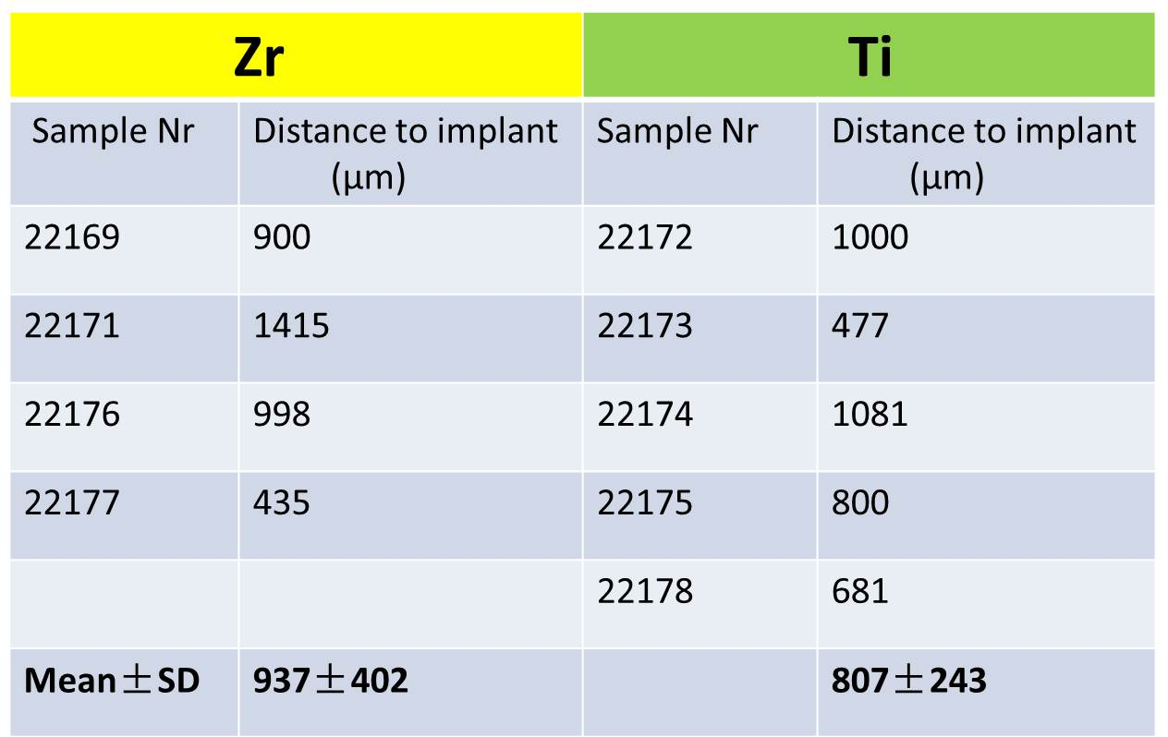

Table 4 The particle size distribution of ZrO2-NPs and ZrO2-MPs

|  |  |  |  |  |
| --- | --- | --- | --- | --- |
| **Particles** | **Particle size distribution (%)** | | | |
| ZrO2-NPs | 20-50 nm | 50-100 nm | 100-200 nm | >200 nm |
| 22.3% | 73% | 4.7% | 0 |
| ZrO2-MPs | <50 nm | 10-100 nm | 100-1000 nm | >1000 nm |
| 0 | 5.3% | 94.7% | 0 |

Table 5 EC50 values ( mean±SD) and relative toxicity of ZrO2-NPs and ZrO2-MPs

|  |  |  |
| --- | --- | --- |
|  | **EC50 (mg/ml)**  **(mean±SD)** | **Relative Toxicity** |
| ZrO2-NPs | 13.96±1.16 | 5.8 |
| ZrO2-MPs | 80.99±3.96 | 1 |

Figures

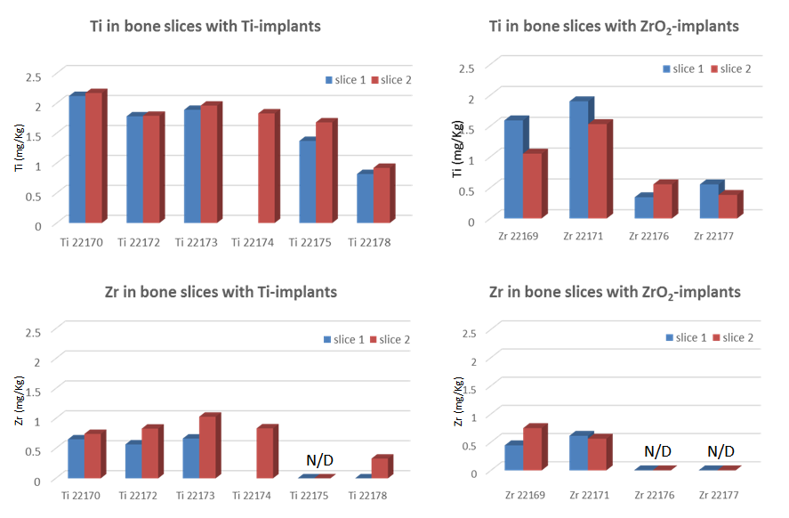

**c**

**d**

**a**

**b**

Sample number

Sample number

Sample number

Sample number

Fig 1. Ti/Zr content in bone slices near Ti-/Zr-implants, two slices were taken from each sample, and slice 1 is the slice closer to implant (the data of slice 1 in sample 22174 was missing because of contamination), N/D represents under detection limit

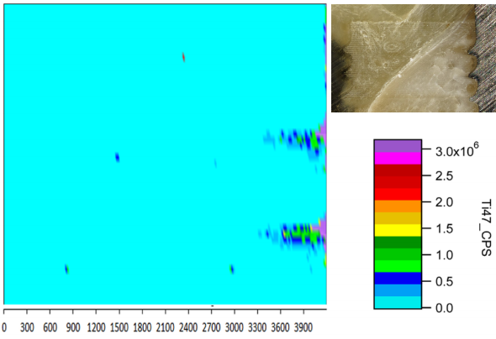

**Intensity of Ti47**

Distance from laser ablation starting point (µm)

point

**ablated bone**

Ti-implant

**ablated bone**

bonebone

Fig 2. The distribution of Ti47 in the bonenear Ti-implant, the color bar represents the intensity of Ti

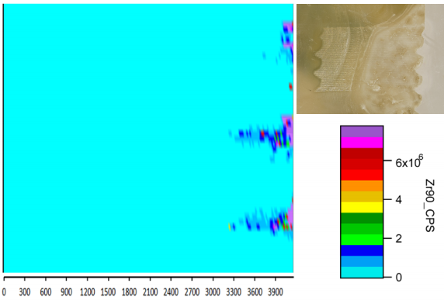

ZrO2-implant

ablated bone

bonebone

**ablated bone**

Distance from laser ablation starting point (µm)

point

Fig 3. The distribution of Zr90 in the bonenear ZrO2-implant, the color bar represents the intensity of Zr.

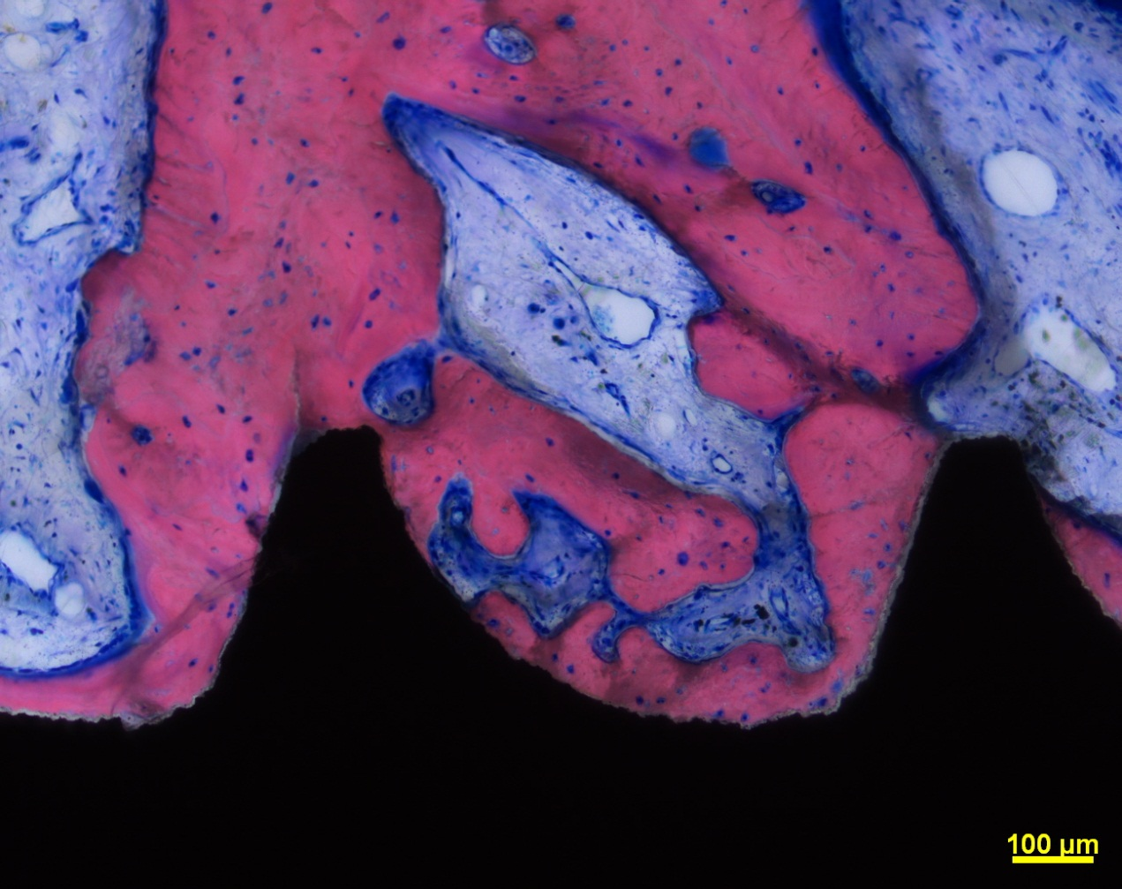

**Bone marrow fibrosis**

**Particles**

**Particles**

**Particles**

**Bone marrow tissues**

**Bone**

**Ti-implant**

Fig 4. Histologic picture of bone slices near Ti implant.

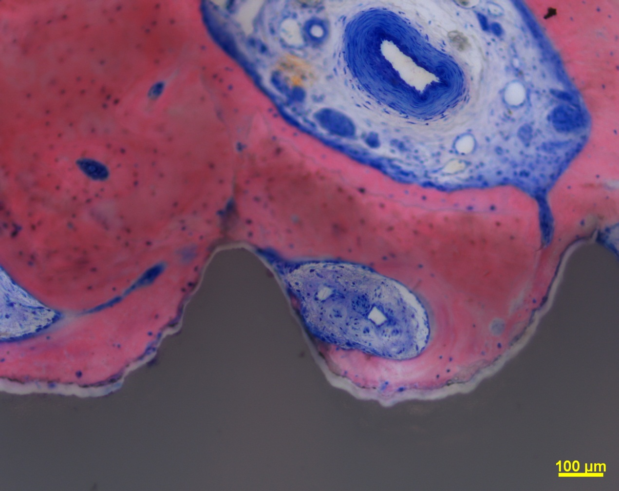

**Bone marrow fibrosis**

**Bone marrow fibrosis**

**ZrO2-implant**

**ZrO2-implant**

Fig 5. Histologic picture of bone slices near ZrO2 implant

Fig 6. Comet assay result of ZrO2-MPs and ZrO2-NPs, * significantly different (p<0.05) with negative control (medium)