**Supplementary Material**

**Supplementary Figure S1.** Flowchart of study population for cortisol profiles analysis.

**Supplementary Table S1.** Salivary cortisol measures by sampling timepoint, by study group and by work shift.

**Supplementary Table S2.** Generalized additive mixed model fitted to log-transformed salivary cortisol.

**Supplementary Figure S2.** Age-, chronotype-, and menopausal-status stratified cortisol smooth curves (with 95% simultaneous CI) in shift workers on day and night shifts.

**Supplementary Table S3:** Number of saliva samples in shift workers on day and night shifts stratified by age, chronotype, and menopausal status.

**Supplementary Table S4:** Shift workers cortisol smooth curves summary measures (with 95% simultaneous confidence intervals) stratified by age (25-34, 35-49, 50-60), by chronotype (early, intermediate, late), and menopausal status (premenopausal, perimenopausal, postmenopausal).

Female hospital staff (77 nurses, 23 other staff) at University Clinic Bergmannsheil in Bochum, Germany (September 2012 – May 2015)

N=100

N=7 women (6 shift workers, 1 non-shift worker) excluded because of:

* N=4 (n=108 saliva samples) corticosteroid-based medication
* N=2 (n=67 saliva samples) antipsychotic medication
* N=1 (n=34 saliva samples) severe obstructive sleep apnea

**Supplementary Figure S1.** Flowchart of study population for cortisol profiles analysis.

Notice: N shows number of participants, and n shows number of saliva samples.

* Exclusion of n=22 saliva samples for night shifts for N=1 woman, who started into the study on the fourth night shift instead of first night shift
* Exclusion of n=395 saliva samples collected during the first night shift, due to lack of time of wake up before first night shift
* Exclusion of n=42 saliva samples with missing time of saliva sampling (n=6 for non-shift workers, n=5 for day shifts in shift workers, n=31 for night shifts)
* Exclusion of n=439 saliva samples with mistimed saliva sampling (n=59 for non-shift workers, n=149 for day shifts in shift workers, n=230 for night shifts)
* Exclusion of n=1 saliva sample (C8: immediately before bed). This sample was taken in the evening after the last night shift instead of directly in the morning

N=21

Day shift: n=216 saliva samples

N=68

Day shift: n=714 saliva samples

Night shift: n=768 saliva samples

N=24

Day shift: n=281 saliva samples

N=69

Day shift: n=809 saliva samples

Night shift: n=1030 saliva samples

N=69

Day shift: n=809 saliva samples

Night shift: n=1447 saliva samples

N=24

Day shift: n=281 saliva samples

**Non-shift workers**

N=25

Day shift: n=293 saliva samples

**Shift workers**

N=75

Day shift: n=880 saliva samples

Night shift: n=1573 saliva samples

**Supplementary Table S1.** Salivary cortisol measures by sampling timepoint, by study group and by work shift.

|  |  |  |  |  |  |  |  |  |  |  |
| --- | --- | --- | --- | --- | --- | --- | --- | --- | --- | --- |
|  | Non-shift workers (N=21) | | |  | Shift workers (N=68) | | | | | |
|  | Day shift (na=216) | | |  | Day shift (na=714) | | | Night shift (na=768) | | |
| Sampling timepoint |  | Time of sampling (clock time) | Cortisol (nmol/L) |  |  | Time of sampling (clock time) | Cortisol (nmol/L) |  | Time of sampling (clock time) | Cortisol (nmol/L) |
|  | *na* | *Mean (95% CI)* | *GM (95% CI)* |  | *na* | *Mean (95% CI)* | *GM (95% CI)* | *na* | *Mean (95% CI)* | *GM (95% CI)* |
| C1: at waking up | 37 | 5:16 (5:03, 5:28) | 16.70 (13.40, 20.80) |  | 120 | 4:40 (4:36, 4:44) | 11.03 (9.68, 12.58) | 100 | 14:40 (14:22, 14:58) | 11.80 (10.60, 13.13) |
| C2: at waking up +30 min | 35 | 5:46 (5:34, 5:59) | 30.68 (25.97, 36.24) |  | 119 | 5:12 (5:08, 5:16) | 28.74 (25.49, 32.40) | 99 | 15:15 (14:57, 15:34) | 20.11 (17.88, 22.62) |
| C3: at the start of work | 37 | 7:05 (6:48, 7:22) | 22.61 (19.42, 26.33) |  | 120 | 6:06 (6:01, 6:10) | 30.15 (27.03, 33.64) | 96 | 21:01 (20:57, 21:06) | 6.37 (5.74, 7.07) |
| C4: at the start of work +2h | NA | NA | NA |  | NA | NA | NA | 95 | 21:42 (20:34, 22:50) | 3.33 (2.96, 3.75) |
| C5: in the middle of work | 37 | 11:21 (11:02, 11:39) | 7.84 (6.59, 9.34) |  | 119 | 10:30 (10:22, 10:38) | 10.13 (9.15, 11.22) | 94 | 1:42 (1:38, 1:47) | 3.75 (3.21, 4.39) |
| C6: at the start of work +6h | NA | NA | NA |  | NA | NA | NA | 95 | 3:18 (3:13, 3:23) | 4.87 (4.22, 5.63) |
| C7: at the end of work | 37 | 15:00 (14:41, 15:20) | 6.93 (5.86, 8.20) |  | 120 | 14:12 (14:07, 14:16) | 8.21 (7.41, 9.10) | 95 | 6:23 (6:19, 6:26) | 8.67 (7.35, 10.23) |
| C8: immediately before bed | 33 | 20:56 (19:06, 22:46) | 2.87 (2.30, 3.58) |  | 116 | 21:24 (20:40, 22:08) | 3.65 (3.20, 4.16) | 94 | 7:49 (7:41, 7:58) | 11.06 (9.47, 12.90) |

Abbreviations: *GM*, geometric mean; *CI*, confidence interval; *NA,* non available.

a Number of saliva samples

**Supplementary Table S2.** Generalized additive mixed model fitted to log-transformed salivary cortisol.

|  |  |  |  |  |
| --- | --- | --- | --- | --- |
| Parametric coefficientsa | Estimate | Std. error | *t*-value | Pr(>|t|) |
| Intercept (shift workers, day shifts) | 2.74 | 0.33 | 8.18 | <0.0001 |
| Shift workers, night shifts | -0.10 | 0.07 | -1.44 | 0.1498 |
| Non-shift workers, day shifts | -0.09 | 0.11 | -0.84 | 0.4025 |
|  |  |  |  |  |
| Smooth terms | edf | Ref.df | *F*-value | *p*-value |
| s(time): shift workers, day shifts | 7.70 | 8.22 | 76.84 | <0.0001 |
| s(time): shift workers, night shifts | 9.70 | 11.71 | 29.33 | <0.0001 |
| s(time): non-shift workers, day shifts | 2.36 | 2.75 | 3.29 | 0.0159 |
| s(time, subject-by-group-by-shift) | 395.2 | 984.0 | 1.76 | <0.0001 |

Abbreviations: *edf*, estimated degrees of freedom; *Ref.df*, reference number of degrees of freedom

aAdjusted for age (years), chronotype (MCTQshift, clocktime), menopausal status (premenopausal, perimenopausal, postmenopausal, other), contraceptive use (no, yes), extreme stress load at saliva sampling time (no, yes), and current smoker status (no, yes)

The parametric part of the model includes the intercept as shift workers on day shifts and the change in the intercept for shift workers on night shifts and non-shift workers on day shifts. The smooth terms of this model include the reference curve for shift workers on day shifts, difference curves for shift workers on night shifts and non-shift workers on day shifts, and the random-effect structure (by subject and shift type).

The *p*-value of the parametric coefficient for “shift workers, night shifts” represents the significance of the intercept difference between day and night shifts in shift workers.

The *p*-value of the smooth term “s(time): shift workers, night shifts” represents the significance of the non-linear difference between day and night shifts in shift workers.

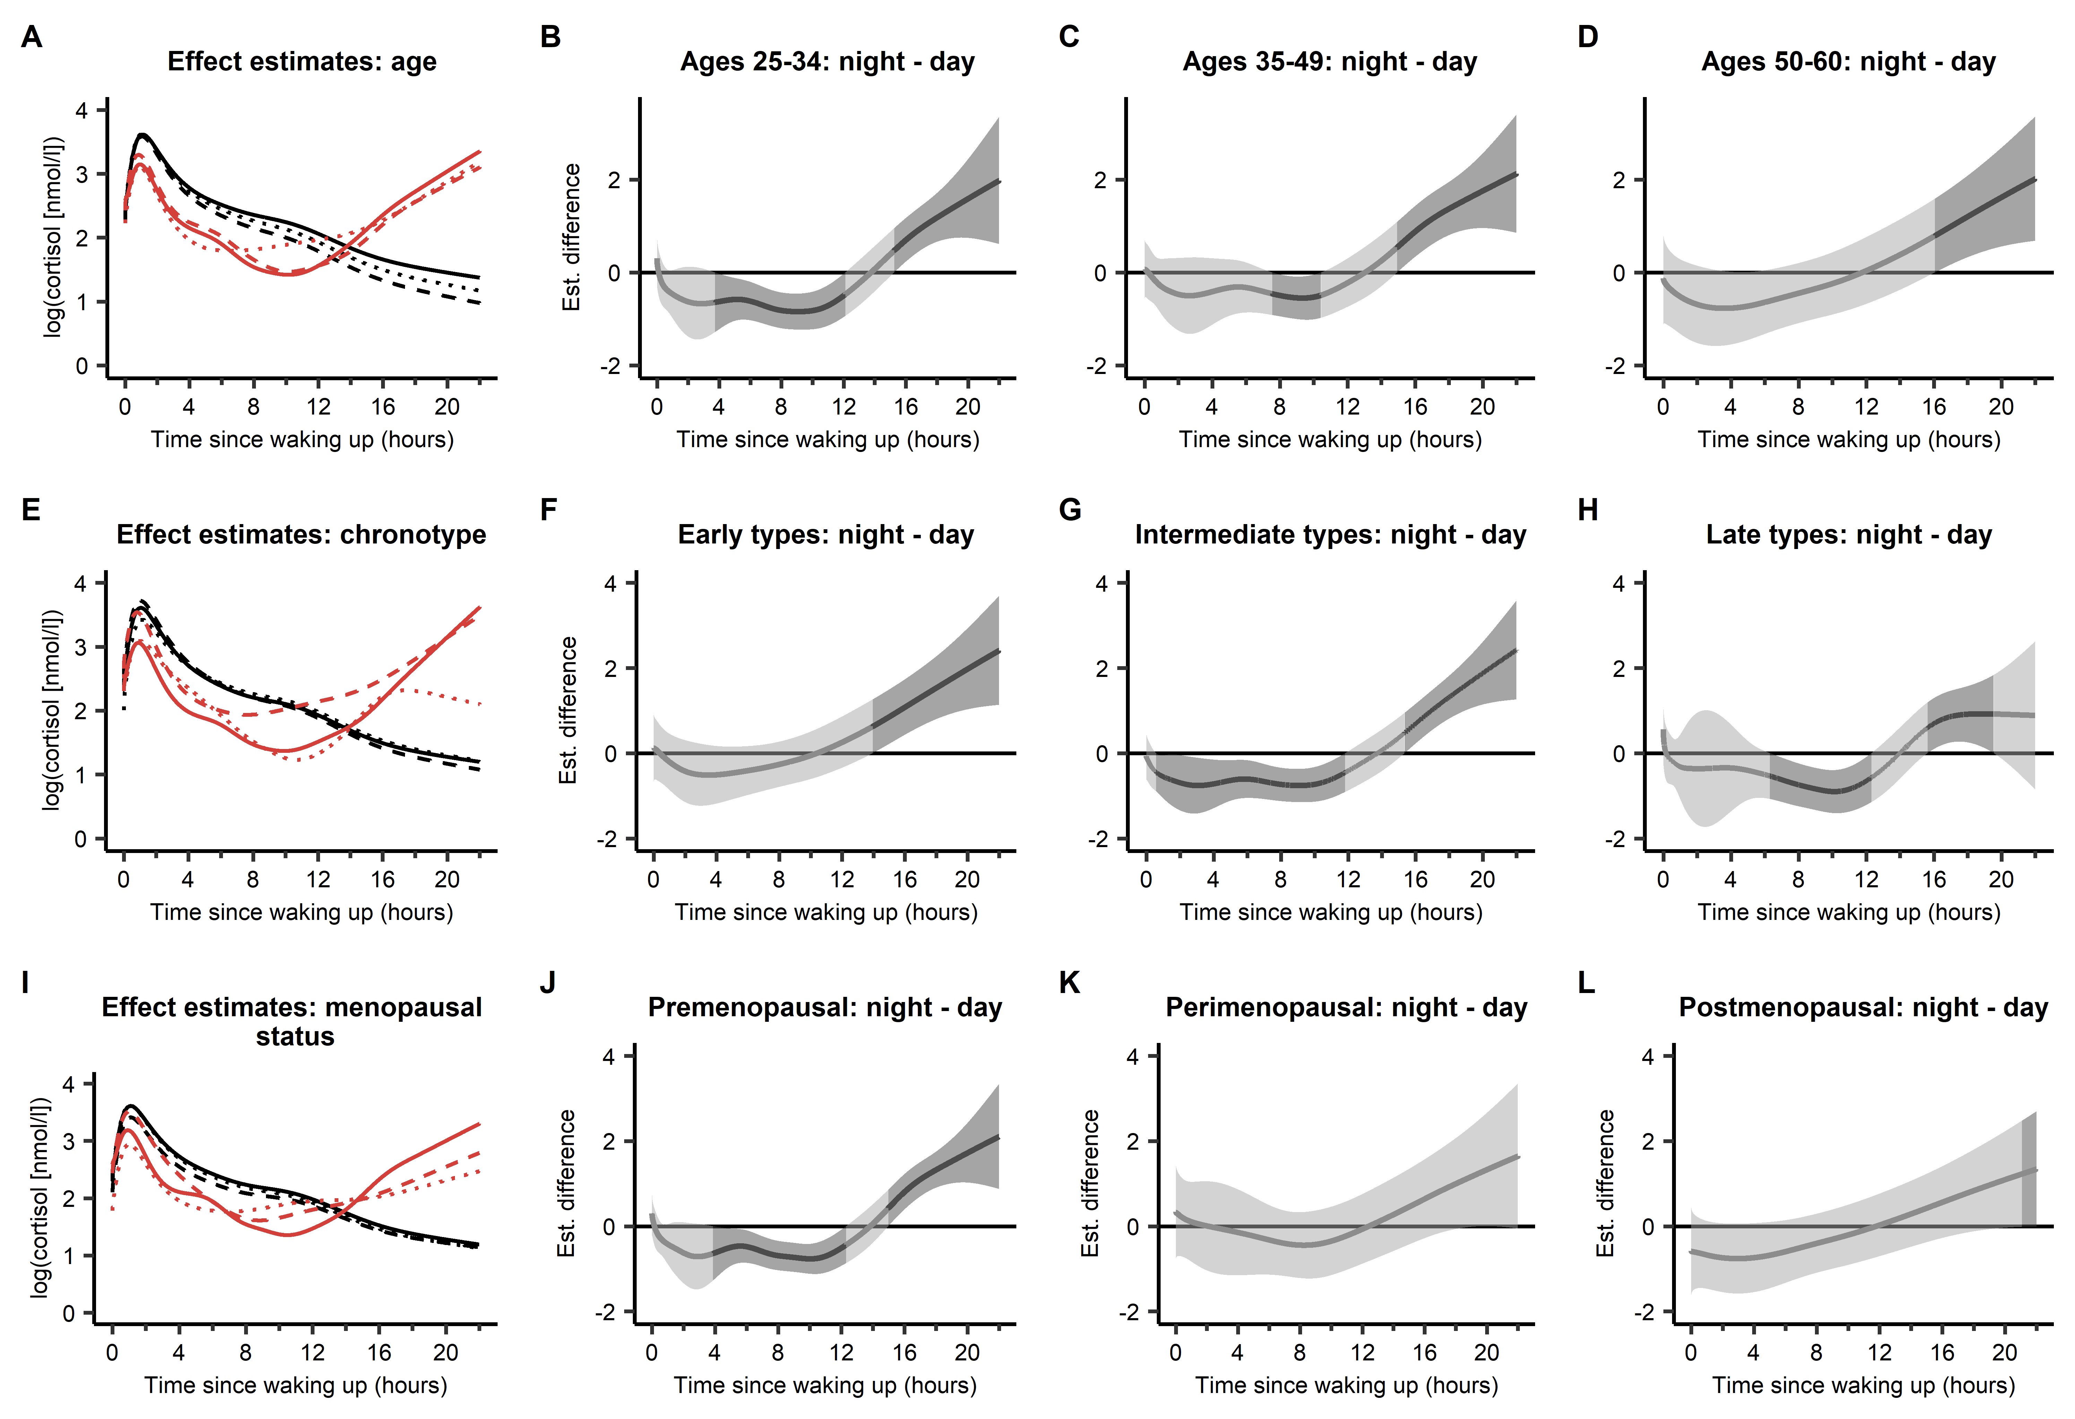

**Supplementary Figure S2.** **Cortisol smooth curves in shift workers on day and night shifts stratified for** **(A)** age groups on day shifts: 25-34 years (──), 35-49 years (- - -), 50-60 years (∙∙∙∙); on night shifts: 25-34 years (──); 35-49 years (- - -), 50-60 years (∙∙∙∙). **(E)** chronotype groups on day shifts: intermediate types (──), early types (- - -), late types (∙∙∙∙); on night shifts: intermediate types (──), early types (- - -); late types (∙∙∙∙). **(I)** menopausal status on day shifts: premenopausal (──), perimenopausal (- - -), postmenopausal (∙∙∙∙); on night shifts: premenopausal (──), perimenopausal (- - -), postmenopausal (∙∙∙∙).

**Estimated difference and 95% simultaneous CI between night and day shifts for** (B) age groups: 25-34 years, (C) 35-49 years, (D) 50-60 years; for chronotype groups: (F) early types, (G) intermediate types, (H) late types; for menopausal status: (J) premenopausal, (K) perimenopausal, (L) postmenopausal. The random effects were set to zero.

In panels B-D, F-H, J-L the dark grey areas represent durations of difference between the curves (night shifts compared to day shifts). The lighter grey areas represent durations of no difference between the curves.

Supplementary Table S3 shows the number of saliva samples for each stratum.

**Supplementary Table S3:** Number of saliva samples in shift workers on day and night shifts stratified by age, chronotype, and menopausal status.

|  |  |  |  |
| --- | --- | --- | --- |
|  | Total | Day shifts | Night shifts |
| Saliva samples, n (%)  Age group, n (%)  25-34  35-49  50-60 | 1482 (100%)  770 (52.0%)  540 (36.4%)  172 (11.6%) | 714 (100%)  258 (36.1%)  272 (38.1%)  84 (11.8%) | 768 (100%)  412 (53.6%)  268 (34.9%)  88 (11.5%) |
| Chronotype group, n (%)  Intermediate  Early  Late | 738 (49.8%)  268 (18.1%)  476 (32.1%) | 352 (49.3%)  138 (19.3%)  224 (31.4%) | 386 (50.3%)  130 (16.9%)  252 (32.8%) |
| Menopausal status, n (%)  Premenopausal  Perimenopausal  Postmenopausal  Surgical/other amenorrhea | 1174 (79.2%)  139 (9.4%)  149 (10.1%)  20 (1.3%) | 577 (80.8%)  59 (8.3%)  66 (9.2%)  12 (1.7%) | 597 (77.7%)  80 (10.4%)  83 (10.8%)  8 (1.0%) |

**Supplementary Table S4:** Shift workers cortisol smooth curves summary measures (with 95% simultaneous confidence intervals) stratified by age (25-34, 35-49, 50-60), by chronotype (early, intermediate, late), and menopausal status (premenopausal, perimenopausal, postmenopausal).

|  |  |  |  |
| --- | --- | --- | --- |
|  | Day shifts | Night shifts | Difference (95% CI) |
| **CARAUC(I) (95% CI)**  Age (years)  25-34  35-49  50-60  Chronotype  Early  Intermediate  Late  Menopausal status  Premenopausal  Perimenopausal  Postmenopausal | 0.69 (0.36, 1.01)  0.60 (0.27, 0.91)  0.64 (0.31, 0.95)  0.58 (0.27, 0.89)  0.64 (0.32, 0.96)  0.81 (0.45, 1.16)  0.68 (0.36, 0.99)  0.69 (0.34, 1.02)  0.63 (0.29, 0.96) | 0.14 (-0.20, 0.46)  0.34 (0.03, 0.65)  0.34 (-0.03, 0.72)  0.35 (0.04, 0.66)  0.31 (-0.01, 0.65)  0.09 (-0.29, 0.49)  0.17 (-0.13, 0.47)  0.47 (0.01, 0.95)  0.52 (0.11, 0.91) | -0.55 (-1.00, -0.08)  -0.26 (-0.70, 0.18)  -0.30 (-0.79, 0.18)  -0.24 (-0.69, 0.19)  -0.33 (-0.78, 0.11)  -0.72 (-1.26, -0.19)  -0.52 (-0.95, -0.09)  -0.22 (-0.77, 0.34)  -0.11 (-0.64, 0.37) |
| **Peak-to-bed slope (95% CI)**  Age (years)  25-34  35-49  50-60  Chronotype  Early  Intermediate  Late  Menopausal status  Premenopausal  Perimenopausal  Postmenopausal | -2.95 (-3.83, -2.05)  -3.37 (-4.35, -2.38)  -3.19 (-4.40, -2.04)  -3.22 (-4.23, -2.19)  -2.96 (-3.83, -2.09)  -2.74 (-3.75, -1.67)  -3.01 (-3.87, -2.12)  -2.82 (-4.00, -1.63)  -3.09 (-4.27, -1.94) | -0.23 (-1.56, 1.14)  -0.69 (-2.00, 0.58)  -0.39 (-1.68, 1.00)  -0.45 (-1.84, 0.89)  0.24 (-0.95, 1.50)  -1.55 (-3.15, -0.02)  -0.51 (-1.66, 0.65)  -1.49 (-3.05, 0.23)  -1.17 (-2.47, 0.14) | 2.72 (1.24, 4.23)  2.68 (1.00, 4.28)  2.81 (1.07, 4.53)  2.77 (1.01, 4.51)  3.20 (1.83, 4.68)  1.19 (-0.62, 2.98)  2.49 (1.13, 3.91)  1.34 (-0.54, 3.27)  1.92 (0.36, 3.57) |
| **AUCG(0-22h) (95% CI)**  Age (years)  25-34  35-49  50-60  Chronotype  Early  Intermediate  Late  Menopausal status  Premenopausal  Perimenopausal  Postmenopausal | 52.43 (45.96, 59.02)  48.89 (41.45, 56.25)  50.94 (40.42, 61.06)  51.68 (43.83, 59.29)  51.16 (44.94, 57.45)  49.91 (42.48, 57.62)  51.94 (45.44, 58.27)  48.68 (39.48, 58.34)  51.48 (41.46, 60.83) | 39.88 (32.02, 47.29)  40.65 (32.66, 48.37)  39.74 (30.08, 50.10)  44.70 (36.22, 53.22)  36.61 (29.04, 44.37)  36.15 (26.81, 45.10)  37.94 (31.22, 45.31)  40.36 (30.19, 50.50)  34.37 (24.52, 44.42) | -12.55 (-21.96, -3.26)  -8.24 (-19.44, 2.84)  -11.20 (-23.76, 1.45)  -6.97 (-19.64, 5.81)  -14.55 (-23.83, -4.61)  -13.75 (-24.90, -2.43)  -14.00 (-23.00, -4.46)  -8.32 (-20.68, 4.54)  -17.11 (-29.74, -4.31) |

Abbreviations: *CI*, confidence interval; *CARAUC(I)*, cortisol awakening response calculated as the area under the curve with respect to increase from 0 to timepoint of post-awakening peak; *AUCG(0-22h*), total area under the fitted cortisol smooth curve over the time since waking up from 0 to 22 hours (log(nmol/L) × hour). All summary measures were estimated from generalized additive mixed models (data not shown).