**Supplementary Material Online**

**THE GIESSEN PULMONARY HYPERTENSION REGISTRY: SURVIVAL IN PULMONARY HYPERTENSION SUBGROUPS**

Henning Gall, MD, Janine F. Felix, PhD, Franziska K. Schneck, MD, Katrin Milger, MD, Natascha Sommer, PhD, Robert Voswinckel, MD, Oscar H. Franco, PhD, Albert Hofman, PhD, Ralph T. Schermuly, PhD, Norbert Weissmann, PhD, Friedrich Grimminger, PhD, Werner Seeger, MD, and Hossein A. Ghofrani, MD

# Supplementary Appendix

## Comparison with other key registries – systematic literature search

In order to discuss the results of our study within the context of other published studies, we performed a systematic literature search to identify registry studies of patients with pulmonary hypertension (PH) or pulmonary arterial hypertension (PAH) that reported survival data. This was performed on 3 August 2016 in PubMed and used the following search string: (“pulmonary hypertension” OR “pulmonary arterial hypertension”) AND (registry OR cohort) AND (survival OR survived OR surviving OR mortality OR died OR dying OR death) [no limits]. This strategy retrieved 1011 publications. Studies were considered for inclusion by manual screening of article titles (and subsequently, of full articles) to identify registry studies in relevant populations, published in English, which also included mortality data. The search identified a range of national and international registry studies.1-30 Results from registries of particular historical relevance 1 or of a reasonable size (i.e. more than 250 patients with PH) have been reported in the main manuscript.2-20 Some additional references fulfilled the systematic search criteria but were too small to draw meaningful comparisons concerning overall mortality rates, and thus are not discussed.21-29 Nevertheless, the mortality rates described in most of these smaller studies broadly agree with those from larger studies of the same era; exceptions that tended to show lower survival than other larger registries included a Chinese PAH registry published in 200723 and two more recently published registries in Africa28 and Saudi Arabia.26 Another study, whilst large (i.e. a cohort of 1283 patients with incident PAH) concerned the effect of anticoagulant use on patients’ survival and thus was not included as it focused exclusively on areas beyond the scope of this article.30

## Supplementary references

1. D'Alonzo GE, Barst RJ, Ayres SM, et al. Survival in patients with primary pulmonary hypertension. Results from a national prospective registry. Ann Intern Med 1991;115:343-9.

2. Benza RL, Miller DP, Gomberg-Maitland M, et al. Predicting survival in pulmonary arterial hypertension: insights from the Registry to Evaluate Early and Long-Term Pulmonary Arterial Hypertension Disease Management (REVEAL). Circulation 2010;122:164-72.

3. Farber HW, Miller DP, Poms AD, et al. Five-Year outcomes of patients enrolled in the REVEAL Registry. Chest 2015;148:1043-54.

4. Humbert M, Sitbon O, Chaouat A, et al. Survival in patients with idiopathic, familial, and anorexigen-associated pulmonary arterial hypertension in the modern management era. Circulation 2010;122:156-63.

5. Humbert M, Sitbon O, Chaouat A, et al. Pulmonary arterial hypertension in France: results from a national registry. Am J Respir Crit Care Med 2006;173:1023-30.

6. Escribano-Subias P, Blanco I, Lopez-Meseguer M, et al. Survival in pulmonary hypertension in Spain: insights from the Spanish registry. Eur Respir J 2012;40:596-603.

7. Alonso-Gonzalez R, Lopez-Guarch CJ, Subirana-Domenech MT, et al. Pulmonary hypertension and congenital heart disease: An insight from the REHAP National Registry. Int J Cardiol 2015;184:717-23.

8. Escribano-Subias P, Del Pozo R, Roman-Broto A, et al. Management and outcomes in chronic thromboembolic pulmonary hypertension: From expert centers to a nationwide perspective. Int J Cardiol 2016;203:938-44.

9. Humbert M, Sitbon O, Yaici A, et al. Survival in incident and prevalent cohorts of patients with pulmonary arterial hypertension. Eur Respir J 2010;36:549-55.

10. Hurdman J, Condliffe R, Elliot CA, et al. Aspire Registry: assessing the spectrum of pulmonary hypertension identified at a referral centre. Eur Respir J 2012;39:945-55.

11. Ling Y, Johnson MK, Kiely DG, et al. Changing demographics, epidemiology, and survival of incident pulmonary arterial hypertension: results from the pulmonary hypertension registry of the United Kingdom and Ireland. Am J Respir Crit Care Med 2012;186:790-6.

12. Peacock AJ, Murphy NF, McMurray JJ, Caballero L, Stewart S. An epidemiological study of pulmonary arterial hypertension. Eur Respir J 2007;30:104-9.

13. Clements PJ, Tan M, McLaughlin VV, et al. The pulmonary arterial hypertension quality enhancement research initiative: comparison of patients with idiopathic PAH to patients with systemic sclerosis-associated PAH. Ann Rheum Dis 2012;71:249-52.

14. Condliffe R, Kiely DG, Gibbs JS, et al. Improved outcomes in medically and surgically treated chronic thromboembolic pulmonary hypertension. Am J Respir Crit Care Med 2008;177:1122-7.

15. Delcroix M, Lang I, Pepke-Zaba J, et al. Long-Term Outcome of Patients With Chronic Thromboembolic Pulmonary Hypertension: Results From an International Prospective Registry. Circulation 2016;133:859-71.

16. Mueller-Mottet S, Stricker H, Domenighetti G, et al. Long-term data from the Swiss pulmonary hypertension registry. Respiration 2015;89:127-40.

17. Fares WH, Bellumkonda L, Tonelli AR, et al. Right atrial pressure/pulmonary artery wedge pressure ratio: A more specific predictor of survival in pulmonary arterial hypertension. J Heart Lung Transplant 2016;35:760-7.

18. Thenappan T, Shah SJ, Rich S, Gomberg-Maitland M. A USA-based registry for pulmonary arterial hypertension: 1982-2006. Eur Respir J 2007;30:1103-10.

19. Chung WJ, Park YB, Jeon CH, et al. Baseline Characteristics of the Korean Registry of Pulmonary Arterial Hypertension. J Korean Med Sci 2015;30:1429-38.

20. Cannon JE, Su L, Kiely DG, et al. Dynamic Risk Stratification of Patient Long-Term Outcome After Pulmonary Endarterectomy: Results From the United Kingdom National Cohort. Circulation 2016;133:1761-71.

21. Jansa P, Jarkovsky J, Al-Hiti H, et al. Epidemiology and long-term survival of pulmonary arterial hypertension in the Czech Republic: a retrospective analysis of a nationwide registry. BMC Pulm Med 2014;14:45.

22. Baptista R, Meireles J, Agapito A, et al. Pulmonary hypertension in Portugal: first data from a nationwide registry. Biomed Res Int 2013;2013:489574.

23. Jing ZC, Xu XQ, Han ZY, et al. Registry and survival study in chinese patients with idiopathic and familial pulmonary arterial hypertension. Chest 2007;132:373-9.

24. Al-Naamani N, Espitia HG, Velazquez-Moreno H, et al. Chronic Thromboembolic Pulmonary Hypertension: Experience from a Single Center in Mexico. Lung 2016;194:315-23.

25. Park SY, Lee SM, Shin JW, et al. Epidemiology of chronic thromboembolic pulmonary hypertension in Korea: results from the Korean registry. Korean J Intern Med 2016;31:305-12.

26. Idrees M, Alnajashi K, Abdulhameed J, et al. Saudi experience in the management of pulmonary arterial hypertension; the outcome of PAH therapy with the exclusion of chronic parenteral prostacyclin. Ann Thorac Med 2015;10:204-11.

27. Korsholm K, Andersen A, Kirkfeldt RE, Hansen KN, Mellemkjaer S, Nielsen-Kudsk JE. Survival in an incident cohort of patients with pulmonary arterial hypertension in Denmark. Pulm Circ 2015;5:364-9.

28. Thienemann F, Dzudie A, Mocumbi AO, et al. The causes, treatment, and outcome of pulmonary hypertension in Africa: Insights from the Pan African Pulmonary Hypertension Cohort (PAPUCO) Registry. Int J Cardiol 2016;221:205-11.

29. Alves JL, Jr., Gavilanes F, Jardim C, et al. Pulmonary arterial hypertension in the southern hemisphere: results from a registry of incident Brazilian cases. Chest 2015;147:495-501.

30. Olsson KM, Delcroix M, Ghofrani HA, et al. Anticoagulation and survival in pulmonary arterial hypertension: results from the Comparative, Prospective Registry of Newly Initiated Therapies for Pulmonary Hypertension (COMPERA). Circulation 2014;129:57-65.

31. Galie N, Humbert M, Vachiery JL, et al. 2015 ESC/ERS Guidelines for the diagnosis and treatment of pulmonary hypertension: The Joint Task Force for the Diagnosis and Treatment of Pulmonary Hypertension of the European Society of Cardiology (ESC) and the European Respiratory Society (ERS): Endorsed by: Association for European Paediatric and Congenital Cardiology (AEPC), International Society for Heart and Lung Transplantation (ISHLT). Eur Heart J 2016;37:67-119.

# Supplementary Tables

## Supplementary Table S1. Baseline Characteristics of Patients with PAH by Main Etiologic Sub-type

|  |  |  |  |  |
| --- | --- | --- | --- | --- |
|  | PAH | IPAH | CTD | CHD |
| Patients, *n* | 685 | 294 | 145 | 91 |
| Female sex, *n* (%) | 447 (65) | 193 (66) | 122 (84) | 54 (59) |
| Age, mean (SD), y | 51 (16) | 49 (16) | 57 (15) | 47 (16) |
| NYHA FC, *n* (%) |  |  |  |  |
| II | 106 (19) | 43 (17) | 19 (16) | 19 (23) |
| III | 338 (59) | 157 (63) | 60 (51) | 54 (65) |
| IV | 126 (22) | 48 (19) | 39 (33) | 10 (12) |
| 6MWD, mean (SD), m | 325 (126) | 347 (121) | 273 (135) | 345 (102) |
| RAP, mean (SD), mmHg | 8 (6) | 7 (6) | 8 (6) | 8 (5) |
| mPAP, mean (SD), mmHg | 51 (16) | 53 (16) | 46 (14) | 58 (25) |
| PCWP, mean (SD), mmHg | 8 (4) | 7 (3) | 8 (4) | 10 (5) |
| CI, mean (SD), L/min/m2 | 2.3 (0.8) | 2.1 (0.6) | 2.2 (0.7) | 2.8 (1.0) |
| PVR, median (IQR), dyne.s/cm5 | 846 (720) | 1080 (582) | 924 (541) | 948 (675) |
| venSO2, mean (SD), % | 61 (10) | 61 (10) | 60 (10) | 67 (9) |
| paO2, mean (SD), mmHg | 68 (14) | 68 (14) | 68 (13) | 64 (14) |

CHD, pulmonary arterial hypertension associated with congenital heart disease; CI, cardiac index; CTD, pulmonary arterial hypertension associated with connective tissue disease; IPAH, idiopathic pulmonary arterial hypertension; IQR, interquartile range; mPAP, mean pulmonary artery pressure; NYHA FC, New York Heart Association functional class; PAH, pulmonary arterial hypertension; paO2, arterial oxygen partial pressure; PCWP, pulmonary capillary wedge pressure; PVR, pulmonary vascular resistance; RAP, right atrial pressure; venSO2, mixed venous oxygen saturation; 6MWD, 6-minute walk distance.

## Supplementary Table S2. Baseline Characteristics of Patients with Pulmonary Hypertension due to Left Heart Disease, Categorized by PVRa

|  |  |  |
| --- | --- | --- |
|  | Ipc-PHb (*n*= 129) | Cpc-PHc (*n*= 172) |
| Female sex, *n* (%) | 75 (58) | 100 (58) |
| Age, mean (SD), y | 66 (11) | 68 (11) |
| NYHA FC, *n* (%) |  |  |
| II | 30 (23) | 34 (20) |
| III | 85 (66) | 110 (64) |
| IV | 14 (11) | 28 (16) |
| 6MWD, mean (SD), m | 315 (115) | 299 (113) |
| RAP, mean (SD), mmHg | 9 (6) | 10 (5) |
| mPAP, mean (SD), mmHg | 29 (7) | 40 (10) |
| PCWP, mean (SD), mmHg | 19 (6) | 18 (7) |
| CI, mean (SD), L/min/m2 | 2.4 (0.4) | 2.1 (0.5) |
| PVR, median (IQR), dyne.s/cm5 | 156 (85) | 367 (231) |
| venSO2, mean (SD), % | 68 (7) | 60 (8) |
| paO2, mean (SD), mmHg | 73 (10) | 69 (14) |

CI, cardiac index; Cpc-PH, combined post-capillary and pre-capillary pulmonary hypertension; DPG, diastolic pressure gradient; Ipc-PH, isolated post-capillary pulmonary hypertension; IQR, interquartile range; mPAP, mean pulmonary artery pressure; NYHA FC, New York Heart Association functional class; paO2, arterial oxygen partial pressure; PCWP, pulmonary capillary wedge pressure; PH, pulmonary hypertension; PVH, pulmonary hypertension owing to left heart disease; PVR, pulmonary vascular resistance; RAP, right atrial pressure; venSO2, mixed venous oxygen saturation; 6MWD, 6-minute walk distance.

aRecent European PH guidelines recommend defining Ipc-PH and Cpc-PH using a combination of DPG and/or PVR (DPG < 7 mmHg and/or PVR ≤ 3 Wood Units for Ipc-PH, and DPG ≥ 7 mmHg and/or PVR > 3 Wood Units for Cpc-PH).31 Eighty-four patients in our PVH group had a negative DPG, which we could not interpret. In addition, many patients in our cohort were not classified when we applied both DPG and PVR criteria to distinguish Ipc-PH and Cpc-PH. Conversely, classification based on either DPG or PVR resulted in many patients being classified as having both Ipc-PH and Cpc-PH. We therefore classified our patients based on PVR. Of 307 patients with PVH, 301 had PVR data and are presented in this table.

bPVR ≤ 3 Wood Units.

cPVR > 3 Wood Units.

## Supplementary Table S3. Baseline Characteristics of Patients with Pulmonary Hypertension Owing to Lung Disease (LD-PH), and its Two Main Etiologic Sub-types

|  |  |  |  |
| --- | --- | --- | --- |
|  | LD-PH (*n*= 546)a | COPD (*n*= 218) | ILD (*n*= 283) |
| Female sex, *n* (%) | 218 (40) | 87 (40) | 115 (41) |
| Age, mean (SD), y | 64 (11) | 64 (10) | 64 (12) |
| NYHA FC, *n* (%) |  |  |  |
| II | 39 (12) | 13 (9) | 21 (12) |
| III | 182 (54) | 87 (61) | 85 (49) |
| IV | 119 (35) | 42 (30) | 68 (39) |
| 6MWD, m (SD) | 263 (115) | 259 (105) | 263 (123) |
| RAP, mean (SD), mmHg | 5 (4) | 5 (4) | 5 (4) |
| mPAP, mean (SD), mmHg | 34 (11) | 32 (10) | 34 (12) |
| PCWP, mean (SD), mmHg | 8 (4) | 8 (4) | 8 (3) |
| CI, mean (SD), L/min/m2 | 2.5 (0.7) | 2.6 (0.7) | 2.4 (0.6) |
| PVR, median (IQR), dyne.s/cm5 | 407 (329) | 416 (245) | 536 (334) |
| venSO2, mean (SD), % | 65 (8) | 66 (7) | 64 (8) |
| paO2, mean (SD), mmHg | 67 (16) | 67 (17) | 67 (16) |
| FEV1, mean (SD), % VC | – | 46.9 (21.0) | 64.6 (19.9) |
| TLC, mean (SD), L | – | 6.8 (1.7) | 4.2 (1.4) |
| DLCO, mean (SD), % pred. | – | 40.5 (23.1) | 40.4 (20.8) |

CI, cardiac index; COPD, chronic obstructive pulmonary disease; DLCO, diffusing capacity of the lung for carbon monoxide; FEV1, forced expiratory volume in the first second of expiration; ILD, interstitial lung disease; IQR, interquartile range; LD-PH, pulmonary hypertension due to lung disease; mPAP, mean pulmonary artery pressure; NYHA FC, New York Heart Association functional class; paO2, arterial oxygen partial pressure; PCWP, pulmonary capillary wedge pressure; pred., predicted; PVR, pulmonary vascular resistance; RAP, right atrial pressure; TLC, total lung capacity; VC, vital capacity; venSO2, mixed venous oxygen saturation; 6MWD, 6-minute walk distance.

aMost patients with LD-PH (*n*= 546) had COPD (*n*= 218; 39.9%) or ILD (*n*= 283; 51.8%). The remaining patients (*n*= 45) had LD-PH from various other causes.

## Supplementary Table S4. Causes of Death in Pulmonary Hypertension Subgroupsa

|  |  |  |  |  |
| --- | --- | --- | --- | --- |
| Cause of death, % | PAH (*n*= 685) | PVH (*n*= 307) | LD-PH (*n*= 546) | CTEPH (*n*= 459) |
| Unknown | 36.7 | 47.5 | 36.0 | 42.7 |
| Right heart failure | 25.8 | 6.9 | 6.8 | 22.9 |
| Respiratory failure | 7.8 | 2.8 | 24.2 | 1.8 |
| Left and right heart failure | 2.7 | 15.2 | 3.9 | 4.6 |
| Sepsis | 4.1 | 3.7 | 6.8 | 3.7 |
| Malignancy | 4.1 | 6.0 | 3.7 | 5.0 |
| Infection | 3.4 | 1.4 | 6.0 | 4.1 |
| Sudden cardiac death | 2.4 | 4.1 | 2.7 | 2.8 |
| At intervention | 1.7 | 1.8 | 0.2 | 4.1 |
| Renal failure | 1.2 | 3.2 | 0.8 | 0.9 |
| Liver failure | 1.0 | 0.9 | 0.0 | 0.5 |
| Intracranial bleeding | 0.2 | 0.9 | 0.4 | 0.0 |
| Gastrointestinal tract bleeding | 0.0 | 0.0 | 0.2 | 0.5 |
| Rupture of pulmonary artery | 0.0 | 0.0 | 0.0 | 0.9 |
| Other | 1.7 | 3.2 | 1.9 | 5.0 |

CTEPH, chronic thromboembolic pulmonary hypertension; LD-PH, pulmonary hypertension due to lung disease; PAH, pulmonary arterial hypertension; PVH, pulmonary hypertension due to left heart disease.

aLung transplant was also counted as an event in survival analyses (i.e. transplant-free survival), and occurred in 7.1%, 2.3%, 6.2%, and 0.5% of the PAH, PVH, LD-PH, and CTEPH groups, respectively.

## Supplementary Table S5. Risk Factors for Survival (All-cause Mortality) Using a Multivariate Cox Regression Model

|  | PAH, *n*= 685  HR (95% CI; *p*-value) | PVH, *n*= 307  HR (95% CI; *p*-value) | LD-PH, *n*= 546  HR (95% CI; *p*-value) | CTEPH, *n*= 459  HR (95% CI; *p*-value) |
| --- | --- | --- | --- | --- |
| NYHA |  |  |  |  |
| Class II | Reference | Reference | Reference | Reference |
| Class III | 1.06 (0.62–1.81; 0.838) | 1.31 (0.34–5.06; 0.695) | 1.26 (0.66–2.42; 0.486) | 1.65 (0.37–7.43; 0.514) |
| Class IV | 1.08 (0.59–1.98; 0.804) | 1.41 (0.33–5.94; 0.641) | 1.14 (0.56–2.35; 0.716) | 2.45 (0.53–11.34; 0.251) |
| Age (years)a |  |  |  |  |
| <50 | Reference | Reference | Reference | Reference |
| 50–63 | 1.24 (0.85–1.80; 0.265) | 1.36 (0.14–13.58; 0.795) | 0.78 (0.40–1.55; 0.484) | 0.82 (0.24–2.75; 0.745) |
| 63–71 | 1.83 (1.23–2.72; 0.003) | 3.17 (0.39–25.58; 0.278) | 0.86 (0.42–1.76; 0.672) | 1.41 (0.45–4.45; 0.558) |
| >71 | 1.32 (0.81–2.14; 0.266) | 2.61 (0.32–21.15; 0.369) | 1.28 (0.63–2.59; 0.500) | 2.80 (0.93–8.48; 0.068) |
| Sex |  |  |  |  |
| Male (female as reference) | 1.81 (1.34–2.45;< 0.001) | 1.77 (0.85–3.66; 0.125) | 1.14 (0.79–1.65; 0.488) | 2.72 (1.59–4.67;< 0.001) |
| 6MWD (meters)b |  |  |  |  |
| >390 | Reference | Reference | Reference | Reference |
| 311–390 | 2.17 (1.34–3.51; 0.002) | 1.89 (0.36–9.97; 0.454) | 1.85 (0.76–4.50; 0.174) | 3.23 (0.89–11.68; 0.074) |
| 216–311 | 2.56 (1.54–4.26; < 0.001) | 5.03 (0.95–26.72; 0.058) | 2.63 (1.10–6.30; 0.029) | 3.65 (1.02–13.11; 0.047) |
| <216 | 5.87 (3.53–9.78; < 0.001) | 10.69 (2.05–55.74; 0.005) | 3.73 (1.52–9.13; 0.004) | 4.53 (1.23–16.76; 0.023) |

CI, confidence interval; CTEPH, chronic thromboembolic pulmonary hypertension; HR, hazard ratio; LD-PH, pulmonary hypertension due to lung disease; NYHA New York Heart Association functional class; PAH, pulmonary arterial hypertension; PVH, pulmonary hypertension due to left heart disease; 6MWD, 6-minute walk distance. aAge groups represent quartiles. b6MWD groups represent quartiles of the full population.

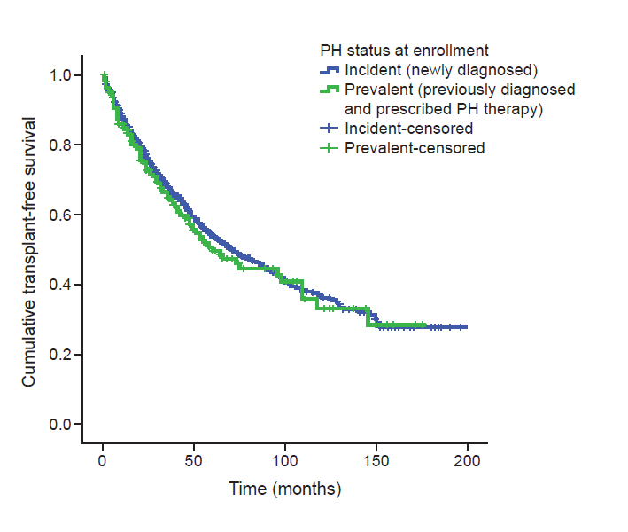

## Supplementary Figure S1. Comparison of transplant-free survival for all pulmonary hypertension etiologies grouped as incident (*n*= 1861) or prevalent (*n*= 206) cases (no significant difference between groups; log rank *p*= 0.447).

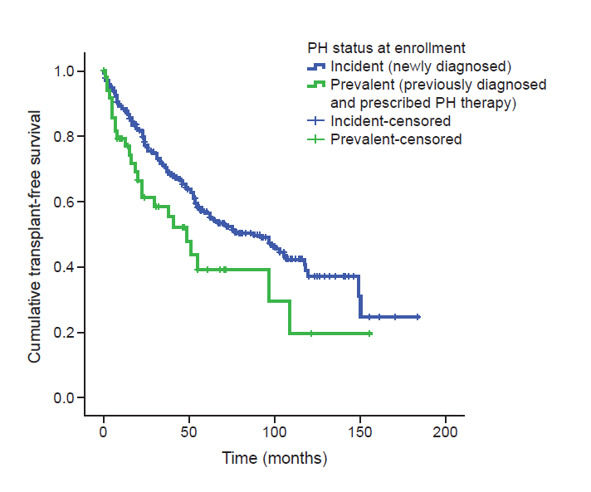

## Supplementary Figure S2. Comparison of transplant-free survival for patients with associated pulmonary arterial hypertension (APAH) grouped as incident (*n*= 325) or prevalent (*n*= 38) cases (significant difference between groups; log rank *p*= 0.023).

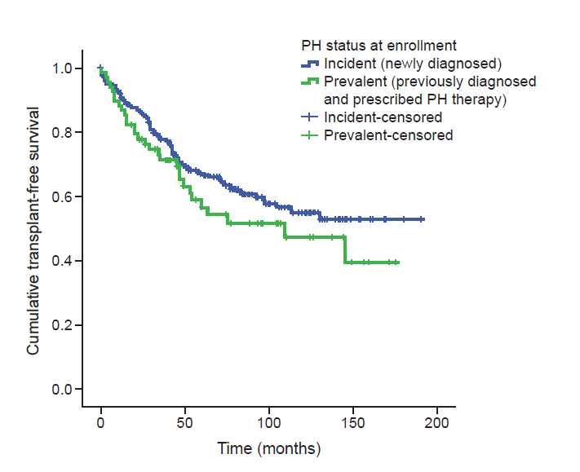

## Supplementary Figure S3. Comparison of transplant-free survival for patients with idiopathic pulmonary arterial hypertension (IPAH) grouped as incident (*n*= 226) or prevalent (*n*= 68) cases (no significant difference between groups; log rank *p* = 0.201).