**Supplemental Materials**

**Community greenness, blood pressure, and hypertension in urban dwellers: the 33 Communities Chinese Health Study**

Bo-Yi Yang, Iana Markevych, Michael S. Bloom, Joachim Heinrich, Yuming Guo, Lidia Morawska, Shyamali C. Dharmage, Luke D. Knibbs, Bin Jalaludin, Pasi Jalava, Xiao-Wen Zeng, Li-Wen Hu, Kang-Kang Liu, Guang-Hui Dong

**Table of contents**

**Table S1** Summary of prior studies of green space and blood pressure and hypertension

**Table S2** Maincharacteristics of study participants

**Table S3** Distribution for NDVI and SAVI in 33 communities

**Table S4** Correlations between NDVI, SAVI, and air pollutants

**Table S5** Associations between per IQR increase in SAVIaand blood pressure metrics

(n=24,845)

**Table S6** Associations between NDVI500-m and blood pressures in sensitivity analyses

**Table S7** Associations between per IQR increase in NDVI and blood pressure metrics before and after additional adjustment for physical activity (n = 24,845)

**Fig. S1**. Directed acyclic graph for the association between greenness and blood pressure, showing all potential confounders and mediators. Pink lines indicate potential confounders and green lines indicate potential mediators.

**Fig. S2**. Directed acyclic graph for the association between greenness and blood pressure, showing only confounders and mediators retained in the final models. Pink lines indicate potential confounders and green lines indicate potential mediators.

**Table S1** Summary of prior studies of green space and blood pressure and hypertension

|  |  |  |  |  |
| --- | --- | --- | --- | --- |
| Authors, publication year [reference] | Study design | Country | Population | Main findings |
| Dzhambov et al. 2018 [1] | Cross-sectional study | Austria | 555 adults with a mean age of 46.59 years | Higher overall greenness was associated with lower odds of hyper/hypotension and lower SBP levels. |
| Groenewegen et al. 2018 [2] | Cross-sectional study | Netherlands | 1,159,529 people of all ages | Higher percentage of green space was associated with lower risk of hypertension. |
| Jia et al. 2018 [3] | Cross-sectional study | China | 1944 residents (40 years or older | Compared to the group with low NDVI levels, people living in moderate-to-high NDVI exposures had a significant reduction in risk of hypertension (55-84% reduction). |
| Jendrossek et al. 2017 [4] | Cross-sectional study | Germany | Women (47.6 years on average in Munich and 45.7 years in Wesel) (n = 3063) | No significant association was observed between NDVI500m and hypertension prevalence. |
| Vienneau et al. 2017 [5] | Cohort study | Switzerland | 4.2 million adults (≥30 years) | Higher greenspace exposure was associated with lower hypertension related deaths. |
| Bijnens et al. 2017 [6] | Cross-sectional study | Belgium | 278 twins with a mean age of 20.9 years | Higher greenness in the early-life environment was independently associated with both SBP and DBP levels. |
| Lane et al. 2017 [7] | Cross-sectional study | India | 3150 adults >20 years | A 0.17-unit decrease in NDVI was associated with 4.3mmHg, 1.2 mmHg, and 3.1mmHg increase in SBP, DBP, and cPP, respectively. |
| Brown et al. 2016 [8] | Cross-sectional study | United States | 249,405 medicare beneficiaries (≥65 years) | Each 0.1-unit increase in NDVI was associated with a significant 7% decrease of hypertension. |
| Markevych et al. 2014 [9] | Cross-sectional study | Germany | Children (10 years on average) (n = 2078) | Children living in low and moderate greenness (NDVI500m) areas had significantly higher SBP and DBP levels than those living in high greenness areas. |
| Grazuleviciene et al. 2014 [10] | Cross-sectional study | Lithuania | 3416 female residents (20-45 years) | Higher distance to city parks was associated with higher odds ratios for high-normal blood pressure and normal blood pressure categories. |
| Tamosiunas et al. 2014 [11] | Cohort study | Lithuania | 5112 men and women with a mean age of 60.4 years | Park use was not significantly associated with arterial hypertension. |
| Morita et al. 2011 [12] | Cross-sectional study | Japan | 5040 individuals aged 35-69 years | No association between either blood pressure levels and hypertension prevalence and the frequency of forest walking was observed. |
| Grazuleviciene et al. 2015 [13] | RCT | Lithuania | 20 stable CAD patients randomly allocated to 7 days controlled walking in a city part or street. | Decreases in SBP and DBP were observed for those walking in green environments. |
| Ochiai et al. 2015 [14] | Pre-post study | Japan | 9 Japanese males with high-normal blood pressure (aged 40-72 years) | Both SBP and DBP were significantly lower than baseline following forest therapy. |
| Calogiuri et al. 2015 [15] | RCT | Norway | 14 municipality employee (mean age: 49 years) | Compared people doing exercising indoor, those who exercising in the green spaces had statistically significant reduced DBP, but not SBP. |
| Lee et al. 2014a [16] | RCT | Japan | 48 young Japanese adult males (mean age: 21.2 years) | No significant change in SBP and DBP was observed between forest walking group and urban walking group. |
| Lee et al. 2014b [17] | RCT | Korean | 62 Korean women aged >60 years | Walking in the forest significantly decreased SBP and DBP. In the city-walking group, no significant changes in blood pressure was observed. |
| Toda et al. 2013 [18] | Pre-post study | Japan | 20 healthy males with a mean age of 67.6 years | Immediately and at 30 min after the walk, SBP was significantly lower in the walking (forest) protocol than in the control (office) protocol. |
| Tsunetsugu et al. 2013 [19] | Controlled trial | Japan | 12 university students with a mean age of 21.1 years | Compared with viewing urban area group, viewing forest group has significantly lower DBP but not SBP. |
| Sung et al. 2012 [20] | Controlled trial | Japan | 56 adults (mean age in control and forest group was 63 and 66, respectively) | The BP change at week 1 and week 8 did not differ between the control and forest group. Significant change was only observed at 3 days for SBP. |
| Li et al. 2011 [21] | Panel study | Japan | 16 healthy male subjects (aged 57.4 ± 11.6 years) | Habitual walking in forest environments may lower both SBP and DBP by reducing sympathetic nerve activity. |
| Hartig et al. 2011 [22] | Field experiment | United States | 112 students of the university of California | After conducting tasks, sitting in a room with views of trees induced significant reduction in DBP (but not SBP) than sitting in a room with no view. |
| Park et al. 2010 [23] | Review and randomized crossover study | Japan | 280 male adult Japanese (aged 21.7 ± 1.5 years) | Forest environments promote lower concentrations of cortisol, lower pulse rate, lower blood pressure (both SBP and DBP), greater parasympathetic nerve activity, and lower sympathetic nerve activity than do city environments. |
| Tsunetsugu et al. 2007 [24] | RCT | Japan | 12 male university students aged 21-23 years | Both SBP and DBP were significantly lower in the forest walking group than in the city area walking group. |
| Parsons et al. 1998 [25] | Field experiment | United States | 160 college-age participants (mean age: 20.2 years) | The SBP of participants who watched a videotape of natural environments after being exposed to a stressor decreased faster than those of participants watched a videotape of urban environments. |

Abbreviations: DBP, diastolic blood pressure; NDVI, normalized difference vegetation index; PP, pulse pressure; RCT, randomized control trial; SBP, systolic blood pressure.

**References**

1. Dzhambov AM, Markevych I, Lercher P. Greenspace seems protective of both high and low blood pressure among residents of an Alpine Valley. Environ Int 2008, 121: 443-452.
2. [Groenewegen PP](https://www.ncbi.nlm.nih.gov/pubmed/?term=Groenewegen%20PP%5BAuthor%5D&cauthor=true&cauthor_uid=29227885), [Zock JP](https://www.ncbi.nlm.nih.gov/pubmed/?term=Zock%20JP%5BAuthor%5D&cauthor=true&cauthor_uid=29227885), [Spreeuwenberg P](https://www.ncbi.nlm.nih.gov/pubmed/?term=Spreeuwenberg%20P%5BAuthor%5D&cauthor=true&cauthor_uid=29227885), [Helbich M](https://www.ncbi.nlm.nih.gov/pubmed/?term=Helbich%20M%5BAuthor%5D&cauthor=true&cauthor_uid=29227885), [Hoek G](https://www.ncbi.nlm.nih.gov/pubmed/?term=Hoek%20G%5BAuthor%5D&cauthor=true&cauthor_uid=29227885), [Ruijsbroek A](https://www.ncbi.nlm.nih.gov/pubmed/?term=Ruijsbroek%20A%5BAuthor%5D&cauthor=true&cauthor_uid=29227885), et al. Neighbourhood social and physical environment and general practitioner assessed morbidity. Health Place 2018, 49: 68-84.
3. [Jia X](https://www.ncbi.nlm.nih.gov/pubmed/?term=Jia%20X%5BAuthor%5D&cauthor=true&cauthor_uid=30029039), [Yu Y](https://www.ncbi.nlm.nih.gov/pubmed/?term=Yu%20Y%5BAuthor%5D&cauthor=true&cauthor_uid=30029039), [Xia W](https://www.ncbi.nlm.nih.gov/pubmed/?term=Xia%20W%5BAuthor%5D&cauthor=true&cauthor_uid=30029039), [Masri S](https://www.ncbi.nlm.nih.gov/pubmed/?term=Masri%20S%5BAuthor%5D&cauthor=true&cauthor_uid=30029039), [Sami M](https://www.ncbi.nlm.nih.gov/pubmed/?term=Sami%20M%5BAuthor%5D&cauthor=true&cauthor_uid=30029039), [Hu Z](https://www.ncbi.nlm.nih.gov/pubmed/?term=Hu%20Z%5BAuthor%5D&cauthor=true&cauthor_uid=30029039), et al. Cardiovascular diseases in middle aged and older adults in China: the joint effects and mediation of different types of physical exercise and neighborhood greenness and walkability. Environ Res 2018, 167: 175-183.
4. [Jendrossek M](https://www.ncbi.nlm.nih.gov/pubmed/?term=Jendrossek%20M%5BAuthor%5D&cauthor=true&cauthor_uid=28689210), [Standl M](https://www.ncbi.nlm.nih.gov/pubmed/?term=Standl%20M%5BAuthor%5D&cauthor=true&cauthor_uid=28689210), [Koletzko S](https://www.ncbi.nlm.nih.gov/pubmed/?term=Koletzko%20S%5BAuthor%5D&cauthor=true&cauthor_uid=28689210), [Lehmann I](https://www.ncbi.nlm.nih.gov/pubmed/?term=Lehmann%20I%5BAuthor%5D&cauthor=true&cauthor_uid=28689210), [Bauer CP](https://www.ncbi.nlm.nih.gov/pubmed/?term=Bauer%20CP%5BAuthor%5D&cauthor=true&cauthor_uid=28689210), [Schikowski T](https://www.ncbi.nlm.nih.gov/pubmed/?term=Schikowski%20T%5BAuthor%5D&cauthor=true&cauthor_uid=28689210), et al. Residential Air Pollution, Road Traffic, Greenness and Maternal Hypertension: Results from GINIplus and LISAplus. [Int J Occup Environ Med.](https://www.ncbi.nlm.nih.gov/pubmed/?term=Residential+air+pollution%2C+road+traffic%2C+greenness+and+maternal+hypertension) 2017, 8(3): 131-142.
5. [Vienneau D](https://www.ncbi.nlm.nih.gov/pubmed/?term=Vienneau%20D%5BAuthor%5D&cauthor=true&cauthor_uid=28863390), [de Hoogh K](https://www.ncbi.nlm.nih.gov/pubmed/?term=de%20Hoogh%20K%5BAuthor%5D&cauthor=true&cauthor_uid=28863390), [Faeh D](https://www.ncbi.nlm.nih.gov/pubmed/?term=Faeh%20D%5BAuthor%5D&cauthor=true&cauthor_uid=28863390), [Kaufmann M](https://www.ncbi.nlm.nih.gov/pubmed/?term=Kaufmann%20M%5BAuthor%5D&cauthor=true&cauthor_uid=28863390), [Wunderli JM](https://www.ncbi.nlm.nih.gov/pubmed/?term=Wunderli%20JM%5BAuthor%5D&cauthor=true&cauthor_uid=28863390), [Röösli M](https://www.ncbi.nlm.nih.gov/pubmed/?term=R%C3%B6%C3%B6sli%20M%5BAuthor%5D&cauthor=true&cauthor_uid=28863390), et al. More than clean air and tranquillity: Residential green is independently associated with decreasing mortality. Environ Int 2017, 108: 176-184.
6. [Bijnens EM](https://www.ncbi.nlm.nih.gov/pubmed/?term=Bijnens%20EM%5BAuthor%5D&cauthor=true&cauthor_uid=28583126), [Nawrot TS](https://www.ncbi.nlm.nih.gov/pubmed/?term=Nawrot%20TS%5BAuthor%5D&cauthor=true&cauthor_uid=28583126), [Loos RJ](https://www.ncbi.nlm.nih.gov/pubmed/?term=Loos%20RJ%5BAuthor%5D&cauthor=true&cauthor_uid=28583126), [Gielen M](https://www.ncbi.nlm.nih.gov/pubmed/?term=Gielen%20M%5BAuthor%5D&cauthor=true&cauthor_uid=28583126), [Vlietinck R](https://www.ncbi.nlm.nih.gov/pubmed/?term=Vlietinck%20R%5BAuthor%5D&cauthor=true&cauthor_uid=28583126), [Derom C](https://www.ncbi.nlm.nih.gov/pubmed/?term=Derom%20C%5BAuthor%5D&cauthor=true&cauthor_uid=28583126), et al. Blood pressure in young adulthood and residential greenness in the early-life environment of twins. Environ Health 2017, 16: 53.
7. [Lane KJ](https://www.ncbi.nlm.nih.gov/pubmed/?term=Lane%20KJ%5BAuthor%5D&cauthor=true&cauthor_uid=28886599), [Stokes EC](https://www.ncbi.nlm.nih.gov/pubmed/?term=Stokes%20EC%5BAuthor%5D&cauthor=true&cauthor_uid=28886599), [Seto KC](https://www.ncbi.nlm.nih.gov/pubmed/?term=Seto%20KC%5BAuthor%5D&cauthor=true&cauthor_uid=28886599), [Thanikachalam S](https://www.ncbi.nlm.nih.gov/pubmed/?term=Thanikachalam%20S%5BAuthor%5D&cauthor=true&cauthor_uid=28886599), [Thanikachalam M](https://www.ncbi.nlm.nih.gov/pubmed/?term=Thanikachalam%20M%5BAuthor%5D&cauthor=true&cauthor_uid=28886599), [Bell ML](https://www.ncbi.nlm.nih.gov/pubmed/?term=Bell%20ML%5BAuthor%5D&cauthor=true&cauthor_uid=28886599). Associations between Greenness, Impervious Surface Area, and Nighttime Lights on Biomarkers of Vascular Aging in Chennai, India. [Environ Health Perspect.](https://www.ncbi.nlm.nih.gov/pubmed/?term=Associations+between+greenness%2C+impervious+surface+area) 2017, 125: 087003.
8. [Brown SC](https://www.ncbi.nlm.nih.gov/pubmed/?term=Brown%20SC%5BAuthor%5D&cauthor=true&cauthor_uid=27061891), [Lombard J](https://www.ncbi.nlm.nih.gov/pubmed/?term=Lombard%20J%5BAuthor%5D&cauthor=true&cauthor_uid=27061891), [Wang K](https://www.ncbi.nlm.nih.gov/pubmed/?term=Wang%20K%5BAuthor%5D&cauthor=true&cauthor_uid=27061891), [Byrne MM](https://www.ncbi.nlm.nih.gov/pubmed/?term=Byrne%20MM%5BAuthor%5D&cauthor=true&cauthor_uid=27061891), [Toro M](https://www.ncbi.nlm.nih.gov/pubmed/?term=Toro%20M%5BAuthor%5D&cauthor=true&cauthor_uid=27061891), [Plater-Zyberk E](https://www.ncbi.nlm.nih.gov/pubmed/?term=Plater-Zyberk%20E%5BAuthor%5D&cauthor=true&cauthor_uid=27061891), et al. Neighborhood Greenness and Chronic Health Conditions in Medicare Beneficiaries. [Am J Prev Med.](https://www.ncbi.nlm.nih.gov/pubmed/?term=neighborhood+greennesss+and+chronic+healthconditions+in+medicare+beneficiaries) 2016, 51: 78-89.
9. [Markevych I](https://www.ncbi.nlm.nih.gov/pubmed/?term=Markevych%20I%5BAuthor%5D&cauthor=true&cauthor_uid=24886243), [Thiering E](https://www.ncbi.nlm.nih.gov/pubmed/?term=Thiering%20E%5BAuthor%5D&cauthor=true&cauthor_uid=24886243), [Fuertes E](https://www.ncbi.nlm.nih.gov/pubmed/?term=Fuertes%20E%5BAuthor%5D&cauthor=true&cauthor_uid=24886243), [Sugiri D](https://www.ncbi.nlm.nih.gov/pubmed/?term=Sugiri%20D%5BAuthor%5D&cauthor=true&cauthor_uid=24886243), [Berdel D](https://www.ncbi.nlm.nih.gov/pubmed/?term=Berdel%20D%5BAuthor%5D&cauthor=true&cauthor_uid=24886243), [Koletzko S](https://www.ncbi.nlm.nih.gov/pubmed/?term=Koletzko%20S%5BAuthor%5D&cauthor=true&cauthor_uid=24886243), et al. A cross-sectional analysis of the effects of residential greenness on blood pressure in 10-year old children: results from the GINIplus and LISAplus studies. [BMC Public Health.](https://www.ncbi.nlm.nih.gov/pubmed/?term=A+cross-sectional+analysis+of+the+effects+of+residential+greenness+on+blood+pressure) 2014, 14: 477.
10. [Grazuleviciene R](https://www.ncbi.nlm.nih.gov/pubmed/?term=Grazuleviciene%20R%5BAuthor%5D&cauthor=true&cauthor_uid=24619158), [Dedele A](https://www.ncbi.nlm.nih.gov/pubmed/?term=Dedele%20A%5BAuthor%5D&cauthor=true&cauthor_uid=24619158), [Danileviciute A](https://www.ncbi.nlm.nih.gov/pubmed/?term=Danileviciute%20A%5BAuthor%5D&cauthor=true&cauthor_uid=24619158), [Vencloviene J](https://www.ncbi.nlm.nih.gov/pubmed/?term=Vencloviene%20J%5BAuthor%5D&cauthor=true&cauthor_uid=24619158), [Grazulevicius T](https://www.ncbi.nlm.nih.gov/pubmed/?term=Grazulevicius%20T%5BAuthor%5D&cauthor=true&cauthor_uid=24619158), [Andrusaityte S](https://www.ncbi.nlm.nih.gov/pubmed/?term=Andrusaityte%20S%5BAuthor%5D&cauthor=true&cauthor_uid=24619158), et al. The influence of proximity to city parks on blood pressure in early pregnancy. Int J Environ Res Public Health 2014, 11: 2958-2972.
11. Tamosiunas A, Grazuleviciene R, Luksiene D, Dedele A, Reklaitiene R, Baceviciene M, et al. Accessibility and use of urban green spaces, and cardiovascular health: Findings from a kaunas cohort study. Environ Health 2014, 13:20.
12. Morita E, Naito M, Hishida A, Wakai K, Mori A, Asai Y, et al. No association between the frequency of forest walking and blood pressure levels or the prevalence of hypertension in a cross-sectional study of a Japanese population. Environ Health Prev Med 2011, 16:299-306.
13. Grazuleviciene R, Vencloviene J, Kubilius R, Grizas V, Dedele A, Grazulevicius T, et al. The effect of park and urban environments on coronary artery disease patients: A randomized trial. Biomed Res Int 2015, 2015: 403012.
14. Ochiai H, Ikei H, Song C, Kobayashi M, Takamatsu A, Miura T, et al. Physiological and psychological effects of forest therapy on middle-aged males with high-normal blood pressure. Int J Environ Res Public Health 2015, 12: 2532-2542.
15. Calogiuri G, Evensen K, Weydahl A, Andersson K, Patil G, Ihlebæk C, et al. Green exercise as a workplace intervention to reduce job stress. Results from a pilot study. Work 2016, 53:99-111.
16. Lee J, Tsunetsugu Y, Takayama N, Park B-J, Li Q, Song C, et al. Influence of forest therapy on cardiovascular relaxation in young adults. Evid Based Complement Alternat Med 2014, 2014: 834360..
17. Lee J-Y, Lee D-C. Cardiac and pulmonary benefits of forest walking versus city walking in elderly women: A randomised, controlled, open-label trial. Eur J Integr Med 2014b, 6: 5-11.
18. Toda M, Den R, Hasegawa-Ohira M, Morimoto K. Effects of woodland walking on salivary stress markers cortisol and chromogranin a. Complement Ther Med 2013, 21: 29-34.
19. Tsunetsugu Y, Lee J, Park B-J, Tyrväinen L, Kagawa T, Miyazaki Y. Physiological and psychological effects of viewing urban forest landscapes assessed by multiple measurements. Landscape Urban Plan 2013, 113:90-93.
20. Sung J, Woo J-M, Kim W, Lim S-K, Chung E-J. The effect of cognitive behavior therapy-based “forest therapy” program on blood pressure, salivary cortisol level, and quality of life in elderly hypertensive patients. Clin Exp Hypertens 2012, 34: 1-7.
21. Li Q, Otsuka T, Kobayashi M, Wakayama Y, Inagaki K, Katsumata M, et al. Acute effects of walking in forest environments on cardiovascular and metabolic parameters. Eur J Appl Physiol 2011, 111(11): 2845-2853.
22. Hartig T, Evans GW, Jamner LD, Davis DS, Gärling T. 2003. Tracking restoration in natural and urban field settings. Journal of environmental psychology 23:109-123.
23. Park BJ, Tsunetsugu Y, Kasetani T, Kagawa T, Miyazaki Y. The physiological effects of shinrin-yoku (taking in the forest atmosphere or forest bathing): evidence from field experiments in 24 forests across Japan. Environ Health Prev Med 2010, 15(1): 18-26.
24. Tsunetsugu Y, Park B-J, Ishii H, Hirano H, Kagawa T, Miyazaki Y. Physiological effects of shinrin-yoku (taking in the atmosphere of the forest) in an old-growth broadleaf forest in yamagata prefecture, japan. J Physiol Anthropol 2007, 26:135-142.
25. Parsons R, Tassinary LG, Ulrich RS, Hebl MR, Grossman-Alexander M. The view from the road: Implications for stress recovery and immunization. J Environ Psychol 1998, 18: 113-139.

**Table S2** Maincharacteristics of study participants

|  |  |  |
| --- | --- | --- |
|  | Hypertension | Non-hypertension |
| Characteristics | (n = 8657) | (n =16,188) |
| Age (n, %)a |  |  |
| <65 years | 7315 (84.5) | 15,296 (94.5) |
| ≥65 years | 1342 (15.5) | 892 (5.5) |
| Sex (n, %)a |  |  |
| Men | 5144 (59.4) | 7517 (46.4) |
| Women | 3513 (40.6) | 8671 (53.6) |
| Nationality (n, %)a |  |  |
| Han | 8291 (95.8) | 15,179 (93.8) |
| Others | 366 (4.2) | 1009 (6.2) |
| Education level (n, %)a |  |  |
| Low (<9 years) | 1941 (22.4) | 2496 (15.4) |
| High (≥9 years) | 6716 (77.6) | 13,692 (84.6) |
| Household income levels per year (n, %)a |  |  |
| <10,000 Yuan | 2156 (24.9) | 3605 (22.3) |
| ≥10,000 Yuan | 6501 (75.1) | 12,583 (77.7) |
| Regular exercise (n, %)a |  |  |
| No | 5486 (63.4) | 11,712 (72.3) |
| Yes | 3171 (36.6) | 4476 (27.7) |
| BMI, kg/m2 (mean ± SD)a | 26.07 ± 3.69 | 23.51 ± 3.39 |
| SBP, mmHg (mean ± SD)a | 148.24 ± 18.01 | 116.05 ± 11.39 |
| DBP, mmHg (mean ± SD)a | 92.62 ± 10.70 | 75.41 ± 7.48 |

Abbreviations: BMI, body mass index; DBP, diastolic blood pressure; SBP, systolic blood pressure; SD, standard deviation.

aDifferencewas significant between hypertension and non-hypertension groups (*P* < 0.05).

**Table S3** Distribution for NDVI and SAVI in 33 communities

|  |  |  |  |  |  |  |  |  |
| --- | --- | --- | --- | --- | --- | --- | --- | --- |
| **Exposures** | **Mean** ± SD |  | **Median** | **25th percentile** | **75th percentile** | **IQR** | **Min** | **Max** |
| NDVI500-m | 0.33 ± 0.13 |  | 0.29 | 0.23 | 0.40 | 0.17 | 0.18 | 0.80 |
| NDVI1000-m | 0.34 ± 0.12 |  | 0.31 | 0.25 | 0.40 | 0.15 | 0.20 | 0.75 |
| SAVI500-m | 0.19 ± 0.08 |  | 0.16 | 0.13 | 0.24 | 0.11 | 0.10 | 0.48 |
| SAVI1000-m | 0.19 ± 0.08 |  | 0.17 | 0.14 | 0.24 | 0.10 | 0.11 | 0.45 |

Abbreviations: IQR, interquartile range (computed by subtracting the 1st quartile from the 3rd quartile); Max, maximum; Min, minimum; NDVI, normalized difference vegetation index; SAVI, soil adjusted vegetation index; SD, standard deviation

**Table S4** Correlations between NDVI, SAVI, and air pollutants in 33 communities

|  |  |  |  |  |  |  |
| --- | --- | --- | --- | --- | --- | --- |
|  | **Correlation coefficient** | | | | | |
|  | **NDVI500-m** | **NDVI1000-m** | **SAVI500-m** | **SAVI1000 -m** | **PM2.5** | **NO2** |
| NDVI500-m | 1 | 0.90a | 0.98a | 0.89a | -0.32 | -0.05 |
| NDVI1000-m |  | 1 | 0.89a | 0.97a | -0.39a | -0.08 |
| SAVI500-m |  |  | 1 | 0.90a | -0.32 | -0.06 |
| SAVI1000-m |  |  |  | 1 | -0.43a | -0.07 |
| PM2.5, μg/m3 |  |  |  |  | 1 | 0.61a |
| NO2, μg/m3 |  |  |  |  |  | 1 |

Abbreviations: NO2, nitrogen dioxide; NDVI, normalized difference vegetation index; PM2.5, particle with aerodynamic diameter ≤2.5 µm; SAVI, soil adjusted vegetation index.

aStatistically significant correlation (p<0.05).

**Table S5** Associations between per IQR increase in SAVIaand blood pressure metrics (n = 24,845)

|  |  |  |  |  |
| --- | --- | --- | --- | --- |
|  | **β (95% CI)b** | |  | **OR (95% CI)b** |
| **Model** | **SBP** | **DBP** |  | **Hypertension** |
| SAVI500-m | -0.89 (-1.21, -0.57) | -0.14 (-0.33, 0.06) |  | 0.95 (0.91, 0.99) |
| SAVI1000-m | -0.85 (-1.17, -0.54) | -0.21 (-0.40, -0.02) |  | 0.94 (0.90, 0.98) |

Abbreviations: β, unstandardized regression coefficient; CI, confidence interval; DBP, diastolic blood pressure; IQR, interquartile range; OR, odds ratio; SAVI, soil adjusted vegetation index; SBP, systolic blood pressure.

aIQR was 0.11 for SAVI500-m and 0.10 for SAVI1000-m

bAdjusted for age, sex, ethnicity, household income level, and district GDP level.

**Table S6** Associations between NDVI500-m and blood pressures in sensitivity analyses

|  |  |  |
| --- | --- | --- |
|  | β **(95% CI)a** | |
|  | **SBP** | **DBP** |
| Excluding participants taking anti-hypertensive medicines (n =22,201 ) | -0.76 (-1.05, -0.46) | -0.13 (-0.31, 0.05) |
| Excluding participants with cardiovascular diseases  (n = 23,839 ) | -0.78 (-1.09, -0.47) | -0.11 (-0.30, 0.07) |
| Excluding participants with hypotension  (n = 24,568) | -0.86 (-1.16, -0.55) | -0.14 (-0.33, 0.05) |

Abbreviations: CI, confidence interval; DBP, diastolic blood pressure; NDVI, normalized difference vegetation index; SBP, systolic blood pressure.

aAdjusted for age, sex, ethnicity, household income level, and district GDP level.

**Table S7** Associations between per IQRa increase in NDVI and blood pressure metrics before and after additional adjustment for physical activity (n = 24,845)

|  |  |  |  |  |
| --- | --- | --- | --- | --- |
|  | β **(95% CI)** | |  | **OR (95% CI)** |
| **Model** | **SBP** | **DBP** |  | **Hypertension** |
| NDVI500-m |  |  |  |  |
| Adjusted modelb | -0.82 (-1.13, -0.51) | -0.12 (-0.31, 0.07) |  | 0.95 (0.92, 0.99) |
| Additionally adjusted modelc | -0.83 (-1.14, -0.52) | -0.12 (-0.31, 0.06) |  | 0.95 (0.92, 0.99) |
| NDVI1000-m |  |  |  |  |
| Adjusted modelb | -0.78 (-1.08, -0.48) | -0.20 (-0.38, -0.02) |  | 0.94 (0.91, 0.98) |
| Additionally adjusted modelc | -0.79 (-1.09, -0.50) | -0.20 (-0.38, -0.02) |  | 0.94 (0.91, 0.98) |

Abbreviations: β, unstandardized regression coefficient; CI, confidence interval; DBP, diastolic blood pressure; IQR, interquartile range; NDVI, normalized difference vegetation index; OR, odds ratio; SAVI, soil adjusted vegetation index; SBP, systolic blood pressure.

aIQR 0.17-unit for NDVI500-m and 0.15-unit for NDVI1000-m.

bAdjusted for age, sex, ethnicity, household income level , and district GDP level.

cAdjusted for age, sex, ethnicity, household income level, district GDP level, and physical activity.

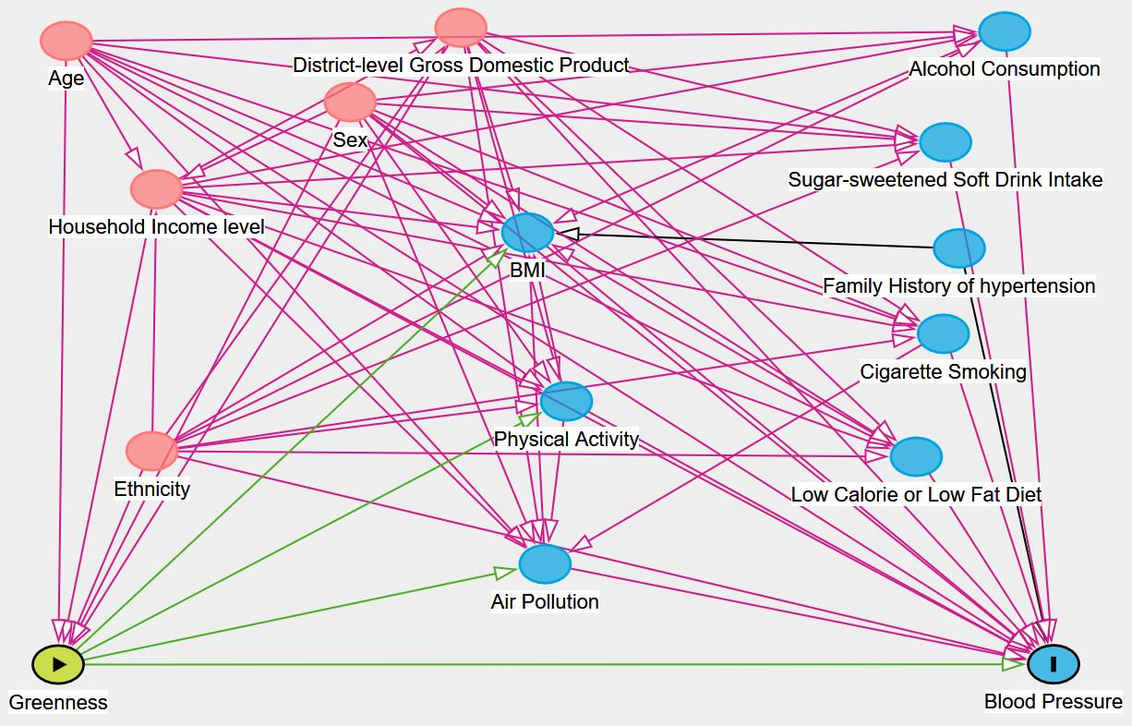

**Fig. S1**. Directed acyclic graph for the association between greenness and blood pressure, showing all potential confounders and mediators. Pink lines indicate potential confounders and green lines indicate potential mediators.

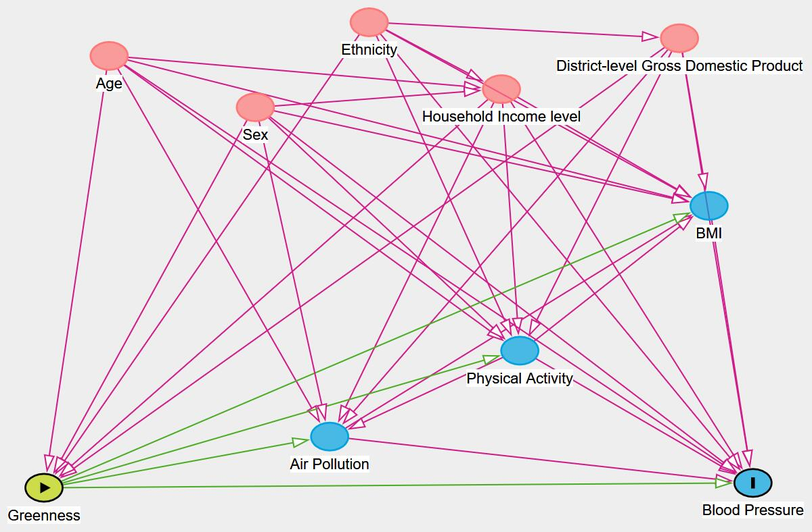

**Fig. S2**. Directed acyclic graph for the association between greenness and blood pressure, showing only confounders and mediators retained in the final models. Pink lines indicate potential confounders and green lines indicate potential mediators.