**Table S1** Data collection and refinement statistics.

Statistics for the highest shell are listed in parentheses.

|  |  |
| --- | --- |
| PDB ID | **7QRC** |
| Inhibitor | **1** |
| *Data collection* |  |
| Space group | P 1 21 1 |
| Cell constants:  a, b, c (Å)          | 44.54, 25.42, 56.03  90.00, 105.56, 90.00 |
| Wavelength (Å) | 1.000 |
| B factor (Wilson) (Å 2) | 32.42 |
| Resolution range (Å) (highest shell) | 42.91 – 2.18 (2.24-2.18) |
| Completeness (%) | 98.0 (80.7) |
| Rmerge (%) | 11.1 (47.6) |
| Rmeas (%) | 13.3 (57.5) |
| Observed reflections | 21060(1656) |
| Unique reflections | 6430(527) |
| I/σ(I) | 6.7 (2.2) |
| CC(1/2) (%) | 98.0 (80.7) |
| Redundancy | 3.3 (3.1) |
| *Refinement* |  |
| Resolution (Å) | 42.91 – 2.18 |
| Number of reflections used | 6424 |
| R-factor (%) | 27.2 |
| Rfree (%) | 28.4 |
| Average B (Å 2)  Protein  Ligand  Water | 21.9  18.5  33.8 |
| RMS from ideal values  Bond length (Å)  Bond angles (°) | 0.006  1.23 |
| Ramachandran statistics (%)  Most favored regions  Additionally allowed regions  Generously allowed regions | 98.3  0.9  0.8 |
| *Content of asymmetric unit* |  |
| Number of protein molecules/residues/atoms  Number of ligand molecules/atoms  Number of solvent molecules | 2/124/970  2/96  25 |

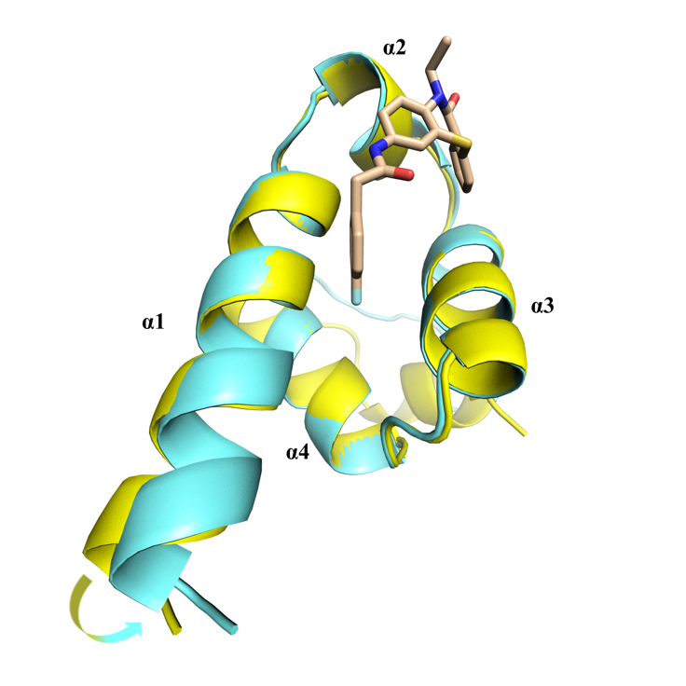

**Figure S1** Superimposition of apo- (yellow) and compound **1**- bound (light blue) structures of T.cruzi NTD-PEX14.

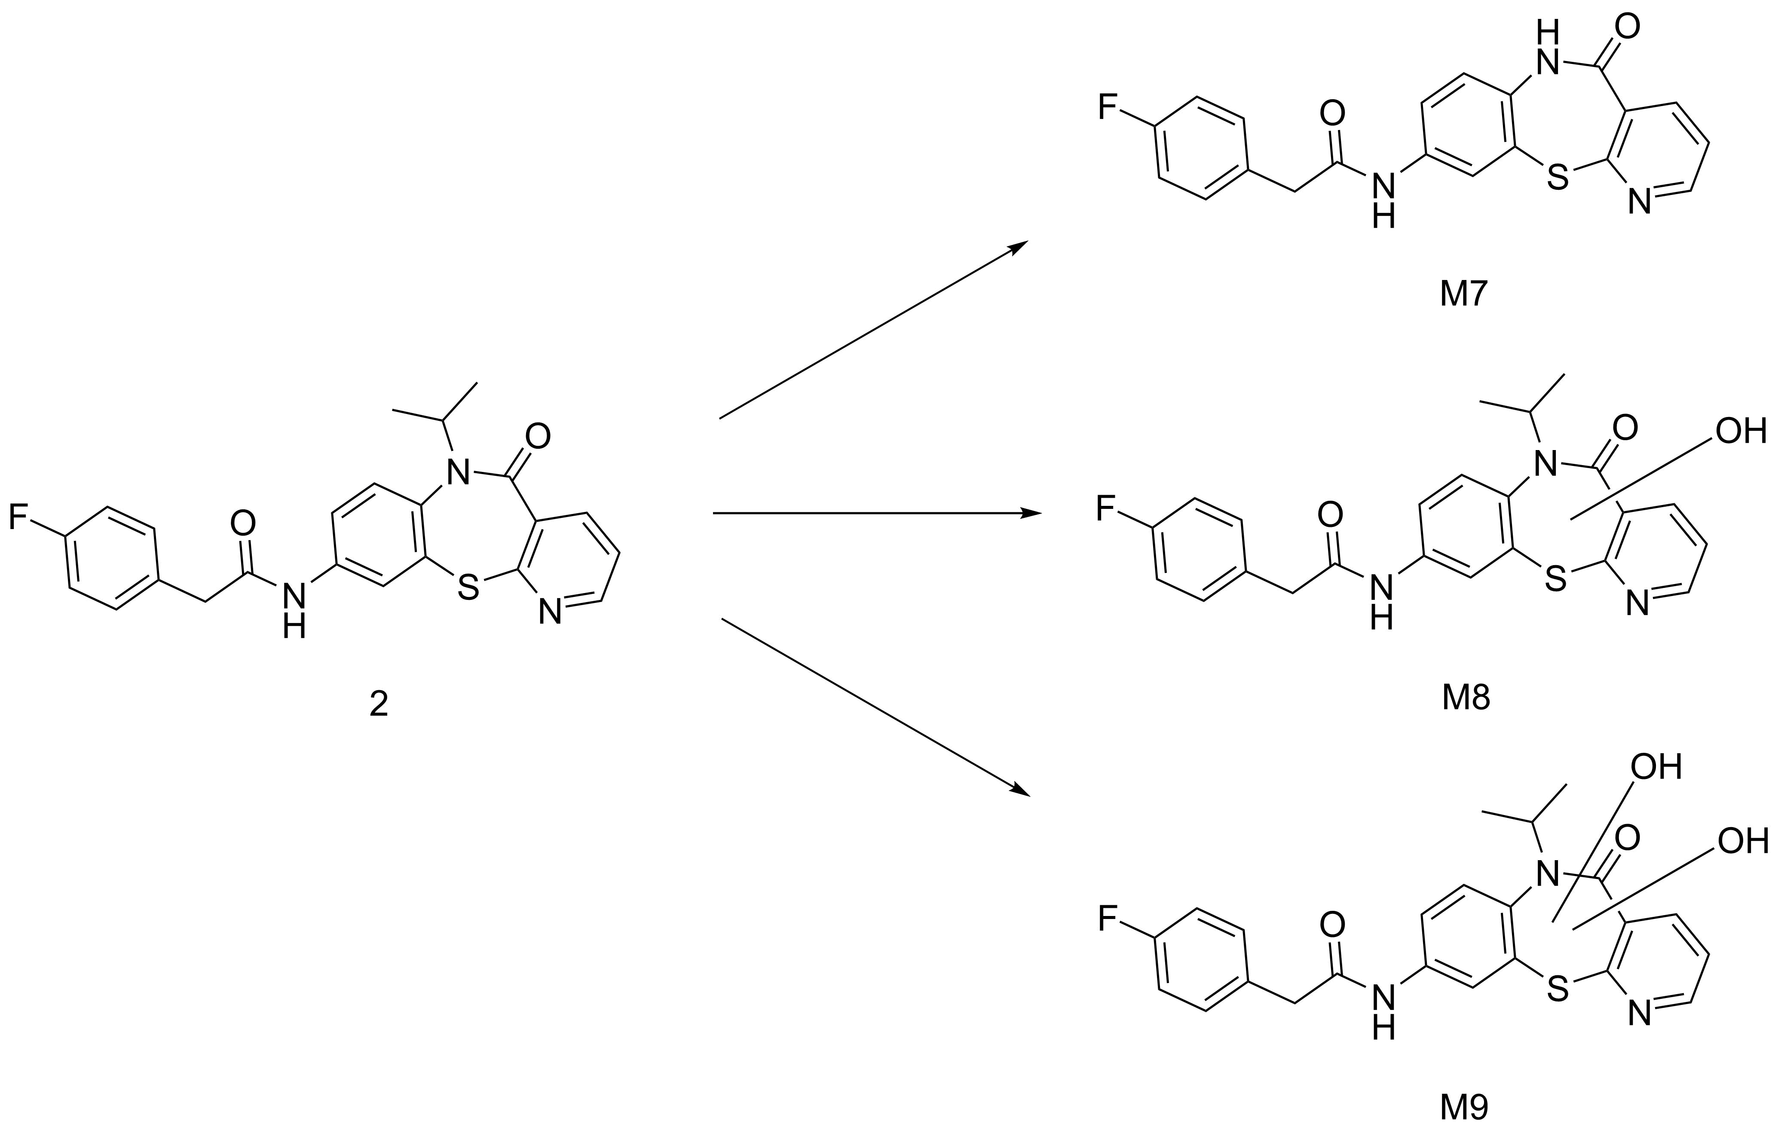

**Figure S2** Metabolic biotransformations of **2** in vitro in mouse liver microsomes. The major metabolite is the **M8** (M+16), the product of mono-oxidation. Minor metabolites include amide dealkylation (**M7**) and bis-oxidation (**M9**) products.

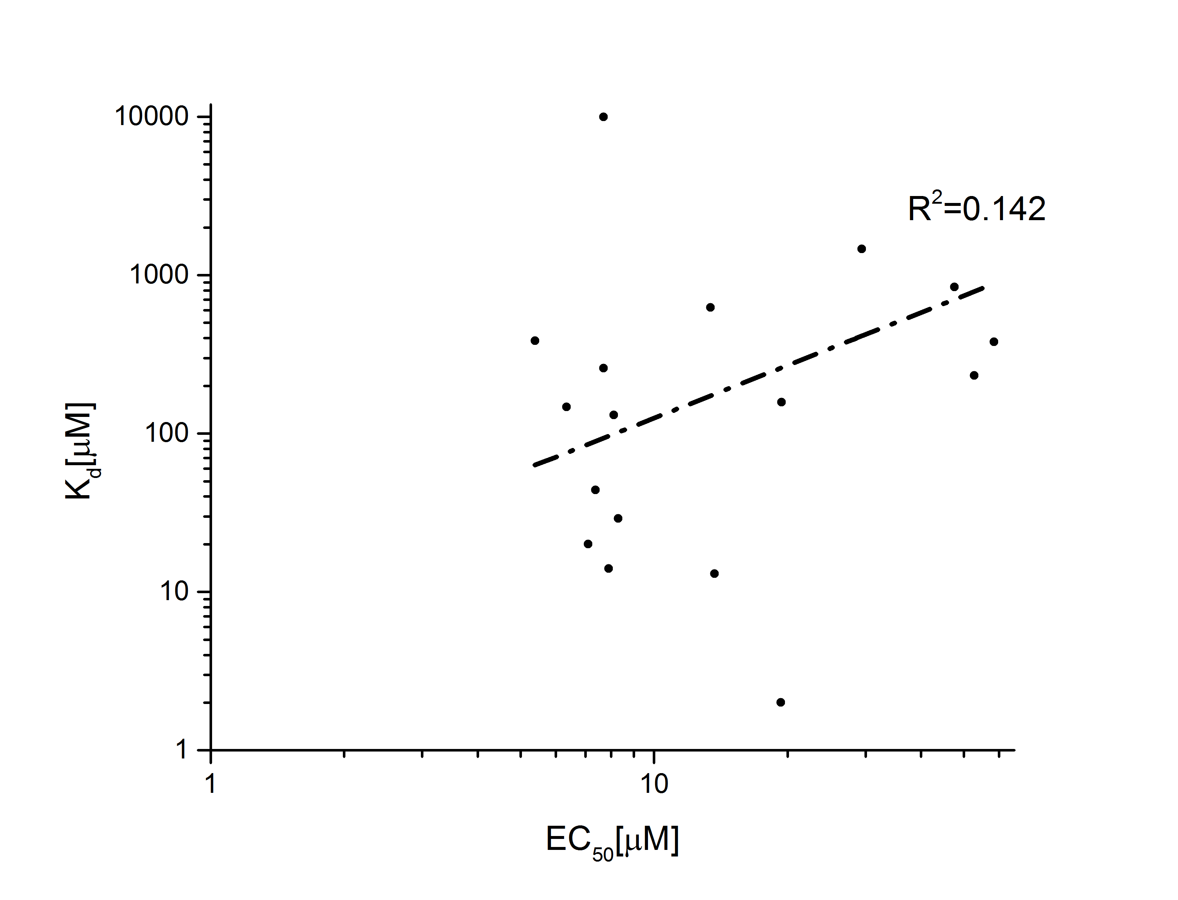

**Figure S3** Correlation between affinity (Kd in MST assay) and trypanocidal activity (EC50).

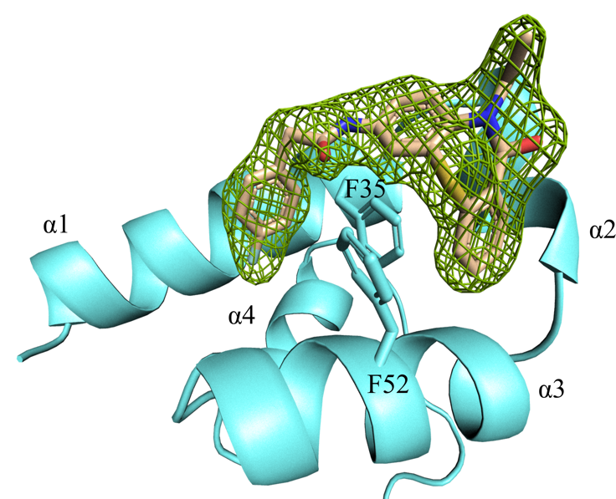

**Figure S4** Fo-Fc omit map contoured at 2.0 σ demonstrating the unambiguous placement of compound **1** at PEX5 binding site of TcPEX14 NTD.

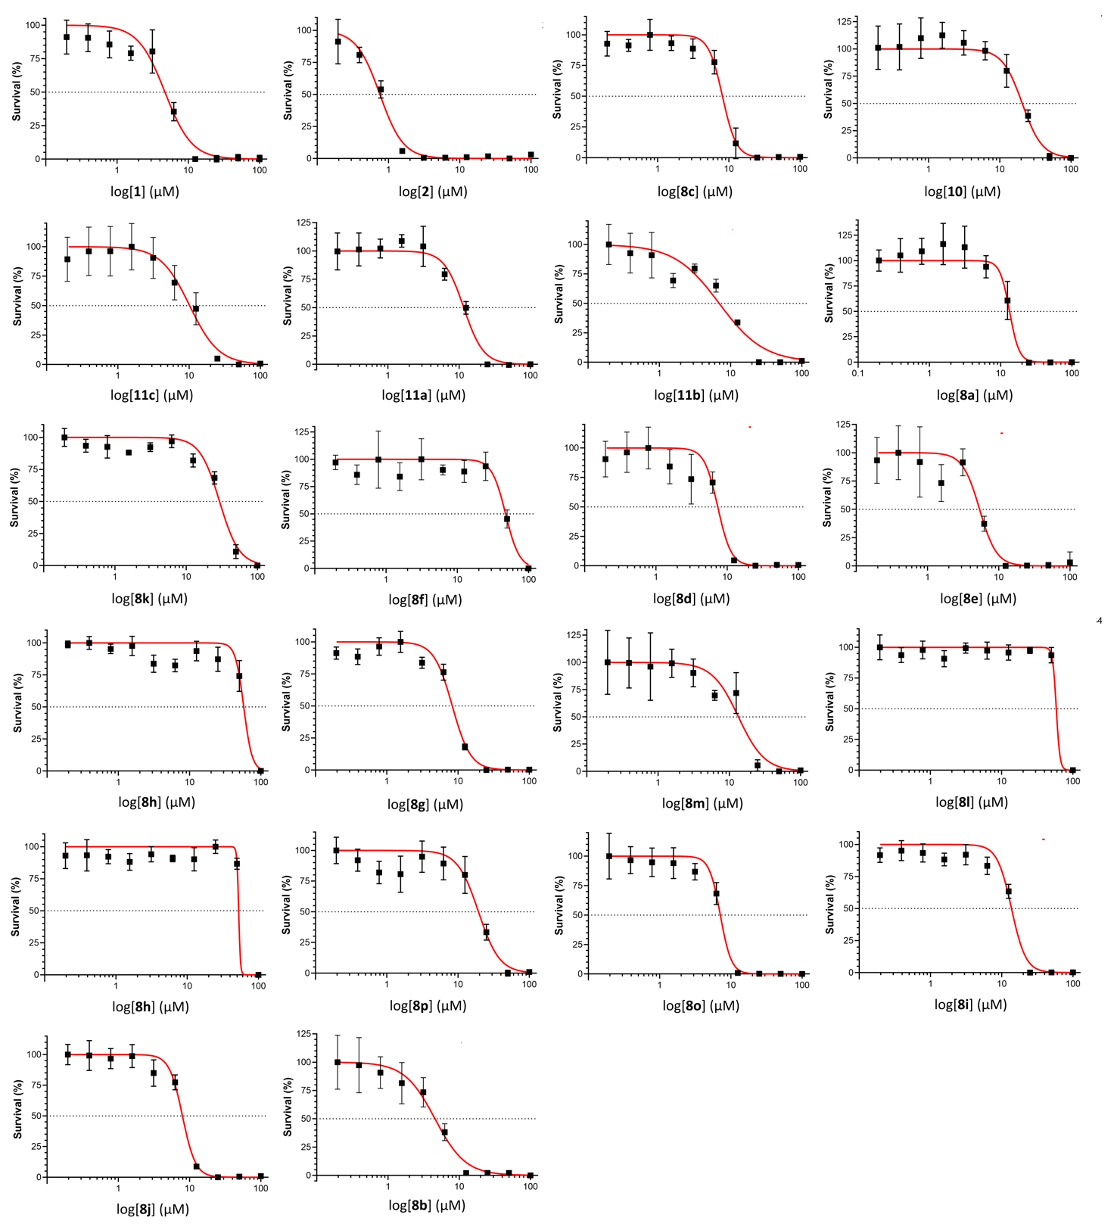

**Figure S5** In vitro trypanocidal activity of compounds against *T. brucei brucei* (bloodstream form). Dose-response curves for all compounds were generated using 10 point 96-well plate resazurin-based assay. Error bars represent standard deviation from independent quadruplicate assays.