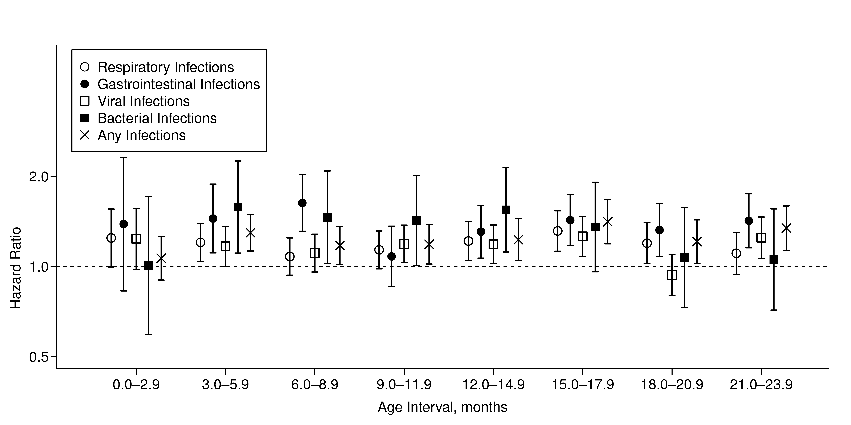

**Web Figure 1.** Hazard ratios (dots) and 95% confidence intervals for celiac disease development by types of medically attended infectious diseases, adjusted for sex, month of birth, number of previous healthcare visits, and number of previous quarterly intervals with infections of the same type, based on data of n=295,420 infants from Bavaria, Germany, born between 2005 and 2007. Time at risk for CD was measured after the respective infection exposure period for each model.

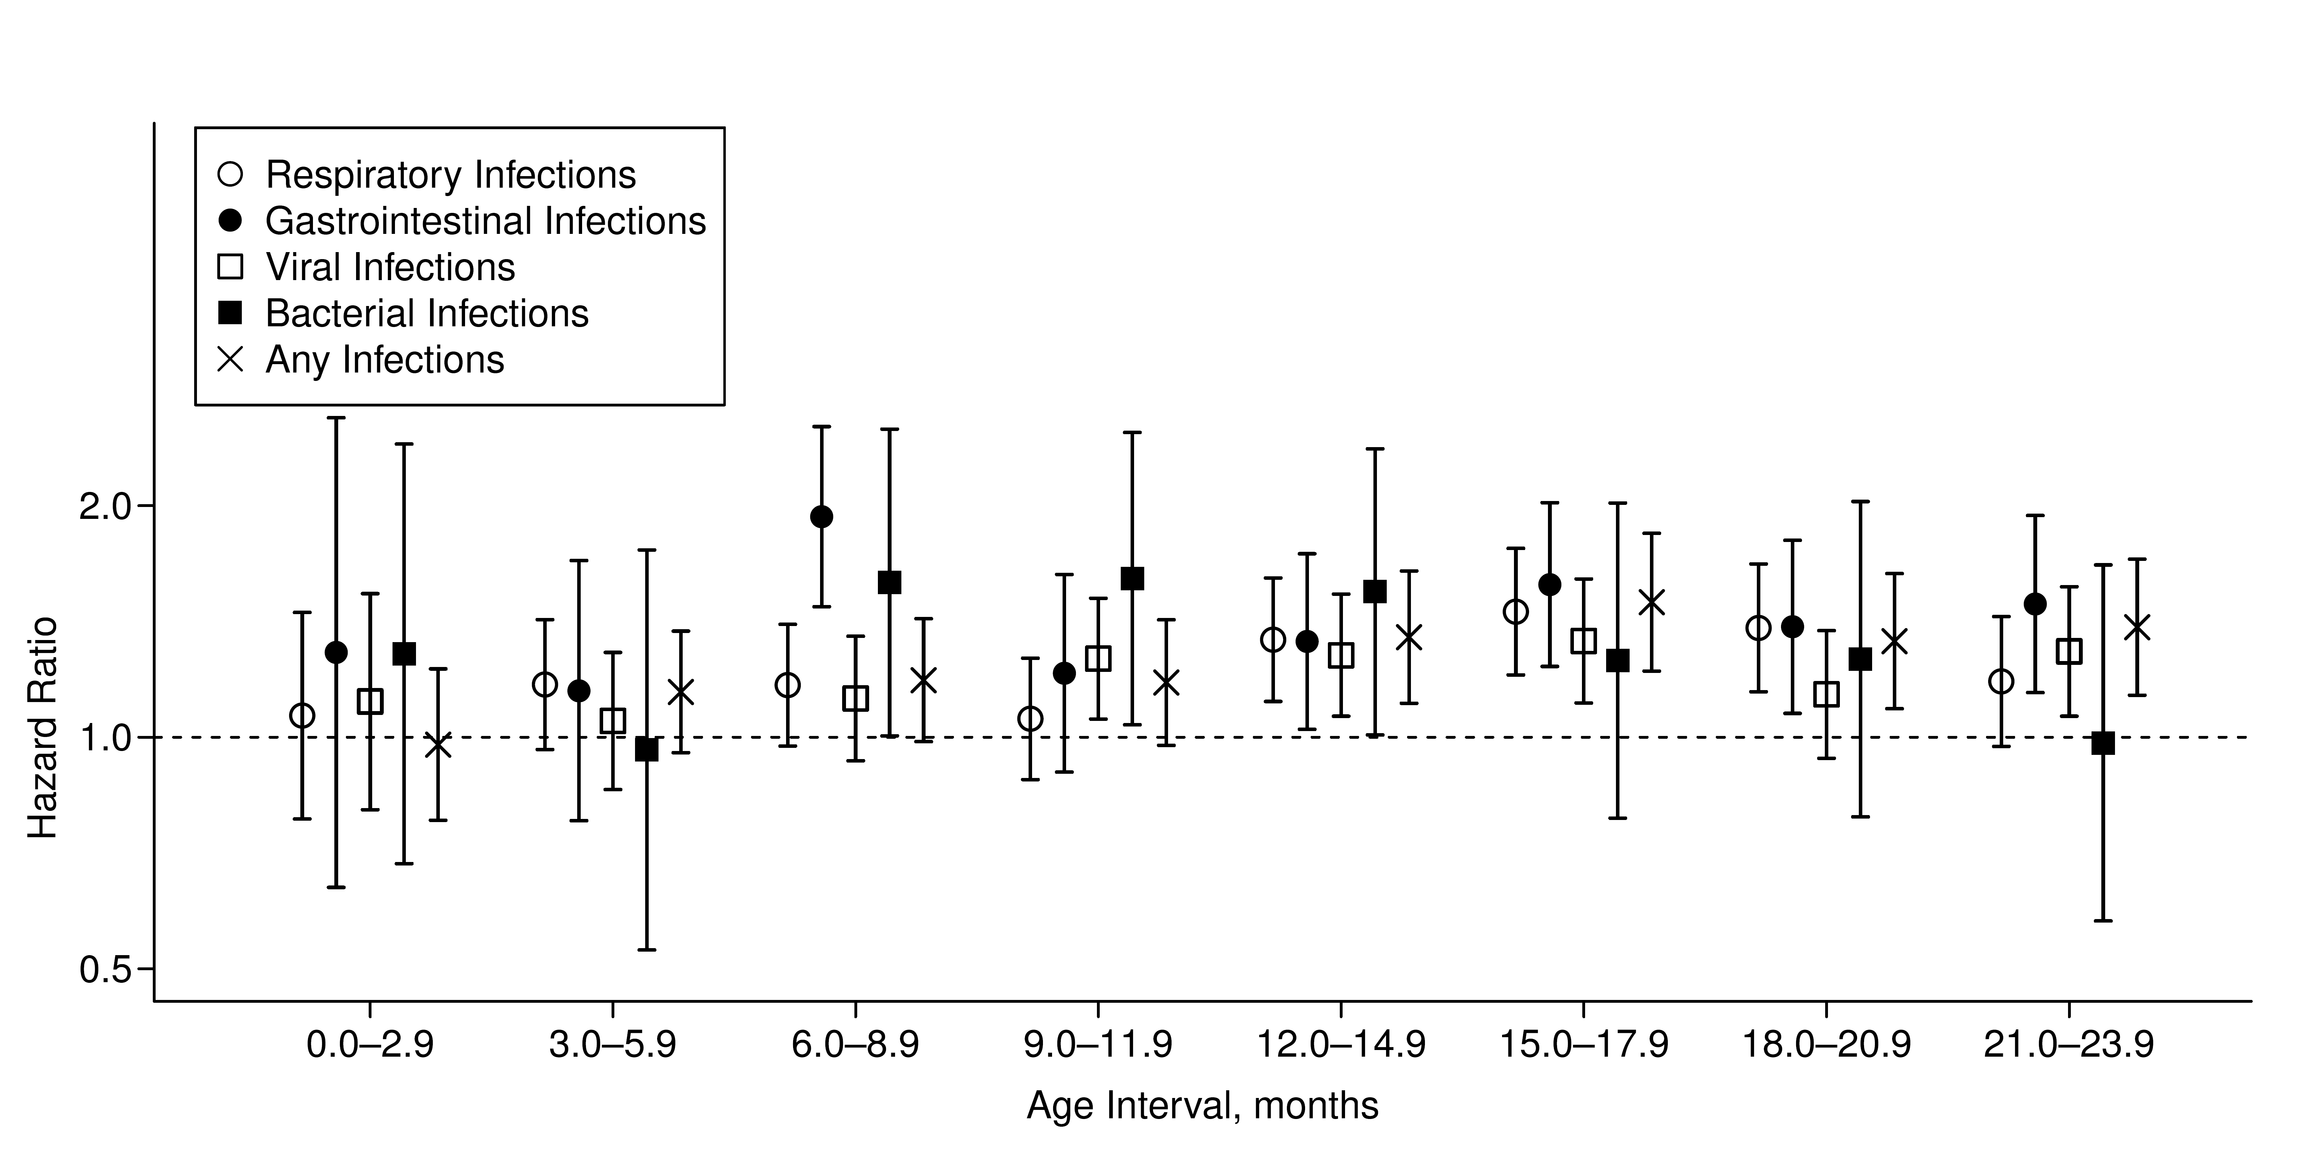

**Web Figure 2.** Hazard ratios (dots) and 95% confidence intervals for celiac disease development as recorded in at least two quarterly intervals by types of medically attended infectious diseases, adjusted for sex, month of birth and number of previous healthcare visits, based on data of n=295,420 infants from Bavaria, Germany, born between 2005 and 2007. Time at risk for CD was measured after the respective infection exposure period for each model.

**Web Table 1.** Infections were categorized by symptoms (respiratory, gastrointestinal, dermal, eye, and other) and causes (viral, bacterial, mycoses, parasites, or unknown) based on their ICD-10 code as tabulated below. For each child, the presence of infections (binary variable) from a specific category – but not their frequency – was reported in quarterly intervals. For example, if a child was diagnosed with a gastrointestinal infection in January, March and November of the same year, respectively, it would have a gastrointestinal infection record in the first and fourth quarter, but not in the second and third quarter of this particular year.

|  |  |  |
| --- | --- | --- |
| **ICD-10 code** | **Categorization by symptoms** | **Categorization by causes** |
| A00 | gastrointestinal | bacterial |
| A01 | gastrointestinal | bacterial |
| A02 | gastrointestinal | bacterial |
| A03 | gastrointestinal | bacterial |
| A04 | gastrointestinal | bacterial |
| A05 | gastrointestinal | bacterial |
| A06 | gastrointestinal | parasites |
| A07 | gastrointestinal | parasites |
| A08.0 | gastrointestinal | viral |
| A08.1 | gastrointestinal | viral |
| A08.2 | gastrointestinal | viral |
| A08.3 | gastrointestinal | viral |
| A08.4 | gastrointestinal | viral |
| A08.5 | gastrointestinal | unknown |
| A09 | gastrointestinal | unknown |
| A16 | other | bacterial |
| A21 | other | bacterial |
| A28 | other | bacterial |
| A37 | other | bacterial |
| A38 | respiratory | bacterial |
| A40 | other | bacterial |
| A41 | other | bacterial |
| A42 | other | bacterial |
| A49 | other | bacterial |
| A52 | other | bacterial |
| A54 | other | bacterial |
| A66 | other | bacterial |
| A68 | other | bacterial |
| A69 | other | bacterial |
| A87 | other | viral |
| A90 | other | viral |
| A93 | other | viral |
| A94 | other | viral |
| A98 | other | viral |
| B00 | other | viral |
| B01 | other | viral |
| B02 | other | viral |
| B05 | other | viral |
| B06 | other | viral |
| B07 | other | viral |
| B08 | other | viral |
| B09 | other | viral |
| B19 | other | viral |
| B26 | other | viral |
| B27 | other | viral |
| B30 | other | viral |
| B33 | other | viral |
| B34 | other | viral |
| B35 | other | mycoses |
| B36 | other | mycoses |
| B37 | other | mycoses |
| B43 | other | mycoses |
| B48 | other | mycoses |
| B49 | other | mycoses |
| B50 | other | parasites |
| B65 | other | parasites |
| B68 | other | parasites |
| B80 | other | parasites |
| B82 | other | parasites |
| B85 | other | parasites |
| B86 | other | parasites |
| B89 | other | parasites |
| B95 | other | bacterial |
| B97 | other | viral |
| B99 | other | unknown |
| G00 | other | bacterial |
| H00 | eye | unknown |
| H01 | eye | unknown |
| H04 | eye | unknown |
| H10.0 | eye | unknown |
| H10.2 | eye | unknown |
| H10.3 | eye | unknown |
| H10.4 | eye | unknown |
| H10.5 | eye | unknown |
| H10.8 | eye | unknown |
| H10.9 | eye | unknown |
| H60.0 | other | unknown |
| H60.3 | other | unknown |
| H60.9 | other | unknown |
| H65 | respiratory | unknown |
| H66 | respiratory | unknown |
| H70.0 | respiratory | unknown |
| H70.9 | respiratory | unknown |
| H73.0 | respiratory | unknown |
| H92 | respiratory | unknown |
| I30.1 | other | unknown |
| I88.0 | other | unknown |
| I88.9 | other | unknown |
| I89.1 | other | unknown |
| J00 | respiratory | viral |
| J01 | respiratory | unknown |
| J02.0 | respiratory | bacterial |
| J02.8 | respiratory | viral |
| J02.9 | respiratory | viral |
| J03.0 | respiratory | bacterial |
| J03.8 | respiratory | viral |
| J03.9 | respiratory | viral |
| J04 | respiratory | viral |
| J05 | respiratory | viral |
| J06 | respiratory | viral |
| J09 | respiratory | viral |
| J10 | respiratory | viral |
| J11 | respiratory | viral |
| J12 | respiratory | viral |
| J13 | respiratory | bacterial |
| J14 | respiratory | bacterial |
| J15 | respiratory | bacterial |
| J18 | respiratory | unknown |
| J20.0 | respiratory | bacterial |
| J20.1 | respiratory | bacterial |
| J20.2 | respiratory | bacterial |
| J20.3 | respiratory | viral |
| J20.4 | respiratory | viral |
| J20.5 | respiratory | viral |
| J20.6 | respiratory | viral |
| J20.7 | respiratory | viral |
| J20.8 | respiratory | unknown |
| J20.9 | respiratory | unknown |
| J21 | respiratory | unknown |
| J22 | respiratory | unknown |
| J32.0 | respiratory | unknown |
| J32.2 | respiratory | unknown |
| J32.8 | respiratory | unknown |
| J32.9 | respiratory | unknown |
| J35.9 | respiratory | unknown |
| J38.5 | respiratory | unknown |
| J40 | respiratory | unknown |
| J41 | respiratory | unknown |
| J42 | respiratory | unknown |
| J44.8 | respiratory | unknown |
| J45.1 | respiratory | unknown |
| J45.8 | respiratory | unknown |
| J45.9 | respiratory | unknown |
| J46 | respiratory | unknown |
| J85.1 | other | bacterial |
| J98 | respiratory | unknown |
| K04.6 | other | unknown |
| K05 | other | unknown |
| K12 | other | unknown |
| K13.7 | other | unknown |
| K14.1 | other | unknown |
| L00 | dermal | bacterial |
| L01 | dermal | bacterial |
| L02.1 | dermal | bacterial |
| L02.2 | dermal | bacterial |
| L02.3 | dermal | bacterial |
| L02.4 | dermal | bacterial |
| L02.9 | dermal | bacterial |
| L03 | dermal | bacterial |
| L04 | dermal | unknown |
| L08 | dermal | bacterial |
| M30.3 | other | unknown |
| M72.6 | other | bacterial |
| N10 | other | unknown |
| N11.9 | other | unknown |
| N30 | other | unknown |
| N34.1 | other | unknown |
| N39 | other | unknown |
| N45.9 | other | unknown |
| N48.1 | other | unknown |
| N48.2 | other | unknown |
| N51.2 | other | unknown |
| N61 | other | bacterial |
| N76.2 | other | unknown |
| N77.1 | other | unknown |
| P36 | other | unknown |
| P39.0 | other | unknown |
| P39.1 | eye | unknown |
| P39.2 | other | unknown |
| P39.3 | other | unknown |
| P39.4 | dermal | unknown |
| P39.8 | other | unknown |
| P39.9 | other | unknown |
| P58.2 | other | unknown |
| R05 | respiratory | unknown |
| R06.2 | respiratory | unknown |
| R06.7 | respiratory | viral |
| R07.0 | respiratory | unknown |
| R11 | gastrointestinal | unknown |
| R21 | dermal | unknown |
| R50 | fever | unknown |
| R56.0 | other | unknown |
| R59 | other | unknown |
| T88.0 | other | unknown |

**Web Table 2.** Characteristics of study subjects according to records of medically attended infections during the first year of life.

|  |  |  |  |
| --- | --- | --- | --- |
|  | **All children  (n=295,420)** | **Children with** **≥ 1 respiratory infections (n=203,160)** | **Children with ≥ 1 gastrointestinal infections (n=54,581)** |
| **Total follow-up, years (median)** | 2,349,386 (8.5) | 1,640,579 (8.5) | 440,595 (8.5) |
| **Celiac disease, n (%)** | 853 (0.29 %) | 626 (0.31 %) | 203 (0.37 %) |
| **Sex, n (%)** |  |  |  |
| *Males* | 162,448 (55.0 %) | 115,103 (56.7 %) | 31,470 (57.6 %) |
| *Females* | 132,972 (45.0 %) | 88,057 (43.3 %) | 23,111 (42.3 %) |
| **Season of birth, n (%)** |  |  |  |
| *March to May* | 73,639 (24.9 %) | 51,422 (25.3 %) | 13,353 (24.5 %) |
| *June to August* | 77,996 (26.4 %) | 55,336 (27.2 %) | 15,361 (28.1 %) |
| *September to November* | 73,218 (24.8 %) | 49,470 (24.4 %) | 13,716 (25.1 %) |
| *December to February* | 70,567 (23.9 %) | 46,932 (23.1 %) | 12,151 (22.3 %) |
| **Number of previous healthcare visits, n (%)** |  |  |  |
| *0-3 visits* | 85,333 (28.9 %) | 38,829 (19.1 %) | 7,850 (14.4 %) |
| *4-6 visits* | 146,733 (49.7 %) | 109,846 (54.1 %) | 27,560 (50.5 %) |
| *7-9 visits* | 51,980 (17.6 %) | 44,086 (21.7 %) | 14,634 (26.8 %) |
| *≥ 10 visits* | 11,374 (3.8 %) | 10,399 (5.1 %) | 4,537 (8.3 %) |