**Supplementary Materials**

**Table of Contents**

**eMethods 1: Description of Study Design and Random Sampling Strategy**

**eMethods 2: Description of Model Predicted PM1, PM2.5, PM10, and NO2 Data**

**eMethods 3: Description of the Monitoring PM10 and NO2 Data**

**eMethods 4: Definition of Current Asthma and Current wheeze**

**eMethods 5: Description of Covariates Collection**

**Table S1 The correlation between seasonal greenness indices in 2010 and 2014.**

**Table S2 The adjusted ORs and 95% CIs of childhood asthma symptoms with per 0.1-unit increase of NDVI/SAVI from August in 2010 (n =59,754).**

**Table S3 The adjusted ORs and 95% CIs of childhood asthma with per 0.1-unit increase of NDVI in 1000 m buffer around schools.**

**Table S4 The adjusted ORs and 95% CIs of childhood asthma symptoms with categorical NDVI/ SAVI (at 300 m and 1000 m buffers) (n = 59,754). a**

**Table S5 The mediation of air pollution, physical activity, BMI, and doctor-diagnosed allergy on the associations between NDVI1000 m around schools and asthma symptoms.**

**Table S6 The adjusted ORs and 95% CIs of childhood asthma symptoms with per 0.1-unit increase of NDVI/SAVI from October in 2010 (n =59,754).**

**Table S7 The adjusted ORs and 95% CIs of childhood asthma symptoms with per 0.1-unit increase of NDVI in 300 m and 1000 m buffer around schools, stratified by age.**

**Table S8 The adjusted ORs and 95% CIs of asthma symptoms with per 0.1-unit increase of NDVI or SAVI in 300 m and 1000 m buffer around schools in children who lived within walking distance from home to school > 15 min (n = 18,864).**

**Table S9 The adjusted ORs and 95% CIs of childhood asthma symptoms with per 0.1-unit increase of NDVI/SAVI, excluding children with family history of asthma (n = 4,113).**

**Figure S1 The direct acyclic graph (DAG) for the association between greenness exposure and current asthma in children using DAGitty (**[**http://dagitty.net/**](http://dagitty.net/)**).**

**Figure S2 The adjusted ORs (95% CIs) of asthma symptoms with per 0.1-unit increase of with NDVI in 1000 m buffer in children, across seven cities.**

**eMethods 1: Description of Study Design and Random Sampling Strategy**

The SNEC is a cross-sectional study of seven cities (Shenyang, Dalian, Fushun, Anshan, Benxi, Liaoyang, and Dandong) from Liaoning province, northeastern China. There are a total of 27 urban districts in these seven cities, including five districts in Shenyang, four districts in Dalian and Fushun, three districts in Anshan, Benxi, and Dandong, and two districts in Liaoyang, respectively.

Among 27 districts, there was only one available local air monitoring station for each district. To generate a representative sample, we applied random sampling strategy to recruit the study participants. We randomly selected 1 or 2 elementary schools and one or two middle schools, located within 1-2 km from the local monitoring station. The number of participants should not be less than 500 in each district. If the number of students from the first selected school was lower than 500, then we continued to recruit the second school in the same district.

Here is an example how we selected the schools in one district in Shenyang city. In Figure S, there are 9 elementary schools (red balloon with number) locate in the areas within 1-2 km from the local air monitoring station (blue balloon).

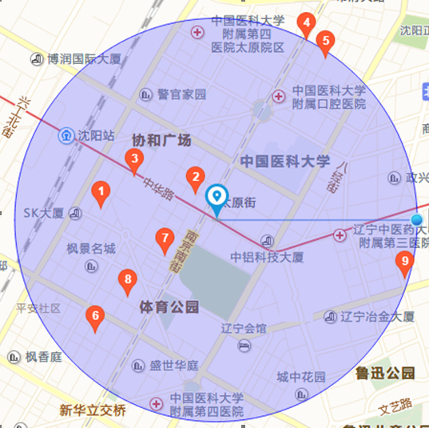

**Figure S.** The area within 2 km radius from a local air monitoring station in Shenyang city.

Note: red balloon indicated the elementary school; blue balloon indicated the air monitoring station; number 1-9 indicated the school number.

In China, each district in a city has the specific administrative code. We selected the last two non-zero valid digits of the administrative code as the number of the district and randomly selected two schools based on a random number table. For example, the administrative code of the Heping district in Shenyang is “210102000000.” We identified “02” as the number of the Heping district. According to a random number table, as shown below, the random numbers “1” and “9” were selected in this survey. So, schools marked with number of 1 and 9 in Figure S were recruited. These randomization procedures ensure that the selected schools are representative of this region.

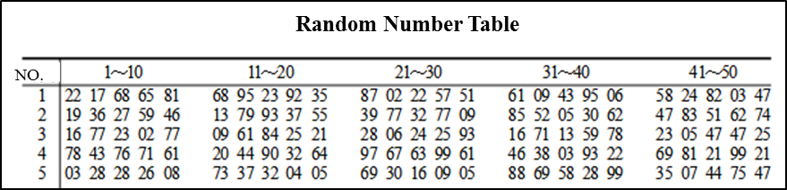

**eMethods 2: Description of Model Predicted PM1, PM2.5, PM10, and NO2 Data**

The prediction models for air pollutant concentrations have been published previously (Chen et al., 2018a, 2018b). Briefly, Ground-monitored PM1, PM2.5 and PM10 were obtained from the China Atmosphere Watch Network (CAWNET) of the China Meteorological Administration (CMA). The network consisted of 96 stations across mainland China. Concentrations of PM1, PM2.5 and PM10 at all stations were measured with GRIMM 180 Environmental dust monitors (Model 1.108, Grimm Aerosol Technik GmbH, Ainring, Germany). Daily concentration of NO2 was estimated with satellite-derived OMI data (Daily Level-3 Nitrogen Dioxide Product) and other predictors. Two quality-control procedures were applied to all PM measurements: a "limit check" and "climatological check". For the limit check, we evaluated each valid PM measurement to determine whether it fell within its possible limits, otherwise, they were removed. In the climatological check, the median and standard deviation (SD) of hourly PM measurements were calculated at each PM observational site. Any PM values lying outside of more than three SDs from the median PM have been removed. Daily PM1, PM2.5, PM10, and NO2 concentrations were estimated by using a random forest model matched to school address. Briefly, each school address was geocoded as a geographical longitude and latitude, and superimposed over the predicted daily PM1, PM2.5, PM10, and NO2 concentration grids, and then the mean concentrations of air pollutants were calculated by averaging the daily concentrations for PM1, PM2.5, PM10, and NO2 over the four-year period of 2009-2012.

This random forest model is user-friendly, as there is no need to define the complex relationships between predictors (e.g., linear or nonlinear relationships and interactions). Also, the variable importance measures provided by random forests help the user to identify important variables and noise variables. The variables included in the final prediction model were listed as below:

*PMij* = *AODij* + *TEMPij* + *RHij* + *BPij* + *WSij*+ *NDVI* + *Urban_cover* + *doy* + log(*elev)*

*NO2ij* = *OMIij* + *TEMPij* + *BPij* + *RHij* + *WSij* + *NDVIij*+*Urban_coverij* + *doyi* + *log(elevj)*

where *PM2.5 ij* is the PM2.5  or PM10 concentration on day *i* at station *j*; *NO2ij* is the NO2 concentration on day *i* at station *j*; *AODij* is the combined aerosol optical depth (AOD, merged values from Dark Blue and Dark Target); *OMIij* is the satellite-derived OMI value; *TEMP*, *RH*, *BP,* and *WS* are mean temperature, relative humidity, barometric pressure, and wind speed on day i, respectively; *NDVI* is the monthly average NDVI value; *Urban_cover* isthe percentage of urban cover with a buffer radius of 10 km; *doy* is day of the year; and *log(elev)* is the log transformed elevation. To evaluate the predictive ability of the final model, a 10-fold cross-validation (CV) was performed.

The results of a 10-fold cross-validation showed R2 values for daily and annual predictions were 55% and 75% for PM1, 83% and 86% for PM2.5, 78% and 81% for PM10, and 64% and 72% for NO2, respectively. The Root Mean Squared Error (RMSE) values for daily and annual predictions were 20.5 µg/m3 and 8.8 µg/m3 for PM1, 18.1 µg/m3 and 6.9 µg/m3 for PM2.5, 31.5 µg/m3 and 14.4 µg/m3 for PM10, and 12.4µg/m3 and 6.5 µg/m3 for NO2, respectively.

**References:**

Chen G, Knibbs L, Zhang W, et al. 2018a. Estimating spatiotemporal distribution of PM1 concentrations in China with satellite remote sensing, meteorology, and land use information. Environmental Pollution. 233, 1086-1094.

Chen G, Li S, Knibbs L, et al. 2018b. A machine learning method to estimate PM2.5 concentrations across China with remote sensing, meteorological and land use information. Science of The Total Environment. 636, 52-60.

**eMethods 3: Description of the Monitoring PM10 and NO2 Data**

The operation of the air monitoring station has strictly followed the quality assurance/quality control (QA/QC) procedure set by the State Environmental Protection Administration of China (SEPAC,1992). The environmental monitoring centers in each of the three cities conducted regularly performance audits and precision checks on the air-monitoring equipment. Quarterly performance audits are conducted to assess data accuracy on PM10 and NO2 monitoring systems.

1) The calculation method

The calculation method is performed according to Chinese National standards (GB8170-87). The unit of monitored pollutants is mg/m3 accurate to the third decimal. The units can also be expressed as μg/m3, depending on the pollutant's concentration. For concentrations that were too low to be measured, half of the lowest checking limit of the equipment will be used as the measured value.

2) Outliers

When the measured concentration is too low (e.g. background value), a negative value can be obtained because of the zero drift of the monitor. There is no physical meaning to this value. This negative value can be regarded as a value of "unable to measure."

For the monitoring station with an automatic calibration system, if equipment zero drift/span drift exceeds the control range during the period of zero/span calibration, the data from the time it becomes out of control until the equipment is recovered should be regarded as invalid data. The data cannot be used statistically.

The data during the period of zero calibration/span calibration should be regarded as invalid data. It cannot be used statistically, but a flag should be made on these data and the records stored as evidence.

When values are missing because of a loss of power, any data received by the central control station during the period of the loss of power should be regarded as invalid data. The period of loss of power should be counted at the start of power outage until complete warm-up of equipment. The data cannot be used statistically.

Because pollutant concentrations change over time and change slowly, there should be no swift change in pollutant concentration in the results of normal monitoring. Either a swift change or no change indicates that there is an equipment problem. The problem should be identified, and the data between the start of problem to recovery should be regarded as outliers. These data cannot be used statistically.

3) Statistics of monitoring data

One time value

The central control station uses an average of 15 minutes of pollutant concentrations measured at the branch station as a one-time value. The central control modifies this value and judge whether this value is an outlier using the report software.

One hour mean value

At least 75% of the one-time values should be used to calculate the one-hour average mean value. One-hour average mean value is calculated by averaging all the valid one-time values within one hour.

Daily average mean

For PM10 at least 12 valid hourly mean values are needed to calculate the daily mean value (using the calendar as the valid time frame), using all available valid hourly mean values. For NO2 at least 18 hourly mean values everyday are needed to calculate valid daily mean value (using the calendar as the valid time frame). dAll of the valid hourly mean values are used to calculate the daily mean. (National Environmental Air Quality Standard GB3095-2012)

Monthly mean values are the arithmetic means of all valid daily mean values within the month. Seasonal mean values are the arithmetic means of all valid daily mean values within the season. Yearly mean values are the arithmetic means of all valid daily mean values within the year. District daily mean values are calculated using the monthly mean value, the seasonal mean value, and the yearly mean value from the available stations in the district.

**eMethods 4: Definition of Current Asthma and Current Wheeze**

We defined current asthma and current wheeze using positive responses to the following questions. For current asthma: “Has a doctor ever diagnosed this child as having asthma”, and “Has this child experienced an asthma attack in the past two years”, or “Has this child taken medication or treatment for asthma or asthma bronchitis in the past two years?”.

For current wheeze: “Has this child’s chest ever sounded wheezy or whistling when he/she had a cold or not?” and “Has this child had more than two times of such episodes in last 12 months?”.

**eMethods 5: Description of Covariates Collection**

The study questionnaire included queries about demographics, lifestyle factors in the home, family medical history, health-related behaviors in the home, and household environmental factors such as second-hand smoke, home coal usage, mould in home, and residential area.

(1) Parental information: We dichotomized parent’s education as having a high school education or not, and categorized annual family income in Chinese Yuan (CNY) as: < 5000 CNY, 5000-9,999 CNY, 10,000-29,999 CNY, 30,000-99,999 CNY, or >100,000 CNY. Family history of asthma was collected from questionnaire by the question: “Has any of the family member (grandparents, parents, parents’ siblings, etc) suffered from asthma?”

(2) Children’s information: The BMI is defined as the body mass divided by the square of the body height (kg/m2). Preterm birth was defined as a gestational age < 37 weeks at delivery. Low birth weight was characterized as a birth weight < 2500 g. Breastfeeding was defined based on a positive response to question: “Has this child been breasted for more than three months?”. Physical activity (hours/week) was collected by question: “How long does your child spend for physical exercise outside per week?” Doctor-diagnosed allergy symptom was defined based on a positive response to question: “Has the doctor diagnosed your child allergic to any of the following items: food, medicine, dust, pollen, detergent, and others?”

(3) Household environmental: Household second-hand smoke (SHS) was defined based on a positive response to question: “Does anyone living with this child smoke in home?”. Mould in home was defined if there was a positive answer to question “Do the house walls get mold due to the leakage of rain or water?”. Home coal usage was assessed defined if coal was used for cooking or heating in home. Residential area (m2/person) was calculated by dividing the area of total living space by the number of household members.

**Table S1 The correlation of seasonal greenness indices in 2010 and 2014.**

|  |  |  |  |  |  |  |  |
| --- | --- | --- | --- | --- | --- | --- | --- |
|  | **Greenness indices in 2010** | | | |  | **Greenness indices in 2014** | |
|  | **NDVI300m in Aug** | **NDVI300m in Oct** | **NDVI1000m in Aug** | **NDVI1000m in Oct** |  | **NDVI300m in Aug** | **NDVI1000m in Aug** |
| Medium  (Q1, Q3) | 0.28  (0.21, 0.39) | 0.18  (0.15, 0.24) | 0.28  (0.23, 0.36) | 0.19  (0.16, 0.25) |  | 0.25  (0.19, 0.34) | 0.26  (0.21, 0.31) |
| Mean ± S.D | 0.32 ± 0.15 | 0.21 ± 0.10 | 0.31 ± 0.12 | 0.21 ± 0.08 |  | 0.28 ± 0.12 | 0.28 ± 0.09 |
| *P-value* a | **< 0.001** | | **< 0.001** | |  |  |  |
| ***Spearman coefficients*** b |  |  |  |  |  |  |  |
| NDVI300m in Aug, 2010 | 1.00 | 0.82 | 0.89 | 0.70 |  | 0.86 | 0.74 |
| 95% CI | 1.00, 1.00 | 0.74, 0.88 | 0.83, 0.93 | 0.57, 0.79 |  | 0.79, 0.91 | 0.63, 0.83 |
| NDVI1000m in Aug, 2010 | 0.82 | 1.00 | 0.65 | 0.87 |  | 0.75 | 0.88 |
| 95% CI | 0.74, 0.88 | 1.00, 1.00 | 0.51, 0.76 | 0.80, 0.91 |  | 0.63, 0.83 | 0.82, 0.92 |
| NDVI300m in Oct, 2010 | / | / | 1.00 | 0.69 |  | 0.80 | 0.63 |
| 95% CI | / | / | 1.00, 1.00 | 0.56, 0.79 |  | 0.71,0.87 | 0.48, 0.74 |
| NDVI1000m in Oct, 2010 | / | / | / | 1.00 |  | 0.68 | 0.83 |
| 95% CI | / | / | / | 1.00, 1.00 |  | 0.54, 0.78 | 0.75, 0.89 |
| NDVI300m in Aug, 2014 | / | / | / | / |  | 1.00 | 0.87 |
| 95% CI | / | / | / | / |  | 1.00, 1.00 | 0.80, 0.91 |
| NDVI1000m in Aug, 2014 | / | / | / | / |  | / | 1.00 |
| 95% CI | / | / | / | / |  | / | 1.00, 1.00 |

a *P-value* in bold indicated the statistical significance between NDVI from Aug and Oct at < 0.05 by *t*-test.

b Values were presented as spearman correlation coefficients (95% confidence limits) between seasonal greenness indices.

S.D: standard deviation; Q1: quartile 1; Q3: quartile 3.

**Table S2 The adjusted ORs and 95% CIs of childhood asthma symptoms with per 0.1-unit increase of NDVI/SAVI from August in 2010 (n =59,754). a**

|  |  |  |  |  |
| --- | --- | --- | --- | --- |
|  | **Current asthma** | ***P*-value** | **Current wheeze** | ***P*-value** |
| **NDVI** |  |  |  |  |
| NDVI100m | 0.94 (0.89, 0.98) | **0.006** | 0.96 (0.92, 1.00) | **0.026** |
| NDVI300m | 0.87 (0.82, 0.92) | **< 0.001** | 0.93 (0.89, 0.98) | **0.004** |
| NDVI500m | 0.82 (0.77, 0.87) | **< 0.001** | 0.92 (0.87, 0.97) | **0.001** |
| NDVI1000m | 0.81 (0.75, 0.86) | **< 0.001** | 0.89 (0.84, 0.94) | **< 0.001** |
| **SAVI** |  |  |  |  |
| SAVI100m | 0.90 (0.83, 0.97) | **0.004** | 0.92 (0.87, 0.98) | **0.010** |
| SAVI 300m | 0.81 (0.75, 0.88) | **< 0.001** | 0.89 (0.83, 0.95) | **0.001** |
| SAVI500m | 0.79 (0.73, 0.85) | **< 0.001** | 0.89 (0.83, 0.94) | **< 0.001** |
| SAVI1000m | 0.79 (0.72, 0.85) | **< 0.001** | 0.85 (0.80, 0.91) | **< 0.001** |

a Models adjusted for age, gender, parental education, family income, breastfeeding status, low birthweight, preterm, residential area, SHS, mould in home, home coal usage, and family history of asthma.

NDVI: normalized difference vegetation index; SAVI: soil adjusted vegetation index; 100 m-1000 m: the green buffers ranged from 100 m to 1000 m.

*P* value in bold represented the association between greenness exposure and asthma symptoms at *P* < 0.05.

**Table S3 The adjusted ORs and 95% CIs of childhood asthma with per 0.1-unit increase of NDVI in 1000 m buffer around schools.**

|  |  |  |  |  |  |  |  |  |  |  |
| --- | --- | --- | --- | --- | --- | --- | --- | --- | --- | --- |
|  | Model 1 | *P* | Model 2 | *P* | Model 3 | *P* | Model 4 | *P* | Model 5 | *P* |
| Current asthma | 0.81 (0.75, 0.86) | < 0.001 | 0.86 (0.78, 0.96) | 0.006 | 0.89 (0.81, 0.99) | 0.027 | 0.89 (0.80, 0.99) | 0.030 | 0.85 (0.77, 0.94) | 0.002 |
| Current wheeze | 0.89 (0.84, 0.94) | < 0.001 | 0.90 (0.83, 0.99) | 0.023 | 0.92 (0.84, 0.99) | 0.040 | 0.92 (0.84, 1.00) | 0.051 | 0.90 (0.83, 0.98) | 0.013 |

Model 1: main model, adjusted for age, gender, parental education, family income, breastfeeding, low birthweight, preterm, residential area, SHS, mould in home, home coal usage, and family history of asthma .

Model 2: model 1 additionally adjusted for PM1 concentration from prediction model.

Model 3: model 1 additionally adjusted for PM2.5 concentration from prediction model.

Model 4: model 1 additionally adjusted for PM10 concentration from prediction model.

Model 5: model 1 additionally adjusted for NO2 concentration from prediction model.

**Table S4 The adjusted ORs and 95% CIs of childhood asthma symptoms with categorical NDVI/ SAVI (at 300 m and 1000 m buffers) (n = 59,754). a**

|  |  |  |  |  |
| --- | --- | --- | --- | --- |
|  | **Lower tertile** | **Middle tertile** | **Higher tertile** | ***P* for trend** |
| **NDVI300m** |  |  |  |  |
| Current asthma | Ref. | 0.83 (0.71, 0.95) | 0.74 (0.63, 0.87) | **< 0.001** |
| Current wheeze | Ref. | 0.86 (0.76, 0.97) | 0.81 (0.74, 0.92) | **0.002** |
| **SAVI300m** |  |  |  |  |
| Current asthma | Ref. | 0.84 (0.73, 0.98) | 0.75 (0.64, 0.87) | **< 0.001** |
| Current wheeze | Ref. | 0.88 (0.78, 1.00) | 0.83 (0.73, 0.95) | **0.004** |
| **NDVI1000m** |  |  |  |  |
| Current asthma | Ref. | 0.78 (0.68, 0.90) | 0.64 (0.54, 0.76) | **< 0.001** |
| Current wheeze | Ref. | 0.85 (0.75, 0.96) | 0.74 (0.64, 0.85) | **< 0.001** |
| **SAVI1000m** |  |  |  |  |
| Current asthma | Ref. | 0.79 (0.69, 0.90) | 0.66 (0.55, 0.78) | **< 0.001** |
| Current wheeze | Ref. | 0.88 (0.79, 0.99) | 0.68 (0.59, 0.79) | **< 0.001** |

a Models adjusted for age, gender, parental education, family income, breastfeeding status, low birthweight, preterm, residential area, SHS, mould in home, home coal usage, and family history of asthma.

NDVI: normalized difference vegetation index; SAVI: soil adjusted vegetation index; 30m-1000m: the green buffers ranged from 30 m to 10000 m.

Lower tertile:NDVI300m< 0.25; SAVI300m < 0.13; NDVI1000m < 0.31; SAVI1000m < 0.13;

Middle tertile: 0.25 ≤ NDVI300m < 0.32; 0.13 ≤ SAVI300m < 0.19; 0.24 ≤ NDVI1000m < 0.31; 0.13 ≤ SAVI1000m < 0.18;

Higher tertile: NDVI300m ≥ 0.32; SAVI300m ≥ 0.19; NDVI1000m ≥ 0.31; SAVI1000m ≥ 0.18.

*P* value in bold represented the association between greenness exposure in tertiles and asthma symptoms at *P* < 0.05.

**Table S5 The mediation of air pollution, physical activity, and BMI, and doctor-diagnosed allergy on the associations between NDVI1000 m around schools and asthma symptoms. a**

|  |  |  |  |
| --- | --- | --- | --- |
|  | **Mediator** | **Percentage of mediation (95% CI) b** | ***P*-value** |
| Current asthma | PM1 | 69.8 (20.1, 136.4) | **0.035** |
|  | PM2.5 | 94.3 (26.9, 161.7) | **0.006** |
|  | PM10 | 95.4 (50.7, 176.5) | **0.007** |
|  | NO2 | 65.0 (21.3, 123.2) | **0.029** |
|  | Physical activity | -1.8 (-4.0, -0.7) | **0.016** |
|  | BMI | 0.1 (-0.2, 0.7) | 0.673 |
|  | Doctor-diagnosed allergy | 30.0 (20.3,52.0) | **< 0.001** |
| Current wheeze | PM1 | -33.9 (-300.7, 86.5) | 0.608 |
|  | PM2.5 | 13.7 (-170.3, 171.4) | 0.816 |
|  | PM10 | 15.0 (-185.4, 164.7) | 0.804 |
|  | NO2 | 4.5 (-106.4, 130.9) | 0.936 |
|  | Physical activity | -2.5 (-12.0, -0.3) | 0.166 |
|  | BMI | 0.3 (-1.2, 3.2) | 0.673 |
|  | Doctor-diagnosed allergy | 52.4 (25.3, 223.5) | 0.073 |

a Models adjusted for age, gender, parental education, family income, breastfeeding, low birthweight, preterm, residential area, SHS, mould in home, home coal usage, and family history of asthma.

b Bootstrap-based 95% CI at 1,000 bootstrap replicates.

PM1, particle with aerodynamic diameter ≤ 1 µm; PM2.5, particle with aerodynamic diameter ≤ 2.5 µm; PM10, particle with aerodynamic diameter ≤ 10 µm; NO2, nitrogen dioxide; BMI, body mass index.

*P* value in bold represented the mediation of certain covariates on the association between greenness exposure and asthma symptoms at *P* < 0.05.

**Table S6 The adjusted ORs and 95% CIs of childhood asthma symptoms with per 0.1-unit increase of NDVI/SAVI from October in 2010 (n =59,754). a**

|  |  |  |  |  |
| --- | --- | --- | --- | --- |
|  | **Current asthma** | ***P*-value** | **Current wheeze** | ***P*-value** |
| **NDVI** |  |  |  |  |
| NDVI100m | 0.89 (0.83, 0.93) | **< 0.001** | 0.96 (0.91, 1.00) | 0.070 |
| NDVI300m | 0.77 (0.71, 0.83) | **< 0.001** | 0.90 (0.84, 0.96) | **0.002** |
| NDVI500m | 0.74 (0.68, 0.82) | **< 0.001** | 0.88 (0.82, 0.95) | **0.001** |
| NDVI1000m | 0.78 (0.71, 0.87) | **< 0.001** | 0.91 (0.84, 0.99) | **0.023** |
| **SAVI** |  |  |  |  |
| SAVI100m | 0.60 (0.49, 0.73) | **< 0.001** | 0.79 (0.67, 0.92) | **0.003** |
| SAVI 300m | 0.60 (0.51, 0.71) | **< 0.001** | 0.79 (0.69, 0.90) | **< 0.001** |
| SAVI500m | 0.57 (0.48, 0.68) | **< 0.001** | 0.76 (0.66, 0.88) | **< 0.001** |
| SAVI1000m | 0.60 (0.49, 0.73) | **< 0.001** | 0.79 (0.67, 0.92) | **0.003** |

a Models adjusted for age, gender, parental education, family income, breastfeeding status, low birthweight, preterm, residential area, SHS, mould in home, home coal usage, and family history of asthma.

NDVI: normalized difference vegetation index; SAVI: soil adjusted vegetation index; 30 m-1000 m: the green buffers ranged from 100 m to 1000 m.

*P* value in bold represented the association between greenness exposure and asthma symptoms at *P* < 0.05.

**Table S7 The adjusted ORs and 95% CIs of childhood asthma symptoms with per 0.1-unit increase of NDVI in 300 m and 1000 m buffer around schools, stratified by age. a**

|  |  |  |  |
| --- | --- | --- | --- |
|  | **Younger children**  **(≤ 12 years old, n = 35,641)** | **Older children**  **(> 12 years old, n = 24,114)** | ***P-int*** |
| **NDVI300m** |  |  |  |
| Current asthma | 0.77 (0.71, 0.84) | 0.94 (0.87, 1.02) | **0.001** |
| Current wheeze | 0.83 (0.77, 0.88) | 0.97 (0.91, 1.04) | **0.001** |
| **SAVI300m** |  |  |  |
| Current asthma | 0.69 (0.61, 0.78) | 0.92 (0.82, 1.03) | **0.001** |
| Current wheeze | 0.74 (0.67, 0.82) | 0.95 (0.86, 1.04) | **< 0.001** |
| **NDVI1000m** |  |  |  |
| Current asthma | 0.70 (0.64, 0.77) | 0.90 (0.82, 0.99) | **< 0.001** |
| Current wheeze | 0.76 (0.70, 0.82) | 0.91 (0.84, 0.99) | **0.001** |
| **SAVI1000m** |  |  |  |
| Current asthma | 0.64 (0.57, 0.72) | 0.90 (0.80, 1.00) | **< 0.001** |
| Current wheeze | 0.67 (0.61, 0.74) | 0.89 (0.81, 0.98) | **< 0.001** |

a Models adjusted for gender, parental education, family income, breastfeeding status, low birthweight, preterm, residential area, SHS, mould in home, home coal usage, and family history of asthma.

NDVI: normalized difference vegetation index; SAVI: soil adjusted vegetation index.

*P-int* in bold represented the interaction between NDVI1000m and air pollutant exposure on childhood asthma at *P* < 0.05.

**Table S8 The adjusted ORs and 95% CIs of asthma symptoms with per 0.1-unit increase of NDVI or SAVI in 300 m and 1000 m buffer around schools in children who lived within walking distance from home to school > 15 min (n = 18,864). a**

|  |  |  |  |  |
| --- | --- | --- | --- | --- |
|  | **Current asthma**  **(n = 540)** | ***P*-value** | **Current wheeze**  **(n = 730)** | ***P*-value** |
| **NDVI** |  |  |  |  |
| NDVI300m | 0.89 (0.81, 0.97) | **0.007** | 0.97 (0.89, 1.05) | 0.435 |
| NDVI1000m | 0.83 (0.75, 0.92) | **< 0.001** | 0.92 (0.84, 1.02) | 0.109 |
| **SAVI** |  |  |  |  |
| SAVI 300m | 0.85 (0.75, 0.96) | **0.009** | 0.95 (0.84, 1.06) | 0.358 |
| SAVI1000m | 0.83 (0.73, 0.94) | **0.004** | 0.91 (0.81, 1.02) | 0.100 |

a Models adjusted for age, gender, parental education, family income, breastfeeding status, low birthweight, preterm, residential area, SHS, mould in home, home coal usage, and family history of asthma.

NDVI: normalized difference vegetation index; SAVI: soil adjusted vegetation index.

*P* value in bold represented the association between greenness exposure and asthma symptoms at *P* < 0.05.

**Table S9 The adjusted ORs and 95% CIs of childhood asthma symptoms with per 0.1-unit increase of NDVI/SAVI, excluding children with family history of asthma (n = 4,113). a**

|  |  |  |  |  |
| --- | --- | --- | --- | --- |
|  | **Current asthma**  **(n = 1,351)** | ***P*-value** | **Current wheeze**  **(n = 2,058)** | ***P*-value** |
| **NDVI** |  |  |  |  |
| NDVI30m | 0.94 (0.90, 0.99) | **0.012** | 0.97 (0.93, 1.00) | 0.069 |
| NDVI100m | 0.94 (0.90, 0.99) | **0.022** | 0.95 (0.91, 1.00) | **0.033** |
| NDVI300m | 0.87 (0.82, 0.93) | **< 0.001** | 0.94 (0.89, 0.98) | **0.009** |
| NDVI500m | 0.83 (0.77, 0.88) | **< 0.001** | 0.92 (0.87, 0.97) | **0.003** |
| NDVI1000m | 0.81 (0.75, 0.87) | **< 0.001** | 0.88 (0.83, 0.94) | **< 0.001** |
| **SAVI** |  |  |  |  |
| SAVI30m | 0.91 (0.84, 0.98) | **0.013** | 0.93 (0.88, 1.00) | **0.036** |
| SAVI100m | 0.91 (0.84, 0.98) | **0.016** | 0.92 (0.86, 0.98) | **0.012** |
| SAVI 300m | 0.83 (0.76, 0.90) | **< 0.001** | 0.89 (0.83, 0.96) | **0.003** |
| SAVI500m | 0.80 (0.74, 0.87) | **< 0.001** | 0.89 (0.83, 0.95) | **0.001** |
| SAVI1000m | 0.80 (0.73, 0.87) | **< 0.001** | 0.85 (0.78, 0.91) | **< 0.001** |

a Models adjusted for age, gender, parental education, family income, breastfeeding status, low birthweight, preterm, residential area, SHS, mould in home, and home coal usage.

NDVI: normalized difference vegetation index; SAVI: soil adjusted vegetation index; 30m-1000m: the green buffers ranged from 30 m to 1000 m.

*P* value in bold represented the association between greenness exposure and asthma symptoms at *P* < 0.05.

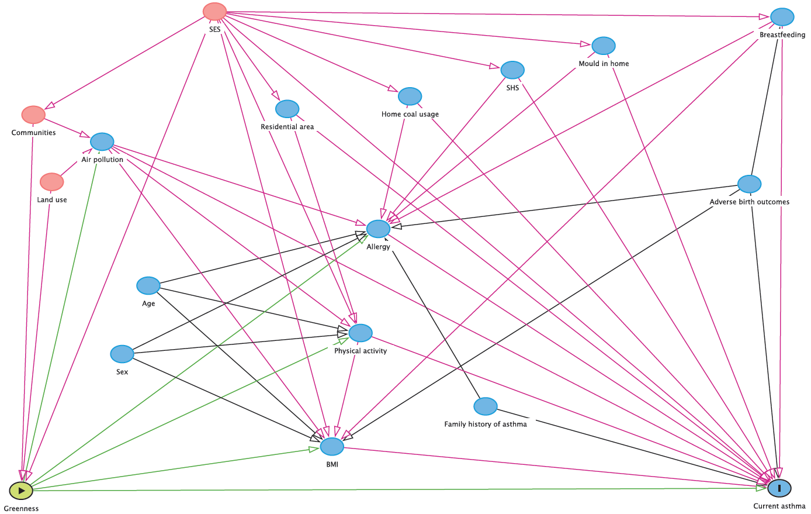

**Figure S1 The direct acyclic graph (DAG) for the association between greenness exposure and current asthma in children using DAGitty (**[**http://dagitty.net/**](http://dagitty.net/)**).**

Note: SES: socio-economic status; SHS: second-hand smoke; BMI: body mass index;

Green circle: ancestor of exposure; Blue circle: ancestor of outcome; Red circle: ancestor of exposure and outcome; Green line: causal path; Red line: biasing path.

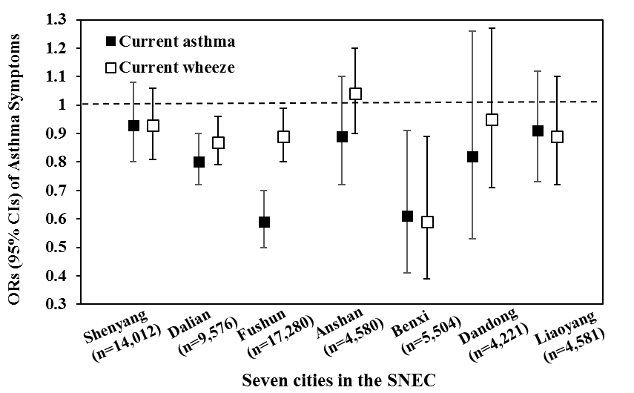

**Figure S2** The adjusted ORs (95% CIs) of asthma symptoms with per 0.1-unit increase of with NDVI in 1000 m buffer in children, across seven cities.

Models adjusted for age, gender, parental education, family income, breastfeeding status, low birthweight, preterm, residential areas per person, environmental tobacco smoke, mould in home, home coal usage, and family history of asthma.