**Study on zinc ions binding to the individual casein fractions: *αS1*-, *β*- and *κ-*casein**

Agnieszka Rodzik1,2, Anna Król-Górniak1,2, Viorica Railean2,3, Mateusz Sugajski1,2, Adrian Gołębiowski1,2, David S. Horne4, Bernhard Michalke5, Myroslav Sprynskyy1, Paweł Pomastowski2*, Bogusław Buszewski1,2

*1Centre for Modern Interdisciplinary Technologies, Nicolaus Copernicus University in Toruń, Wileńska 4, 87-100, Toruń, Poland*

*2Department of Environmental Chemistry and Bioanalysis, Faculty of Chemistry, Nicolaus Copernicus University in Toruń, Gagarina 7, 87-100 Toruń, Poland*

*3 Department of Public Health Protection and Animal Welfare, Faculty of Biological and Veterinary Sciences, Nicolaus Copernicus University in Torun, Gagarina 7, 87-100 Toruń, Poland*

*4Wisconsin Center for Dairy Research, University of Wisconsin—Madison, Madison, WI,*

*United States*

*5Research Unit Analytical BioGeoChemistry, Helmholtz Center Munich—German Research Center for Environmental Health, 85764 Neuherberg, Germany*

*\*Corresponding author: Paweł Pomastowski (*[*p.pomastowski@umk.pl*](mailto:p.pomastowski@umk.pl)*)*

The colloidal behaviour of various caseins forms during the metal binding process is crucial for the further modulation of their stability during the dairy technological processes [1]. The reducing of the repulsive forces responsible for the micelles stability, it is possible to induce aggregation of protein. In the consequence, the texture and structure of dairy products are created [2], [3]. The destabilization of caseins is the common process used in e.g. making a cheese – the milk is coagulated by using chymosin in the presence of calcium and at acidic conditions [4]. Furthermore, the aggregation of caseins seems to be metal-dependent. Metal ions can act as both, promoters or inhibitors, of the protein aggregation process [5], [6]. In the case of caseins, the most discussed is the influence of calcium on this process [7], [8], [9]. Choi, Horne and Lucey [7] have demonstrated that removing of insoluble Ca2+ from casein micelles strongly influnce on rennet gelation properties. The lack of calcium ions have significantly reduced the repulsion forces between phosphoserine residues of caseins, and consequently, the weaker gels were formed. Dalgleish [2], have shown thte Ca2+ caused the aggregation of casein micelles by decreasing their zeta potential. The removal of Ca2+ have increased the repulsion forces as the phosphoserines are negatively charged and the calcium has been neutrailiising this. In the consequence, the gels were found to be weaker. Calcium ions preferably bind to oxygen-containing ligands such as e.g., carboxyl group, but also oxygens of asparagine (Asn), glutamine (Gln), or serine (Ser) [10]. Another important issue, crucial for casein-metal binding is the phosprylation occuring in their amino acid sequence and the ability of phosphorylated serine residues to bind calcium ions. The amount of Ca2+ is important in forming stable micelles [11], [12]. Also zinc might play an important role in casein stabilization through binding to the phosphoserines. Based on the literature, zinc are able to be bound to casein phopsphopeptides (CCP) containing the phosphoserine residues [13], [14], [15]. Singh, Flynn and Fox [14] have observed that *α*S1-casein aggregation was observed with the increasing Zn2+ concentration. Therefore, the aggregation of the all tested in this study casein fractions might be also zinc-dependent, as it follows from the experimental data we received in the present study. In contrast to calcium, Zn2+ ions are able to bind aditionally to sulfur and nitrogen [16]. On the other hand, both zinc and calcium, might exist in the aqua complexes forms, which might influence the stability of biocolloids. This process can described by the bridging effect – divalent aqua complexes screen the charges that make up the electrostatic forces, bind to negatively charged amino acids groups by displacing water molecules from the Stern-Helmholtz layer and, in the consequence, the system charge is increased [17], [18], [19], [20], [21]. As an exaple, in aqueous solutions, zinc forms stable aqua complexes [Zn(H2O)6]2+. Polarization of water molecules by the central zinc ion causes proton dissociation and results in formation of an aqua-hydroxo complex [Zn(OH)(H2O)5]+, which can be further transformed to [Zn(OH)4]2− [17], [16]. Finally, the formation of differently-charged species and binding to the protein might modulate the surface charge of metal-protein complexes. It is in a good correlation with results of Alhazmi et al [20] who have examined the zeta potential of bovine serum albumin after the divalent metal ion (Cu2+) exposure. They have observed that protein dispersion stability depends on the coordination capacity of the metal ions. What is more, metal-protein binding involves the formation of intermolecular bridges between the Me2+ and protein molecules. Another example can be work of Chakraborty and Basak [22] work, who have investigated the influence of the Zn2+ ions on the structure and stability of bovine caseins. At the highest concentration of the added metal, the aggregation and precipitation of protein occurred. Based on our results, due to the various availability of carboxyl groups on the individual caseins surface, the binding of zinc also occur in different manner. It is strongly connected with the generating of stable Zn*αS1*CN complexes. It has a great reflection in the experimental FTIR-ATR analysis results, which was the crucial step in the proper understanding of the described phenomenom.

**References**

[1] C. Broyard, F. Gaucheron, Modifications of structures and functions of caseins: a scientific and technological challenge, Dairy Science and Technology. 95 (2015) 831–862. https://doi.org/10.1007/s13594-015-0220-y.

[2] D.G. Dalgleish, Measurement of electrophoretic mobilities and zeta-potentials of particles from milk using laser Doppler electrophoresis, Journal of Dairy Research. 51 (1984) 425–438. https://doi.org/10.1017/S0022029900023724.

[3] D.G. Dalgleish, M. Corredig, The structure of the casein micelle of milk and its changes during processing, Annual Review of Food Science and Technology. 3 (2012) 449–467. https://doi.org/10.1146/ANNUREV-FOOD-022811-101214.

[4] S. Sandra, M. Alexander, D.G. Dalgleish, The rennet coagulation mechanism of skim milk as observed by transmission diffusing wave spectroscopy, Journal of Colloid and Interface Science. 308 (2007) 364–373. https://doi.org/10.1016/J.JCIS.2007.01.021.

[5] K. Garai, P. Sengupta, B. Sahoo, S. Maiti, Selective destabilization of soluble amyloid beta oligomers by divalent metal ions, Biochemical and Biophysical Research Communications. 345 (2006) 210–215. https://doi.org/10.1016/J.BBRC.2006.04.056.

[6] G. Navarra, M. Leone, V. Militello, Thermal aggregation of beta-lactoglobulin in presence of metal ions, Biophysical Chemistry. 131 (2007) 52–61. https://doi.org/10.1016/J.BPC.2007.09.003.

[7] J. Choi, D.S. Horne, J.A. Lucey, Effect of Insoluble Calcium Concentration on Rennet Coagulation Properties of Milk, Journal of Dairy Science. 90 (2007) 2612–2623. https://doi.org/10.3168/JDS.2006-814.

[8] G.J.O. Martin, R.P.W. Williams, D.E. Dunstan, Effect of manufacture and reconstitution of milk protein concentrate powder on the size and rennet gelation behaviour of casein micelles, International Dairy Journal. 20 (2010) 128–131. https://doi.org/10.1016/J.IDAIRYJ.2009.08.007.

[9] S. Sandra, M. Corredig, Rennet induced gelation of reconstituted milk protein concentrates: The role of calcium and soluble proteins during reconstitution, International Dairy Journal. 29 (2013) 68–74. https://doi.org/10.1016/J.IDAIRYJ.2012.10.011.

[10] N. Tang, L.H. Skibsted, Calcium binding to amino acids and small glycine peptides in aqueous solution: Toward peptide design for better calcium bioavailability, Journal of Agricultural and Food Chemistry. 64 (2016) 4376–4389. https://doi.org/10.1021/acs.jafc.6b01534.

[11] T. Huppertz, P.F. Fox, A.L. Kelly, The caseins: structure, stability, and functionality, in: Proteins in Food Processing: Second Edition, Second Edi, Elsevier Ltd., 2018: pp. 49–92. https://doi.org/10.1016/B978-0-08-100722-8.00004-8.

[12] T. Huppertz, Chemistry of the Caseins, in: Advanced Dairy Chemistry: Volume 1A: Proteins: Basic Aspects, 4th Edition, Springer, Boston, MA, 2013: pp. 135–160. https://doi.org/10.1007/978-1-4614-4714-6_4.

[13] E. Miquel, A. Alegría, R. Barberá, R. Farré, Casein phosphopeptides released by simulated gastrointestinal digestion of infant formulas and their potential role in mineral binding, International Dairy Journal. 16 (2006) 992–1000. https://doi.org/10.1016/j.idairyj.2005.10.010.

[14] H. Singh, A. Flynn, P.F. Fox, Binding of zinc to bovine and human milk proteins, The Journal of Dairy Research. 56 (1989) 235–248. https://doi.org/10.1017/S0022029900026455.

[15] X. Wang, J. Zhou, P.S. Tong, X.Y. Mao, Zinc-binding capacity of yak casein hydrolysate and the zinc-releasing characteristics of casein hydrolysate-zinc complexes, Journal of Dairy Science. 94 (2011) 2731–2740. https://doi.org/10.3168/JDS.2010-3900.

[16] T. Kochańczyk, A. Drozd, A. Krężel, Relationship between the architecture of zinc coordination and zinc binding affinity in proteins - insights into zinc regulation, Metallomics. 7 (2015) 244–257. https://doi.org/10.1039/c4mt00094c.

[17] A. Krężel, W. Maret, The biological inorganic chemistry of zinc ions, Archives of Biochemistry and Biophysics. 611 (2016) 3–19. https://doi.org/10.1016/j.abb.2016.04.010.

[18] L. Ehrl, Z. Jia, H. Wu, M. Lattuada, M. Soos, M. Morbidelli, Role of Counterion Association in Colloidal Stability, Langmuir. 25 (2009) 2696–2702. https://doi.org/10.1021/LA803445Y.

[19] F. Roosen-Runge, B.S. Heck, F. Zhang, O. Kohlbacher, F. Schreiber, Interplay of pH and binding of multivalent metal ions: charge inversion and reentrant condensation in protein solutions, Journal of Physical Chemistry B. 117 (2013) 5777–5787. https://doi.org/10.1021/jp401874t.

[20] H.A. Alhazmi, W. Ahsan, A.M.M. Ibrahim, R.A.Y. Khubrani, Z.A.A. Haddadi, A.Y.F. Safhi, N. Shubayr, M. Al Bratty, A. Najmi, Investigation of bovine serum albumin aggregation upon exposure to silver(i) and copper(ii) metal ions using Zetasizer, Open Chemistry. 19 (2021) 987–997. https://doi.org/10.1515/CHEM-2021-0089/MACHINEREADABLECITATION/RIS.

[21] J. Zhang, H. Li, S. Li, X. Hou, Effects of metal ions with different valences on colloidal aggregation in low-concentration silica colloidal systems characterized by continuous online zeta potential analysis, Colloids and Surfaces A: Physicochemical and Engineering Aspects. 481 (2015) 1–6. https://doi.org/10.1016/j.colsurfa.2015.04.024.

[22] A. Chakraborty, S. Basak, Interaction with Al and Zn induces structure formation and aggregation in natively unfolded caseins, Journal of Photochemistry and Photobiology B: Biology. 93 (2008) 36–43. https://doi.org/10.1016/j.jphotobiol.2008.06.011.

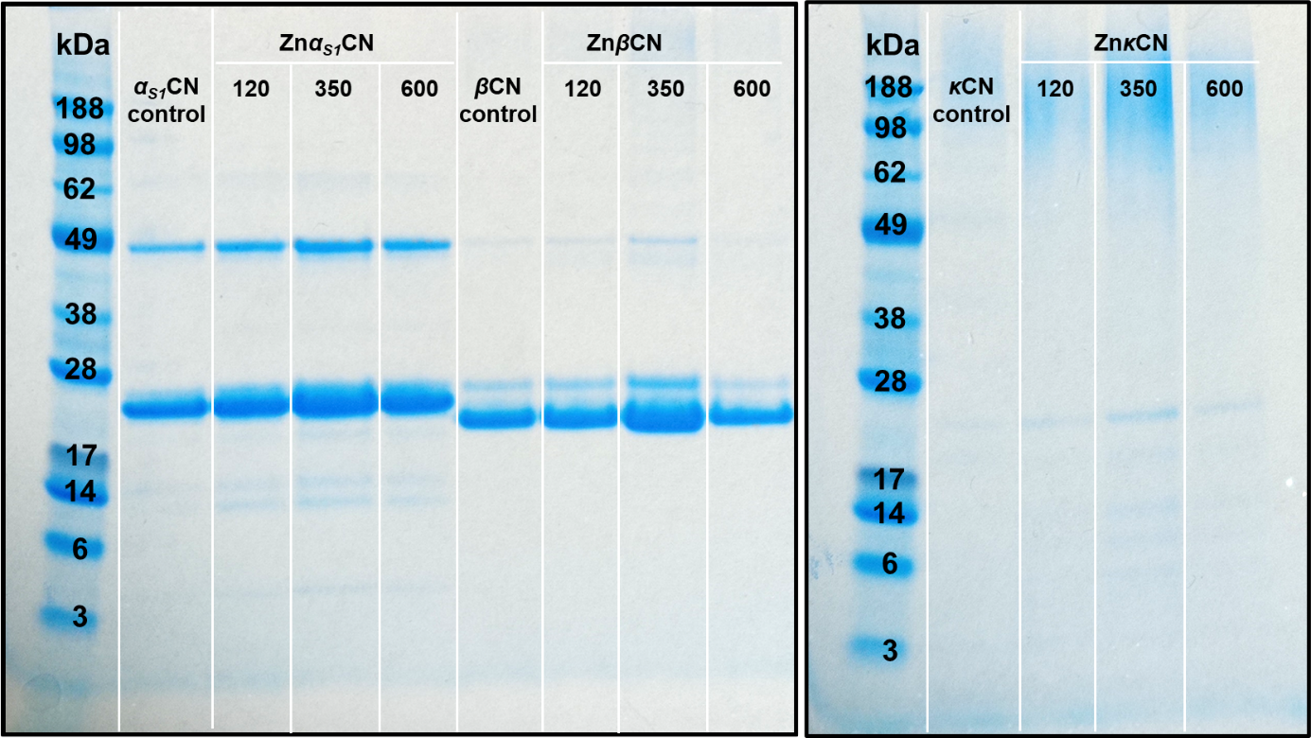

**Fig. S1.** Electrophoretic separation of casein fractions and their complexes with zinc ions.