**Supplementary Material for the manuscript, entitled:**

Dihydrogen phosphate anion boosts the detection of sugars in ESI-MS: A combined experimantal and computational investigation

Alexander Ruf*1,2,3, Basem Kanawati1* , Philippe Schmitt-Kopplin1,21Analytical BioGeoChemistry, Helmholtz Zentrum München, Munich, Germany,

2Analytical Food Chemistry,Technische Universität München, Munich, Germany,

3Université Aix-Marseille, Laboratoire de Physique des Interactions Ioniques et Moléculaires (PIIM), Marseille, France.

**∗** Correspondence Authors: [rufalexan@gmail.com](mailto:rufalexan@gmail.com) ; [basem.kanawati@helmholtz-muenchen.de](mailto:basem.kanawati@helmholtz-muenchen.de) ; +49 89 3187 2412



**Figure S1**: Representative mass spectrum for H2PO4 ̅-sugar dopant systems. FT-ICR mass spectrum of glucose, sucrose and melezitose in the presence of the NH4H2PO4 dopant (with M = neutral sugar substrate). In this depicted experiment, a NH4H2PO4 concentration of 100 µM and a sugar concentration of 1 ppm was used.



**Figure S2**: DFT optimized geometries for the investigated sugars, whose MS intensity profiles are illustrated in Figure 1, computed at B3LYP/6-31+G(d,p). Orange atoms = P, red atoms = O, grey atoms = C, white atoms = H, dashed lines = non-covalent interactions.



**Figure S3**: Optimized geometries of A: [Salicyl alcohol - H2PO4] ̅ complex anion, B: [Salicin - H2PO4] ̅ with the dopant connected to the aglycon side of the molecule, C: [Salicin - H2PO4] ̅ complex anion with   
H2PO4 ̅ forming a pseudo-ring between the aglycon and the sugar side of the molecule,   
D: [Salicin - H2PO4] ̅ complex anion formed as a result of dopant anion attachment to β-glucose.

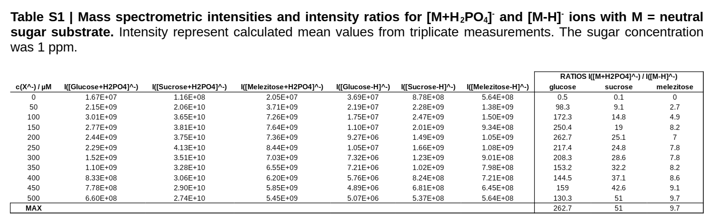

**Gaussian output archives for optimized geometries:**

The following archives include full obtimized geometry of the structure of the adduct ions discussed in the manuscript, equivalent to the structure, which represents energy minimum (fully relaxed geometries). The single point energy value on the B3LYP/6-311+G(2d,p) level of theory is given as SCF in Hartrees.

1. **α-Glucose-H2PO4 Adduct anion:**



SCF= -1331.25214849

1. **β-Glucose-H2PO4 Adduct anion:**



SCF= -1331.25250030

1. **α-Galactose-H2PO4 Adduct anion:**



SCF= -1331.25042145

1. **β-Galactose-H2PO4 Adduct anion:**



SCF= -1331.24838499

1. **Sucrose-H2PO4 Adduct anion:**



SCF= -1942.22478486

1. **Gentiobiose-H2PO4 Adduct anion:**



SCF= -1942.21684893

1. **Melizitose-H2PO4 Adduct anion:**

SCF= -2553.15166448

1. **Raffinose-H2PO4 Adduct anion:**



SCF= -2553.16106445

1. **Salisyl alcohol - H2PO4 Adduct anion**



SCF= -1065.96003429

1. **Salicin - H2PO4 Adduct anion (Aglycon side complexation)**



SCF= -1676.90442637

1. **Salicin - H2PO4 complex anion (Pseudo ring)**



SCF= -1676.90985786

1. **Salicin - H2PO4 complex anion (saccharide side)**



SCF= -1676.92409214