Supplementary file for

**Acute mental stress drives vascular inflammation and promotes plaque destabilization in mouse atherosclerosis**

**This file includes:**

Supplementary methods

Supplementary references

Supplementary figures S1 to S6

Supplementary tables S1 to S2

**Methods**

**Clinical study**

Our clinical study was entitled “Effects of acute psychosocial stress on blood inflammatory leukocyte numbers” and was approved by the local ethics committee of the Technical University Munich (79/16S) and complies with the Declaration of Helsinki. Here, 35 healthy volunteers (age 26.1±1.3, 46% female, German citizens from the local area, with no acute or chronic illness, on no regular medication, 11.4% smokers), all confirmed soccer fans, were enrolled after providing informed consent. Participants watched a key soccer match (round of sixteen during the 2016 European Championship) in which they were emotionally involved because their national team played (the German team played the Slovakia team, final score 3:0 with goals scored at game minutes 8, 43, and 63). All participants completed a visual analog scale test (scale 1-10) to measure short-term stress intensity perception 24 h before (pre-game) and immediately after (post-game) the game ended. Additionally, blood samples and oscillometric blood pressure and heart rate measurements were taken at respective time points. Total leukocyte and leukocyte subpopulation counts were assessed by the routine clinical laboratory of the German Heart Centre, Munich, and by flow cytometric staining.

**Mice**

Male and female C57BL/6J mice (wild-type), *Ubc-GFP* mice (C57BL/6-Tg(UBC-GFP)30Scha/J), and *ApoE-/-* mice (B6.129P2-Apoetm1Unc/J) were either purchased from Charles River Laboratories or the Jackson Laboratory and used for experiments directly or for further in-house breeding. Starting at 8-12 weeks of age, *ApoE-/-*mice were fed a high-cholesterol diet (HCD, 21.2 % fat by weight and 0.2 % cholesterol, TD.88137, Envigo) for 8 weeks. In all experiments, age-matched littermates from both sexes were randomly allocated to treatment or control groups. For intravital microscopy, both male and female *Cx3cr1GFP/WTApoE-/-*mice (with GFP-labeled monocytes on an *ApoE-/-* background, generated by the Institute for Cardiovascular Prevention (IPEK, Munich)) were fed HCD for 4 weeks. For plaque rupture experiments, male *ApoE-/-* (B6.129P2-Apoetm1Unc/J) mice were purchased from Taconic Biosciences and fed HCD for 4 weeks. All genetically modified mice were on a C57BL/6J background. All procedures were approved by respective local committees for animal welfare (Government of Bavaria and Hesse, Germany or Sweden) and experiments were carried out in adherence to NIH Guide for the Care and Use of Laboratory Animals.

**Stress procedures**

Acute stress was simulated by placing animals in mouse holders/restrainers (HLD-MM, Kent Scientific), without squeezing or compression, for up to 3 h (as either a single session or once daily for three days). This immobilization procedure is a common method to apply psychological stress due to perceived confinement20,40,47. Mice were sacrificed up to 24 h after the final stress episode. Restraint stress procedures were never applied more often than once daily for 3 h on three consecutive days (3x3 h stress). Alternatively, acute stress was achieved by placing animals into cages containing a piece of filter paper on which 1 g of fox odor (2,5-Dihydro-2,4,5-trimethylthiazoline, PheroTech Inc., Delta, Canada) was applied. This method generates acute psychological stress by simulating the presence of a predator48. Predator-prey stress procedures were carried out once for 3 h.

**Intravital microscopy**

Intravital microscopy of the right carotid artery was performed in hypercholesterolimic *Cx3cr1GFP/WTApoE-/-* mice (with GFP-labeled monocytes) after intravenous injection of Ly6G-PE antibody to label neutrophils (127608, clone 1A8, BioLegend) as previously described49. CD11b-PE antibody to label all myeloid cells (101208, clone M1/70, BioLegend) was also injected 15 min later. For imaging, an Olympus BX51 microscope with a Hamamatsu 9100-02 EMCCD camera and a 10X saline-immersion objective was used. To analyze leukocyte interactions with the endothelium, 30 s movies were acquired. In offline analysis, myeloid cells were considered adherent if they were permanently located at the same place during the recording. Recordings and analyses were performed in a blinded fashion.

**Inducible carotid artery plaque rupture**

This experiment used 8-week-old male *ApoE-/-* mice. As previously described by Jin *et al*.24, the right common carotid artery was incompletely ligated proximal to the bifurcation under isoflurane anesthesia. Additionally, mice were fed HCD for 4 weeks to accelerate atherosclerotic lesion formation. Plaque rupture was provoked by placing a 300 and 150 µm diameter conical polyethylene cuff (Promolding) under isoflurane anesthesia. Buprenorphine (0.1 mg/kg) was injected subcutaneously as an analgesic for both ligation and cuff placement. Control and stressed mice were analyzed on day 3 after cuff placement for carotid artery plaque rupture. Features of ruptured plaques were assessed via histology.

**Invasive blood pressure and heart rate measurement**

Telemetric transducers (PA-C10, Data Sciences) were implanted into the aortic arch via the left carotid under MMF anesthesia (midazolam 5.0 mg/kg BW; medetomidine 0.5 mg/kg BW; fentanyl 0.05 mg/kg BW). After a one-week recovery period, baseline heart rate and blood pressure measurements were performed for 1 d using the Dataquest ART analysis software. Afterwards, parameters were constantly measured during intermittent stress episodes (once daily for 3 h on three consecutive days) in 5-10 min intervals.

**Chemical depletion of sympathetic nervous fibers/noradrenaline**

6-hydroxydopamine (6-OHDA, 636-00-0, Sigma-Aldrich) was injected intraperitoneally to deplete sympathetic nervous fibers28. Mice received a dose of 100 mg/kg body weight (BW) six days and another dose of 250 mg/kg BW four days before stress exposure.

**Surgical depletion of sympathetic nervous fibers**

The cardiac plexus is a network of nerves that innervates the heart and the aortic arch around which it is located50. Both left and right superior cervical ganglia supply sympathetic input to the cardiac plexus51. Mice were anesthetized using MMF, and a vertical neck incision was made to localize the carotid bifurcation. The superior cervical ganglion (SCG, part of the cervical sympathetic ganglia) was identified beneath the carotid bifurcation and excised bilaterally as previously described29. Half of the animals underwent sham surgery (without final excision of the SCG). Mice were left to recover for two weeks after surgery.

**Surgical adrenalectomy**

Adrenalectomized mice (all C57BL/6J mice, removal of both adrenal glands) were purchased from Charles River and received saline (0.9%) as drinking water. Half of the animals underwent sham surgery. Mice were left to recover for ten days after surgery.

**Intervention with anti-CXCL1 and anti-CCL7**

Animals were injected intravenously either with anti-CXCL1 and anti-CCL7 (AF-456-NA and AF-453-NA, 20 µg each, R&D) or an IgG control (AB-108-C, R&D) under isoflurane anesthesia 30 min prior to stress exposure. Tissues were harvested 21 h after stress exposure ended.

**Tissue processing**

Peripheral blood samples underwent red blood cell lysis in 1X RBC lysis buffer (BioLegend) for 5 min. After the reaction was stopped, the samples were resuspended in FACS buffer (PBS containing 0.5 % bovine serum albumin, Sigma). Flushed bone marrow was triturated and filtered through a 40 µm cell strainer. Excised spleens and inguinal lymph nodes were plunged through a 40 µm cell strainer and collected in FACS buffer. For the flow cytometric analysis of aortic leukocytes, aortas were excised while removing perivascular fat and other tissue, minced, and digested in digestion buffer (collagenase I, 450 U/ml; collagenase XI, 125 U/ml; DNase I, 60 U/ml; hyaluronidase, 60 U/ml; all Sigma-Aldrich) at 37 °C at 750 rpm for 1 h on a thermoshaker. The same digestion protocol was used for lung, skin, heart, kidney, and liver. All digested organs were then processed through a 40 µm cell strainer, centrifuged, and resuspended to generate single cell suspensions. For fluorescence-activated sorting of aortic endothelial cells, aortas were excised, minced, and digested in DNase I (250 U/ml) and collagenase IV (10 mg/ml, Worthington Biochemical Corporation) at 37 °C at 750 rpm for 40 min. For fluorescence-activated sorting of different aortic cell populations, atherosclerotic aortas were excised, minced, and digested in DNase I (250 U/ml), collagenase II (280 U/ml, Worthington Biochemical Corporation), collagenase IV (215 U/ml, Worthington Biochemical Corporation) and dispase (1.2 U/ml, Gibco) at 37 °C at 750 rpm for 1 h.

**Flow cytometry**

All staining was conducted at 4 °C in 300 µl FACS buffer. For myeloid cell analysis, cells were first stained with mouse hematopoietic lineage markers including phycoerythrin (PE) anti-mouse antibodies directed against B220 (103208, clone RA3-6B2), CD90.2 (140308, clone 53-2.1, 1:3000 dilution), CD49b (108908, clone DX5, 1:1200 dilution), NK1.1 (108708, clone PK136), Ter-119 (116208, clone TER-119), and Ly6G-PE (127608, clone 1A8). This was followed by a second staining for CD45.2-PerCP/Cy5.5 (109828, clone 104, 1:300), CD11b-APC/Cy7 (101226, clone M1/70), CD115-BV711 or CD115-biotin (135515 or 135508, clone AFS98; streptavidin-BV510 (405234, 1:300) was used for secondary labelling of CD115-biotin), F4/80-PE/Cy7 (123114, clone BM8), and Ly6C-FITC or Ly6C-BV421 (128006 or 128032, clone HK1.4, 1:600 dilutions unless indicated otherwise, all BioLegend). In every analysis, cells were gated on viable (FSC-A vs. SSC-A) and single (FSC-A vs. FSC-W and SSC-A vs. SSC-W) cells. Neutrophils were identified as lineagehighCD45.2highCD11bhighCD115lowLy6Cintermediate. Monocytes were identified as lineagelowCD45.2highCD11bhighF4/80lowLy6Chigh/low or lineagelowCD45.2highCD11bhighCD115highLy6Chigh/low. Macrophages were identified as lineagelowCD45.2highCD11bhighLy6Clow/intermediateF4/80high. For *in vivo* staining of circulating blood leukocytes, we additionally injected an antibody directed against CD45-BV605 (103140, clone 30-F11, 1:10 in 100 µl PBS, BioLegend) intravenously 5 min before euthanizing the animals. For blood lymphoid cell analysis, cells were stained for CD3-BV421 (100227, clone 17A2), CD19-BV605 (115539, clone 6D5), Ly6C-FITC (128006, clone HK1.4), and CD115-PerCP/Cy5.5 (135525, clone AFS98, all 1:600 dilutions, all Biolegend). B cells were identified as CD19highCD3low and T cells as CD19lowCD3high.

To stain aortic endothelial cells, we used antibodies against CD54-APC (ICAM1) (116120, clone YN1/1.7.4, 1:600), CD102-biotin (ICAM2) (105604, clone 3C4, 1:600), CD106-PE/Cy7 (VCAM1) (105720, clone 429, 1:300), CD62E-PE (E-Selectin) (553751, clone 10E9.6, 1:300, BD Bioscience), CD62P-FITC (P-Selectin) (553744, clone RB40.34, 1:300, BD Bioscience), CD31-BV421 (102424, clone 390, 1:600), CD107a-APC/Cy7 (LAMP1) (121616, clone 1D4B, 1:300), and CD45.2-PerCP/Cy5.5 (109828, clone 104, 1:300, all BioLegend unless indicated otherwise). Streptavidin-BV510 (405234, 1:300, BioLegend) was used to label biotinylated antibodies. Endothelial cells were identified as CD45.2low, CD31high, and CD107aintermediate/high. For staining of cultivated murine aortic endothelial cells, we used antibodies mentioned above, except for CD45.2. For sorting different aortic cell types, we stained for mouse hematopoietic lineage markers including phycoerythrin (PE) anti-mouse antibodies directed against B220 (103208, clone RA3-6B2), CD90.2 (140308, clone 53-2.1, 1:3000 dilution), CD49b (108908, clone DX5, 1:1200 dilution), NK1.1 (108708, clone PK136), Ter-119 (116208, clone TER-119), and Ly6G-PE (127608, clone 1A8), and antibodies against CD31-BV421 (102424, clone 390), CD45-BV605 (103140, clone 30-F11), CD140a-PerCP/Cy5.5 (clone APA5, 135914), and CD11b-APC/Cy7 (101226, clone M1/70, 1:600 dilutions unless indicated otherwise, all BioLegend). Fibroblasts were identified as CD45lowCD140high, endothelial cells as CD45lowCD31high, macrophages as CD45highCD11bhighlineagelow, and neutrophils as CD45highCD11bhighlineagehigh.

For human monocyte subset analysis, cells were first stained with biotin-conjugated antibodies directed against human hematopoietic lineage markers, including CD3 (300404, clone UCHT1), CD19 (302204, clone HIB19), CD20 (302350, clone 2H7), and CD56 (362536, clone 5.1H11, all BioLegend, all 1:600) after red blood cell lysis (RBC Lysis buffer, BioLegend). A second staining was carried out and cells were stained for CD11b-APC (301310, clone ICRF44, 1:600), CD16-BV711 (302044, clone 3G8, 1:600), CD14-BV421 (325628, clone HCD14, 1:600) and streptavidin-FITC (405202, 1:600). Monocytes were identified using forward and side scatter as well as CD11b. Within this population, numbers of monocyte subsets CD14highCD16low, CD14lowCD16high, and CD14highCD16high were quantified. Neutrophils and lymphocytes were identified using forward and side scatter.

For compensation, the above-mentioned antibodies were conjugated to OneComp eBeads (01-1111-42, Thermo Fisher). GFPhigh control samples were used to compensate for GFP fluorescence. Flow cytometry data were acquired on an LSRFortessa (BD Bioscience) and corresponding data were analyzed using FlowJo software (version 9).

**Cell sorting and adoptive transfer**

To purify aortic endothelial cells, single-cell suspensions were stained for CD31-BV421 (102424, clone 390, 1:600), CD107a-APC/Cy7 (LAMP1) (121616, clone 1D4B, 1:300), and CD45.2-PerCP/Cy5.5 (109828, clone 104, 1:300, all BioLegend) after digestion. Aortic endothelial cells were identified as CD45.2lowCD31highCD107aintermediate/high and FACS-sorted using a BD FACSAria III cell sorter.

To obtain purified neutrophils and monocytes for adoptive transfer experiments, cells were isolated from the bone marrow of *Ubc-GFP* donor animals using Ly6G-PE (127608, clone 1A8) and CD115-biotin (135508, clone AFS98, both BioLegend), which allowed coupling to magnetic beads (anti-PE and streptavidin microbeads, 130-048-801 and 130-048-101, Miltenyi Biotec) and separation of cells via magnetic-activated cell separation columns (130-042-401, Miltenyi Biotec). Equal amounts of purified neutrophils and monocytes were injected i.v. into C57BL/6J or *ApoE*−/− mice and the organs listed above were harvested 24 h later. The number of CD11bhighGFPhigh cells within the organs was quantified using flow cytometry.

**Histology**

Aortic roots were dissected and embedded in OCT compound (SA62550-01, Tissue Tek, Science Services). Molds were frozen on liquid nitrogen and 5 µm cross-sections were obtained. Tissue was fixed in ice-cold acetone for 10 min, treated with peroxidase block (S202386-2, Agilent), and stained using an anti-CD11b antibody (101202, BioLegend), an anti-Ly6G antibody (127602, BioLegend), an anti-CD19 antibody (ab25232, Abcam), and an anti-CD3 antibody (ab16669, Abcam) followed by a biotinylated secondary antibody (BA-4001 or B-1000, Vector Laboratories). For staining visualization, we used the VECTASTAIN ABC kit (PK-4000, Vector Laboratories) together with AEC substrate (K3461, Dako). Cell nuclei were counterstained with Gill´s hematoxylin solution no. 2 (1051752500, Merck Millipore). CD11b staining was analyzed by quantifying the CD11b-positive area per total plaque area. CD19 and CD3 staining was analyzed by quantifying the number of cells per plaque area.

To analyze plaque rupture, carotid arteries were embedded in OCT compound and sectioned at 6 µm. Standard hematoxylin and eosin (H&E) staining was performed for tissue morphology, and sections were imaged using NanoZoomer 2.0-HT Digital Slide Scanner (Hamamatsu Photonics). Thrombus formation was regarded as an indicator for plaque rupture. For further characterization of the carotid arteries, tissue was fixed in ice-cold acetone for 10 min and stained using antibodies against CD11b (101202, BioLegend), Collagen I (ab21286, Abcam), and alpha smooth muscle actin (SMA, ab5694, Abcam) followed by a biotinylated secondary antibody (BA-4001 or B-1000, Vector Laboratories). Antibody detection and cell nuclei counterstaining was performed as described above. Immunohistochemistry staining was analyzed by quantifying the positive area per total plaque area.

**RNA sequencing**

Messenger RNA (mRNA) was extracted from FACS-sorted endothelial cells using the Arcturus PicoPure RNA Isolation Kit (KIT0204, Applied Biosystems) according to the manufacturer’s protocol. Samples were analyzed by IMGM Laboratories (Munich), where RNA quantification and purity were assessed on a NanoDrop ND-1000 (Peqlab) and RNA integrity control was performed on a 2100 Bioanalyzer (Agilent Technologies). After library preparation with TruSeq Stranded kit (Illumina) and subsequent quality control and quantification, sequencing was performed on a NextSeq 500 sequencing system (Illumina). Raw data were generated and processed using the Real Time Analysis 2.4.11 Software (RTA) and Illumina Sequence Analysis Viewer (SVA) 2.4.7.

**RNAseq data analysis**

After standard quality control procedures using FastQC and read trimming with Trimmomatic52, we mapped the reads onto the *Mus musculus* reference genome using the STAR aligner53 and performed quality control on the respective alignments with Qualimap54. We further used featureCounts55 to de-convolute read data into gene abundances. After removing features with consistently low counts (median < 10), we normalized the raw count data using the trimmed mean of M-values (TMM) normalization method56, as implemented in the edgeR57 package. LIMMA t-statistic approach with Benjamini-Hochberg multiple testing correction (BH or the false discovery rate (FDR) or adj. P-value)58 was used to select the differentially expressed genes (DEGs) from the normalized gene expression data. Genes were defined as differentially expressed if they demonstrated a -0.58 ≤ log2 FC ≥ 0.58 (i.e. fold change of at least 1.5) and an adj. P-value ≤ 0.05 between the two comparison groups. DEGs were visualized as a Volcano plot using the ggplot2 R package59 and the most significant DEGs (FDR or adj. P-value ≤ 0.25) were labeled. Functional enrichment analysis of the DEGs was performed using ToppFun from the ToppGene Suite (https://toppgene.cchmc.org/60), which detects functional enrichment in 14 annotation categories.

**Real-time quantitative polymerase chain reaction (qPCR)**

We extracted total RNA from aortic arches using the RNeasy Mini kit (74104, Qiagen). DNA was removed via a RNase-free DNase set (79254, Qiagen) for DNA digestion. RNA quality was assessed with a NanoQuant Plate on an Infinite M200 PRO plate reader (both TECAN) and first-strand cDNA was generated with the High-Capacity RNA-to-cDNA kit (4388950, Applied Biosystems).

Real-time qPCR was carried out using TaqMan probes (*Mmp3*, Mm00440295_m1; *Col1a2*, Mm00483888_m1; *Tgfb1*, Mm01178820_m1; *Col3a1*, Mm01254476_m1; *Ccl7*, Mm00443113_m1; *Cxcl1*, Mm04207460_m1) and TaqMan Fast Universal Master Mix (all Thermo Fisher). The reactions were performed in a total volume of 10 µl and over 40 cycles on a ViiA 7 system. *Gapdh* (Mm99999915_g1) was used as a housekeeping gene. To quantify mRNA levels, 2-ΔCt values were used.

**Chemokine & Cytokine Assay**

Blood samples were obtained by cardiac puncture and collected in EDTA-coated tubes. For plasma extraction, blood was centrifuged at 2000 x g for 15 min at 4 °C. The chemokine & cytokine assay (36-Plex Mouse ProcartaPlex™ Panel 1A, EPX360-26092-90, Thermo Fisher) was performed according to the manufacturer´s instructions.

**ELISA**

Blood samples were obtained as described above. Aortic arches were excised, stored in catecholamine stabilizing buffer (0.01 N hydrochloric acid, 0.15 mM ethylenediaminetetraacetic acid, 4mM sodium metabisulfite in H2O dest.; adjusted to pH 7) at -80 °C for up to one week, and minced using a mechanical disruptor (TH220, Omni) with soft-tissue tips (32750, Omni). ab108821 (Abcam), EA633/96 (DLD Diagnostika), and EA632/96 (DLD Diagnostika) were used for corticosterone (1:100 sample dilution), norepinephrine, and epinephrine measurements, respectively. For the measurement of intimal norepinephrine concentrations, human atherosclerotic plaque samples from carotid (approval by the local ethics committee of the Technical University Munich: 2799/10) and coronary (approval by the local ethics committee of the Technical University Munich: 5943/13, performed as an adjunct to coronary artery bypass grafting) endarterectomy procedures were used. Samples were directly frozen at -80 °C after the intervention, and minced using a mechanical disruptor with hard-tissue tips (32750H). Samples were centrifuged at 12,000 g for 15 min at 4 °C to remove debris and measured using the above-mentioned norepinephrine ELISA.

ab216951, ab205571 (both Abcam) and MJE00B (R&D) were used to determine CXCL1, CCL7, and CCL2 plasma levels. ab216951, ab205571, ab100712, ab229440, ab229393 (all Abcam) were used to determine CXCL1, CCL7, IL-6, IL-1ß, and TNFalpha levels in cell culture supernatants. All measurements were performed according to the manufacturers’ instructions.

**Cholesterol measurements**

Blood samples were obtained as described above and assessed on a Cobas photometer (Roche) with the respective analysis kit (LDL-c: LDLC3, HDL-c: HDLC4, total cholesterol: CHOL2; all Roche) by the routine clinical laboratory of the German Heart Centre, Munich.

**Immunoblotting**

Aortic arches were excised, stored at -80 °C, and minced in 200 µl RIPA buffer (Cell Signaling Technology) supplemented with 1 % proteinase (Halt™ Protease Inhibitor Cocktail, Thermo Fisher) and phosphatase inhibitor cocktail (Halt™ Phosphatase Inhibitor Cocktail, Thermo Fisher) using scissors followed by mechanical disruption with soft-tissue tips. To generate cell lysates, cells were sonicated 3 times for 30 s with intermitting 30 s on ice and centrifuged at 21,000 g for 5 min to remove cell debris. Protein concentrations were determined with a bicinchoninic acid (BCA) assay (ThermoFisher) according to the manufacturer´s protocol. Samples were adjusted to insert 35 µg total protein, supplemented with 4X Laemmli samples buffer, and heated for 5 min at 95 °C. SDS-gel electrophoresis was performed with 4-20 % Mini-PROTEAN® TGX™ precast gradient gels (Bio-Rad) at 300 V for 18 min in 1X Tris/glycine/SDS buffer (Bio-Rad). Wet blotting (25 mM Tris, 192 mM glycine, 20 % v/v methanol, pH 8.3) was carried out at 100 V for 90 min using methanol-activated polyvinylidene difluoride (PVDF) membranes (Merck Millipore). All subsequent buffers were based on TBS-T (20 mM Tris, 150 mM NaCL, 0.1 % Tween, pH 7.6) and contained 5 % BSA. The membrane was blocked for 1 h at room temperature with the aforementioned buffer. Primary antibodies (anti-pTH, ab5935, 1:500, Merck Millipore; anti-GAPDH, 5174P, 1:50000, Cell Signaling) were incubated overnight at 4 °C and the appropriate HRP-conjugated secondary antibody (anti-rabbit, 7074, 1:100,000, Cell Signaling) was incubated for 1 h at room temperature. For signal detection, membranes were incubated using SuperSignal™ West Dura Extended Duration Substrate (Thermo Fisher) according to the manufacturer´s protocol and imaged with an ImageQuant LAS 400 imaging system (GE Healthcare Life Sciences).

**Cell culture**

Primary murine aortic endothelial cells (C57-6052, mAoECS), primary murine aortic smooth muscle cells (C57-6080), and primary murine aortic fibroblasts (C57-6075, all CellBiologics) were cultured in appropriate cell culture medium (PB-M1168, PB-M2268, PB-M1167, PeloBiotech) in a humidified incubator with 5 % CO2 at 37 °C. For static experiments, 50,000 mAoECs, smooth muscle cells or fibroblasts were seeded into a 24-well plate. After cultivation for 24 h, norepinephrine (1 µM, A7257-1G, Sigma) or HCl vehicle was added repetitively every 8 h for 24 h. Afterwards, the supernatant was collected for chemokine measurements. Bone marrow-derived macrophages (BMDM) were generated by flushing one femur of each mouse with 20 ml PBS (0.5% BSA). Cells were centrifuged at 400 g for 5 min at 4 °C, treated with RBC lysis as described above, and 1,000,000 cells were plated in a 6-well plate containing 1 ml of RPMI medium (A1049101, Gibco) containing 10% fetal calve serum, 1% Pen/Strep, and 100 ng/ml M-CSF (416-ML-050, R&D). An additional 1 ml of medium was added the day after, and following a wash step with PBS, medium was completely replaced at day 3 and 5. From day 5 on, norepinephrine (1 µM) or 0.5 M HCl vehicle was added repetitively every 8 h for 24 h. Afterwards, the supernatant was collected for chemokine measurements. For flow experiments, 200,000 mAoECs were seeded into channel slides with 0.2 mm (high shear stress) and 0.8 mm (low shear stress) chamber height (80166 and 80196, Ibidi) and cultivated under flow conditions (flow profile: 1 h at 7 dyn/cm2 , 1 h at 10 dyn/cm2, 1 h at 15 dyn/cm2, and 30 dyn/cm2 until harvest for 0.2 mm slides; 1 h at 0.5 dyn/cm2, 1 h at 0.7 dyn/cm2, 1 h at 1 dyn/cm2, and 2 dyn/cm2 until harvest for 0.8 mm slides). After cultivation under flow conditions for 24 h, hormones were added (1 µM norepinephrine A7257-1G repetitively every 8 h, 1 µM epinephrine E-4250-1G repetitively every 8 h, 1 µM corticosterone 27840-100MG once; all Sigma). Cells were harvested using accutase solution (A6964-100ML, Sigma). For leukocyte adhesion assays, neutrophils and monocytes were isolated and purified from bone marrow using magnetic-activated cell sorting, as described above. Cells were stained with Calcein-AM (C3100MP, Invitrogen) for 1 h and mAoECs were incubated with the leukocytes under flow conditions for 1 h. For adrenoreceptor-blocker experiments, phentolamine hydrochloride (P7547, 1 µM, Sigma), propranolol hydrochloride (P0884, 1 µM, Sigma) or respective vehicle were added to the culture medium once a day. For neutralization experiments, anti-CXCL1, anti-CCL7 (AF-456-NA and AF-453-NA, 0.1 µg/ml each, R&D) or an IgG control (AB-108-C, 0.2 µg/ml, R&D) were added to the culture medium together with the leukocytes and incubated under high flow conditions (30 dyn/cm2) for 1 h. After washing off non-adherent cells, slides were imaged at 10x magnification using a fluorescence microscope with a green filter set (DMRB, Leica). Adherent leukocytes were quantified with ImageJ. For flow experiments in human primary endothelial cells, human umbilical vein endothelial cells (HUVECs, C-12200, PromoCell) were cultured in endothelial cell growth medium (C-22011, PromoCell), seeded into channel slides with 0.8 mm chamber height and cultivated under flow conditions (flow profile: 1 h at 1 dyn/cm2, 1 h at 3 dyn/cm2, 1 h at 5 dyn/cm2, and 10 dyn/cm2 until harvest). After cultivation under flow conditions for 24 h, norepinephrine (1 µM) or HCl vehicle was added repetitively every 8 h for 24 h. For monocyte adhesion assays, THP-1 cells (ATCC TIB-202, ATCC) were stained with Calcein-AM (C3100MP, Invitrogen) for 1 h, and HUVECs were incubated with THP-1 cells under flow conditions for 1 h. Afterwards, slides were imaged and analyzed as described above.

**Statistical analysis**

For statistical analysis, GraphPad Prism version 8 was used. If the sample size was large enough (n≥8), normal distribution of data was assessed using the D’Agostino-Pearson omnibus normality test. Sample sizes with n<8 were analyzed using the Shapiro-Wilk test. For single comparisons, data were analyzed using two-tailed Student´s unpaired/Student´s paired (for normally distributed data) or Mann-Whitney/Wilcoxon test (for non-normally distributed data) as appropriate, indicated in the respective figure legends. When comparing more groups, a one-way ANOVA followed by a Holm-Sidak test for multiple comparisons or a Kruskal-Wallis test followed by a Dunn´s test for multiple comparisons was performed for in vivo data. For paired designs in *in vitro* experiments and repeated blood leukocyte analysis, repeated measures one-way ANOVA or mixed-effects analysis were used to compare more groups. Contingency analysis for plaque rupture experiments was performed using Fisher´s exact test. To determine statistical outliers, the two-sided ROUT´s test was used. Sample sizes are indicated in the figure legends and data are displayed as mean + s.d. P-values < 0.05 were regarded as significant and murine experiments were performed at least twice. To adjust for inter-experimental variations, absolute values were normalized to one representative experiment if appropriate.

Every experiment was started with the exact same number of mice in each group. However, in some experiments some samples are missing because:

-mice died or turned severely sick during experiments (particularly when surgery was performed)

-some mice needed to be excluded (and euthanized) because they developed severe dermatitis, a known side effect of high cholesterol diet in ApoE deficient mice

-of technical problems with processing a sample

However, one has to consider that missing samples/data may result in bias and that findings may be influenced by missing data.

**References**

47. Dhabhar FS, Satoskar AR, Bluethmann H, David JR, McEwen BS. Stress-induced enhancement of skin immune function: A role for gamma interferon. *Proc National Acad Sci* 2000;**97**:2846–2851.

48. Barnum CJ, Page TWW, F. H, Neigh GN, Tansey MG. Psychological stress in adolescent and adult mice increases neuroinflammation and attenuates the response to LPS challenge. *J Neuroinflamm* 2012;**9**:15.

49. Winter C, Silvestre-Roig C, Ortega-Gomez A, Lemnitzer P, Poelman H, Schumski A, Winter J, Drechsler M, Jong R de, Immler R, Sperandio M, Hristov M, Zeller T, Nicolaes GAF, Weber C, Viola JR, Hidalgo A, Scheiermann C, Soehnlein O. Chrono-pharmacological Targeting of the CCL2-CCR2 Axis Ameliorates Atherosclerosis. *Cell Metab* 2018;**28**:175-182.e5.

50. Kapa S, DeSimone CV, Asirvatham SJ. Innervation of the heart: An invisible grid within a black box. *Trends Cardiovas Med* 2015;**26**:245–257.

51. Fukuda K, Kanazawa H, Aizawa Y, Ardell JL, Shivkumar K. Cardiac innervation and sudden cardiac death. *Circ Res* 2015;**116**:2005–2019.

52. Bolger AM, Lohse M, Usadel B. Trimmomatic: a flexible trimmer for Illumina sequence data. *Bioinform Oxf Engl* 2014;**30**:2114–2120.

53. Dobin A, Davis CA, Schlesinger F, Drenkow J, Zaleski C, Jha S, Batut P, Chaisson M, Gingeras TR. STAR: ultrafast universal RNA-seq aligner. *Bioinform Oxf Engl* 2012;**29**:15–21.

54. Okonechnikov K, Conesa A, García-Alcalde F. Qualimap 2: advanced multi-sample quality control for high-throughput sequencing data. *Bioinform Oxf Engl* 2015;**32**:292–294.

55. Liao Y, Smyth GK, Shi W. featureCounts: An efficient general-purpose program for assigning sequence reads to genomic features. *Bioinformatics* 2013;**30**:923–930.

56. Robinson MD, Oshlack A. A scaling normalization method for differential expression analysis of RNA-seq data. *Genome Biol* 2010;**11**:R25.

57. Robinson MD, McCarthy DJ, Smyth GK. edgeR: a Bioconductor package for differential expression analysis of digital gene expression data. *Bioinform Oxf Engl* 2009;**26**:139–140.

58. Benjamini Y, Hochberg Y. Controlling the False Discovery Rate: A Practical and Powerful Approach to Multiple Testing. *J Royal Statistical Soc Ser B Methodol* 1995;**57**:289–300.

59. Wickham H. ggplot2. *Wiley Interdiscip Rev Comput Statistics* 2011;**3**:180–185.

60. Chen J, Bardes EE, Aronow BJ, Jegga AG. ToppGene Suite for gene list enrichment analysis and candidate gene prioritization. *Nucleic Acids Res* 2009;**37**:W305-11.

**Supplementary figures and supplementary figure legends**

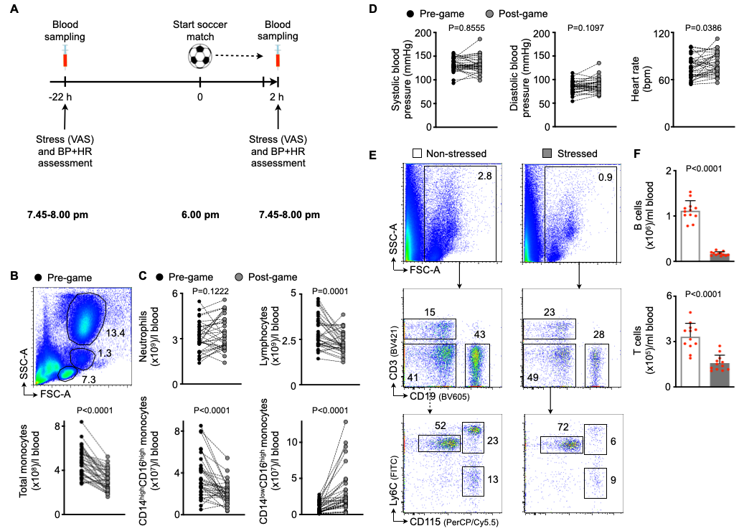

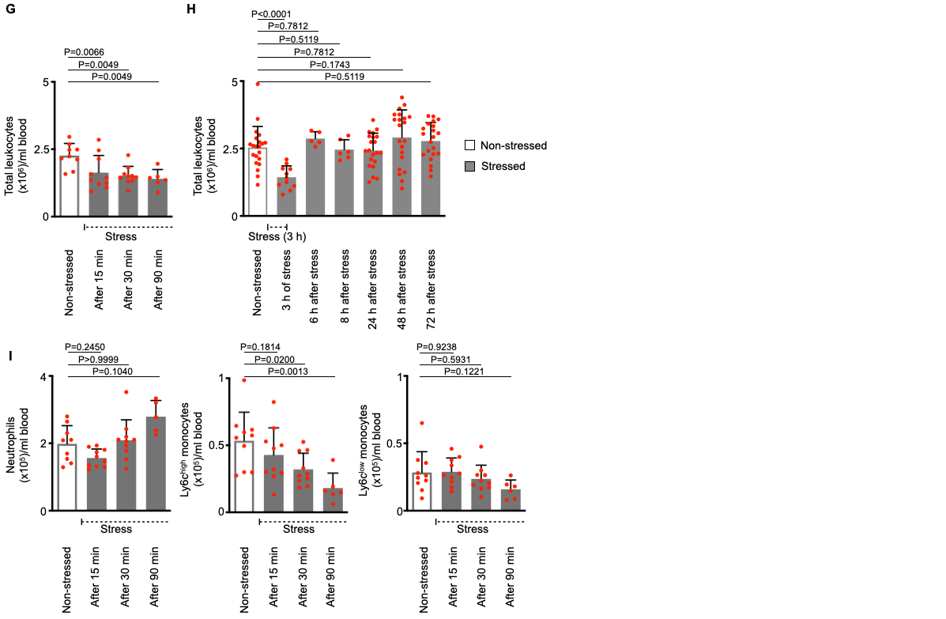

**Fig. S1: Acute mental stress exposure lowers numbers of inflammatory blood leukocytes in humans and mice.**

**(A)** Experimental setup for Fig. 1A-C and panels B+C. **(B, C)** Gating and quantification of human blood leukocyte subsets in soccer spectators either 24 h before or immediately after watching a key soccer match (n = 35 healthy individuals, paired *t*-test, Wilcoxon matched-pairs test for CD14highCD16high and CD14low CD16high monocytes). **(D)** Hemodynamic parameters in soccer spectators (paired *t*-test for heart rate, Wilcoxon matched-pairs test for systolic and diastolic blood pressure). **(E, F)** Gating and quantification of murine blood lymphocytes in non-stressed vs. stressed wild-type mice (immediately after a single 3 h episode of restraint stress, n= 12 per group, Student´s *t*-test). **(G, H)** Murine blood leukocyte kinetics **(G)** during (n= 6-10 per group, one-way ANOVA, result of overall testing *P* = 0.0035, only *p*-values for comparisons with non-stressed control group are annotated) and **(H)** after (n= 5-21 per group, Mixed-effects analysis, result of overall testing *P* < 0.0001, only *p*-values for comparisons with non-stressed control group are annotated) a single 3 h stress episode. **(I)** Murine blood leukocyte subset kinetics during a single 3 h stress episode (n= 6-10 per group, one-way ANOVA for Ly6Chigh and Ly6Clow monocytes, result of overall testing *P* = 0.0027 for Ly6Chigh monocytes and *P* = 0.1361 for Ly6Clow monocytes; Kruskal-Wallis test for neutrophils, result of overall testing *P* < 0.0036; only *p*-values for comparisons with non-stressed control group are annotated). Data are presented as mean + s.d. BP = blood pressure, HR = heart rate, VAS = visual analog scale.

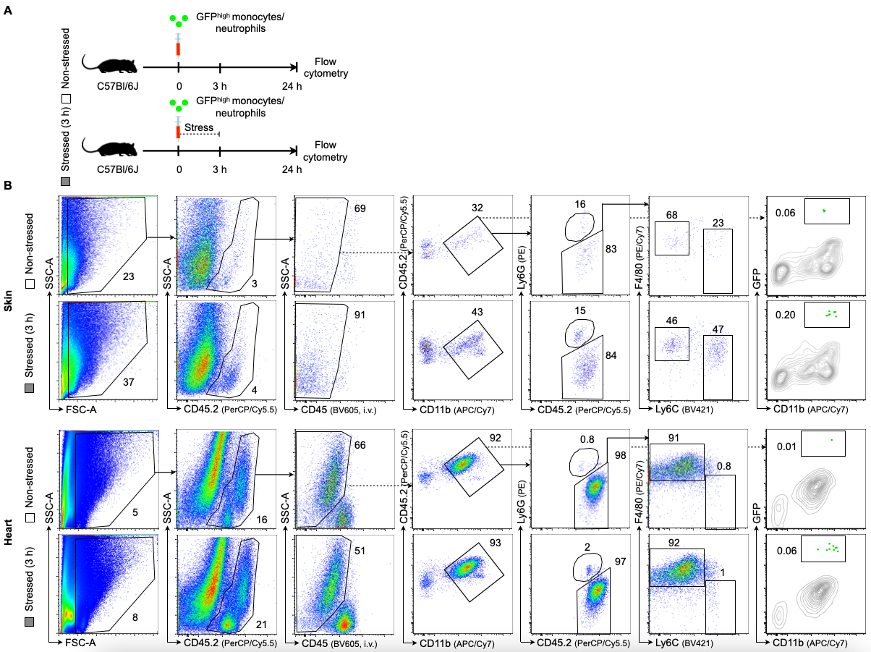

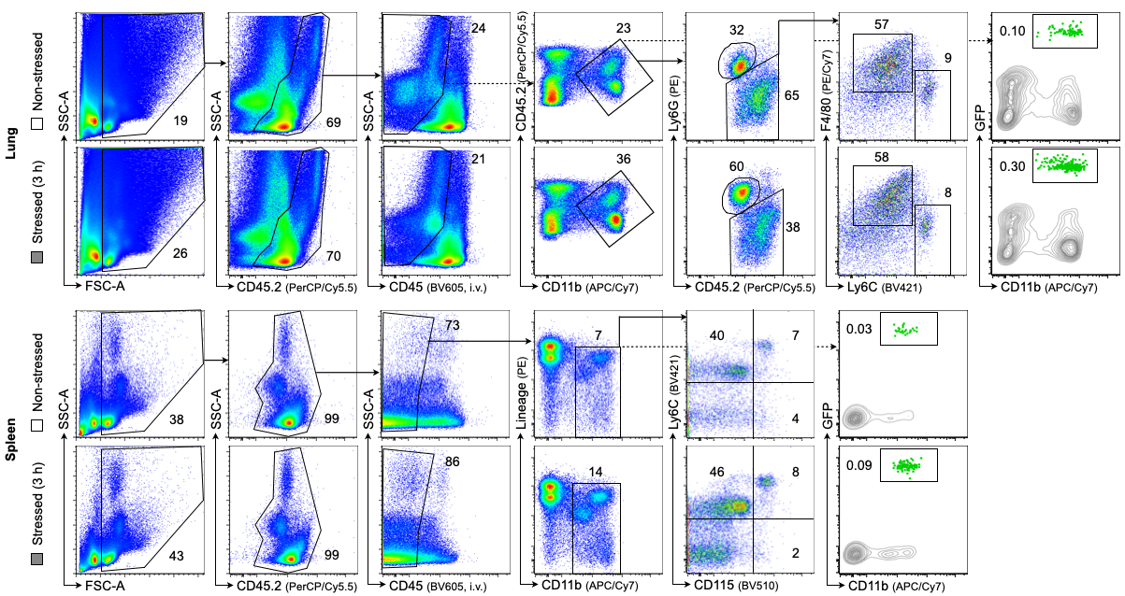

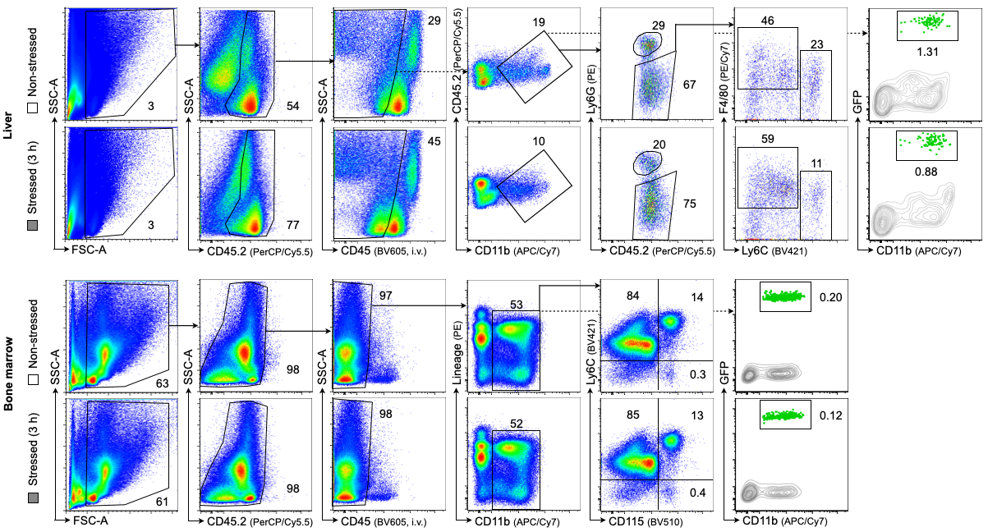

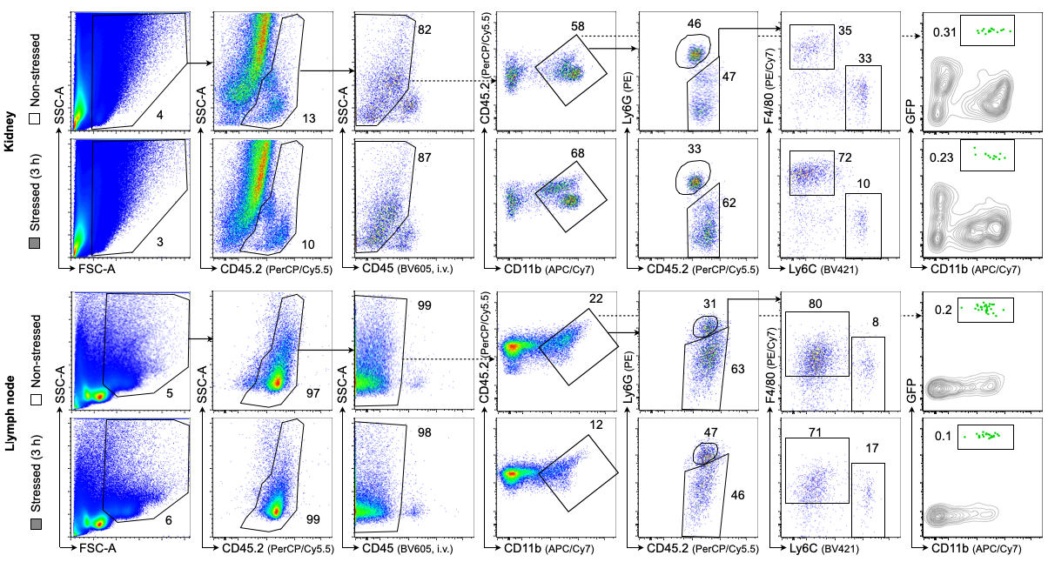

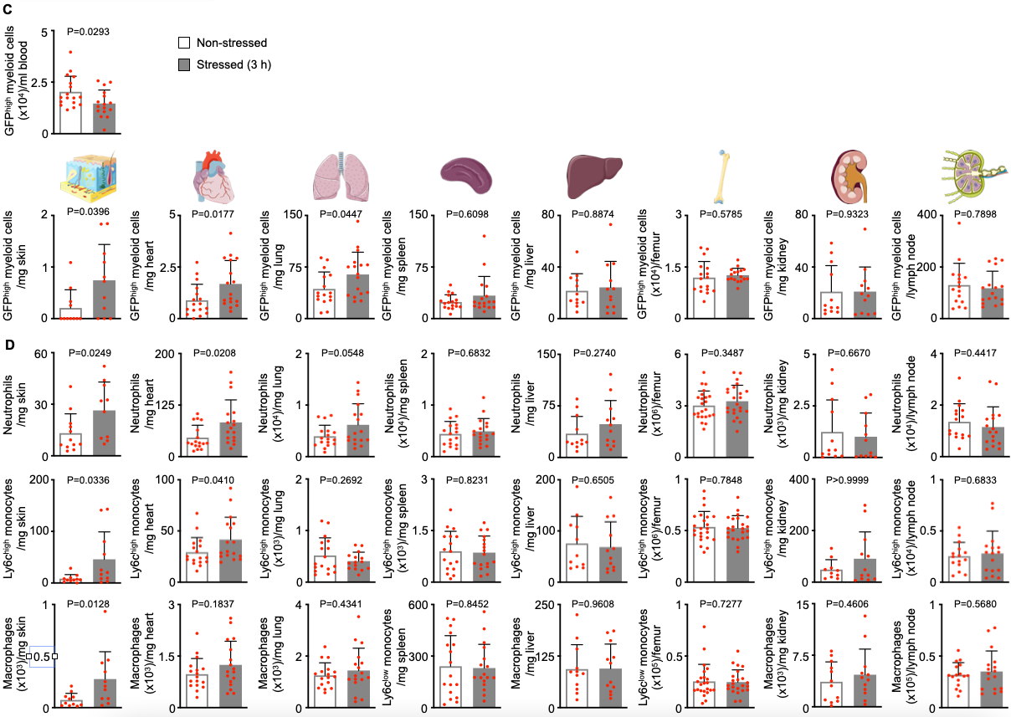

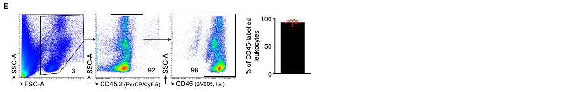

**Fig. S2: Acute mental stress promotes recruitment of inflammatory blood leukocytes into distinct organs.**

**(A)** Experimental setup for Fig. 1F+G and panels B-D. Recruited GFPhigh myeloid cells and total numbers of inflammatory leukocytes were analyzed across various organs from non-stressed vs. stressed wild-type mice (21 h after a single 3 h episode of restraint stress). **(B)** Gating of GFPhigh myeloid cells and leukocyte subsets across distinct organs from non-stressed vs. stressed mice. **(C)** Quantification of GFPhigh myeloid cells in various organs after adoptive transfer of GFPhigh monocytes and neutrophils in non-stressed vs. stressed mice (n = 12 to 18 per group, Student´s *t*-test for lung, bone marrow and blood; Mann-Whitney *U*-test for skin, heart, spleen, liver, kidney and lymph node). **(D)** Quantification of leukocyte subsets across distinct organs from non-stressed vs. stressed mice (n = 11 to 18 per group, Student´s *t*-test or Mann-Whitney *U-*test as appropriate). **(E)** Efficiency of blood leukocyte labelling 5 min after intravenous application of a fluorescently-labeled anti-CD45 antibody (n = 10). Numbers next to gates indicate frequencies (%). Data are presented as mean + s.d.

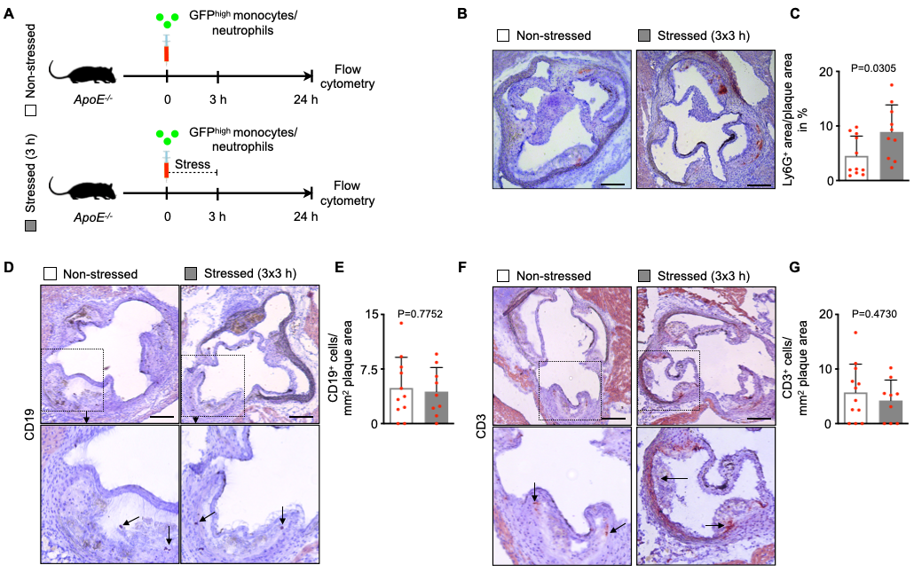

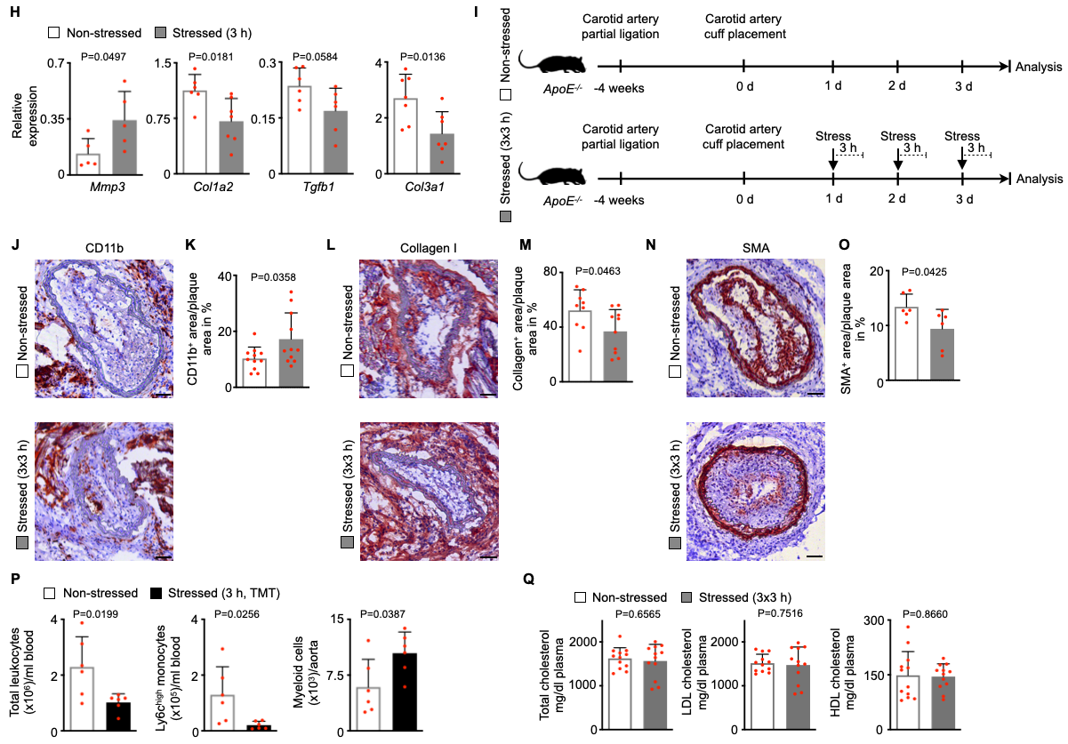

**Fig. S3: Acute mental stress exposure promotes migration of inflammatory blood myeloid cells into atherosclerotic plaques.**

**(A)** Experimental setup for Fig. 2A. Recruited GFPhigh myeloid cells and total numbers of inflammatory leukocytes were analyzed in atherosclerotic aortas from non-stressed vs. stressed *ApoE-/-* mice (21 h after a single 3 h episode of restraint stress). **(B+C)** Representative immunohistochemical staining of aortic roots from non-stressed vs. stressed *ApoE-/-* mice (after three episodes of 3 h restraint stress once daily) for neutrophils (Ly6G). Scale bars represent 200 µm. Bar graphs show percentage of positive are per plaque area (n = 10-11 per group, Students *t*-test). (**D-G)** Representative immunohistochemical staining of aortic roots from non-stressed vs. stressed *ApoE-/-* mice (after three episodes of 3 h restraint stress once daily) for **(D+E)** B lymphocytes (CD19) and **(F+G)** T lymphocytes (CD3). Scale bars represent 200 µm. Bar graphs show number of positive cells per evaluated plaque area (n = 9-12 per group, Students *t*-test). **(H)** Quantitative real-time PCR for fibrotic gene messenger RNAs in aortas of non-stressed vs. stressed *ApoE-/-* (21 h after a single 3 h episode of restraint stress, n = 5-7 per group, Mann-Whitney *U-*test). **(I)** Experimental setup for Fig. 2K+L and panels J-O. **(J-O)** Representative immunohistochemical staining of carotid arteries from non-stressed vs. stressed *ApoE-/-* mice (after three episodes of 3 h restraint stress once daily, both groups underwent prior carotid artery ligation and cuff placement to induce plaque rupture) for (**J, K**) myeloid cells (CD11b, n = 11 per group, Students *t*-test), (**L, M**) collagen content (Collagen I, n = 9-10 per group, Students *t*-test), and (**N, O**) smooth muscle cells (smooth muscle actin, SMA, n = 6 per group, Students *t*-test). Scale bars represent 50 µm. Bar graphs show percentage of positive area per plaque area. **(P)** Quantification of blood and aortic myeloid cells from non-stressed vs. stressed *ApoE-/-* mice (21 h after a single 3 h episode of predator/prey stress using fox odor exposure (trimethylthiazoline, TMT, a component of fox feces/urine, n = 6 per group, Students *t*-test). **(Q)** Blood lipid profiles of non-stressed vs. stressed *ApoE-/-* mice (after three episodes of 3 h restraint stress once daily, n = 12, Student´s *t*-test). Data are presented as mean + s.d.

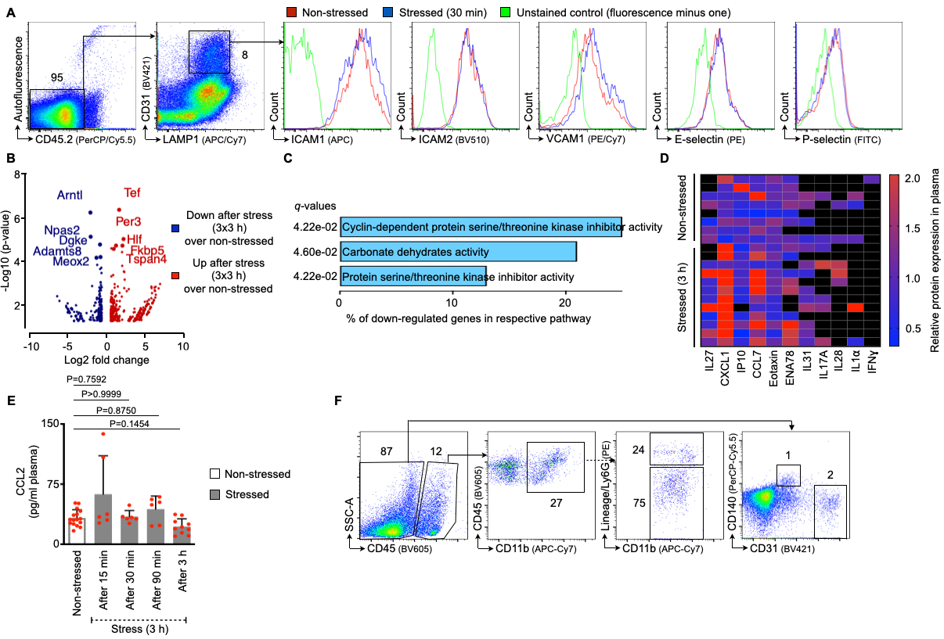

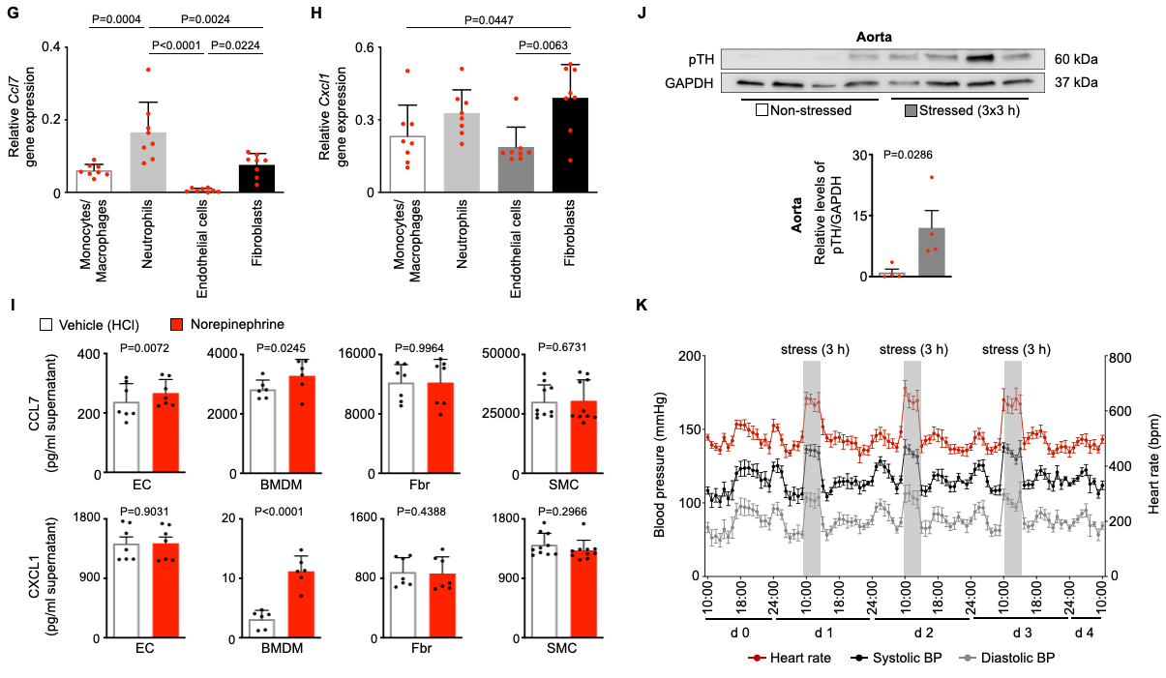

**Fig. S4: Acute mental stress induces phenotypic changes in endothelial cells.**

**(A)** Gating strategy and histograms of leukocyte adhesion molecules on aortic endothelial cells. **(B)** Volcano plot displaying differentially expressed genes (DEGs) as assessed by RNA sequencing from FACS-isolated aortic endothelial cells from non-stressed vs. stressed *ApoE-/-* mice (after three episodes of 3 h restraint stress once daily, n = 3 per group, LIMMA t-statistic approach with Benjamini-Hochberg multiple testing correction). **(C)** Pathway analysis of down-regulated genes as assessed by RNA sequencing from FACS-isolated aortic endothelial cells from non-stressed vs. stressed *ApoE-/-* mice (after three episodes of 3 h restraint stress once daily, n = 3 per group). Percentage of down-regulated genes per respective pathway and *q*-values as assessed by Benjamini-Hochberg correction are shown for significant pathways (*P* < 0.05). **(D)** Heat map showing relative cytokine and chemokine levels measured by a cytokine/chemokine array in plasma from non-stressed vs. stressed wild-typemice (immediately after 3 h of restraint stress, n = 8-12 per group). Out of 36 cytokines/chemokines measured, only proteins with a detectable signal are visualized. **(E)** Quantification of plasma CCL2 levels measured by ELISA in non-stressed vs. stressed wild-typemice (before, during, and immediately after 3 h of restraint stress, n = 6-18 per group, Kruskal-Wallis test). **(F)** Gating strategy for FACS-sorting monocytes/macrophages, neutrophils, endothelial cells, and fibroblasts from atherosclerotic aortas. **(G, H)** Quantitative real-time PCR for *Ccl7* and *Cxcl1* gene messenger RNAs in FACS-isolated aortic cell populations from *ApoE-/-* mice (n = 8, one-way ANOVA, only *p*-values from significant (*p* < 0.05) comparisons are annotated for reasons of clarity). **(I)** Quantification of chemokine levels measured by ELISA in supernatant from cultured bone marrow-derived macrophages (BMDM, 400,000 in 2 ml medium, n = 6, paired *t*-test), primary murine aortic endothelial cells (EC), primary murine aortic fibroblasts (Fbr), and primary murine aortic smooth muscle cells (SMC, all 50,000 cells in 0.5 ml medium; n = 7/10, paired *t*-test). **(J)** Quantification of phospho-tyrosine hydroxylase levels (pTH) in aortic arches from non-stressed vs. stressed wild-type mice (after three episodes of 3 h restraint stress once daily) using Western Blotting (n= 4 per group, Mann-Whitney *U-*test). **(K)** Hemodynamic alterations in response to 3 h episodes of restraint stress (n = 6). Numbers next to gates indicate frequencies (%). Data are presented as mean + s.d.

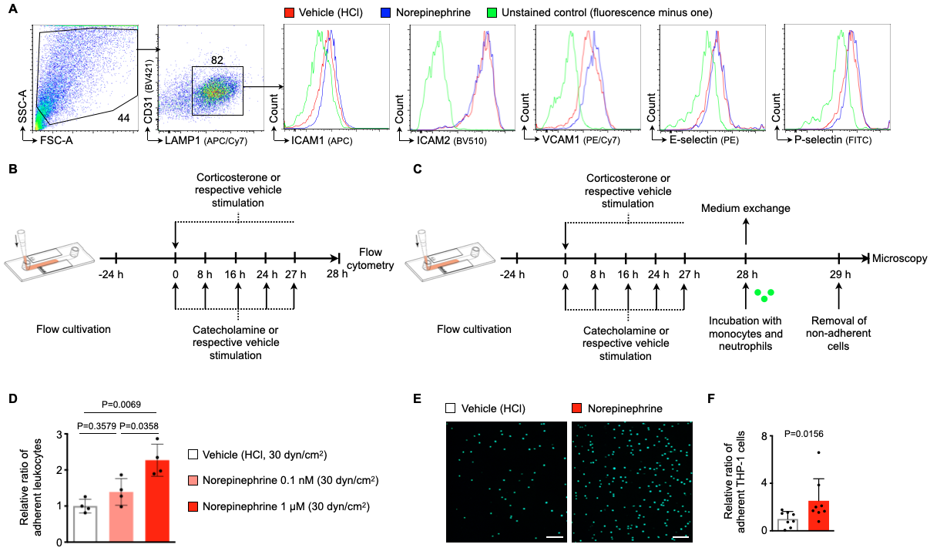

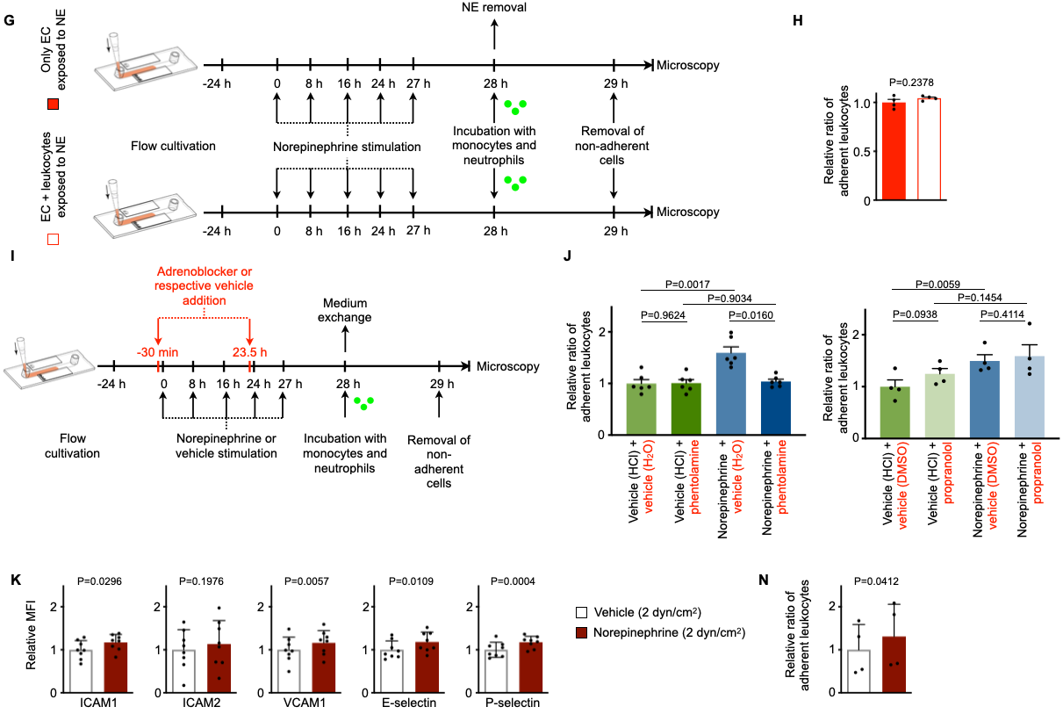

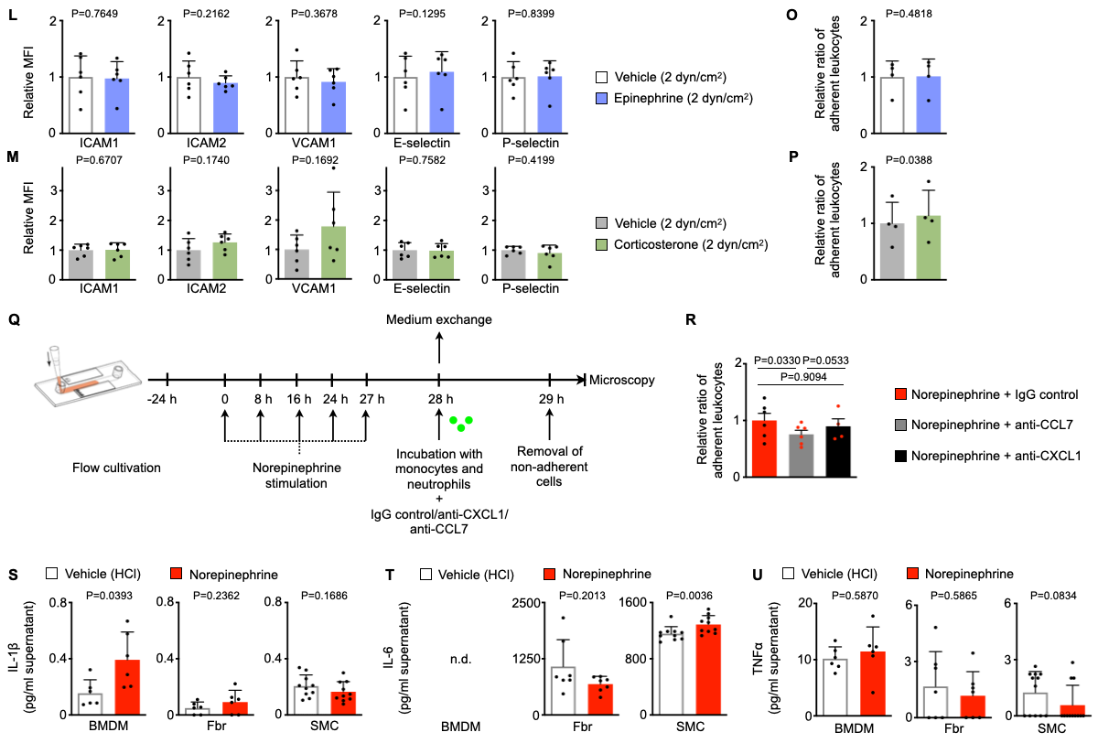

**Fig. S5: Acute mental stress modulates cultured endothelial cells.**

**(A)** Gating strategy and histograms of leukocyte adhesion molecules on cultured primary murine aortic endothelial cells. **(B)** Experimental setup for Fig. 3E-G. **(C)** Experimental setup for Fig. 3H-M. **(D)** Quantification of monocyte and neutrophil adherence to primary murine aortic endothelial cells cultured under high flow conditions (high shear stress, 30 dyn/cm2) and primed with either norepinephrine (0.1 nM or 1 µM) or vehicle (n = 4, repeated measures one-way ANOVA). **(E, F)** Representative images and quantification of monocyte (THP-1 cells) adherence to primary human umbilical vein endothelial cells cultured under flow conditions (10 dyn/cm2) and primed with either norepinephrine or respective vehicle (n = 8 per group, Wilcoxon test). **(G)** Experimental setup for panel H. **(H)** Quantification of adherent monocytes and neutrophils on primary murine aortic endothelial cells cultured under high flow/shear stress conditions (30 dyn/cm2) where either endothelial cells only or both endothelial cells and leukocytes were exposed to norepinephrine (n = 4, Student´s *t*-test). **(I)** Experimental setup for panel J. **(J)** Quantification of monocyte and neutrophil adherence to primary murine aortic endothelial cells cultured under high flow conditions (high shear stress, 30 dyn/cm2). Endothelial cells were primed with either norepinephrine or vehicle and incubated with either adrenoblockers (phentolamine or propranolol) or vehicle (n = 4-6 per group, repeated measures one-way ANOVA, only *p*-values from planned comparisons are annotated for reasons of clarity). **(K-M)** Protein levels as mean fluorescent intensities (MFI) of adhesion molecules expressed by primary murine aortic endothelial cells cultured under low flow/shear stress conditions (2 dyn/cm2) incubated with either a stress hormone or respective vehicle (n = 6-8 per group, paired *t*-test). **(N-P)** Quantification of adherent monocytes and neutrophils on primary murine aortic endothelial cells cultured under low flow/shear stress conditions (2 dyn/cm2) which were primed with either a stress hormone or respective vehicle (n = 4 per group, paired t-test). **(Q)** Experimental setup for panel R. **(R)** Quantification of monocyte and neutrophil adherence to primary murine aortic endothelial cells cultured under high flow conditions (high shear stress, 30 dyn/cm2). Endothelial cells were primed with norepinephrine and incubated with either anti-CXCL1, anti-CCL7, or IgG control (n = 4-6 per group, mixed-effects analysis). **(S-U)** Quantification of pro-inflammatory cytokine levels measured by ELISA in supernatant from cultured bone marrow-derived macrophages (BMDM, 400,000 in 2 ml medium, n = 6, paired *t*-test), primary murine aortic fibroblasts (Fbr), and primary murine aortic smooth muscle cells (SMC, all 50,000 cells in 0.5 ml medium; n = 7/10, paired *t*-test). N.d. = not detectable. Numbers next to gates indicate frequencies (%). Scale bars represent 100 µm. Data are presented as mean + s.d. EC = endothelial cells, NE = norepinephrine.

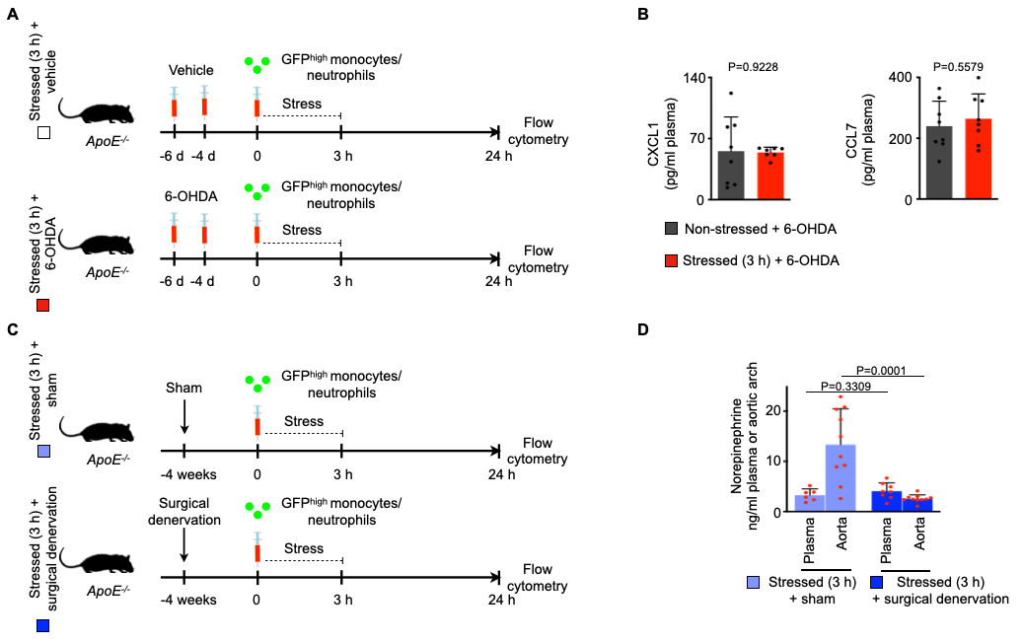

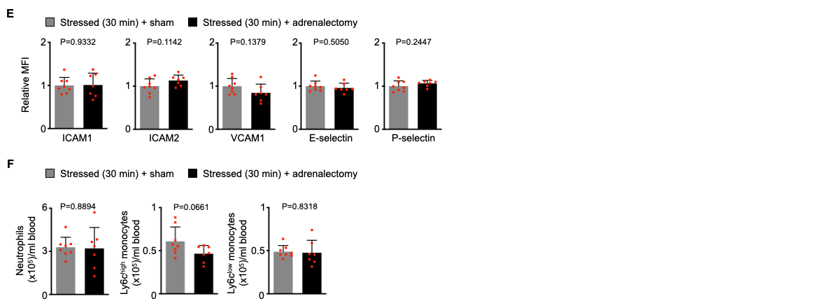

**Fig. S6: Depletion of norepinephrine signaling reverts stress-induced leukocyte recruitment.**

**(A)** Experimental setup for Fig. 4A. 6-OHDA = 6-Hydroxydopamine. **(B)** Quantification of plasma chemokine levels measured by ELISA in non-stressed vs. stressed 6-OHDA-treated wild-typemice (n = 7-8 per group, Student´s *t*-test). **(C)** Experimental setup for Fig. 4B+C and panel D. **(D)** Norepinephrine levels measured by ELISA in plasma and aortic arch from stressed *ApoE-/-* mice with or without prior surgical norepinephrine depletion (21 h after a single 3 h episode of restraint stress, n = 7-8 for plasma per group, n = 11 for aortic arch per group, Mann-Whitney *U*-test). **(E)** Protein levels as mean fluorescent intensities (MFI) of adhesion molecules expressed by aortic endothelial cells from stressed wild-type mice with or without prior surgical bilateral adrenalectomy (immediately after 30 min of restraint stress, n = 7-8 per group, Student´s *t*-test). **(F)** Quantification of murine blood leukocyte subsets in non-stressed vs. stressed wild-type mice with or without prior surgical bilateral adrenalectomy (immediately after 30 min of restraint stress, n= 7-8 per group, Student´s *t*-test). Data are presented as mean + s.d.

**Supplementary tables**

|  |  |  |  |  |  |
| --- | --- | --- | --- | --- | --- |
| ID | Category | Name | p-value | q-value FDR B&H | Hit Count in Query List |
| GO:2000026 | Biological process | Regulation of multicellular organismal development | 6.64E-09 | 1.43E-05 | 61 |
| GO:0007155 | Biological process | Cell adhesion | 7.4E-09 | 1.43E-05 | 53 |
| GO:0022610 | Biological process | Biological adhesion | 9.65E-09 | 1.43E-05 | 53 |
| GO:0045595 | Biological process | Regulation of cell differentiation | 1.48E-08 | 1.64E-05 | 56 |
| GO:0040011 | Biological process | Locomotion | 1.87E-07 | 1.67E-04 | 54 |
| GO:0016477 | Biological process | Cell migration | 3.31E-07 | 2.45E-04 | 44 |
| GO:0006928 | Biological process | Movement of cell or subcellular component | 4.62E-07 | 2.93E-04 | 56 |
| GO:0048870 | Biological process | Cell motility | 6.97E-07 | 3.44E-04 | 46 |
| GO:0051674 | Biological process | Localization of cell | 6.97E-07 | 3.44E-04 | 46 |
| GO:0006954 | Biological process | Inflammatory response | 1.16E-06 | 5.07E-04 | 29 |
| GO:0051094 | Biological process | Positive regulation of developmental process | 1.35E-06 | 5.07E-04 | 43 |
| GO:0009611 | Biological process | Response to wounding | 1.37E-06 | 5.07E-04 | 35 |
| GO:0098742 | Biological process | Cell-cell adhesion via plasma-membrane adhesion molecules | 2.22E-06 | 7.59E-04 | 15 |
| GO:0034097 | Biological process | Response to cytokine | 2.70E-06 | 8.00E-04 | 31 |
| GO:0030334 | Biological process | Regulation of cell migration | 2.70E-06 | 8.00E-04 | 29 |
| GO:0048667 | Biological process | Cell morphogenesis involved in neuron differentiation | 3.39E-06 | 8.56E-04 | 25 |
| GO:0009931 | Molecular function | Calcium-dependent protein serine/threonine kinase activity | 1.30E-04 | 4.31E-02 | 4 |
| GO:0009931 | Molecular function | Calcium-dependent protein serine/threonine kinase activity | 1.30E-04 | 4.31E-02 | 4 |
| GO:0010857 | Molecular function | Calcium-dependent protein kinase activity | 1.63E-04 | 4.31E-02 | 4 |
| GO:0070888 | Molecular function | E-box binding | 1.68E-04 | 4.31E-02 | 5 |

**Table S1: Up-regulated pathways after 3x3 h stress**

|  |  |  |  |  |  |
| --- | --- | --- | --- | --- | --- |
| ID | Category | Name | p-value | q-value FDR B&H | Hit Count in Query List |
| GO:0030291 | Molecular function | Protein serine/threonine kinase inhibitor activity | 1.06E-04 | 4.22E-02 | 4 |
| GO:0004861 | Molecular function | Cyclin-dependent protein serine/threonine kinase inhibitor activity | 1.17E-04 | 4.22E-02 | 3 |
| GO:0004089 | Molecular function | Carbonate dehydratase activity | 1.91E-04 | 4.60E-02 | 3 |

**Table S2: Down-regulated pathways after 3x3 h stress**