**Supplement to**

**Label-free analytic histology of carotid atherosclerosis by mid-infrared optoacoustic microscopy**

Mirjam Visscher1, Miguel A. Pleitez2,3, Kim Van Gaalen1, Ingeborg M. Nieuwenhuizen-Bakker1, Vasilis Ntziachristos2,3, Gijs Van Soest1

1. Department of Cardiology, Erasmus MC University Medical Center Rotterdam, PO Box 2040, 3000 CA Rotterdam, The Netherlands
2. Institute of Biological and Medical Imaging, Helmholtz Zentrum München, Neuherberg, Germany
3. Chair of Biological Imaging (CBI) and Center for Translational Cancer Research (TranslaTUM), Technische Universität München, München, Germany

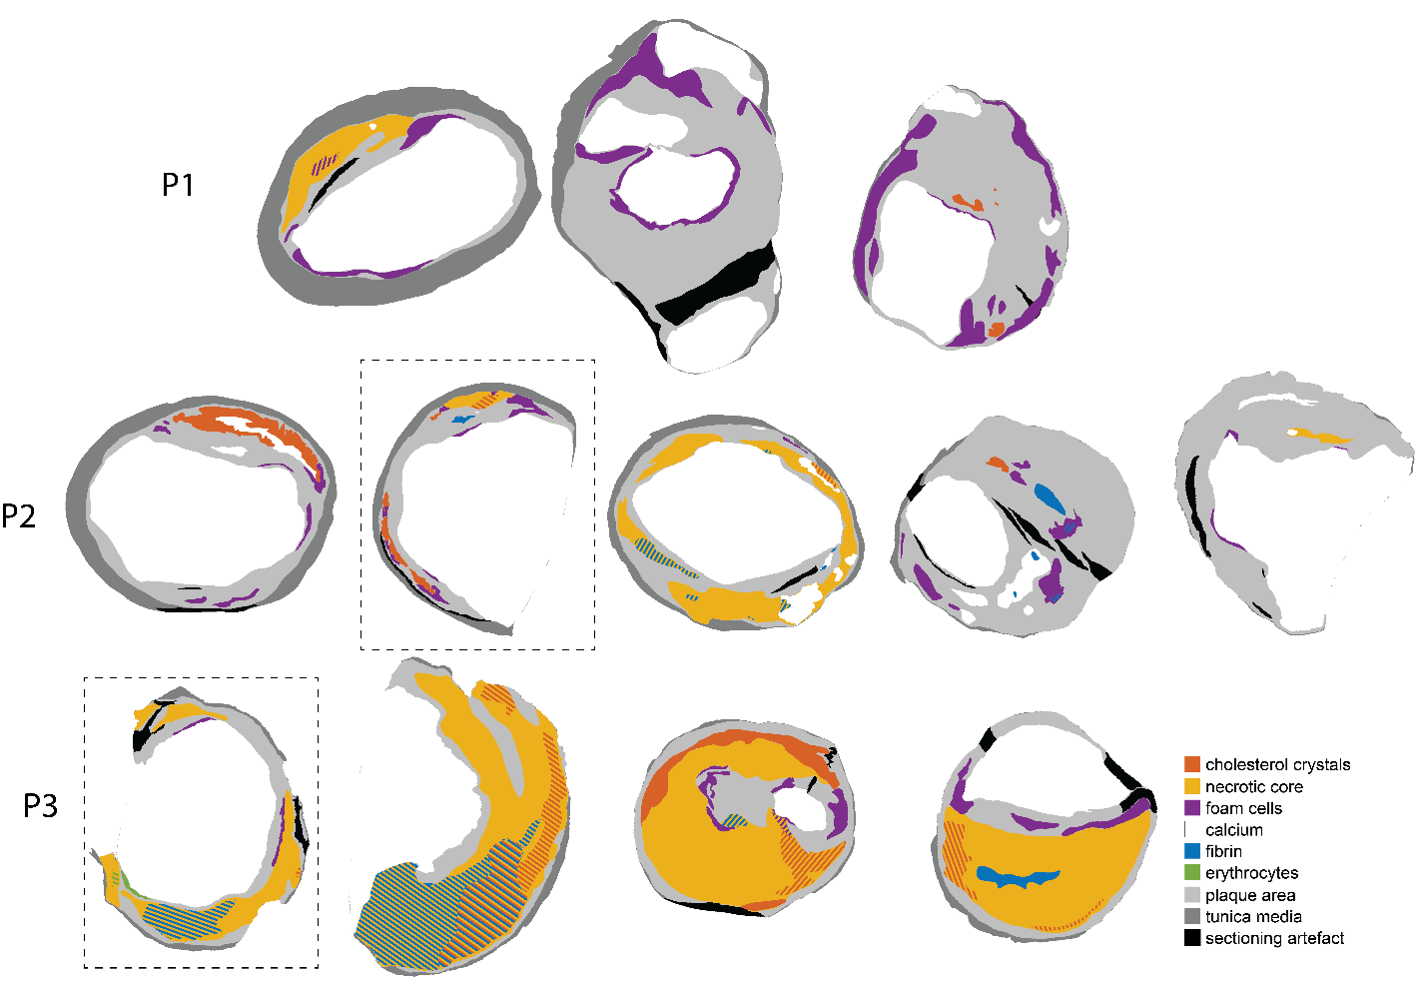

Supplementary figure S1: Histology analysis of all analyzed sections, grouped per patient. Boxed sections are not included in the histology comparison in Suppl. Fig. S2.

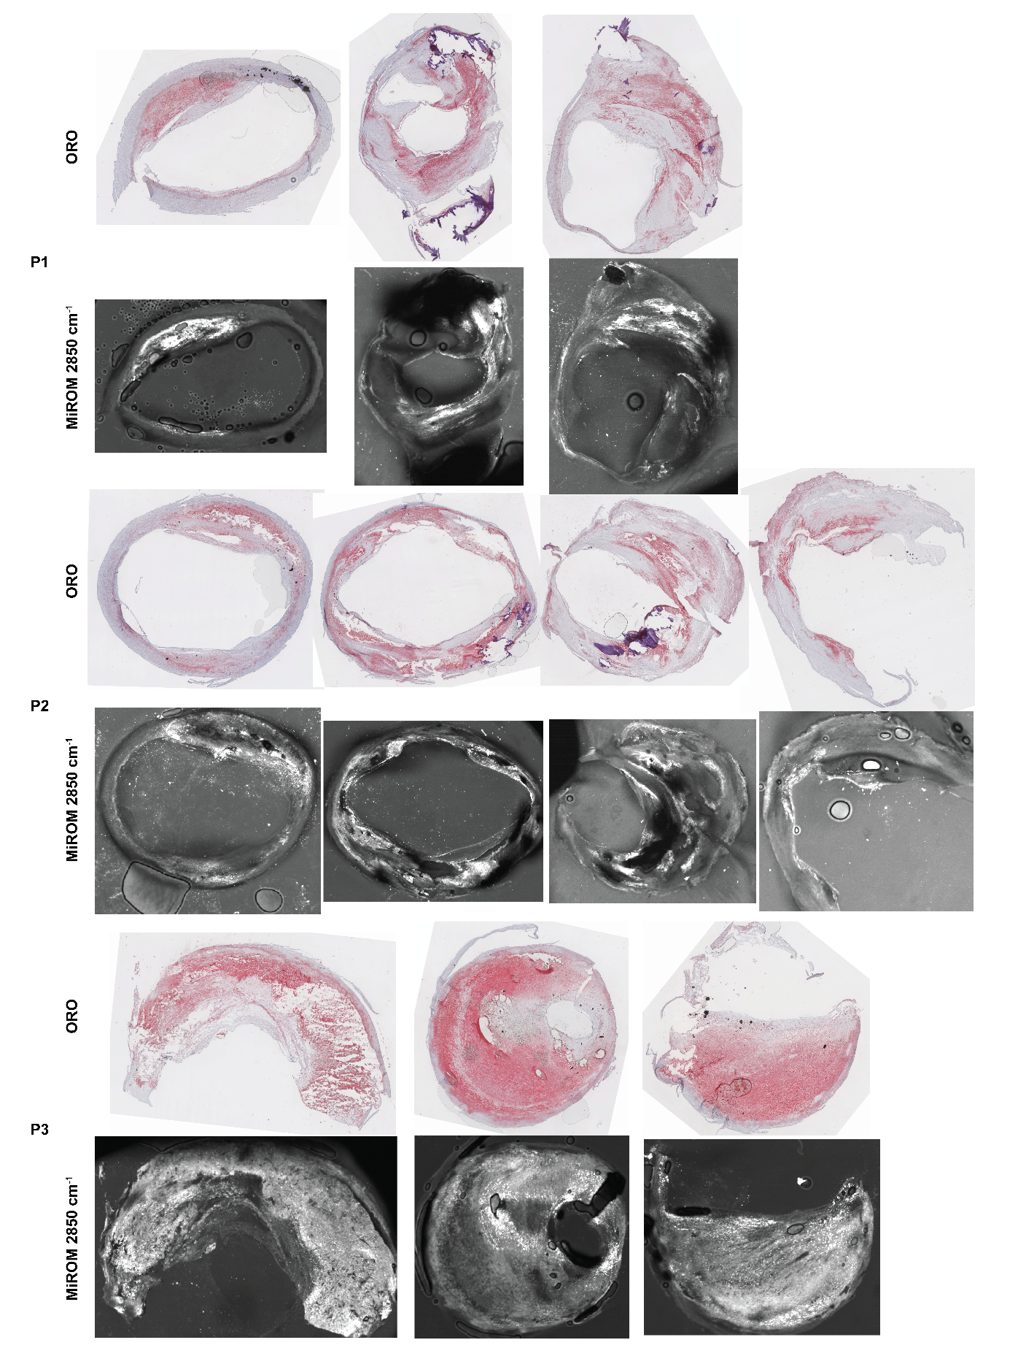

Supplementary figure S2: Overviews of the Oil Red O-stained sections compared to MiROM scans at 2850 cm-1. Two sections have been omitted from this comparison due to prominent bubble artifacts in the MiROM data.