**The 3-year cost-effectiveness of a nurse-based case management versus usual care for elderly patients with myocardial infarction: Results from the KORINNA follow-up study**

# 1 Introduction

Coronary heart disease (CHD) is a major cause of mortality worldwide (13.2%) with an increasing prevalence over the past decade (1). Although recommended by the European Association of Cardiovascular Prevention and Rehabilitation (2), only 36.5% of patients with CHD participate in secondary prevention programmes such as cardiac rehabilitation in Europe (3). A different approach for secondary prevention is a nurse-based case management programme, which is considered as a low-cost and effective alternative to cardiac rehabilitation (4). In Germany, no nurse-based case management programmes are currently available although only 51.6% of patients with a cardiac event receive cardiac rehabilitation (3). In addition, elderly patients participate less frequent in cardiac rehabilitation (3) although they present more adverse health outcomes than younger patients who have been diagnosed with CHD (5). Several studies have shown that case management can reduce hospitalisation and increase quality of life, but only a few studies have focused on patients with acute myocardial infarction (AMI) and elderly patients (4, 6-8). Moreover, studies evaluating the cost-effectiveness of case management are scarce and did not consider long-term effects and costs.

We conducted the KORINNA study (‘Coronary infarction follow-up in the elderly’) to analyse whether case management in elderly people with an AMI can postpone unplanned readmission or death (combined endpoint) within 1 year after hospital discharge.(9). To analyse long-term effects, the KORINNA study was extended for another 2 years. The findings regarding readmissions or death have been published elsewhere (10, 11) and showed that differences between groups were neither significant after the first year nor after three years. Analysis of secondary outcomes demonstrated that case management can improve blood lipid levels, functional status and malnutrition risk after one year (12) and that improvements of functioning and malnutrition risk were maintained or results even advanced further after three years (10). The one-year cost-effectiveness analysis showed that case management was associated with improvements in self-rated health, but there were no significant differences in quality-adjusted life years (QALYs) or health care costs between treatment arms (13).

Up to this point, no study has yet evaluated the cost-effectiveness of a case management programme in elderly patients with an AMI after hospital discharge. There are only three studies that performed a formal cost-effectiveness analysis for patients with CHD (14-16) and five studies for patients with heart failure (17-21) estimating cost per QALY with different results.

The objective of our paper was to assess the three-year cost-effectiveness of the case management programme KORINNA from a societal perspective.

# 2 Methods

The randomised controlled KORINNA trial evaluated a case management intervention by trained nurses in elderly patients with AMI.

Between September 2008 and May 2010, 340 patients were enrolled. Inclusion criteria consisted of aged 65 years or older with an acute first or recurrent AMI treated in the Central Hospital of Augsburg, which is the major hospital for the population of 830,000 in the Greater Augsburg area, southern Germany. Exclusion criteria were planned or present residence in a nursing home, severe comorbidity associated with a life expectancy of less than one year (e.g. terminal cancer), insufficient ability to speak German and lack of ability due to cognitive disorders or willingness to consent.

All patients were assigned to either the intervention or control groups based on randomised blocks within strata for gender, age (65–69 vs. 70–79 vs. 80+) and number of comorbidities (none, diabetes or chronic heart failure, both).

Baseline assessment was performed shortly before hospital discharge. In the first year, participants were interviewed quarterly; in the second and third years, participants were interviewed annually, either by computer-assisted telephone interview (CATI) or in a face-to-face interview for outcome assessment. In the case of CATI, plausibility checks were included and in the case of face-to-face interviews, double data entry was applied. Economic analyses were performed from the societal perspective. Owing to 36-month follow-up, analyses of costs and effects were performed without and including a discount rate of 3% (22).

The trial was approved by the Ethics Committee of the Bavarian Chamber of Physicians. The registration number is ISRCTN02893746. Further details on design and sample size calculation can be found in the study protocol, which has been published elsewhere (9). The intervention and observation period spanned three years.

# 2.1 Comparators

The control group received usual care, i. e. patients regularly visit their physician, may receive cardiac rehabilitation or be treated in a long-term disease management programme offered by health insurance companies (23). The intervention was described in detail elsewhere (10, 11). In brief, shortly before hospital discharge, patients received an information booklet and a first home visit or an appointment for a telephone call was arranged. At least one home visit and quarterly telephone calls were carried out in the first year, and two telephone calls in each of the following two years (every 6 months), with additional visits and calls according to the patient’s needs and risk level. The risk level, which was assessed by the study nurse during the home visits and telephone calls, based on compliance, social network and New York Heart Association Functional Classification (NYHA) class. The risk level classification suggested by Russell et al. was used (11, 24). In a structured interview, the nurses provided counselling on the intake of medication, nutrition, physical activity, weight control and general health behaviour. During the home visits, additional measurements of vital functions (e.g. blood pressure, pulse rate) and blood glucose were performed.

# 2.2 Effects

In all interviews, health-related quality of life was assessed using the generic EuroQol five-dimensional questionnaire with three levels each (EQ-5D-3L) and the visual analogue scale (VAS). Validity and reliability of the EQ-5D-3L in patients after AMI have been shown in several studies (25, 26). The primary effect measure in the economic evaluation was QALYs, based on EQ-5D-3L health states converted into utility scores using the German time trade-off (TTO) scoring algorithm (27). QALYs were estimated for each individual as the area under the curve through linear interpolation of values for the periods between measurements (28). When patients died during the observation period, their values were set to 0 from the day of death. It was assumed that, prior to death, the utility function declined linearly from the observed preceding value.

To assess the sensitivity of results to different health state valuation methods, a sensitivity analysis considered life years adjusted by patients’ self-rated health as measured by their VAS scores (VAS-ALs). To ensure comparability with utility-based QALYs, VAS scores were transformed to the zero-to-one scale before constructing VAS-ALs.

Secondary objectives were to examine EQ-5D-3L TTO-based utility scores and VAS scores among survivors over time.

# 2.3 Costs

Cost measurements were conducted from the societal perspective and data collection was not limited to disease-related services. In accordance with the study protocol (9), in the first year, medical resource use was collected quarterly and in the second and third years annually. Indirect costs were not considered because of participants’ retirement. All unit prices were reported for the year 2012 and are presented in Euros. Intervention costs consisted of labour costs for study nurses to perform the case management (€31.33/hour; overhead costs and wage rates of the Central Hospital of Augsburg) and travel costs (€0.30/km). The average time that nurses spent making telephone calls was documented by computer-assisted telephone interview (19 minutes) and for home visits (117 minutes) by logbooks. Based on this information, costs per telephone call (€10) and per home visit (€57.40) were calculated.

Costs from inpatient care were calculated according to days spent in the hospital, separated in days spent in general ward and days spent in intensive care unit. Self-reported admissions were validated by the study physician using information from hospital records and discharge letters and where required readjusted and completed. For the Central Hospital of Augsburg, all hospital records were available for the 3-year period. For every participant admitted at least once to any other hospital, all hospital records and discharge letters were requested from these hospitals. Costs of all other healthcare components (i.e. physicians, physiotherapists, ambulatory clinic in the hospital, rehabilitation, drugs and direct non-healthcare resources) were calculated from patients’ self-reported resource use. Single missing values of these other costs were replaced by patients’ cost data from subsequent time frame (29, 30).

Unit price calculation was primarily based on estimates published by Bock et al.(31), which provide valid and reliable information about unit prices of several medical and nonmedical resources in Germany from a societal perspective. Medication was recorded using IDOM software, a database-supported identification system (32) that logs name, units, pharmaceutical identification number, time period, package size and price per package (33). To estimate the cost of informal care we use the information of the existence of a care level. In Germany, the care level is declared by the Long Term Care Insurance (34) due to assessing whether and to what extent patients need help in activities of daily living. If the patient is assigned to a care level and does not receive formal care, the patient gets a transfer payment. Although transfer payments are ordinarily excluded from a societal perspective, they are used here as a proxy value for informal care because it can be assumed that these patients require informal care. When patients died during the observation period, their costs were set to 0 from the day of death, hence, effects and costs were treated in the same way. Table 1 gives an overview of prices assigned to the resource quantities.

[Insert Table 1]

**Table 1** Unit prices. All unit prices are expressed in Euros at 2012 values (31)

|  |  |  |  |  |
| --- | --- | --- | --- | --- |
| Resource category |  | Unit price in Euros (2012) |  | Units |
| Direct healthcare |  |  |  |  |
| Physicians1 |  |  |  |  |
| General practitioner |  | 20.22 | per | contact |
| Internist |  | 64.65 | per | contact |
| Orthopaedist |  | 25.27 | per | contact |
| Neurologist |  | 45.58 | per | contact |
| Ophthalmologist |  | 35.09 | per | contact |
| Otolaryngologist |  | 27.55 | per | contact |
| Gynaecologist |  | 30.53 | per | contact |
| Dermatologist |  | 19.10 | per | contact |
| Urologist |  | 24.97 | per | contact |
| Other |  | 43.97 | per | contact |
| Physiotherapist |  | 16.62 | per | contact |
| Ambulatory clinic in the hospital |  | 40.31 | per | contact |
| Inpatient care/hospital/General ward |  | 589.32 | per | day |
| Inpatient care/hospital/Intensive care unit |  | 1357.65 | per | day |
| Inpatient rehabilitation |  | 122.09 | per | day |
| Outpatient rehabilitation |  | 48.29 | per | day |
| Drugs |  | various | quantity according to medication | |
| Direct non-healthcare |  |  |  |  |
| Outpatient nursing service |  | 30.00 | per | hour |
| Paid household help |  | 10.20 | per | hour |
| Informal care |  |  |  |  |
| care level |  |  |  |  |
| none |  | 0 | per | month |
| 1 |  | 235.00 | per | month |
| 2 |  | 440.00 | per | month |
| 3 |  | 700.00 | per | month |

# 2.4 Statistical analysis

To calculate mean QALY differences between treatment groups we used a linear regression model controlling for stratification variables of the trial (gender, age groups, and number of comorbidities) and baseline utility (35). The same method was applied to determine the intervention effect expressed by VAS-AL.

To analyse EQ-5D-3L utility and VAS data over time, linear mixed models with the stratification variables as fixed effects and an additional random intercept were fitted. Mixed models based on full maximum likelihood estimation have been shown to be an effective method to account for dropout when estimating longitudinal change (36). Resource use data and corresponding cost data were presented as mean values with standard deviation. To analyse costs, a generalised gamma regression model with log-link was used in order to account for the skewed distribution of the data (37). From the gamma model, adjusted mean differences in costs between intervention and control groups were estimated using the method of recycled predictions. This method creates an identical covariate structure for each treatment group by first assuming that all individuals are cases and predicting costs and then assuming that all individuals are controls and predicting costs (38, 39). Calculating the difference in the mean predictions for all individuals between these two scenarios then yields an estimate of the adjusted marginal difference in costs between intervention and control groups. A 95% CI for the adjusted cost difference was estimated from 1000 bootstrap replications using the percentile method.

We performed a cost-effectiveness analysis, in which incremental cost-effectiveness ratios (ICERs) were calculated only in the case of a positive ICER meaning case management is neither dominant nor dominated (40).

Estimation uncertainty was addressed by bootstrapping (n=1000) incremental cost and effect estimates and plotting them on the cost-effectiveness plane (CE plane) in order to generate the joint density of incremental costs and incremental effects (41, 42). The proportion of the joint density located within the south east (SE) quadrant of the CE plane suggests the likelihood of dominance of case management and the joint density in the north west quadrant of being dominated (41). From the resulting bootstrap distribution, we also calculated cost-effectiveness acceptability curves (CEAC), which indicate the likelihood that the intervention is cost-effective for a given value of willingness to pay (WTP).

The primary cost-effectiveness analysis excluded patients who withdraw consent or were lost to follow-up during the three-year study period. In a sensitivity analysis, we applied a missing value imputation approach in order to include data from all randomised patients. To impute missing values for an individual who dropped out before measurement time point t, we first fitted a logistic model to predict survival of the participant at t. Explanatory variables were the stratification variables (i.e. gender, age in groups and number of comorbidities), treatment assignment and the one-period-lagged health status (EQ-5D-3L utility or VAS) (43). From the resulting predicted distribution, a Bernoulli random number was drawn reflecting whether the participant was assumed to have died or not. In the case of death, the cost and utility from time point t were set to 0. Otherwise, a second imputation model with the same covariates as the logistic model was fitted on the subsample of all participants still living at time point t in order to predict values for cost and utility. For the imputation of utilities, this second model used the predictive mean matching method in order to ensure that imputed data are actually observable EQ-5D-3L (or VAS) values (44). The model for cost used the ‘regression method’ applied to log-transformed values in order to account for the skewness of the underlying data. The above two steps were then repeated for all subsequent time points until the 36-month measurement. To avoid missing lagged values in the following cycles, the imputed values from the preceding cycle were used (43). Overall, this imputation model is based on the assumption that the missing observations are missing at random given the observed data, especially given gender, age, number of comorbidities, treatment arm and health status before drop out.

To account for the uncertainty associated with imputed values, we bootstrapped the whole imputation and estimation process. Therefore, the full data set including missing values was first bootstrapped and then, in each bootstrap sample, the imputation process was applied (45).

All analyses were performed with SAS (Version 9.2, SAS-Institute Inc., Cary, NC, USA).

# 3 Results

From the 340 patients randomised, 11 patients were retrospectively excluded in coordination with the study’s Advisory Board because of death or withdrawal of consent before hospital discharge. Thus, our analysis included 329 patients (Fig. 1). Within the first 3 months, four participants in the control group and 13 participants in the intervention group died, of whom 10 had no contact with the study nurse between hospital discharge and death. Within the next 9 months, nine participants in the control group and five participants in the intervention group died. Within the next 24 months, 19 participants in the control group and 11 participants in the intervention group died. Characteristics of both all randomised patients and patients without withdrawals at baseline are presented in Table 2.

Fig. 1 Consort flow chart

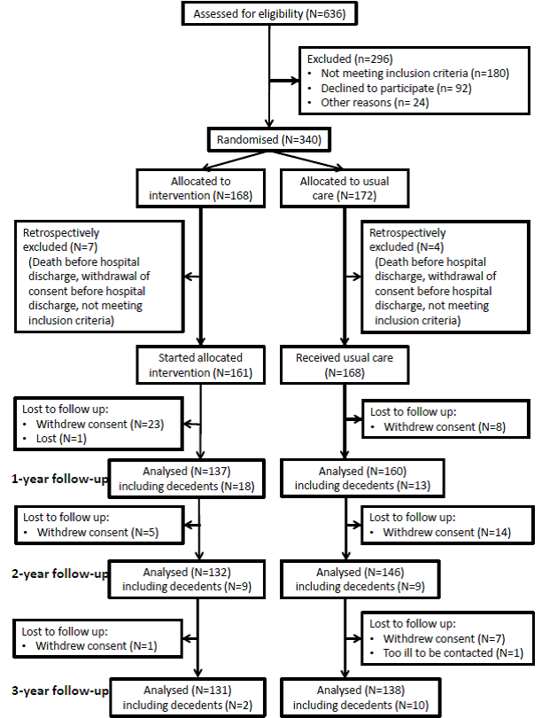

Insert Table 2

**Table 2** Patient baseline characteristics

|  |  |  |  |  |  |  |  |  |
| --- | --- | --- | --- | --- | --- | --- | --- | --- |
|  | randomised patients n=329 | | | | patients without withdrawals n=269 | | | |
| Patient baseline characteristics | Intervention n=161 | | Control n=168 | | Intervention n=131 | | Control n=138 | |
| Age (year [SD]) | 75.2 | [6.0] | 75.6 | [5.9] | 74.8 | [5.8] | 75.6 | [6.1] |
| Sex (% females) | 37.3 |  | 38.7 |  | 35.1 |  | 38.4 |  |
| No comorbidity (neither diabetes nor chronic heart failure) (%) | 54.7 |  | 51.2 |  | 53.4 |  | 51.5 |  |
| One comorbidity (diabetes or chronic heart failure) (%) | 32.9 |  | 33.3 |  | 35.1 |  | 32.6 |  |
| Two comorbidities (diabetes and chronic heart failure) (%) | 12.4 |  | 15.5 |  | 11.5 |  | 15.9 |  |
| Living alone (%) | 27.9 |  | 26.8 |  | 24.4 |  | 28.3 |  |
| NYHA I (%) | 46.0 |  | 41.7 |  | 48.1 |  | 42.0 |  |
| NYHA II (%) | 24.8 |  | 31.6 |  | 22.9 |  | 29.7 |  |
| NYHA III (%) | 24.8 |  | 22.6 |  | 24.4 |  | 23.9 |  |
| NYHA IV (%) | 2.5 |  | 2.4 |  | 2.3 |  | 2.2 |  |
| VAS [SD] | 58.9 | [20.7] | 57.8 | [20.1] | 59.5 | [20.2] | 58.3 | [20.2] |
| EQ-5D Index [SD] | 0.74 | [0.32] | 0.73 | [0.31] | 0.74 | [0.31] | 0.74 | [0.31] |
| NYHA, New York Heart Association; VAS, visual analogue scale; EQ-5D, EuroQol five-dimensional; Chronic heart failure: NYHA III and NYHA IV, , EQ-5D Index based on German population tariff and time-trade-off scoring (27) | | | | | | | | |

# 3.1 Effects

Table 3 summarises the results of the primary analysis together with the corresponding sensitivity analyses. The adjusted mean QALY difference between intervention and control group during the three-year period was 0.0295 (p=0.2968; CI: –0.1579; 0.2169). The adjusted mean difference in VAS-ALs was 0.1332 (p=0.0912; CI: –0.0215; 0.2878). The goodness of fit of our regression models in terms of R squared (R2) was 0.35 (QALYs) and 0.34 (VAS-ALs). Applying a discount rate of 3% did not alter results. The analyses based on a multiple imputation approach reduced the differences for either measure of effectiveness.

Table 4 summarises the secondary analyses and shows utilities (EQ-5D Index) and VAS scores among survivors in the two treatment arms over time. In the intervention group, utility scores from EQ-5D-3L were significantly higher at month 3 (+0.078) and month 6 (+0.052) than at baseline. However, scores returned towards baseline levels at 12 months and were lower than baseline scores in the second and third years, although statistically not significant. In the control group, utility scores did not change during the first year, but there was a significant decrease in utility scores in the second (–0.068) and third years (–0.142). In the third year, the intervention group had a significantly higher utility score than the control group (+0.104, p=0.0054).

VAS values showed significant improvements between baseline and all subsequent measurement time points in the intervention group and no significant changes from baseline in the control group. In the third year, the intervention group had a significantly higher VAS value than the control group (+8.15, p=0.0010) and VAS values in the intervention group were significantly higher over all time points.

Insert Table 3

**Table 3** Effectiveness in QALYs and VAS-ALs adjusted for gender, age, number of comorbidities (diabetes and CHF), and baseline values for health states; cost differences adjusted for gender, age, and number of comorbidities (diabetes and CHF)

|  |  |  |  |  |
| --- | --- | --- | --- | --- |
|  | Primary analysis  (n=269) without discounting | Primary analysis  (n=269)  discount rate = 3% | Sensitivity analysis Multiple Imputation (n=329)  without discounting | Sensitivity analysis Multiple Imputation (n=329)  discount rate = 3% |
|  | Difference (p-value)  IG-CG | Difference (p-value)  IG-CG | Difference (p-value)  IG-CG | Difference (p-value)  IG-CG |
| QALYs (p-value) | 0.0295 (0.7568)  CI: –0.1579 to 0.2169 | 0.0268 (0.7714)  CI: –0.1544 to 0.2079 | 0.0023 (0.984)  CI: –0.1847 to 0.1843 | 0.0010 (0.996)  CI: –0.1799 to 0.1771 |
| Sensitivity analysis  VAS-ALs (p-value) | 0.1332 (0.0912)  CI: –0.0215 to 0.2878 | 0.1288 (0.0913)  CI: –0.0208 to 0.2783 | 0.1158 (0.124)  CI: –0.0400 to 0.2653 | 0.1124 (0.122)  CI: –0.0380 to 0.2567 |
| Costs | –2,575 (0.2968)  CI: –8158 to 2386 | –2,509 (0.2986)  CI: –7950 to 2339 | –3,401 (0.176)  CI: –8304 to 1922 | –3,290 (0.182)  CI: –8057 to 1884 |

IG, intervention group; CG, control group; CI, confidence interval; VAS, visual analogue scale; QALY, quality-adjusted life year using the EQ-5D Index based on German population tariff and time-trade-off scoring (27); VAS-AL, VAS-adjusted life year using patients’ EQ VAS score (self-rated health); Complete Case, sample including decedents

Insert Table 4

**Table 4** Secondary analyses: Effectiveness in quality of life for survivors only, adjusted for gender, age, number of comorbidities (none, diabetes or chronic heart failure, both)

|  |  |  |  |
| --- | --- | --- | --- |
| Effects  (Mean change in the respective month compared to baseline) | Intervention | Control | Difference in mean change between intervention and control group |
| **EQ-5D Index based on German population tariff and time-trade-off** (27) |  |  |  |
| Mean change, month 3 (p-value) | (n=130) 0.078 (0.0019) | (n=161) 0.018 (0.4324) | 0.060 (0.0757) |
| Mean change, month 6 (p-value) | (n=127) 0.052 (0.0401) | (n=153) 0.033 (0.1490) | 0.019 (0.5868) |
| Mean change, month 9 (p-value) | (n=123) 0.012 (0.6325) | (n=152) 0.006 (0.7800) | 0.006 (0.8656) |
| Mean change, month 12 (p-value) | (n=119) –0.005 (0.8617) | (n=147) –0.012 (0.6012) | 0.008 (0.8228) |
| Mean change, month 24 (p-value) | (n=105) –0.020 (0.4519) | (n=124) –0.068 (0.0061) | 0.048 (0.1883) |
| Mean change, month 36 (p-value) | (n=102) –0.038 (0.1613) | (n=106) –0.142 (<.0001) | 0.104 (0.0054) |
| **Patients’ VAS score, self-rated health** |  |  |  |
| Mean change, month 3 (p-value) | (n=130) 7.98 (<0.0001) | (n=161) 2.36 (0.1251) | 5.61 (0.0145) |
| Mean change, month 6 (p-value) | (n=127) 10.83 (<0.0001) | (n=153) 2.83 (0.0615) | 8.00 (0.0004) |
| Mean change, month 9 (p-value) | (n=123) 11.84 (<0.0001) | (n=152) 1.97 (0.1940) | 9.88 (<0.0001) |
| Mean change, month 12 (p-value) | (n=119) 10.11 (<0.0001) | (n=147) 0.90 (0.5591) | 9.21 (<0.0001) |
| Mean change, month 24 (p-value) | (n=105) 8.28 (<0.0001) | (n=124) 0.87 (0.5976) | 7.42 (0.0021) |
| Mean change, month 36 (p-value) | (n=102) 8.13 (<0.0001) | (n=106) –0.03 (0.9886) | 8.15 (0.0010) |
| EQ-5D, EuroQol five-dimensional; VAS, visual analogue scale | | | |

# 3.2 Resource use and costs

Table 5 gives an overview of unadjusted mean resource use over the course of time and mean costs during the three-year period per patient. On average, patients received 1.2 home visits and 5.6 telephone interviews in the intervention group resulting in intervention costs of €166 per participant. About 90 % of patients received no benefits from the German Long Term Care Insurance, 7% were assigned to care level one, 3% to care level two and none to care level three. Resource use within 3 years was stable with the exception of inpatient care, rehabilitation and paid household help. Inpatient care decreased over time. In the first year, patients spent on average 8.7 days in hospital in the intervention group and 11.71 days in the control group. These numbers decreased to 3.55 days in the intervention group and 4.93 days in the control group in the third year. Case management was associated with lower costs in all health care resource categories with the exception of paid household work. The largest difference between groups was found for inpatient care, where patients in the control group had on average €3,170 higher costs than those in the intervention group. The adjusted overall cost difference (Table 3) from the gamma model was estimated at –€2,576. (CI: –8,158; 2,386). Applying a discount rate of 3%, the difference remained stable (–€2,509; CI: –7,950; 2,339). The analysis with multiple imputations led to an undiscounted and discounted difference of –€3,401 (CI: –8,304; 1,922) and –€3,290 (CI: –8,057; 1,884), respectively. Mean costs per day survived showed no difference between groups (€34.66 in the intervention and €34.03 in the control group).

**Table 5** Mean resource use per patient (in number of contacts unless stated otherwise) over different years and raw unadjusted mean costs over 3 years in € (calculated from unit prices from 2012)

|  |  |  |  |  |  |  |  |  |  |
| --- | --- | --- | --- | --- | --- | --- | --- | --- | --- |
| **Category** | **Intervention** | | | |  | **Control** | | | |
| mean resource use (SD) | | | mean costs € (SD)  3 years  N=131 |  | mean resource use (SD) | | | mean costs € (SD)  3 years  N=138 |
| year 1  N=137 | year 2  N=132 | year 3  N=131 |  | year 1  N=160 | year 2  N=146 | year 3  N=138 |
| **Physicians** | 17.23 (12.38) | 20.65 (17.79) | 20.78 (20.50) | 1,328 (1,139) |  | 21.68 (15.83) | 21.94 (15.60) | 20.83 (16.60) | 1,543 (1,138) |
| **Physiotherapist** | 3.59 (8.36) | 3.92 (10.42) | 3.02 (9.74) | 145 (319) |  | 5.35 (13.05) | 6.13 (13.44) | 5.43 (13.65) | 279 (604) |
| **Ambulatory clinic in the hospital** | 0.85 (2.73) | 0.91 (3.00) | 1.14 (3.49) | 90 (206) |  | 1.35 (6.08) | 0.81 (2.75) | 1.40 (3.79) | 117 (264) |
| **Inpatient care (days)** | 8.70 (17.18) | 5.21 (13.68) | 3.55 (8.89) | 10,747 (16,689) |  | 11.71 (25.29) | 6.19 (14.18) | 4.93 (11.71) | 13,916 (22,240) |
| **Rehabilitation (days)** | 11.32 (11.84) | 0.78 (3.92) | 0.90 (5.63) | 1,529 (1,704) |  | 12.43 (12.50) | 1.36 (5.28) | 0.59 (3.50) | 1,674 (1,831) |
| **Drugs (number of medications)** | 6.97 (2.45) | 6.93 (2.67) | 6.81 (2.88) | 2,833 (2,324) |  | 7.4 (2.38) | 7.37 (2.55) | 7.35 (2.60) | 3,131 (2,177) |
| **Intervention programme** |  |  |  | 166 (83) |  |  |  |  |  |
| **Sum of direct healthcare costs**  **(incl. intervention)** |  |  |  | 16,837 (17,768) |  |  |  |  | 20,660 (23,285) |
| **Outpatient nursing service (hours)** | 3.66 (16.09) | 2.39 (15.00) | 3.23 (17.57) | 240 (1,169) |  | 5.72 (21.66) | 10.90 (70.08) | 7.60 (30.91) | 502 (2,135) |
| **Paid household help (hours)** | 37.96 (193.12) | 90.36 (852.39) | 64.70 (577.00) | 1,632 (14,844) |  | 13.25 (62.58) | 25.16 (98.46) | 13.00 (51.00  ) | 482 (1,637) |
| **Informal care** |  |  |  | 110 (500) |  |  |  |  | 363 (1,391) |
| **Sum of direct non-healthcare costs** |  |  |  | 1,982 (14,927) |  |  |  |  | 1,347 (3,303) |
| **Sum of total costs** |  |  |  | 18,819 (23,256) |  |  |  |  | 22,008 (24,166) |

# 3.3 Cost-effectiveness

As costs were lower (–€2,576; p=0.2968) and QALYs were higher (+0.0295; p=0.7568) in the intervention group and differences remained stable after applying a discount rate of 3%, no ICER was calculated (40). The corresponding CE plane (Figure 2a) plots differences in mean total costs on the vertical axis and differences in mean QALYs on the horizontal axis for each of the 1000 bootstrap resamples. Fifty three percent of the bootstrap observations were located in the south east (SE) quadrant of the CE plane.

The sensitivity analysis using adjusted life years based on patients’ self-rated health states also showed that case management was associated with higher effects (0.1332 VAS-ALs; p=0.0912) and lower costs (–€2,576; p=0.2968) and 78% of bootstrap samples were located in the SE quadrant (Figure 2b).

The resulting CEAC is a decreasing function so it does not asymptote to 1 (Figure 3a). This means that 84% of the density involves cost saving (cut point of the y-axis) but only 62% of the density involves health gains (asymptote) and 38 % involves health losses. As a consequence, the probability of acceptable cost-effectiveness of the case management was 84% at a WTP of €0 per QALY. The probability in the case of applying the method of self-rating was 81% at a WTP of €0 per VAS-AL, increasing to 95% at a WTP of €24,290 per VAS-AL (Figure 3b). Discounting did not alter probabilities at a WTP of €0 and probability of 95% was reached at a WTP of €26,690 per VAS-AL.

After applying a multiple imputation approach, the probability of acceptable cost-effectiveness at a WTP of €0 per QALY and per VAS-AL, respectively, was 91% and was not influenced by discounting; at a WTP of €8,400 per VAS-AL and €8,640 with discounting, respectively, the probability was 95%.

Insert Figure 2 (a+b)

**Fig 2** Cost-effectiveness planes; a: Costs and QALYs; b:Sensitivity analysis of Costs and VAS-ALs; QALY, quality-adjusted life year using the EQ-5D Index based on German population tariff and time trade-off scoring (27); VAS-AL, quality-adjusted life year using patients’ EQ VAS score (self-rated health)

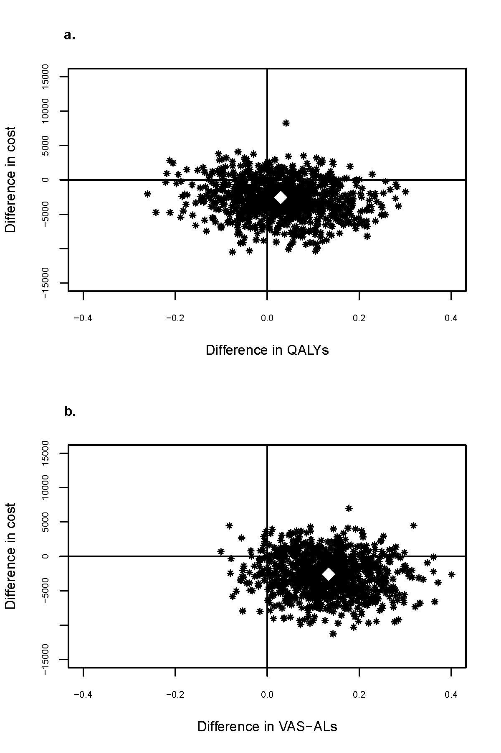

Insert Figure 3 (a+b)

**Fig. 3** Cost-effectiveness acceptability curves (CEAC); a: CEAC QALY; b: Sensitivity analysis of CEAC VAS-ALs; QALY, quality-adjusted life year using the EQ-5D Index based on German population tariff and time trade-off scoring (27); VAS-AL, quality-adjusted life year using patients’ EQ VAS score (self-rated health)

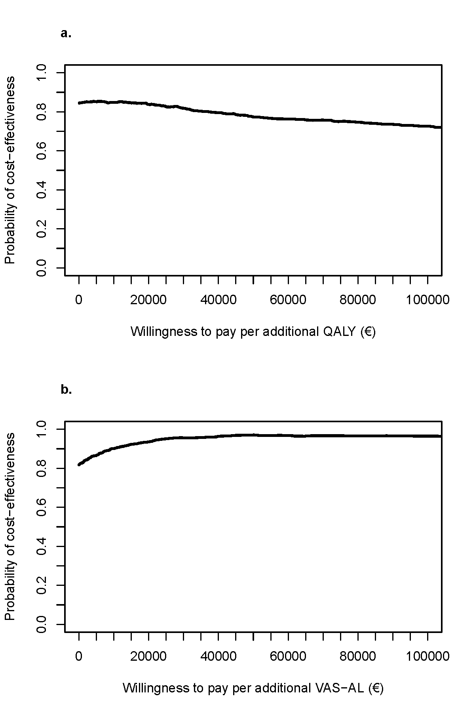

# 4 Discussion

This study compared the costs and effects of a case management intervention by trained nurses in elderly patients suffering from AMI with usual care over a time horizon of three years. The primary effect measure in the economic evaluation was QALYs constructed using population-based EQ-5D-3L utilities which ensures comparability to other studies. To assess the sensitivity of results to different health state valuation methods, we also constructed adjusted life years with patients’ self-rated health as expressed by the VAS score (46). Both methods indicated quality adjusted life year gains, whether or not discounting. Within the first year, results varied depending on health state valuation methods: applying the QALY concept, case management indicated quality adjusted life year losses; using VAS-AL, case management indicated quality adjusted life year gains (13). The reason behind this could be that the case management, as a complex intervention, improved domains within the first year that are not fully reflected in EQ-5D-3L or the sensitivity of the EQ-5D-3L was not sufficient to detect improvements. In the intervention group, 10 participants died in the first three months after discharge before having any contact with the study nurse so that their early deaths should be regarded as random since the intervention is unlikely to be the reason for. In the further course of the study the number of decedents were balanced and increased in the control group in third year. The combination of early deaths in the intervention group and the delayed positive effect on EQ-5D utilities led to QALY losses within the first year. Moreover, it brought about insignificance of QALY gains and led to QALY losses in 38 %, respectively after third year.

The secondary outcomes both in terms of EQ-5D-3L utilities and VAS scores among survivors showed a significantly higher health state in the intervention group after 3 years. The positive effect on EQ-5D-3L utilities (0.104) can be regarded as important since the minimally important difference (MID) for patients with AMI was 0.089 (47). Compared with the results of the 1-year follow-up, the positive effect increased and became significant regarding EQ-5D utilities and maintained regarding VAS scores, respectively after three years. This could indicate that, as also found in another study (48), VAS scores are more sensitive in heart patients and thus revealed improvements, which are not covered by EQ-5D utilities in early stages but later on. In the 1-year follow-up, we assumed that VAS scores could only reflect an adaption process rather than a better health but this could not be confirmed. Regardless of VAS scores, EQ-5D utilities only became significant in the long run. In contrast, significant intervention effects could be shown within the first year for functional status and for malnutrition risk, which maintained after the 3-year follow-up intervention (10, 49). It is conceivable that improvements in functional status were subsequently translated into higher utility scores.

Direct costs were mainly driven by hospitalisation and were lower in the intervention group (–€3,189). Only costs of paid household work were higher in the intervention group (€1.150) but, at baseline, a difference already existed in the use of paid household help (13.5% in the intervention group vs.8% in the control group). All cost differences were not significant. Similar cost differences already emerged within the first year. There were lower direct costs at an altitude of €1.072 and higher costs of paid household work (€388). It became obvious that cost differences increased linear. In case of differences continuing in this way, it can be assumed that differences would become significant in longer follow-up. Economic evaluations almost always are piggy back analyses which are embedded in clinical trials. Therefore, low power is a common problem in economic evaluation since sample size calculation is oriented towards clinical main outcome rather than to detect differences in costs or QALYs (50). Due to high variance of cost data, very large differences or study samples are needed to achieve significant results.

However, the results also could be affected concerning the lower costs in the intervention group because costs were set to 0 from the day of death. For that reason, we analysed the mean costs per day survived which showed no difference (€34.66 in the intervention and €34.03 in the control group) although costs during the last year of life usually are higher than those for nonterminal years (51).

A limitation of our study is the single centre design, which restricts generalisation to other population characteristics and health care structures. Furthermore, 92 of the 636 patients assessed for eligibility declined to participate before randomisation and 60 withdrew consent after randomisation. Patients refusing participation (n=92) were, on average, 2 years younger than participants but did not differ with respect to gender and comorbidities. If there were additional systematic differences, the external validity of our findings may be affected. As 60 patients withdrew consent, we applied a missing value imputation approach by including subjects who withdrew consent or were lost to follow-up during the three-year study period. The resulting estimation of probability of cost-effectiveness of the case management remained stable so that our results can be considered to be robust with respect to attrition.

Strengths of the study include its randomised design, the inclusion of different valuation perspectives with regard to quality of life impacts and thorough cost collection. For the last, all hospital admissions were validated in order to reduce recall bias. Resource use was not limited to disease-related services but broadly defined, thus taking into account that case management is a complex intervention. Moreover, the follow up period of three years is suited to detect long-term cost-effectiveness of case management programme in elderly people with an AMI.

To our knowledge, no cost-effectiveness study has yet been conducted to evaluate a case management programme in elderly patients with AMI after hospital discharge. Several nurse-led intervention programmes focused on patients younger than 65 years or were tailored to patients with heart failure so that the generalisation to higher age groups or to patients discharged after an acute cardiac event cannot be ensured. For patients with CHD, there is only one study on cost-effectiveness with a follow up period of 4 years (14) and two studies covering a period of 1 year (15, 16). In the 4 year follow-up study, Raftery et al. (Scotland) (14) observed no difference in costs but differences in QALYs (+0.124 QALYs, ICER: €1,590/QALY). They also reported non-significantly lower costs for hospital admissions in the intervention group. Compared to the KORINNA study, the intervention took place in clinics, the study participants were almost 9 years younger and only cardiac-related resource use data were collected so that estimated total costs are not comparable to our study.

# 5 Conclusion

The case management KORINNA was cost neutral and led to an important and significant improvement in health status among survivors. It was associated with higher QALYs and lower costs within a time horizon of three years but the differences in costs and QALYs were not statistically significant.

# References

1. World Health Organization. The top 10 causes of death http://who.int/mediacentre/factsheets/fs310/en/ [Accessed May 26, 2015].

2. Piepoli MF, Corra U, Benzer W, et al. Secondary prevention through cardiac rehabilitation: from knowledge to implementation. A position paper from the Cardiac Rehabilitation Section of the European Association of Cardiovascular Prevention and Rehabilitation. Eur J Cardiovasc Prev Rehabil. 2010; 17: 1-17.

3. Kotseva K, Wood D, De Backer G, et al. Use and effects of cardiac rehabilitation in patients with coronary heart disease: results from the EUROASPIRE III survey. European journal of preventive cardiology. 2013; 20: 817-26.

4. Clark AM, Haykowsky M, Kryworuchko J, et al. A meta-analysis of randomized control trials of home-based secondary prevention programs for coronary artery disease. Eur J Cardiovasc Prev Rehabil. 2010; 17: 261-70.

5. Fleg JL, Forman DE, Berra K, et al. Secondary prevention of atherosclerotic cardiovascular disease in older adults: a scientific statement from the American Heart Association. Circulation. 2013; 128: 2422-46.

6. McAlister FA, Lawson FM, Teo KK, et al. A systematic review of randomized trials of disease management programs in heart failure. Am J Med. 2001; 110: 378-84.

7. Schadewaldt V, Schultz T. Nurse-led clinics as an effective service for cardiac patients: results from a systematic review. International Journal of Evidence-Based Healthcare. 2011; 9: 199-214.

8. Stolic S, Mitchell M, Wollin J. Nurse-led telephone interventions for people with cardiac disease: a review of the research literature. Eur J Cardiovasc Nurs. 2010; 9: 203-17.

9. Kirchberger I, Meisinger C, Seidl H, et al. Nurse-based case management for aged patients with myocardial infarction: study protocol of a randomized controlled trial. BMC geriatrics. 2010; 10: 29.

10. Kirchberger I, Hunger M, Stollenwerk B, et al. Effects of a 3-year nurse-based case management in aged patients with acute myocardial infarction on rehospitalisation, mortality, risk factors, physical functioning and mental health. a secondary analysis of the randomized controlled KORINNA study. PLoS One. 2015; 10: e0116693.

11. Meisinger C, Stollenwerk B, Kirchberger I, et al. Effects of a nurse-based case management compared to usual care among aged patients with myocardial infarction: results from the randomized controlled KORINNA study. BMC Geriatr. 2013; 13: 115.

12. Hunger M, Kirchberger I, Holle R, et al. Does nurse-based case management for aged myocardial infarction patients improve risk factors, physical functioning and mental health? The KORINNA trial. European journal of preventive cardiology. 2014.

13. Seidl H, Hunger M, Leidl R, et al. Cost-effectiveness of nurse-based case management versus usual care for elderly patients with myocardial infarction: results from the KORINNA study. Eur J Health Econ. 2014.

14. Raftery JP, Yao GL, Murchie P, et al. Cost effectiveness of nurse led secondary prevention clinics for coronary heart disease in primary care: follow up of a randomised controlled trial. BMJ. 2005; 330: 707.

15. Turkstra E, Hawkes AL, Oldenburg B, et al. Cost-effectiveness of a coronary heart disease secondary prevention program in patients with myocardial infarction: results from a randomised controlled trial (ProActive Heart). BMC Cardiovasc Disord. 2013; 13: 33.

16. Turner DA, Paul S, Stone MA, et al. Cost-effectiveness of a disease management programme for secondary prevention of coronary heart disease and heart failure in primary care. Heart. 2008; 94: 1601-6.

17. Hebert PL, Sisk JE, Wang JJ, et al. Cost-effectiveness of nurse-led disease management for heart failure in an ethnically diverse urban community. Ann Intern Med. 2008; 149: 540-8.

18. Mejia A, Richardson G, Pattenden J, et al. Cost-effectiveness of a nurse facilitated, cognitive behavioural self-management programme compared with usual care using a CBT manual alone for patients with heart failure: secondary analysis of data from the SEMAPHFOR trial. Int J Nurs Stud. 2014; 51: 1214-20.

19. Neumann A, Mostardt S, Biermann J, et al. Cost-effectiveness and cost-utility of a structured collaborative disease management in the Interdisciplinary Network for Heart Failure (INH) study. Clinical research in cardiology : official journal of the German Cardiac Society. 2015; 104: 304-9.

20. Postmus D, Pari AA, Jaarsma T, et al. A trial-based economic evaluation of 2 nurse-led disease management programs in heart failure. Am Heart J. 2011; 162: 1096-104.

21. Smith B, Hughes-Cromwick PF, Forkner E, et al. Cost-effectiveness of telephonic disease management in heart failure. Am J Manag Care. 2008; 14: 106-15.

22. Schad M, John J. Towards a social discount rate for the economic evaluation of health technologies in Germany: an exploratory analysis. Eur J Health Econ. 2012; 13: 127-44.

23. Stark R, Kirchberger I, Hunger M, et al. Improving care of post-infarct patients: effects of disease management programmes and care according to international guidelines. Clinical research in cardiology : official journal of the German Cardiac Society. 2014; 103: 237-45.

24. Russell K, Freeman A, Blue L, et al. A Blueprint for Identifying and Managing Patients within a Heart Failure Service. Second Edition ed. London: BMJ Publishing Group, 2004.

25. Nowels D, McGloin J, Westfall JM, et al. Validation of the EQ-5D quality of life instrument in patients after myocardial infarction. Qual Life Res. 2005; 14: 95-105.

26. Schweikert B, Hahmann H, Leidl R. Validation of the EuroQol questionnaire in cardiac rehabilitation. Heart. 2006; 92: 62-7.

27. Greiner W, Claes C, Busschbach JJ, et al. Validating the EQ-5D with time trade off for the German population. Eur J Health Econ. 2005; 6: 124-30.

28. Drummond MF, Sculpher MJ, Torrance GW, et al. Methods for the economic evaluation of health care programmes. Third ed. Oxford: Oxford University Press, 2005.

29. Goossens MEJB, Mölken MPMHR-v, Vlaeyen JWS, et al. The cost diary: a method to measure direct and indirect costs in cost-effectiveness research. J Clin Epidemiol. 2000; 53: 688-95.

30. Seidl H, Meisinger C, Wende R, et al. Empirical analysis shows reduced cost data collection may be an efficient method in economic clinical trials. BMC Health Serv Res. 2012; 12: 318.

31. Bock JO, Brettschneider C, Seidl H, et al. [Calculation of standardised unit costs from a societal perspective for health economic evaluation]. Gesundheitswesen. 2015; 77: 53-61.

32. Mühlberger N, Behrend C, Stark R, et al. Datenbankgestützte Online-Erfassung von Arzneimitteln im Rahmen gesundheitswissenschaftlicher Studien Erfahrungen mit der IDOM-Software. Informatik Biometrie und Epidemiologie in Medizin und Biologie. 2003; 34: 601-11.

33. Wissenschaftliches Institut der AOK. Available from URL: http://www.wido.de/arzneimittel.html [Accessed January 15, 2013].

34. Sozialgesetzbuch (SGB), Elftes Buch (XI), Soziale Pflegeversicherung. Available from URL: http://www.sozialgesetzbuch-sgb.de/sgbxi/1.html [Accessed 2011, April 15].

35. Manca A, Hawkins N, Sculpher MJ. Estimating mean QALYs in trial-based cost-effectiveness analysis: the importance of controlling for baseline utility. Health Econ. 2005; 14: 487-96.

36. Molenberghs G, Kenward MG. Missing Data in Clinical Studies. UK: John Wiley & Sons Ltd, 2007.

37. Dodd S, Bassi A, Bodger K, et al. A comparison of multivariable regression models to analyse cost data. J Eval Clin Pract. 2006; 12: 76-86.

38. Glick H, Doshi JA, Sonnad SS, et al. Economic Evaluation in Clinical Trials. In: Gray A, Briggs A, eds., Handbooks in Health Economic Evaluation Series. New York: Oxford University Press 2007.

39. Graubard BI, Korn EL. Predictive margins with survey data. Biometrics. 1999; 55: 652-9.

40. Husereau D, Drummond M, Petrou S, et al. Consolidated Health Economic Evaluation Reporting Standards (CHEERS)--explanation and elaboration: a report of the ISPOR Health Economic Evaluation Publication Guidelines Good Reporting Practices Task Force. Value Health. 2013; 16: 231-50.

41. Fenwick E, O'Brien BJ, Briggs A. Cost-effectiveness acceptability curves--facts, fallacies and frequently asked questions. Health Econ. 2004; 13: 405-15.

42. van Hout BA, Al MJ, Gordon GS, et al. Costs, effects and C/E-ratios alongside a clinical trial. Health Econ. 1994; 3: 309-19.

43. Briggs AH, Lozano-Ortega G, Spencer S, et al. Estimating the cost-effectiveness of fluticasone propionate for treating chronic obstructive pulmonary disease in the presence of missing data. Value Health. 2006; 9: 227-35.

44. Horton NJ, SR L. Multiple imputation in Practice: Comparison of Software Packages for Regression Models with Missing Variables. . The American Statistician. 2001; 55: 244-54.

45. Ramsey S, Willke R, Briggs A, et al. Good research practices for cost-effectiveness analysis alongside clinical trials: the ISPOR RCT-CEA Task Force report. Value Health. 2005; 8: 521-33.

46. Parkin D, Devlin N. Is there a case for using visual analogue scale valuations in cost-utility analysis? Health Econ. 2006; 15: 653-64.

47. Walters SJ, Brazier JE. Comparison of the minimally important difference for two health state utility measures: EQ-5D and SF-6D. Qual Life Res. 2005; 14: 1523-32.

48. Leidl R, Schweikert B, Hahmann H, et al. Assessing quality of life in a clinical study on heart rehabilitation patients: how well do value sets based on given or experienced health states reflect patients' valuations? Health Qual Life Outcomes. 2016; 14: 48.

49. Hunger M, Kirchberger I, Holle R, et al. Does nurse-based case management for aged myocardial infarction patients improve risk factors, physical functioning and mental health? The KORINNA trial. European journal of preventive cardiology. 2015; 22: 442-50.

50. Briggs A. Economic evaluation and clinical trials: size matters. BMJ. 2000; 321: 1362-3.

51. Hoover DR, Crystal S, Kumar R, et al. Medical expenditures during the last year of life: findings from the 1992-1996 Medicare current beneficiary survey. Health Serv Res. 2002; 37: 1625-42.