**Optical and optoacoustic imaging**

Daniel Razansky 1,2 and Vasilis Ntziachristos 3,4

1 Faculty of Medicine and Institute of Pharmacology and Toxicology, University of Zurich, Switzerland

2 Institute for Biomedical Engineering and Department of Information Technology and Electrical Engineering, ETH Zurich, Switzerland

3 Institute of Biological and Medical Imaging, Helmholtz Zentrum München, Neuherberg, Germany

4 Chair of Biological Imaging, TranslaTUM, Technical University of Munich, Munich, Germany

**\*Corresponding author**. Technical University of Munich, Ismaningerstr. 22, D-81675 Munich, Germany. Tel: +49 89 3187 3852. Email: v.ntziachristos@tum.de

**Abstract**

The present chapter summarizes progress with optical methods that go beyond human vision. The focus is on two particular technologies: fluorescence molecular imaging and optoacoustic (photoacoustic) imaging. The rationale for the selection of these two methods is that in contrast to optical microscopy techniques, both fluorescence and optoacoustic imaging can achieve large fields of view, i.e. spanning several centimeters in two or three dimensions. Such fields of views relate better to human vision and can visualize large parts of tissue, a necessary premise for clinical detection. Conversely, optical microscopy methods only scan millimeter sized dimensions or smaller. With such operational capacity, optical microscopy methods need to be guided by another visualization technique in order to scan a very specific area in tissue and typically only provide superficial measurements, i.e. information from depths that are of the order of 0.05 – 1 mm. This practice has generally limited their clinical applicability to some niche applications, such as optical coherence tomography of the retina. On the other hand, fluorescence molecular imaging and optoacoustic imaging emerge as more global optical imaging methods with wide applications in surgery, endoscopy and non-invasive clinical imaging, as summarized in the following. The current progress in this field is based on a volume of recent review and other literature that highlights key advances achieved in technology and biomedical applications. Context and figures from references from the authors of this chapter has been used here, as it reflects our general view of the current status of the field.

**Keywords:** Fluorescence imaging, Surgical navigation, Optical imaging, Biophotonics, Intraoperative imaging, Multispectal Optoacoustic Tomography, Photoacoustic imaging

Human vision has been used for disease detection since the beginning of medicine. Using both morphological and spectral features, the visual observation remains a major detection method in many clinical segments today, including general examinations or surgical and endoscopic procedures. Even today, surgeons and endoscopists are guided by what they see with their own eyes either directly or through optical systems that produce photographic and video representations of tissue, such as the color videos viewed during laparoscopy on a computer screen. Therefore, even when using advanced methods such as high-definition white-light imaging 1 or stereoscopic imaging 2, detection in many surgical and endoscopic procedures depends on human vision in ways that resemble those from the beginning of medicine.

More sophisticated forms of "vision" exist in medicine, but are impractical or impossible to bring into the surgical suite 3,4. X-ray imaging and magnetic resonance imaging systems, for example, cannot fit into typical operating rooms or allow surgical teams to come close enough to the patient. In addition, x-ray imaging lacks the contrast or resolution to image cancer borders or detect lymph node metastases. Tomography scanners are far too expensive to become routine tools during surgery, and in fact they lack the resolution and contrast needed to guide surgeons effectively during procedures. Gamma scanners can be used in the surgical suite, such as for identifying lymph nodes, but they offer low resolution and require radioactivity. Ultrasonography offers limited contrast, it must be performed with the probe in direct contact with the tissue, which increases risk of contamination, and it cannot survey areas as large as wide-field optical methods.

**Surgical vision through fluorescence**

Fluorescence imaging can surpass limitations of human vision to image cancerous or otherwise diseased tissue that would be invisible or indistinguishable from healthy tissue, as first demonstrated 70 years ago 5,6. It can illuminate tissues lying several millimeters below the surface, or deeper, especially when near-infrared dyes are used, without the need for dangerous or fast-decomposing radioactive contrast from isotopes. Fluorescence imaging systems are generally of small form factors and can be seamlessly integrated into surgical and endoscopic suites or miniaturized as parts of endoscopes, making them well-suited as surgical and endoscopic tools. Fluorescence imaging now promises to become fully integrated into the surgical suite within a decade.

Fluorescence contrast can be engineered by utilizing agents that reveal specific aspects of morphology, function or cellular and molecular features associated with disease and/or tissue differentiation. For instance cancer can be identified in the context of functional contrast, such as when an agent that outlines abnormal permeability is utilized. Lymph nodes can be visualized by injecting appropriate fluorescence dyes into the lymphatic drainage. Alternatively, a fluorescent agent with targeting ability to specific cellular moieties can identify receptors, enzymes or other cellular expression and function associated with features of the disease of interest. Targeted fluorescent agents that recognize specific disease biomarkers support so-called fluorescence molecular imaging (FMI), which offers high sensitivity and imaging below the surface 7-9. For example, a fluorescence dye that can target the folate receptor on ovarian cancer cells may improve detection of ovarian cancer 9,10. Fluorescently labelled Cetuximab may improve precision in surgery to excise oral tumors 11. Fluorescent dyes have been developed to target sarcoma, colonic dysplasia and Crohn's disease 12-14.

FMI relies on a camera sensitive to fluorescence photons **(Fig. 1a)**, which is fitted with high-pass or band-pass filters that block photons at the excitation wavelength and instead allow only photons exiting the tissue surface at the emission wavelengths to pass through to the camera's detector. Different spectral bands are considered for fluorescence imaging, typically over a range that could span a region of the 400 to 1,700 nm range **(Fig. 1c)**. Different cameras are required for different parts of this range, using photon detection technology that is sensitive to the visible (~400-650nm), near-infrared (NIR: ~650 – 950nm) and short-wavelength infrared (SWIR : ~ 950 – 1700nm) ranges. The fluorescence camera is often combined with a color camera **(Fig. 1b)**, which provides a morphological reference that allows registration of the two types of image **(Fig. 1e)**. A preferred method to superimpose the fluorescence image onto the color image is to render pixels transparent if their fluorescence intensity is low; in this case, strong fluorescence signals appear in pseudocolor, while weak fluorescence signals are invisible 15. The fluorescence camera, alone or combined with a color camera, can be used as a stand-alone device operating above the operating table, in handheld modes or it can be combined with flexible endoscopes 16.

**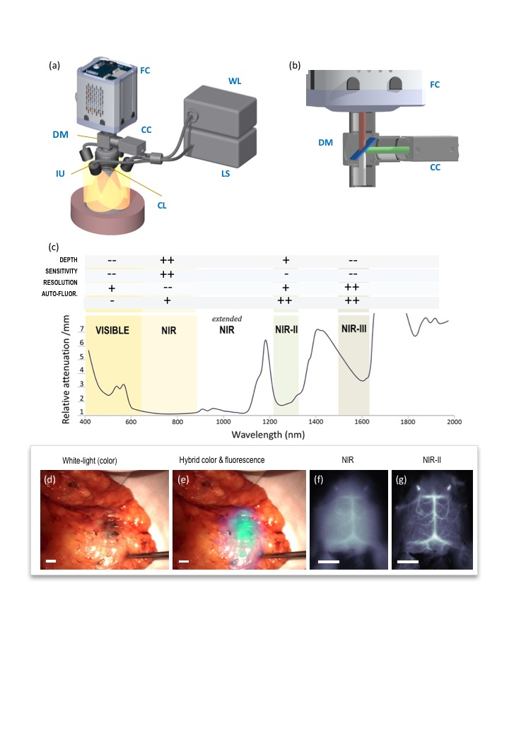 Figure 1. Intraoperative fluorescence imaging. (a)** Composite camera system using a highly sensitive fluorescence camera (FC) to collect fluorescence images and a color camera (CC) to collect white-light images through a dichroic mirror (DM) and common less (CL). Different sources may be used for white-light excitation (WL) and fluorescence excitation using a laser source (LS) and common illumination unit (IU). **(b)** Optical paths collected through the dichroic mirror. Visible light (green path) is directed to the color camera and near-infrared light (brown path) is directed to the fluorescence camera. **(c)** Absorption spectrum of tissue obtained by optoacoustic spectroscopy from mouse skin in vivo. The spectrum shows the different spectral ranges typically used in FMI. The "+" and "-" symbols indicate advantages and disadvantages of each range. **(d)** Color image collected intraoperatively from breast tissue of a breast cancer patient. **(e)** Superposition of the color image in panel (d) onto a fluorescence image in pseudo-cyan/green, identifying breast cancer below the surface. The fluorescence image was obtained after systemic administration of bevacizumab labelled with the NIR fluorescence dye CW800 (Licor). **(f)** Image of a mouse brain in the NIR region. **(g)** Image corresponding to panel (f) but obtained in the NIR-II region. Resolution is better in the NIR-II region because of less scatter. Scale bars, 5 mm. Figure reproduced from 17.

Corresponding to the camera technology used, fluorescent agents for FMI have been described covering a broad spectral range, covering the visible, NIR and SWIR. Each spectral range comes with different detection characteristics, due to the variation of tissue optical properties with wavelength. In particular, imaging in the visible may showcase images with low photon diffusion (good resolution) but at superficial depths, due to the high absorption of visible photons by tissue. In the NIR, FMI can achieve greater imaging depth, because tissue (in particular hemoglobin) absorbs NIR photons much less than visible photons. Conversely, due this lower absorption, the effects of photon scattering in tissue are more visible, leading to images that appear low resolution due to photon diffusion effects. Finally, imaging in the extended NIR (950-1,100 nm) or even more so in the NIR-II (1,100 – 1,700nm) benefits for the reduced photon scattering with increasing wavelength. However, in these ranges water and lipids absorb significantly, which also weights the image toward more superficial depths compared to the NIR range. Nevertheless, imaging at longer wavelengths may balance the effects of absorption and scattering and offers an interesting range for FMI as well, where by imaging deeper than in the visible is possible but with reduced scattering (photon diffusion) compared to the NIR **(Fig. 1f-g)**.

**Selection of fluorescence agent**

An advantage of FMI is that the contrast offered can be engineered and tuned to specific applications through the development and selection of particular fluorescence agents. Nonspecific fluorescent dyes can reveal morphological and functional features of tissue to guide medical research and various types of surgery, as we have highlighted elsewhere 7. Since the 1950s, indocyanine green (ICG) has been used to study hepatic clearance 18, cardiac output 19 and retinal vasculature 20. More recently, it has been used in the technique called ICG video-angiography to analyze tissue perfusion in many contexts. Since ICG remains mostly within the vascular system, it allows visualization of vascular flow in real time to assess perfusion in organ transplantation 21, plastic surgery 22-25, cardiac surgery 26 and neurosurgery 27. The technique has been used to monitor perfusion following colorectal anastomosis in order to detect leakage 28, which can cause severe and potentially deadly complications. It can assess whether transplanted tissue is adequately perfused during mastectomy and reconstructive surgery; if not, the resulting ischemia and necrosis can cause severe complications 29.

ICG has also proven extremely useful for localizing sentinel lymph nodes, which are often embedded deep within adipose tissue **(Fig. 2)**. In many types of cancer, these lymph nodes are extracted and analyzed for the presence of metastastic cancer 30,31, which is critical for accurate staging and treatment planning. ICG is more effective than methylene blue for identifying deep-seated lymph nodes because it fluoresces in the NIR range. ICG also avoids the need for radioactivity, in contrast to gamma sensor-based detection of lymph nodes 32. The power of ICG-based detection of lymph nodes has been demonstrated for numerous types of cancer 33-41. In fact, ICG can aid the identification of nearly all lymph nodes into which the tumor drains, not only sentinel lymph nodes 42. In this case, longitudinal monitoring of ICG distribution can identify the first draining node.

**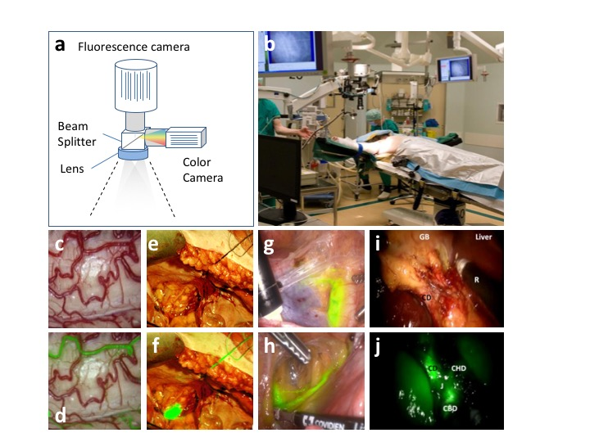**

**Figure 2. Indocyanine green (ICG)-enhanced interventional imaging. (a)** Intraoperative fluorescence imaging system using simultaneous image collection from a fluorescence and white-light (color) camera visualizing the same field of view through a shared optical system (beam splitter and lens). An endoscope system can be connected instead of a lens. **(b)** Photograph of a camera in the operating room. The camera is placed above the patient; white-light, fluorescence, and overlay images can be projected on monitors in the operating room. The camera is typically wrapped in sterile drapes (not shown). From 9. **(c-d)** Color reflection image (c) and ICG-based video-angiography (d) of the spinal cord. The fluorescence signal was overlaid on the color reflection image. The image was rendered by alpha-blending the fluorescence values after spatial anatomical landmark registration from images in 43. ICG-angiography visualized the microvascular flow and anatomical orientation, necessary to ensure safe and precise resection of spinal intramedullary tumors. The image shows an early stage soon after ICG injection and highlights the posterior spinal arteries on both sides. **(e-f)** White-light reflection image (e) overlaid with a fluorescence image (f) revealing a lymph node in early-stage cergical cancer surgery. The lymph node cannot be identified by human vision on the white light image as it is located under the tissue surface. Panels (e-f) are from 39. **(g-h)** Endoscopic sentinel lymph node (SLN) mapping (g) in the right external iliac region after cervical ICG injection in a woman with endometrial cancer as well as (h) endoscopic cervical lymph node mapping in the left obturator region likewise reveal a lymph node hidden under the tissue surface and not visible to the eye. From 44. **(i-j)** Color reflection image (i) and fluorescence pseudo-color image (j) of intraoperative fluorescent cholangiography during robotic single-site cholecystectomy. The fluorescence image contributed to the identification of the extrahepatic biliary anatomy, necessary to minimize the risk of biliary injury. Abbreviations: CBD, common bile duct; CD, cystic duct; CHD, common hepatic duct; GB, gallbladder; J, junction between cystic duct and common hepatic duct; R, robotic instrument. Panels (i-j) are from 45.

For certain types of surgery involving cancer or other diseases, targeted fluorescent agents rather than ICG are used. One key application is in aiding identification of tumor margins. When using visual inspection, it is not generally possible to know whether surgeons have completely resected a tumor until after postoperative histopathology, which can take several hours or even days. If excision is incomplete, then secondary procedures may be needed, which increase patient stress, risk of complications, and healthcare costs. On the other hand, excessive resection can mean removal of too much healthy issue around the tumor, increasing risk of irreversible damage (e.g. nerve damage) and postoperative complications. Several targeted fluorescent agents show potential for use during tumor resection, such as an FITC-conjugated ligand of the folate receptor- 9, fluorescently labelled versions of clinically approved anti-cancer therapeutic antibodies 11,46, and even agents that induce fluorogenic reactions within tumors 47-51. It may also be possible to use specific fluorescence agents to identify tumor metastasis in lymph nodes without the need to remove them from the body or analyze them postoperatively 7.

Clinical fluorescence imaging must offer sensitivity adequate to help surgeons make critical decisions in real time. Non-specific vascular dyes such as ICG are often injected in doses of up to 25 mg when given systemically, or in doses of approximately 1 mg when given intratumorally 7. The final concentration in tissue is usually several-hundred nanomolar to several micromolar. Targeted agents are used at much lower concentrations 7,46,52 because most of the dye is ultimately cleared from the body. Targeted agents may be present in the desired tissue at concentrations 5-6 orders of magnitude lower than ICG 7,53.

**Need for standardization in clinical fluorescence imaging**

To realize the full potential FMI in particular, and fluorescence imaging more broadly, universal standards are needed that define appropriate fluorescence performance. Such standards already exist for radiology, but they have yet to be formulated for fluorescence imaging. FMI standardization is complicated by the existence of a broad range of commercially available imaging systems featuring diverse cameras, illumination sources, and data processing software. This means that different FMI systems can differ in their sensitivity and specificity when analyzing the same disease using the same fluorescent agent. This problem can be avoided by defining minimum standard performance parameters that can be applied across fluorescence imaging systems and medical centers. Developing uniform standards is always challenging, but it is even more so in the case of clinical fluorescence imaging because available dyes cover such a broad spectral range from the visible to NIR-II and even longer wavelengths 17,54-56. Uniform standards are essential for achieving what we term high-fidelity fluorescence imaging (HiFFI), as we have described in greater depth elsewhere 57. Analogous to the use of "high fidelity" in audio systems, we refer to high-fidelity in fluorescence imaging as the accurate reproduction of fluorescence signal with minimal distorsions, leading to accurate visualization of the biodistribution of the dye in tissue, independently of the imaging system and processing algorithms used, the tissue analyzed, or the surgical conditions.

Separation of FMI measurements from the particular imaging set-up and data processing used is important for comparing results obtained for different patients within the same medical center or at different medical centers. This may facilitate the definition of consensus guidelines for disease diagnosis, staging, and treatment; it may also facilitate large, multi-site clinical studies. It may allow a change in the current practice of regulatory authorities of licensing the combination of fluorescent agents and a specific FMI camera. With the establishment of HiFFI, fluorescent agents could be licensed on their own.

Several parameters need to be taken into account in order to develop uniform standards. One set of parameters can be considered invariable. They are defined by the hardware and overall design of the FMI system and therefore do not change during measurements **(Table 1,** *upper section*). One invariable parameter is sensitivity: FMI should be able to detect fluorescent dye concentrations from sub-nanomolar to 0.1-micromolar 7. The requirement for sensitivity becomes particularly acute in video-rate FMI, where the typical 24 frames-per-second video means that each frame is captured during only approximately 42 milliseconds. This highlights the importance of highly sensitive cameras **(Fig. 3a-c)**. Other parameters affecting FMI sensitivity include the intensity and spectral response of the fluorochrome excitation, and the ability to block excitation light and other light from entering the fluorescence channel (cross-talk). More sensitive detection means that lower concentrations of dye can be used, which reduces risk to the patient and costs of preparing or purchasing the dye.

**Table 1. Parameters affecting FMI performance**

**INVARIABLE PARAMETERS**

|  |  |  |  |  |
| --- | --- | --- | --- | --- |
| **PARAMETER** | **TYPICAL RANGE** | **EFFECT ON FMI PERFORMANCE** | **CALIBRATION** | **REMEDY** |
| Camera Sensitivity  Electrical / read noise | nM - pM  2e- - 20e-  per read operation | * Dose of agent required * Frame rate achieved * Minimum fluorescence activity detected * Phase 0 / Micro-dosing operation * Sensitivity and specificity of clinical findings | Measure (calibrate) sensitivity with standard (FIS) | Use highly sensitive CCD /CMOS / InGaAs technology, current amplification methods, low-noise electronics, and cooling technology to reduce noise |
| Resolution | 10 – 500 micrometres | Minimum lesion size visible on white-light images | Register white-light and apparent diffusive resolution with standard | Match the number of pixels and field of view to the desired resolution |
|  |  |  |  |  |
| Dynamic range and dark current | 104-106 | * Ability to differentiate between different amounts of distributed agent * Saturation effects | Measure with standard | Select sensors with high full well capacity |
| Frame capture Speed | 1 – 100 Hz | * Quality of video | N/A | Select camera with fast read-electronics and data transfer |
| Spectral coverage | 400 – 1700 nm | * Resolution achieved * Sensitivity achieved * Depth achieved | Use fluorochromes (quantum dots) whose spectral responses are known | Select sensor technology with sufficient sensitivity in spectral range covered |
| Filters, cross-talk & ambient light | 0.1-50% of excitation light | * Reduction of sensitivity * Increase background noise * Increase image artefacts | Measure cross-talk and ambient light under control conditions | Select proper filters;  condition light source;  subtract reference light / time-share measurement |
| Illumination intensity & spectral profile | 1-200 mW/m2  Upper value may be regulated by ANSI limits | * Same as in “Camera sensitivity” | Measure (calibrate) intensity with a standard (FIS), power meter and/or spectrometer | Employ illumination close to the ANSI limit and sources of optimal spectral response. |
| Illumination homogeneity | Varies with system design | * Shadowing effects on the images collected * Accuracy (quantification) variations of different lesions * Sensitivity and specificity of clinical findings | Measure the illumination pattern (see also Box 1) | Multi-angle illumination;  normalise image with captured illumination pattern |
| **VARIABLE PARAMETERS** | | | | | |
| **PARAMETER** | **TYPICAL RANGE** | **EFFECT ON FMI PERFORMANCE** | **CALIBRATION** | **REMEDY** |
| Camera –tissue distance and field of view | 15 - 100 cm | * Variations in fluorescence intensity recorded. * Changes in focus. * Sensitivity | Record changes in field of view and distance | Real-time distance and FOV sensors or estimators |
| Depth of focus | 1-10 cm | Reduced resolution with changes in tissue elevation and camera-tissue distance | Record iris and depth of focus settings | Use high depth of focus to avoid out-of-focus images; use an autofocus mechanism |
| Variation of optical properties | Scatter :  5 – 30 cm-1  Absorption :  0.05 – 0.5 cm-1 | * Variations in fluorescence signal intensity * Variations in apparent fluorescence distribution * Variations in resolution and diffusion on the image | Record system performance as a function of optical property changes | Record variations in tissue absorption and scattering in real time |
| Auto-fluorescence | Varies with spectral region (see Fig.1c) | * Reduces detection sensitivity * May lead to false positives | Record system performance as a function of background fluorescence | Use spectral differentiation of target fluorescence over background fluorescence |
| Lesion depth | 0 – 2 cm | * Attenuation of fluorescence intensity * Variable diffusion and loss of resolution * Spectral changes | Record system performance as a function of fluorescence depth | Tomography; depth reconstruction based on spectral changes |

ANSI, American National Standards Institute; CCD, charge-coupled device; CMOS, complementary metal oxide semiconductor; FIS, fluorescence imaging standard; FOV, field of view; InGaAs, indium-gallium-arsenide; N/A, not applicable

**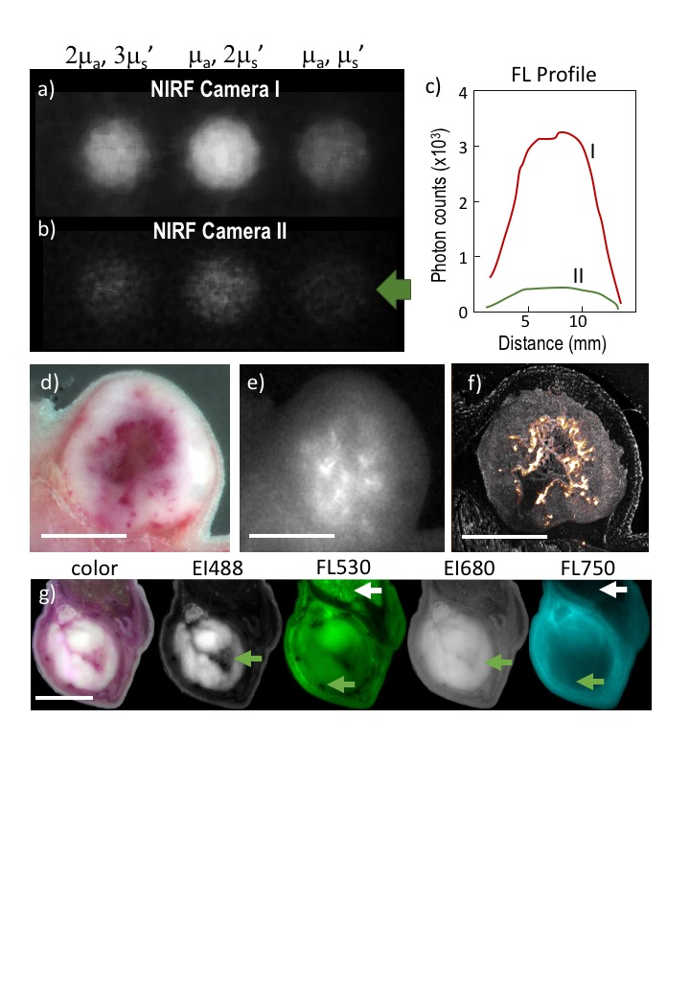Figure 3. Challenges in fluorescence imaging.** These examples illustrate the effects of system and tissue parameters on fluorescence images. **(a-b)** Three fluorescent wells in the upper right quadrant of the composite phantom described in **Box 1** were imaged using near-infrared fluorescence (NIRF) camers with the same filters and illumination parameters. Camera I (iXon, Andor) offers 10-fold higher sensitivity than camera II (Luca, Andor). Camera II nearly fails to detect a well (green arrow) that camera I resolves. All wells contained the same amount of fluorophore; intensity variations are attributed to variation in optical properties. **(c)** Fluorescence profiles through the rightmost well imaged by the two cameras illustrate the marked detection difference between them. **(d-e)** Color image (d) obtained by cryo-slicing through a 4T1 tumor subcutaneously grown on a nude mouse, and corresponding image at 750 nm (e) after administration of liposomal ICG (24 h before euthanasia). **(f)** Fluorescence image of a 100-micron slide obtained from panel (e) reveals a more detailed pattern of fluorescence distribution not prone to photon diffusion. Such images may contain cross-talk from the excitation channel (see Table 1), which can be eliminated using calibration. **(g)** Effects of optical properties and spectral region on the fluorescence image. A mouse bearing an intramuscular 4T1 tumor was injected intravenously with equal amounts of AF488 and AF750 fluorescent dyes, then imaged in epi-illumination mode using white-light (color) illumination. Excitation wavelengths were 488 and 680 nm (EI488, EI680); fluorescence was imaged at approximately 530 and 750 nm (FL530; FL750). Arrows indicate regions of special interest: white arrows indicate an area of strong autofluorescence in the visible range, which disappears in the NIR range; green arrows indicate regions of high absorption that also disappear in the NIR region. Scale bars, 5 mm.

The ability to detect agents with high sensitivity can make possible "microdosing" studies, in which the agent is administered at doses orders of magnitude lower than the likely therapeutic dose in order to analyze the body's response to the drug while minimizing the risk of serious adverse events 46. Researchers succeeded in carrying out such studies with bevacizumab, a recombinant humanized monoclonal antibody effective against various cancers 58. In that work, signal-to-noise ratios of approximately 12 dB were achieved using cooled cameras capable of detecting a few electrons. Whether the FMI system can support video-rate imaging, preferred for intraoperative uses, also depends on the camera's maximum frame rate and sensitivity.

Several other invariable parameters may affect image performance. Dynamic range, defined as the distance between the largest and smallest signals that can be recorded by a camera, determines how well the camera captures strong and weak fluorescence signals. Spatial resolution, defines the smallest fluorescence source that can be recorded accurately, or how close can two sources be so that they can be reliably separated. How uniformly the illumination energy excites the field of view is also important, because spatial variations in this energy can cause changes in fluorescence intensity unrelated to agent concentration. Moreover, tissue elevations and curved surfaces can give rise to "shadowing" effects, therefore another aspect of illumination is the angle distribution by which it illuminates tissue. The range of fluorescent agents that can be imaged adequately depends on the spectral range covered by the camera.

The second set of parameters to take into account when developing uniform standards can be considered variable, because they can differ from one measurement to the next or even during a single measurement **(Table 1,** *lower section*). Such parameters include camera focus, zoom and distance from the tissue; all these factors influence the fluorescence intensity that is recorded, the field of view that is observed, and the minimum field of view that can be resolved. Several variable parameters relate to the optical properties of the tissue being imaged 59-61. This is because fluorescence photons are generated inside the tissue, not on the tissue surface. These photons are isotropically emitted within tissue and most are scattered multiple times before detection, so the optical properties of the surrounding tissue affect their behavior and therefore the resulting fluorescence image **(Fig. 3e-g)**. For example, images collected with excitation in the NIR-II range appear to have higher resolution than images collected with NIR illumination because NIR-II wavelengths are scattered less. NIR wavelengths, in turn, can interrogate deeper in tissues than visible or NIR-II illumination because of lower light absorption by tissue in these wavelengths. Finally contrast in the NIR and NIR-II regions is generally better than in the visible, due to strong autofluorescence from components such as collagen and nicotinamide adenine dinucleotide in visible wavelengths **(Fig. 3g)**.

The strong dependence of fluorescence images on optical properties of the tissue under study has at least three important implications for analyzing and optimizing FMI and for defining appropriate standards. Fluorescence images do not report the true biodistribution of fluorescent agents but rather a composite signal that depends on the concentration of the agent and the optical properties of the tissue. Second, the diffusive behavior of fluorescence photons within the tissue blurs edges and borders, which makes it more difficult to differentiate healthy and diseased tissue. Third, the fluorescence signal measured by the camera depends strongly and non-linearly on the depth of the fluorescence source. As a result, the same type or size of lesion may appear quite differently on fluorescence images depending on experimental parameters.

The range of invariable and variable parameters can affect fluorescence imaging, and the resulting range in FMI performance between medical centers and even within the same medical center, between commercially available devices and even for the same device used on different patients or by different operators. These factors make clear the need for consensus standards on what system performance is adequate to make diagnostic decisions or guide surgeries. For example, no standards exist on the minimal acceptable sensitivity in clinical fluorescence imaging. This lack of standardization is hindering broader clinical implementation of FMI, which is unfortunate given the technique's potential for real-time, patient-specific guidance on procedures. The benefits of FMI become all the more important as medical care moves towards minimally invasive and robot-assisted surgery 62.

For standardization purposes, we have recently proposed a phantom **(Box 1)** 57,63 that integrates different experimental conditions and can measure for multiple camera parameters simultaneously. Such phantom could lead to system quality control and calibration, or more generally in system standardization. Measurements performed with standardized systems can facilitate comparisons of data obtained using different imaging systems, such as those obtained at different medical centers in a multi-site clinical study, which may improve reproducibility of procedures and treatments and facilitate benchmarking of FMI systems against one another. It can also alert operators to a decrease in performance by their system, perhaps indicating the need to replace or upgrade components, or adjust their measurement procedure to take into account features of particular patients or disease situations. FMI characterization using a calibrated phantom standard could serve as a quantitation of the reliability of FMI analysis in applications for regulatory approval of a novel treatment or intervention.

\_\_\_\_\_\_\_\_\_\_\_\_start of box\_\_\_\_\_\_\_\_\_\_\_\_\_\_\_\_\_\_\_\_\_\_\_\_\_\_\_\_\_\_\_\_\_

**Box 1. Phantoms**

Imaging phantoms, i.e. objects that contain features simulating tissue features with predetermined shapes and contrast, are common in radiological imaging for evaluating, confirming or measuring the performance of a device or method. Phantoms are generally employed in medical imaging for quality control and quality assurance. For optical imaging standardisation, phantoms should meet three basic requirements, i.e.

1. allow the implementation of desired optical properties (absorption, scattering, fluorescence),
2. provide long-term photostability in diverse environmental conditions, and
3. assume a fixed shape (termed a "solid phantom") that suffers no mechanical deformation over time.

To meet these requirements, optical phantoms typically use epoxy, polyester resin or polyurethane as base material. When cured, these materials can be machined into different shapes and volumes. Optical properties can be flexibly manipulated by adding absorbers, scatterers and fluorophores prior to curing. Typically, absorption properties are based on the addition of absorbing dyes (e.g. India ink, nigrosin) and scattering properties are based on the addition of TiO2 particles into the base material. Homogeneous distribution can be ensured with sonication. Quantum dots are typically preferred for fluorescence emission. Unlike organic fluorophores, which suffer from fast photo-bleaching, quantum dots provide better photostability, which is required in applications involving long-term imaging 64-67.

Several phantoms have been considered for fluorescence imaging studies. A typical parameter addressed is sensitivity, using different titrations of a known fluorochrome 68. Other parameters have been considered, such as the effects of depth 69 or the cross-talk between excitation and emission channels 68. However, a limitation of current phantoms is that they address only one or a few of the specifications in Table I 68,70,71.

HiFFI standardisation and reversion require the measurement and calibration of a large number of parameters (Table I). Fortunately, modern cameras used for FMI contain more than 106 pixels, and the high pixel density means that each photograph may contain more than 1 million independent measurements. The actual number of independent features that an FMI camera captures is probably less given the presence of diffusion, the need for a minimum signal-to-noise ratio and other practical considerations; nevertheless, this number of features is sufficient to retrieve all invariable and variable parameters in Table I. Consequently, we have recently introduced the concept of ***composite phantoms***, i.e. phantoms that enable the characterization of the parameters in Table I in a single snapshot (photograph). A first composite phantom (**inset**) was constructed out of polyurethane and employed multiple targets, each exploring a different camera performance parameter. The construction of the phantom and its application have been described in detail elsewhere 63,72. In brief, the background material and the different targets introduced are made of different mixtures of TiO2 particles, photon-absorbing dyes and quantum dots. The phantom uses nigrosin as a generic absorber with a flat absorption spectrum, as well as hemin, an iron-containing porphyrin with a haemoglobin-like absorption spectrum that simulates the absorption of blood. This composite phantom enables the implementation of multiple features, including the measurement of sensitivity, cross-talk, illumination homogeneity, dark current, resolution and the effects of depth and optical properties (see legend to **inset**).

Composite phantoms could be employed as fluorescence imaging standards (FIS) for different standardisation operations, as discussed in the main text, and for examining the performance of reversion methods. Preferably phantoms should be relatively straightforward and inexpensive to manufacture. An ideal phantom should balance imaging features against manufacturing complexity. It is therefore possible that simpler or more complex features could be introduced, depending on the particular application. The preliminary phantom in the inset is not a comprehensive phantom for all parameters in Table I; for example, it does not contain features for spectral measurements or calibrations. Next-generation phantoms can contain a larger number of wells that more accurately report on camera performance over a wider dynamic and spectral range. 3D printing techniques may significantly simplify manufacturing of complex phantoms for FMI standardisation.

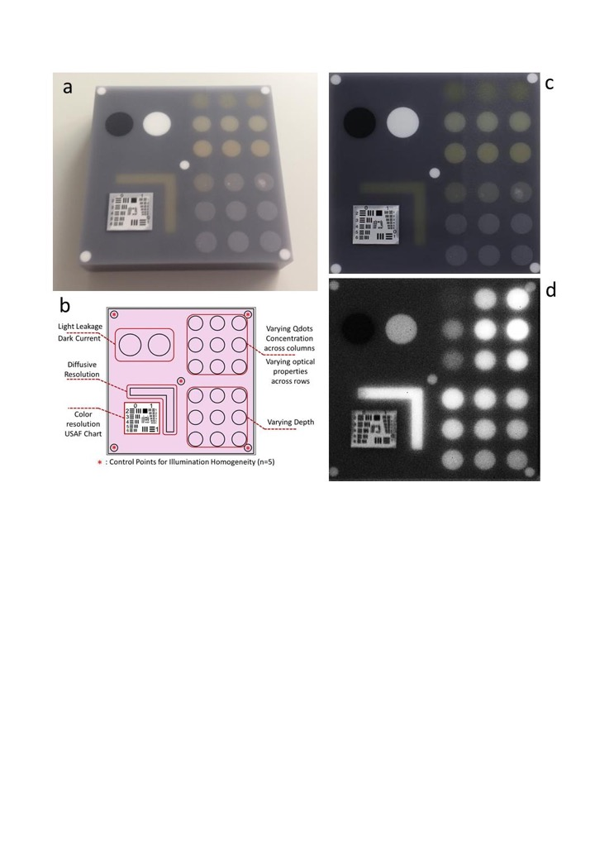**Inset.** Composite Phantom for FMI Standardization in the Visible Range. (a) Colour photograph of the phantom, which has outer dimensions of 10 x 10 x 2.2 cm3. (b) Schematic explaining the function of the different parts of the phantom. (c) Reflectance image of the phantom obtained with the colour camera of a hybrid FMI system. (d) Fluorescence image of the phantom. Background absorption was set to ~2.2 cm-1 by adding nigrosin dissolved in alcohol (Sigma Aldrich, St. Louis, USA) to the base material, while the reduced scattering coefficient was set to ~10 cm-1 by adding 1 mg/g TiO2 particles [titanium(IV) oxide; Sigma Aldrich, St. Louis, USA). The upper right quadrant of the phantom contains an array of nine fluorescent wells (10 mm diameter) that interrogates the sensitivity and fluorescence intensity variation as a function of optical properties. The wells contain a mix of cured polyurethane with organic quantum dots at varying concentrations (1, 5 and 10 nM) across the columns and varying hemin concentration (20, 20 and 40 μg/g) and TiO2 amount (0.33, 0.66 and 1 mg/g) across the rows. The bottom right quadrant contains nine fluorescence wells embedded within the phantom at increasing depths below the phantom surface (0.2, 0.4, 0.6, 0.8, 1, 1.33, 1.66, 2 and 3 mm). The upper left quadrant examines camera dark-current offset and camera cross-talk, i.e. excitation light leakage into the fluorescence channel. The lower left quadrant assesses the resolution of the fluorescence and visible images. Five identical reflective circular areas (5 mm diameter), made of 10 mg/g titanium oxide in polyurethane, sample the homogeneity of the light illumination employed by the camera system. Four circular areas lie at the corners of the phantom, and one area lies in the centre.

\_\_\_\_\_\_\_\_\_\_\_\_\_end of box\_\_\_\_\_\_\_\_\_\_\_\_\_\_\_\_\_\_\_\_\_\_\_\_\_\_\_\_\_\_\_\_

Standardized measurements can also permit the conversion of measurements into absolute concentrations of fluorophores. Currently FMI focuses on reporting relative measures 61,73,74, such as the intensity of fluorescence signal in one area over background intensity **(Fig. 3g)** or calculating other ratios. HiFFI aims to go one step further by enabling the use of absolute metrics. This requires correcting, or "reverting" 57,59 experimental measurements to take into account the effects of the parameters in Table 1.

Another objective of such standards is to validate methods that minimize FMI sensitivity to experimental parameters and achieve what we have defined as HiFFI: the accurate representation of fluorochrome biodistribution in tissue, independent of the FMI system or environmental conditions during the measurement. In HiFFI, the clinical results do not change when the parameters in Table 1 are modified. One key to developing such FMI performance is to develop methods that obtain detailed information about the experimental parameters of an FMI acquisition at any point in time, such as based on measurements of a calibrated phantom and possibly also from tissue, in real-time. Overall, correcting for the effects of invariable parameters is relatively straightforward. For example, the cross-talk coefficient relating different channels can be quantitated using a calibration phantom such as in **Box 1,** and the excitation image can be multiplied by this coefficient and then subtracted from the fluorescence image. Effects of ambient light can also be quantitated through calibration and then controlled through improvements in hardware and data processing techniques 75,76. More complex is correcting for variable parameters, which typically requires dedicated hardware that collects additional information about the environment and the tissue measured. For example, it is possible to record tissue properties with another camera, so that the variation of optical properties in the tissue imaged is collected **(Fig. 4e-f)**. It has been shown that imaging of light reflected from tissue depends on the ratio of the absorption coefficient to the reduced scattering coefficient (*a / s'*) 77,78. An additional complication therefore in FMI occurs because when this ratio is uniform across the image, then the reflectance image collected will show spatially uniform intensity, even if the absolute optical properties and the fluorescence signal collected may vary. Correcting for optical properties using reflectance images remains a challenge because simple reflectance measurements cannot independently separate absorption from scattering 79,80. Collection methods and data processing schemes are currently under research to record data that allow for separation of absorption from scatter and the accurate correction of fluorescence images 59.

**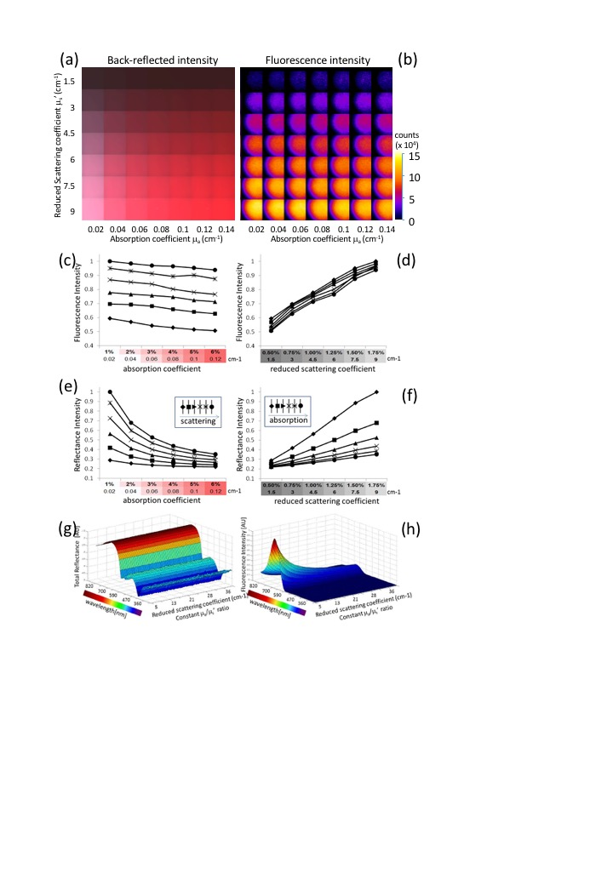Figure 4. Effects of tissue optical properties on the fluorescence and back-reflected intensity. (a)** Phantom containing wells showing different levels of absorption (x axis) and scatter (y axis). All wells contain 1 M Alexa 750 fluorochrome. **(b)** Fluorescence intensity measured in wells shown in panel (a). Signal variation across the wells is due to inhomogeneous illumination. **(c)** Fluorescence intensity recorded from the wells in panel (b) as a function of absorption coefficient. The symbols are defined in panel (e). **(d)** Fluorescence intensity recorded from wells in panel (b) as a function of reduced scattering coefficient. The symbols are defined in panel (f). **(e)** Reflectance intensity recorded from the wells in panel (b) as a function of absorption coefficient. Symbols are organized with scatter increasing towards the right. **(f)** Reflectance intensity recorded from the wells in panel (b) as a function of reduced scattering coefficient. Symbols are organized with absorption increasing towards the right. **(g)** Reflectance intensity spectra generated by Monte Carlo simulations as scattering and absorption coefficients increase, but their ratio remains constant. **(h)** Fluorescence intensity spectra generated by Monte Carlo simulations as scattering and absorption coefficients increase, but their ratio remains constant. Measurements in panels (g-h) have been experimentally confirmed (data not shown).

In addition to methods that explicitly resolve optical properties, ratiometric approaches are being used to report relative measures in FMI. For example, ratios can be measured using at least two fluorescence images obtained in different spectral regions in order to minimize the effects of autofluorescence and scatter 61,81. In a study involving a mouse model of pulmonary inflammation, animals were injected with a protease-sensitive fluorescent agent that emits at 780 nm and a fluorescent agent with similar biodistribution that emits at 695 nm. Normalization of images at 780 nm with those at 695 nm minimized the effects of agent distribution and depth, improving quantitation of inflammation 82. This normalization approach has also proved effective in a study quantitating expression of epidermal growth factor receptor in a mouse model of metastatic breast cancer 83.

**Multi-Spectral Opto-acoustic Tomography (MSOT)**

Optoacoustic interrogation of biological tissues has been considered since the early 1970’s 84-86 and offers a powerful methodology for molecular imaging investigations. In-vivo imaging of cellular and sub-cellular markers can be achieved by multi-spectral optoacoustic tomography (MSOT), an emerging field in the imaging sciences. MSOT overcomes major limitations of conventional optical imaging while it retains many of the advantages of photonic methods.

The MSOT principle of operation is shown on Fig. 5. Short laser pulses in the nano-second range illuminate the tissue of interest at multiple wavelengths. Absorption of the fast laser pulses by tissue photo-absorbers, such as oxy- and deoxy- hemoglobin, melanin, or extrinsically administered probes and agents creates a transient temperature increase which in turn leads to a thermo-elastic expansion. This process creates ultrawideband acoustic waves in the 0.1 -100 MHz range, which can then be detected with multiple ultrasound elements placed around the illuminated area. By combining the ultrasonic measurements in the mathematical data inversion scheme, high resolution images of tissue can be produced. The amplitude of the generated broadband ultrasound waves reflects local optical absorption properties. As a result, MSOT reports on the versatile optical absorption contrast but relative to other optical methods provides a sort of ‘super-vision’ by exploiting the low scattering of ultrasound to break through the barriers imposed by optical diffusion. The spatial resolution of the method is therefore solely determined by the diffraction limit of ultrasound waves or the available bandwidth of the ultrasonic detector.

MSOT further employs spectral identification of known reporter molecules, such as common fluorochromes or other chromophores, dyes and photo-absorbing nano-particles. Molecules with spectra that are different than the ones of background tissue can be accurately resolved by MSOT with high specificity 87. However, in practice, MSOT images obtained from tissues represent a mixed contribution of photon energy delivered in each volume element imaged and the total absorption contribution from the volume element. Consequently significant measures are taken to decompose the resulting image from the effects of inhomogeneous light attenuation in the tissue of interest 88,89.

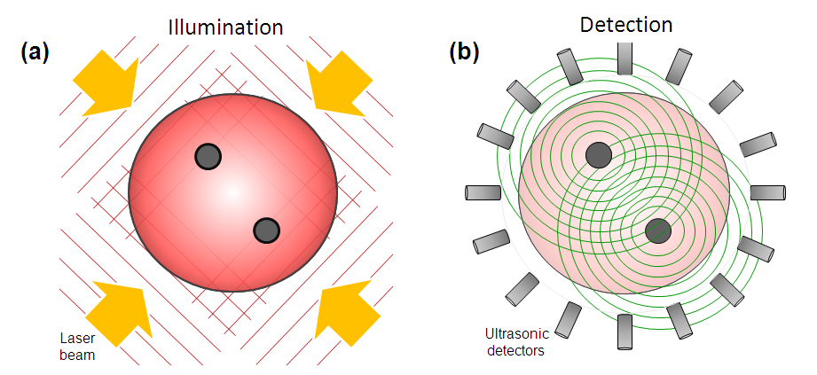

**Figure 5.** principle of MSOT operation. (a) Pulsed light of time-shared multiple wavelengths illuminates the tissue of interest and establishes transient photon fields in tissue. (b) In response to the fast absorption transients by tissue elements, acoustic responses are generated via the thermo-acoustic phenomenon, which are then detected with acoustic detectors. By modeling photon and acoustic propagation in tissues and using inversion (tomographic) methods images can then be generated and spectrally unmixed to yield the bio-distribution of reporter molecules and tissue biomarkers. Taken from ref. 90

**MSOT imaging of endogenous absorption contrast**

Biological tissues contain a variety of endogenous chromophores with distinct absorption spectra that can be exploited for label-free structural and functional imaging with MSOT 91. In the visible and NIR ranges, light is mainly absorbed in living mammalian tissues by haemoglobin, melanin, lipids and water (Fig. 6). Differences in the absorption spectrum of haemoglobin associated to oxygen binding encode important information related to physiological activity. Since many diseases undergo structural changes at time scales ranging from days to weeks and months, imaging can be used to visualize and quantify these changes. For example, vascular structures can be mapped for depths of millimetres to centimetres within mammalian tissues 92 and accurate estimation of oxygen saturation is possible with proper models of light attenuation 93. Due to the strong intrinsic haemoglobin contrast, MSOT represents a valuable tool to study the evolution of important hallmarks of cancer such as angiogenesis 94,95 and hypermetabolism 96,97. Imaging the vascular fat deposition in atherosclerotic plaques is also possible at infrared wavelengths 98,99, while the strong absorption of melanin can be exploited to characterize skin melanomas 100 and metastatic melanoma cells 101. Measurable endogenous changes may also occur on significantly shorter time scales. Changes in blood oxygen saturation, total haemoglobin, blood volume, oxygenized and deoxygenized forms of haemoglobin can be readily monitored with optoacoustic systems operating at sub-second or even millisecond-scale temporal resolution 102-104.

**F:\IBMI_Papers\Journal\Review_Chemical\V4\Figures\Section 3\Figure_3_1.tif**

**Fig. 6** Optical absorption spectra of major endogenous chromophores at typical concentrations occurring in living mammalian tissues. Melanin spectrum (brown) is shown for typical concentrations in the skin 105; haemoglobin (red – oxygenated, blue – deoxygenated) for typical concentrations in whole blood (150 g/l – continuous lines) and average soft tissues (15 g/l – dashed lines) (http://omic.org/spectra); water (cyan) for a typical concentration of 80% by volume in soft tissues 106; lipids (yellow) for a concentration of 20% by volume 107,108. The first (NIR – I) and second (NIR – II) windows 109, where optical absorption is minimized, are indicated.

Background absorption of light by intrinsic tissue chromophores along with optical scattering are also responsible for the strong attenuation of light in biological tissues. Optical attenuation is significantly stronger as compared with acoustic attenuation for frequencies below 20-30 MHz, thus it represents the main limiting factor for deep tissue imaging 110. Light penetration is maximized in the so-called near-infrared (NIR) window between 650 and 1350 nm 111, while it is significantly aggravated by strong absorption of blood at shorter wavelengths and water at longer wavelengths (Fig. 6). For deep-tissue imaging purposes, excitation optical wavelengths within this range are therefore commonly selected, where MSOT imaging with centimetre-scale penetration is possible 112,113. The wavelength dependence of optical attenuation further contributes to the distortion (spectral colouring) of the MSOT signals originating from deep locations 114. Thereby, the performance of the particularly employed unmixing approach, rather than the signal-to-noise performance of the imaging system, generally determines the minimum detectable concentration of extrinsically administered contrast agents.

**Molecular sensing with MSOT**

The presence of strong endogenous (background) contrast may in fact hinder detection of useful signals when attempting to enhance the contrast extrinsically, e.g. in targeted molecular imaging applications. With a typical 2 mM concentration of haemoglobin in blood 115, vascular structures may conceal e.g. signals from genetically-expressed labels that can typically attain concentrations on the micro-molar level *in vivo* 116. Thereby, signal amplification approaches based on spectral unmixing or dynamic contrast enhancement become essential in order to efficiently map the distribution of relatively low concentrations of contrast agents 117,118.

To this end, various molecular sensors have been used to probe tumour microenvironments and monitor treatments with MSOT. A temperature sensitive nanoswitch probe was synthetized by intercalation of light-harvesting porphyrins within thermoresponsive nanovesicles 119. The probe functions by absorbing light at two distinct wavelengths (680 and 824 nm) while its spectral features can be reversibly switched by exceeding a temperature threshold. Using this thermochromic property, localized temperature changes within tumour Xenografts were determined *in vivo* and non-invasively (Fig. 7a).

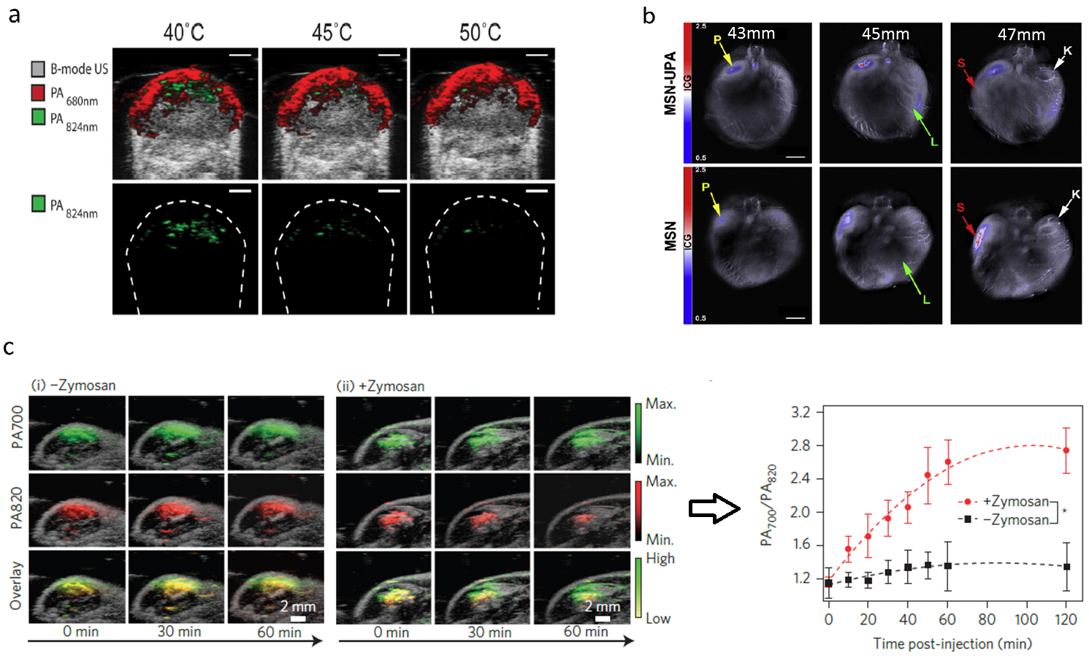**Fig. 7.** Optoacoustic molecular imaging and sensing. (a) Temperature threshold sensing in tumour xenografts injected with J-aggregating bacteriopheophorbide a-lipid nanoparticles JPN16 by comparison of cross-sectional optoacoustic images at two different wavelengths. Figure is used under the License from Standard ACS AuthorsChoice/Editors' Choice Usage Agreement from 120. A 1 mm scale bar was added and image identification was altered. (b) Multispectral optoacoustic tomography (MSOT) images of a mouse implanted with S2VP10 pancreatic cancer cells after injection of mesoporous silica nanoparticles (MSN) with chitosan and urokinase plasmonigen activator (MSN-UPA) (top) or untargeted MSN (bottom). Scale bar – 5 mm. Adapted with permission from 121. © 2015 Elsevier. (c) Optoacoustic sensing of reactive oxygen species (ROS) by comparison of cross-sectional optoacoustic images for saline-treated (left) and zymosan-treated (middle) regions in a mouse and the time profiles of the optoacoustic amplitude ratios for two wavelengths (right) after injection of ratiometric semiconducting polymer nanoparticles (RSPN). Adapted with permission from 122. © 2014 - Macmillan Publishers Ltd.

Similar strategies may be applied to detect other stimuli such as pH and enzymatic activity. Due to their high metabolic rate, malignant tumours are commonly characterised by lower than normal pH levels. A theranostic nanovehicle for targeting pancreatic cancer was designed based on mesoporous silica nanoparticles (MSN) that encapsulate Indocyanine Green for enhancing MSOT contrast 123. The tumour specificity was improved with the addition of both chitosan, targeting acidic pH, and urokinase plasminogen activator (UPA), targeting UPAR. Accordingly, the signal increase due to acidic pH conditions resulted in a 20-fold stronger optoacoustic response. In vivo, MSN-UPA particles demonstrated orthotopic pancreatic tumour specific accumulation compared to liver or kidney, as identified using real-time MSOT. By tracking *in vivo* nanoparticle biodistribution with MSOT, it was further confirmed that pH responsive, ligand targeted MSNs preferentially bind to pancreatic tumours for payload delivery (Fig. 7b).

MSOT imaging has also been found capable of imaging oedema, whose different variants include cerebral, pulmonary, macular or lymphatic fluid build-ups within the body. One suitable probe for this is a nanoparticle based on semiconducting polymer particles (SPN1) 124. It exhibits preferential narrowband absorption in the NIR and is resilient against photodegradation and oxidation. Most important is its ability to ratiometrically detect reactive oxygen species (ROS) at 700 and 820 nm (Fig. 7c). In fact, the increase in ROS has also been shown as a marker of apoptosis. In the same study, using a mouse model of acute oedema and Zymosan to simulate ROS generation, SNP1 was successfully used to monitor the ROS regulation process intra-muscularly.

Another promising application of dynamic molecular sensing with MSOT is the monitoring of thyroid-related disorders. The thyroid gland regulates many of the most important functions of the body, from metabolism to breathing. Thyroid cancer is rare but benign nodules on the gland are common. Follicular thyroid carcinomas are very similar to benign nodules yet differ in terms of environmental conditions. One noticeable difference is the activity and presence of the matrix metalloproteinases (MMPs) and two members of this family (MMP-2 & MMP-9) were determined as biomarkers of malignant thyroid lesions. An MMP-activatable optoacoustic probe based on Alexa-Fluor 750 was successfully used to image FTC133 thyroid tumours subcutaneously implanted in nude mice *in vivo* 125. Both MMP-2 & MMP-9 cleave the protein in a non-reversible fashion, which increases its optoacoustic and fluorescent signal.

**Clinical translation of optoacoustic imaging**

The great potential of optoacoustic imaging showcased in preclinical research has encouraged the translation of this technology into the clinics with multiple applications envisioned, from intraoperative diagnostics to ophthalmology, dermatology and endoscopic imaging. One of the key advantages of optoacoustic imaging is its intrinsic potential to deliver complete volumetric tomographic datasets from the imaged object with a single interrogating laser pulse, a possibility that does not exist in other clinical imaging modalities. This capacity also comes with important clinical advantages, such as the ability to dynamically visualize the bio-distribution of contrast agents in 3D and reduce out-of-plane and motion artefacts, thus facilitating clinical observations.

Dedicated handheld optoacoustic probes have recently been introduced for high performance imaging of human subjects. Those come with real-time tomographic imaging capacities in 2D 126,127 and 3D 128 as well as integrated pulse-echo ultrasonography capabilities 129. One promising application is the assessment of the metastatic status of sentinel lymph nodes in human melanoma. In the first-in-human study, cross-sectional and volumetric MSOT were used to image SLNs *ex vivo* and *in vivo* in patients with melanoma 101. In comparison with the conventional protocols for analysis of excised SLNs, it was possible to significantly improve the tumour metastasis detection rate from 214 melanoma patients using MSOT. When combining non-invasive MSOT imaging with subcutaneous injection of the ICG contrast agent, visualization of the SLNs *in vivo* in 20 patients was further performed with up to 5-cm effective imaging depth (Fig. 8a). MSOT identified cancer-free SLNs *in vivo* and *ex vivo* without a single false negative (189 total lymph nodes), with 100% sensitivity and 48 to 62% specificity. The handheld MSOT imaging technology was also used in a feasibility study assessing peripheral blood supply and vascular disease in human feet. Such diagnosis is important in the context of peripheral arterial diseases, diabetic foot, and (autoimmune) vasculitis 130. In this study, MSOT imaging has been shown to be superior to conventional imaging methods (e.g. duplex ultrasonography) in terms of resolution (capillaries as small as 100 µm in diameter were resolved) and its intrinsic spectroscopic capacity to differentiate between arteries and veins. Also, due to its imaging speed, MSOT imaging allowed to identify pulsation in arteries.

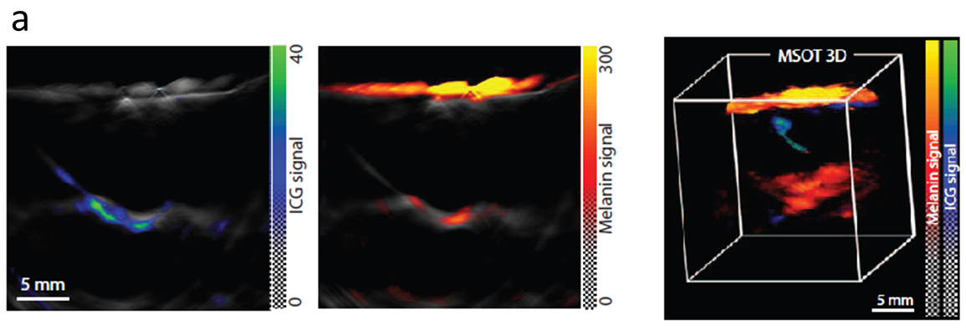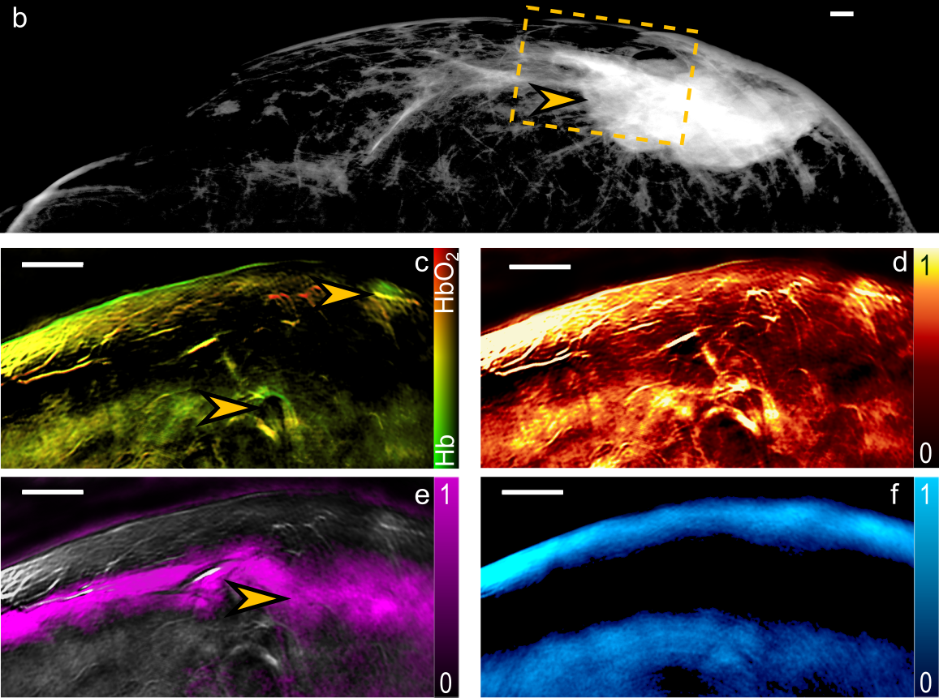

**Fig. 8** **Examples of clinical multi-spectral optoacoustic tomography (MSOT) studies in oncology. (a)** Metastatic status of sentinel lymph nodes in melanoma patients determined noninvasively with MSOT. Preoperative non-invasive assessment of ICG (green scale) and melanin (orange) distribution in suspected metastatic sentinel lymph nodes using handheld cross-sectional and volumetric MSOT scanners. Penetration of up to 5cm was claimed with 100% sensitivity and 48 to 62% lesion detection specificity. Adapted with permission from 131.

**(b)** X-Ray mammography image revealing a >4 cm, subcutaneous, nonspecific breast tumor. **(c)** MSOT image of Hb and HbO2 obtained from the field of view labelled in panel (b); arrows point to areas of increased blood volume. **(d)** MSOT image of TBV showing constitutive hyperemia through an extended area of the tumor. **(e)** MSOT image of lipid showing disruption of the fat layer (arrow) at the area of the tumor mass. **(f)** MSOT image of water. Adapted with permission from 132.

One potential valuable application of MSOT is the diagnosis of breast lesions. It is a favoured application due to the generally low light attenuation in the breast as compared with other tissues 115, which allows penetrating the entire human breast 133. Indeed, breast cancer diagnosis was aimed with the very first implementations of optoacoustic tomography scanners 134,135, which was recently followed by several designs optimized for deeper imaging and better detection sensitivity 136. Several clinical breast imaging studies are ongoing and the method has shown potential for non-invasive detection of malignant lesions. In a clinical study on infiltrating ductal carcinoma, distinct optoacoustic patterns could be classified as mass-like, non-mass like and ring-shaped 137. In another pilot clinical study, real-time handheld MSOT scanner was used to identify high-resolution patterns of lesions in 10 patients ages 48–81 years with malignant nonspecific breast cancer or invasive lobular carcinoma 132 (Fig. 8a-e). MSOT data acquisitions were guided by ultrasonography and X-ray mammography or MRI. The extended spectral range in the 700-970nm window allowed the computation of oxygenated hemoglobin (HBO2), deoxygenated hemoglobin (HB), total blood volume (TBV), lipid, and water contributions, allowing first insights into in vivo high-resolution breast tissue MSOT cancer patterns. TBV and Hb/HBO2 images resolved marked differences between cancer and control tissue, manifested as a vessel-rich tumor periphery with highly heterogeneous spatial appearance compared with healthy tissue. Significant TBV variations between different tumors and between tumors over healthy tissues were reported. Water and fat lipid layers further appeared disrupted in cancer versus healthy tissue.

In the field of dermatology, new non-invasive skin imaging tools are essential to aid real-time diagnosis of skin tumours, chronic inflammation, alopecia, scarring, burns etc, thus minimizing the need for invasive skin biopsy. MSOT offers the unique capacity for high resolution 3D optical mapping of tissue by further delivering highly specific optical contrast from a depth of several millimetres to centimetres in living tissues. A recent study performed on human volunteers, has shown capacity for non-invasive structural and functional analysis of intact hair follicles and pilosebaceous units by volumetric handheld MSOT 138. On-the-fly assessment of key morphometric parameters of follicles and lipid content as well as functional oxygenation parameters of the associated capillary bed was demonstrated with high spatial resolution below 70µm. Precision assessment of label-free psoriasis biomarkers in the human skin has been demonstrated with a high resolution version of MSOT termed ultra-broadband optoacoustic mesoscopy 139. In particular, skin morphology and vascular patterns in the dermis and sub-dermis of psoriasis patients have been visualized, enabling quantification of inflammation and other biomarkers of psoriasis without the need for contrast agents. The label-free biomarkers detected by the handheld imaging scanner correlated well with the clinical score.

One major limitation for clinical translation remains the lack of clinically-approved probes for contrast-enhanced optoacoustic imaging. ICG has been approved for human use since the 1960s. However, there are currently no other approved compounds that absorb light in the near infrared, which is essential for deep tissue imaging with MSOT. In addition, successful completion of multicenter trials in a number of key clinical applications is crucial in order to facilitate the transition of MSOT from a highly potent research platform to an accepted clinical imaging modality.

**The future of fluorescence and MSOT imaging**

FMI is expected to augment interventional procedures in surgery suites for guiding procedures but could play a key role in early detection of disease in endoscopic procedures such as colonoscopy or esophageal and gastric inspection. We expect that significant attention will be given to research and translation of targeted fluorescence agents for further improving tumor visualization, margin identification or early cancer detection compared to the current state of the art fluorescence imaging agents. Agents that identify other tissue structures such as nerves can also play a major role in interventional procedures. We further anticipate the fluorescent agents will play a role in other medical fields, such as interventional cardiology, for example in identify biological parameters associated with atheroma and stent condition 140.

On the technology front, we expect that attention will shift from camera developments to advanced measurement schemes and data processing methods that account for the effects of the parameters in **Table 1.** Phantoms such as the one described in **Box 1** can play a key role in validating these methods and in quality control and standardization processes. Such quality control in necessary to develop FMI as a reliable tool for clinical propagation and for ensuring accurate studies as required for regulatory approval of clinical systems and agents.

The great potential of MSOT imaging showcased in preclinical research has encouraged the translation of this technology into the clinics with multiple applications envisioned, from intraoperative diagnostics to ophthalmology, dermatology, cardiovascular and endoscopic imaging. One of the key advantages of MSOT its intrinsic potential to deliver complete volumetric tomographic datasets from the imaged object with a single interrogating laser pulse, a possibility that does not exist in other clinical imaging modalities. This capacity enables dynamic visualization of contrast agent bio-distribution in 3D with high spatial resolution, thus reducing image blurring and motion artefacts and facilitating quantified depth-resolved observations.

Given the current progress in nanoparticle research and the versatility of MSOT contrast mechanisms, it is anticipated that future developments in light absorbing agents would bring the contrast enhancement approaches to a new level of performance. Novel smart agents that selectively change their absorption-based contrast with environmental changes or theranostic agents releasing drugs at specific targets may all lead to paradigm shifts in biomedical research. Ideally, agents need to be optimized for more efficient optoacoustic signal generation, both in terms of the overall generated signal strength and spectral response. In this regard, development of novel dyes and genetic labels with preferential absorption in the far-red or NIR ranges for deep tissue MSOT imaging represents a highly promising research direction. To this end, most novel MSOT contrast agents have only been tested at a proof-of-principle level or early stages of exploration, thus further validations for biocompatibility, toxicity and targeting efficiency are necessary to establish *in vivo* applicability.

**Acknowledgments**

The work of DR is supported by the European Research Council Grant *ERC-2015-CoG-682379*, National Institute of Health grant UF1-NS107680, Human Frontier Science Program (HFSP) Grant RGY0070/2016 and the German research Foundation Grant RA1848/5-1. The work of VN is supported by the European Union's Horizon 2020 research and innovation programme under grant agreement 687866 (INNODERM) and from the German Research Foundation (Gottfried Wilhelm Leibnitz Prize 2013; NT 3/10-1).

**Conflicts of Interest**

VN and DR have equity in iThera Medical GmBH. VN also serves as a consultant to SurgVision BV.

**References**

1 Galloro, G. High technology imaging in digestive endoscopy. *World J Gastrointest Endosc* **4**, 22-27 (2012).

2 Freschi, C. *et al.* Technical review of the da Vinci surgical telemanipulator. *Int J Med Robot* **9**, 396-406 (2013).

3 Roberts, D. W., Hartov, A., Kennedy, F. E., Miga, M. I. & Paulsen, K. D. Intraoperative brain shift and deformation: a quantitative analysis of cortical displacement in 28 cases. *Neurosurgery* **43**, 749-758 (1998).

4 Labadie, R. F., Davis, B. M. & Fitzpatrick, J. M. Image-guided surgery: What is the accuracy? *Curr Opin Otolaryngol Head Neck Surg* **13**, 27-31 (2005).

5 Moore, G., Hunter, S. & Hubbard, T. Clinical and experimental studies of fluorescein dyes with special reference to their use for the diagnosis of central nervous system tumors. *Ann Surg* **130**, 637-642 (1949).

6 Novotny, H. & Alvis, D. A method of photographing fluorescence in circulating blood of the human eye. *Tech Doc Rep SAM-TDR USAF Sch Aerosp Med* **60**, 1-4 (1960).

7 Koch, M. & Ntziachristos, V. Advancing surgical vision with fluorescence imaging. *Ann Rev Med* **67**, 153-164 (2016).

8 Zhang, R. R. *et al.* Beyond the margins: real-time detection of cancer using targeted fluorophores. *Nat Rev Clin Oncol* **14**, 347-364 (2017).

9 van Dam, G. M. *et al.* Intraoperative tumor-specific fluorescence imaging in ovarian cancer by folate receptor-a targeting: first in-human results. *Nat Med* **17**, 1315-1319 (2011).

10 Tummers, Q. R. J. G., Hoogstins, C. E. S. & Gaarenstroom, K. N. Intraoperative imaging of folate receptor alpha positive ovarian and breast cancer using the tumor specific agent EC17. *Oncotarget* **7**, 32144-32155 (2016).

11 Rosenthal, E. L. *et al.* Safety and tumor specificity of cetuximab-IRDye800 for surgical navigation in head and neck cancer. *Clin Cancer Res* **21**, 3658-3666 (2015).

12 Whitley, M. J. *et al.* A mouse-human phase 1 co-clinical trial of a protease-activated fluorescent probe for imaging cancer. *Sci Transl Med* **8**, 320ra324 (2016).

13 Hsiung, P. *et al.* Detection of colonic dysplasia in vivo using a targeted fluorescent septapeptide and confocal microendoscopy. *Nat Med* **14**, 454-458 (2008).

14 Atreya, R. *et al.* In vivo imaging using fluorescent antibodies to tumor necrosis factor predicts therapeutic response in Crohn's disease. *Nat Med* **20**, 313-318 (2014).

15 Glatz, J., Symvoulidis, P., Garcia-Allende, P. B. & Ntziachristos, V. Robust overlay schemes for the fusion of fluorescence and color channels in biological imaging. *J Biomed Opt* **19**, 040501 (2014).

16 Glatz, J. *et al.* Concurrent video-rate color and near-infrared fluorescence laparoscopy. *J Biomed Opt* **18**, 101302 (2013).

17 Hong, G. *et al.* Through-skull fluorescence imaging of the brain in a new near-infrared window. *Nat Photonics* **8**, 723-730 (2014).

18 Leevy, C. M., Smith, F., Longueville, J., Paumgartner, G. & Howard, M. M. Indocyanine green clearance as a test for hepatic function: evaluation by dichromatic ear densitometry. *J Am Med Assoc* **200**, 236-240 (1967).

19 Rowell, L. B., Marx, H. J., Bruce, R. A., Conn, R. D. & Kusumi, F. Reductions in cardiac output, central blood volume, and stroke volume with thermal stress in normal men during exercise. *J Clin Invest* **45**, 1801-1816 (1966).

20 Craandijk, A. & van Beek, C. Indocyanine green fluorescence angiography of the choroid. *Br J Ophthalmol* **60**, 377-385 (1976).

21 Sekijima, M. *et al.* An intraoperative fluorescent imaging system in organ transplantation. *Transplant Proc* **36**, 2188-2190 (2004).

22 Jonsson, K. *et al.* Tissue oxygenation, anemia, and perfusion in relation to wound healing in surgical patients. *Ann Surg* **214**, 605-613 (1991).

23 Azuma, R. *et al.* Detection of skin perforators by indocyanine green fluorescence nearly infrared angiography. *Plast Reconstr Surg* **122**, 1062-1067 (2008).

24 Liu, D. Z., Mathes, D. W., Zenn, M. R. & Neligan, P. C. The application of indocyanine green fluorescence angiography in plastic surgery. *J Reconstr Microsurg* **27**, 355-364 (2011).

25 Holm, C. *et al.* Intraoperative evaluation of skin-flap viability using laser-induced fluorescence of indocyanine green. *Br J Plast Surg* **55**, 635-644 (2002).

26 Detter, C. *et al.* Near-infrared fluorescence coronary angiography: a new noninvasive technology for intraoperative graft patency control. *Heart Surg Forum* **5**, 364-369 (2002).

27 Ferroli, P., Nakaji, P., Acerbi, F., Albanese, E. & Broggi, G. Indocyanine green (ICG) temporary clipping test to assess collateral circulation before venous sacrifice. *World Neurosurg* **75**, 122-125 (2011).

28 Sherwinter, D. A. Transanal near-infrared imaging of colorectal anastomotic perfusion. *Surg Laparosc Endosc Percutan Tech* **22**, 433-436 (2012).

29 Yamaguchi, S. *et al.* The "perfusion map" of the unipedicled TRAM flap to reduce postoperative partial necrosis. *Ann Plast Surg* **53**, 205-209 (2004).

30 Lyman, G. H. *et al.* Sentinel lymph node biopsy for patients with early-stage breast cancer: American Society of Clinical Oncology clinical practice guideline update. *J Clin Oncol* **32**, 1365-1383 (2014).

31 Yared, M. A. *et al.* Recommendations for sentinel lymph node processing in breast cancer. *Am J Surg Pathol* **26**, 377-382 (2002).

32 Cox, C. E. *et al.* Guidelines for sentinel node biopsy and lymphatic mapping of patients with breast cancer. *Ann Surg* **227**, 645-651 (1998).

33 Mieog, J. S. *et al.* Toward optimization of imaging system and lymphatic tracer for near-infrared fluorescent sentinel lymph node mapping in breast cancer. *Ann Surg Oncol* **18**, 2483-2491 (2011).

34 Wishart, G., Loh, S.-W., Jones, L. & Benson, J. A feasibility study (ICG-10) of indocyanine green (ICG) fluorescence mapping for sentinel lymph node detection in early breast cancer. *Eur J Surg Oncol* **38**, 651-656 (2012).

35 Verbeek, F. P. *et al.* Near-infrared fluorescence sentinel lymph node mapping in breast cancer: a multicenter experience. *Breast Cancer Res Treat* **143**, 333 (2014).

36 Fujiwara, M., Mizukami, T., Suzuki, A. & Fukamizu, H. Sentinel lymph node detection in skin cancer patients using real-time fluorescence navigation with indocyanine green: preliminary experience. *J Plastic Reconstr Aesthetic Surg* **62**, e373-e378 (2009).

37 van den Berg, N. S. *et al.* Concomitant radio- and fluorescence-guided sentinel lymph node biopsy in squamous cell carcinoma of the oral cavity using ICG-(99m)Tc-nanocolloid. *Eur J Nucl Med Mol Imaging* **39**, 1128-1136 (2012).

38 Crane, L. M. *et al.* Intraoperative near-infrared fluorescence imaging for sentinel lymph node detection in vulvar cancer: first clinical results. *Gynecol Oncol* **120**, 291-295 (2011).

39 Crane, L. M. *et al.* Intraoperative multispectral fluorescence imaging for the detection of the sentinel lymph node in cervical cancer: a novel concept. *Mol Imaging Biol* **13**, 1043-1049 (2011).

40 Misiek, M., Rzepka, J. K., Zalewski, K., Kopczyński, J. & Gozdz, S. Fluorescence-guided lymph node mapping with indocyanine green for endometrial cancer: a feasiblity study. *Clin J Oncol (Meet. Abstr.)* **32**, e16549 (2014).

41 Yamashita, S. *et al.* Sentinel node navigation surgery by thoracoscopic fluorescence imaging system and molecular examination in non-small cell lung cancer *Ann Surg Oncol* **19**, 728-733 (2012).

42 Rasmussen, J. C., Tan, I. C., Marshall, M. V., Fife, C. E. & Sevick-Muraca, E. M. Lymphatic imaging in humans with near-infrared fluorescence. *Curr Opin Biotechnol* **20**, 74-82 (2009).

43 Takami, T., Yamagata, T., Naito, K., Arima, H. & Ohata, K. Intraoperative assessment of spinal vascular flow in the surgery of spinal intramedullary tumors using indocyanine green videoangiography. *Surg Neurol Int* **4**, 135 (2013).

44 Abu-Rustum, N. R. Sentinel lymph node mapping for endometrial cancer: a modern approach to surgical staging. *J Natl Compr Cancer Netw* **12**, 288-297 (2014).

45 Buchs, N. C. *et al.* Intra-operative fluorescent cholangiography using indocyanin green during robotic single site cholecystectomy. *Int J Med Robot* **8**, 436-440 (2012).

46 Scheuer, W., van Dam, G. M., Dobosz, M., Schwaiger, M. & Ntziachristos, V. Drug-based optical agents: infiltrating clinics at lower risk. *Sci Transl Med* **4**, 134ps111 (2012).

47 Harada, K. *et al.* Detection of lymph node metastases in human colorectal cancer by using 5-aminolevulinic acid-induced protoporphyrin IX fluorescence with spectral unmixing. *Int J Mol Sci* **14**, 23140-23152 (2013).

48 Kamp, M. A. *et al.* 5-aminolevulinic acid (5-ALA)-induced fluorescence in intracerebral metastases: a retrospective study. *Acta Neurochir (Wien)* **154**, 223-228 (2012).

49 Kishi, K. *et al.* Staging laparoscopy using ALA-mediated photodynamic diagnosis improves the detection of peritoneal metastases in advanced gastric cancer. *J Surg Oncol* **106**, 294-298 (2012).

50 Stummer, W. *et al.* Fluorescence-guided resection of glioblastoma multiforme by using 5-aminolevulinic acid-induced porphyrins: a prospective study in 52 consecutive patients. *J Neurosurg* **93**, 1003-1013 (2000).

51 Stummer, W. *et al.* Fluorescence-guided surgery with 5-aminolevulinic acid for resection of malignant glioma: a randomised controlled multicentre phase III trial. *Lancet Oncol* **7**, 392-401 (2006).

52 DSouza, A., Lin, H., Henderson, E. R., Samkoe, K. S. & Pogue, B. W. Review of fluorescence guided surgery systems: identification of key performance capabilities beyond indocyanine green imaging. *J Biomed Opt* **21**, 080901 (2016).

53 Marshall, M. V. *et al.* Near-infrared fluorescence imaging in humans with indocyanine green: a review and update. *Open Surg Oncol* **2**, 12-25 (2010).

54 Hong, G. *et al.* Multifunctional in vivo vascular imaging using near-infrared II fluorescence. *Nat Med* **18**, 1841-1846 (2012).

55 Ghosh, D. *et al.* Deep, noninvasive imaging and surgical guidance of submillimeter tumors using targeted M13-stabilized single-walled carbon nanotubes. *Proc Natl Acad Sci USA* **111**, 13948-13953 (2014).

56 Carr, J. A. *et al.* Shortwave infrared fluorescence imaging with the clinically approved near-infrared dye indocyanine green. *Proc Natl Acad Sci USA* **115**, 4465-4470 (2018).

57 Koch, M., Symvoulidis, P. & Ntziachristos, V. Tackling standardization in fluorescence molecular imaging. *Nat Photonics* **12**, 505-515 (2018).

58 Medicine, U. N. L. o. *VEGF-targeted fluorescent tracer imaging in breast cancer*, <<https://clinicaltrials.gov/ct2/show/NCT01508572>> (2012).

59 Bradley, R. S. & Thorniley, M. S. A review of attenuation correction techniques for tissue fluorescence. *J R Soc Interface* **3**, 1-13 (2006).

60 Themelis, G., Yoo, J. S., Soh, K.-S., Schulz, R. & Ntziachristos, V. Real-time intraoperative fluorescence imaging system using light absorption correction. *J Biomed Opt* **14**, 064012 (2014).

61 Moriyama, E. H., Kim, A., Bogaards, A., Lilge, L. & Wilson, B. C. A ratiometric fluorescence imaging system for surgical guidance *Adv Opt Technol* **2008**, 532368 (2008).

62 Barbash, G. I. & Glied, S. A. New technology and health care costs--the case of robot-assisted surgery. *N Engl J Med* **363**, 701-704 (2010).

63 Gorpas, D., Koch, M., Anastasopoulou, M., Klemm, U. & Ntziachristos, V. Benchmarking of fluorescence cameras through the use of a composite phantom. *J Biomed Opt* **22**, 16009 (2017).

64 Niedre, M. J. *et al.* Early photon tomography allows fluorescence detection of lung carcinomas and disease progression in mice in vivo. *Proc Natl Acad Sci USA* **105**, 19126-19131 (2008).

65 Resch-Genger, U., Grabolle, M., Cavaliere-Jaricot, S., Nitschke, R. & Nann, T. Quantum dots versus organic dyes as fluorescent labels. *Nat Methods* **5**, 763-775 (2008).

66 Gao, X. *et al.* In vivo molecular and cellular imaging with quantum dots. *Curr Opin Biotechnol* **16**, 63-72 (2005).

67 Alivisatos, A. P., Gu, W. & Larabell, C. Quantum dots as cellular probes. *Annu Rev Biomed Eng* **7**, 55-76 (2005).

68 Zhu, B., Tan, I.-C., Rasmussen, J. C. & Sevick-Muraca, E. M. Validating the sensitivity and performance of near-infrared fluorescence imaging and tomography devices using a novel solid phantom and measurement approach. *Technol Cancer Res Treat* **11**, 95-104 (2012).

69 Roy, M., Kim, A., Dadani, F. & Wilson, B. C. Homogenized tissue phantoms for quantitative evaluation of subsurface fluorescence contrast. *J Biomed Opt* **16**, 016013 (2011).

70 Zhu, B., Rasmussen, J. C. & Sevick-Muraca, E. M. A matter of collection and detection for intraoperative and noninvasive near-infrared fluorescence molecular imaging: to see or not to see? *Med Phys* **41**, 022105 (2014).

71 Moffitt, T., Chen, Y.-C. & Prahl, S. A. Preparation and characterization of polyurethane optical phantoms. *J Biomed Opt* **11**, 041103 (2006).

72 Anastasopoulou, M. *et al.* Comprehensive phantom for interventional fluorescence molecular imaging. *J Biomed Opt* **21**, 091309 (2016).

73 Ntziachristos, V. *et al.* Planar fluorescence imaging using normalized data. *J Biomed Opt* **10**, 064007 (2005).

74 Valdés, P. A. *et al.* Quantitative, spectrally-resolved intraoperative fluorescence imaging. *Sci Rep* **2**, 798 (2012).

75 Zhu, B., Rasmussen, J. C. & Sevick-Muraca, E. M. Non-invasive fluorescence imaging under ambient light conditions using a modulated ICCD and laser diode. *Biomed Opt Express* **5**, 562-572 (2014).

76 Sexton, K. *et al.* Pulsed-light imaging for fluorescence guided surgery under normal room lighting. *Opt Lett* **38**, 3249-3252 (2013).

77 Zonios, G. & Dimou, A. Modeling diffuse reflectance from semi-infinite turbid media: application to the study of skin optical properties. *Opt Express* **14**, 8661-8674 (2006).

78 Garcia-Allende, P. B. *et al.* Uniqueness in multispectral constant-wave epi-illumination imaging. *Opt Lett* **41**, 3098-3101 (2016).

79 Saager, R. B., Cuccia, D. J., Saggese, S., Kelly, K. M. & Durkin, A. J. Quantitative fluorescence imaging of protoporphyrin IX through determination of tissue optical properties in the spatial frequency domain. *J Biomed Opt* **16**, 126013 (2011).

80 Yang, B. & Tunnell, J. W. Real-time absorption reduced surface fluorescence imaging. *J Biomed Opt* **19**, 090505 (2014).

81 Bogaards, A., Sterenborg, H. J. C. & Wilson, B. C. In vivo quantification of fluorescent molecular markers in real-time: a review to evaluate the performance of five existing methods. *Photodiagnosis Photodyn Ther* **4**, 170-178 (2007).

82 Haller, J. *et al.* Visualization of pulmonary inflammation using noninvasive fluorescence molecular imaging. *J Appl Physiol (1985)* **104**, 795-802 (2008).

83 Tichauer, K. M. *et al.* Microscopic lymph node tumor burden quantified by macroscopic dual-tracer molecular imaging. *Nat Med* **20**, 1348-1353 (2014).

84 Rosencwaig, A. Photoacoustic spectroscopy of biological materials. *Science* **181**, 657-658 (1973).

85 Bowen, T. Radiation-induced thermoacoustic soft-tissue imaging. *IEEE Trans Sonics Ultrasonics* **29**, 187 (1982).

86 Oraevsky, A., Steven, J., Esenaliev, R. & Tittel, F. Laser-based optoacoustic imaging in biological tissues. *Proc SPIE* **2134**, 122 (1994).

87 Razansky, D., Vinegoni, C. & Ntziachristos, V. Multispectral photoacoustic imaging of fluorochromes in small animals. *Optics Letters* **32**, 2891-2893 (2007).

88 Rosenthal, A., Razansky, D. & Ntziachristos, V. Quantitative optoacoustic signal extraction using sparse signal representation. *IEEE Tran. Med. Imag.* **28**, 1997-2006 (2009).

89 Rosenthal, A., Razansky, D. & Ntziachristos, V. Fast semi-analytical model-based acoustic inversion for quantitative optoacoustic tomography. *IEEE Trans Med Imaging* **29**, 1275 - 1285 (2010).

90 Ntziachristos, V. & Razansky, D. Molecular imaging by means of multi-spectral opto-acoustic tomography (MSOT). *ACR Chemical Review* **110**, 2783-2794 (2010).

91 Deán-Ben, X. L., Gottschalk, S., Mc Larney, B., Shoham, S. & Razansky, D. Advanced optoacoustic methods for multiscale imaging of in vivo dynamics. *Chem Soc Rev* **46**, 2158 (2017).

92 Wang, L. H. V. & Hu, S. Photoacoustic Tomography: In Vivo Imaging from Organelles to Organs. *Science* **335**, 1458-1462, doi:10.1126/science.1216210 (2012).

93 Tzoumas, S. *et al.* Eigenspectra optoacoustic tomography achieves quantitative blood oxygenation imaging deep in tissues. *Nat Commun* **7**, doi:Artn 12121

10.1038/Ncomms12121 (2016).

94 Laufer, J. *et al.* In vivo preclinical photoacoustic imaging of tumor vasculature development and therapy. *Journal of biomedical optics* **17**, doi:Artn 056016

10.1117/1.Jbo.17.5.056016 (2012).

95 Omar, M., Schwarz, M., Soliman, D., Symvoulidis, P. & Ntziachristos, V. Pushing the Optical Imaging Limits of Cancer with Multi-Frequency-Band Raster-Scan Optoacoustic Mesoscopy (RSOM). *Neoplasia* **17**, 208-214, doi:10.1016/j.neo.2014.12.010 (2015).

96 Herzog, E. *et al.* Optical Imaging of Cancer Heterogeneity with Multispectral Optoacoustic Tomography. *Radiology* **263**, 461-468, doi:10.1148/radiol.11111646 (2012).

97 Yao, J. J., Maslov, K. I. & Wang, L. H. V. In vivo Photoacoustic Tomography of Total Blood Flow and Potential Imaging of Cancer Angiogenesis and Hypermetabolism. *Technol Cancer Res T* **11**, 301-307, doi:10.7785/tcrt.2012.500278 (2012).

98 Jansen, K., van der Steen, A. F. W., van Beusekom, H. M. M., Oosterhuis, J. W. & van Soest, G. Intravascular photoacoustic imaging of human coronary atherosclerosis. *Opt Lett* **36**, 597-599, doi:Doi 10.1364/Ol.36.000597 (2011).

99 Wang, B. *et al.* Detection of lipid in atherosclerotic vessels using ultrasound-guided spectroscopic intravascular photoacoustic imaging. *Optics express* **18**, 4889-4897, doi:10.1364/Oe.18.004889 (2010).

100 Zhang, H. F., Maslov, K., Stoica, G. & Wang, L. H. V. Functional photoacoustic microscopy for high-resolution and noninvasive in vivo imaging. *Nat Biotechnol* **24**, 848-851, doi:10.1038/nbt1220 (2006).

101 Stoffels, I. *et al.* Metastatic status of sentinel lymph nodes in melanoma determined noninvasively with multispectral optoacoustic imaging. *Sci Transl Med* **7**, doi:ARTN 317ra199

10.1126/scitranslmed.aad1278 (2015).

102 Gottschalk, S., Fehm, T. F., Dean-Ben, X. L. & Razansky, D. Noninvasive real-time visualization of multiple cerebral hemodynamic parameters in whole mouse brains using five-dimensional optoacoustic tomography. *J Cerebr Blood F Met* **35**, 531-535, doi:10.1038/jcbfm.2014.249 (2015).

103 Hu, S. Listening to the Brain With Photoacoustics. *Ieee J Sel Top Quant* **22**, doi:Artn 6800610

10.1109/Jstqe.2015.2487890 (2016).

104 Nasiriavanaki, M. *et al.* High-resolution photoacoustic tomography of resting-state functional connectivity in the mouse brain. *Proceedings of the National Academy of Sciences of the United States of America* **111**, 21-26, doi:10.1073/pnas.1311868111 (2014).

105 Jacques, S. L., Glickman, R. D. & Schwartz, J. A. in *Photonics West '96* Vol. 2681 (San José, CA, USA, 1996).

106 Hale, G. M. & Querry, M. R. Optical constants of water in the 200-nm to 200-mm wavelength region. *Applied Opt* **12** (1973).

107 van Veen, R. L. P. *et al.* Determination of visible near-IR absorption coefficients of mammalian fat using time- and spatially resolved diffuse reflectance and transmission spectroscopy. *J Biomed Opt* **10**, 054004 (2005).

108 Tsai, C.-L., Chen, J.-C. & Wang, W.-J. Near-infrared absorption property of biological soft tissue constituents. *J Med Biol Eng* **21**, 7-14 (2001).

109 Smith, A. M., Mancini, M. C. & Nie, S. Second window for in vivo imaging. *Nat Nanotechnol* **4**, 710-711 (2009).

110 Dean-Ben, X. L., Razansky, D. & Ntziachristos, V. The effects of acoustic attenuation in optoacoustic signals. *Physics in medicine and biology* **56**, 6129-6148, doi:Doi 10.1088/0031-9155/56/18/021 (2011).

111 Smith, A. M., Mancini, M. C. & Nie, S. Second window for in vivo imaging. *Nature nanotechnology* **4**, 710 (2009).

112 Ku, G. & Wang, L. H. V. Deeply penetrating photoacoustic tomography in biological tissues enhanced with an optical contrast agent. *Opt Lett* **30**, 507-509, doi:Doi 10.1364/Ol.30.000507 (2005).

113 Dean-Ben, X. L., Fehm, T. F., Gostic, M. & Razansky, D. Volumetric hand-held optoacoustic angiography as a tool for real-time screening of dense breast. *Journal of biophotonics* **9**, 253-259, doi:10.1002/jbio.201500008 (2016).

114 Cox, B., Laufer, J. G., Arridge, S. R. & Beard, P. C. Quantitative spectroscopic photoacoustic imaging: a review. *Journal of biomedical optics* **17**, doi:Artn 061202

10.1117/1.Jbo.17.6.061202 (2012).

115 Jacques, S. L. Optical properties of biological tissues: a review. *Physics in medicine and biology* **58**, R37-R61, doi:10.1088/0031-9155/58/11/R37 (2013).

116 Krumholz, A., Shcherbakova, D. M., Xia, J., Wang, L. H. V. & Verkhusha, V. V. Multicontrast photoacoustic in vivo imaging using near-infrared fluorescent proteins. *Sci Rep-Uk* **4**, doi:Artn 3939

10.1038/Srep03939 (2014).

117 Stiel, A. C. *et al.* High-contrast imaging of reversibly switchable fluorescent proteins via temporally unmixed multispectral optoacoustic tomography. *Opt Lett* **40**, 367-370, doi:10.1364/Ol.40.000367 (2015).

118 Tzoumas, S., Deliolanis, N. C., Morscher, S. & Ntziachristos, V. Unmixing Molecular Agents From Absorbing Tissue in Multispectral Optoacoustic Tomography. *IEEE transactions on medical imaging* **33**, 48-60, doi:10.1109/Tmi.2013.2279994 (2014).

119 Ng, K. K. *et al.* Stimuli-Responsive Photoacoustic Nanoswitch for in Vivo Sensing Applications. *Acs Nano* **8**, 8363-8373, doi:10.1021/nn502858b (2014).

120 Ng, K. K. *et al.* Stimuli-responsive photoacoustic nanoswitch for in vivo sensing applications. *ACS Nano* **8**, 8363-8373 (2014).

121 Gurka, M. K. *et al.* Identification of pancreatic tumors in vivo with ligand-targeted, pH responsive mesoporous silica nanoparticles by multispectral optoacoustic tomography. *J Control Release* **231**, 60-67 (2016).

122 Pu, K. *et al.* Semiconducting polymer nanoparticles as photoacoustic molecular imaging probes in living mice. *Nat Nanotechnol* **9**, 233-239 (2014).

123 Gurka, M. K. *et al.* Identification of pancreatic tumors in vivo with ligand-targeted, pH responsive mesoporous silica nanoparticles by multispectral optoacoustic tomography. *J Control Release* **231**, 60-67 (2016).

124 Pu, K. *et al.* Semiconducting polymer nanoparticles as photoacoustic molecular imaging probes in living mice. *Nature nanotechnology* **9**, 233-239 (2014).

125 Levi, J. *et al.* Molecular Photoacoustic Imaging of Follicular Thyroid Carcinoma. *Clin Cancer Res* **19**, 1494-1502, doi:10.1158/1078-0432.CCR-12-3061 (2013).

126 Dima, A. & Ntziachristos, V. Non-invasive carotid imaging using optoacoustic tomography. *Optics express* **20**, 25044-25057, doi:10.1364/Oe.20.025044 (2012).

127 Buehler, A., Dean-Ben, X. L., Claussen, J., Ntziachristos, V. & Razansky, D. Three-dimensional optoacoustic tomography at video rate. *Optics express* **20**, 22712-22719, doi:10.1364/Oe.20.022712 (2012).

128 Deán-Ben, X. L. & Razansky, D. Functional optoacoustic human angiography with handheld video rate three dimensional scanner. *Photoacoustics* **1**, 68-73 (2013).

129 Fehm, T. F., Dean-Ben, X. L. & Razansky, D. Four dimensional hybrid ultrasound and optoacoustic imaging via passive element optical excitation in a hand-held probe. *Appl Phys Lett* **105**, doi:Artn 173505

10.1063/1.4900520 (2014).

130 Taruttis, A. *et al.* Optoacoustic Imaging of Human Vasculature: Feasibility by Using a Handheld Probe. *Radiology* **281**, 256-263 (2016).

131 Stoffels, I. *et al.* Metastatic status of sentinel lymph nodes in melanoma determined noninvasively with multispectral optoacoustic imaging. *Sci Transl Med* **7**, 317ra199 (2015).

132 Diot, G. *et al.* Multispectral optoacoustic tomography (MSOT) of human breast cancer. *Clin Cancer Res* **23**, 6912-6922 (2017).

133 Kruger, R. A., Lam, R. B., Reinecke, D. R., Del Rio, S. P. & Doyle, R. P. Photoacoustic angiography of the breast. *Medical physics* **37**, 6096-6100, doi:10.1118/1.3497677 (2010).

134 Manohar, S., Kharine, A., van Hespen, J. C. G., Steenbergen, W. & van Leeuwen, T. G. Photoacoustic mammography laboratory prototype: imaging of breast tissue phantoms. *Journal of biomedical optics* **9**, 1172-1181, doi:10.1117/1.1803548 (2004).

135 Ermilov, S. A. *et al.* Laser optoacoustic imaging system for detection of breast cancer. *Journal of biomedical optics* **14**, doi:Artn 024007

10.1117/1.3086616 (2009).

136 Valluru, K. S., Wilson, K. E. & Willmann, J. K. Photoacoustic Imaging in Oncology: Translational Preclinical and Early Clinical Experience. *Radiology* **280**, 332-349 (2016).

137 Heijblom, M. *et al.* Photoacoustic image patterns of breast carcinoma and comparisons with Magnetic Resonance Imaging and vascular stained histopathology. *Sci Rep-Uk* **5** (2015).

138 Ford, S. J. *et al.* Structural and Functional Analysis of Intact Hair Follicles and Pilosebaceous Units by Volumetric Multispectral Optoacoustic Tomography. *J Invest Dermatol* **136**, 753-761 (2016).

139 Aguirre, J. *et al.* Precision assessment of label-free psoriasis biomarkers with ultra-broadband optoacoustic mesoscopy. *Nat Biomed Eng* **1**, 0068 (2017).

140 Jaffer, F. A. *et al.* Two-dimensional intravascular near-infrared fluorescence molecular imaging of inflammation in atherosclerosis and stent-induced vascular injury. *J Am Coll Cardiol* **57**, 2516-2526 (2011).