**Changes of soil-rhizosphere microbiota after organic amendment application in a *Hordeum vulgare* L. short-term greenhouse experiment**

Michael M. Obermeier1,†, Eva-Maria L. Minarsch1,2,†, Abilash C. Durai Raj1, Francois Rineau3 and Peter Schröder1,*

1. Helmholtz Zentrum München, German Research Center for Environmental Health, GmbH, Research Unit for Comparative Microbiome Analysis, Ingolstädter Landstraße 1, D-85764 Neuherberg, Germany
2. Justus-Liebig-University Gießen, Chair of Organic Farming, Karl-Glöckner-Straße 21 C, 35394 Gießen, Germany
3. Hasselt University, Centre for Environmental Sciences, Agoralaan Gebouw D, B-3590 Diepenbeek, Belgium

**\*Correspondence:** peter.schroeder@helmholtz-muenchen.de

**†** These authors contributed equally to this work

# Supplementary Figures and Tables

**Figure S1** Management and sampling scheme of the short-term greenhouse experiment in weeks (W1 – W8). Black arrows indicate seeding of 4 seeds (S4), picking of 2 seedlings (P2) and application of mineral fertilizer (MF). Red arrows mark time points for soil sampling including initial and final (together with plant harvesting) and non destructive samplings for extracellular enzyme activity analysis (d0, d14, d28 and d42). Green arrows mark time points for chlorophyll measurements.

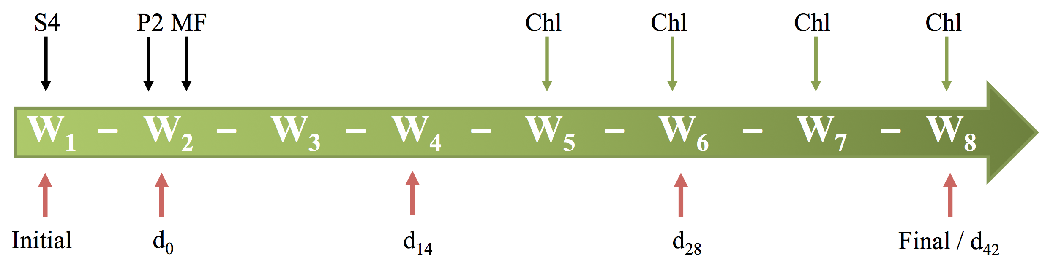

**Figure S2** Correlation analysis of dry total plant biomass (TPB in g *dw*) with **(A)** leaf area index (LAI in % of green pixel), **(B)** nitrate-N (in µg g-1 *dw*) and **(C)** amount of biochar applied to the soil (in g kg-1) as well as the correlation of **(D)** nitrate-N to biochar (*n*=56). The 95% confidence interval, correlation coefficient (r) and its p-value are given.

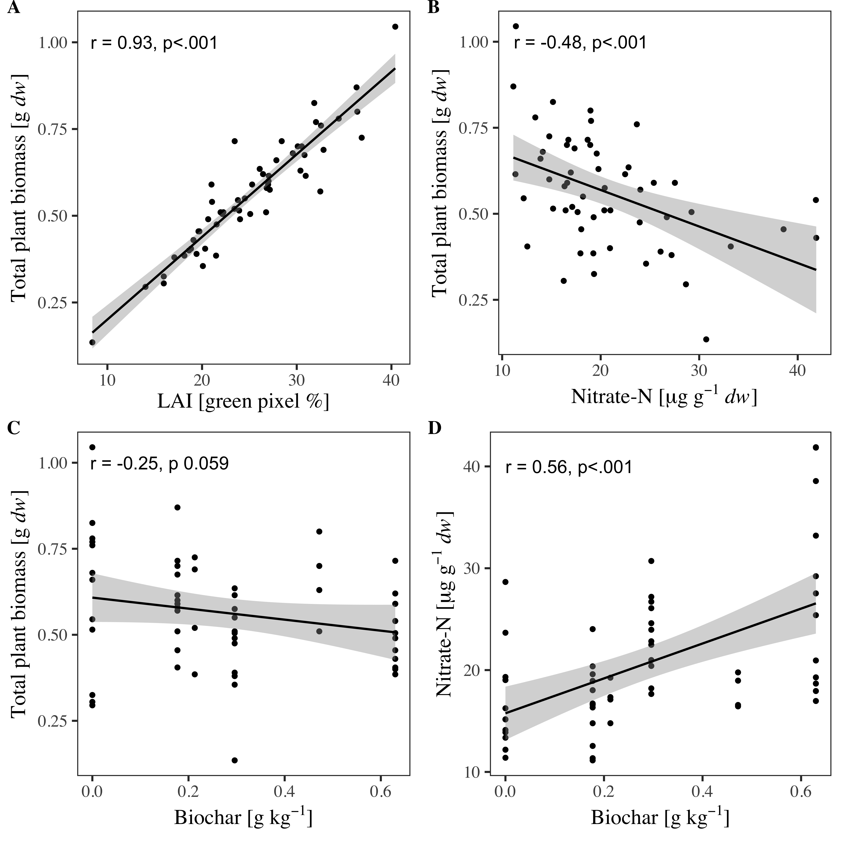

**Figure S3** Ratio between treatments and mean of the initial soil fortotal dissolved nitrogen **(**TDN) with *n* = 4. Black dashed line indicates no difference to the initial soil. Different letters (a, b, c, d, and e) indicate signiﬁcant differences (p < 0.05) calculated with multivariate ANOVA (Tukey's post-hoc test).

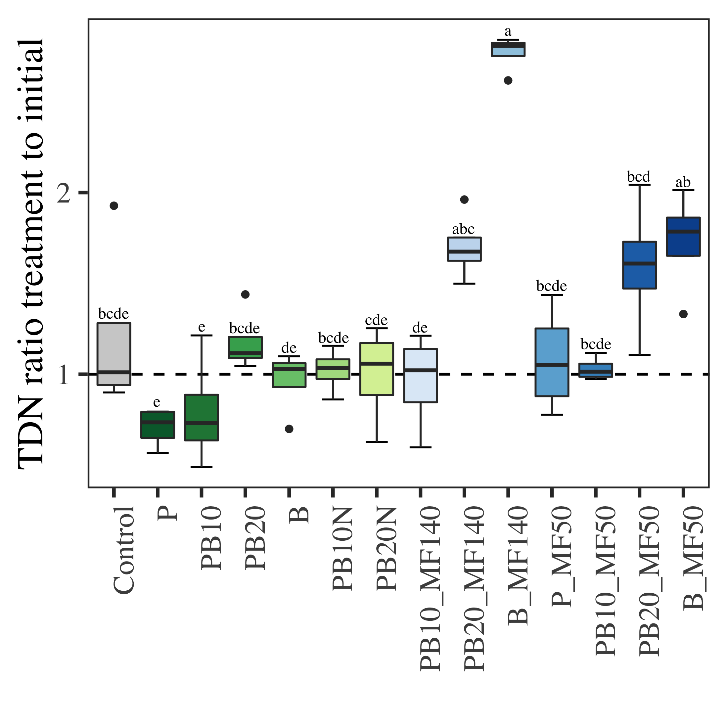

**Figure S4** Potential soil enzyme activities. **(A)** Overall potential microbial activity in mg fluorescein kg-1 *dw* h-1 measured by a fluorescein diacetate (FDA) hydrolysis assay according to Green *et al.* 2006. Measurements were conducted in triplicates in 96-well plates at a wavelength of 490 nm using a FLUOstar® Omega Plate Reader (BMG Labtech, Ortenberg, Germany). Potential activity was determined using a standard curve measured at 490 nm with 2, 5, 8, 11 and 15 µg mL-1 fluorescein. **(B)** Average well color development (AWCD) of carbon source metabolization using BIOLOG EcoPlatesTM (Biolog Inc., Hayward, United States). A 1:10 (w/v) soil suspension was performed with 10 mM PBS buffer (130 mM NaCl, 7 mM Na2HPO4, 3 mM NaH2PO4, pH 7.4), mixed for 20 min at room temperature and incubated for 30 min at 4 °C. The 1:20 diluted suspension was incubated at 28-30 °C for six days. Absorbance was measured at 595 nm after 0, 3, 6, 21, 24, 48, 72 and 144 h using a FLUOstar® Omega Plate Reader. Calculations were done according to Li *et al.* (2018) and Guckert *et al.* (1996). Different letters (a, and b) indicate signiﬁcant differences (p < 0.05) calculated with multivariate ANOVA (Tukey's post-hoc test).

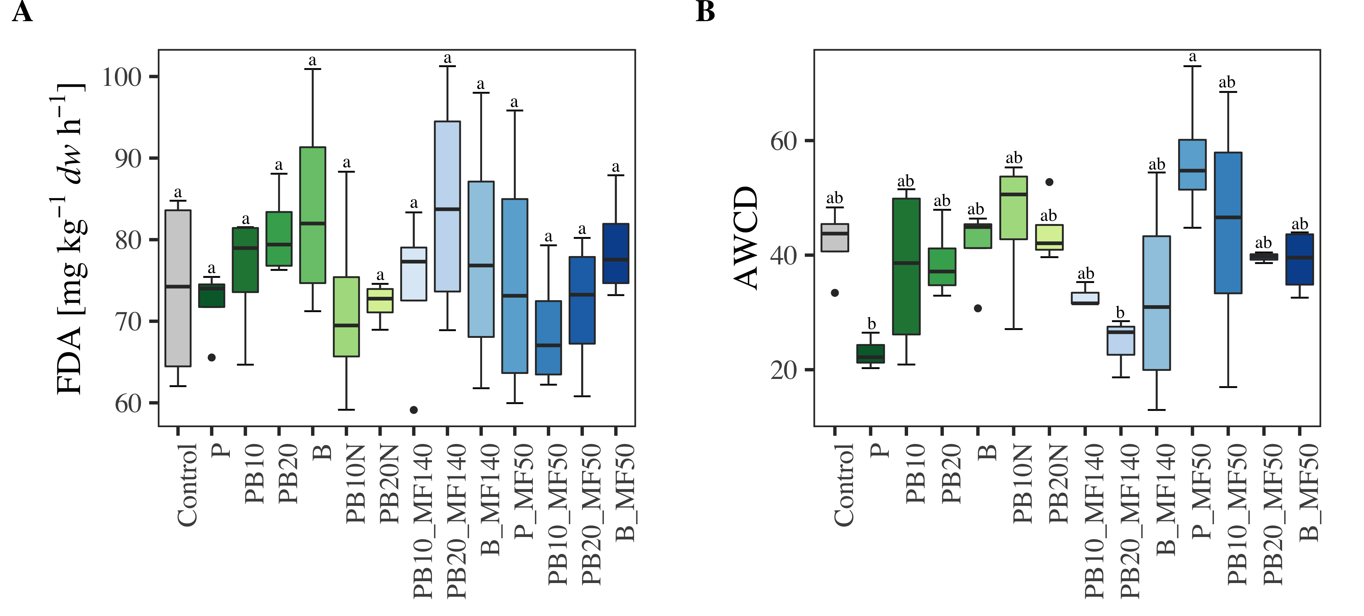

**Figure S5** Rarefaction curves before subsampling to 45,750 sequencing reads per sample (see red dashed line).

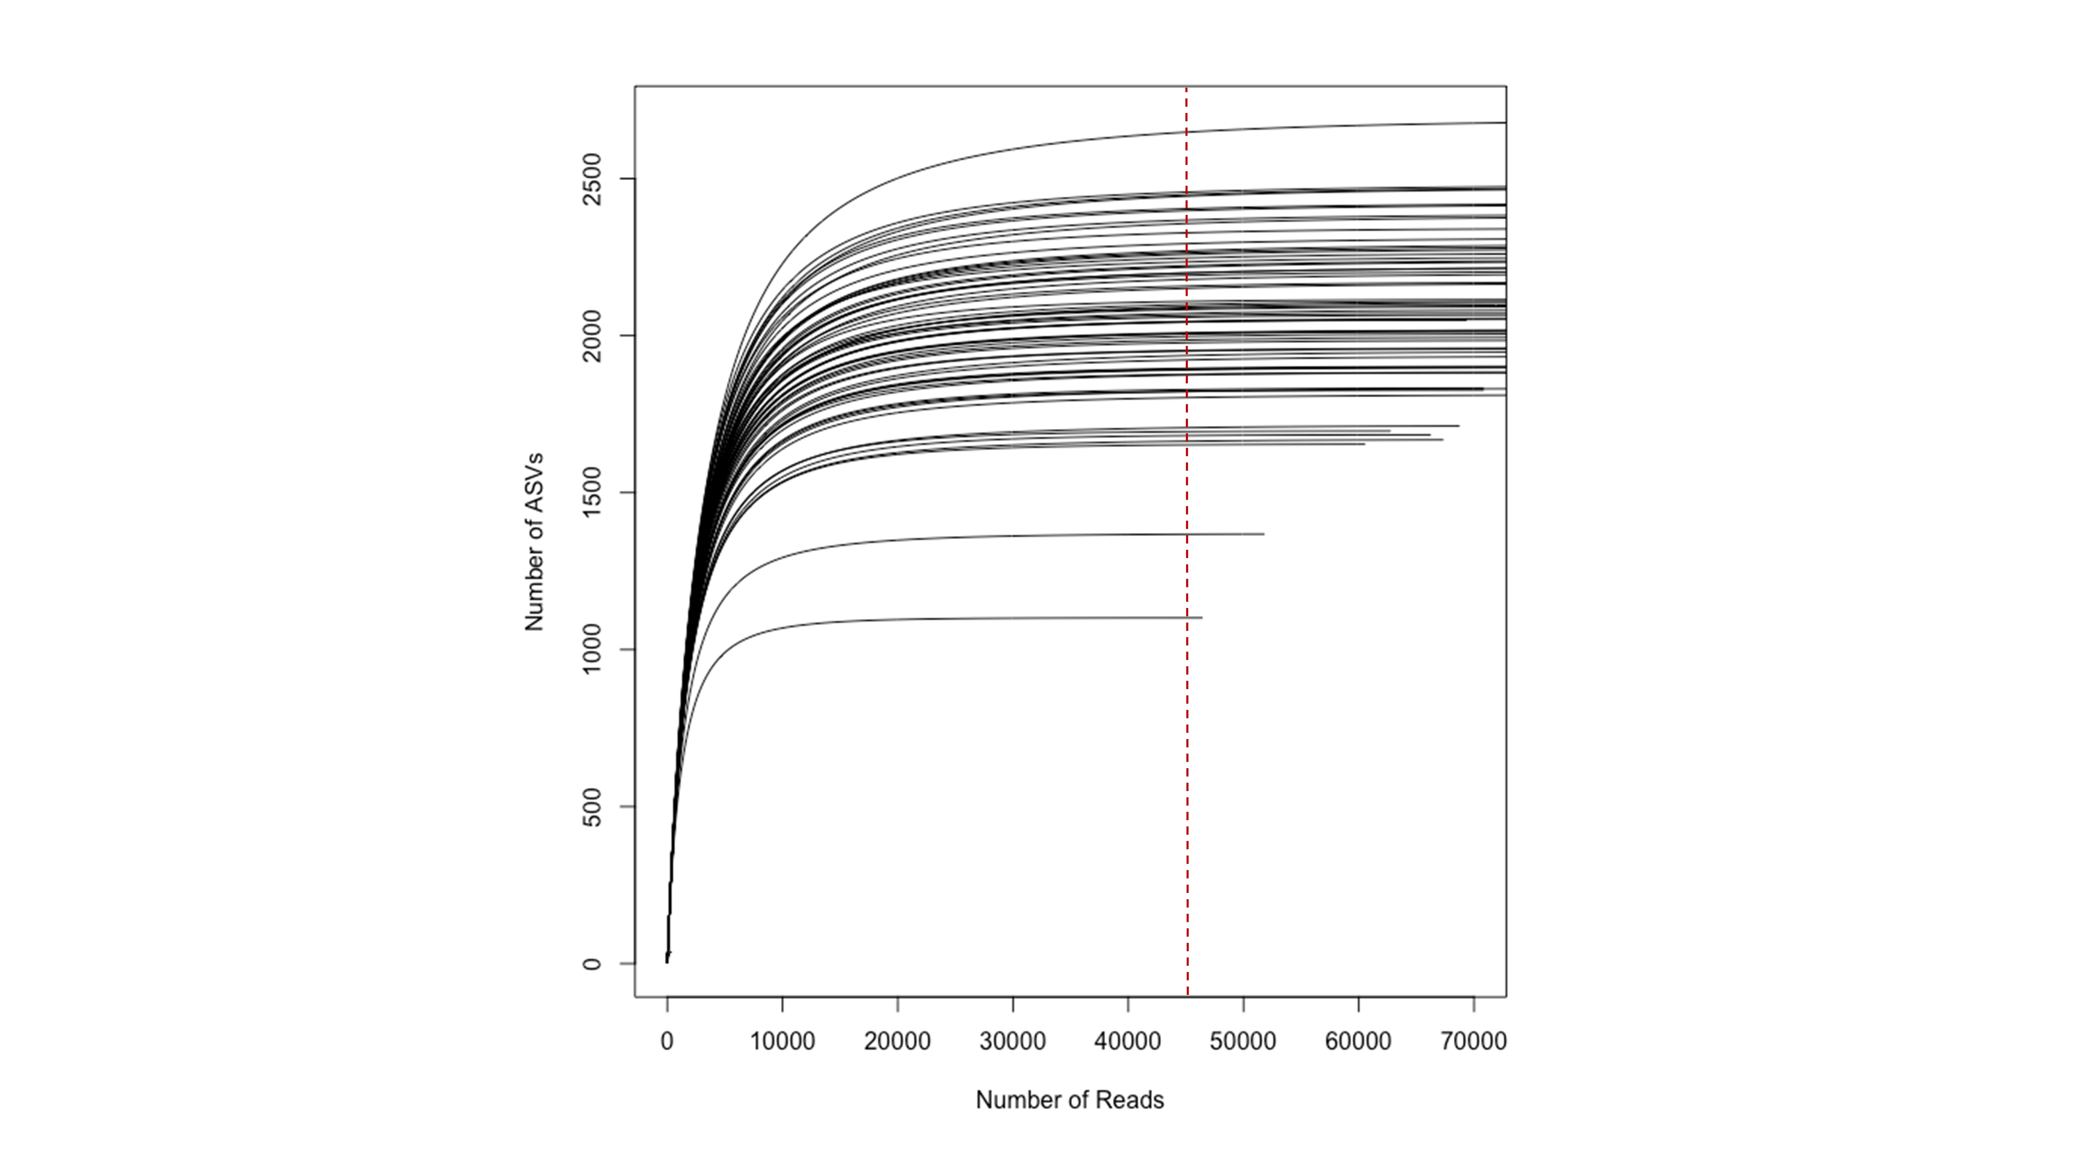

**Figure S6** Bacterial alpha diversity **(A)** Shannon diversity index and **(B)** observed ASVs for the 13 different fertilizer combinations, control and the initial soil (*n* = 4). No significant differences (p < 0.05) calculated with multivariate ANOVA (Tukey's post-hoc test) have been observed.

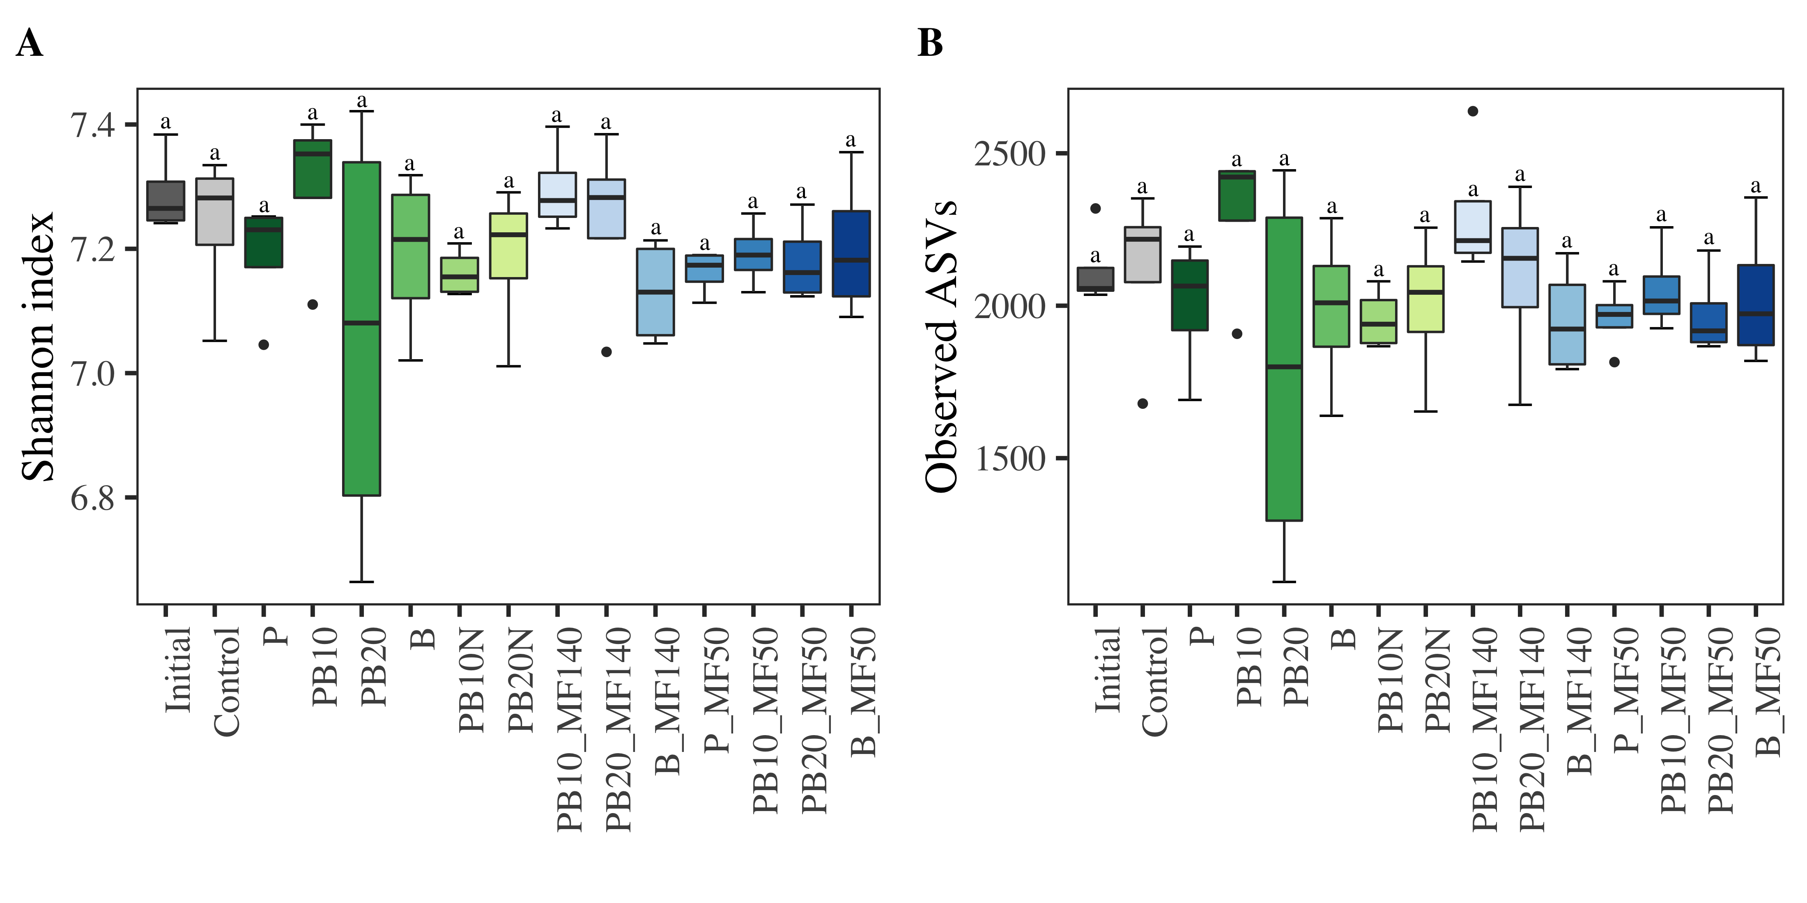

**Figure S7** Mean relative abundances with standard deviations for the 6 most abundant classes observed for the 15 variants in percent (*n* = 4). Different letters (a and b) indicate signiﬁcant differences (p < 0.05) calculated with multivariate ANOVA (Tukey's post-hoc test).

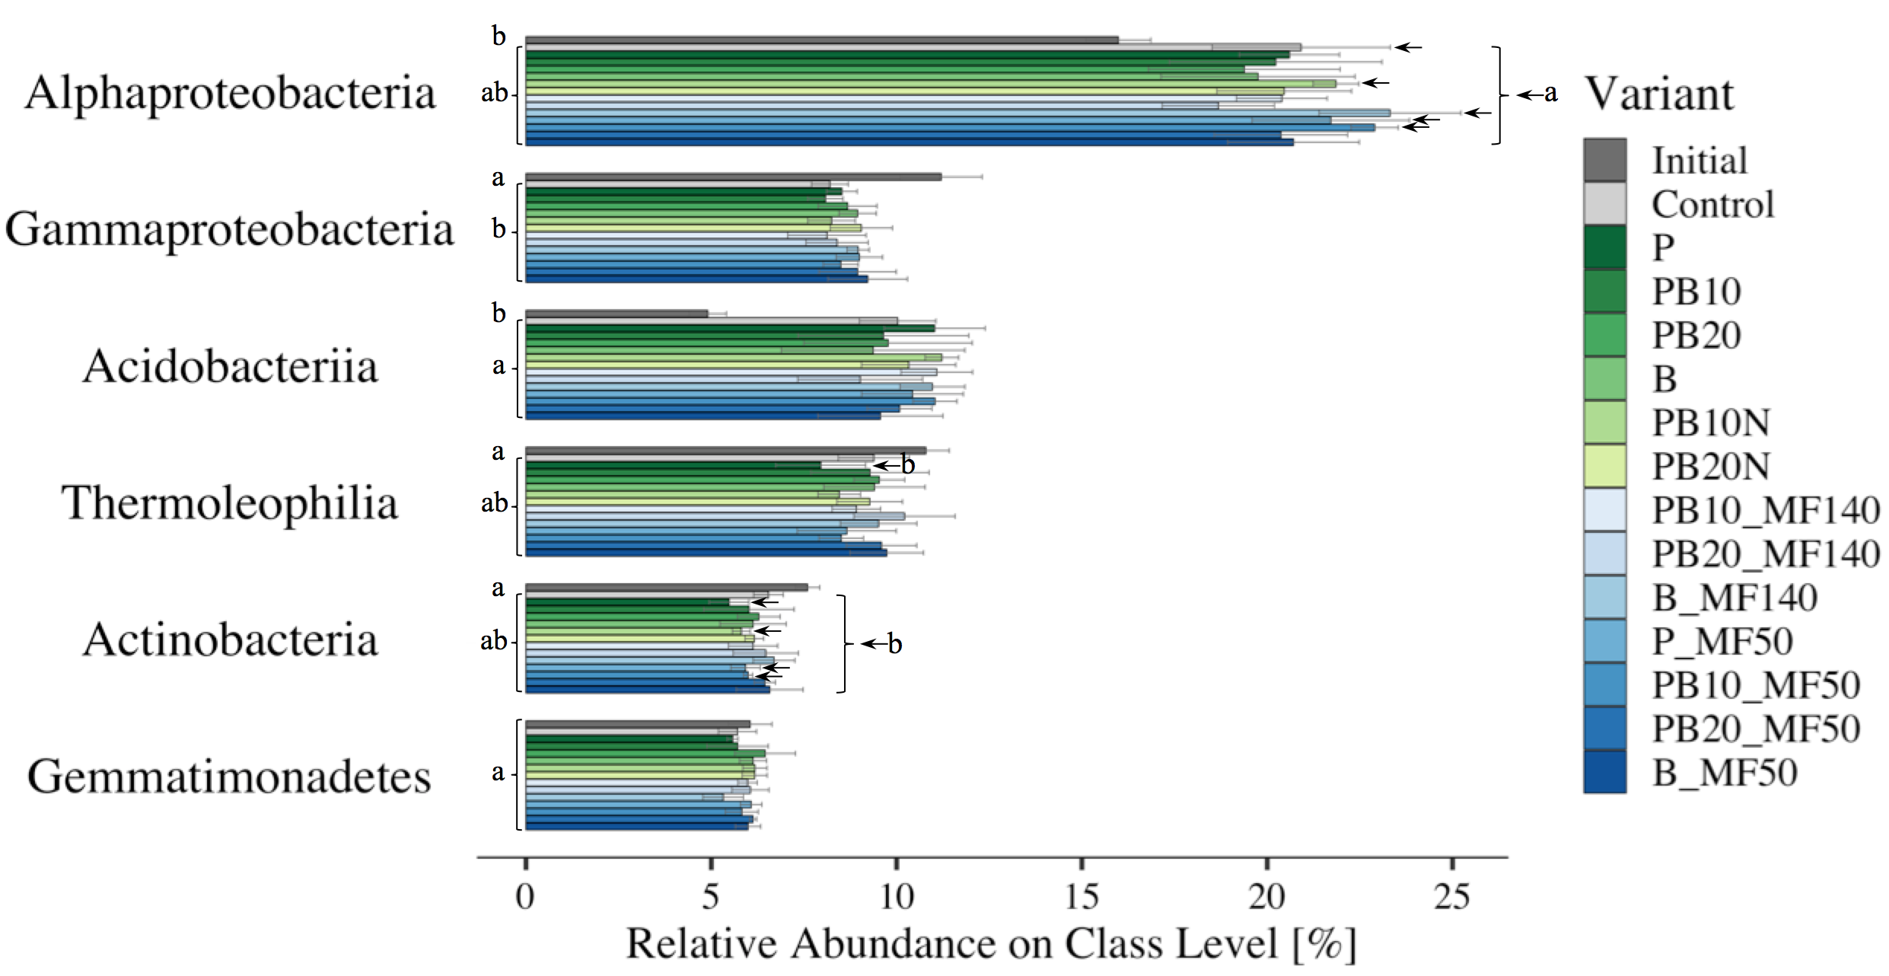

**Table S1** Fertilization scheme of the short-term greenhouse experiment. Thirteen different fertilizer compositions of organic amendments (OA) only and in combination with mineral fertilizer (OA+MF). Organic amendments comprise biochar (B) and pellets (P) from 50% spent mushroom substrate, 30% bio-rest from biogas production and 20% straw and in part blended with biochar 10% (PB10) and 20% (PB20). Amount of used OA and MF in g kg-1 as well as total nitrogen (Ntot) and total carbon (Ctot) content in kg ha-1 for 1.5 t m-3 bulk density and 30 cm soil depth.

|  |  |  |  |  |  |  |  |
| --- | --- | --- | --- | --- | --- | --- | --- |
| **Treatment** | | **OA [g kg-1]** | **MF [g kg-1]** | **Ntot** | **[kg ha-1]** | **Ctot** | **[kg ha-1]** |
| OA | P | 2.10 | - | 140 | | 2013 | |
| PB10 | 1.77 | - | 116 | | 2013 | |
| PB20 | 1.48 | - | 88 | | 2013 | |
| B | 0.63 | - | 6 | | 2013 | |
| PB10N | 2.13 | - | 140 | | 2424 | |
| PB20N | 2.36 | - | 140 | | 3204 | |
| OA + MF | PB10_MF140 | 1.77 | 0.02 | 140 | | 2013 | |
| PB20_MF140 | 1.48 | 0.04 | 140 | | 2013 | |
| B_MF140 | 0.63 | 0.11 | 140 | | 2013 | |
| P_MF50 | 2.10 | 0.04 | 190 | | 2013 | |
| PB10_MF50 | 1.77 | 0.04 | 166 | | 2013 | |
| PB20_MF50 | 1.48 | 0.04 | 138 | | 2013 | |
| B_MF50 | 0.63 | 0.04 | 56 | | 2013 | |

**Table S2** Determination of key quality parameters of soil and plant material. Given are min, max, mean and SD for soil measurements in μg g-1 *dw* and plant measurements with total plant biomass (TPB), shoot and root in g *dw*, shoot and root carbon and nitrogen in μg g-1 *dw*, LAI in green pixel % and chlorophyll (Chl) in μg cm-2 leaf area for sampling week 5, 6, 7 and 8. Mean values refer to average values with *n* = 60 and *n* = 56 for soil and plant measurements, respectively. Results of one-way ANOVA with degrees of freedom [*df*], F-statistic [*F*] and its p-value [*p*] using variant and treatment as factor for soil and plant measurements, respectively.

|  |  |  |  |  |  |  |  |
| --- | --- | --- | --- | --- | --- | --- | --- |
| **Measurement** | **Min** | **Max** | **Mean** | **SD** | ***df*** | ***F*** | ***p*** |
| pHCaCl2 | 4.86 | 5.45 | 5.13 | 0.13 | 14 | 2.03 | 0.037 |
| Nitrate-N | 11.13 | 41.88 | 21.39 | 7.29 | 14 | 12.71 | <0.001 |
| Ammonium-N | 0.06 | 0.35 | 0.16 | 0.06 | 14 | 1.45 | 0.173 |
| TDN | 17.98 | 104.39 | 45.89 | 20.10 | 14 | 10.03 | <0.001 |
| DOC | 4.35 | 54.13 | 24.93 | 8.65 | 14 | 0.83 | 0.638 |
| DON | 21.86 | 92.86 | 42.58 | 14.95 | 14 | 2.34 | 0.003 |
| DOC:DON | 0.17 | 1.33 | 0.62 | 0.25 | 14 | 0.77 | 0.693 |
| MBC | 405.67 | 809.72 | 587.57 | 85.59 | 14 | 1.14 | 0.355 |
| MBN | 17.83 | 155.36 | 62.09 | 20.54 | 14 | 0.91 | 0.554 |
| MBC:MBN | 3.37 | 28.06 | 10.30 | 3.41 | 14 | 0.73 | 0.747 |
| TPB | 0.14 | 1.04 | 0.56 | 0.16 | 13 | 3.60 | <0.001 |
| Shoot | 0.12 | 0.92 | 0.51 | 0.15 | 13 | 3.80 | <0.001 |
| Root | 0.01 | 0.13 | 0.05 | 0.02 | 13 | 1.43 | 0.135 |
| CShoot | 43.57 | 72.45 | 57.08 | 4.65 | 13 | 1.05 | 0.401 |
| NShoot | 7.63 | 11.88 | 9.55 | 0.65 | 13 | 0.65 | 0.810 |
| C:NShoot | 5.55 | 6.43 | 5.97 | 0.19 | 13 | 1.50 | 0.108 |
| CRoot | 65.24 | 142.31 | 90.90 | 16.12 | 13 | 1.13 | 0.324 |
| NRoot | 2.81 | 6.66 | 4.18 | 0.76 | 13 | 1.39 | 0.204 |
| C:NRoot | 19.92 | 24.03 | 21.79 | 0.76 | 13 | 1.52 | 0.150 |
| LAI | 8.41 | 40.41 | 25.18 | 6.33 | 13 | 3.28 | 0.002 |
| ChlW5 | 22.25 | 32.56 | 27.98 | 1.76 | 13 | 1.69 | 0.099 |
| ChlW6 | 24.41 | 36.25 | 31.78 | 2.17 | 13 | 1.65 | 0.109 |
| ChlW7 | 25.20 | 36.33 | 30.97 | 2.13 | 13 | 1.15 | 0.346 |
| ChlW8 | 26.06 | 34.95 | 30.06 | 2.26 | 13 | 1.21 | 0.310 |

**Table S3** Measurements of soil enzyme activity. Given are min, max, mean and SD for FDA in mg fluorescein kg-1 h-1, AWCD with Shannon and Evenness as well as β-glucosidase (MUG), β-N-acetylhexosaminidase (MUN) and acid phosphatase (MUP) in pmol MU g-1 h-1 for the different sampling times in days (d0, d14, d28, d42). Mean values refer to average values with *n* = 56. Results of one-way ANOVA with degrees of freedom [*df*], F-statistic [*F*] and its p-value [*p*] using treatment as factor.

|  |  |  |  |  |  |  |  |
| --- | --- | --- | --- | --- | --- | --- | --- |
| **Measurement** | **Min** | **Max** | **Mean** | **SD** | ***df*** | ***F*** | ***p*** |
| FDA | 59.12 | 101.27 | 75.94 | 10.38 | 13 | 0.79 | 0.669 |
| AWCD | 12.97 | 72.99 | 39.46 | 12.48 | 13 | 2.16 | 0.032 |
| ShannonAWCD | 2.13 | 3.00 | 2.64 | 0.19 | 13 | 1.15 | 0.349 |
| EvennessAWCD | 0.62 | 0.87 | 0.77 | 0.05 | 13 | 1.15 | 0.349 |
| MUGd0 | 55.69 | 144.98 | 103.14 | 19.08 | 13 | 0.84 | 0.618 |
| MUGd14 | 62.93 | 252.65 | 126.94 | 41.51 | 13 | 0.92 | 0.546 |
| MUGd28 | 49.87 | 224.90 | 103.58 | 35.58 | 13 | 1.31 | 0.197 |
| MUGd42 | 43.02 | 161.71 | 88.29 | 31.10 | 13 | 0.62 | 0.824 |
| MUNd0 | 0.53 | 8.59 | 4.00 | 1.36 | 13 | 1.24 | 0.245 |
| MUNd14 | 1.13 | 16.77 | 5.26 | 2.42 | 13 | 1.01 | 0.441 |
| MUNd28 | 1.24 | 8.57 | 3.59 | 1.53 | 13 | 1.28 | 0.214 |
| MUNd42 | 1.07 | 7.51 | 3.49 | 1.57 | 13 | 0.72 | 0.743 |
| MUPd0 | 18.39 | 87.13 | 57.80 | 14.75 | 13 | 1.11 | 0.381 |
| MUPd14 | 33.51 | 123.06 | 74.71 | 24.31 | 13 | 3.69 | 0.002 |
| MUPd28 | 21.70 | 149.62 | 60.70 | 25.97 | 13 | 1.12 | 0.338 |
| MUPd42 | 12.59 | 90.48 | 40.84 | 17.38 | 13 | 0.93 | 0.516 |

|  |  |  |  |  |  |  |  |  |  |  |  |  |  |  |
| --- | --- | --- | --- | --- | --- | --- | --- | --- | --- | --- | --- | --- | --- | --- |
|  | ***Xanthobacteraceae*** | ***Gemmatimonadaceae*** | ***Nitrosomonadaceae*** | | ***Solirubrobacterales***  ***(67-14)*** | ***Gaiellaceae*** | ***Mycobacteriaceae*** | ***Chitinophagaceae*** | ***Haliangiaceae*** | ***Nitrospiraceae*** | ***Pyrinomonadaceae*** | ***Xanthomonadaceae*** | ***Burkholderiaceae*** | |
| **Initial** | 8.1 ± 0.4 c | 6 ± 0.6 a | | 3.1 ± 0.2 a | 2.8 ± 0.1 a | 2.4 ± 0.2 a | 1.4 ± 0.1 c | 2.6 ± 0.3 a | 1.3 ± 0.1 bc | 2 ± 0.3 a | 0.8 ± 0.1 b | 1.8 ± 0.5 a | | 2.3 ± 0.3 a |
| **Control** | 11 ± 1.2 ab | 5.7 ± 0.5 a | | 2.4 ± 0.3 ab | 2.4 ± 0.2 ab | 2.2 ± 0.2 a | 2.2 ± 0.3 ab | 1.9 ± 0.1 b | 1.6 ± 0.2 ab | 1.4 ± 0.3 ab | 1.4 ± 0.1 ab | 0.8 ± 0.1 c | | 1 ± 0.2 b |
| **P** | 10.7 ± 0.8 abc | 5.6 ± 0.1 a | | 2.2 ± 0.3 ab | 2 ± 0.4 b | 2.1 ± 0.2 a | 2.1 ± 0.1 ab | 1.8 ± 0.2 b | 1.7 ± 0.1 ab | 1.6 ± 0.2 ab | 1.8 ± 0.2 a | 1 ± 0.2 bc | | 0.9 ± 0.1 b |
| **PB10** | 10.7 ± 1.8 abc | 5.7 ± 0.8 a | | 2.2 ± 0.6 ab | 2.4 ± 0.3 ab | 2.2 ± 0.3 a | 2 ± 0.4 bc | 1.8 ± 0.1 b | 1.8 ± 0.2 a | 1.4 ± 0.4 ab | 1.5 ± 0.5 a | 0.8 ± 0.1 c | | 1 ± 0.2 b |
| **PB20** | 10.3 ± 1.9 abc | 6.5 ± 0.8 a | | 2.5 ± 0.6 ab | 2.5 ± 0.1 ab | 2.3 ± 0.3 a | 2.1 ± 0.4 ab | 1.8 ± 0.2 b | 1.6 ± 0.3 ab | 1.5 ± 0.2 ab | 1.6 ± 0.6 a | 1.2 ± 0.3 bc | | 1.1 ± 0.3 b |
| **B** | 10.4 ± 1.4 abc | 6.1 ± 0.4 a | | 2.8 ± 0.6 ab | 2.4 ± 0.4 ab | 2.2 ± 0.3 a | 2 ± 0.3 abc | 1.8 ± 0.1 b | 1.6 ± 0.1 ab | 1.5 ± 0.3 ab | 1.4 ± 0.3 ab | 1.1 ± 0.3 bc | | 1 ± 0.2 b |
| **PB10N** | 11.6 ± 0.2 ab | 6.2 ± 0.3 a | | 2.1 ± 0.3 b | 2.2 ± 0.2 ab | 2.1 ± 0.2 a | 2.2 ± 0.1 ab | 1.6 ± 0.1 b | 1.6 ± 0.2 ab | 1.3 ± 0.1 b | 1.5 ± 0.1 a | 1 ± 0 bc | | 0.9 ± 0.1 b |
| **PB20N** | 10.8 ± 1 abc | 6.2 ± 0.3 a | | 2.4 ± 0.4 ab | 2.4 ± 0.2 ab | 2.1 ± 0.2 a | 2.1 ± 0.3 ab | 1.8 ± 0.2 b | 1.6 ± 0.1 ab | 1.4 ± 0.2 ab | 1.5 ± 0.2 a | 1.4 ± 0.1 abc | | 1 ± 0.2 b |
| **PB10_MF140** | 10.9 ± 0.8 ab | 6 ± 0.3 a | | 2.1 ± 0.3 b | 2.3 ± 0.2 ab | 2.2 ± 0.1 a | 2.2 ± 0.3 ab | 1.9 ± 0.3 b | 1.6 ± 0.3 ab | 1.3 ± 0.3 b | 1.6 ± 0 a | 1 ± 0.2 bc | | 0.9 ± 0.1 b |
| **PB20_MF140** | 9.6 ± 0.9 bc | 6.1 ± 0.5 a | | 2.5 ± 0.2 ab | 2.7 ± 0.4 ab | 2.3 ± 0.3 a | 1.9 ± 0.2 bc | 2 ± 0.2 b | 1.3 ± 0.1 bc | 1.7 ± 0.2 ab | 1.3 ± 0.4 ab | 1 ± 0.3 bc | | 1.1 ± 0.2 b |
| **B_MF140** | 12.4 ± 1 a | 5.3 ± 0.5 a | | 2.1 ± 0.4 b | 2.3 ± 0.3 ab | 2.3 ± 0.2 a | 2.6 ± 0.3 a | 1.8 ± 0.2 b | 1 ± 0.1 c | 1.2 ± 0.1 b | 1.6 ± 0.4 a | 1.5 ± 0.2 ab | | 1 ± 0.1 b |
| **P_MF50** | 11.3 ± 1 ab | 6.1 ± 0.3 a | | 2.3 ± 0.4 ab | 2.2 ± 0.5 ab | 2.1 ± 0.2 a | 2.2 ± 0.2 ab | 1.8 ± 0.2 b | 1.7 ± 0.2 ab | 1.4 ± 0.3 ab | 1.5 ± 0.1 a | 1.2 ± 0.2 abc | | 1 ± 0.1 b |
| **PB10_MF50** | 12 ± 0.4 ab | 5.8 ± 0.4 a | | 2.2 ± 0.1 ab | 2.3 ± 0.2 ab | 2.1 ± 0.2 a | 2.4 ± 0.2 ab | 1.8 ± 0.2 b | 1.5 ± 0.1 ab | 1.2 ± 0.2 b | 1.6 ± 0.2 a | 1.2 ± 0.2 bc | | 0.9 ± 0.1 b |
| **PB20_MF50** | 10.6 ± 0.9 abc | 6.1 ± 0.1 a | | 2.5 ± 0.2 ab | 2.3 ± 0.2 ab | 2.4 ± 0.2 a | 2.2 ± 0.2 ab | 2 ± 0.3 b | 1.4 ± 0.1 abc | 1.6 ± 0.2 ab | 1.4 ± 0.1 ab | 1.2 ± 0.3 abc | | 1 ± 0.1 b |
| **B_MF50** | 10.7 ± 1 abc | 6 ± 0.3 a | | 2.6 ± 0.2 ab | 2.4 ± 0.3 ab | 2.3 ± 0.2 a | 2.2 ± 0.3 ab | 2.1 ± 0.2 b | 1.3 ± 0.1 bc | 1.6 ± 0.1 ab | 1.5 ± 0.2 ab | 1.2 ± 0.3 abc | | 1.1 ± 0.1 b |

**Table S4** Mean relative abundances [%] and standard deviations for the 12 most abundant families observed for the 15 variants (*n* = 4). Different letters (a, b, and c) indicate significant differences between all variants (p < 0.05) calculated with multivariate ANOVA (Tukey’s post-hoc test).

|  |  |  |  |  |  |  |  |  |  |  |  |  |
| --- | --- | --- | --- | --- | --- | --- | --- | --- | --- | --- | --- | --- |
|  | ***Xanthobacteraceae*** | ***Gemmatimonadaceae*** | ***Nitrosomonadaceae*** | ***Solirubrobacterales  (67-14)*** | ***Gaiellaceae*** | ***Mycobacteriaceae*** | ***Chitinophagaceae*** | ***Haliangiaceae*** | ***Nitrospiraceae*** | ***Pyrinomonadaceae*** | ***Xanthomonadaceae*** | ***Burkholderiaceae*** |
| **Control** | 39.5 ± 14.8 ab | -7.4 ± 8.3 a | -20.9 ± 11 a | -14.3 ± 6 a | -7.9 ± 7.8 a | 58.7 ± 22.7 ab | -29.5 ± 5 a | 25.3 ± 18.8 ab | -28 ± 16.1 a | 85.9 ± 17.5 a | -54.3 ± 4.8 c | -58.5 ± 6.7 a |
| **P** | 35.1 ± 10.2 ab | -9.5 ± 2.4 a | -29.5 ± 10.5 a | -29.9 ± 14.1 a | -13.4 ± 8.5 a | 55.6 ± 9.5 ab | -32.7 ± 7.7 a | 28.9 ± 9 ab | -21.6 ± 11.9 a | 131.4 ± 28.2 a | -42.2 ± 13.4 abc | -60.3 ± 4.6 a |
| **PB10** | 34.6 ± 22.1 ab | -7.3 ± 13.4 a | -27.2 ± 19.3 a | -17.3 ± 12 a | -5.3 ± 13.1 a | 42.9 ± 27.5 b | -33.3 ± 3.5 a | 36 ± 12.6 a | -27.7 ± 18.5 a | 102.2 ± 71 a | -52.8 ± 6  bc | -57.7 ± 8.2 a |
| **PB20** | 30.5 ± 23.8 ab | 4.7 ± 13.3 a | -19 ± 20.3 a | -11.3 ± 4.8 a | -1.1 ± 10.7 a | 51.3 ± 25.8 ab | -33.3 ± 8.1 a | 22.5 ± 23.2 ab | -24.2 ± 12.6 a | 113.3 ± 76.9 a | -35.2 ± 15.3 abc | -53 ± 11.6 a |
| **B** | 31 ± 18.3 ab | -0.6 ± 5.9 a | -9.1 ± 18.3 a | -16.8 ± 12.9 a | -5.9 ± 12.4 a | 47.3 ± 20.5 ab | -31.6 ± 4.5 a | 22.9 ± 7.3 ab | -22.1 ± 15.4 a | 81.2 ± 36.9 a | -39.9 ± 14.8 abc | -56.2 ± 7.3 a |
| **PB10N** | 46 ± 1.9 ab | 0.2 ± 5.3 a | -31.4 ± 8.3 a | -23 ± 8.6 a | -9.7 ± 9.6 a | 59 ± 9.8 ab | -38.3 ± 2.8 a | 23.9 ± 16.7 ab | -33.8 ± 5.2 a | 99.8 ± 9.6 a | -43.9 ± 2.7 abc | -61.5 ± 4.3 a |
| **PB20N** | 36.1 ± 12.3 ab | 0.1 ± 5.5 a | -23.2 ± 14.3 a | -16.4 ± 7.4 a | -9.7 ± 10.4 a | 50.3 ± 19 ab | -33.5 ± 9.1 a | 27.9 ± 10.9 ab | -27 ± 10 a | 99.5 ± 24.3 a | -22.8 ± 4.5 ab | -57.7 ± 10.7 a |
| **PB10_MF140** | 37.7 ± 10.4 ab | -3 ± 4.2 a | -32.1 ± 9.8 a | -18.9 ± 5.3 a | -5.8 ± 6.2 a | 59.9 ± 21.4 ab | -28.7 ± 10.6 a | 23.2 ± 20.5 ab | -32.4 ± 16 a | 104.2 ± 2.6 a | -44.2 ± 11.5 abc | -59.3 ± 6.2 a |
| **PB20_MF140** | 20.7 ± 11 b | -1.7 ± 8.1 a | -17.7 ± 5.8 a | -6.4 ± 13.6 a | -2 ± 13.7 a | 35.8 ± 11.8 b | -26 ± 8.1 a | 1.3 ± 9.1 bc | -13.4 ± 8.4 a | 73.3 ± 45.8 a | -44.5 ± 17.6 abc | -54.7 ± 8 a |
| **B_MF140** | 56.6 ± 13.2 a | -13.7 ± 8.9 a | -33.3 ± 11.5 a | -17.5 ± 12 a | -2.9 ± 8.8 a | 91.7 ± 21.8 a | -32 ± 6.3 a | -18.7 ± 4.2 c | -40.6 ± 7.2 a | 107.3 ± 55 a | -15.8 ± 13.8 a | -57.3 ± 4.3 a |
| **P_MF50** | 43.2 ± 12.7 ab | -1.4 ± 4.7 a | -25.9 ± 11.8 a | -23 ± 17.1 a | -9.4 ± 8.7 a | 62.9 ± 16.6 ab | -31.6 ± 8.6 a | 28.5 ± 14.3 ab | -29 ± 17.5 a | 95.4 ± 18.8 a | -32.6 ± 9.6 abc | -59.3 ± 6.3 a |
| **PB10_MF50** | 50.9 ± 4.8 ab | -5.5 ± 7.2 a | -29.6 ± 2 a | -19.5 ± 6.7 a | -11.9 ± 9.6 a | 73 ± 12.8 ab | -31.5 ± 7 a | 18.2 ± 10.3 ab | -37.7 ± 11.7 a | 112.7 ± 20.4 a | -35.8 ± 9.9 abc | -62 ± 4.1 a |
| **PB20_MF50** | 34.2 ± 11.6 ab | -0.6 ± 1.6 a | -18 ± 6.9 a | -17.6 ± 5.8 a | -0.1 ± 7.2 a | 57.2 ± 16.2 ab | -25.3 ± 10.1 a | 4.9 ± 5.5 abc | -20.8 ± 9.3 a | 78.7 ± 6.6 a | -32.6 ± 15.3 abc | -55.8 ± 4.3 a |
| **B_MF50** | 35.2 ± 12.5a ab | -2.8 ± 5.6 a | -14.7 ± 5.1 a | -15.3 ± 10.4 a | -1.8 ± 7.4 a | 61.2 ± 19.5 ab | -21 ± 9.1 a | 0.4 ± 7.6 bc | -19.4 ± 7.5 a | 93.2 ± 28.2 a | -33 ± 18 abc | -54.2 ± 3.3 a |
| **Average** | **38.0 ± 15.1** | **-3.5 ± 8** | **-23.7 ± 12.9** | **-17.7 ± 10.6** | **-6.2 ± 9.5** | **57.6 ± 21.1** | **-30.6 ± 7.8** | **17.5 ± 18.7** | **-27.0 ± 13.2** | **98.4 ± 37** | **-37.8 ± 14.8** | **-57.7 ± 6.6** |

**Table S5** Ratio of the 12 most abundant families compared to the mean of the initial soil for 14 different treatments (*n* = 4) and the average trend across all treatments (final compared to initial). Different letters (a, b, and c) indicate significant differences between treatments (p < 0.05) calculated with multivariate ANOVA (Tukey’s post-hoc test).

**Table S6** Differences among treatments observed with edgeR and given by log2FC, logCPM, p-value and false discovery rate (FDR). Shown are bacterial families with a FDR-value lower 0.05. Families belonging to the 12 most abundant families are written in bold. Asterisks (*) indicate seven families that revealed most pronounced differences for treatment B_MF140 compared to the other treatments.

|  |  |  |  |  |
| --- | --- | --- | --- | --- |
| **Family** | **log2FC** | **logCPM** | **p-value** | **FDR** |
| *BIrii41 \** | -2.85 | 11.27 | <0.0001 | <0.0001 |
| *Sandaracinaceae \** | -0.82 | 11.58 | 0.0002 | 0.0110 |
| *Reyranellaceae \** | 0.56 | 12.81 | 0.0017 | 0.0417 |
| ***Mycobacteriaceae \**** | 0.42 | 14.55 | 0.0019 | 0.0417 |
| *bacteriap25* | 0.34 | 13.42 | 0.0020 | 0.0417 |
| *Bdellovibrionaceae \** | -1.03 | 10.34 | 0.0022 | 0.0417 |
| *NS11_12_marine_group* | 1.80 | 8.26 | 0.0034 | 0.0493 |
| ***Haliangiaceae \**** | -0.38 | 13.78 | 0.0035 | 0.0493 |
| *Anaerolineaceae \** | -1.92 | 9.41 | 0.0042 | 0.0493 |
| ***Nitrosomonadaceae*** | -0.44 | 14.55 | 0.0044 | 0.0493 |

**References**

Green VS, Stott DE, Diack M (2006) Assay for fluorescein diacetate hydrolytic activity: optimization for soil samples. Soil Biology & Biochemistry 38(4):693–701

Guckert JB, Carr GJ, Johnson TD, Hamm BG, Davidson DH and Kumagai Y (1996) Community analysis by Biolog: curve integration for statistical analysis of activated sludge microbial habitats. Journal of Microbiological Methods 27:183–197

Li L, Xu M, Eyakub Ali M, Zhang W, Duan Y, Li D (2018) Factors affecting soil microbial biomass and functional diversity with the application of organic amendments in three contrasting cropland soils during a field experiment. PLoS One 13:e0203812