**Table S1:** Summary of metabolites measurements in the four studies (EPIC-Potsdam, EPIC-Heidelberg, KORA and CARLA). Presented are mean with standard deviations (SD) and coefficient of variations (CV).

| **Metabolites** | **EPIC-Potsdam** | | **EPIC-Heidelberg** | | **KORA** | | **CARLA** | |
| --- | --- | --- | --- | --- | --- | --- | --- | --- |
|  | **Mean (SD)** | **CV** | **Mean (SD)** | **CV** | **Mean (SD)** | **CV** | **Mean (SD)** | **CV** |
| C0 | 36.2 (8.34) | 23.04 | 31.28 (7.93) | 25.36 | 35.1 (7.4) | 21.08 | 44.53 (11.91) | 26.75 |
| C2 | 6.56 (2.9) | 44.15 | 4.47 (1.91) | 42.73 | 7.71 (2.68) | 34.71 | 7.43 (3.64) | 48.96 |
| Arg | 104 (22.26) | 21.41 | 50.7 (22.35) | 44.07 | 115 (18.88) | 16.42 | 119.89 (22.77) | 18.99 |
| Gln | 579 (86.91) | 15.01 | 581 (153.19) | 26.37 | 618 (94.83) | 15.34 | 576.73 (109.18) | 18.93 |
| Gly | 240 (73.4) | 30.58 | 184 (83.28) | 45.26 | 293 (77.36) | 26.4 | 241.67 (78.63) | 32.54 |
| His | 91.6 (15.42) | 16.83 | 73.6 (62.48) | 84.89 | 96.35 (15.17) | 15.74 | 80.3 (22.07) | 27.48 |
| Orn | 98.5 (25.46) | 25.85 | 80.2 (28.41) | 35.42 | 80.6 (18.79) | 23.31 | 66.51 (19.17) | 28.82 |
| Phe | 55 (11.56) | 21.03 | 54.6 (12.35) | 22.63 | 61.2 (10.38) | 16.96 | 53.48 (11.17) | 20.89 |
| Pro | 208 (69.17) | 33.26 | 169 (56.17) | 33.24 | 167 (51.35) | 30.75 | 222.26 (77.42) | 34.83 |
| Ser | 111 (27.06) | 24.38 | 92.6 (33.82) | 36.52 | 127 (24.53) | 19.32 | 108.05 (26.3) | 24.34 |
| Thr | 93.2 (28.12) | 30.17 | 102 (39.32) | 38.55 | 103 (24.67) | 23.95 | 105.01 (29.94) | 28.51 |
| Trp | 80.1 (11.56) | 14.43 | 52.4 (11.17) | 21.31 | 82.45 (9.68) | 11.74 | 85.59 (13.71) | 16.02 |
| Tyr | 79 (21.99) | 27.84 | 59.6 (17.78) | 29.83 | 83.6 (17.29) | 20.68 | 97.44 (28.73) | 29.49 |
| Val | 288 (69.48) | 24.13 | 208 (61.28) | 29.46 | 273 (55.36) | 20.28 | 177.31 (68.31) | 38.52 |
| PC.aa.C28.1 | 3.54 (0.84) | 23.64 | 2.22 (0.57) | 25.51 | 3.29 (0.76) | 23.16 | 3.54 (1) | 28.29 |
| PC.aa.C30.0 | 5.29 (1.78) | 33.56 | 3.45 (1.31) | 38.09 | 4.43 (1.51) | 34.18 | 5.91 (2.21) | 37.38 |
| PC.aa.C32.0 | 14.4 (3.33) | 23.1 | 13.06 (3.14) | 24.02 | 14.7 (3.42) | 23.27 | 14.76 (4.06) | 27.51 |
| PC.aa.C32.1 | 14.8 (10.66) | 72.01 | 16.66 (11.66) | 70 | 19 (11.09) | 58.35 | 18.2 (12.29) | 67.5 |
| PC.aa.C32.2 | 5.11 (1.9) | 37.14 | 4.64 (1.95) | 41.97 | 3.65 (1.64) | 45.05 | 5.29 (2) | 37.78 |
| PC.aa.C32.3 | 0.59 (0.15) | 25.25 | 0.52 (0.13) | 25.73 | 0.46 (0.11) | 24.17 | 0.59 (0.21) | 36.13 |
| PC.aa.C34.1 | 231 (62.56) | 27.08 | 186 (51.68) | 27.79 | 230 (61.3) | 26.65 | 234.13 (75.85) | 32.4 |
| PC.aa.C34.2 | 426 (88.8) | 20.85 | 375.77 (91.14) | 24.25 | 385.5 (92.92) | 24.1 | 381.82 (117.55) | 30.79 |
| PC.aa.C34.3 | 17.7 (5.67) | 32.05 | 16.87 (5.39) | 31.93 | 17.1 (5.28) | 30.85 | 19.48 (6.67) | 34.22 |
| PC.aa.C34.4 | 2.28 (0.85) | 37.07 | 1.81 (0.77) | 42.27 | 2.13 (0.81) | 38.16 | 2.5 (1) | 40.12 |
| PC.aa.C36.0 | 2.36 (0.81) | 34.21 | 1.74 (0.73) | 41.96 | 2.56 (0.85) | 33.14 | 3.17 (1.03) | 32.53 |
| PC.aa.C36.1 | 55.6 (15.31) | 27.54 | 36.96 (11.91) | 32.21 | 51.6 (13.61) | 26.38 | 58.43 (17.87) | 30.58 |
| PC.aa.C36.2 | 274 (56.11) | 20.48 | 217 (49.06) | 22.61 | 227 (45.67) | 20.12 | 253.58 (71.75) | 28.3 |
| PC.aa.C36.3 | 150 (34.85) | 23.23 | 131.6 (31.29) | 23.78 | 146 (32.55) | 22.29 | 156.57 (43.99) | 28.1 |
| PC.aa.C36.4 | 215 (55.07) | 25.61 | 180.41 (49.52) | 27.45 | 211 (55.24) | 26.18 | 210.24 (64.11) | 30.49 |
| PC.aa.C36.5 | 30.6 (17.06) | 55.77 | 22.26 (13.72) | 61.6 | 25.85 (13.9) | 53.77 | 35.04 (20.31) | 57.97 |
| PC.aa.C36.6 | 1.32 (0.54) | 40.89 | 0.93 (0.44) | 47.28 | 1.05 (0.44) | 41.47 | 1.41 (0.66) | 46.89 |
| PC.aa.C38.0 | 3.12 (0.88) | 28.21 | 2.31 (0.68) | 29.59 | 3.12 (0.9) | 28.75 | 3.11 (1.08) | 34.63 |
| PC.aa.C38.3 | 53.8 (13.42) | 24.94 | 36.73 (11.24) | 30.6 | 52.2 (12.78) | 24.49 | 60.81 (17.22) | 28.32 |
| PC.aa.C38.4 | 113 (28.82) | 25.5 | 88.93 (27.26) | 30.66 | 116 (29.67) | 25.58 | 119.58 (36.42) | 30.45 |
| PC.aa.C38.5 | 57.6 (16.07) | 27.9 | 46.18 (13.99) | 30.29 | 60.4 (15.55) | 25.74 | 62.88 (19.64) | 31.24 |
| PC.aa.C38.6 | 101 (30.49) | 30.18 | 72.39 (23.99) | 33.13 | 86.5 (26.99) | 31.21 | 102.38 (34.35) | 33.55 |
| PC.aa.C40.2 | 0.36 (0.14) | 38.07 | 0.29 (0.11) | 36.77 | 0.34 (0.1) | 30.28 | 0.36 (0.12) | 34.65 |
| PC.aa.C40.3 | 0.56 (0.2) | 36.9 | 0.46 (0.15) | 31.47 | 0.63 (0.15) | 24.66 | 0.64 (0.21) | 32.48 |
| PC.aa.C40.4 | 3.85 (1.1) | 28.56 | 2.44 (0.83) | 34.05 | 3.93 (1.18) | 29.88 | 3.89 (1.39) | 35.64 |
| PC.aa.C40.5 | 11 (3.32) | 30.21 | 6.47 (2.24) | 34.61 | 11 (3.12) | 28.33 | 13.25 (4.62) | 34.9 |
| PC.aa.C40.6 | 31.6 (10.43) | 33 | 21.14 (7.62) | 36.04 | 27.4 (9.2) | 33.57 | 36.21 (13.37) | 36.91 |
| PC.aa.C42.0 | 0.58 (0.17) | 28.99 | 0.45 (0.13) | 29.35 | 0.56 (0.17) | 29.94 | 0.56 (0.2) | 35.57 |
| PC.aa.C42.1 | 0.29 (0.08) | 26.96 | 0.23 (0.07) | 31.55 | 0.28 (0.08) | 27.8 | 0.28 (0.09) | 32.22 |
| PC.aa.C42.2 | 0.2 (0.07) | 33.09 | 0.19 (0.07) | 36.39 | 0.2 (0.06) | 29.33 | 0.26 (0.09) | 32.27 |
| PC.aa.C42.4 | 0.2 (0.04) | 22.68 | 0.17 (0.06) | 34.24 | 0.21 (0.05) | 22.43 | 0.18 (0.05) | 26.87 |
| PC.aa.C42.5 | 0.4 (0.14) | 34.75 | 0.29 (0.1) | 33.79 | 0.4 (0.13) | 31.38 | 0.45 (0.17) | 37.62 |
| PC.ae.C30.0 | 0.4 (0.12) | 30.69 | 0.41 (0.14) | 34.29 | 0.44 (0.13) | 30.43 | 0.39 (0.14) | 36.71 |
| PC.ae.C30.2 | 0.14 (0.05) | 33.91 | 0.09 (0.03) | 31.94 | 0.15 (0.04) | 27.79 | 0.18 (0.06) | 36.06 |
| PC.ae.C32.1 | 2.8 (0.62) | 22.04 | 2.51 (0.59) | 23.41 | 2.78 (0.62) | 22.41 | 2.72 (0.74) | 27.15 |
| PC.ae.C32.2 | 0.71 (0.17) | 24.12 | 0.64 (0.15) | 24.1 | 0.73 (0.17) | 22.85 | 0.69 (0.2) | 29.61 |
| PC.ae.C34.0 | 1.78 (0.5) | 28.23 | 1.39 (0.41) | 29.2 | 1.66 (0.45) | 26.82 | 1.72 (0.57) | 32.93 |
| PC.ae.C34.1 | 9.88 (2.25) | 22.74 | 8.51 (2.02) | 23.68 | 10.3 (2.3) | 22.3 | 10.25 (2.87) | 27.96 |
| PC.ae.C34.2 | 12.9 (3.39) | 26.3 | 10.96 (2.94) | 26.84 | 12.2 (3.27) | 26.77 | 11.94 (3.73) | 31.28 |
| PC.ae.C34.3 | 8.17 (2.31) | 28.23 | 6.76 (2) | 29.61 | 8.03 (2.33) | 28.97 | 7.8 (2.55) | 32.63 |
| PC.ae.C36.0 | 0.76 (0.27) | 35.84 | 0.92 (0.32) | 34.78 | 0.97 (0.35) | 36.35 | 0.97 (0.3) | 31.44 |
| PC.ae.C36.1 | 9.23 (2.14) | 23.18 | 7.32 (1.97) | 26.9 | 8.07 (1.84) | 22.83 | 8.28 (2.4) | 29.02 |
| PC.ae.C36.2 | 16.7 (4.04) | 24.21 | 13.55 (3.59) | 26.5 | 14.6 (3.68) | 25.22 | 15.7 (4.49) | 28.62 |
| PC.ae.C36.3 | 9.31 (2.27) | 24.34 | 6.56 (1.74) | 26.57 | 8.33 (2.1) | 25.17 | 8.97 (2.68) | 29.92 |
| PC.ae.C36.4 | 18.5 (4.94) | 26.7 | 14.3 (4.49) | 31.37 | 19.9 (5.53) | 27.78 | 18.45 (6.23) | 33.79 |
| PC.ae.C36.5 | 11.3 (3.13) | 27.73 | 8.94 (2.74) | 30.58 | 13.3 (3.57) | 26.88 | 13.1 (4.21) | 32.1 |
| PC.ae.C38.0 | 2.22 (0.73) | 32.66 | 2.17 (0.7) | 32.35 | 2.34 (0.74) | 31.8 | 2.24 (0.85) | 38.11 |
| PC.ae.C38.2 | 2.15 (0.51) | 23.93 | 1.96 (0.7) | 35.8 | 2.06 (0.48) | 23.26 | 2.32 (0.61) | 26.13 |
| PC.ae.C38.3 | 4.66 (1.04) | 22.28 | 3.93 (1.39) | 35.33 | 4.2 (0.92) | 21.9 | 4.55 (1.2) | 26.45 |
| PC.ae.C38.4 | 14 (3.04) | 21.7 | 10.88 (2.56) | 23.51 | 15.3 (3.41) | 22.27 | 13.63 (3.68) | 27.02 |
| PC.ae.C38.5 | 18.2 (4.12) | 22.65 | 13.37 (3.49) | 26.09 | 19.3 (4.57) | 23.69 | 19.3 (5.35) | 27.72 |
| PC.ae.C38.6 | 8.17 (2.15) | 26.35 | 5.83 (1.71) | 29.27 | 8.42 (2.18) | 25.87 | 8.26 (2.55) | 30.84 |
| PC.ae.C40.1 | 1.44 (0.37) | 25.86 | 1.18 (0.34) | 28.97 | 1.62 (0.39) | 24.05 | 1.4 (0.41) | 29.6 |
| PC.ae.C40.2 | 2.18 (0.54) | 24.97 | 1.37 (0.33) | 23.92 | 2.03 (0.47) | 23.01 | 2.12 (0.6) | 28.32 |
| PC.ae.C40.3 | 1.14 (0.23) | 19.76 | 1.15 (0.61) | 52.96 | 1.1 (0.23) | 20.6 | 1.08 (0.25) | 22.86 |
| PC.ae.C40.4 | 2.28 (0.49) | 21.51 | 1.97 (0.57) | 28.82 | 2.52 (0.49) | 19.39 | 2.51 (0.63) | 24.98 |
| PC.ae.C40.5 | 3.89 (0.82) | 20.98 | 2.95 (1.03) | 34.84 | 3.49 (0.66) | 18.79 | 3.99 (1) | 25.09 |
| PC.ae.C40.6 | 5.35 (1.34) | 24.97 | 3.54 (0.93) | 26.39 | 4.84 (1.27) | 26.29 | 5.29 (1.6) | 30.17 |
| PC.ae.C42.1 | 0.34 (0.09) | 26.77 | 0.31 (0.09) | 30.61 | 0.36 (0.09) | 25.93 | 0.42 (0.12) | 28.18 |
| PC.ae.C42.2 | 0.68 (0.16) | 24.25 | 0.42 (0.12) | 27.47 | 0.65 (0.15) | 22.73 | 0.66 (0.18) | 27.83 |
| PC.ae.C42.3 | 0.84 (0.19) | 23.03 | 0.67 (0.16) | 24.32 | 0.84 (0.19) | 22.72 | 0.77 (0.2) | 26.21 |
| PC.ae.C42.4 | 0.91 (0.21) | 23.33 | 0.63 (0.19) | 29.2 | 0.98 (0.23) | 23.81 | 0.94 (0.26) | 28.16 |
| PC.ae.C42.5 | 2.29 (0.49) | 21.56 | 1.53 (0.42) | 27.29 | 2.28 (0.48) | 21.27 | 2.2 (0.57) | 25.91 |
| PC.ae.C44.3 | 0.11 (0.03) | 29.98 | 0.19 (0.14) | 71.04 | 0.11 (0.03) | 25.2 | 0.13 (0.04) | 29.51 |
| PC.ae.C44.4 | 0.37 (0.09) | 25.57 | 0.32 (0.1) | 31.33 | 0.41 (0.11) | 25.79 | 0.4 (0.12) | 30.11 |
| PC.ae.C44.5 | 1.71 (0.45) | 26.38 | 1.02 (0.3) | 29.16 | 2.03 (0.54) | 26.82 | 1.84 (0.6) | 32.84 |
| PC.ae.C44.6 | 1.13 (0.3) | 26.54 | 0.76 (0.25) | 32.26 | 1.33 (0.37) | 27.64 | 1.21 (0.4) | 32.82 |
| lysoPC.a.C16.0 | 110 (24.03) | 21.84 | 62.72 (14.33) | 22.85 | 92.5 (19.81) | 21.42 | 84.04 (24.69) | 29.38 |
| lysoPC.a.C16.1 | 3.18 (1.25) | 39.45 | 1.94 (0.71) | 36.67 | 2.71 (0.98) | 36.02 | 2.7 (1.2) | 44.27 |
| lysoPC.a.C17.0 | 1.92 (0.58) | 30.28 | 1.28 (0.4) | 30.91 | 1.67 (0.49) | 29.52 | 1.39 (0.54) | 38.78 |
| lysoPC.a.C18.0 | 29.8 (7.66) | 25.71 | 19.98 (5.55) | 27.8 | 25.7 (6.23) | 24.23 | 23.69 (7.21) | 30.44 |
| lysoPC.a.C18.1 | 18.8 (5.46) | 29.05 | 14.28 (4.14) | 28.97 | 18.5 (5.27) | 28.49 | 18.62 (6.66) | 35.79 |
| lysoPC.a.C18.2 | 32.7 (12.82) | 39.2 | 25.69 (8.8) | 34.25 | 25.7 (8.54) | 33.22 | 32.07 (12.94) | 40.35 |
| lysoPC.a.C20.3 | 2.39 (0.74) | 31.12 | 1.99 (0.6) | 30.21 | 2.31 (0.68) | 29.39 | 2.38 (0.92) | 38.68 |
| lysoPC.a.C20.4 | 6.09 (1.85) | 30.33 | 5.55 (1.67) | 30.08 | 6.5 (2.02) | 31.13 | 5.83 (2.22) | 38.01 |
| SM.OH.C14.1 | 7.2 (1.95) | 27.02 | 7.04 (1.95) | 27.73 | 6.01 (1.64) | 27.23 | 7.74 (2.79) | 36.01 |
| SM.OH.C16.1 | 3.77 (1.04) | 27.67 | 3.8 (1.03) | 27.15 | 3.26 (0.79) | 24.37 | 4.26 (1.49) | 35.06 |
| SM.OH.C22.1 | 14.4 (3.79) | 26.3 | 10.37 (2.82) | 27.14 | 13.1 (3.27) | 24.95 | 17.04 (6.1) | 35.8 |
| SM.OH.C22.2 | 12 (3.15) | 26.24 | 9.05 (2.35) | 25.97 | 11.1 (2.71) | 24.43 | 14.32 (5.11) | 35.69 |
| SM.C16.0 | 114 (22.6) | 19.83 | 119.62 (24.57) | 20.54 | 104 (19.68) | 18.92 | 124.52 (34.89) | 28.02 |
| SM.C16.1 | 17.3 (3.48) | 20.12 | 15.86 (3.45) | 21.78 | 15.5 (3.13) | 20.2 | 20.34 (5.87) | 28.88 |
| SM.C18.0 | 24.4 (5.84) | 23.93 | 22.67 (5.97) | 26.36 | 22.8 (4.64) | 20.37 | 32.32 (9.63) | 29.8 |
| SM.C18.1 | 11.6 (2.89) | 24.9 | 10.83 (2.86) | 26.38 | 10.9 (2.54) | 23.27 | 15.03 (4.85) | 32.25 |
| SM.C24.0 | 25.2 (6.52) | 25.87 | 15.44 (4.07) | 26.39 | 21.1 (5.07) | 24.01 | 28.59 (9.51) | 33.28 |
| SM.C24.1 | 48.2 (14.04) | 29.12 | 36.74 (10.53) | 28.66 | 51.4 (11.46) | 22.29 | 70.45 (21.64) | 30.71 |
| H1 | 4575 (1405.38) | 30.72 | 4388.51 (1451.91) | 33.08 | 5015 (842.88) | 16.81 | 6138.48 (1990.98) | 32.43 |

Shown are the mean, standard deviation (SD) and the coefficient of variation (CV) adjusted for BMI, age, and sex.

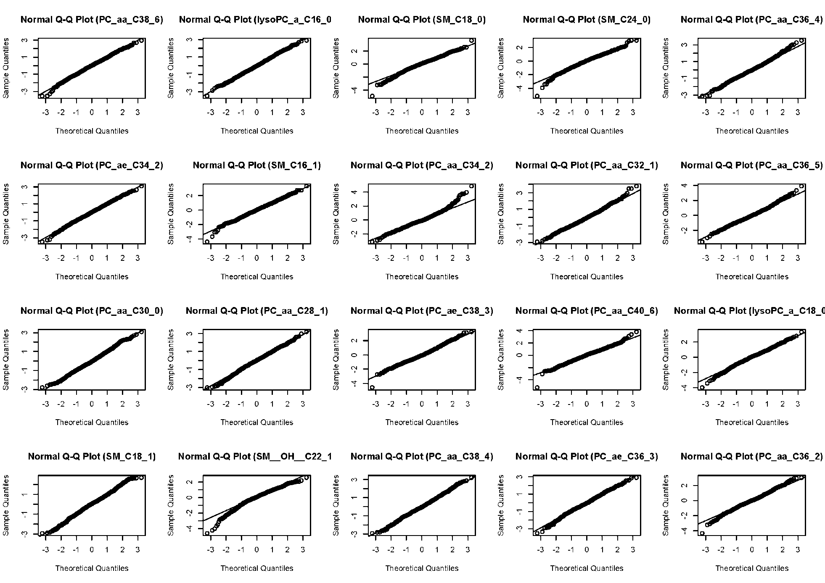Figure S1: QQ-plots of top 20 highly correlated metabolites in EPIC-Heidelberg

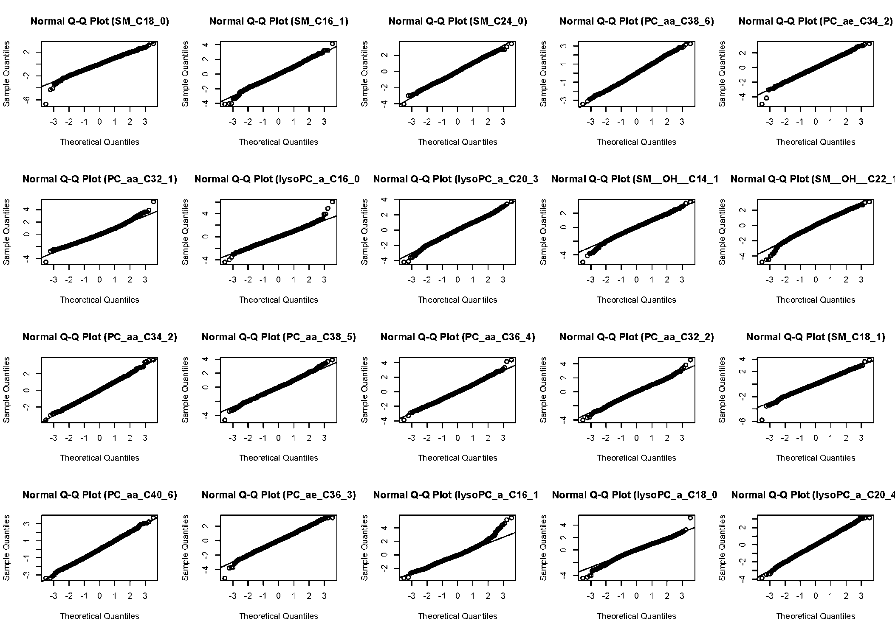Figure S2: QQ-plots of top 20 highly correlated metabolites in EPIC-Potsdam

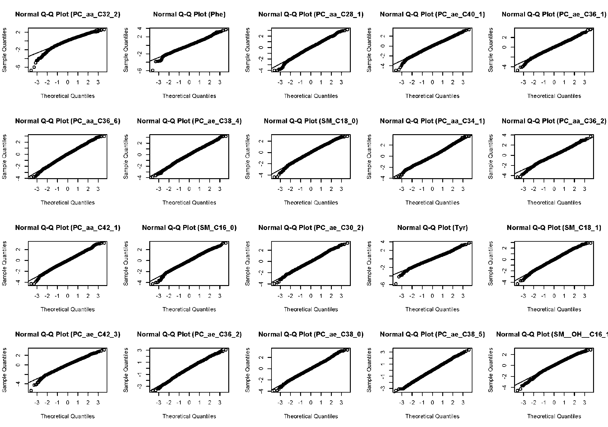Figure S3: QQ-plots of top 20 highly correlated metabolites in KORA

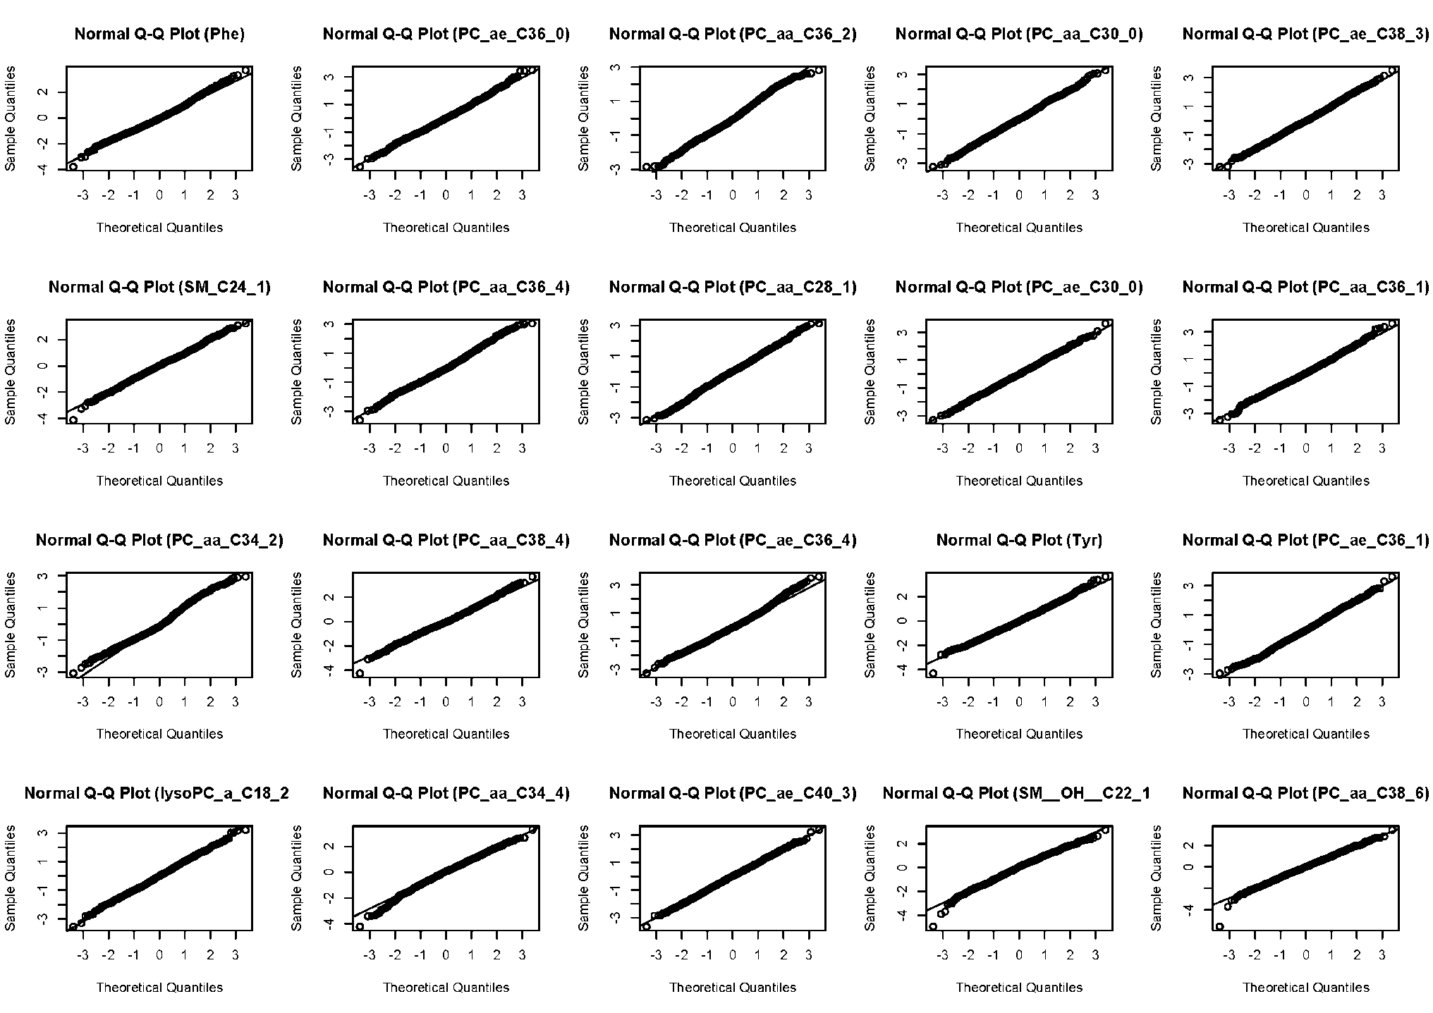Figure S4: QQ-plots of top 20 highly correlated metabolites in CARLA

Figure S5: Serum metabolite network of the EPIC-Heidelberg. Nodes represent metabolites and edges are partial correlations between two metabolites adjusted for the other metabolites as well as age, sex, and BMI. Continuous black lines represent positive and dash-lines represent inverse partial correlations. Thicknesses of edges are proportional to the strength of the correlations. Nodes with different border color represent different metabolite classes: yellow: acylcarnitines, black: amino acids, purple: lyso-phosphatidylcholines, sky-blue: sphingolipids, green: diacyl-phosphatidylcholines, and red: acyl-alkyl- phosphatidylcholines.

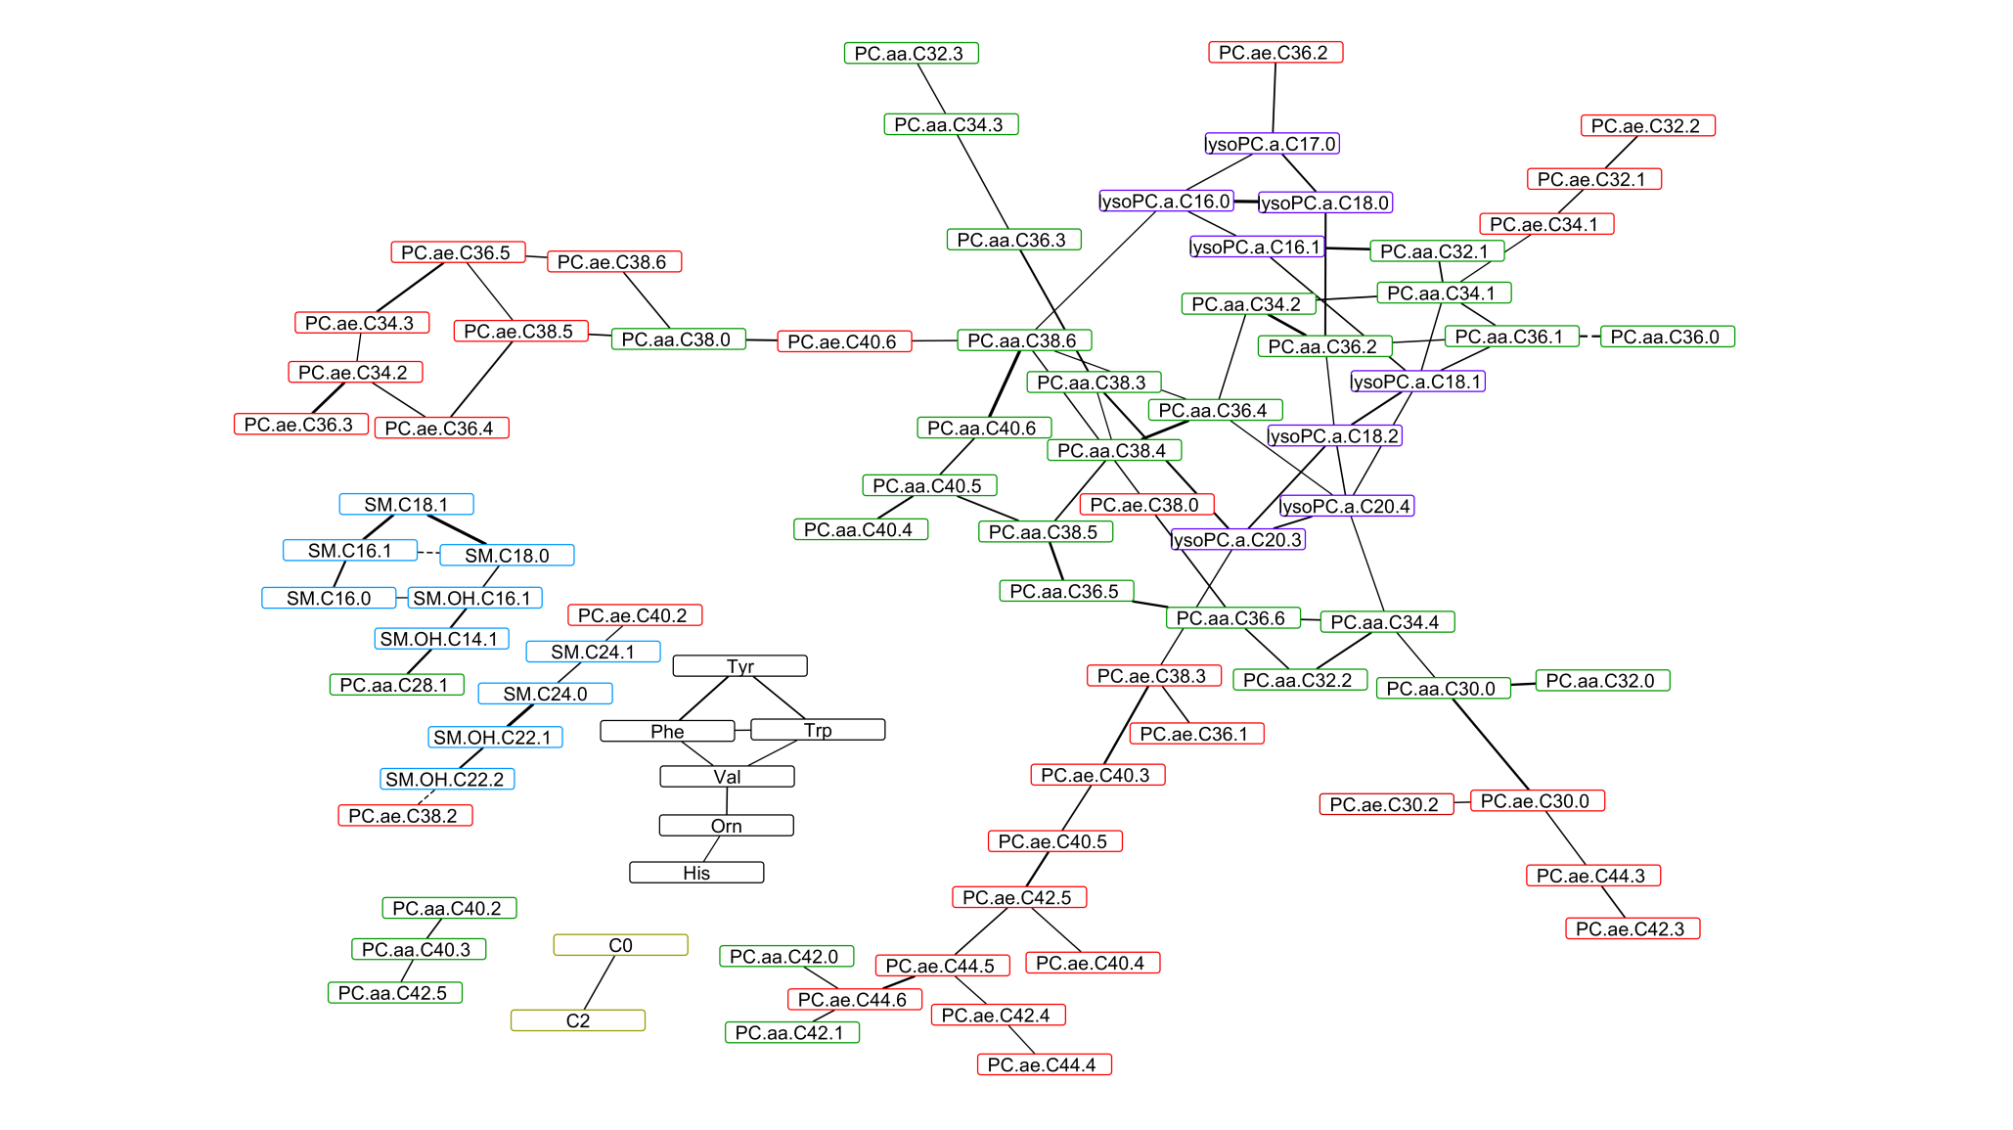

Figure S6: Serum metabolite network of the EPIC-Potsdam. Nodes represent metabolites and edges are partial correlations between two metabolites adjusted for the other metabolites as well as age, sex, and BMI. Continuous black lines represent positive and dash-lines represent inverse partial correlations. Thicknesses of edges are proportional to the strength of the correlations. Nodes with different border color represent different metabolite classes: yellow: acylcarnitines, black: amino acids, purple: lyso-phosphatidylcholines, sky-blue: sphingolipids, green: diacyl-phosphatidylcholines, and red: acyl-alkyl- phosphatidylcholines.

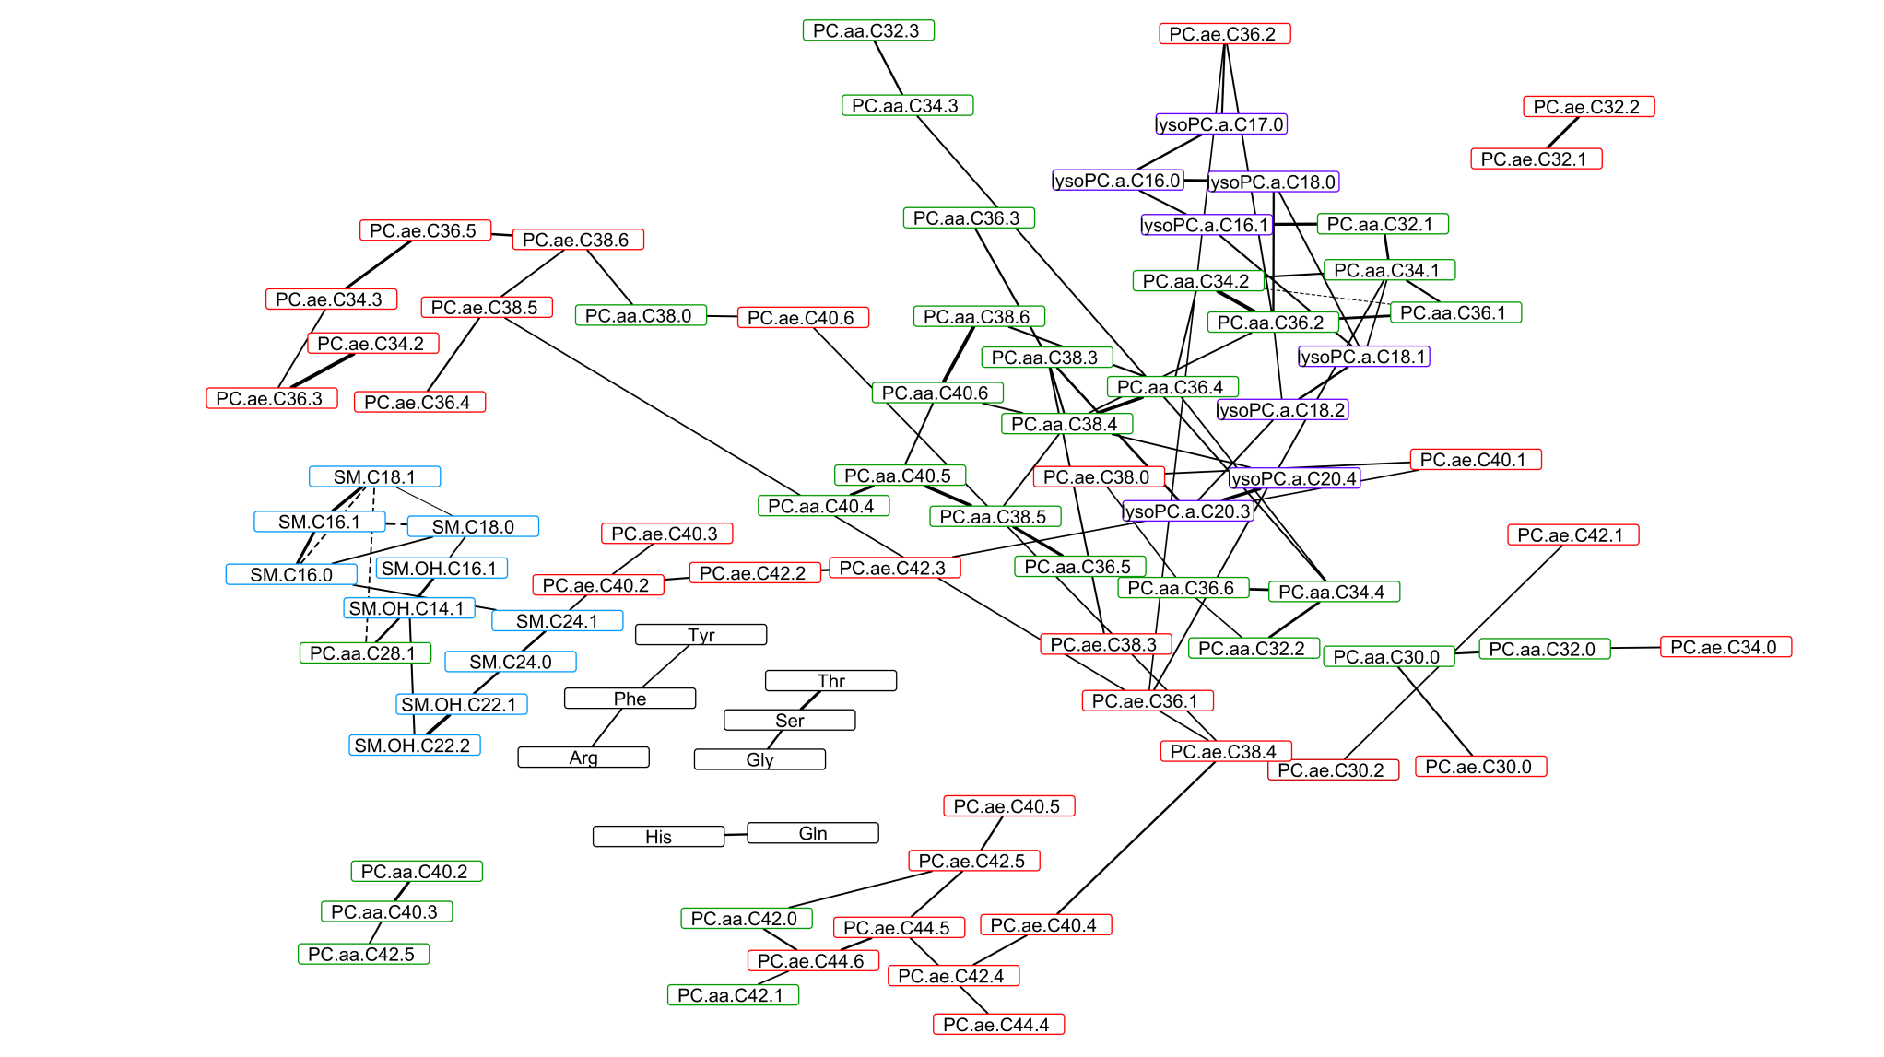

Figure S7: Serum metabolite network of the KORA study. Nodes represent metabolites and edges are partial correlations between two metabolites adjusted for the other metabolites as well as age, sex, and BMI. Continuous black lines represent positive and dash-lines represent inverse partial correlations. Thicknesses of edges are proportional to the strength of the correlations. Nodes with different border color represent different metabolite classes: yellow: acylcarnitines, black: amino acids, purple: lyso-phosphatidylcholines, sky-blue: sphingolipids, green: diacyl-phosphatidylcholines, and red: acyl-alkyl- phosphatidylcholines.

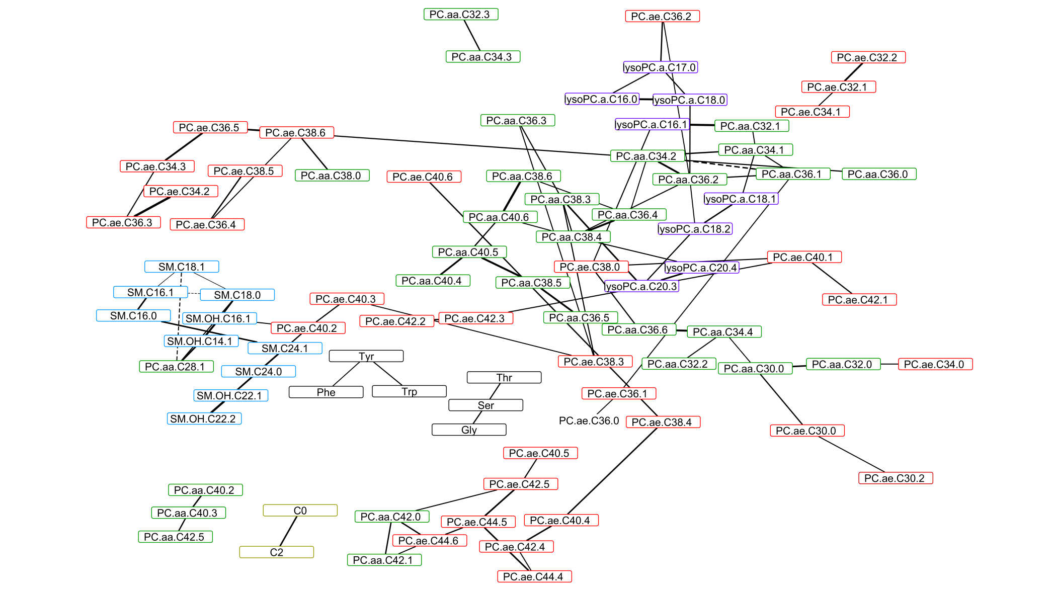

Figure S8: Serum metabolite network of the CARLA study. Nodes represent metabolites and edges are partial correlations between two metabolites adjusted for the other metabolites as well as age, sex, and BMI. Continuous black lines represent positive and dash-lines represent inverse partial correlations. Thicknesses of edges are proportional to the strength of the correlations. Nodes with different border color represent different metabolite classes: grey: hexoses, yellow: acylcarnitines, black: amino acids, purple: lyso-phosphatidylcholines, sky-blue: sphingolipids, green: diacyl-phosphatidylcholines, and red: acyl-alkyl- phosphatidylcholines.

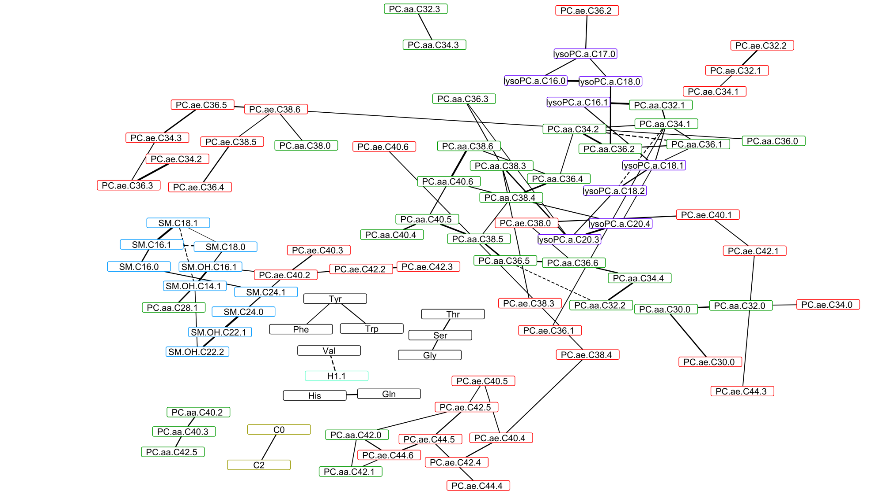

Figure S9: Comparative network of the common network of the three networks (EPIC-Potsdam, CARLA, and KORA) and the meta-analytic network of the four cohorts: EPIC-Heidelberg, EPIC-Potsdam, KORA, and CARLA. Nodes represent metabolites and edges are partial correlations between two metabolites adjusted for the other metabolites as well as age, sex, and BMI. Black edge colors represent common edges in the common network and the meta-analytic network, whereas, the grey color represents edges present only in the meta-analytic network and the light red color of represent edges present in the common network. Similarly, white color of nodes represents common nodes in the compared networks whereas the red color represent nodes present only in meta-analytic network and yellow color (filled) edge represents node present in the common network. Nodes with different border color represent different metabolite classes: yellow: acylcarnitines, black: amino acids, purple: lyso-phosphatidylcholines, sky-blue: sphingolipids, green: diacyl-phosphatidylcholines, and red: acyl-alkyl- phosphatidylcholines.

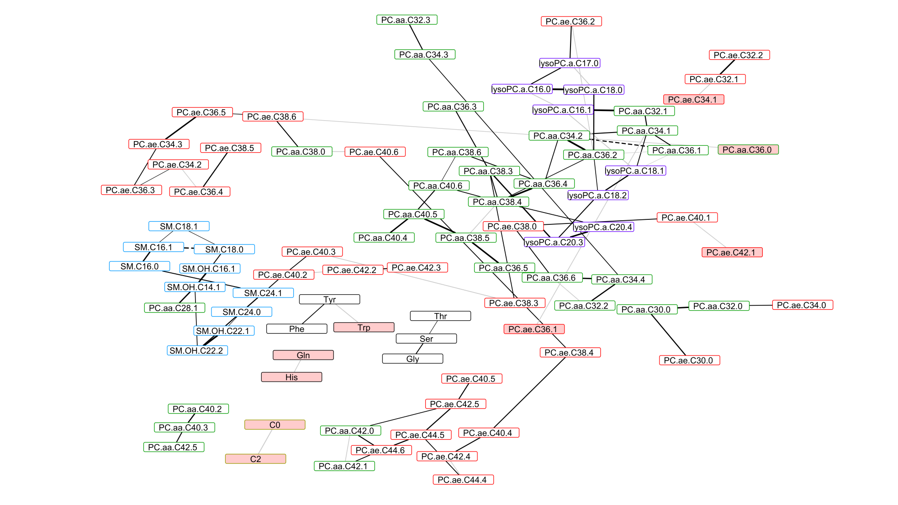

Figure S10: Serum metabolite network of the EPIC-Heidelberg constructed using Spearman Rank Partial Correlations. Nodes represent metabolites and edges are partial correlations between two metabolites adjusted for the other metabolites as well as age, sex, and BMI. Continuous black lines represent positive and dash-lines represent inverse partial correlations. Thicknesses of edges are proportional to the strength of the correlations. Nodes with different border color represent different metabolite classes: yellow: acylcarnitines, black: amino acids, purple: lyso-phosphatidylcholines, sky-blue: sphingolipids, green: diacyl-phosphatidylcholines, and red: acyl-alkyl- phosphatidylcholines.

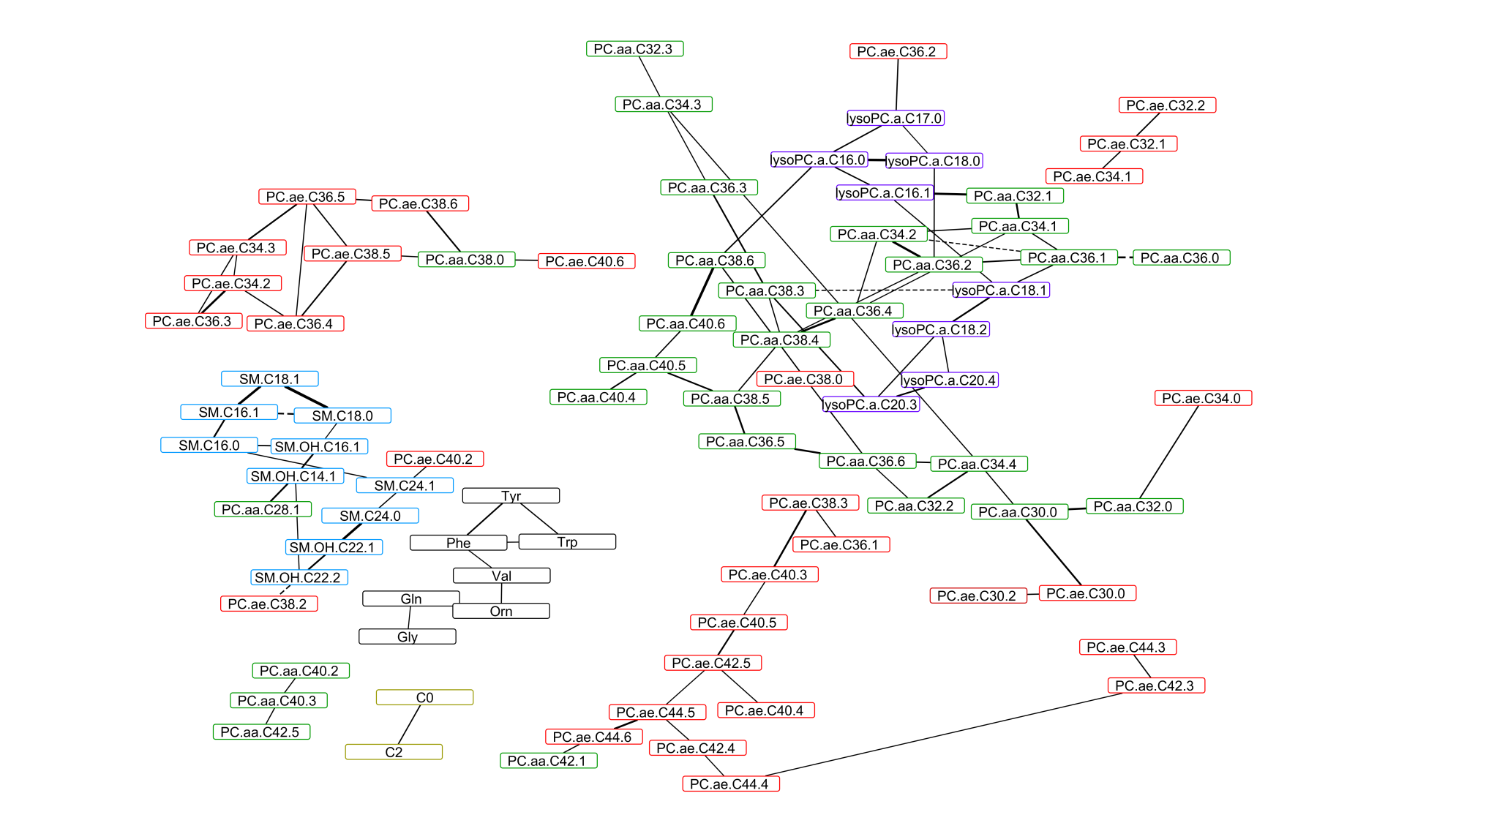

Figure S11: Serum metabolite network of the EPIC-Potsdam constructed using Spearman Rank Partial Correlations. Nodes represent metabolites and edges are partial correlations between two metabolites adjusted for the other metabolites as well as age, sex, and BMI. Continuous black lines represent positive and dash-lines represent inverse partial correlations. Thicknesses of edges are proportional to the strength of the correlations. Nodes with different border color represent different metabolite classes: yellow: acylcarnitines, black: amino acids, purple: lyso-phosphatidylcholines, sky-blue: sphingolipids, green: diacyl-phosphatidylcholines, and red: acyl-alkyl- phosphatidylcholines.

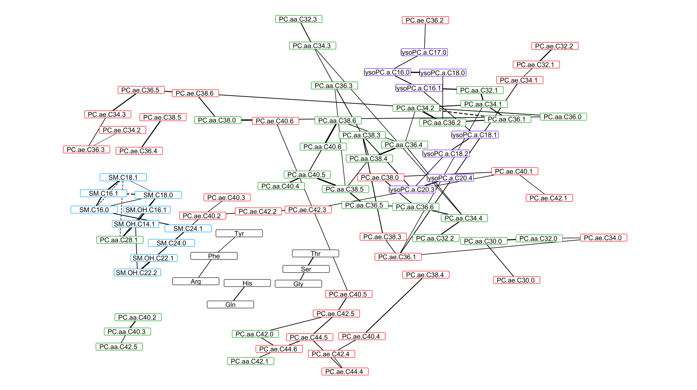

Figure S12: Serum metabolite network of the KORA study constructed using Spearman Rank Partial Correlations. Nodes represent metabolites and edges are partial correlations between two metabolites adjusted for the other metabolites as well as age, sex, and BMI. Continuous black lines represent positive and dash-lines represent inverse partial correlations. Thicknesses of edges are proportional to the strength of the correlations. Nodes with different border color represent different metabolite classes: grey: hexoses, yellow: acylcarnitines, black: amino acids, purple: lyso-phosphatidylcholines, sky-blue: sphingolipids, green: diacyl-phosphatidylcholines, and red: acyl-alkyl- phosphatidylcholines.

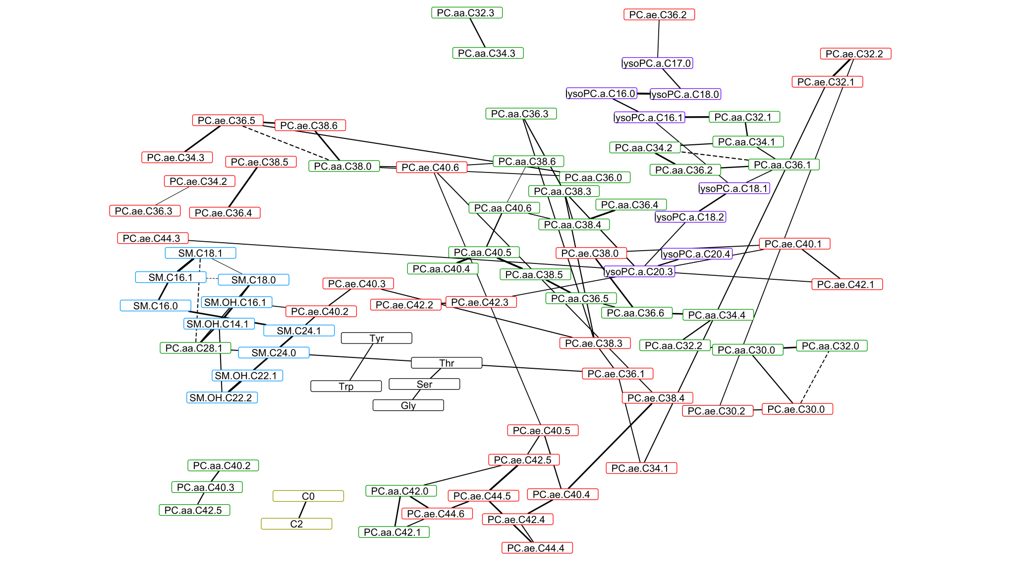

Figure S13: Serum metabolite network of the CARLA study constructed using Spearman Rank Partial Correlations. Nodes represent metabolites and edges are partial correlations between two metabolites adjusted for the other metabolites as well as age, sex, and BMI. Continuous black lines represent positive and dash-lines represent inverse partial correlations. Thicknesses of edges are proportional to the strength of the correlations. Nodes with different border color represent different metabolite classes: yellow: acylcarnitines, black: amino acids, purple: lyso-phosphatidylcholines, sky-blue: sphingolipids, green: diacyl-phosphatidylcholines, and red: acyl-alkyl- phosphatidylcholines.

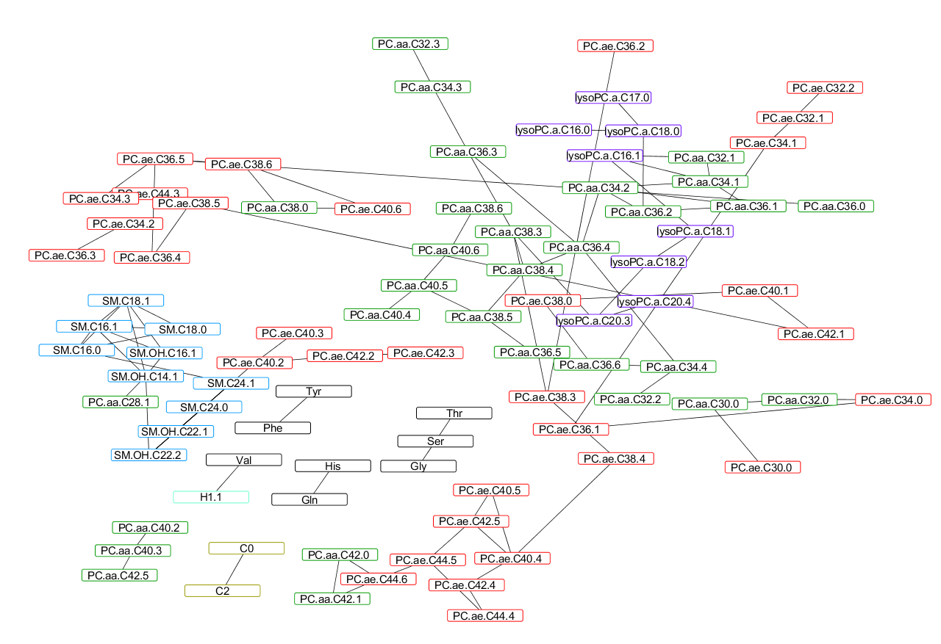

Figure 14: Common edges of the serum metabolite network of the four studies using non-parametric Spearman Rank Partial Correlations: EPIC-Heidelberg, EPIC-Potsdam, CARLA, and KORA. Nodes represent metabolites and edges are partial correlations between two metabolites adjusted for the other metabolites as well as age, sex, and BMI. Continuous black lines represent positive and dash-lines represent inverse partial correlations. Thicknesses of edges are proportional to the strength of the correlations. Nodes with different border color represent different metabolite classes: black: amino acids, purple: lyso-phosphatidylcholines, sky-blue: sphingolipids, green: diacyl-phosphatidylcholines, and red: acyl-alkyl- phosphatidylcholines.

