|  |  |
| --- | --- |
| FT-ICR-MS instrument | SolariX™ (Bruker Daltonics GmbH, Bremen, Germany)  12 T superconducting magnet A (Magnex Scientific Inc., Yarnton, GB) |
| Autosampler | Batch 1-20: Gilson 233 Sample Changer (Gilson, Inc., Middleton, USA)  Batch 21-32: RTC PAL (CTC Analytics AG, Zwingen, Switzerland)  Flowrate: 120 μL h-1 |
| Electrospray ionization | Apollo II Electrospray Source (Bruker Daltonics GmbH, Bremen, Germany)  Ionization mode: negative  Nebulizing Gas: N2 at 4.0 L min-1  Dry temperature: 180 °C  Pressure: 2.2 bar  Capillary voltage: 3600 V  End Plate Offset: -500 V |
| Ion transfer | Source Optics: -200 V Capillary exit, -180 V Deflector plate, -100 V funnel 1, -25 V skimmer 1, 150 Vpp Funnel RF Amplitude  Octopole: 5 MHz Frequency, 150 Vpp RF Amplitude  Collision cell: 3 V Collision voltage, -0.2 V DC extract bias  Transfer optics: 0.6 ms ToF, 4 MHz frequency, 175 Vpp RF amplitude |
| Acquisition | *m/z* range: 92.15-1000.00  Number of Scans: 400  Transient size: 4 Megawords  Ion accumulation: 0.35 s  Acquisition time: 9 min  Overall measurement time per sample: 12 min |

**Supplementary Information 1: Table of FT-ICR-MS instrumental setup and parameters.**

|  |  |  |  |  |  |  |  |
| --- | --- | --- | --- | --- | --- | --- | --- |
| Manufacturer code | Brand / sub-brand | Number of products in category | Number of Sub-brands included in category | Variety / Flavour | Format | Life-stage | Manufacturing sites |
| A | 1 | 23 | 1 | 11 | 2 | 2 | 4 |
| A | 2 | 38 | 3 | 9 | 3 | 1 | 4 |
| A | 3 | 6 | 2 | 4 | 1 | 1 | 1 |
| A | 4 | 3 | 1 | 2 | 1 | 2 | 2 |
| A | 5 | 49 | 1 | 9 | 1 | 3 | 4 |
| A | 6 | 16 | 1 | 6 | 2 | 1 | 4 |
| B | 1 | 3 | 1 | 3 | 2 | 1 | 1 |
| C | 1 | 1 | 1 | 1 | 1 | 1 | 1 |
| D | 1 | 6 | 1 | 3 | 1 | 1 | 1 |
| D | 2 | 1 | 1 | 1 | 1 | 1 | 1 |
| E | 1 | 110 | 1 | 11 | 3 | 3 | 7 |
| E | 2 | 5 | 1 | 3 | 1 | 1 | 1 |
| E | 3 | 9 | 1 | 2 | 1 | 2 | 1 |
| E | 4 | 4 | 1 | 2 | 1 | 1 | 1 |
| E | 5 | 3 | 1 | 3 | 1 | 1 | 1 |
| E | 6 | 11 | 1 | 1 | 2 | 2 | 1 |
| E | 7 | 33 | 4 | 6 | 3 | 1 | 3 |
| E | 8 | 11 | 1 | 8 | 2 | 1 | 2 |
| E | 9 | 7 | 3 | 4 | 1 | 1 | 1 |
| E | 10 | 27 | 2 | 9 | 1 | 1 | 2 |
| E | 11 | 83 | 1 | 2 | 2 | 1 | 1 |
| E | 12 | 10 | 2 | 9 | 2 | 1 | 2 |
| F | 1 | 1 | 1 | 1 | 1 | 1 | 1 |
| G | 1 | 7 | 2 | 6 | 2 | 2 | 1 |

**Supplementary Information 2 Table Summarizing Commercial Pet Foods analysed between 2015 and 2021.** Coding corresponding to manufacturer (letter), brand or sub-brand (number) and the number of products grouped for each category. Sub-brand contains similar products from the same manufacturer together where more than one is listed. Variety/Flavor includes different meat, poultry and fish variants, Format may include chunk in jelly or gravy and pate/loaf type products, Life-stages may include Senior, Adult and Kitten and manufacturing site may include factories from different regions. All products were extracted and analysed (within three months of purchase), over a six-year period 2015-2021 in one of 32 mixed product batches.

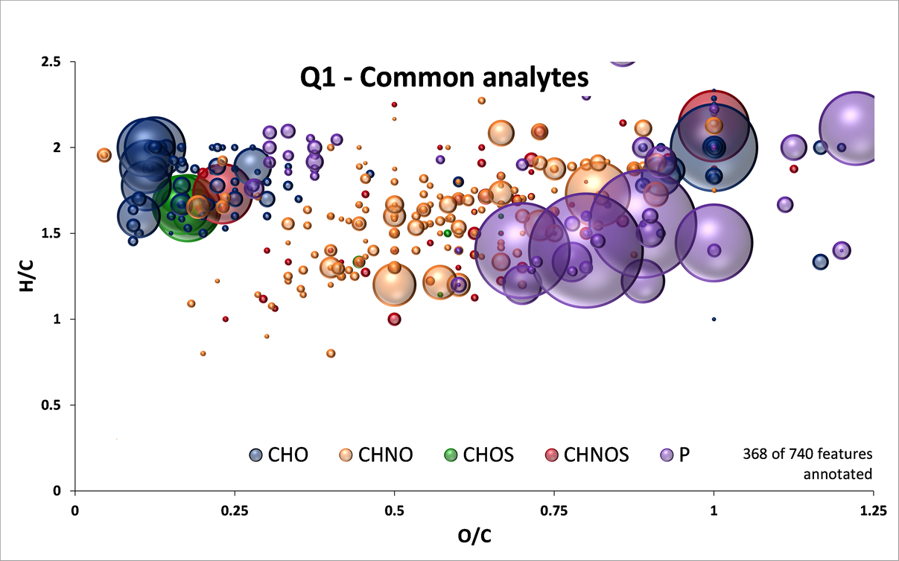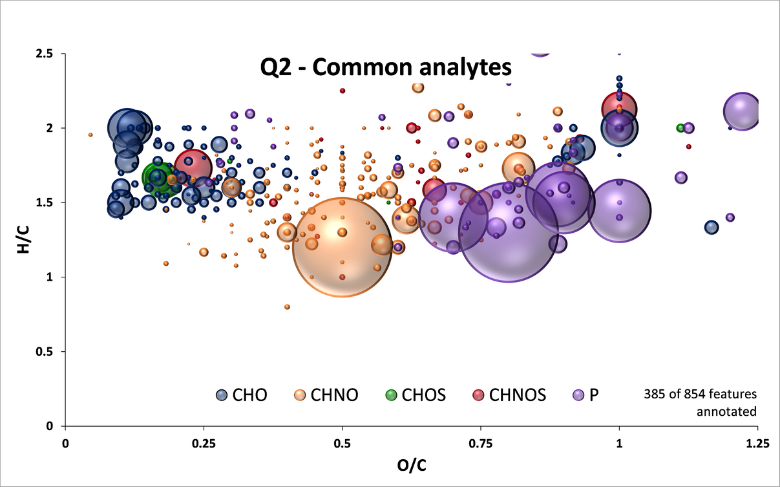

**QC1 – Common Features**

**QC2 – Common Features**

**Supplementary Information 3 Van Krevelen diagrams of common features detected in QC materials.** Features present in at least 40 of 41 QC1 measurements and 39 of 40 QC2 measurements showing changes are predominately in lipid, amino sugar, and carbohydrate chemical classes. Neutral formulae are depicted. Bubble sizes are scaled to mean intensities in the respective quality control sample. Chemical spaces colour code: CHO (blue); CHNO (orange); CHOS (green); CHNOS (red); CH(N)O(S)P (purple).

|  |  |  |  |  |
| --- | --- | --- | --- | --- |
| Batch | Extraction analyst | Instrument analyst | Firmware update version | Auto-sampler |
| 2 | A | 1 | Original | Gilson |
| 3 | A | 1 | Original | Gilson |
| 4 | B | 1 | Updated | Gilson |
| 5 | B | 1 | Updated | Gilson |
| 6 | C | 1 | Updated | Gilson |
| 7 | C | 1 | Updated | Gilson |
| 8 | C | 1 | Updated | Gilson |
| 9 | C | 1 | Updated | Gilson |
| 10 | C | 1 | Updated | Gilson |
| 11 | C | 1 | Updated | Gilson |
| 12 | C | 2 | Updated | Gilson |
| 13 | C/E/F | 2 | Updated | Gilson |
| 14 | C/E/F | 3 | Updated | Gilson |
| 15 | F | 3 | Updated | Gilson |
| 16 | F | 3 | Updated | Gilson |
| 17 | F | 3 | Updated | Gilson |
| 18 | F/G/I | 3 | Updated | Gilson |
| 19 | G | 3 | Updated | Gilson |
| 20 | G/D | 3 | Updated | Gilson |
| 21 | G | 3 | Updated | PAL |
| 22 | G/D | 3 | Updated | PAL |
| 23 | G/D/I | 3 | Updated | PAL |
| 24 | H/D | 3 | Updated | PAL |
| 25 | D | 3 | Updated | PAL |
| 26 | H/D/I | 2 | Updated | PAL |
| 27 | H | 2 | Updated | PAL |
| 28 | H | 4 | Updated | PAL |
| 29 | J/E/D | 4 | Updated | PAL |
| 30 | J/C | 4 | Updated | PAL |
| 31 | E | 4 | Updated | PAL |
| 32 | E | 4 | Updated | PAL |
| 33 | E | 4 | Updated | PAL |

**Supplementary Information 4 Table of identified variables across experimental period per batch of sample acquisition. Batches 0 and 1 were method development batches and are not included in this study.**

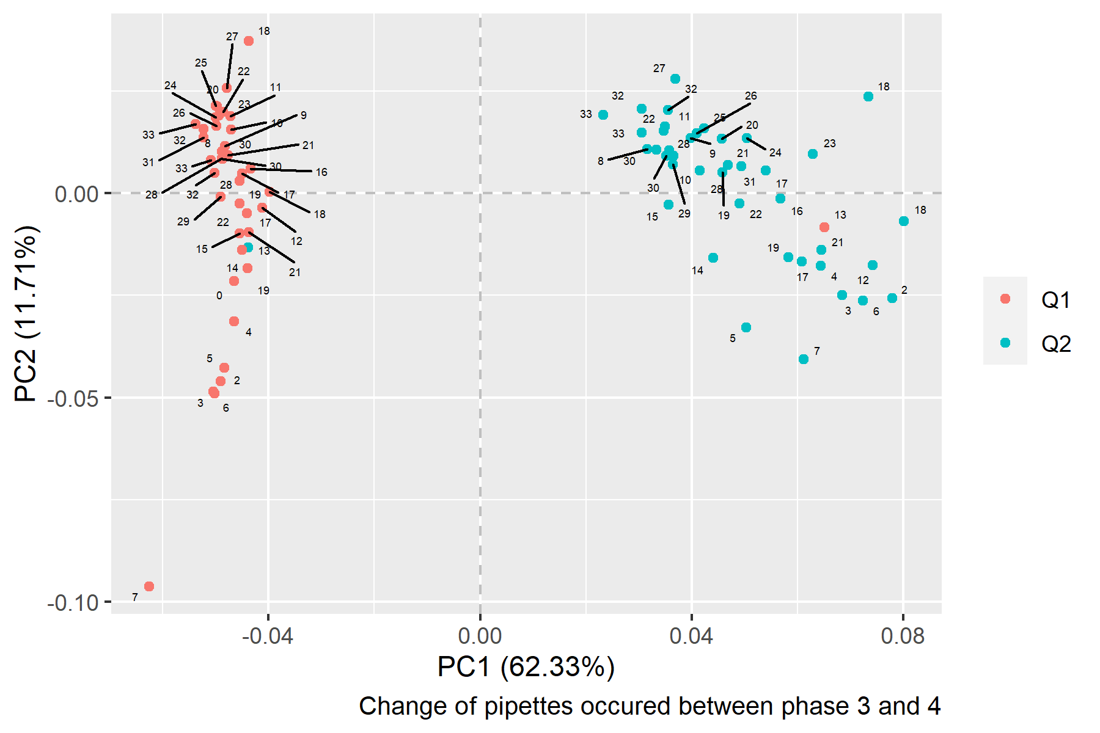

QC2

QC1

**Supplementary Information 5 PCA of all Quality Control data labeled by batch number.** A known mislabelling event occurred in batch 13.

**Supplementary Information 6 Scree plot of variance across dimensions (Principal Components) for PCA (Figure 3)** illustrating the weight (%) each dimension attributes to the separation(PC1 62.33 %, PC2 11.71 %, PC3 6.58 %, PC4 4.66 %, PC5 3.12 %).

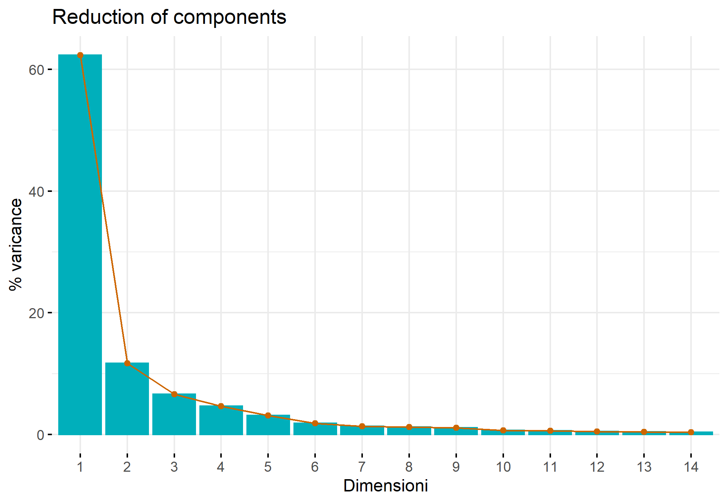

% Variance

Dimension