**Additional file**

**TiO2 tube and TiO2 cube synthesis**

***Preparation of hydrogen titanate nanotubes***

Hydrogen titanate nanotubes (HTiNTs) were prepared from sodium titanate nanotubes [**A**] (NaTiNRs) by an ion exchange. In brief, a suspension of 2.0 g of NaTiNTs and 400 mL of 0.1 M HCl(aq) was stirred for 2 h and centrifuged. This procedure was repeated five times. After the last centrifugation the sediment was washed first with deionized water until the pH of the supernatant was ca. 5.5, then rinsed with ethanol, and finally dried in an oven at 100 °C for 12 h.

[**A**] Umek, P.; Korošec, R. C.; Jančar, B.; Dominko, R.; Arčon, D. *J. Nanosci. Nanotechnol.* **2007,** *7,* 3502–3508. doi:10.1166/jnn.2007.838

***Transformation of hydrogen titanate nanotubes to TiO2 nanotubes***

TiO2 nanotubes (TiO2 NTs) were prepared by thermal conversion of hydrogene titanate nanotubes at 380 °C [**B**]. In brief, 300 mg of HTiNTs was weighed in an alumina boat, placed into an oven and heated at a ramp rate of 1 °C/min to 380 °C. The sample was kept at the selected temperature for 12 h, and cooled down to room temperature afterwards. The sample was labeled TiO2 NTs.

[**B**] Garvas, M.; Testen, A.; Umek, P.; Gloter, A.; Koklič, T.; Štrancar, *J. Protein Corona Prevents TiO2 Phototoxicity*. PLoS One **2015**, 10 (6), e0129577.

***Transformation of hydrogen titanate nanotubes to TiO2 nanocubes***

HTiNTs (250 mg) were suspended in 20 mL of 0.1 M solution of ethanol amine in deionized water. The prepared reaction mixture was transferred in a 30 mL glass vial and inserted into a microwave reactor (Anton Paar microwave reactor Monowave 300) and heated in 5 minutes to 180 °C under constant stirring (300 rpm) for three and a half hours. After being cooled down to room temperature the product mixture was first centrifuged then washed with EtOH, and dried in an oven at 100 °C for 12 h and then finally calcined at 280 °C for 10 h. The sample was labeled TiO2 NCs.

C:\Users\ped\AppData\Local\Microsoft\Windows\Temporary Internet Files\Content.Outlook\84YFLC4E\Figure S1 R300 A4 new (2).tif

**Fig. S1** X-ray diffractograms of TiO2 materials used in the study: TiO2 NM-1, TiO2 NM-2, TiO2 tube and TiO2 cube. Labels, 🞰 and ⬥, stand for anatase (ICDD card no. 01-086-1157) and rutile (ICDD card no. 00-002-494, respectively. In diffractograms of TiO2 NM-1 and TiO2 NM-2 appear rutile diffractions, using Spurr’s formula (%Anatase = 100 / (1+1.265 IR/IA) [**C**] amount of rutile was calculated to be about 11.5 wt. % (TiO2 NM-1) and 5.6 wt. % (TiO2 NM-2).

[**C**] Spurr, R. A.; Myers, H. *Anal. Chem.* **1957,** *29,* 760–762. doi: 10.1021/ac60125a006

**Fig. S2**  Dynamic light scattering number-based size distributions of TiO2 NMs and DQ12 in instillation suspensions (3.24 mg/ml in Nanopure water with 2 % mouse serum).

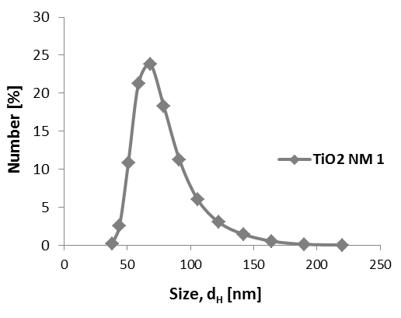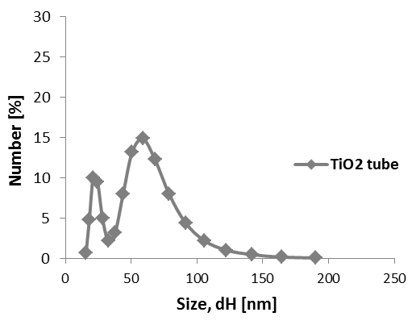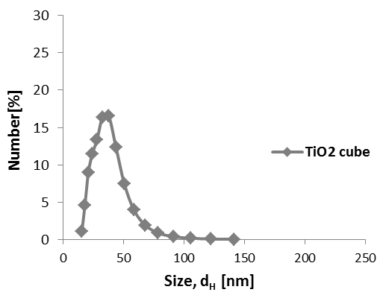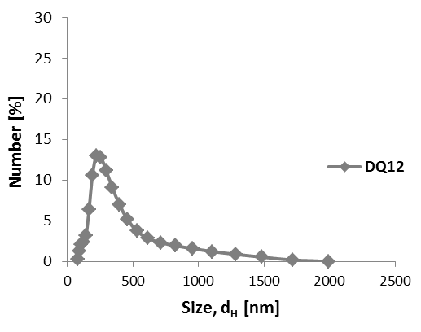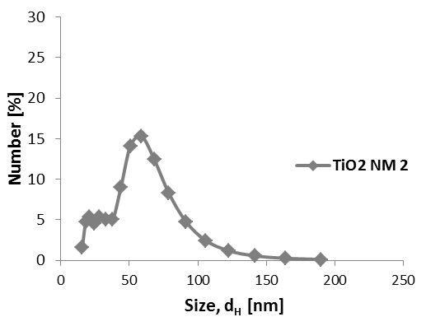

**Table S1**.

|  |  |  |  |
| --- | --- | --- | --- |
|  | z-average size | PI |  |
| TiO2 NM-1 | 243.0 nm | 0.592 |  |
| TiO2 NM-2 | 183.0 nm | 0.703 |  |
| TiO2 tube | 168.7 nm | 0.586 |  |
| TiO2 cube | 212.4 nm | 0.727 |  |
| DQ12 | 555.6 nm | 0.370 |  |

The intensity-based z-average size and polydispersity index (PI) of TiO2 NMs and DQ12 measured in instillation suspensions (3.24 mg/ml in Nanopure water with 2 % mouse serum).

**Table S2**. Selected physiochemical parameters of the rutile TiO2 NMs

|  |  |  |  |  |  |  |
| --- | --- | --- | --- | --- | --- | --- |
| Name | NM type | Source | Size | Surface modification | BET (m2/g) | Reference |
| NRCWE-001 | Rutile TiO2 | NanoAmor, Houston, USA | 10 nm | None | 99 | Kermanizadeh *et al*. 2013 |
| NRCWE-002 | Rutile TiO2 |  | 10 nm | Positively charged | 84 | Kermanizadeh *et al*. 2013 |
| NRCWE-025 | Rutile TiO2 | Nabond, Shenzhen, China | 38 nm | None | 28.2 | Gomez *et al*. 2014, Halappanavar *et al*. 2015 |
| NRCWE-30 | Rutile TiO2 | NanoAmor, Houston, USA | 10.5 nm | None | 139.1 | Gomez *et al*. 2014, Halappanavar *et al*. 2015 |
| UV-Titan L181 | Rutile TiO2 | Kemira Pigments, Finland | 20.6 nm | Si, Al, Zr, polyalcohol | 107.7 | Saber *et al*. 2012b |

|  |
| --- |
|  |

**Fig. S3** Acellular oxidation potential measured with DCFH-DA assay for rutile TiO2 NMs (NRCWE-001, -002, -025, -030, UV-Titan L181) and anatase TiO2 NMs (NM-1, NM-2, tube, cube) and DQ12.

|  |  |  |  |  |  |  |  |  |  |  |
| --- | --- | --- | --- | --- | --- | --- | --- | --- | --- | --- |
| **Table S3.** BAL fluid cell counts in mice 90 and 180 days post-exposure to 18, 54 and 162 µg TiO2 NMs, 162 µg DQ12 and control mice. | | | | | | | | | | |
|  |  | **Control** |  |  | **TiO2 NM-1** |  |  |  | **TiO2 NM-2** |  |
|  |  | 0 µg |  | 18 µg | 54 µg | 162 µg |  | 18 µg | 54 µg | 162 µg |
|  |  |  |  |  |  |  |  |  |  |  |
| **90 days** |  |  |  |  |  |  |  |  |  |  |
| Neutrophils (× 103) | | 3.30 ± 4.44 |  | 0.53 ± 0.42 | 12.3 ± 7.94 | 1.81 ± 1.60 |  | 1.98 ± 1.62 | 3.13 ± 3.31 | 0.75 ± 0.99 |
| Macrophages (× 103) | | 66.1 ± 49.2 |  | 45.2 ± 12.1 | 50.1 ± 14.3 | 60.8 ± 14.6 |  | 45.2 ± 8.05 | 41.9 ± 19.5 | 58.6 ± 19.3 |
| Eosinophils (× 103) | | 0.03 ± 0.09 |  | 0.66 ± 1.13 | 0.37 ± 0.4 | 0.12 ± 0.31 |  | 0.07 ± 0.12 | 0.05 ± 0.14 | 0.15 ± 0.30 |
| Lymphocytes (× 103) | | 3.30 ± 3.64 |  | 2.39 ± 1.75 | 1.78 ± 1.44 | 6.51 ± 7.66 |  | 1.54 ± 0.77 | 1.18 ± 0.78 | 1.87 ± 0.69 |
| Epithelial (× 103) | | 8.42 ± 7.52 |  | 3.59 ± 1.95 | 14.2 ± 11.7 | 7.33 ± 4.36 |  | 3.14 ± 2.46 | 5.14 ± 3.95 | 4.47 ± 2.67 |
| Total BAL cells (× 103) | | 81.2 ± 60.3 |  | 52.4 ± 13.5 | 78.7 ± 21.6 | 76.6 ± 11.0 |  | 52.0 ± 8.78 | 58.8 ± 10.9 | 66.1 ± 20.2 |
|  |  |  |  |  |  |  |  |  |  |  |
| **180 days** |  |  |  |  |  |  |  |  |  |  |
| Neutrophils (× 103) | | 0.69 ± 0.98 |  |  |  | 2.08 ± 1.16 |  |  |  | 0.39 ± 0.23 |
| Macrophages (× 103) | | 43.0 ± 11.4 |  |  |  | 56.4 ± 10.8 |  |  |  | 34.3 ± 10.5 |
| Eosinophils (× 103) | | 0.10 ± 0.29 |  |  |  | 0.21 ± 0.27 |  |  |  | 0.00 ± 0.00 |
| Lymphocytes (× 103) | | 1.64 ± 1.86 |  |  |  | 1.49 ± 0.72 |  |  |  | 1.15 ± 0.55 |
| Epithelial (× 103) | | 5.26 ± 3.25 |  |  |  | 5.85 ± 3.69 |  |  |  | 6.86 ± 6.69 |
| Total BAL cells (× 103) | | 50.7 ± 14.7 |  |  |  | 66.6 ± 13.1 |  |  |  | 42.7 ± 10.8 |

|  |  |  |  |  |  |  |  |  |  |  |
| --- | --- | --- | --- | --- | --- | --- | --- | --- | --- | --- |
| **Table S3. continued** | |  |  |  |  |  |  |  |  |  |
|  |  |  | **TiO2 tube** |  |  |  | **TiO2 cube** |  |  | **DQ12** |
|  |  | 18 µg | 54 µg | 162 µg |  | 18 µg | 54 µg | 162 µg |  | 162 µg |
|  |  |  |  |  |  |  |  |  |  |  |
| **90 days** |  |  |  |  |  |  |  |  |  |  |
| Neutrophils (× 103) | | 3.63 ± 1.96 | 2.82 ± 1.47 | 9.02 ± 5.31 |  | 2.00 ± 3.59 | 3.87 ± 3.64 | 2.00 ± 2.99 |  | 4.23 ± 3.92 |
| Macrophages (× 103) | | 51.4 ± 14.7 | 57.8 ± 22.2 | 90.4 ± 19.7 |  | 54.7 ± 18.6 | 44.5 ± 9.63 | 46.5 ± 7.98 |  | 54.6 ± 12.6 |
| Eosinophils (× 103) | | 0.15 ± 0.31 | 0.05 ± 0.11 | 0.18 ± 0.30 |  | 0.16 ± 0.30 | 0.00 ± 0.00 | 0.04 ± 0.11 |  | 0.00 ± 0.00 |
| Lymphocytes (× 103) | | 2.21 ± 0.95 | 12.7 ± 12.1 | 39.8 ± 34.5 |  | 2.78 ± 2.05 | 1.14 ± 0.48 | 2.20 ± 2.94 |  | 13.2 ± 6.31 |
| Epithelial (× 103) | | 3.73 ± 1.72 | 6.08 ± 1.58 | 6.39 ± 3.48 |  | 3.40 ± 2.25 | 2.85 ± 1.00 | 4.60 ± 2.23 |  | 5.35 ± 1.40 |
| Total BAL cells (× 103) | | 61.1 ± 13.3 | 72.4 ± 35.2 | 146 ± 48.2 |  | 63.0 ± 21.5 | 52.3 ± 12.3 | 55.3 ± 5.69 |  | 77.4 ± 15.1 |
|  |  |  |  |  |  |  |  |  |  |  |
| **180 days** |  |  |  |  |  |  |  |  |  |  |
| Neutrophils (× 103) | |  |  | 4.97 ± 2.94** |  |  |  | 1.93 ± 1.42 |  | 1.68 ± 1.96 |
| Macrophages (× 103) | |  |  | 54.3 ± 17.5 |  |  |  | 56.3 ± 23.0 |  | 37.4 ± 12.2 |
| Eosinophils (× 103) | |  |  | 0.10 ± 0.19 |  |  |  | 0.04 ± 0.10 |  | 0.08 ± 0.20 |
| Lymphocytes (× 103) | |  |  | 10.1 ± 8.06* |  |  |  | 3.68 ± 4.18 |  | 10.1 ± 7.06* |
| Epithelial (× 103) | |  |  | 7.05 ± 5.71 |  |  |  | 8.16 ± 5.60 |  | 4.31 ± 2.17 |
| Total BAL cells (× 103) | |  |  | 76.6 ± 24.9 |  |  |  | 70.1 ± 31.6 |  | 53.5 ± 18.4 |

All values are presented as mean ± SD. A symbol (*) denotes P ≤ 0.05 and (**) P ≤ 0.01 compared to vehicle control.

|  |  |  |  |  |  |  |  |  |  |  |  |  |  |  |  |  |  |  |  |  |  |
| --- | --- | --- | --- | --- | --- | --- | --- | --- | --- | --- | --- | --- | --- | --- | --- | --- | --- | --- | --- | --- | --- |
| **Table S4.** DNA strand breaks in mice 1, 3, 28 and 90 days post-exposure to 18, 54 and 162 µg TiO2 NMs, 162 µg DQ12 and control mice. | | | | | | | | | | | | | | | | | | | | | |
|  |  | **Control** | | |  |  | | **TiO2 NM-1** | | |  | |  |  | | | **TiO2 NM-2** | |  | | |
|  |  | 0 µg | | |  | 18 µg | | 54 µg | | | 162 µg | |  | 18 µg | | | 54 µg | | 162 µg | | |
| **1 day** |  |  | | |  |  | |  | | |  | |  |  | | |  | |  | | |
| BAL TL |  | 13.5 ± 3.28 | | |  | 11.2 ± 0.87 | | 11.6 ± 0.86 | | | 11.2 ± 0.69 | |  | 11.5 ± 1.37 | | | 11.1 ± 0.46 | | 11.2 ± 1.04 | | |
| BAL TL% |  | 4.55 ± 2.05 | | |  | 2.57 ± 0.58 | | 2.90 ± 0.77 | | | 3.19 ± 0.58 | |  | 3.17 ± 0.69 | | | 3.23 ± 0.54 | | 3.45 ± 0.45 | | |
| Lung TL |  | 16.8 ± 4.44 | | |  | 16.5 ± 5.44 | | 12.8 ± 1.37 | | | 12.2 ± 1.02 | |  | 17.0 ± 4.98 | | | 19.0 ± 10.4 | | 16.6 ± 3.91 | | |
| Lung TL% |  | 7.87 ± 3.52 | | |  | 6.19 ± 4.04 | | 4.08 ± 0.91 | | | 3.37 ± 0.72b | |  | 6.04 ± 3.25 | | | 10.9 ± 11.3 | | 10.8 ± 9.42 | | |
| Liver TL |  | 14.3 ± 1.87 | | |  | 14.7 ± 1.55 | | 13.2 ± 1.88 | | | 12.3 ± 1.05 | |  | 14.4 ± 1.93 | | | 12.5 ± 1.59 | | 14.1 ± 1.89 | | |
| Liver TL% |  | 4.02 ± 0.83 | | |  | 4.17 ± 1.03 | | 3.29 ± 0.80 | | | 2.89 ± 0.33a | |  | 4.00 ± 1.30 | | | 3.47 ± 1.13 | | 3.94 ± 0.68 | | |
|  |  |  | | |  |  | |  | | |  | |  |  | | |  | |  | | |
| **3 days** |  |  | | |  |  | |  | | |  | |  |  | | |  | |  | | |
| BAL TL |  | 11.7 ± 2.76 | | |  | 12.5 ± 2.73 | | 12.5 ± 1.30 | | | 12.5 ± 0.98 | |  | 9.71 ± 1.22 | | | 10.6 ± 1.60 | | 11.1 ± 0.55 | | |
| BAL TL% |  | 3.95 ± 2.29 | | |  | 5.27 ± 2.63 | | 5.44 ± 0.75 | | | 5.90 ± 0.96d | |  | 2.59 ± 0.53 | | | 3.31 ± 1.78 | | 4.51 ± 0.56 | | |
| Lung TL |  | 14.3 ± 4.75 | | |  | 12.0 ± 1.81 | | 11.1 ± 0.70 | | | 11.9 ± 1.43 | |  | 13.3 ± 1.80 | | | 11.8 ± 1.59 | | 11.6 ± 2.26 | | |
| Lung TL% |  | 6.41 ± 2.84 | | |  | 4.31 ± 1.53 | | 3.19 ± 0.71c | | | 3.79 ± 0.91a | |  | 4.17 ± 1.30 | | | 3.49 ± 0.55b | | 4.23 ± 1.23 | | |
| Liver TL |  | 13.1 ± 1.83 | | |  | 12.4 ± 1.09 | | 12.3 ± 1.71 | | | 13.2 ± 1.85 | |  | 12.8 ± 1.95 | | | 12.2 ± 1.04 | | 14.1 ± 1.63 | | |
| Liver TL% |  | 3.47 ± 0.48 | | |  | 3.17 ± 0.86 | | 3.14 ± 0.77 | | | 3.29 ± 0.92 | |  | 2.97 ± 0.62 | | | 2.97 ± 0.42 | | 3.79 ± 1.52 | | |
|  |  |  | | |  |  | |  | | |  | |  |  | | |  | |  | | |
| **28 days** |  |  | | |  |  | |  | | |  | |  |  | | |  | |  | | |
| BAL TL |  | 10.9 ± 1.52 | | |  | 11.3 ± 1.28 | | 9.58 ± 1.02 | | | 9.32 ± 1.28 | |  | 9.52 ± 1.17 | | | 9.71 ± 1.72 | | 9.08 ± 0.87 | | |
| BAL TL% |  | 3.06 ± 0.74 | | |  | 4.17 ± 1.27 | | 2.41 ± 0.44 | | | 2.43 ± 1.01 | |  | 2.26 ± 0.38 | | | 3.00 ± 1.46 | | 2.13 ± 0.34 | | |
| Lung TL |  | 13.6 ± 3.14 | | |  | 10.5 ± 1.45 | | 10.1 ± 1.16a | | | 10.5 ± 1.47 | |  | 11.0 ± 1.80 | | | 13.2 ± 3.45 | | 12.2 ± 3.08 | | |
| Lung TL% |  | 4.57 ± 1.37 | | |  | 3.46 ± 0.61 | | 3.17 ± 0.49 | | | 3.69 ± 0.92 | |  | 3.54 ± 0.55 | | | 3.91 ± 1.58 | | 3.31 ± 0.70 | | |
| Liver TL |  | 12.1 ± 1.55 | | |  | 10.8 ± 0.77 | | 12.3 ± 1.48 | | | 11.7 ± 0.86 | |  | 11.0 ± 0.55 | | | 12.3 ± 1.26 | | 11.0 ± 1.20 | | |
| Liver TL% |  | 2.81 ± 0.60 | | |  | 2.36 ± 0.59 | | 2.80 ± 0.64 | | | 2.50 ± 0.77 | |  | 2.59 ± 0.53 | | | 2.76 ± 0.64 | | 2.60 ± 0.84 | | |
|  |  |  | | |  |  | |  | | |  | |  |  | | |  | |  | | |
| **90 days** |  |  | | |  |  | |  | | |  | |  |  | | |  | |  | | |
| BAL TL |  | 11.1 ± 1.90 | | |  | 11.0 ± 1.73 | | 11.6 ± 0.92 | | | 10.7 ± 1.37 | |  | 9.96 ± 0.84 | | | 9.94 ± 1.80 | | 9.55 ± 1.44 | | |
| BAL TL% |  | 3.72 ± 1.05 | | |  | 2.33 ± 0.60 | | 3.93 ± 1.90 | | | 2.79 ± 0.73 | |  | 2.36 ± 1.21 | | | 2.64 ± 1.50 | | 2.56 ± 0.66 | | |
| Lung TL |  | 14.8 ± 1.61 | | |  | 13.2 ± 1.26 | | 11.8 ± 1.32a | | | 11.8 ± 2.32 | |  | 11.1 ± 1.06b | | | 11.2 ± 0.55b | | 13.1 ± 2.62 | | |
| Lung TL% |  | 5.27 ± 1.17 | | |  | 4.10 ± 1.00a | | 3.27 ± 0.66b | | | 3.17 ± 1.30 | |  | 2.87 ± 0.77b | | | 3.14 ± 0.91a | | 4.17 ± 1.27 | | |
| Liver TL |  | 14.8 ± 0.86 | | |  | 14.1 ± 2.00 | | 15.1 ± 2.69 | | | 15.4 ± 1.95 | |  | 14.7 ± 1.68 | | | 13.5 ± 1.42 | | 14.0 ± 1.96 | | |
| Liver TL% |  | 4.11 ± 0.60 | | |  | 3.74 ± 1.19 | | 4.38 ± 1.31 | | | 4.17 ± 1.03 | |  | 3.91 ± 0.67 | | | 3.63 ± 1.03 | | 3.47 ± 1.46 | | |
| **Table S4.** continued | | | |  | | |  | |  |  | |  | | |  |  | |  | |  |
|  | | |  |  | | | **TiO2 tube** | |  |  | |  | | | **TiO2 cube** |  | |  | | **DQ12** |
|  | | |  | 18 µg | | | 54 µg | | 162 µg |  | | 18 µg | | | 54 µg | 162 µg | |  | | 162 µg |
| **1 day** | | |  |  | | |  | |  |  | |  | | |  |  | |  | |  |
| BAL TL | | |  | 11.8 ± 1.30 | | | 11.1 ± 1.19 | | 10.8 ± 1.45 |  | | 10.7 ± 0.94 | | | 12.1 ± 1.03 | 13.3 ± 0.79 | |  | | 11.3 ± 1.75 |
| BAL TL% | | |  | 4.23 ± 1.01 | | | 4.63 ± 0.59 | | 3.76 ± 0.49 |  | | 2.80 ± 0.40 | | | 3.50 ± 0.74 | 4.70 ± 0.42 | |  | | 4.79 ± 1.39 |
| Lung TL | | |  | 13.6 ± 1.93 | | | 14.3 ± 2.94 | | 16.3 ± 5.51 |  | | 12.2 ± 2.68 | | | 14.7 ± 4.28a | 14.2 ± 3.04 | |  | | 12.5 ± 1.66 |
| Lung TL% | | |  | 4.61 ± 0.97 | | | 6.13 ± 2.15 | | 8.63 ± 4.76 |  | | 5.40 ± 1.91 | | | 6.73 ± 2.79 | 6.50 ± 2.89 | |  | | 5.89 ± 1.26 |
| Liver TL | | |  | 13.9 ± 1.10 | | | 13.5 ± 0.83 | | 13.5 ± 0.98 |  | | 13.0 ± 0.54 | | | 13.3 ± 1.33 | 12.7 ± 1.32 | |  | | 11.6 ± 1.04b |
| Liver TL% | | |  | 3.5 ± 0.56 | | | 3.24 ± 0.66 | | 2.90 ± 0.46a |  | | 3.29 ± 0.51 | | | 3.23 ± 0.60 | 3.09 ± 0.20 | |  | | 2.87 ± 0.77a |
|  | | |  |  | | |  | |  |  | |  | | |  |  | |  | |  |
| **3 days** | | |  |  | | |  | |  |  | |  | | |  |  | |  | |  |
| BAL TL | | |  | 10.8 ± 1.45 | | | 12.4 ± 1.44 | | 11.6 ± 0.91 |  | | 10.9 ± 0.66 | | | 11.0 ± 1.05 | 11.0 ± 0.49 | |  | | 9.84 ± 0.81 |
| BAL TL% | | |  | 3.76 ± 0.49 | | | 6.20 ± 1.23d | | 5.54 ± 0.97 |  | | 2.49 ± 0.67 | | | 3.21 ± 0.87 | 3.83 ± 0.98 | |  | | 4.51 ± 1.39 |
| Lung TL | | |  | 11.3 ± 1.89 | | | 10.5 ± 1.04a | | 13.3 ± 1.43 |  | | 11.2 ± 1.46 | | | 10.5 ± 0.76 | 10.9 ± 1.93 | |  | | 14.0 ± 4.02 |
| Lung TL% | | |  | 3.73 ± 0.95a | | | 3.57 ± 0.65b | | 6.04 ± 1.24 |  | | 3.91 ± 0.90 | | | 4.29 ± 0.76 | 4.27 ± 1.10 | |  | | 8.09 ± 6.15 |
| Liver TL | | |  | 14.5 ± 3.06 | | | 17.3 ± 11.2 | | 12.0 ± 0.81 |  | | 12.6 ± 2.00 | | | 12.4 ± 1.79 | 13.0 ± 1.21 | |  | | 13.2 ± 2.49 |
| Liver TL% | | |  | 3.69 ± 0.64 | | | 7.44 ± 11.5 | | 3.41 ± 0.57 |  | | 4.24 ± 1.46 | | | 3.01 ± 0.58 | 3.47 ± 0.48 | |  | | 3.89 ± 1.17 |
|  | | |  |  | | |  | |  |  | |  | | |  |  | |  | |  |
| **28 days** | | |  |  | | |  | |  |  | |  | | |  |  | |  | |  |
| BAL TL | | |  | 9.56 ± 1.02 | | | 9.30 ± 0.88 | | 9.42 ± 0.94 |  | | 11.1 ± 1.92 | | | 10.8 ± 1.14 | 11.0 ± 1.39 | |  | | 9.62 ± 1.23 |
| BAL TL% | | |  | 3.09 ± 1.37 | | | 3.31 ± 0.73 | | 3.43 ± 0.75 |  | | 3.07 ± 1.33 | | | 3.00 ± 1.02 | 3.00 ± 0.30 | |  | | 2.50 ± 0.57 |
| Lung TL | | |  | 11.3 ± 1.90 | | | 11.3 ± 1.21 | | 12.1 ± 1.90 |  | | 14.5 ± 1.82 | | | 13.2 ± 1.64 | 12.2 ± 0.65 | |  | | 12.4 ± 2.31 |
| Lung TL% | | |  | 3.13 ± 0.89 | | | 3.29 ± 0.72 | | 3.34 ± 0.72 |  | | 4.89 ± 0.60 | | | 4.26 ± 0.94 | 3.56 ± 0.55 | |  | | 3.41 ± 1.07 |
| Liver TL | | |  | 12.0 ± 1.17 | | | 12.5 ± 1.40 | | 11.5 ± 1.64 |  | | 13.4 ± 1.38 | | | 15.4 ± 3.39d | 13.4 ± 0.94 | |  | | 11.2 ± 1.32 |
| Liver TL% | | |  | 2.94 ± 0.83 | | | 3.50 ± 0.26 | | 2.94 ± 0.95 |  | | 3.66 ± 0.90 | | | 5.11 ± 2.55 | 3.70 ± 0.51 | |  | | 2.19 ± 0.60 |
|  | | |  |  | | |  | |  |  | |  | | |  |  | |  | |  |
| **90 days** | | |  |  | | |  | |  |  | |  | | |  |  | |  | |  |
| BAL TL | | |  | 9.19 ± 1.00 | | | 8.71 ± 0.51a | | 8.36 ± 0.48b |  | | 10.3 ± 0.50 | | | 10.1 ± 0.87 | 10.9 ± 1.29 | |  | | 11.6 ± 1.75 |
| BAL TL% | | |  | 1.90 ± 0.67b | | | 2.00 ± 0.74a | | 2.24 ± 0.59 |  | | 3.21 ± 0.36 | | | 2.91 ± 0.33 | 3.49 ± 0.79 | |  | | 5.14 ± 1.70 |
| Lung TL | | |  | 12.3 ± 2.00 | | | 11.5 ± 2.44a | | 12.8 ± 2.06 |  | | 14.7 ± 1.53 | | | 12.1 ± 1.62 | 13.1 ± 1.93 | |  | | 12.9 ± 2.20 |
| Lung TL% | | |  | 4.11 ± 1.39 | | | 3.19 ± 1.19a | | 3.60 ± 0.91 |  | | 5.10 ± 1.47 | | | 3.96 ± 0.93 | 4.53 ± 1.06 | |  | | 4.16 ± 1.04 |
| Liver TL | | |  | 14.0 ± 2.23 | | | 12.0 ± 1.06 | | 11.7 ± 1.02a |  | | 16.1 ± 1.40 | | | 15.7 ± 4.73 | 14.5 ± 0.83 | |  | | 13.2 ± 2.70 |
| Liver TL% | | |  | 3.31 ± 1.43 | | | 3.09 ± 0.80 | | 3.10 ± 0.90 |  | | 3.80 ± 0.88 | | | 3.06 ± 1.17 | 4.26 ± 0.59 | |  | | 3.37 ± 1.05 |

All values are presented as mean ± SD. a, b, c denote significantly decreased levels of strand breaks in exposed groups versus control with P ≤ 0.05, P ≤0 .001 and P ≤ 0.001, respectively.  d denote significantly increased levels of strand breaks in exposed groups versus control with P ≤ 0.05



**Fig. S4** Correlation between neutrophil influx and Saa3 mRNA expression in mice exposed to anatase TiO2 NMs (all doses) 1 day post-exposure.