**Supplementary material**

Air pollution during infancy and lung function development into adolescence: the GINIplus/LISA birth cohorts study

Qi Zhao, Sara Kress, Iana Markevych, Dietrich Berdel, Andrea von Berg, Monika Gappa, Sibylle Koletzko, Carl-Peter Bauer, Holger Schulz, Marie Standl, Joachim Heinrich, Tamara Schikowski

1. **Table S1** Results of crude and extended models.
2. **Table S2** Results of models only using complete data at age 10 and 15, and at 6, 10 and 15, respectively.
3. **Table S3** Results of models without and with adjustment for short-term effects of air pollution.
4. **Figure S1** Effect estimates of early air pollution exposure stratified by maternal age at delivery: extended analysis using pooled data from Munich and Wesel.
5. **Figure S2** Effect estimates of early air pollution exposure stratified by asthma: extended analysis using pooled data from Munich and Wesel.
6. **Figure S3** Effect estimates of early air pollution exposure stratified by duration of breastfeeding (BF): extended analysis using pooled data from Munich and Wesel.
7. **Figure S4** Effect estimates of early air pollution exposure stratified by whether participants moved or not after the age of 1 in Wesel.

**Table S1** Results of crude and extended models.

|  |  |  |
| --- | --- | --- |
|  | **Crude model** | **Extended model** |
| **FEV1** |  |  |
| NO2 (μg/m3) | -0.028 (-0.035, -0.021) | -0.027 (-0.036, -0.019) |
| PM2.5 absorbance (10-5/m) | -0.022 (-0.027, -0.017) | -0.021 (-0.027, -0.015) |
| PM2.5 (μg/m3) | -0.012 (-0.014, -0.009) | -0.012 (-0.015, -0.009) |
| PM10 (μg/m3) | -0.016 (-0.019, -0.013) | -0.016 (-0.019, -0.012) |
| PMcoarse (μg/m3) | -0.025 (-0.030, -0.020) | -0.025 (-0.031, -0.019) |
| **FVC** |  |  |
| NO2 (μg/m3) | -0.015 (-0.023, -0.007) | -0.013 (-0.022, -0.003) |
| PM2.5 absorbance (10-5/m) | -0.012 (-0.018, -0.005) | -0.010 (-0.017, -0.003) |
| PM2.5 (μg/m3) | -0.006 (-0.008, -0.003) | -0.006 (-0.008, -0.003) |
| PM10 (μg/m3) | -0.008 (-0.011, -0.004) | -0.007 (-0.011, -0.003) |
| PMcoarse (μg/m3) | -0.013 (-0.019, -0.007) | -0.012 (-0.018, -0.005) |

The analyses were confined to children in Wesel. Meta-regression was applied for significant test, with effect estimates from the main model (see Table 4 and Table S3) set as the references. Non-significant results were reported. Crude models were additionally adjusted for log-transformed weight. Extended models were additionally adjusted for log-transformed birth weight, older siblings, cohort, childcare attendance and wheezing in the past 12 months, log-transformed weight, maternal smoking during pregnancy, maternal age at delivery, maternal and paternal atopy, maximal parental education, breastfeeding ≥12 weeks, passive smoking/natural gas cooking/mould/furry pets in home during the first year, respiratory infections in the past 4 weeks.

**Table S2** Results of models only using complete data at age 10 and 15, and at 6, 10 and 15, respectively.

|  |  |  |
| --- | --- | --- |
|  | **Model 10-15** | **Model 6-10-15** |
| **FEV1** |  |  |
| NO2 (μg/m3) | -0.038 (-0.047, -0.030) | -0.021 (-0.033, -0.009) |
| PM2.5 absorbance (10-5/m) | -0.028 (-0.035, -0.021) | -0.017 (-0.026, -0.008) |
| PM2.5 (μg/m3) | -0.013 (-0.016, -0.010) | -0.012 (-0.016, -0.007) |
| PM10 (μg/m3) | -0.017 (-0.021, -0.014) | -0.015 (-0.021, -0.010) |
| PMcoarse (μg/m3) | -0.028 (-0.034, -0.022) | -0.023 (-0.032, -0.014) |
| **FVC** |  |  |
| NO2 (μg/m3) | -0.010 (-0.020, -0.001) | 0.006 (-0.013, 0.025) |
| PM2.5 absorbance (10-5/m) | -0.008 (-0.015, -0.001) | 0.002 (-0.013, 0.017) |
| PM2.5 (μg/m3) | -0.004 (-0.007, -0.001) | 0.000 (-0.007, 0.007) |
| PM10 (μg/m3) | -0.005 (-0.009, -0.001) | 0.001 (-0.008, 0.009) |
| PMcoarse (μg/m3) | -0.008 (-0.014, -0.002) | -0.002 (-0.015, 0.012) |

The analyses were confined to children in Wesel. Meta-regression was applied for significant test, with effect estimates from the main model (see Table 4 and Table S3) set as the references. Non-significant results were reported. Model 10-15 was fitted only using complete data at age 10 and 15. Model 6-10-15 was fitted only using complete data at age 6, 10 and 15.

**Table S3** Results of models without and with adjustment for short-term effects of air pollution.

|  |  |  |
| --- | --- | --- |
|  | **Main model** | **Model with adjustment for short-term air pollution effects** |
| **FEV1** |  |  |
| NO2 (μg/m3) | -0.027 (-0.035, -0.020) | -0.031 (-0.039, -0.023) |
| PM2.5 absorbance (10-5/m) | -0.021 (-0.027, -0.015) | -0.021 (-0.027, -0.015) |
| PM2.5 (μg/m3) | -0.012 (-0.014, -0.009) | -0.012 (-0.014, -0.009) |
| PM10 (μg/m3) | -0.015 (-0.019, -0.012) | -0.015 (-0.019, -0.012) |
| PMcoarse (μg/m3) | -0.024 (-0.030, -0.019) | -0.024 (-0.030, -0.019) |
| **FVC** |  |  |
| NO2 (μg/m3) | -0.012 (-0.021, -0.003) | -0.013 (-0.023, -0.004) |
| PM2.5 absorbance (10-5/m) | -0.010 (-0.016, -0.003) | -0.009 (-0.016, -0.003) |
| PM2.5 (μg/m3) | -0.005 (-0.008, -0.002) | -0.005 (-0.008, -0.002) |
| PM10 (μg/m3) | -0.007 (-0.011, -0.003) | -0.007 (-0.011, -0.003) |
| PMcoarse (μg/m3) | -0.011 (-0.017, -0.005) | -0.011 (-0.017, -0.005) |

The analyses were confined to children in Wesel. Meta-regression was applied for significant test, with effect estimates from the main model (also see Table 4) set as the references. Non-significant results were reported. The short-term effects of air pollution were defined as the effects of 7-day moving average concentration of air pollution preceding the spirometric measurements. In this study, only data on NO2 and PM10 were available. The main model was not adjusted for short-term effects of air pollution.

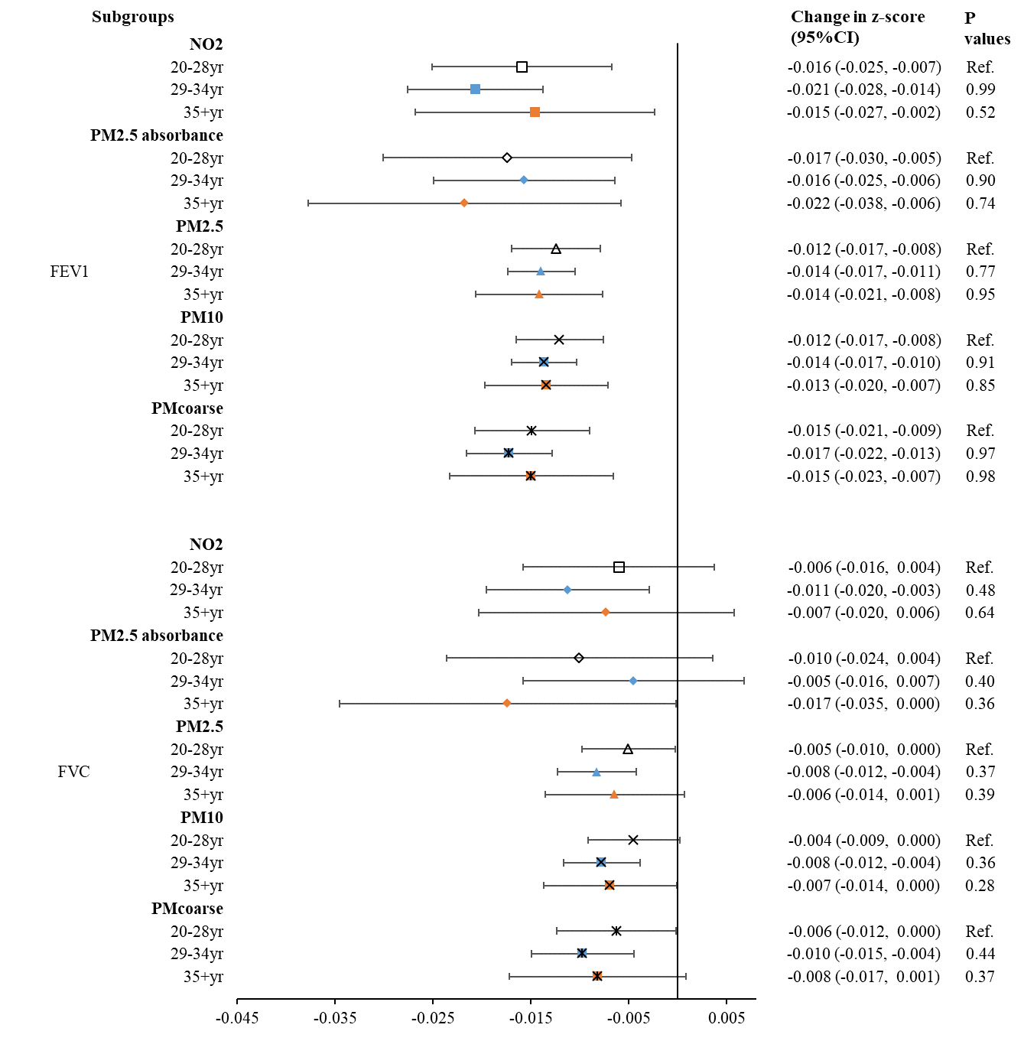**Figure S1** Effect estimates of early air pollution exposure stratified by maternal age at delivery: extended analysis using pooled data from Munich and Wesel.

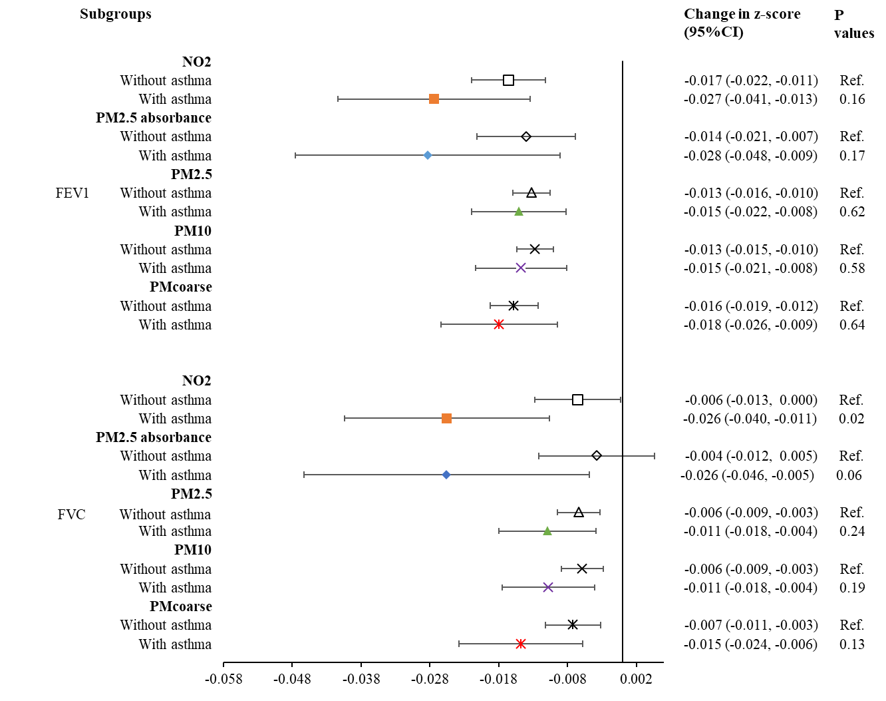**Figure S2** Effect estimates of early air pollution exposure stratified by asthma: extended analysis using pooled data from Munich and Wesel.

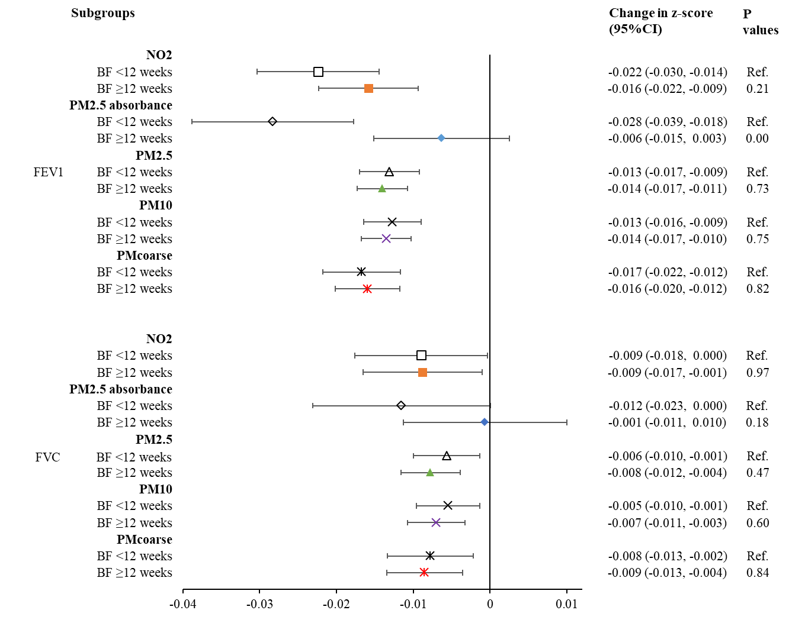 **Figure S3** Effect estimates of early air pollution exposure stratified by duration of breastfeeding (BF): extended analysis using pooled data from Munich and Wesel.

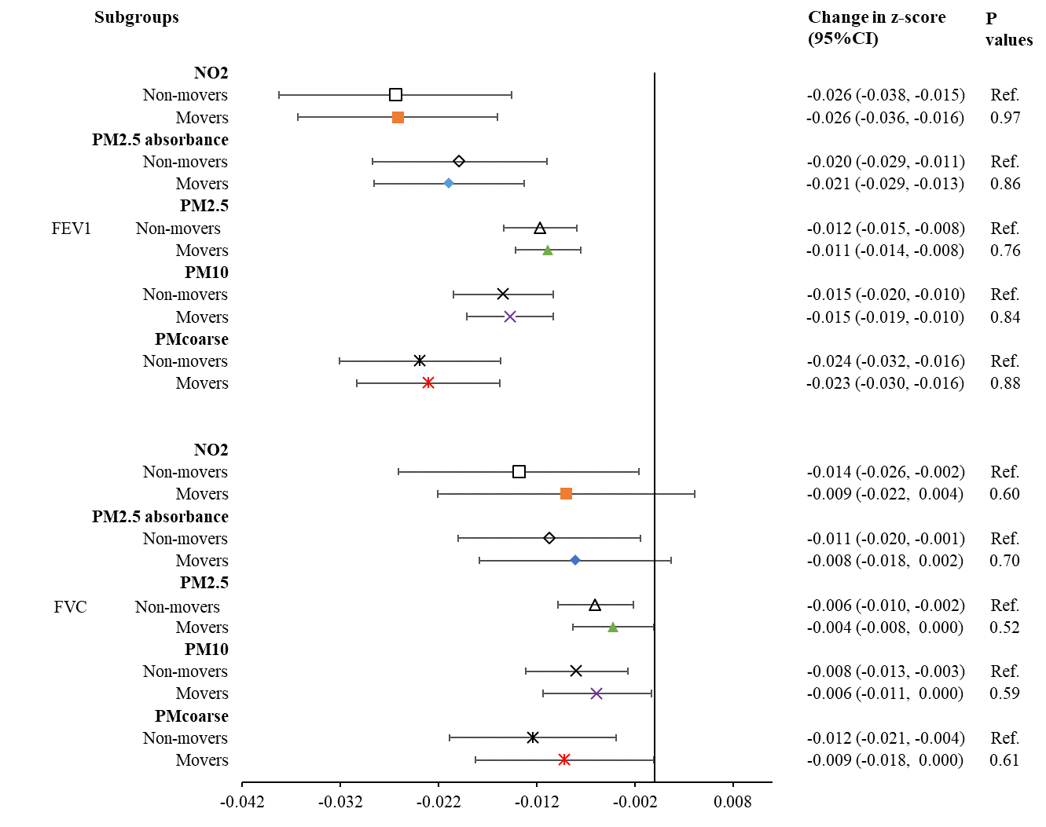**Figure S4** Effect estimates of early air pollution exposure stratified by whether participants moved or not after the age of 1 in Wesel.